

database management systems

LAB ASESSMENT – 1

­­ Name: **VIBHU KUMAR SINGH**

Reg. No: **19BCE0215**

Teacher: **Nancy Victor**

**Q) create a table employee with attributes emp name, emp id and salary.**

**Use DDL commands to create and alter the table.**

**1) create table**

**2) add a new column year of joining with the datatype as date**

**3) change the emp id datatype to varchar2.**

**4) add another column incentive**

**5) drop the column incentive**

**6) rename column emp name to e_name**

**7) rename the table as emp_details**

**A)** Commands:

1. ***create table emp_details(emp_name varchar2(10),emp_id number(5),salary number(6));***

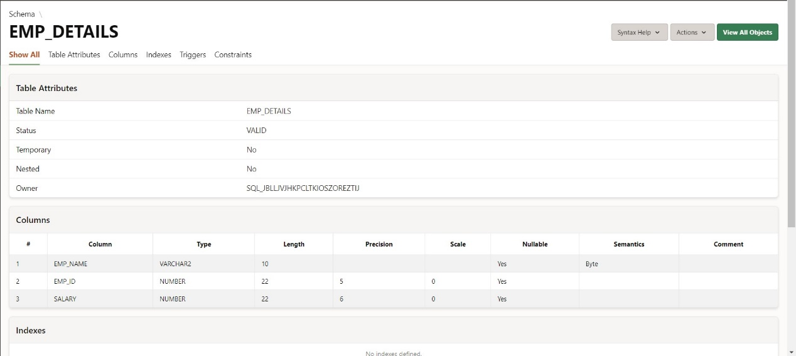

1. ***alter table emp_details add year_of_joining date;***

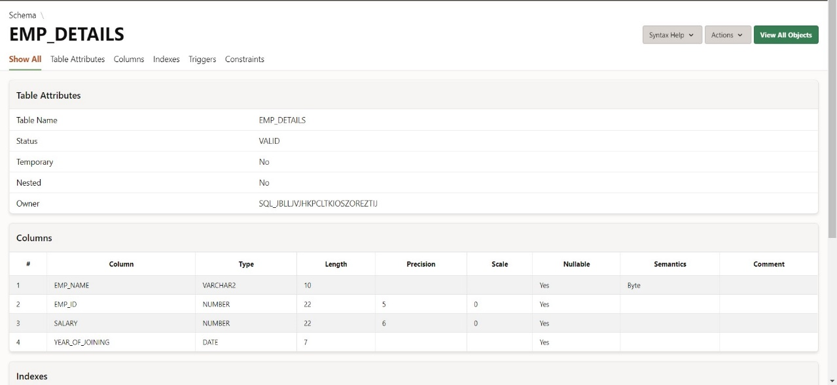

1. ***alter table emp_details modify (emp_id varchar2(10));***

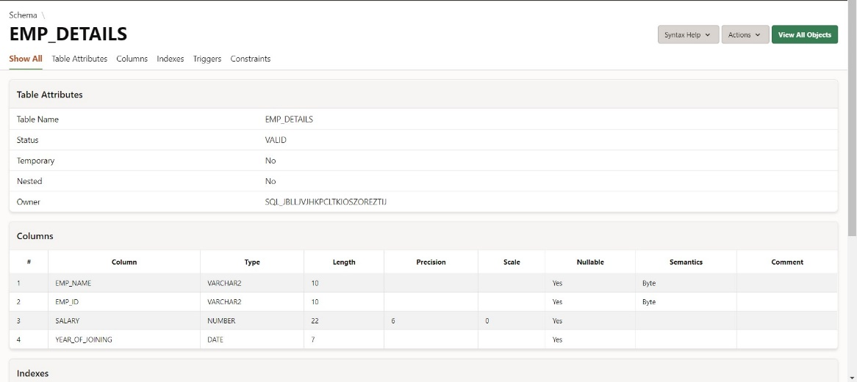

1. ***alter table emp_details add incentive number(4);***

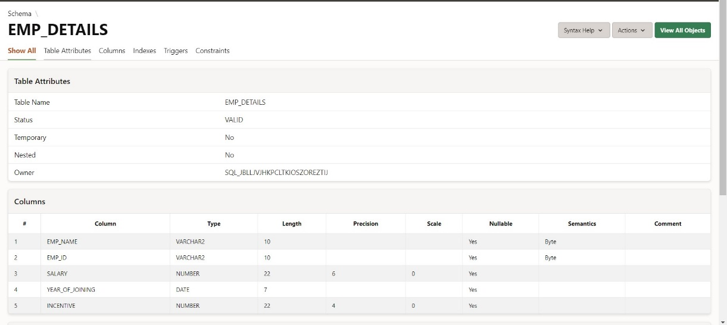

1. ***alter table emp_details drop column incentive;***

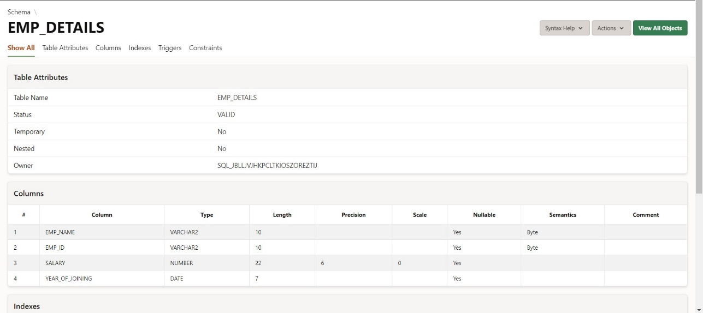

1. ***alter table emp_details rename column emp_name to e_name;***

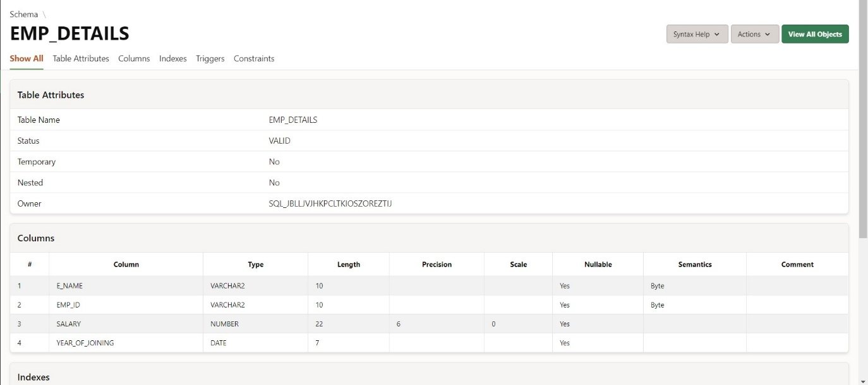

1. ***rename emp_details to emplyee_details;***

