1. Write a query to display the name ( first name and last name ) for those employees who gets more salary than the employee whose ID is 163.

A1.

SELECT first_name, last_name

FROM employees

WHERE salary >

( SELECT salary

FROM employees

WHERE employee_id=163

);

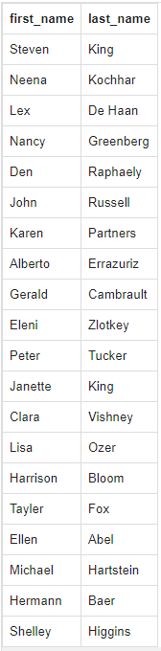

1. Write a query to display the name ( first name and last name ), salary, department id, job id for those employees who works in the same designation as the employee works whose id is 169.

A2.

SELECT first_name, last_name, salary, department_id, job_id

FROM employees

WHERE job_id =

( SELECT job_id

FROM employees

WHERE employee_id=169

);

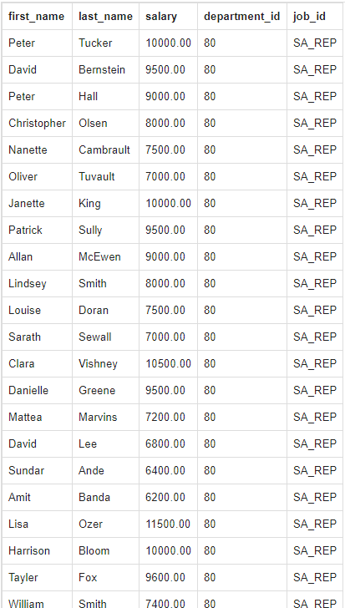

1. Write a query to display the employee id, employee name (first name and last name ) for all employees who earn more than the average salary.

A4.

SELECT employee_id, first_name,last_name

FROM employees

WHERE salary >

( SELECT AVG(salary)

FROM employees

);

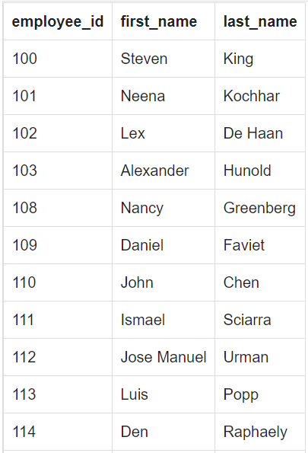

1. Write a query to display the employee name ( first name and last name ), employee id and salary of all employees who report to Payam.

A5.

SELECT first_name, last_name, employee_id, salary

FROM employees

WHERE manager_id =

(SELECT employee_id

FROM employees

WHERE first_name = 'Payam'

);

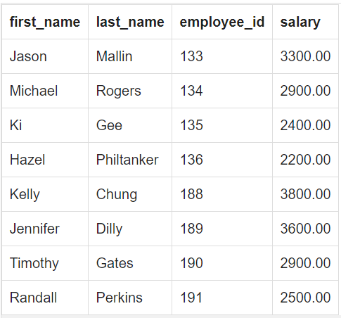

**12.** Write a query to display all the information for those employees whose id is any id who earn the second highest salary.

A12.

SELECT *

FROM employees

WHERE employee_id IN

(SELECT employee_id

FROM employees

WHERE salary =

(SELECT MAX(salary)

FROM employees

WHERE salary <

(SELECT MAX(salary)

FROM employees)));

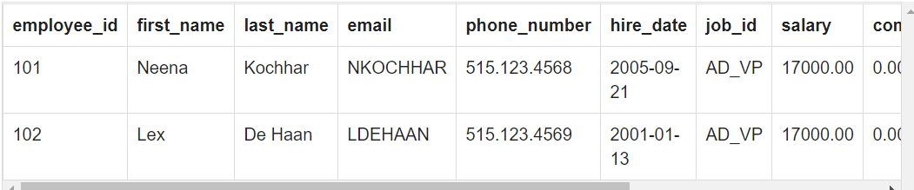

**53.** Write a query in SQL to display the details of departments managed by Susan.

A53.

SELECT *

FROM departments

WHERE manager_id IN

(SELECT employee_id

FROM employees

WHERE first_name='Susan');

