

dIgital logic and design

LAB ASESSMENT – 1

­­

Name: **VIBHU KUMAR SINGH**

Reg. No: **19BCE0215**

Teacher: **Sairabanu J.**

**Q1) Verify the truth tables of the following gates:**

**1)AND 2)OR**

**3)NOT 4)NAND**

**5)NOR 6)XOR**

**7)XNOR**

**Ans 1)**

Truth Tables:

|  |  |  |  |  |  |  |  |
| --- | --- | --- | --- | --- | --- | --- | --- |
| INPUT | | OUTPUT | | | | | |
| A | **B** | A and B | A or B | A nand B | A nor B | A xor B | A xnor B |
| 0 | **0** | 0 | 0 | 1 | 1 | 0 | 1 |
| 0 | **1** | 0 | 1 | 1 | 0 | 1 | 0 |
| 1 | **0** | 0 | 1 | 1 | 0 | 1 | 0 |
| 1 | **1** | 1 | 1 | 0 | 0 | 0 | 1 |

|  |  |
| --- | --- |
| Input | Output |
| A | **A’** |
| 0 | 1 |
| 1 | 0 |

SCREENSHOTS:

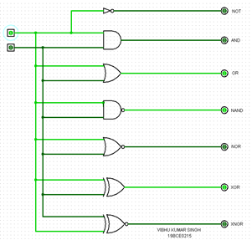 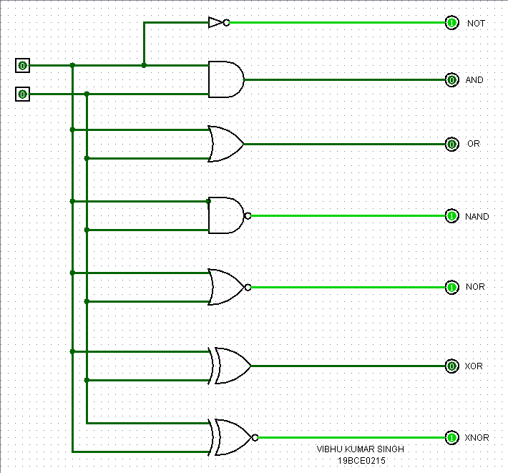 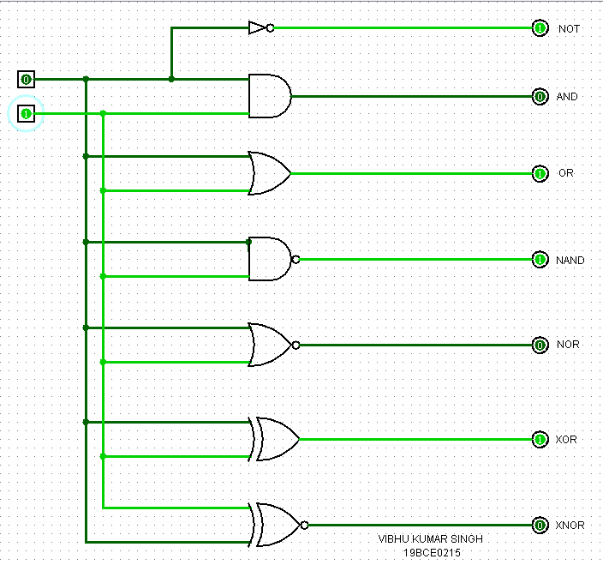

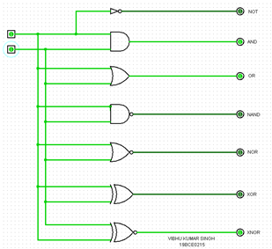

**Q2) Show that NAND and NOR gates are universal gates.**

**Ans 2)**

Truth Table:

|  |  |  |  |  |  |
| --- | --- | --- | --- | --- | --- |
| INPUT | | OUTPUT | | | |
| A | **B** | A and B | A or B | A nand B | A nor B |
| 0 | **0** | 0 | 0 | 1 | 1 |
| 0 | **1** | 0 | 1 | 1 | 0 |
| 1 | **0** | 0 | 1 | 1 | 0 |
| 1 | **1** | 1 | 1 | 0 | 0 |

SCREENSHOTS:

**USING NAND GATES:**

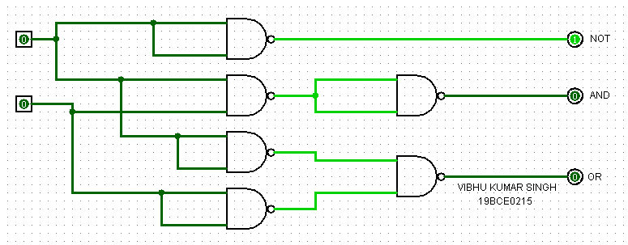 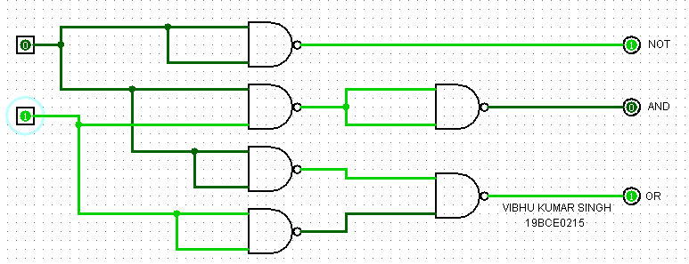

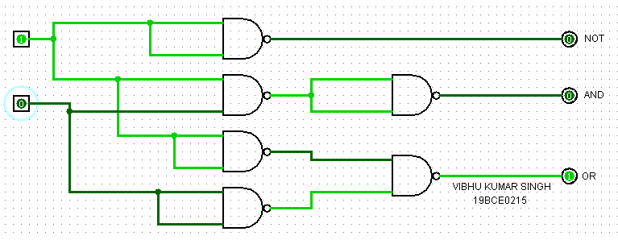 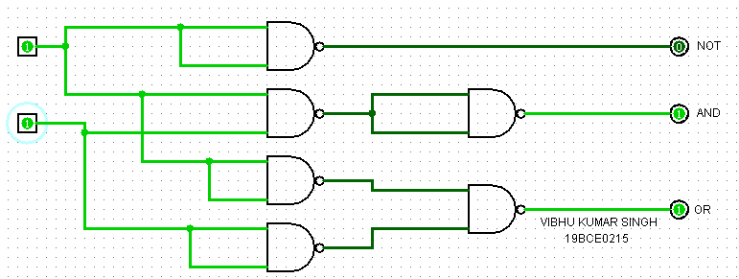

**USING NOR GATES:**

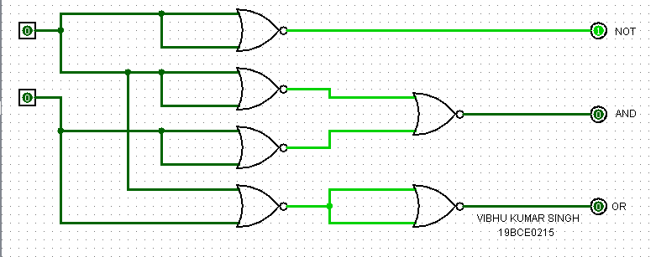 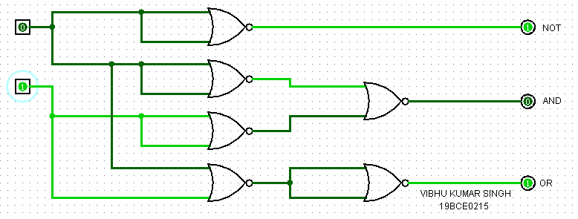

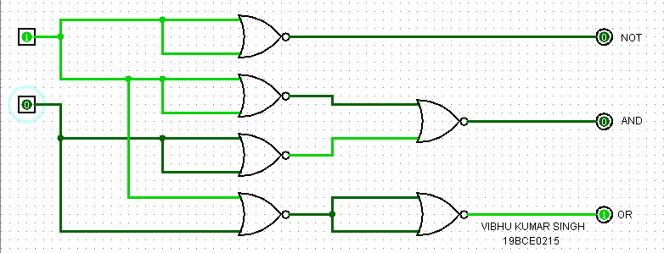 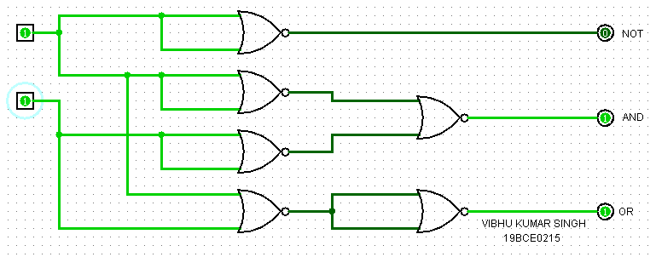

**Q3) Verify De-Morgan’s law for three variables.**

**Ans 3)**

1)Proof: (A+B+C)’=(A’.B’.C’)

Truth Tables:

|  |  |  |  |  |
| --- | --- | --- | --- | --- |
| INPUT | | | OUTPUT | |
| A | **B** | **C** | **(A+B+C)** | **(A+B+C)’** |
| 0 | **0** | **0** | 0 | 1 |
| 0 | **0** | **1** | 1 | 0 |
| 0 | **1** | **0** | 1 | 0 |
| 0 | **1** | **1** | 1 | 0 |
| 1 | **0** | **0** | 1 | 0 |
| 1 | **0** | **1** | 1 | 0 |
| 1 | **1** | **0** | 1 | 0 |
| 1 | **1** | **1** | 1 | 0 |

|  |  |  |  |
| --- | --- | --- | --- |
| INPUT | | | OUTPUT |
| A | **B** | **C** | **(A’.B’.C’)** |
| 0 | **0** | **0** | 1 |
| 0 | **0** | **1** | 0 |
| 0 | **1** | **0** | 0 |
| 0 | **1** | **1** | 0 |
| 1 | **0** | **0** | 0 |
| 1 | **0** | **1** | 0 |
| 1 | **1** | **0** | 0 |
| 1 | **1** | **1** | 0 |

Verification using basic gates:

SCREENSHOTS:

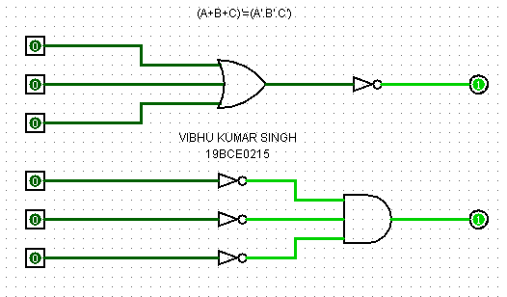 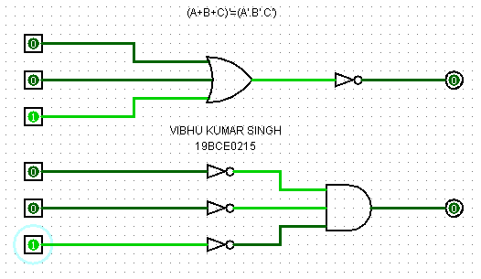

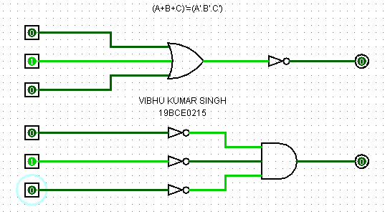 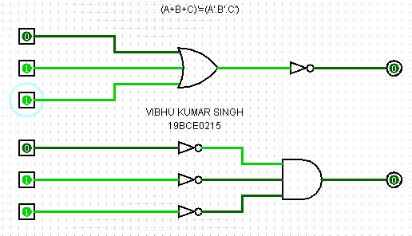

2) Proof: (A.B.C)’=(A’+B’+C’)

Truth Tables:

|  |  |  |  |  |
| --- | --- | --- | --- | --- |
| INPUT | | | OUTPUT | |
| A | **B** | **C** | **(A.B.C)** | **(A.B.C)’** |
| 0 | **0** | **0** | 0 | 1 |
| 0 | **0** | **1** | 0 | 1 |
| 0 | **1** | **0** | 0 | 1 |
| 0 | **1** | **1** | 0 | 1 |
| 1 | **0** | **0** | 0 | 1 |
| 1 | **0** | **1** | 0 | 1 |
| 1 | **1** | **0** | 0 | 1 |
| 1 | **1** | **1** | 1 | 0 |

|  |  |  |  |
| --- | --- | --- | --- |
| INPUT | | | OUTPUT |
| A | **B** | **C** | **(A’+B’+C’)** |
| 0 | **0** | **0** | 1 |
| 0 | **0** | **1** | 1 |
| 0 | **1** | **0** | 1 |
| 0 | **1** | **1** | 1 |
| 1 | **0** | **0** | 1 |
| 1 | **0** | **1** | 1 |
| 1 | **1** | **0** | 1 |
| 1 | **1** | **1** | 0 |

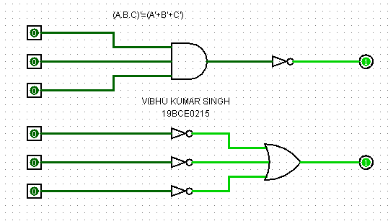 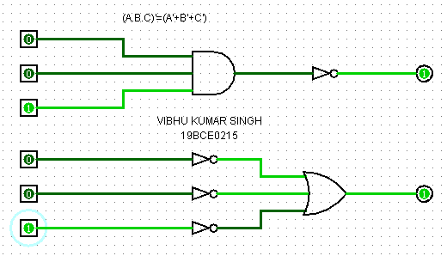

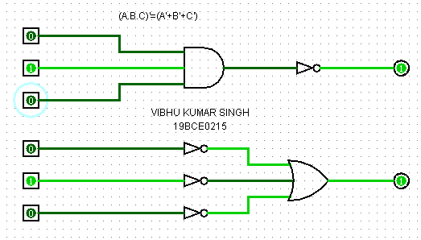 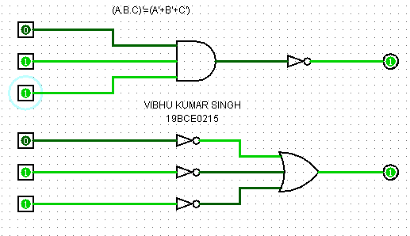

**Q4) You should wear your overshoes if you are outside in a heavy rain and you are wearing your new suede shoes, or if your mother tells you to.**

**Ans 4)**

A=You are outside in heavy rain

B=You are wearing new suede shoes

C=Your mother tells you to wear overshoes

F=You should wear overshoes

**F=(A.B+C)**

|  |  |  |  |
| --- | --- | --- | --- |
| INPUT | | | OUTPUT |
| A | **B** | **C** | **(A.B+C)** |
| 0 | **0** | **0** | 0 |
| 0 | **0** | **1** | 1 |
| 0 | **1** | **0** | 0 |
| 0 | **1** | **1** | 1 |
| 1 | **0** | **0** | 0 |
| 1 | **0** | **1** | 1 |
| 1 | **1** | **0** | 1 |
| 1 | **1** | **1** | 1 |

Truth Table:

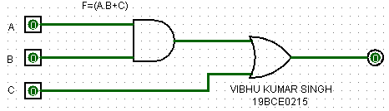 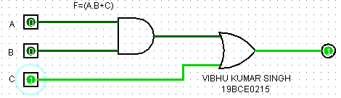

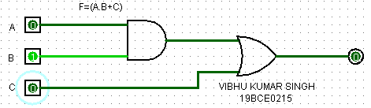 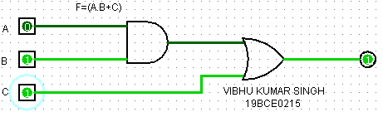

**Q5)** **You should laugh at a joke if it is funny, it is in good taste, and it is not offensive to others, or if it is told in class by your professor (regardless of whether it is funny and in good taste) and it is not offensive to others. Implement using basic gates.**

**Ans 5)**

A=Joke is funny

B=Joke is in good taste

C=Joke is not offensive to others

D=Joke is told in class by your professor

F=You should laugh at a joke

**F=(A.B.C+C.D)**

Truth Table:

|  |  |  |  |  |  |  |
| --- | --- | --- | --- | --- | --- | --- |
| INPUT | | | | OUTPUT | | |
| A | **B** | **C** | **D** | **A.B.C** | **C.D** | **(A.B.C+C.D)** |
| 0 | **0** | **0** | **0** | 0 | 0 | 0 |
| 0 | **0** | **0** | **1** | 0 | 0 | 0 |
| 0 | **0** | **1** | **0** | 0 | 0 | 0 |
| 0 | **0** | **1** | **1** | 0 | 1 | 1 |
| 0 | **1** | **0** | **0** | 0 | 0 | 0 |
| 0 | **1** | **0** | **1** | 0 | 0 | 0 |
| 0 | **1** | **1** | **0** | 0 | 0 | 0 |
| 0 | **1** | **1** | **1** | 0 | 1 | 1 |
| 1 | **0** | **0** | **0** | 0 | 0 | 0 |
| 1 | **0** | **0** | **1** | 0 | 0 | 0 |
| 1 | **0** | **1** | **0** | 0 | 0 | 0 |
| 1 | **0** | **1** | **1** | 0 | 1 | 1 |
| 1 | **1** | **0** | **0** | 0 | 0 | 0 |
| 1 | **1** | **0** | **1** | 0 | 0 | 0 |
| 1 | **1** | **1** | **0** | 1 | 0 | 1 |
| 1 | **1** | **1** | **1** | 1 | 1 | 1 |

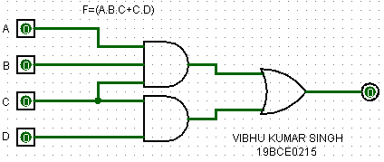 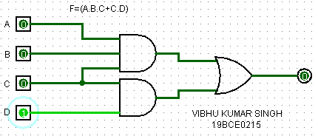

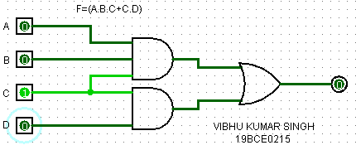 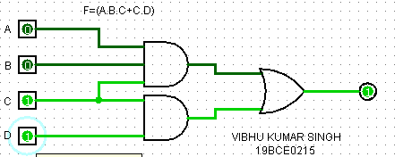

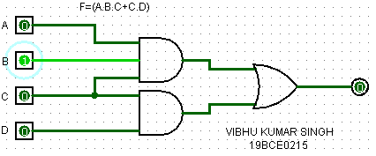 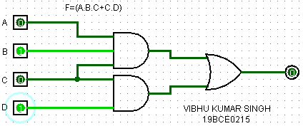

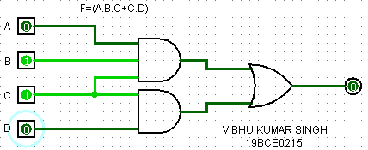 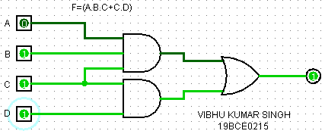

**Q6) The company safe should be unlocked only when Mr. Jones is in the office or Mr. Evans is in the office, and only when the company is open for business, and only when the security guard is present. Implement using only NAND gates.**

**Ans 6)**

A=Mr. Jones is in the office

B=Mr. Evans is in the office

C=Company is open for business

D=Security guard is present

F=The company safe should be unlocked

**F=(A+B).C.D=A.C.D+B.C.D**

Truth Table:

|  |  |  |  |  |  |  |
| --- | --- | --- | --- | --- | --- | --- |
| INPUT | | | | OUTPUT | | |
| A | **B** | **C** | **D** | **A.C.D** | **B.C.D** | **(A.C.D)+(B.C.D)** |
| 0 | **0** | **0** | **0** | 0 | 0 | 0 |
| 0 | **0** | **0** | **1** | 0 | 0 | 0 |
| 0 | **0** | **1** | **0** | 0 | 0 | 0 |
| 0 | **0** | **1** | **1** | 0 | 0 | 0 |
| 0 | **1** | **0** | **0** | 0 | 0 | 0 |
| 0 | **1** | **0** | **1** | 0 | 0 | 0 |
| 0 | **1** | **1** | **0** | 0 | 0 | 0 |
| 0 | **1** | **1** | **1** | 0 | 1 | 1 |
| 1 | **0** | **0** | **0** | 0 | 0 | 0 |
| 1 | **0** | **0** | **1** | 0 | 0 | 0 |
| 1 | **0** | **1** | **0** | 0 | 0 | 0 |
| 1 | **0** | **1** | **1** | 1 | 0 | 1 |
| 1 | **1** | **0** | **0** | 0 | 0 | 0 |
| 1 | **1** | **0** | **1** | 0 | 0 | 0 |
| 1 | **1** | **1** | **0** | 0 | 0 | 0 |
| 1 | **1** | **1** | **1** | 1 | 1 | 1 |

Using basic gates:

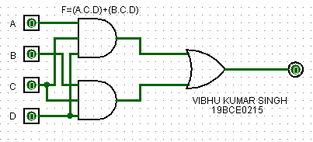

SCREENSHOTS:

Using NAND gates:

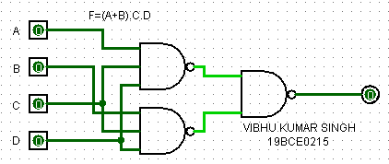 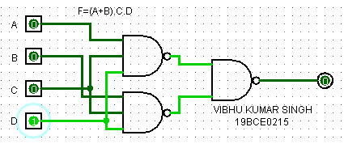

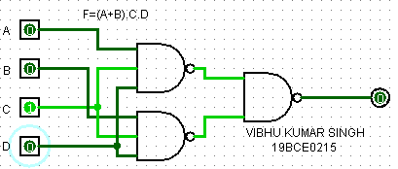 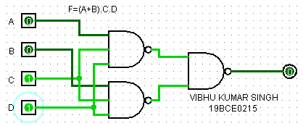

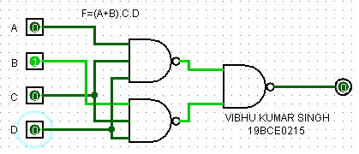 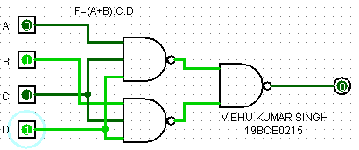

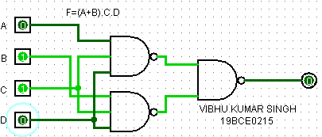 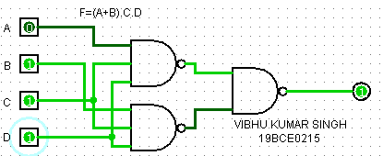

**Q7) Four chairs are placed in a row: Each chair may be occupied (1) or empty (0). F (A, B, C, D) is 1 iff there are more people sitting in the left two chairs than in the right two chairs. Implement the expression by using basic gates.**

**Ans 7)**

A=Occupancy of left chair 1

B=Occupancy of left chair 2

C=Occupancy of right chair 1

D=Occupancy of right chair 2

Truth Table:

|  |  |  |  |  |  |  |  |  |
| --- | --- | --- | --- | --- | --- | --- | --- | --- |
| INPUT | | | | OUTPUT | | | | |
| A | **B** | **C** | **D** | **A.B.C’** | **A.B.D’** | **A.C’D’** | **B.C’.D’** | **(A.B.C’)+(A.B.D’)+(A.C’.D’)+(B.C’.D’)** |
| 0 | **0** | **0** | **0** | 0 | 0 | 0 | 0 | 0 |
| 0 | **0** | **0** | **1** | 0 | 0 | 0 | 0 | 0 |
| 0 | **0** | **1** | **0** | 0 | 0 | 0 | 0 | 0 |
| 0 | **0** | **1** | **1** | 0 | 0 | 0 | 0 | 0 |
| 0 | **1** | **0** | **0** | 0 | 0 | 0 | 1 | 1 |
| 0 | **1** | **0** | **1** | 0 | 0 | 0 | 0 | 0 |
| 0 | **1** | **1** | **0** | 0 | 0 | 0 | 0 | 0 |
| 0 | **1** | **1** | **1** | 0 | 0 | 0 | 0 | 0 |
| 1 | **0** | **0** | **0** | 0 | 0 | 1 | 0 | 1 |
| 1 | **0** | **0** | **1** | 0 | 0 | 0 | 0 | 0 |
| 1 | **0** | **1** | **0** | 0 | 0 | 1 | 0 | 1 |
| 1 | **0** | **1** | **1** | 0 | 0 | 0 | 0 | 0 |
| 1 | **1** | **0** | **0** | 1 | 1 | 0 | 1 | 1 |
| 1 | **1** | **0** | **1** | 1 | 0 | 0 | 0 | 1 |
| 1 | **1** | **1** | **0** | 0 | 1 | 0 | 0 | 1 |
| 1 | **1** | **1** | **1** | 0 | 0 | 0 | 0 | 0 |

Using truth table:

**F=(A.C’.D’)+(B.C’.D’)+(A.B.C’)+(A.B.D’)**

