

dIgital logic and design

LAB ASESSMENT – 4

­­

Name: **VIBHU KUMAR SINGH**

Reg. No: **19BCE0215**

Teacher: **Sairabanu J.**

**EXPERIMENT 5:**

**Q1) Design a 4-bit Binary parallel Adder.**

**A1)**

**AIM:**

To design a 4-bit Binary Parallel Adder.

**DESIGN**:

In order to make 4-bit Binary Parallel Adder, a single Full Adder circuit is saved as user I.C. and imported in another Logisim file to make Binary Parallel Adder. The circuit for Full Adder is:

|  |  |  |  |  |
| --- | --- | --- | --- | --- |
| FULL ADDER | | | | |
| INPUT | | | **OUTPUT** | |
| X | **Y** | **Z** | **Sum** | **Carry** |
| 0 | 0 | 0 | **0** | **0** |
| 0 | 0 | 1 | **1** | **0** |
| 0 | 1 | 0 | **1** | **0** |
| 0 | 1 | 1 | **1** | **1** |
| 1 | 0 | 0 | **1** | **0** |
| 1 | 0 | 1 | **0** | **1** |
| 1 | 1 | 0 | **0** | **1** |
| 1 | 1 | 1 | **1** | **1** |

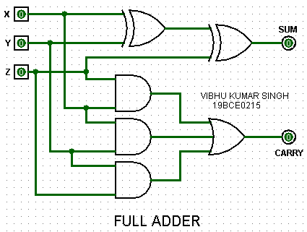

This Full Adder circuit is saved as user I.C. and imported in another file. The circuit for 4-bit Binary Parallel Adder is:

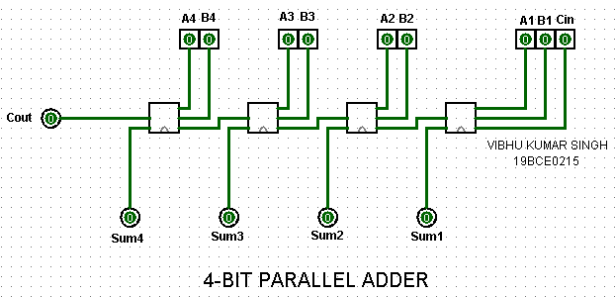

**SCREENSHOTS:**

EXAMPLE 1:

**A=1110 B=1010**

A4/B4 A3/B3 A2/B2 A1/B1

1 1 1 0

+ 1 0 1 0

**1 1 0 0 0**

OUTPUT 1:

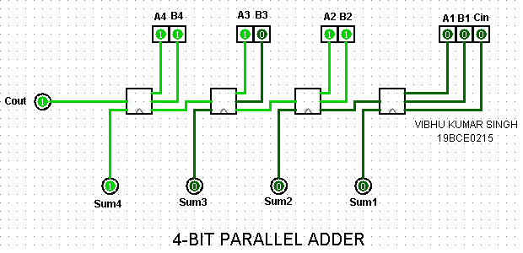

EXAMPLE 2:

**A=1111 B=1011**

A4/B4 A3/B3 A2/B2 A1/B1

1 1 1 1

+ 1 0 1 1

**1 1 0 1 0**

OUTPUT 2:

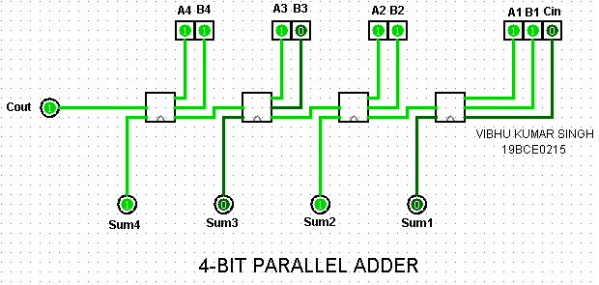

EXAMPLE 3:

**A=0111 B=0011**

A4/B4 A3/B3 A2/B2 A1/B1

0 1 1 1

+ 0 0 1 1

**0 1 0 1 0**

OUTPUT 3:

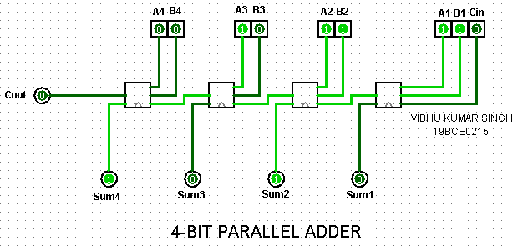

EXAMPLE 4:

**A=1000 B=1100**

A4/B4 A3/B3 A2/B2 A1/B1

1 0 0 0

+ 1 1 0 0

**1 0 1 0 0**

OUTPUT 4:

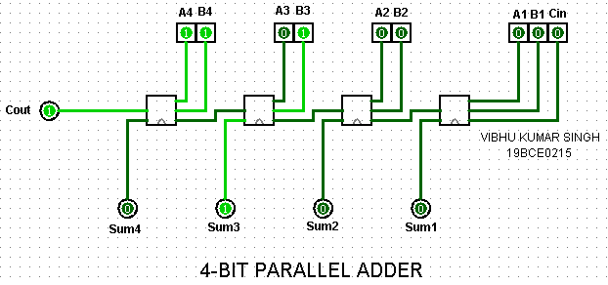

**Q2) Design Excess 5 to BCD using Binary parallel adder.**

**A2)**

**AIM:**

To design Excess 5 to BCD using Binary Parallel Adder.

**DESIGN**:

It has the same principle as a regular 4-bit Binary Parallel Adder except we will be subtracting 5(0101) from the given BCD code using 2’s complement subtraction ie. add (1011) . The circuit for Binary Parallel Adder is saved as user I.C. and imported in a new Logisim file. The circuit for Binary Parallel Adder is:

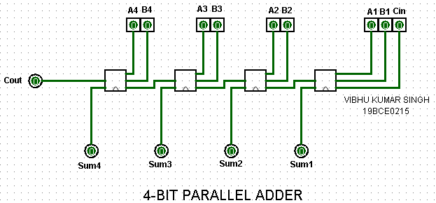

This Binary Parallel Adder circuit is saved as user I.C. and imported in another file. The circuit for Excess 5 to BCD converter using Binary Parallel Adder is:

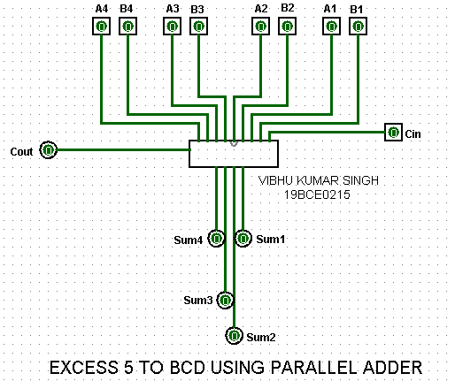

**SCREENSHOTS:**

EXAMPLE 1:

**Convert A=1000 into BCD code.**

A4/B4 A3/B3 A2/B2 A1/B1

1 0 0 0

+ 1 0 1 1

**1 0 0 1 1**

Since end carry is generated, it is discarded.

So, the BCD code is **0011**.

OUTPUT 1:

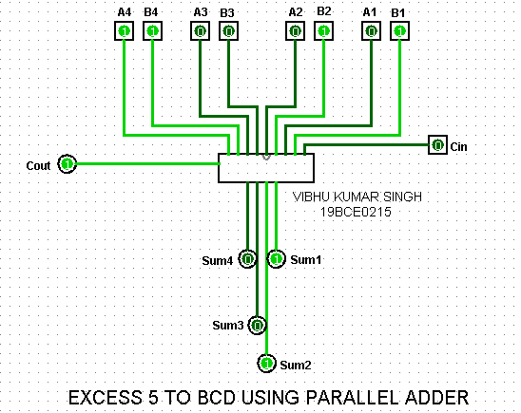

EXAMPLE 2:

**Convert A=1001 into BCD code.**

A4/B4 A3/B3 A2/B2 A1/B1

1 0 0 1

+ 1 0 1 1

**1 0 1 0 0**

Since end carry is generated, it is discarded.

So, the BCD code is **0100**.

OUTPUT 2:

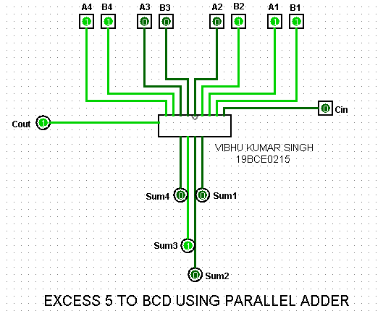

EXAMPLE 3:

**Convert A=1010 into BCD code.**

A4/B4 A3/B3 A2/B2 A1/B1

1 0 1 0

+ 1 0 1 1

**1 0 1 0 1**

Since end carry is generated, it is discarded.

So, the BCD code is **0101**.

OUTPUT 3:

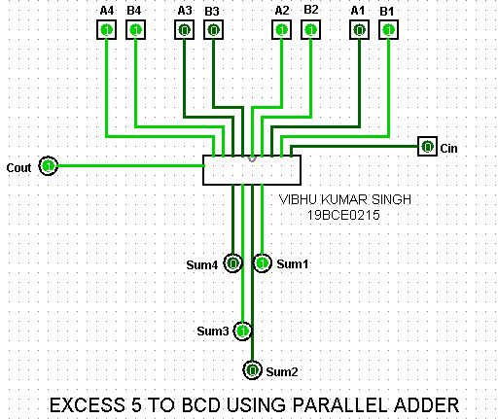

EXAMPLE 4:

**Convert A=1011 into BCD code.**

A4/B4 A3/B3 A2/B2 A1/B1

1 0 1 1

+ 1 0 1 1

**1 0 1 1 0**

Since end carry is generated, it is discarded.

So, the BCD code is **0110**.

OUTPUT 4:

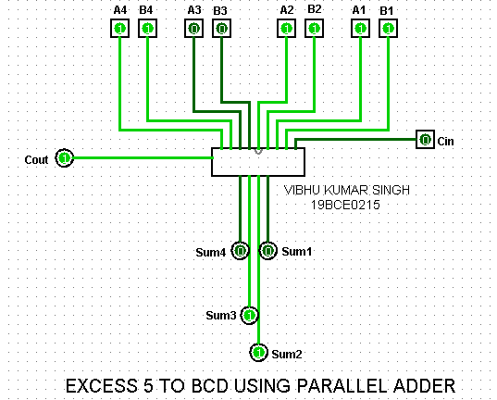

**Q3) Design a 2-bit magnitude comparator.**

**A3)**

**AIM:**

To design a 2-bit Magnitude Comparator.

**TRUTH TABLE:**

|  |  |  |  |  |
| --- | --- | --- | --- | --- |
| 2-BIT MAGNITUDE COMPARATOR | | | | |
| INPUT | | **OUTPUT** | | |
| A2 A1 | **B2 B1** | **A>B** | **A=B** | **A<B** |
| 0 0 | 0 0 | **0** | **1** | **0** |
| 0 0 | 0 1 | **0** | **0** | **1** |
| 0 0 | 1 0 | **0** | **0** | **1** |
| 0 0 | 1 1 | **0** | **0** | **1** |
| 0 1 | 0 0 | **1** | **0** | **0** |
| 0 1 | 0 1 | **0** | **1** | **0** |
| 0 1 | 1 0 | **0** | **0** | **1** |
| 0 1 | 1 1 | **0** | **0** | **1** |
| 1 0 | 0 0 | **1** | **0** | **0** |
| 1 0 | 0 1 | **1** | **0** | **0** |
| 1 0 | 1 0 | **0** | **1** | **0** |
| 1 0 | 1 1 | **0** | **0** | **1** |
| 1 1 | 0 0 | **1** | **0** | **0** |
| 1 1 | 0 1 | **1** | **0** | **0** |
| 1 1 | 1 0 | **1** | **0** | **0** |
| 1 1 | 1 1 | **0** | **1** | **0** |

**BOOLEAN EXPRESSIONS:**

* FOR (A>B):

=**A1.B1’ + X1.A0.B0’**

* FOR (A=B):

=**X1.X0**

* FOR (A<B):

=**A1’.B1 + X1.A0’.B0**

**DESIGN:**

The circuit of 2-bit Magnitude Comparator is made using a predefined I.C. in Logisim.

The circuit for 2-bit Magnitude Comparator is:

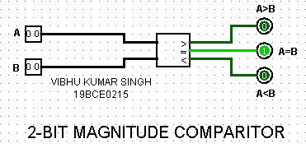

**SCREENSHOTS(4):**

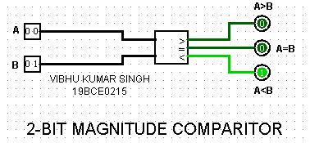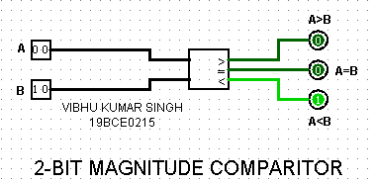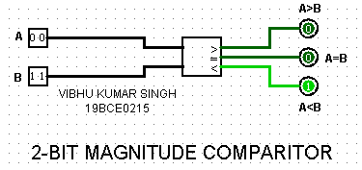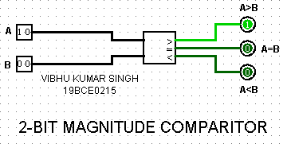

**Q4) Design a circuit to determine the greatest of 3 2-bit numbers using a 2 bit magnitude comparator.**

**A4)**

**AIM:**

Design a circuit to determine the greatest of 3 2-bit numbers using a 2-bit Magnitude Comparator.

**TRUTH TABLE:**

|  |  |  |  |  |
| --- | --- | --- | --- | --- |
| 2-BIT MAGNITUDE COMPARATOR | | | | |
| INPUT | | **OUTPUT** | | |
| A2 A1 | **B2 B1** | **A>B** | **A=B** | **A<B** |
| 0 0 | 0 0 | **0** | **1** | **0** |
| 0 0 | 0 1 | **0** | **0** | **1** |
| 0 0 | 1 0 | **0** | **0** | **1** |
| 0 0 | 1 1 | **0** | **0** | **1** |
| 0 1 | 0 0 | **1** | **0** | **0** |
| 0 1 | 0 1 | **0** | **1** | **0** |
| 0 1 | 1 0 | **0** | **0** | **1** |
| 0 1 | 1 1 | **0** | **0** | **1** |
| 1 0 | 0 0 | **1** | **0** | **0** |
| 1 0 | 0 1 | **1** | **0** | **0** |
| 1 0 | 1 0 | **0** | **1** | **0** |
| 1 0 | 1 1 | **0** | **0** | **1** |
| 1 1 | 0 0 | **1** | **0** | **0** |
| 1 1 | 0 1 | **1** | **0** | **0** |
| 1 1 | 1 0 | **1** | **0** | **0** |
| 1 1 | 1 1 | **0** | **1** | **0** |

**BOOLEAN EXPRESSIONS:**

* FOR (A>B):

=**A1.B1’ + X1.A0.B0’**

* FOR (A=B):

=**X1.X0**

* FOR (A<B):

=**A1’.B1 + X1.A0’.B0**

**DESIGN:**

Three 2-bit Magnitude Comparator I.C.(s) are used to determine the greatest of 3 2-bit

numbers. The circuit is as follows:

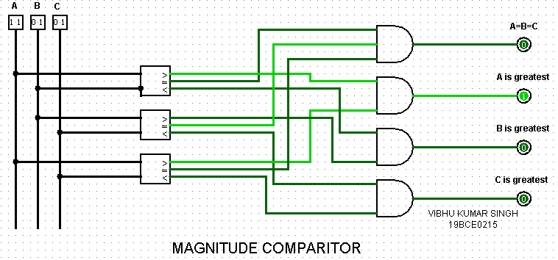

**SCREENSHOTS(4):**

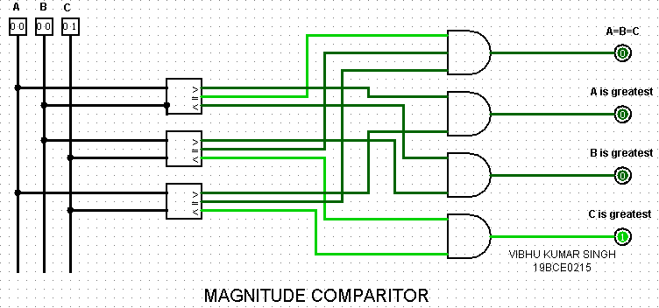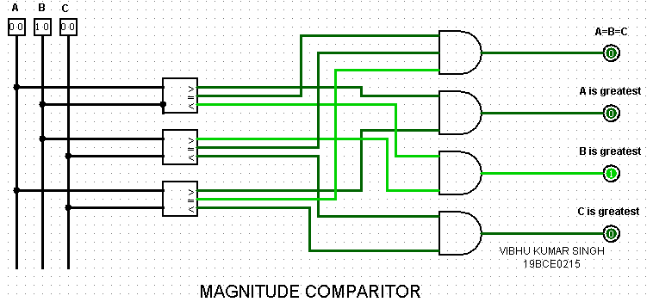

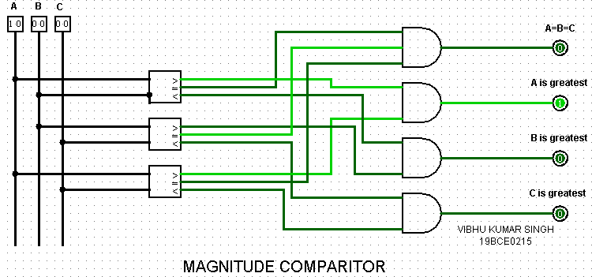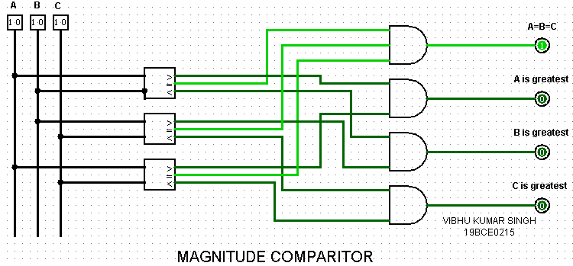

**EXPERIMENT 6:**

**Q1) To design 2 to 4 line decoder using AND Gates.**

**A1)**

**AIM:**

To design 2 to 4 line decoder using AND Gates.

**TRUTH TABLE:**

|  |  |  |  |  |  |
| --- | --- | --- | --- | --- | --- |
| 2-TO-4 DECODER | | | | | |
| INPUT | | **OUTPUT** | | | |
| X | **Y** | **D0** | **D1** | **D2** | **D3** |
| 0 | 0 | **1** | **0** | **0** | **0** |
| 0 | 1 | **0** | **1** | **0** | **0** |
| 1 | 0 | **1** | **0** | **1** | **0** |
| 1 | 1 | **0** | **0** | **0** | **1** |

**BOOLEAN EXPRESSIONS:**

**D0=X’Y’**

**D1=X’Y**

**D2=XY’**

**D3=XY**

**DESIGN:**

Using the above Boolean expressions, the Decoder can be made using basic AND

Gates. The circuit for 2 to 4 line decoder is:

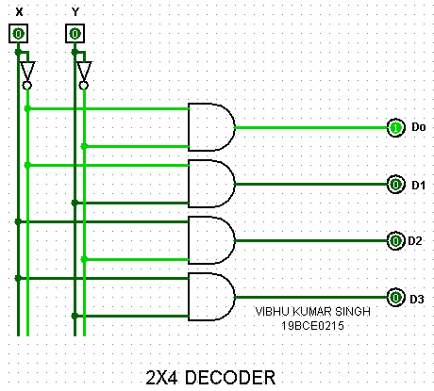

**SCREENSHOTS(4):**

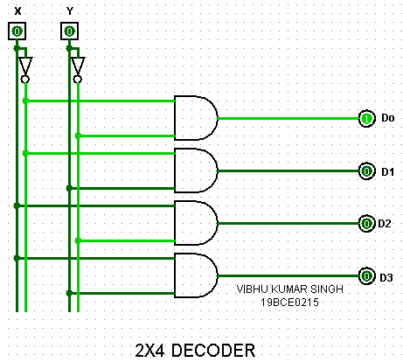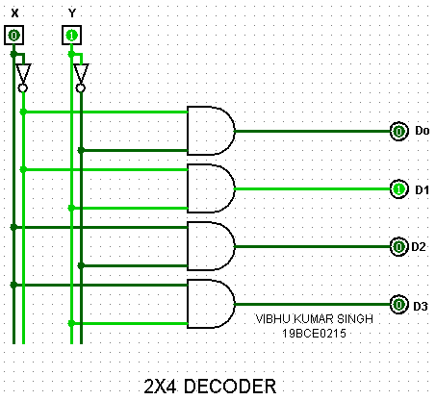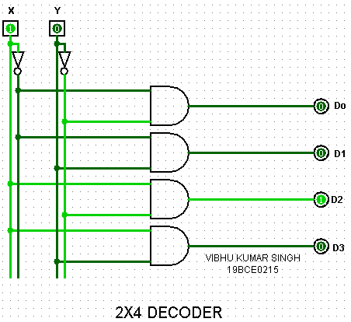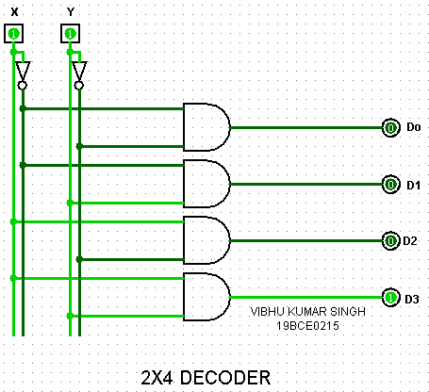

**Q2) Design a logic circuit to control the traffic light as per the given details. Vehicle detection sensors are placed along C and D (main road) and lanes A and B (access road). These sensor outputs are LOW (0) when no vehicle is present and HIGH (1) when a vehicle is present. The intersection traffic light is to be controlled according to the following logic:**

1. **The east-west (E-W) traffic light will be green whenever both**

**lanes C and D are occupied.**

1. **The E-W light will be green whenever either C or D is occupied**

**but lanes A or B are not occupied.**

1. **The north-south (N-S) light will be green whenever both lanes**

**A and B are occupied but C or D are not occupied.**

1. **The N-S light will also be green when either A or B is occupied**

**while C and D are both vacant.**

1. **The E-W light will be green when no vehicles are present. Using the sensor outputs A, B, C and D as inputs, N-S and E-W be two outputs that go high when the corresponding light to be green. Simulate the above scenario using decoders.**

**A2)**

**AIM:**

To obtain a circuit to solve the traffic light problem.

|  |  |  |  |  |  |
| --- | --- | --- | --- | --- | --- |
| TRAFFIC LIGHT PROBLEM | | | | | |
| INPUT | | | | **OUTPUT** | |
| A | **B** | **C** | **D** | **E/W** | **N/S** |
| 0 | 0 | 0 | 0 | **1** | **0** |
| 0 | 0 | 0 | 1 | **0** | **0** |
| 0 | 0 | 1 | 0 | **0** | **0** |
| 0 | 0 | 1 | 1 | **1** | **0** |
| 0 | 1 | 0 | 0 | **1** | **0** |
| 0 | 1 | 0 | 1 | **1** | **0** |
| 0 | 1 | 1 | 0 | **1** | **0** |
| 0 | 1 | 1 | 1 | **1** | **0** |
| 1 | 0 | 0 | 0 | **0** | **1** |
| 1 | 0 | 0 | 1 | **1** | **0** |
| 1 | 0 | 1 | 0 | **1** | **0** |
| 1 | 0 | 1 | 1 | **1** | **0** |
| 1 | 1 | 0 | 0 | **0** | **0** |
| 1 | 1 | 0 | 1 | **0** | **1** |
| 1 | 1 | 1 | 0 | **0** | **1** |
| 1 | 1 | 1 | 1 | **1** | **0** |

**TRUTH TABLE:**

**DESIGN:**

This can be designed using a 4-to-16 Decoder and simple OR Gates in the

following manner:

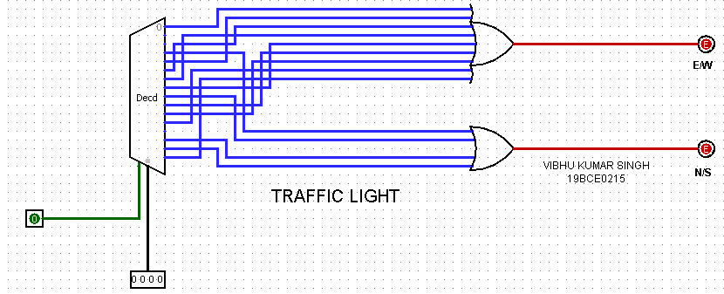

**SCREENSHOTS:**

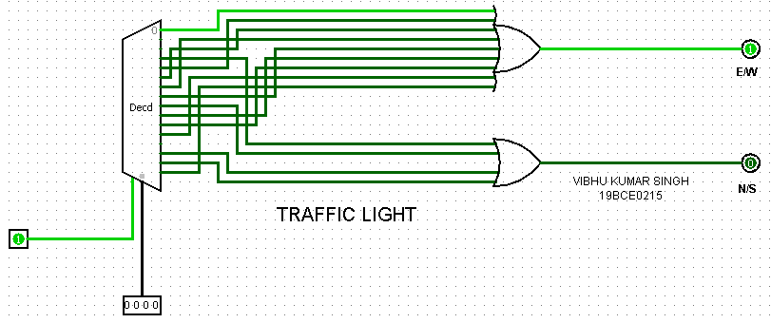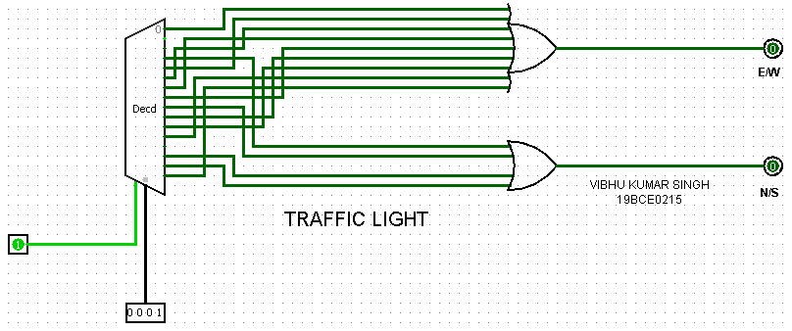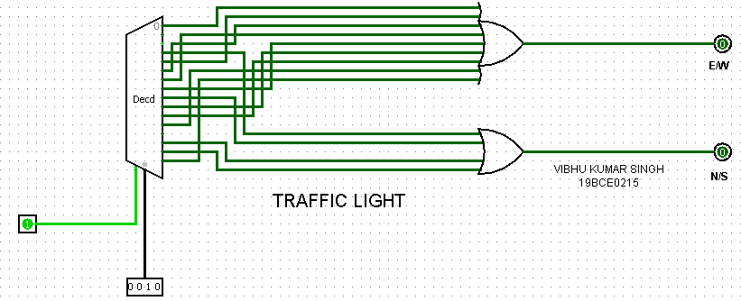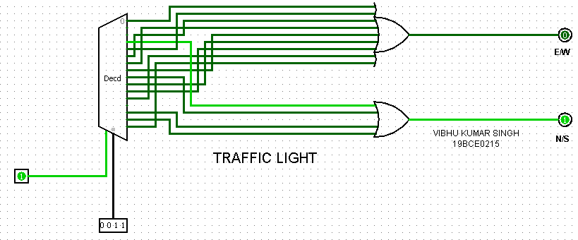

**Q3) Show how two 4-to-1 and one 2-to-1 multiplexers could be connected to form an 8-to-1 MUX with three control inputs.**

**A3)**

**AIM:**

To design 8-to-1 MUX using two 4-to-1 and one 2-to-1 MUX.

|  |  |  |  |
| --- | --- | --- | --- |
| 8-TO-1 MUX | | | |
| INPUT | | | **OUTPUT** |
| A | **B** | **C** |
| 0 | 0 | 0 | **I0** |
| 0 | 0 | 1 | **I1** |
| 0 | 1 | 0 | **I2** |
| 0 | 1 | 1 | **I3** |
| 1 | 0 | 0 | **I4** |
| 1 | 0 | 1 | **I5** |
| 1 | 1 | 0 | **I6** |
| 1 | 1 | 1 | **I7** |

**TRUTH TABLE:**

**DESIGN:**

The 8-to-1 MUX using two 4-to-1 and one 2-to-1 MUX can be made like this:

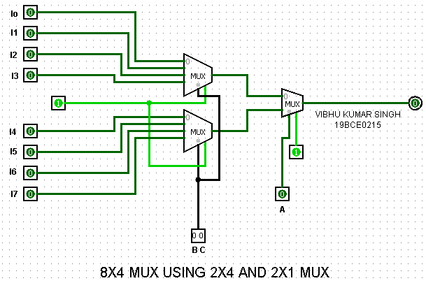

**SCREENSHOTS(4):**

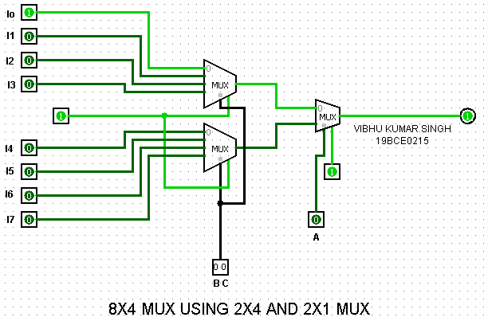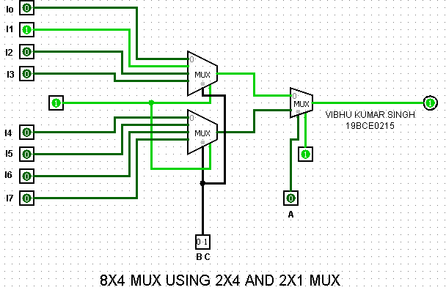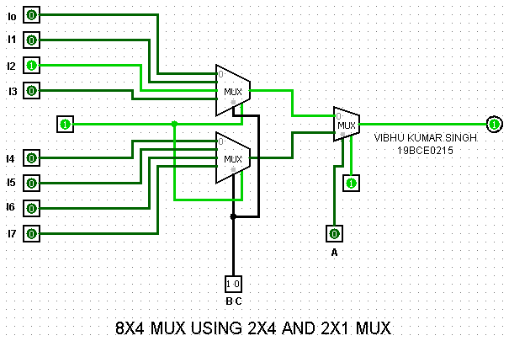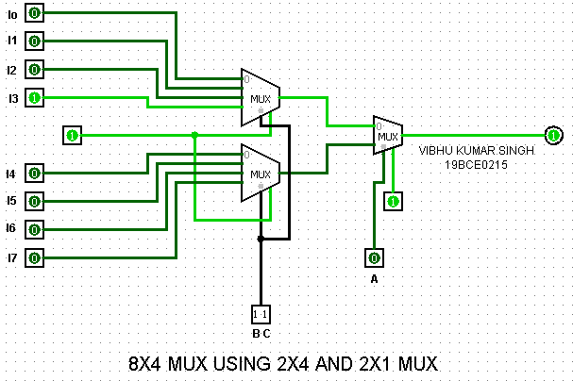

**Q4) Design a 4-bit Even parity Checker using a multiplexer.**

**A4)**

**AIM:**

Todesign a 4-bit Even Parity Checker using a multiplexer.

|  |  |  |  |  |
| --- | --- | --- | --- | --- |
| EVEN PARITY CHECKER | | | | |
| INPUT | | | | OUTPUT |
| A | **B** | **C** | **D** | **EVEN PARITY CHECKER** |
| 0 | 0 | 0 | 0 | **0** |
| 0 | 0 | 0 | 1 | **1** |
| 0 | 0 | 1 | 0 | **1** |
| 0 | 0 | 1 | 1 | **0** |
| 0 | 1 | 0 | 0 | **1** |
| 0 | 1 | 0 | 1 | **0** |
| 0 | 1 | 1 | 0 | **0** |
| 0 | 1 | 1 | 1 | **1** |
| 1 | 0 | 0 | 0 | **1** |
| 1 | 0 | 0 | 1 | **0** |
| 1 | 0 | 1 | 0 | **0** |
| 1 | 0 | 1 | 1 | **1** |
| 1 | 1 | 0 | 0 | **0** |
| 1 | 1 | 0 | 1 | **1** |
| 1 | 1 | 1 | 0 | **1** |
| 1 | 1 | 1 | 1 | **0** |

**TRUTH TABLE:**

**DESIGN:**

We will use reduced MUX to obtain the minimum number of input variables.

MINTERMS:

Select lines

**PARITY CHECKER(A,B,C,D)=∑m(1,2,4,7,8,11,13,14)**

Input variable

MAPPING MINTERMS:

**I0 I1 I2 I3 I4 I5 I6 I7**

**A’** 0 1 2 3 4 5 6 7

**A**  8 9 10 11 12 13 14 15

**A A’ A’ A A’ A A A’**

The circuit fora 4-bit Even Parity Checker using a multiplexer is:

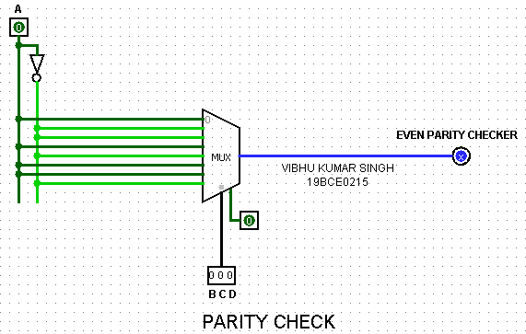

**SCREENSHOTS(4):**

