

dIgital logic and design

MID-SEM EXAM

­­

Name: **VIBHU KUMAR SINGH**

Reg. No: **19BCE0215**

Teacher: **Sairabanu J.**

5. a) Each of the coin has two sides heads and tails. Represent the heads or tails status of each coin by a logical variable (A for the first coin, B for the second and C for the third coin) where the logical variable is 1 for heads and 0 for tails. Write the logical function F(A, B, C) which is 1 iff exactly one of the coin is heads after the toss of the coins. Express F in Product of Maxterms and draw the circuit using NAND gates

b) Design a combinational circuit that detects an error in the representation of a decimal digit in BCD. In other words, obtain a logic diagram whose output is logic 1 when the inputs contain a un used combination in the code.

A5)

1. Aim: To find the maxterms of the given function and implement it using NAND gates only.

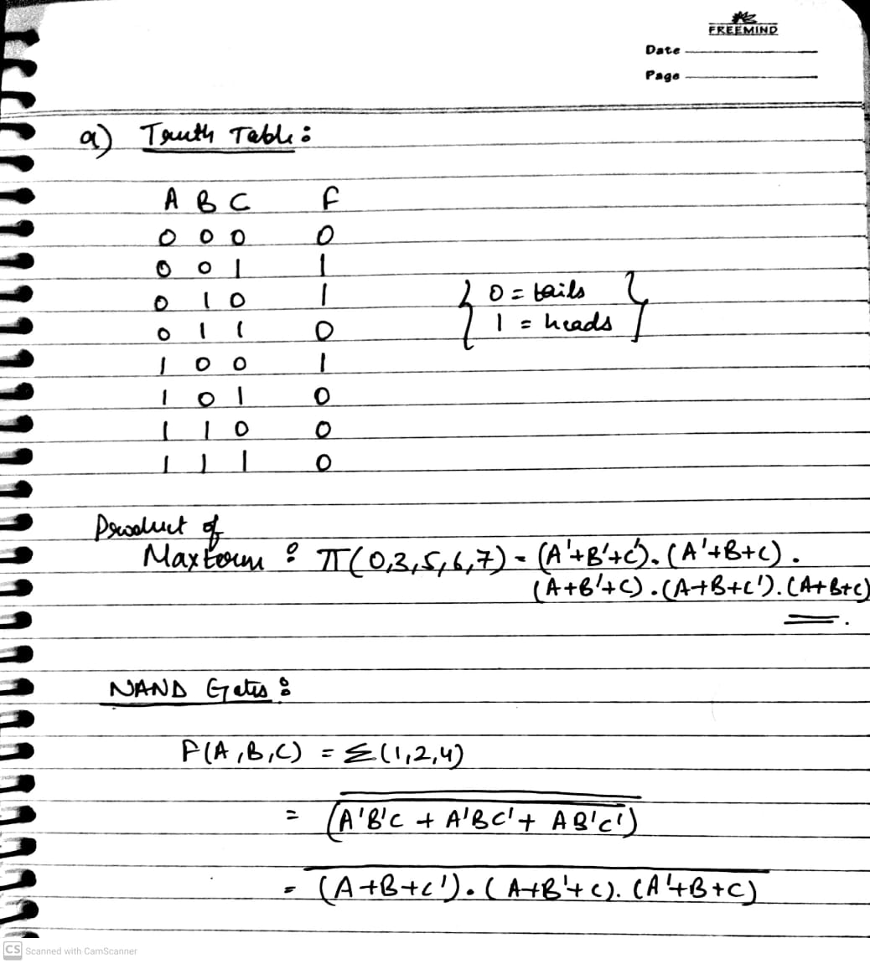

Circuit:

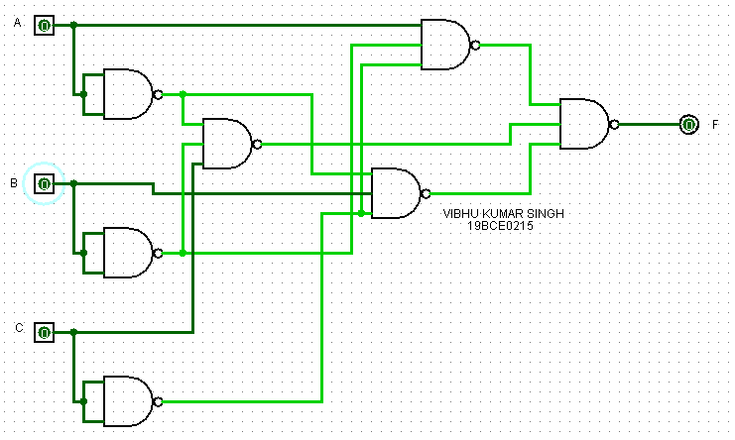

OUTPUT SCREENSHOTS:

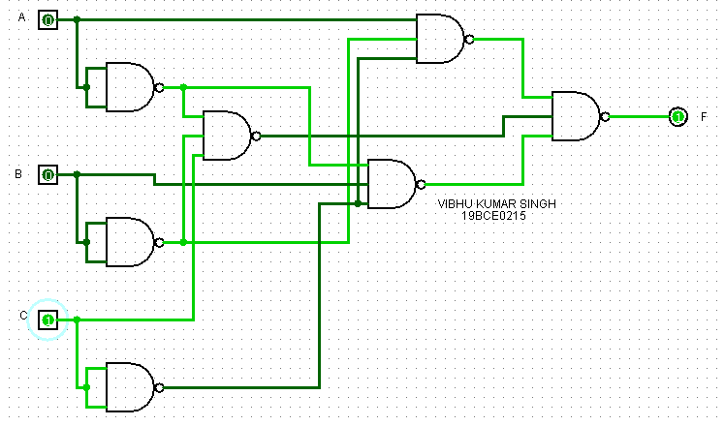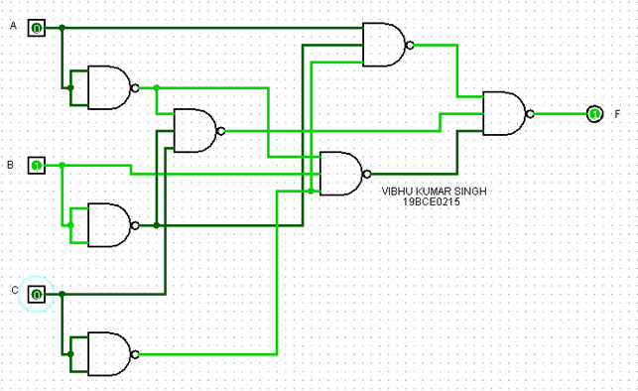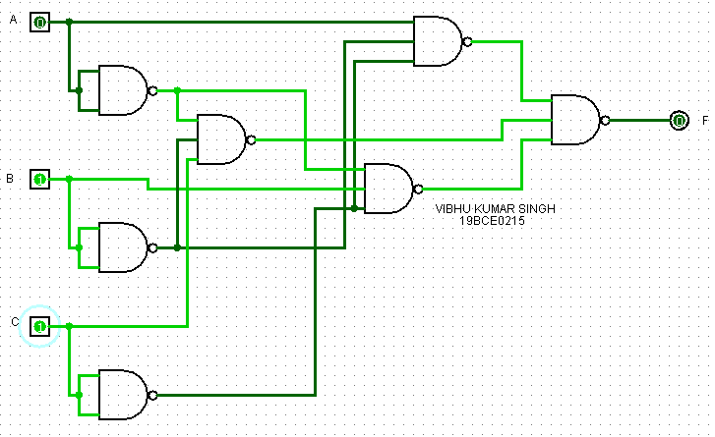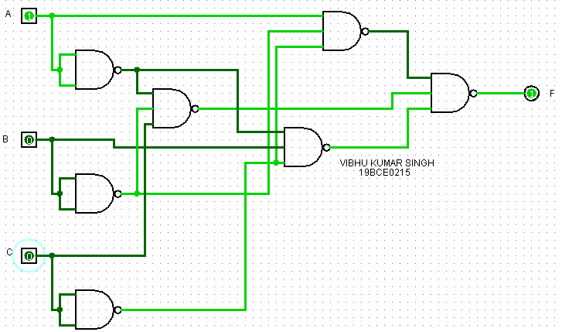

1. Aim: To output 1 if BCD uses more than possible digits (0-9).

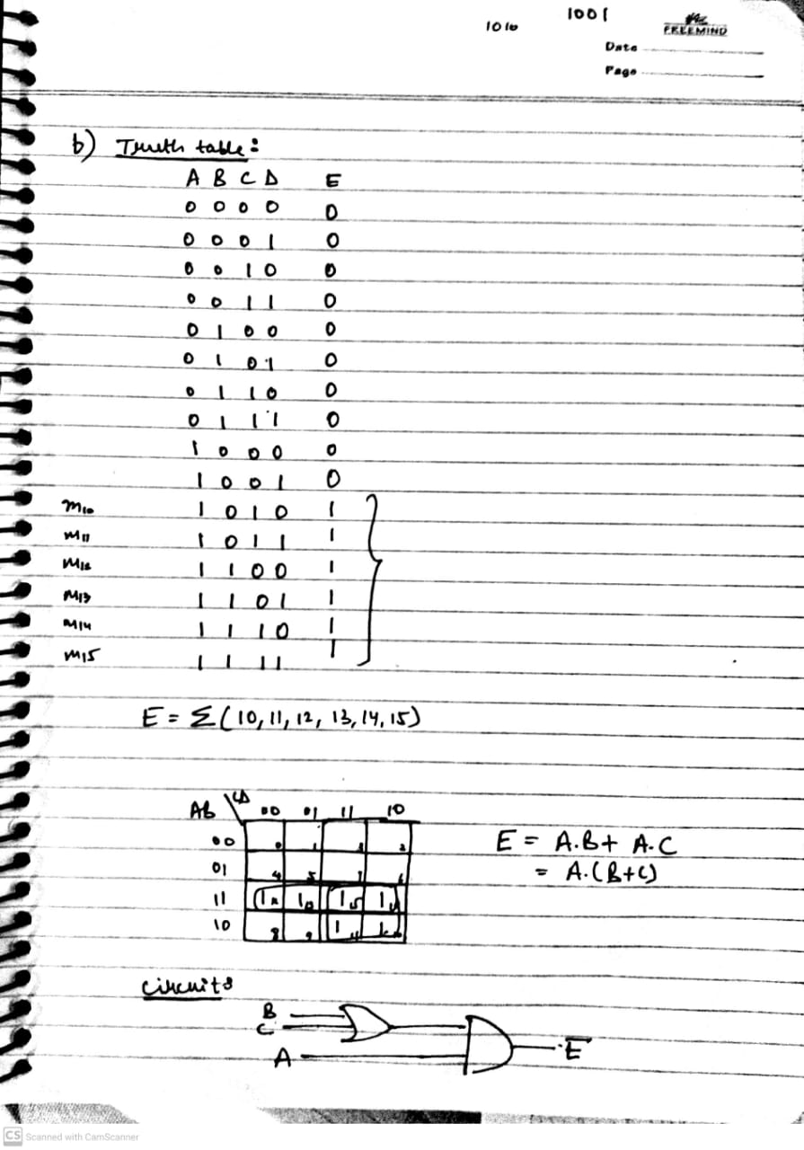

OUTPUT SCREENSHOTS:

