

dIgital logic and design

LAB ASESSMENT – 5

Name: VIBHU KUMAR SINGH
Reg. No: 19BCE0215
Teacher: Sairabanu J.
Q1) Realization of characteristic table of different types of flip flop.
A1)
- S-R Flip Flop
Logic Diagram:
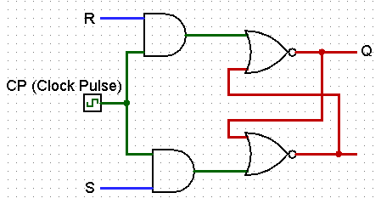

Characteristic Table:

Q | S | R | Q(t+1)
0 | 0 | 0 | 0
0 | 0 | 1 | 0
0 | 1 | 0 | 1
0 | 1 | 1 | Forbidden(0)
1 | 0 | 0 | 1
1 | 0 | 1 | 0
1 | 1 | 0 | 1
1 | 1 | 1 | Forbidden(0)

S-R Flip Flop:

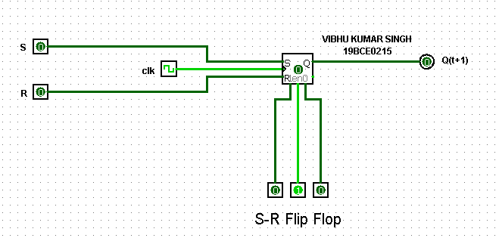

Logging Table:

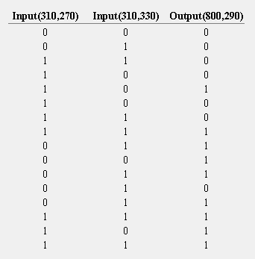

- D Flip Flop
Logic Diagram:

Characteristic Table:
Q | D | Q(t+1)
0 | 0 | 0
0 | 1 | 1
1 | 0 | 0
1 | 1 | 1

D Flip Flop:

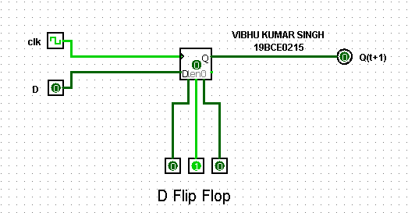

Logging Table:

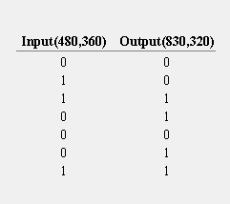

- JK Flip Flop
Logic Diagram:

Characteristic Table:
Q | J | K | Q(t+1)
0 | 0 | 0 | 0
0 | 0 | 1 | 0
0 | 1 | 0 | 1
0 | 1 | 1 | 1
1 | 0 | 0 | 1
1 | 0 | 1 | 0
1 | 1 | 0 | 1
1 | 1 | 1 | 0

JK Flip Flop:

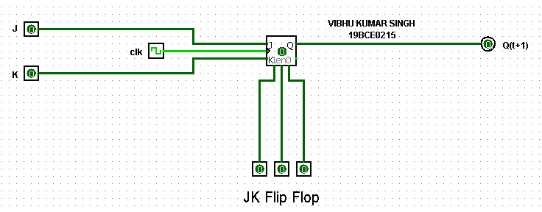
Logging Table:

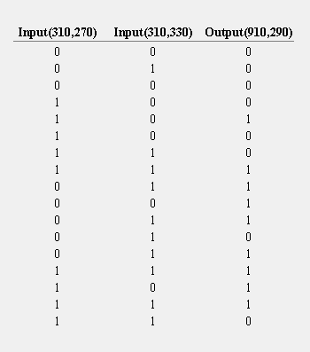
- T Flip Flop
Logic Diagram:

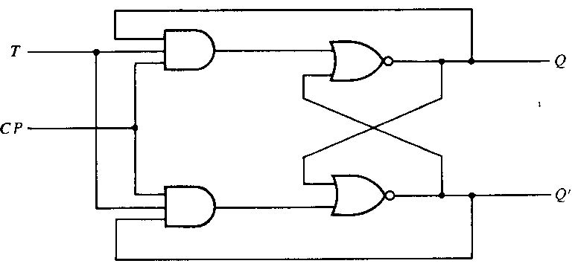

Characteristic Table:
Q | T | Q(t+1)
0 | 0 | 0
0 | 1 | 1
1 | 0 | 1
1 | 1 | 0

T Flip Flop:

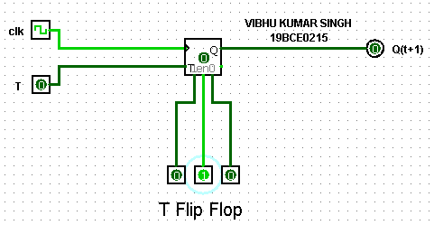

Logging Table:

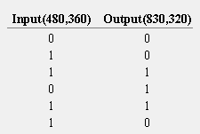

Q2) Design and implement a 3 bit binary synchronous counter using T flip Flop.
A2)
Excitation Table:

Present State |  |  | Next State |  |  | Flip-Flop
A2 | A1 | A0 | A2 | A1 | A0 | TA2 | TA1 | TA0
0 | 0 | 0 | 0 | 0 | 1 | 0 | 0 | 1
0 | 0 | 1 | 0 | 1 | 0 | 0 | 1 | 1
0 | 1 | 0 | 0 | 1 | 1 | 0 | 0 | 1
0 | 1 | 1 | 1 | 0 | 0 | 1 | 1 | 1
1 | 0 | 0 | 1 | 0 | 1 | 0 | 0 | 1
1 | 0 | 1 | 1 | 1 | 0 | 0 | 1 | 1
1 | 1 | 0 | 1 | 1 | 1 | 0 | 0 | 1
1 | 1 | 1 | 0 | 0 | 0 | 1 | 1 | 1

Equations:

TA2=A1A0
TA1=A0
TA0=1

Circuit:

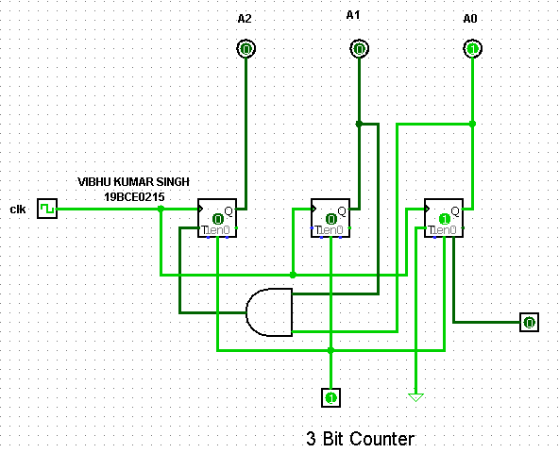

Logging Table:
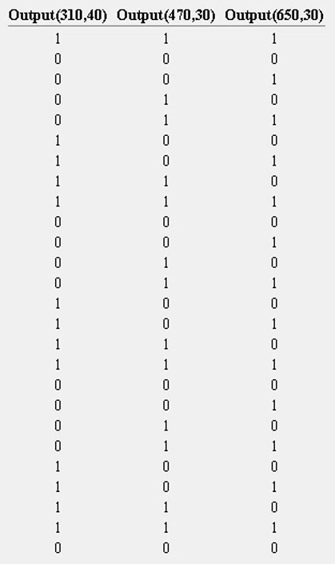
Q3) Design a SISO Shift register.
A3)
Truth Table:
Clock pulse No | QA | QB | QC | QD
0 | 0 | 0 | 0 | 0
1 | 1 | 0 | 0 | 0
2 | 0 | 1 | 0 | 0
3 | 0 | 0 | 1 | 0
4 | 0 | 0 | 0 | 1
5 | 0 | 0 | 0 | 0

Screenshots(4):

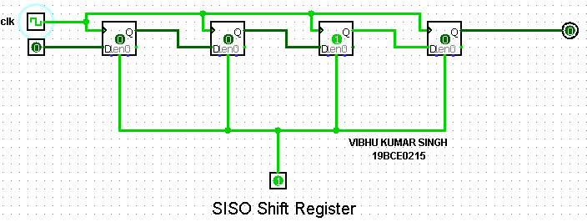
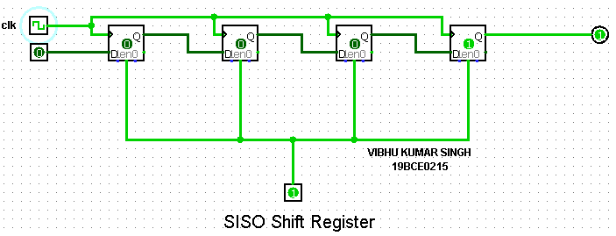
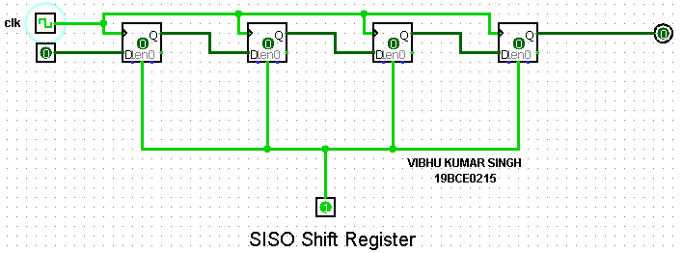

Logging Table:
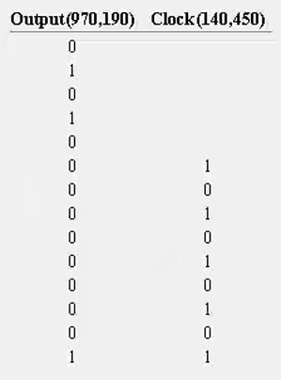

Q4) Design the state diagram using JK flip flops.

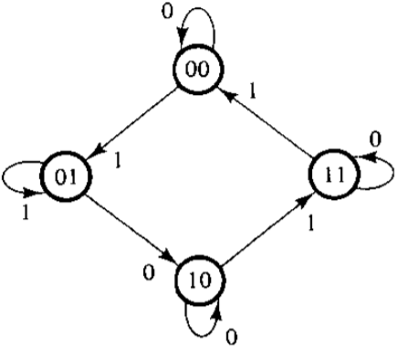
A4)
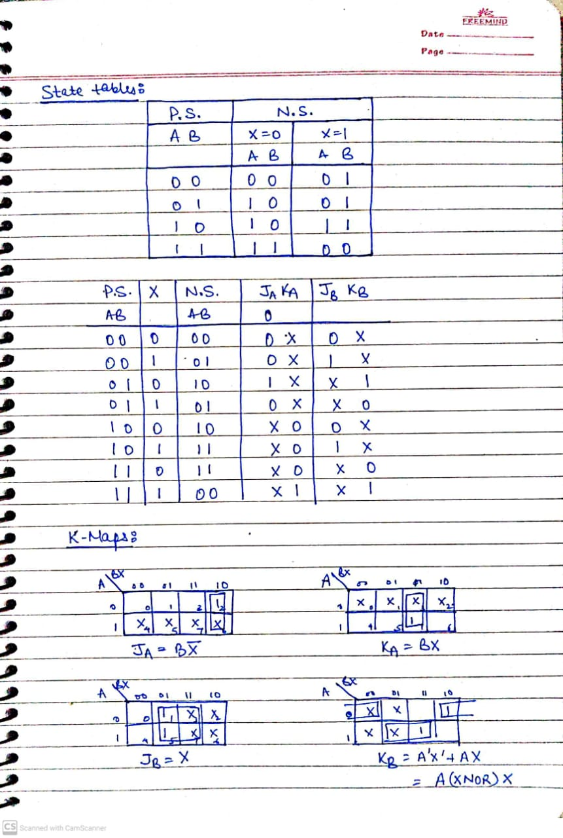
Equations:
JA=BX’
KA=BX
JB=X
KB=A’X’+AX=A (XNOR) X

K-Maps:

Screenshots:

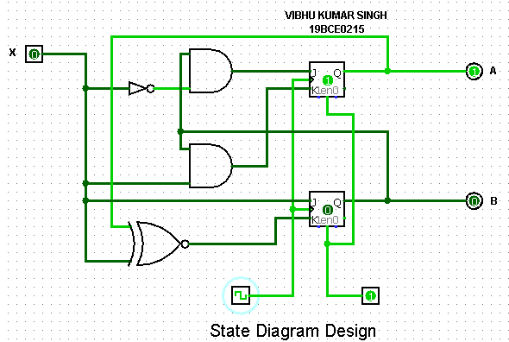
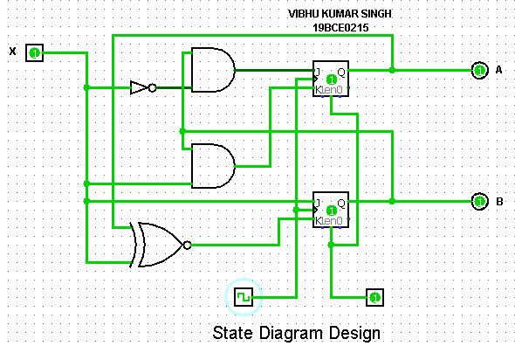
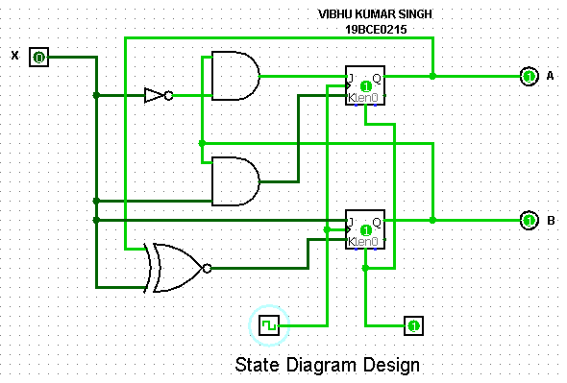
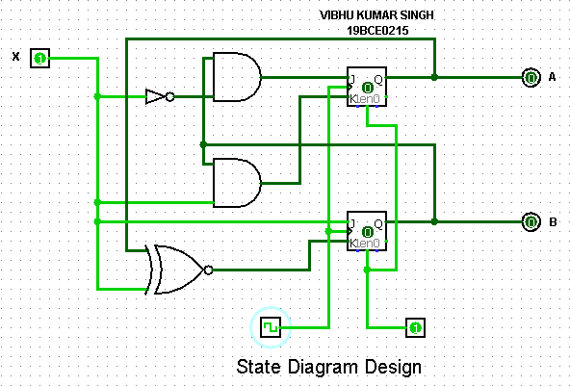
Logging Table:
