

Operating Systems

DIGITAL ASSIGNMENT-1

Name: **VIBHU KUMAR SINGH**

Reg. No: **19BCE0215**

Teacher: **Manikandan K.**

**1) Consider a file system in which a file can be deleted and its disk space reclaimed while links to that file still exist. What problems may occur if a new file is created in the same storage area or with the same absolute path name? How can these problems be avoided?**

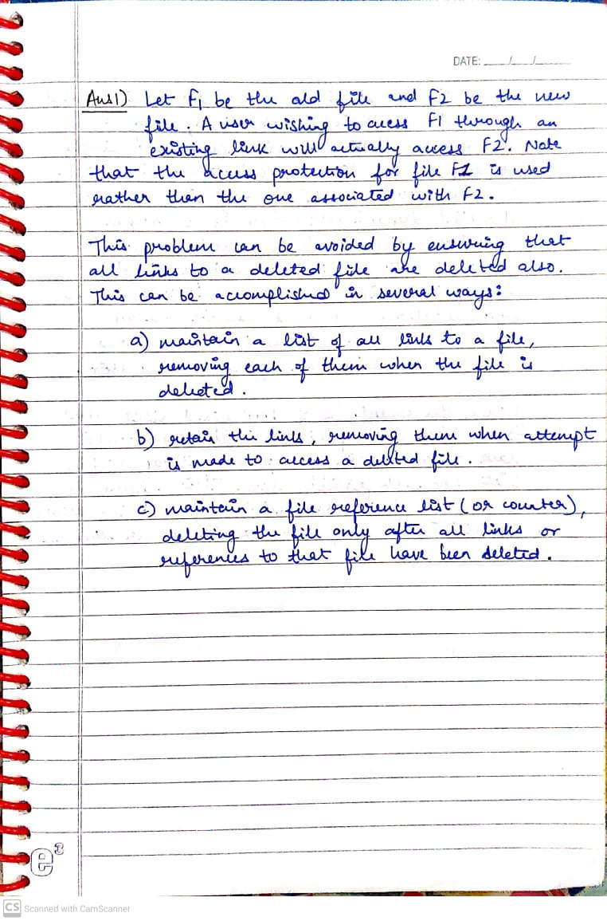

**2) Consider a file system that uses a modified contiguous-allocation scheme with support for extents. A file is a collection of extents, with each extent corresponding to a contiguous set of blocks. A key issue in such systems is the degree of variability in the size of the extents. What are the advantages and disadvantages of the following schemes?**

**a. All extents are of the same size, and the size is predetermined.**

**b. Extents can be of any size and are allocated dynamically.**

**c. Extents can be of a few fixed sizes, and these sizes are predetermined.**

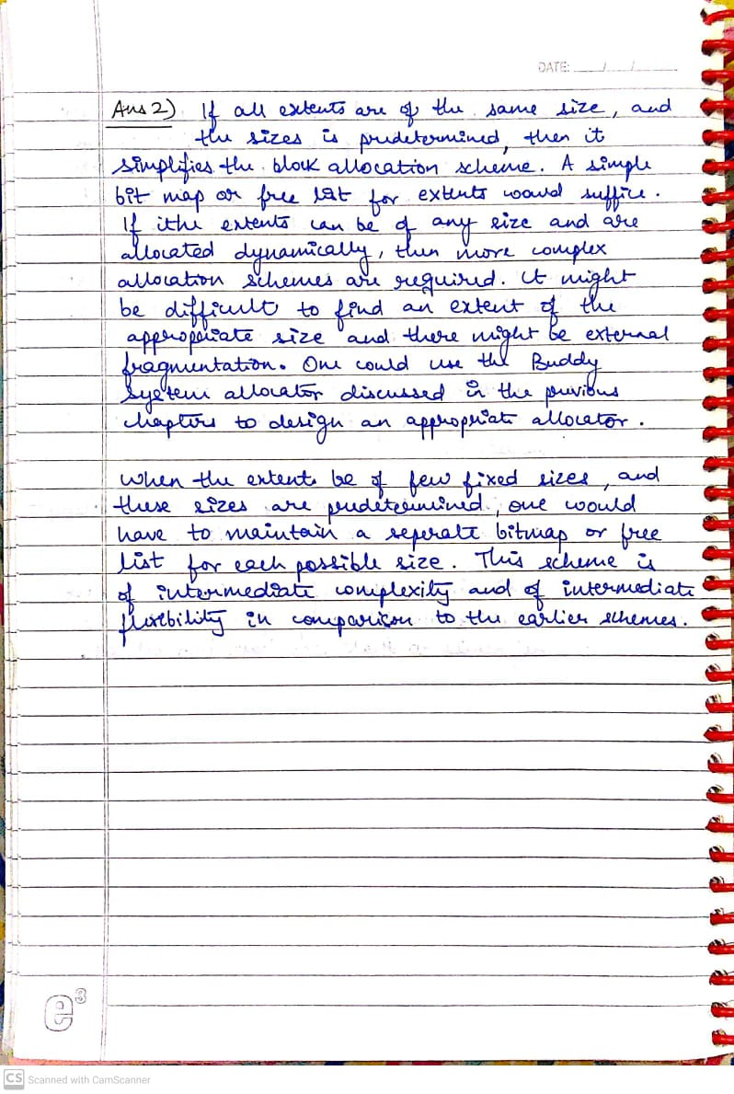

**3) If all the access rights to an object are deleted, the object can no longer be accessed. At this point the object should also be deleted, and the space it occupies should be returned to the system. Suggest an efficient implementation of this scheme.**

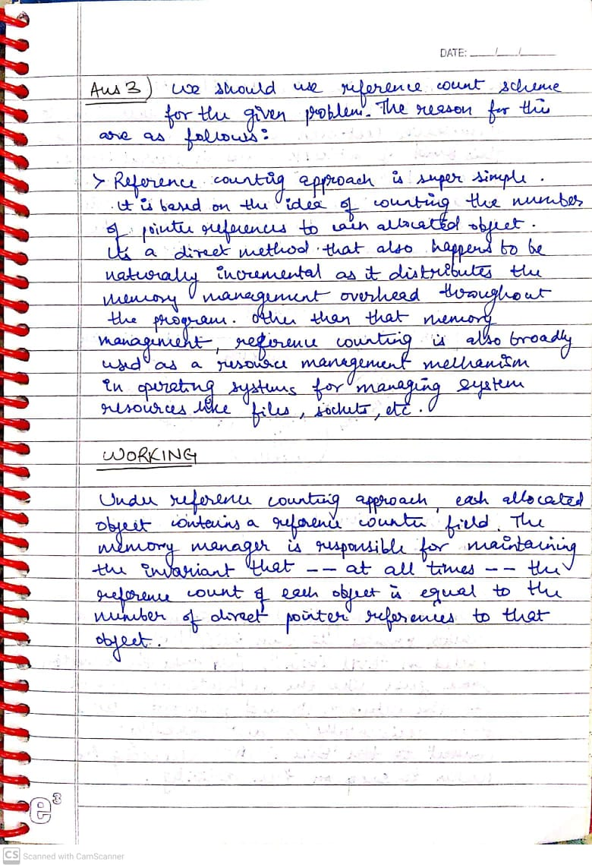

**4) What commonly used computer programs are prone to man-in-the-middle attacks? Discuss solutions for preventing this form of attack.**

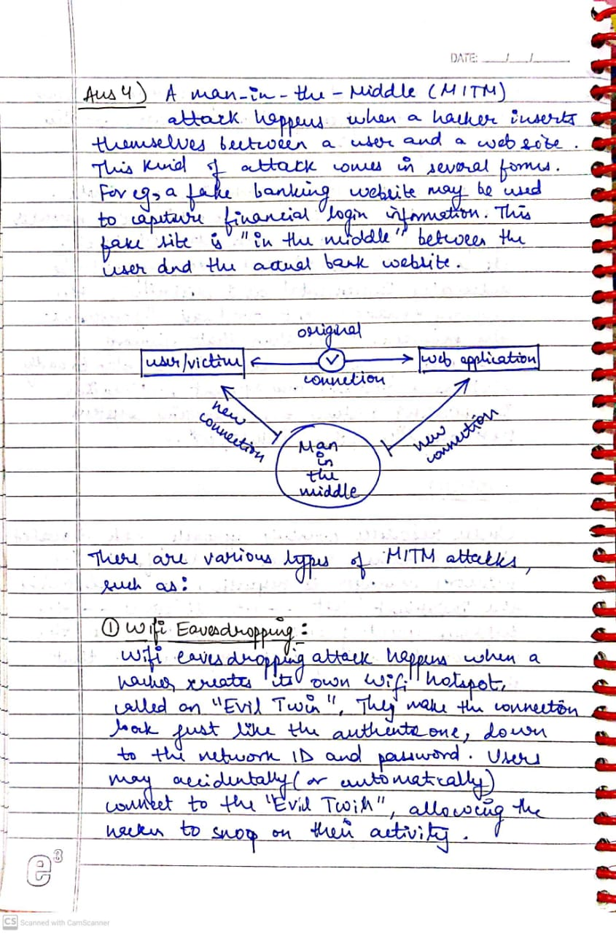

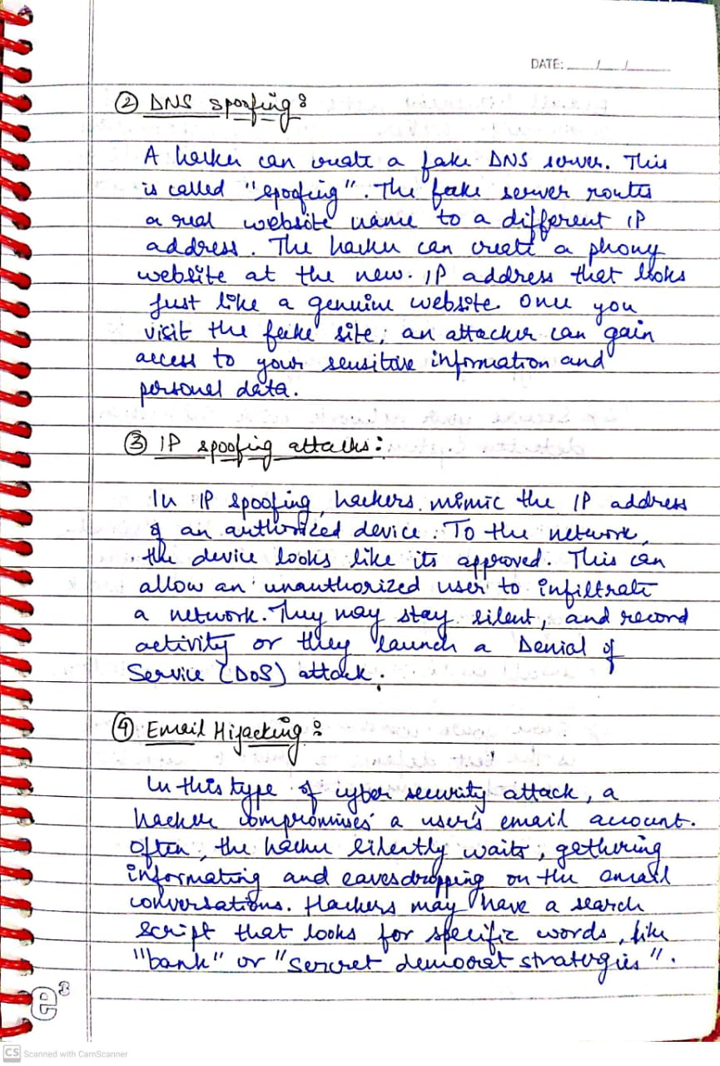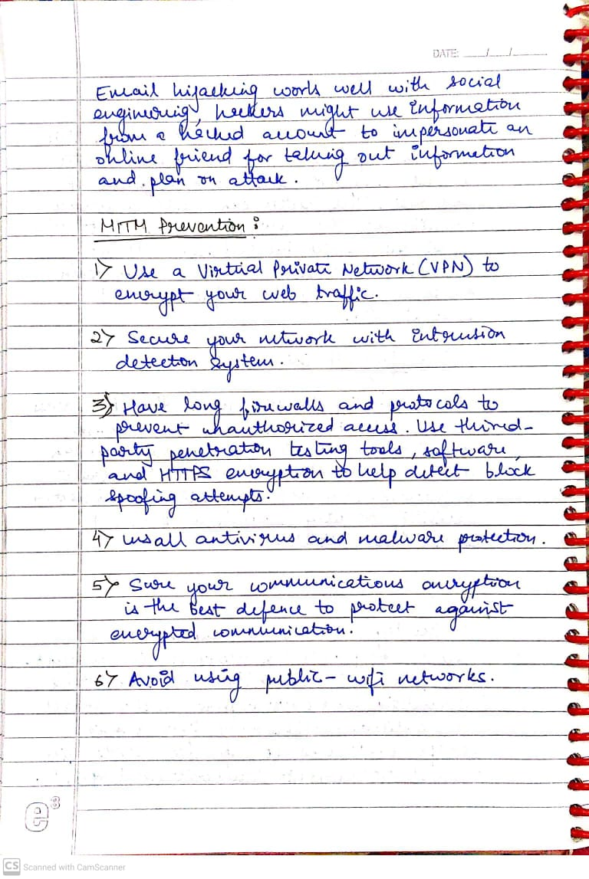

**5) Discuss the following with neat diagram**

**a. Virtualization and its types**

**b. Hypervisor**

