

CSE 3001

Software Engineering

LAB CAT

**NAME**: Vibhu Kumar Singh

**REG. NO**: 19BCE0215

**TEACHER**: Ushus Elizebeth Zachariah

**ONLINE CAB BOOKING SYSTEM**

**Q 1) Define the System and Scope/ Assumptions [4]**

**Ans 1)**

**SCOPE AND ASSUMPTIONS:-**

Online Cab Scheduling System is software which is helpful for Cab travellers, who wants to travel by Cab all over different routes. This system provides different routes for passengers, passengers can also have a look over how many trips are their available for specific route and what is the time table for different traveling. Passengers can book his ride with a specific route and for a specific day.

There are mainly four modules in this software:

* Cab Management
* Route Management
* Employee Management
* Passenger Management

In Cab module a project manager add or delete a Cab details to the database.

Route Management module deals with the route management of the Cab. A project manager can add the route and if he wants he can change it or delete that route. Route modules contain time table for different routes and their related stoppage.

Employee management module is work over maintaining employees details. Employee details of any Cab can add to the database and this is helpful to the Cab operators to provide all work status report and working route and time table report to the employees working with this system.

The passenger module mainly used to give advantage for the passengers. This module is helpful for the passengers to get details of the route and the details of the Cab which have trip to that route. He can also get the information of the number of seats available in a particular day. This system is useful for reserving tickets for specific route and for a specific date. Details of every passenger are stored in the system.

**Q 2)** **Draw a Use case diagram[3]**

**Ans 2)**

The use case diagram describes the interaction between the system and users. This sows which actor performs which action so that it is graphical representation of actor and their associative actions:-

**USE CASE:**

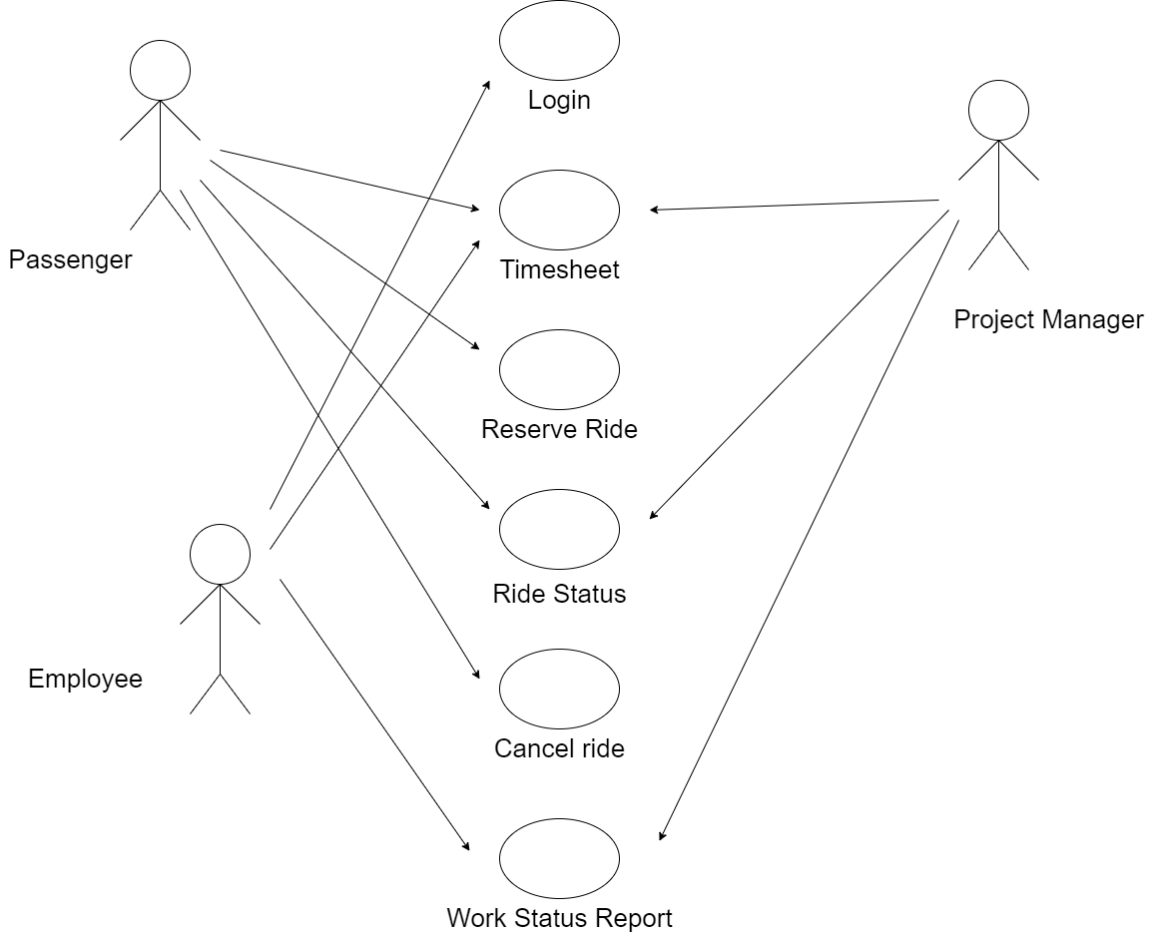

[made on draw.io]

This is the use-case diagram for our proposed system for Online Cab booking System.

**Q 3) Take any scenario and draw a sequence diagram[3]**

**Ans 3)**

Considering the process of Work Status Report for Employees:

**SEQUENCE DIAGRAM**

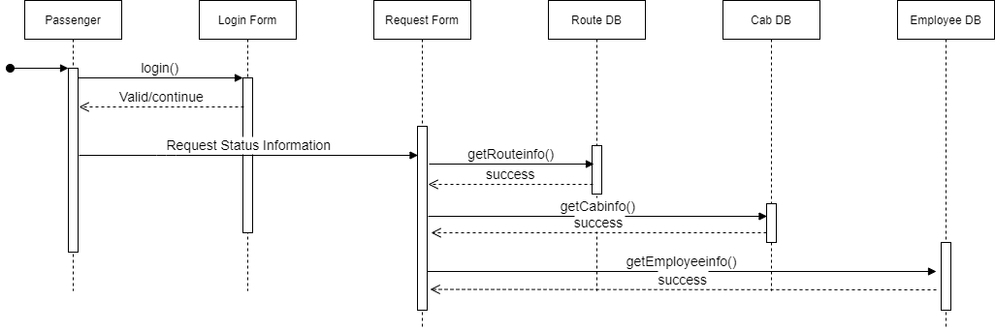

[made on draw.io]

This is the sequence diagram for the scenario where the passenger logs into the system and requests for a new ride through a request form. The request is granted according to the route info, availability of Cab and Employee in the database.