

CSE 3001

Software Engineering

LAB Assessment - 2

**NAME**: Vibhu Kumar Singh

**REG. NO**: 19BCE0215

**TEACHER**: Ushus Elizebeth Zachariah

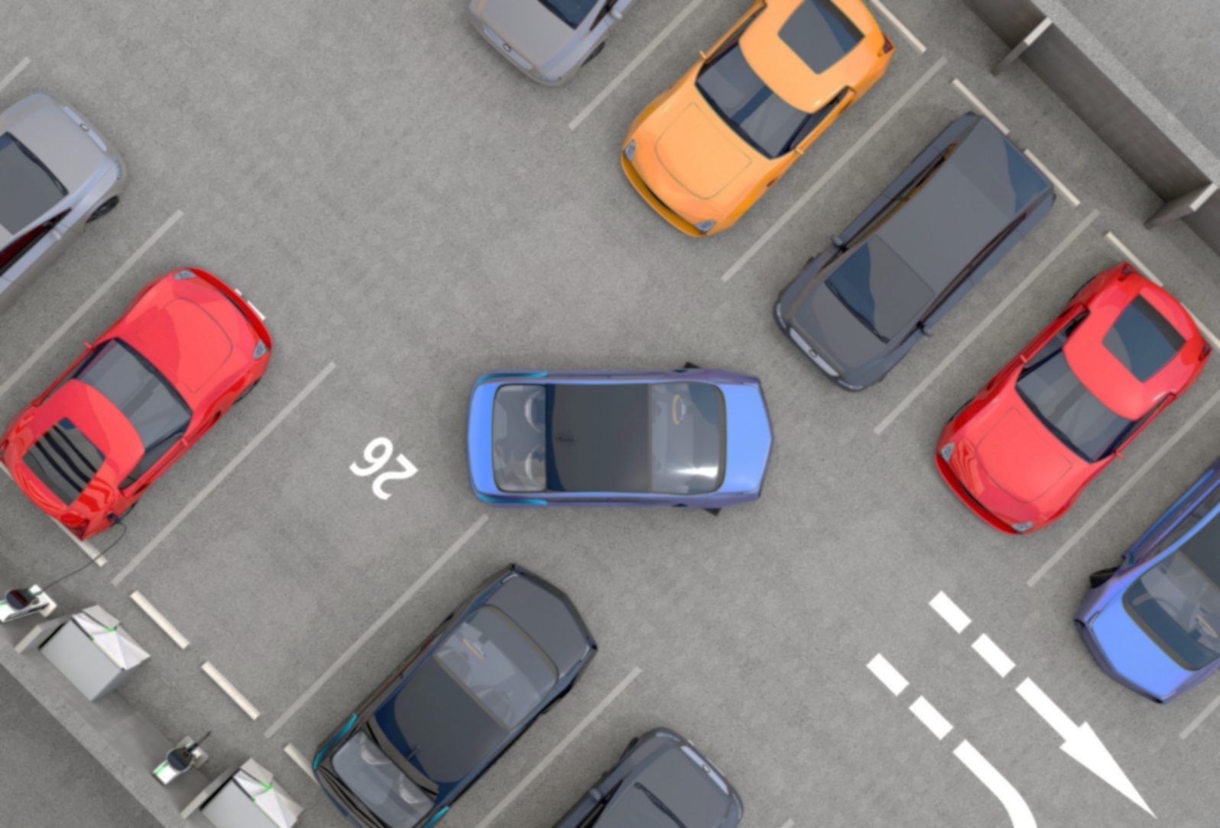

PROJECT TOPIC:

Smart Parking System

(19BCE0215)

1. **Identify the Functional and Non-functional Requirement**

Functional requirement

* + It can show an available space for parking a car.
  + It can synchronize with sensor for preventing robbery purpose.
  + It can memorize location of user's car.
  + It can calculate parking fee.

    Non-functional requirement

* + Registration is required for keeping data.
  + It must display the parking lot map in real-time (if possible)
  + The time must be based on GMT.

1. **Draw the WBS**

**Work Breakdown Structure:**

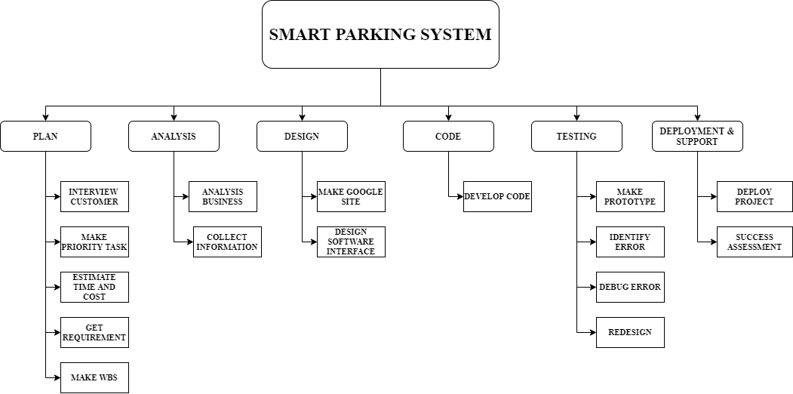

1. **Draw the ER or DFD**

**ER Diagram:**

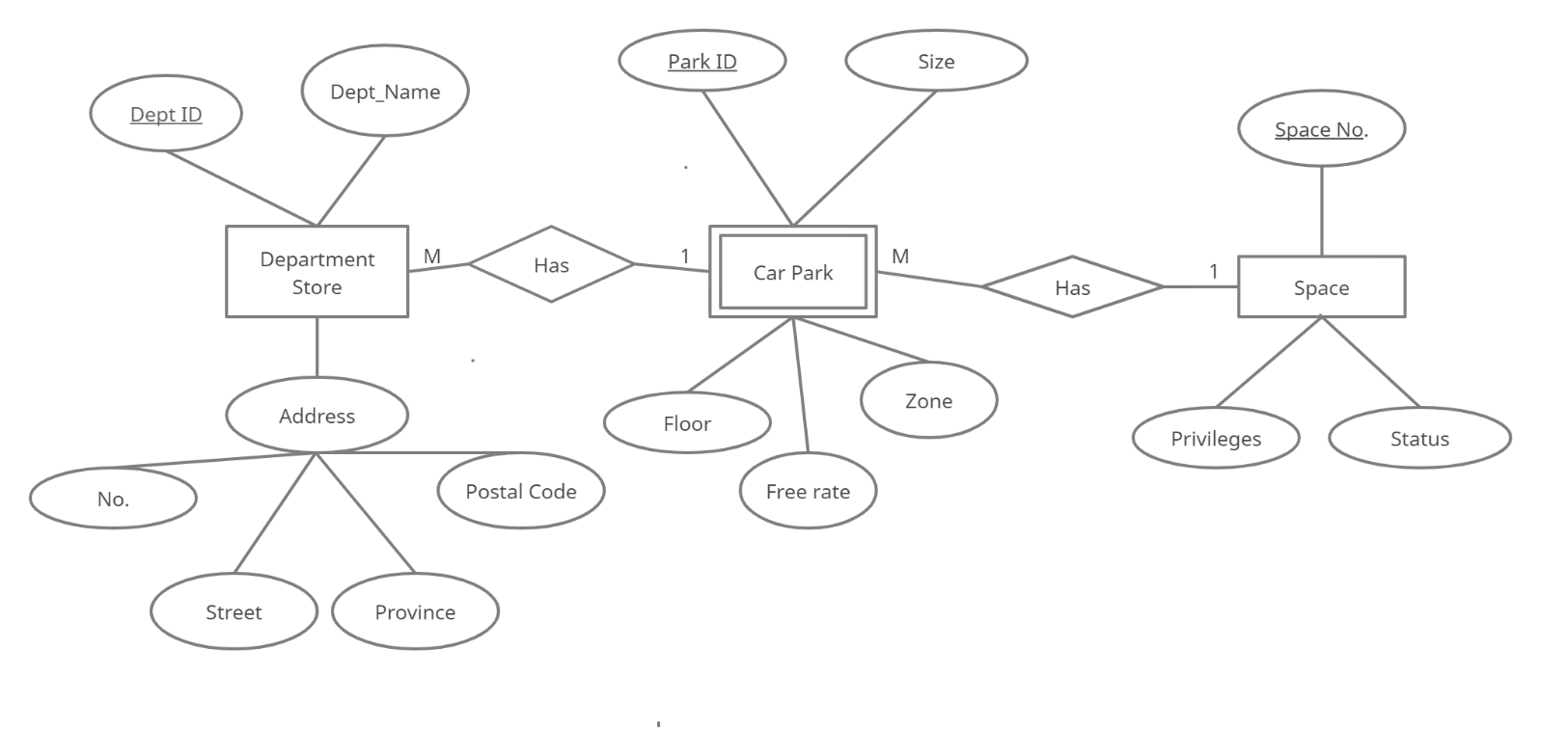

ENTITIES:

* Department Store
* Dept_ID (Primary key)
* Dept_Name
* Address
* No.
* Street
* Province
* Postal Code
* Car Park (Weak Entity)
* Park_ID (Primary key)
* Size
* Floor
* Free Rate
* Zone
* Space
* Space_No. (Primary key)
* Privileges
* Status

RELATIONS:

* Department Store has Car Park (Many to One).
* Car Park has Space (Many to One).