

CSE 3001

Software Engineering

LAB Assessment - 3

**NAME**: Vibhu Kumar Singh

**REG. NO**: 19BCE0215

**TEACHER**: Ushus Elizebeth Zachariah

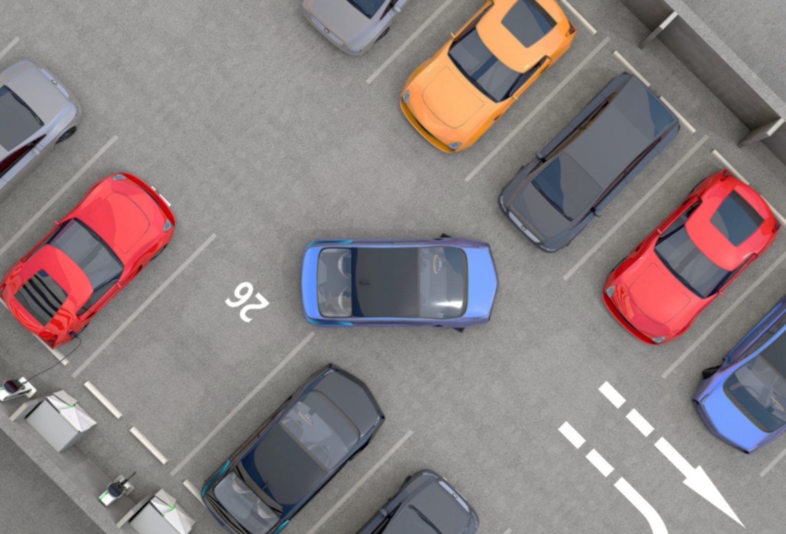

PROJECT TOPIC:

Smart Parking System

(19BCE0215)

Use Case Diagram:

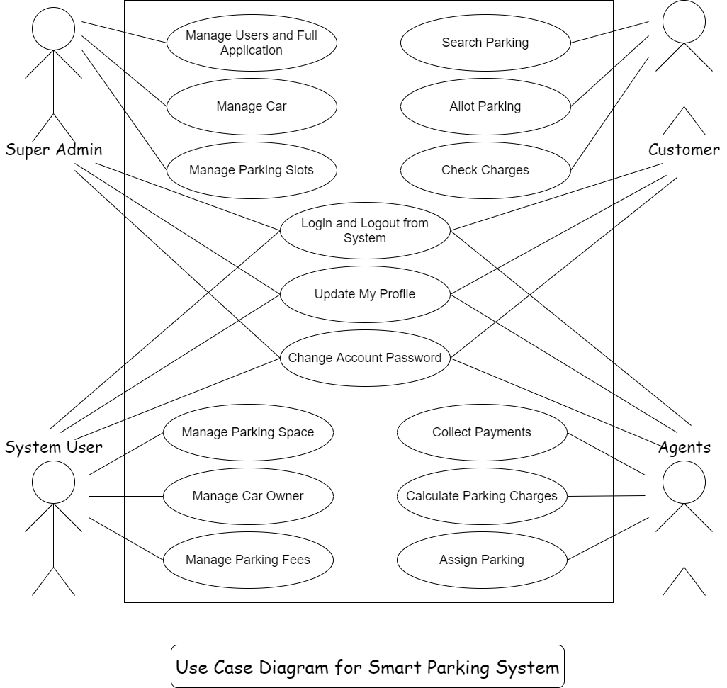

(Made on www.draw.io)

Class Diagram:

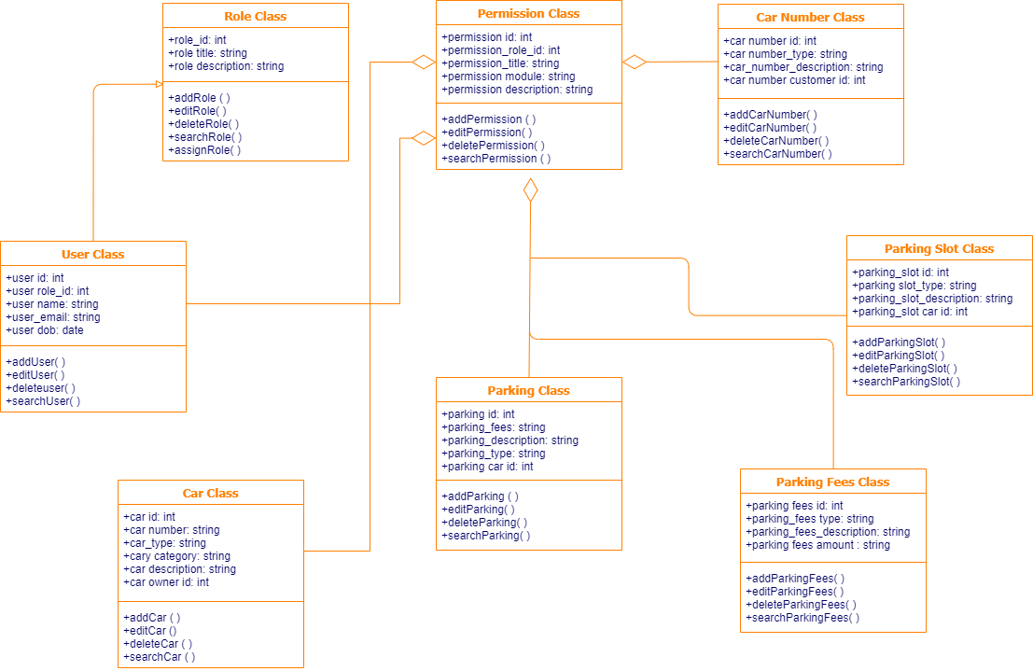



(Made on www.draw.io)

Sequence diagram:

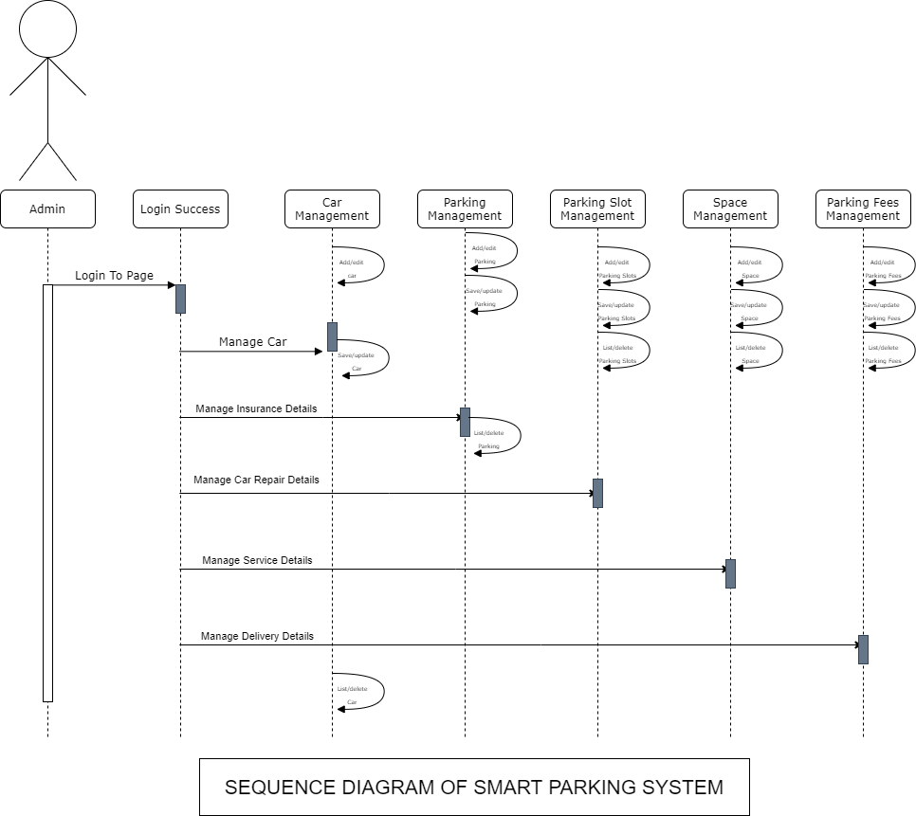

(Made on www.draw.io)