

CSE 3001

Software Engineering

LAB Assessment - 5

**NAME**: Vibhu Kumar Singh

**REG. NO**: 19BCE0215

**TEACHER**: Ushus Elizebeth Zachariah

**Q1. A savings account in a bank has a different rate of interest depending on the balance in the account. In order to test the software that calculates the interest due, we can identify the ranges of balance values that earn the different rates of interest. For example, 3% rate of interest is given if the balance in the account is in the range of $0 to $100, 5% rate of interest is given if the balance in the account is in the range of $100 to $1000, and 7% rate of interest is given if the balance in the account is $1000 and above,**

1. **Perform boundary value analysis and create test cases that test the boundary cases.**
2. **Partition the given specification into equivalent classes and generate the test case for each class.**

**Ans 1.**

1. **Boundary Value Analysis:**

|  |  |  |  |
| --- | --- | --- | --- |
| **Invalid** | **Valid** | **Valid** | **Valid** |
| $0 | $0 $100 | $100 $1000 | $1000 |
| **0%** | **3%** | **5%** | **7%** |

**Test Cases of Boundary Cases:**

|  |  |  |
| --- | --- | --- |
| **Test Scenario #** | **Test Scenario Description** | **Expected Outcome** |
| 1 | Boundary Value =$ -1 | System should not accept |
| 2 | Boundary Value =$0 | System should accept with rate of 3% |
| 3 | Boundary Value =$99 | System should accept with rate of 3% |
| 4 | Boundary Value =$100 | System should accept with rate of 5% |
| 5 | Boundary Value =$999 | System should accept with rate of 5% |
| 6 | Boundary Value =$1000 | System should accept with rate of 7% |
| 7 | Boundary Value =$1001 | System should accept with rate of 7% |

1. **Equivalent Classes**

$0

$99

$100

$999

$1000

Invalid

Valid

Valid

Valid

$-1

$10

$253

$2000

3%

5%

7%

**Generation of the Test Case:**

|  |  |  |
| --- | --- | --- |
| **Test Scenario #** | **Test Scenario Description** | **Expected Outcome** |
| 1 | Amount less than $0 | System Should not Accept |
| 2 | Amount between $0 and $99 | System should accept with rate of 3% |
| 3 | Amount between $100 and $999 | System should accept with rate of 5% |
| 4 | Amount greater than or equal to $1000 | System should accept with rate of 7% |

**Q2. Identify any software tool and make a note on how to perform testing.**

**Ans 2.**

There are a number of tools to perform testing. Some of them are : Selenium, appium, Xray, TestPad etc.

Selenium

Selenium is a framework for automating website and mobile apps tests. This is done by simulating user activities and by taking remote control of browsers. Actions like opening a page, scrolling, clicking on single elements or text fields are all possible. In this manner Selenium offers countless possibilities to automate the process of a website test. These commands can be used in several different programming languages. This is how a test script emerges to check a website’s functions: it performs all the actions one after another and evaluates results.

A big advantage of Selenium is its compatibility with common systems, as this is an important requirement for testing desktop devices.

Its Key features include:

* It is one of the best qa tools which offers the support for parallel test execution that reduces the time taken in executing parallel tests.
* Selenium needs very lesser resources when compared to other manual testing tools.
* Test cases prepared using this testing tool can be executed on any OS
* It supports the many known programming languages like Java, Python, C#, Perl, PHP, and JavaScript.

Appium

Appium is the most popular open-source framework for mobile app automation testing. It allows QAs to automate tests for popular mobile platforms like Android, iOS, and Windows. Appium uses the mobile JSON wire protocol (an extension of Selenium JSON wire protocol) to drive native, mobile web and hybrid applications.

The Appium server is scripted in Node.js and is compatible with leading client libraries like Java, Python, Ruby, PHP, and a few others.

Its Key Features include:

* Test the same application which is going to the marketplace.
* It is a simple application which needs very little memory for our testing process.

Testing Native apps do not need SDK, it offers standard automation APIs which can be used on all types of platforms.

**Q3. Sample generation of any test cases in your project.**

**Ans 3.**

**Topic - College Management System (J component Project)**

1. **Student Registration**

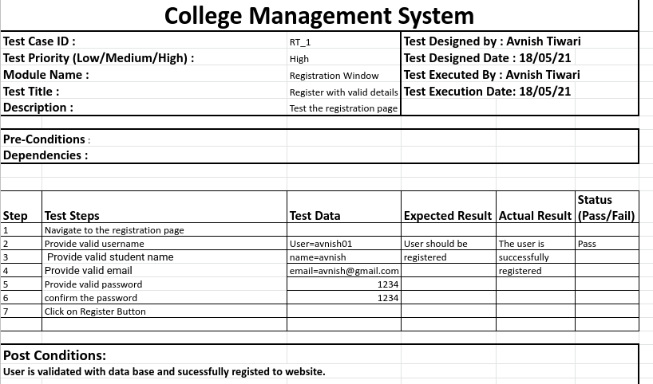

1. **College Registration**

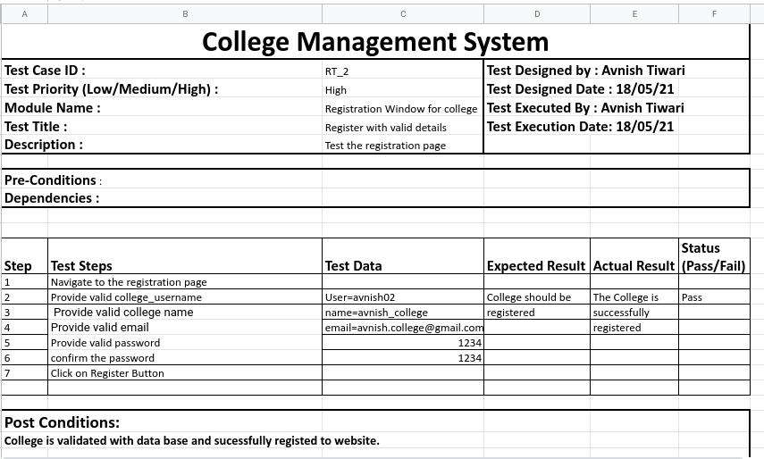

1. **Student Login**

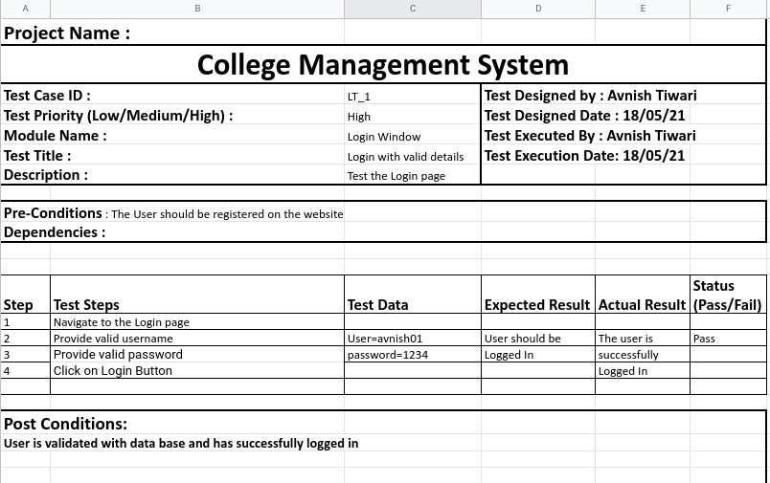

1. **College Login**

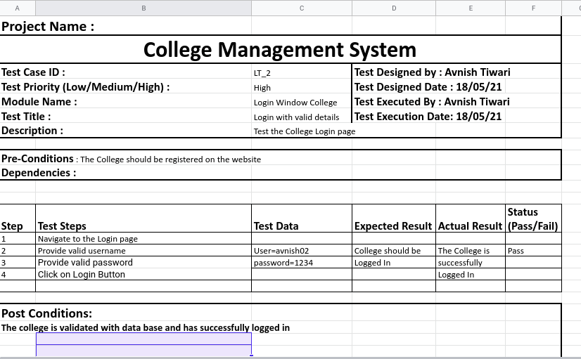

1. **College Dashboard**

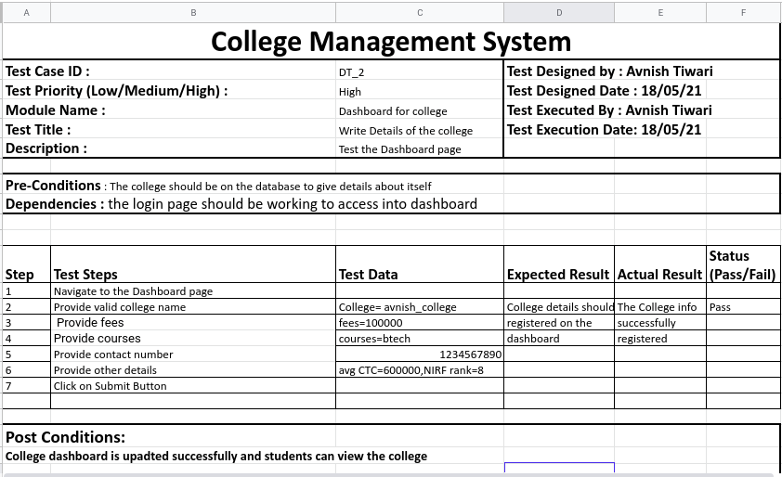

1. **Student Dashboard**

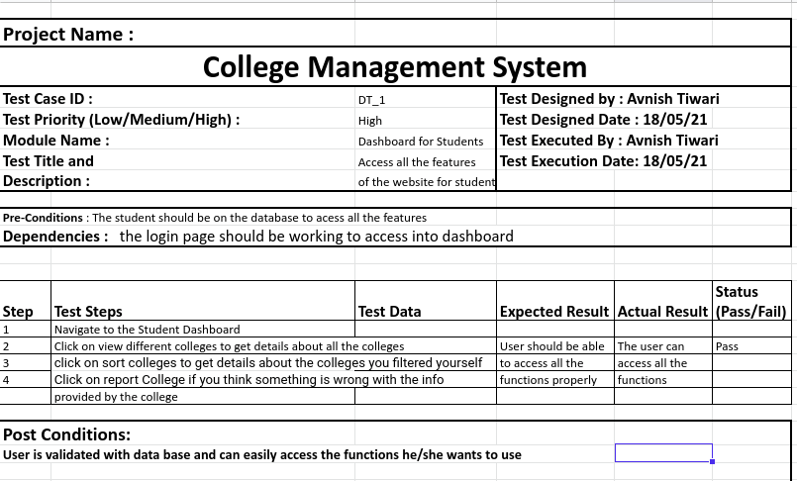

1. **Sort Colleges**

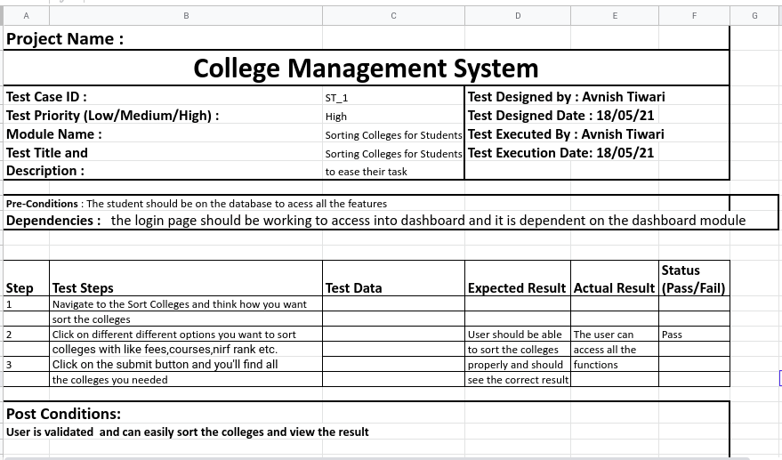

1. **Report Colleges**

