HDOC DAY-21
Menu-Driven C Program

Aim
To write a menu-driven C program that accepts two positive integers m and n (m ≤ n) and performs different operations using a switch statement.

Question / Problem Statement
Write a menu-driven C program that accepts two positive integers, m and n, where m ≤ n. Display the following menu and accept the user's choice. Use a switch statement to perform the selected operation:
1. Print the first 10 multiples of each integer from m to n.
2. Print the addition table of each integer from m to n, using addends from 1 to 10.
3. Print the subtraction table of each integer from m to n, using subtrahends from 1 to 10.
4. Print the results obtained by dividing each integer from m to n by the integers from 1 to 10. Display the results rounded to two decimal places.
5. Exit the program.
Display an appropriate error message for an invalid menu choice. Continue displaying the menu and performing the selected operation until the user chooses Exit.

Algorithm
1. Start the program.
2. Declare integer variables m, n, choice, i and j.
3. Ask the user to enter two positive integers m and n.
4. Check that m and n are positive and m is less than or equal to n. If not, display an error message and stop.
5. Display the menu containing five choices.
6. Read the user's choice.
7. Use a switch statement to select the required operation.
8. If choice is 1, for every number from m to n, print its first 10 multiples using a loop from 1 to 10.
9. If choice is 2, for every number from m to n, print its addition results using addends from 1 to 10.
10. If choice is 3, for every number from m to n, print its subtraction results using subtrahends from 1 to 10.
11. If choice is 4, for every number from m to n, divide it by each number from 1 to 10 and print the result using two decimal places.
12. If choice is 5, display an exit message and terminate the program.
13. For any other choice, display an invalid choice error message.
14. After choices 1 to 4 or an invalid choice, return to the menu and ask for another choice.
15. Continue until the user selects choice 5.
16. Stop the program.

C Program
#include <stdio.h>
int main()
{
int m, n, choice, i, j;
printf("Enter two positive integers m and n (m <= n): ");
scanf("%d %d", &m, &n);
if (m <= 0 || n <= 0 || m > n)
{
printf("Invalid input. Enter positive integers with m <= n.\n");
return 0;
}
do
{
printf("\n----- MENU -----\n");
printf("1. First 10 multiples\n");
printf("2. Addition table\n");
printf("3. Subtraction table\n");
printf("4. Division results\n");
printf("5. Exit\n");
printf("Enter your choice: ");
scanf("%d", &choice);
switch (choice)
{
case 1:
printf("\nFirst 10 multiples:\n");
for (i = m; i <= n; i++)
{
printf("\nMultiples of %d: ", i);
for (j = 1; j <= 10; j++)
{
printf("%d ", i * j);
}
printf("\n");
}
break;
case 2:
printf("\nAddition tables:\n");
for (i = m; i <= n; i++)
{
printf("\nAddition table of %d:\n", i);
for (j = 1; j <= 10; j++)
{
printf("%d + %d = %d\n", i, j, i + j);
}
}
break;
case 3:
printf("\nSubtraction tables:\n");
for (i = m; i <= n; i++)
{
printf("\nSubtraction table of %d:\n", i);
for (j = 1; j <= 10; j++)
{
printf("%d - %d = %d\n", i, j, i - j);
}
}
break;
case 4:
printf("\nDivision results:\n");
for (i = m; i <= n; i++)
{
printf("\nDivision results for %d:\n", i);
for (j = 1; j <= 10; j++)
{
printf("%d / %d = %.2f\n", i, j, (float)i / j);
}
}
break;
case 5:
printf("Exiting the program...\n");
break;
default:
printf("Invalid menu choice. Please enter a number from 1 to 5.\n");
}
} while (choice != 5);
return 0;
}
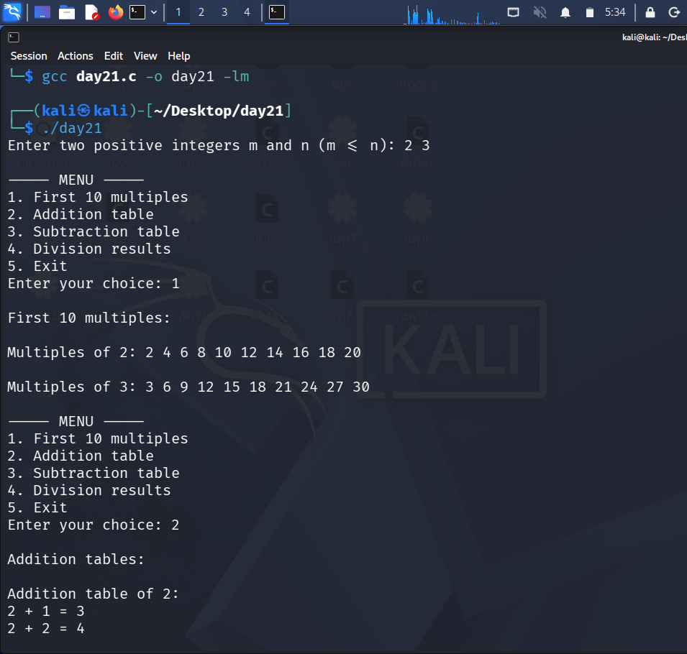
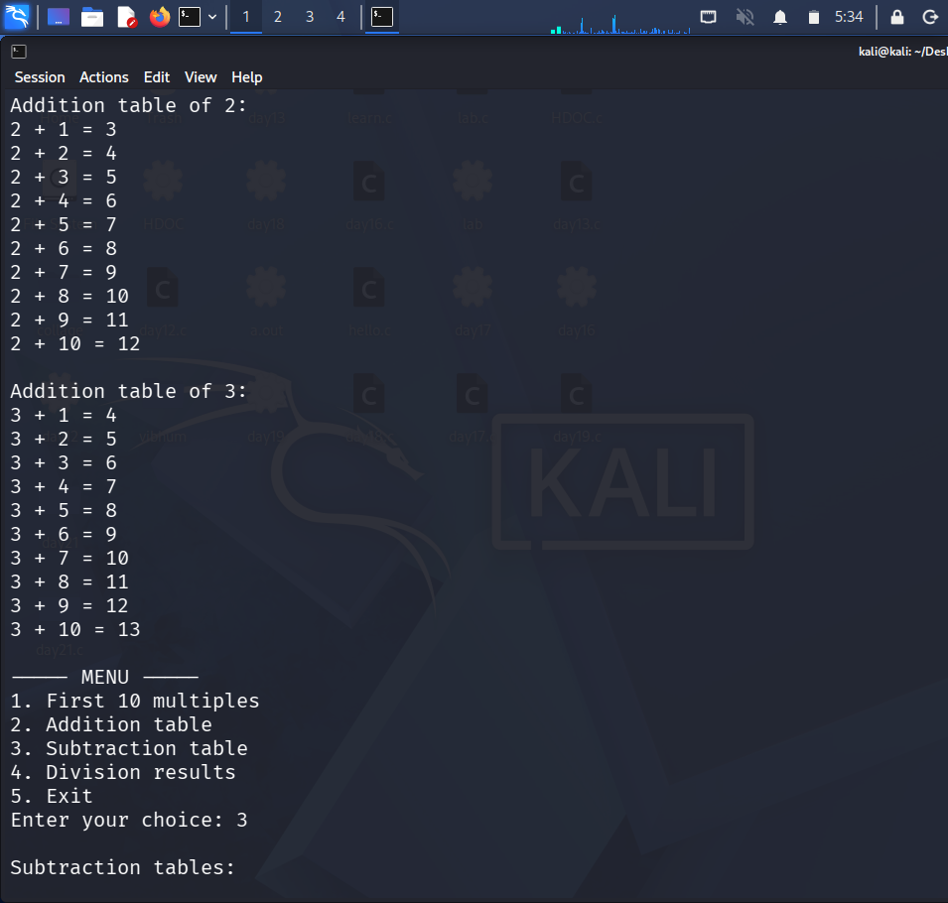
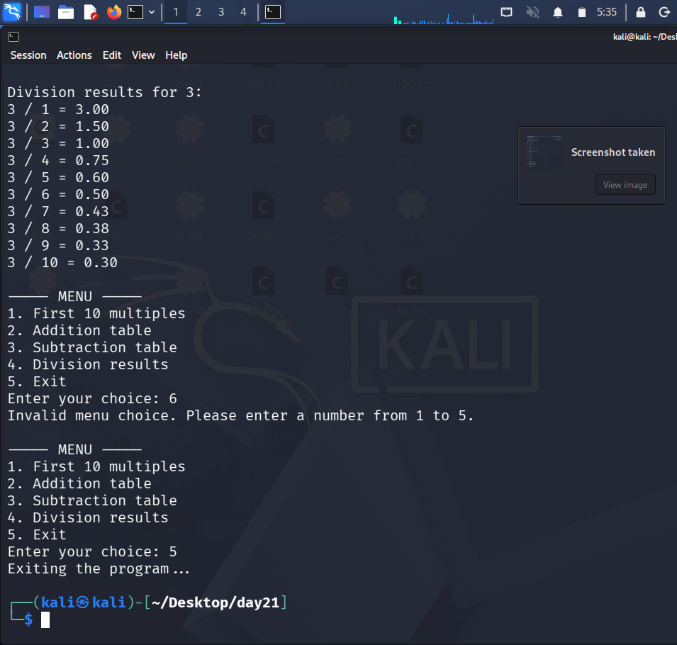

Test Case Table:
Test Case | m | n | Choice | Expected Output | Actual Output | Result
1 | 2 | 3 | 1 | First 10 multiples of 2 and 3 are displayed. | First 10 multiples of 2 and 3 displayed. | Pass
2 | 2 | 3 | 2 | Addition tables of 2 and 3 from 1 to 10 are displayed. | Addition tables of 2 and 3 from 1 to 10 displayed. | Pass
3 | 2 | 3 | 3 | Subtraction tables of 2 and 3 from 1 to 10 are displayed. | Subtraction tables of 2 and 3 from 1 to 10 displayed. | Pass
4 | 2 | 3 | 4 | Division results for 2 and 3 by 1 to 10 are displayed to 2 decimals. | Division results for 2 and 3 displayed to 2 decimals. | Pass
5 | 2 | 3 | 8 | Invalid menu choice message is displayed. | Invalid menu choice message displayed. | Pass
6 | 2 | 3 | 5 | Exit message is displayed and program terminates. | Exit message displayed and program terminates. | Pass

