HDOC Day-22
Menu-Driven C Program
Problem Statement: Write a menu-driven C program that accepts two positive integers m and n, where m <= n. Use a switch statement to perform the selected operation: (1) multiplication tables of m and n side by side, (2) multiplication grid from 1 to m and 1 to n, (3) for each integer from m to n print that integer followed by the next five consecutive integers, and (4) exit. Continue showing the menu until Exit is selected and display an error message for an invalid choice.

Algorithm
1. Start.
2. Declare integers m, n and choice.
3. Input two positive integers m and n.
4. Check that m > 0, n > 0 and m <= n. If not, display an error message and stop.
5. Display the menu with four choices.
6. Input the user's choice.
7. Use a switch statement for the selected choice.
8. For choice 1, print multiplication tables of m and n side by side using multipliers 1 to 10.
9. For choice 2, print a multiplication grid containing products of integers 1 to m and 1 to n.
10. For choice 3, for every integer i from m to n, print i followed by i+1, i+2, i+3, i+4 and i+5.
11. For choice 4, display an exit message and terminate the menu loop.
12. For any other choice, display an invalid choice message.
13. Repeat the menu until the user selects choice 4.
14. Stop.

C Program
#include <stdio.h>
int main()
{
int m, n, choice;
int i, j;
printf("Enter two positive integers m and n (m <= n): ");
scanf("%d %d", &m, &n);
if (m <= 0 || n <= 0 || m > n)
{
printf("Invalid input! Enter positive integers with m <= n.\n");
return 0;
}
do
{
printf("\n===== MENU =====\n");
printf("1. Multiplication tables of m and n\n");
printf("2. Multiplication grid\n");
printf("3. Consecutive integers\n");
printf("4. Exit\n");
printf("Enter your choice: ");
scanf("%d", &choice);
switch (choice)
{
case 1:
printf("\nMultiplication tables of %d and %d:\n", m, n);
for (i = 1; i <= 10; i++)
{
printf("%d x %d = %-4d %d x %d = %d\n",
m, i, m * i, n, i, n * i);
}
break;
case 2:
printf("\nMultiplication Grid:\n");
printf(" ");
for (j = 1; j <= n; j++)
{
printf("%4d", j);
}
printf("\n");
for (i = 1; i <= m; i++)
{
printf("%4d", i);
for (j = 1; j <= n; j++)
{
printf("%4d", i * j);
}
printf("\n");
}
break;
case 3:
printf("\nConsecutive integers:\n");
for (i = m; i <= n; i++)
{
printf("%d %d %d %d %d %d\n",
i, i + 1, i + 2, i + 3, i + 4, i + 5);
}
break;
case 4:
printf("\nExiting the program...\n");
break;
default:
printf("\nInvalid menu choice! Please enter 1 to 4.\n");
}
} while (choice != 4);
return 0;
}

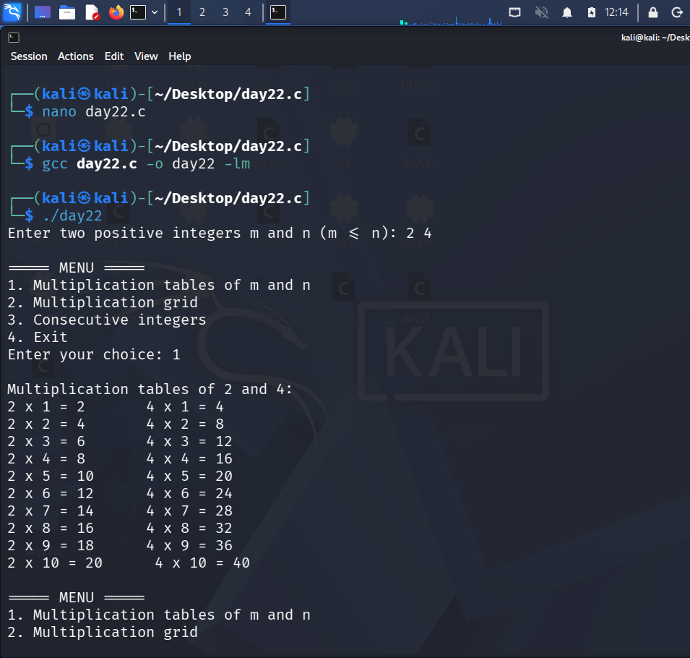
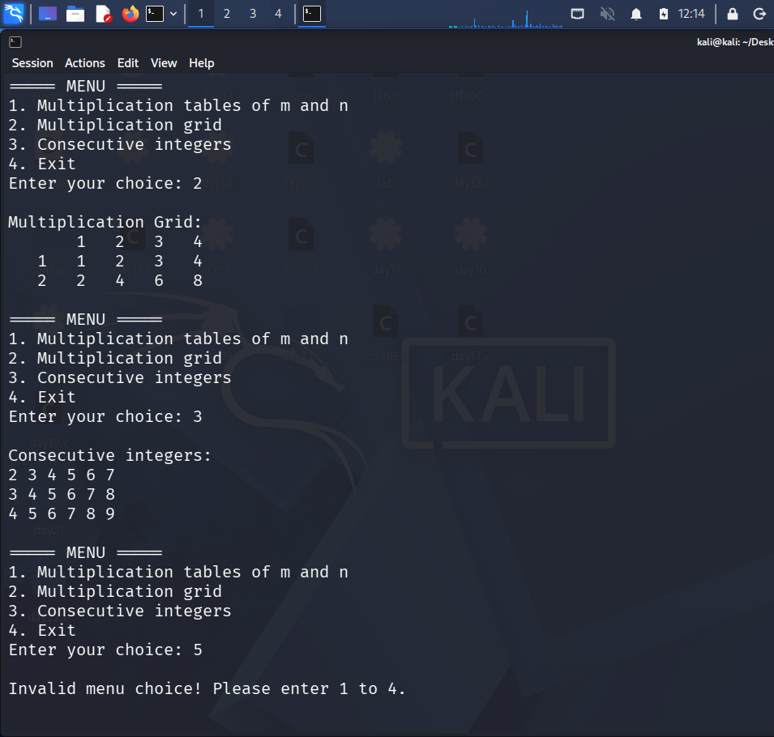
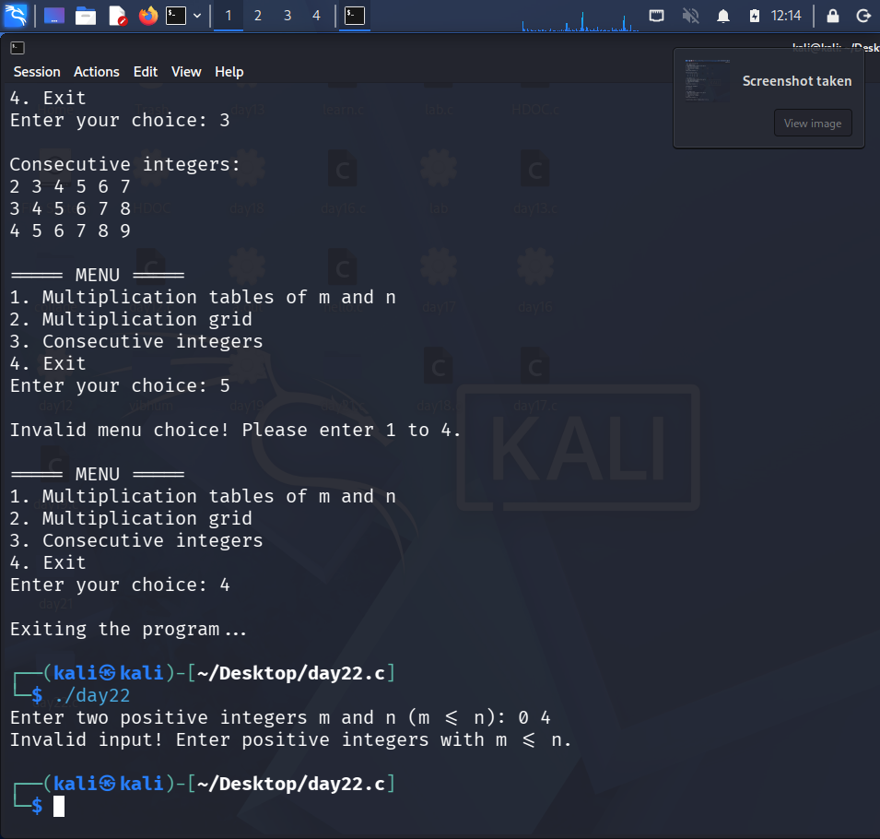

Test-Case Table
TC | m | n | Choice | Expected Result | Actual output
1 | 2 | 4 | 1 | Print tables of 2 and 4 side by side from 1 to 10. | Print tables of 2 and 4 side by side from 1 to 10.
2 | 2 | 4 | 2 | Print grid with rows 1–2 and columns 1–4. | Print grid with rows 1–2 and columns 1–4.
3 | 2 | 4 | 3 | Print: 2 3 4 5 6 7; 3 4 5 6 7 8; 4 5 6 78 9. | Print: 2 3 4 5 6 7; 3 4 5 6 7 8; 4 5 6 78 9.
4 | 2 | 4 | 5 | Display 'Invalid menu choice! Please enter 1 to 4.' | Display 'Invalid menu choice! Please enter 1 to 4.'
5 | 2 | 4 | 4 | Display exit message and terminate the program. | Display exit message and terminate the program.
6 | 0 | 4 | 1 | Display invalid input because m and n must be positive and m <= n. | Display invalid input because m and n must be positive and m <= n.

