**Module –3 (RDBMS & Database Programming With JDBC)**

* **Employee Table Structure**

|  |  |  |  |  |
| --- | --- | --- | --- | --- |
| **Field** | **Type** | **Null** | **Key** | **Default** |
| Empno | int(4) | NO | PRI | 0 |
| Ename | varchar(10) | YES |  | (NULL) |
| Job | varchar(9) | YES |  | (NULL) |
| Mgr | int(4) | YES |  | (NULL) |
| Hiredate | date | YES |  | (NULL) |
| Sal | decimal(7,2) | YES |  | (NULL) |
| Comm | decimal(7,2) | YES |  | (NULL) |
| Deptno | int(2) | YES | MUL | (NULL) |

* **Employee Table Data**

|  |  |  |  |  |  |  |  |
| --- | --- | --- | --- | --- | --- | --- | --- |
| **Empno** | **Ename** | **Job** | **Mgr** | **Hiredate** | **Sal** | **Comm** | **Deptno** |
| 7369 | SMITH | CLERK | 7902 | 1980-12-17 | 800.00 | (NULL) | 20 |
| 7499 | ALLEN | SALESMAN | 7698 | 1981-02-20 | 1600.00 | 300.00 | 30 |
| 7521 | WARD | SALESMAN | 7698 | 1981-02-22 | 1250.00 | 500.00 | 30 |
| 7566 | JONES | MANAGER | 7839 | 1981-04-02 | 2975.00 | (NULL) | 20 |
| 7654 | MARTIN | SALESMAN | 7698 | 1981-09-28 | 1250.00 | 1400.00 | 30 |
| 7698 | BLAKE | MANAGER | 7839 | 1981-05-01 | 2850.00 | (NULL) | 30 |
| 7782 | CLARK | MANAGER | 7839 | 1981-06-09 | 2450.00 | (NULL) | 10 |
| 7788 | SCOTT | ANALYST | 7566 | 1987-06-11 | 3000.00 | (NULL) | 20 |
| 7839 | KING | PRESIDENT | (NULL) | 1981-11-17 | 5000.00 | (NULL) | 10 |
| 7844 | TURNER | SALESMAN | 7698 | 1981-08-09 | 1500.00 | 0.00 | 30 |
| 7876 | ADAMS | CLERK | 7788 | 1987-07-13 | 1100.00 | (NULL) | 20 |
| 7900 | JAMES | CLERK | 7698 | 1981-03-12 | 950.00 | (NULL) | 30 |
| 7902 | FORD | ANALYST | 7566 | 1981-03-12 | 3000.00 | (NULL) | 20 |
| 7934 | MILLER | CLERK | 7782 | 1982-01-23 | 1300.00 | (NULL) | 10 |

* **Department Table Structure**

|  |  |  |  |  |
| --- | --- | --- | --- | --- |
| **Field** | **Type** | **Null** | **Key** | **Default** |
| Deptno | int(2) | NO | PRI | 0 |
| Dname | varchar(14) | YES |  | (NULL) |
| Loc | varchar(13) | YES |  | (NULL) |

* **Department Table Data**

|  |  |  |
| --- | --- | --- |
| **Deptno** | **Dname** | **Loc** |
| 10 | ACCOUNTING | NEW YORK |
| 20 | RESEARCH | DALLAS |
| 30 | SALES | CHICAGO |
| 40 | OPERATIONS | BOSTON |

* **Student Table Structure**

|  |  |  |  |  |
| --- | --- | --- | --- | --- |
| **Field** | **Type** | **Null** | **Key** | **Default** |
| Rno | int(2) | NO | PRI | 0 |
| Sname | varchar(14) | YES |  | (NULL) |
| City | varchar(20) | YES |  | (NULL) |
| State | varchar(20) | YES |  | (NULL) |

* **Emp Log Table Structure**

|  |  |  |  |  |
| --- | --- | --- | --- | --- |
| **Field** | **Type** | **Null** | **Key** | **Default** |
| Emp_id | int(5) | NO |  | (NULL) |
| Log_date | date | YES |  | (NULL) |
| New_Salary | int(10) | YES |  | (NULL) |
| Action | varchar(20) | YES |  | (NULL) |

**Query:**

**[1] Select unique job from EMP table.**

**Query:** [SELECT](http://localhost/phpmyadmin/url.php?url=https://dev.mysql.com/doc/refman/8.0/en/select.html) DISTINCT job FROM employee;

**Output:**

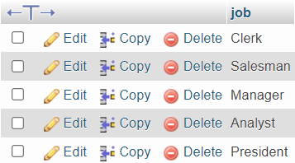

**[2] List the details of the emps in asc order of the Dptnos and desc of Jobs?**

**Query:** [SELECT](http://localhost/phpmyadmin/url.php?url=https://dev.mysql.com/doc/refman/8.0/en/select.html) * FROM employee ORDER BY dept_no ASC,job DESC;

**Output:**

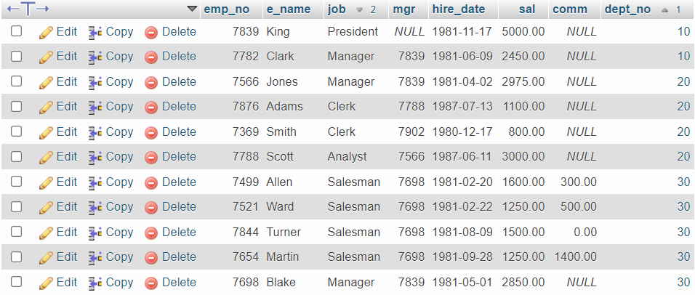

**[3] Display all the unique job groups in the descending order?**

**Query:** [SELECT](http://localhost/phpmyadmin/url.php?url=https://dev.mysql.com/doc/refman/8.0/en/select.html) DISTINCT job FROM employee ORDER BY job DESC;

**Output:**

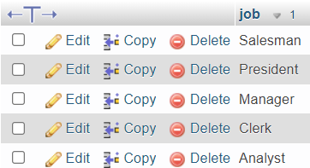

**[4] List the emps who joined before 1981.**

**Query:** [SELECT](http://localhost/phpmyadmin/url.php?url=https://dev.mysql.com/doc/refman/8.0/en/select.html) * FROM employee WHERE hire_date < ('1981-01-01');

**Output:**



**[5] List the Empno, Ename, Sal, Daily sal of all emps in the asc order of Annsal.**

**Query:** [SELECT](http://localhost/phpmyadmin/url.php?url=https://dev.mysql.com/doc/refman/8.0/en/select.html) emp_no, e_name, sal Monthly_Salary, sal/30 Daily_Salary, sal*12 Anual_Salary FROM employee ORDER BY Anual_Salary ASC;

**Output:**

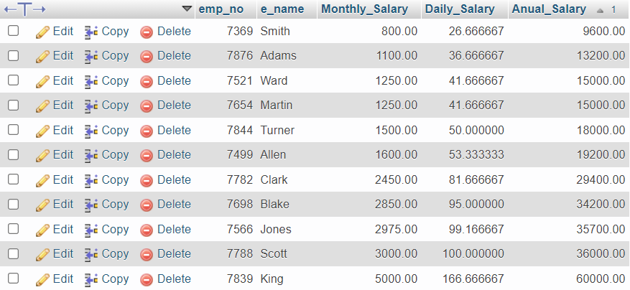

**[6] List the Empno, Ename, Sal, Exp of all emps working for Mgr 7369.**

**Query:** [SELECT](http://localhost/phpmyadmin/url.php?url=https://dev.mysql.com/doc/refman/8.0/en/select.html) emp_no, e_name, sal FROM employee where mgr=7839;

**Output:**

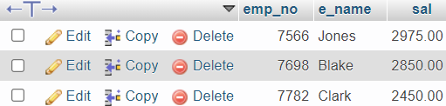

**[7] Display all the details of the emps who’s Comm. Is more than their Sal?**

**Query:** [SELECT](http://localhost/phpmyadmin/url.php?url=https://dev.mysql.com/doc/refman/8.0/en/select.html) * FROM employee WHERE comm > sal;

**Output:**



**[8] List the emps who are either ‘CLERK’ or ‘ANALYST’ in the Desc order.**

**Query:** [SELECT](http://localhost/phpmyadmin/url.php?url=https://dev.mysql.com/doc/refman/8.0/en/select.html) * FROM employee WHERE job='Clerk' [OR](http://localhost/phpmyadmin/url.php?url=https://dev.mysql.com/doc/refman/8.0/en/logical-operators.html%23operator_or) job='Analyst' ORDER BY

job DESC;

**Output:**

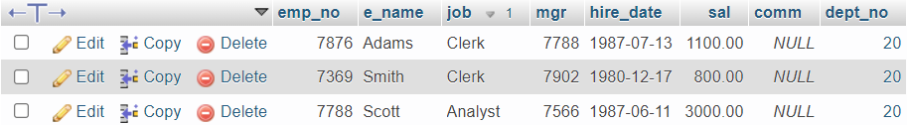

**[9] List the emps Who Annual sal ranging from 22000 and 45000.**

**Query:** [SELECT](http://localhost/phpmyadmin/url.php?url=https://dev.mysql.com/doc/refman/8.0/en/select.html) *,sal*12 FROM `employee` WHERE sal*12 BETWEEN 22000 [AND](http://localhost/phpmyadmin/url.php?url=https://dev.mysql.com/doc/refman/8.0/en/logical-operators.html%23operator_and) 45000;

**Output:**

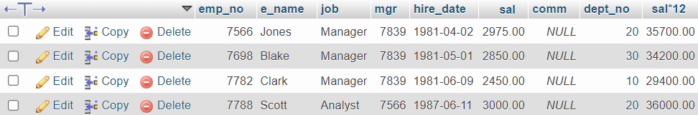

**[10] List the Enames those are starting with ‘S’ and with five characters.**

**Query:** [SELECT](http://localhost/phpmyadmin/url.php?url=https://dev.mysql.com/doc/refman/8.0/en/select.html) e_name FROM employee WHERE e_name [LIKE](http://localhost/phpmyadmin/url.php?url=https://dev.mysql.com/doc/refman/8.0/en/string-comparison-functions.html%23operator_like) 'S%' [AND](http://localhost/phpmyadmin/url.php?url=https://dev.mysql.com/doc/refman/8.0/en/logical-operators.html%23operator_and) length(e_name) = 5;

**Output:**

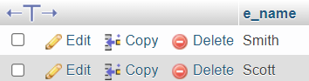

**[11] List the emps whose Empno not starting with digit78.**

**Query:** [SELECT](http://localhost/phpmyadmin/url.php?url=https://dev.mysql.com/doc/refman/8.0/en/select.html) * FROM employee WHERE emp_no [NOT](http://localhost/phpmyadmin/url.php?url=https://dev.mysql.com/doc/refman/8.0/en/logical-operators.html%23operator_not) [LIKE](http://localhost/phpmyadmin/url.php?url=https://dev.mysql.com/doc/refman/8.0/en/string-comparison-functions.html%23operator_like) '78%';

**Output:**

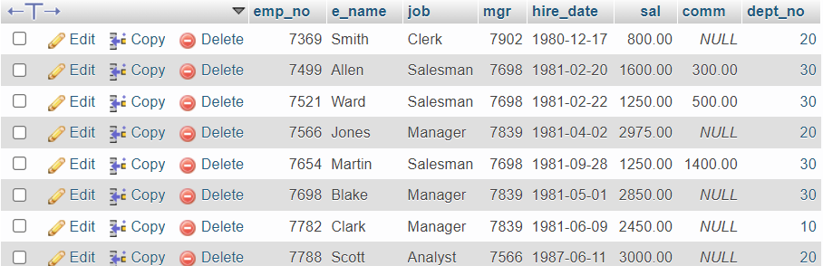

**[12] List all the Clerks of Deptno 20.**

**Query:** [SELECT](http://localhost/phpmyadmin/url.php?url=https://dev.mysql.com/doc/refman/8.0/en/select.html) * FROM employee WHERE job='Clerk' [AND](http://localhost/phpmyadmin/url.php?url=https://dev.mysql.com/doc/refman/8.0/en/logical-operators.html%23operator_and) dept_no=20;

**Output:**

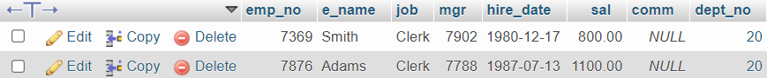

**[13] List the Emps who are senior to their own MGRS.**

**Query:**

**Output:**

**[14] List the Emps of Deptno 20 who’s Jobs are same as Deptno10.**

**Query:** [SELECT](http://localhost/phpmyadmin/url.php?url=https://dev.mysql.com/doc/refman/8.0/en/select.html) * FROM employee WHERE dept_no=20 [AND](http://localhost/phpmyadmin/url.php?url=https://dev.mysql.com/doc/refman/8.0/en/logical-operators.html%23operator_and) job [IN](http://localhost/phpmyadmin/url.php?url=https://dev.mysql.com/doc/refman/8.0/en/comparison-operators.html%23function_in)([SELECT](http://localhost/phpmyadmin/url.php?url=https://dev.mysql.com/doc/refman/8.0/en/select.html) DISTINCT job FROM employee WHERE dept_no=10);

**Output:**



**[15] List the Emps who’s Sal is same as FORD or SMITH in desc order of Sal.**

**Query:**

[SELECT](http://localhost/phpmyadmin/url.php?url=https://dev.mysql.com/doc/refman/8.0/en/select.html) * FROM employee WHERE sal [IN](http://localhost/phpmyadmin/url.php?url=https://dev.mysql.com/doc/refman/8.0/en/comparison-operators.html%23function_in)([SELECT](http://localhost/phpmyadmin/url.php?url=https://dev.mysql.com/doc/refman/8.0/en/select.html) sal FROM employee WHERE e_name [IN](http://localhost/phpmyadmin/url.php?url=https://dev.mysql.com/doc/refman/8.0/en/comparison-operators.html%23function_in)('Ford','Smith')) ORDER BY sal DESC;

**Output:**



**[16] List the emps whose jobs same as SMITH or ALLEN.**

**Query:** [SELECT](http://localhost/phpmyadmin/url.php?url=https://dev.mysql.com/doc/refman/8.0/en/select.html) * FROM employee WHERE job [IN](http://localhost/phpmyadmin/url.php?url=https://dev.mysql.com/doc/refman/8.0/en/comparison-operators.html%23function_in)([SELECT](http://localhost/phpmyadmin/url.php?url=https://dev.mysql.com/doc/refman/8.0/en/select.html) job FROM employee where e_name [IN](http://localhost/phpmyadmin/url.php?url=https://dev.mysql.com/doc/refman/8.0/en/comparison-operators.html%23function_in)('Allen','Smith'));

**Output:**

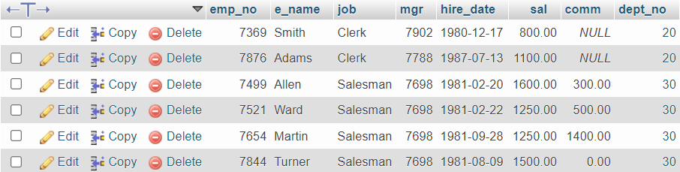

**[17] Any jobs of deptno 10 those that are not found in deptno 20.**

**Query:** [SELECT](http://localhost/phpmyadmin/url.php?url=https://dev.mysql.com/doc/refman/8.0/en/select.html) * FROM employee WHERE dept_no=10 [AND](http://localhost/phpmyadmin/url.php?url=https://dev.mysql.com/doc/refman/8.0/en/logical-operators.html%23operator_and) job [NOT](http://localhost/phpmyadmin/url.php?url=https://dev.mysql.com/doc/refman/8.0/en/logical-operators.html%23operator_not) [IN](http://localhost/phpmyadmin/url.php?url=https://dev.mysql.com/doc/refman/8.0/en/comparison-operators.html%23function_in)([SELECT](http://localhost/phpmyadmin/url.php?url=https://dev.mysql.com/doc/refman/8.0/en/select.html) job FROM employee where dept_no=20);

**Output:**



**[18] Find the highest sal of EMP table.**

**Query:** [SELECT](http://localhost/phpmyadmin/url.php?url=https://dev.mysql.com/doc/refman/8.0/en/select.html) [MAX](http://localhost/phpmyadmin/url.php?url=https://dev.mysql.com/doc/refman/8.0/en/aggregate-functions.html%23function_max)(sal) FROM employee;

**Output:**



**[19] Find details of highest paid employee.**

**Query:** [SELECT](http://localhost/phpmyadmin/url.php?url=https://dev.mysql.com/doc/refman/8.0/en/select.html) * FROM employee WHERE sal [IN](http://localhost/phpmyadmin/url.php?url=https://dev.mysql.com/doc/refman/8.0/en/comparison-operators.html%23function_in)([SELECT](http://localhost/phpmyadmin/url.php?url=https://dev.mysql.com/doc/refman/8.0/en/select.html) [MAX](http://localhost/phpmyadmin/url.php?url=https://dev.mysql.com/doc/refman/8.0/en/aggregate-functions.html%23function_max)(sal) FROM employee);

**Output:**



**[20] Find the total sal given to the MGR.**

**Query:** [SELECT](http://localhost/phpmyadmin/url.php?url=https://dev.mysql.com/doc/refman/8.0/en/select.html) [sum](http://localhost/phpmyadmin/url.php?url=https://dev.mysql.com/doc/refman/8.0/en/aggregate-functions.html%23function_sum)(sal) FROM employee where job='Manager';

**Output:**



**[21] List the emps whose names contains ‘A’.**

**Query:** [SELECT](http://localhost/phpmyadmin/url.php?url=https://dev.mysql.com/doc/refman/8.0/en/select.html) * FROM employee where e_name [LIKE](http://localhost/phpmyadmin/url.php?url=https://dev.mysql.com/doc/refman/8.0/en/string-comparison-functions.html%23operator_like) '%A%';

**Output:**

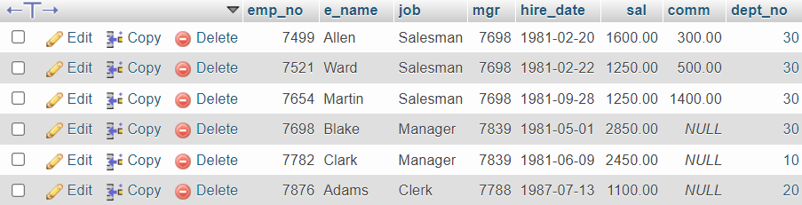

**[22] Find all the emps who earn the minimum Salary for each job wise in ascending order.**

**Query:** [SELECT](http://localhost/phpmyadmin/url.php?url=https://dev.mysql.com/doc/refman/8.0/en/select.html) * FROM employee WHERE sal [IN](http://localhost/phpmyadmin/url.php?url=https://dev.mysql.com/doc/refman/8.0/en/comparison-operators.html%23function_in)([SELECT](http://localhost/phpmyadmin/url.php?url=https://dev.mysql.com/doc/refman/8.0/en/select.html) [MIN](http://localhost/phpmyadmin/url.php?url=https://dev.mysql.com/doc/refman/8.0/en/aggregate-functions.html%23function_min)(sal) FROM employee GROUP BY job) ORDER BY sal ASC;

**Output:**

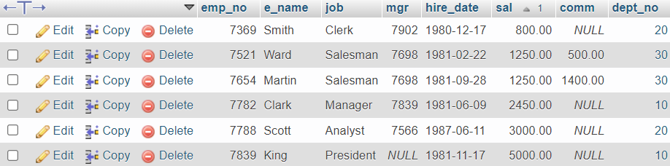

**[23] List the emps whose sal greater than Blake’s sal.**

**Query:** [SELECT](http://localhost/phpmyadmin/url.php?url=https://dev.mysql.com/doc/refman/8.0/en/select.html) * FROM employee WHERE sal > ([SELECT](http://localhost/phpmyadmin/url.php?url=https://dev.mysql.com/doc/refman/8.0/en/select.html) sal FROM employee WHERE e_name='Blake');

**Output:**

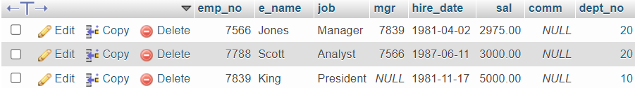

**[24] Create view v1 to select ename, job, dname, loc whose deptno are same.**

**Query:**

**Output:**

**[25] Create a procedure with dno as input parameter to fetch ename and dname.**

**Query:**

**Output:**

**[26] Add column Pin with bigint data type in table student.**

**Query:**

**Output:**

**[27] Modify the student table to change the sname length from 14 to 40. Create trigger to insert data in emp_log table whenever any update of sal in EMP table. You can set action as ‘New Salary’.**

**Query:**

**Output:**