1.) Write a program to take a list of 10 farmers, fruits they sell, their cities & the quantity of fruits they have as input. Save the data to notepad before & after sorting based on quantity in tabular manner. Also perform search operation based on farmers' name.
import java.io.*;
import java.util.*;
public class maincode {
static class Farmer {
private String name, city, fruit;
private int quantity;
public Farmer(String name, String city, String fruit, int quantity) {
this.name = name;
this.city = city;
this.fruit = fruit;
this.quantity = quantity;
}
public String getName() { return name; }
public String getCity() { return city; }
public String getFruit() { return fruit; }
public int getQuantity() { return quantity; }
}
// Display table
public static void displayTable(List<Farmer> farmers) {
System.out.printf("%-15s %-15s %-15s %-10s\n",
"Name", "City", "Fruit", "Quantity");
System.out.println("----------------------------------------------------------");
for (Farmer f : farmers) {
System.out.printf("%-15s %-15s %-15s %-10d\n",
f.getName(), f.getCity(), f.getFruit(), f.getQuantity());
}
}
// Write to file
public static void writeToFile(List<Farmer> farmers, String filename) {
try {
BufferedWriter writer = new BufferedWriter(new FileWriter(filename));
writer.write(String.format("%-15s %-15s %-15s %-10s\n",
"Name", "City", "Fruit", "Quantity"));
writer.write("----------------------------------------------------------\n");
for (Farmer f : farmers) {
writer.write(String.format("%-15s %-15s %-15s %-10d\n",
f.getName(), f.getCity(), f.getFruit(), f.getQuantity()));
}
writer.close();
} catch (IOException e) {
System.out.println("File error");
}
}
// SEARCH FUNCTION
public static void searchFarmer(List<Farmer> farmers, String name) {
boolean found = false;
System.out.println("\n--- SEARCH RESULT ---");
System.out.printf("%-15s %-15s %-15s %-10s\n",
"Name", "City", "Fruit", "Quantity");
System.out.println("----------------------------------------------------------");
for (Farmer f : farmers) {
if (f.getName().equalsIgnoreCase(name)) {
System.out.printf("%-15s %-15s %-15s %-10d\n",
f.getName(), f.getCity(), f.getFruit(), f.getQuantity());
found = true;
}
}
if (!found) {
System.out.println("Farmer not found");
}
}
public static void main(String[] args) {
Scanner sc = new Scanner(System.in);
List<Farmer> farmers = new ArrayList<>();
// Input
for (int i = 0; i < 10; i++) { // change to 10 if needed
System.out.println("\nEnter details for Farmer " + (i + 1));
System.out.print("Name: ");
String name = sc.nextLine();
System.out.print("City: ");
String city = sc.nextLine();
System.out.print("Fruit: ");
String fruit = sc.nextLine();
System.out.print("Quantity: ");
int quantity = sc.nextInt();
sc.nextLine();
farmers.add(new Farmer(name, city, fruit, quantity));
}
// BEFORE SORTING
System.out.println("\n--- BEFORE SORTING ---");
displayTable(farmers);
writeToFile(farmers, "before_sort.txt");
// SORT BY QUANTITY
farmers.sort((f1, f2) -> f1.getQuantity() - f2.getQuantity());
// AFTER SORTING
System.out.println("\n--- AFTER SORTING ---");
displayTable(farmers);
writeToFile(farmers, "after_sort.txt");
// SEARCH
System.out.print("\nEnter farmer name to search: ");
String searchName = sc.nextLine();
searchFarmer(farmers, searchName);
sc.close();
}
}
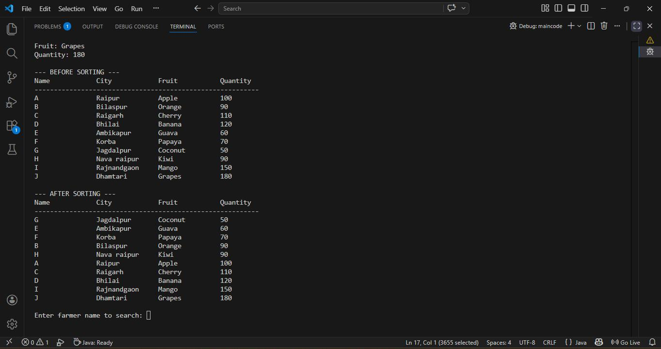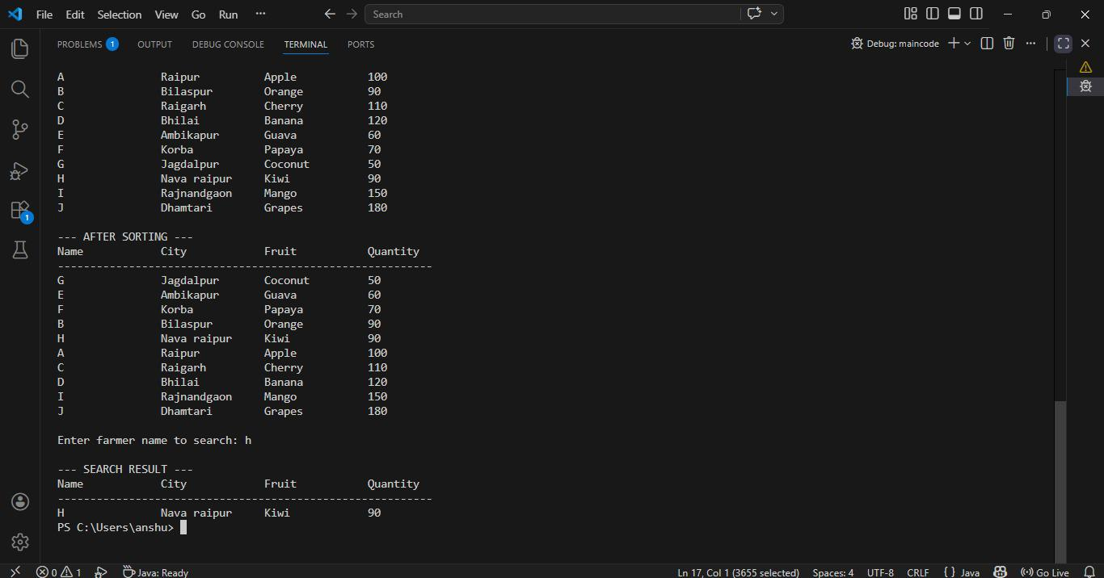

2.) Write a program to take quantity & quality of fruits Mango, Apple & Papaya as input. Quality may be good, bad or average. If entered quantity of fruit is greater than 1000, store it as half. Perform search for a given fruit with given quality.
import java.util.*;
class Fruit {
private String name;
private int quantity;
private String quality;
public Fruit(String name, int quantity, String quality) {
this.name = name;
// If quantity > 1000, store half
if (quantity > 1000) {
this.quantity = quantity / 2;
} else {
this.quantity = quantity;
}
this.quality = quality.toLowerCase();
}
public String getName() {
return name;
}
public int getQuantity() {
return quantity;
}
public String getQuality() {
return quality;
}
@Override
public String toString() {
return String.format("%s - Quantity: %d, Quality: %s", name, quantity, quality);
}
}
class FruitManager {
private List<Fruit> fruits;
public FruitManager() {
fruits = new ArrayList<>();
}
public void addFruit(Fruit fruit) {
fruits.add(fruit);
}
public void displayFruits() {
System.out.println("Fruit List:");
for (Fruit f : fruits) {
System.out.println(f);
}
}
public void searchFruit(String name, String quality) {
boolean found = false;
for (Fruit f : fruits) {
if (f.getName().equalsIgnoreCase(name) && f.getQuality().equalsIgnoreCase(quality)) {
System.out.println("Found: " + f);
found = true;
}
}
if (!found) {
System.out.println("No fruit found with name " + name + " and quality " + quality);
}
}
}
public class FruitApp {
public static void main(String[] args) {
Scanner sc = new Scanner(System.in);
FruitManager manager = new FruitManager();
// Input for Mango, Apple, Papaya
String[] fruitNames = {"Mango", "Apple", "Papaya"};
for (String fname : fruitNames) {
System.out.println("Enter quantity for " + fname + ": ");
int qty = sc.nextInt();
System.out.println("Enter quality for " + fname + " (good/bad/average): ");
String quality = sc.next();
manager.addFruit(new Fruit(fname, qty, quality));
}
// Display all fruits
manager.displayFruits();
// Search operation
System.out.println("\nEnter fruit name to search: ");
String searchName = sc.next();
System.out.println("Enter quality to search: ");
String searchQuality = sc.next();
manager.searchFruit(searchName, searchQuality);
sc.close();
}
}
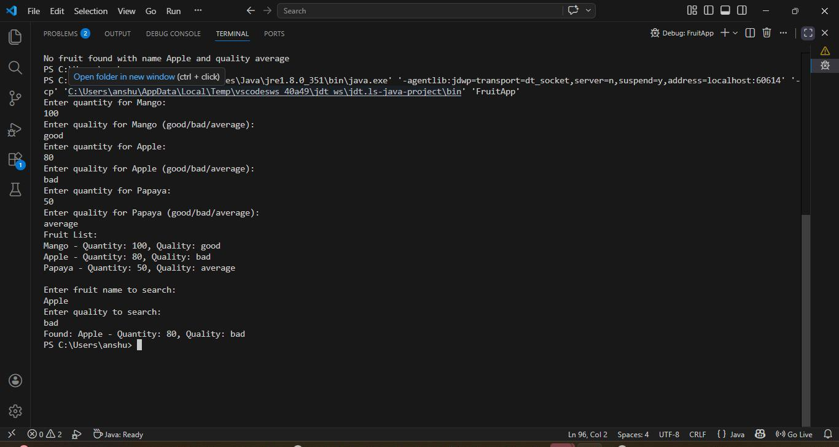

3.) There are four orchards, namely A, B, C & D with fruits in them as Apple, Litchi, Mango, Apple respectively. The qualities of the fruits in the orchards are good, good, good & bad respectively.
The available orchards in a tree-view.
Search for a given fruit in the available orchards after taking input from the user & print the tree.
public class Fruit {
private String name;
private String quality;
public Fruit(String name, String quality) {
this.name = name;
this.quality = quality;
}
public String getName() {
return name;
}
public String getQuality() {
return quality;
}
@Override
public String toString() {
return name + " (" + quality + ")";
}
}
public class Orchard {
private String name;
private Fruit fruit;
public Orchard(String name, Fruit fruit) {
this.name = name;
this.fruit = fruit;
}
public String getName() {
return name;
}
public Fruit getFruit() {
return fruit;
}
@Override
public String toString() {
return "Orchard " + name + " -> " + fruit.toString();
}
}
import java.util.ArrayList;
import java.util.List;
public class OrchardTree {
private List<Orchard> orchards;
public OrchardTree() {
orchards = new ArrayList<>();
}
public void addOrchard(Orchard orchard) {
orchards.add(orchard);
}
public void displayTree() {
System.out.println("Tree View of Orchards:");
for (Orchard orchard : orchards) {
System.out.println(" └── " + orchard.toString());
}
}
public void searchFruit(String fruitName) {
boolean found = false;
System.out.println("\nSearching for fruit: " + fruitName);
for (Orchard orchard : orchards) {
if (orchard.getFruit().getName().equalsIgnoreCase(fruitName)) {
System.out.println("Found in " + orchard.getName() + " with quality: "
+ orchard.getFruit().getQuality());
found = true;
}
}
if (!found) {
System.out.println("Fruit not found in any orchard.");
}
}
}
import java.util.ArrayList;
import java.util.List;
public class OrchardTree {
private List<Orchard> orchards;
public OrchardTree() {
orchards = new ArrayList<>();
}
public void addOrchard(Orchard orchard) {
orchards.add(orchard);
}
public void displayTree() {
System.out.println("Tree View of Orchards:");
for (Orchard orchard : orchards) {
System.out.println(" └── " + orchard.toString());
}
}
public void searchFruit(String fruitName) {
boolean found = false;
System.out.println("\nSearching for fruit: " + fruitName);
for (Orchard orchard : orchards) {
if (orchard.getFruit().getName().equalsIgnoreCase(fruitName)) {
System.out.println("Found in " + orchard.getName() + " with quality: "
+ orchard.getFruit().getQuality());
found = true;
}
}
if (!found) {
System.out.println("Fruit not found in any orchard.");
}
}
}
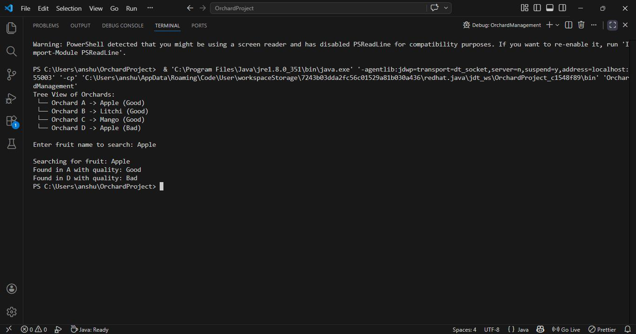

4.) Take a map provided as a graph & display all the subtrees of connected points.
public class Node {
private String name;
public Node(String name) {
this.name = name;
}
public String getName() {
return name;
}
@Override
public String toString() {
return name;
}
}
import java.util.*;
public class Graph {
private Map<Node, List<Node>> adjacencyList;
public Graph() {
adjacencyList = new HashMap<>();
}
public void addNode(Node node) {
adjacencyList.putIfAbsent(node, new ArrayList<>());
}
public void addEdge(Node node1, Node node2) {
adjacencyList.get(node1).add(node2);
adjacencyList.get(node2).add(node1); // undirected graph
}
public void displaySubtrees() {
Set<Node> visited = new HashSet<>();
for (Node node : adjacencyList.keySet()) {
if (!visited.contains(node)) {
System.out.println("Subtree starting at " + node + ":");
dfs(node, visited, " ");
System.out.println();
}
}
}
private void dfs(Node node, Set<Node> visited, String indent) {
visited.add(node);
System.out.println(indent + node);
for (Node neighbor : adjacencyList.get(node)) {
if (!visited.contains(neighbor)) {
dfs(neighbor, visited, indent + " ");
}
}
}
}
public class GraphManagement {
public static void main(String[] args) {
Graph graph = new Graph();
// Create nodes
Node A = new Node("A");
Node B = new Node("B");
Node C = new Node("C");
Node D = new Node("D");
Node E = new Node("E");
Node F = new Node("F");
// Add nodes to graph
graph.addNode(A);
graph.addNode(B);
graph.addNode(C);
graph.addNode(D);
graph.addNode(E);
graph.addNode(F);
// Add edges (connections)
graph.addEdge(A, B);
graph.addEdge(A, C);
graph.addEdge(D, E);
graph.addEdge(E, F);
// Display all subtrees
graph.displaySubtrees();
}
}
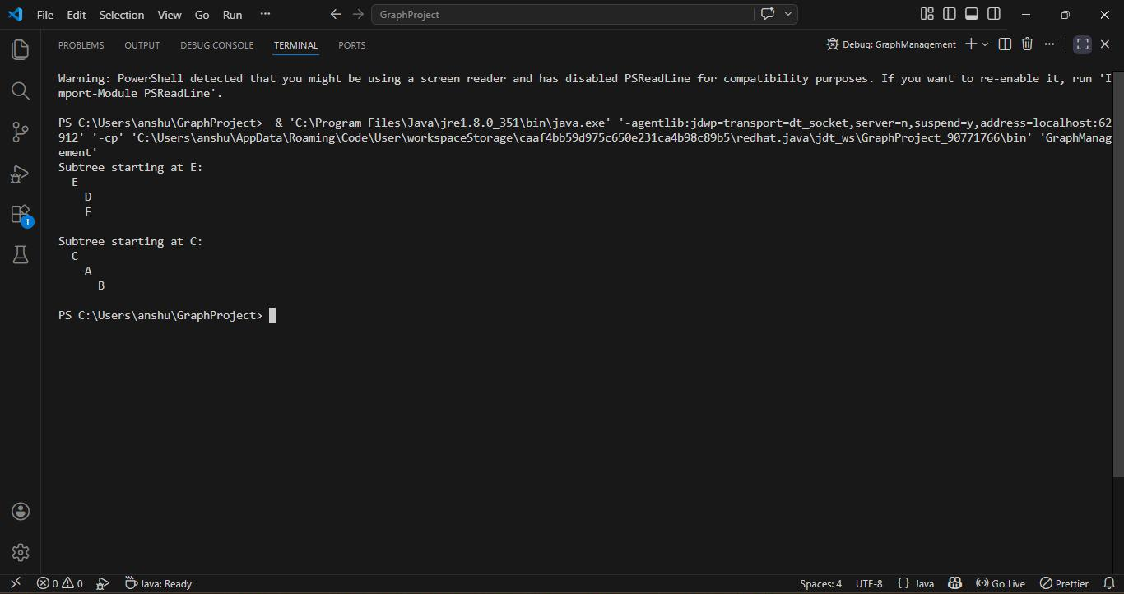

5.) Enter entry point & goal point & produce the matching subtree of the graph.
public class Node {
private String name;
public Node(String name) {
this.name = name;
}
public String getName() {
return name;
}
@Override
public String toString() {
return name;
}
}
import java.util.*;
public class Graph {
private Map<Node, List<Node>> adjacencyList;
public Graph() {
adjacencyList = new HashMap<>();
}
public void addNode(Node node) {
adjacencyList.putIfAbsent(node, new ArrayList<>());
}
public void addEdge(Node node1, Node node2) {
adjacencyList.get(node1).add(node2);
adjacencyList.get(node2).add(node1); // undirected graph
}
// Find path (subtree) between entry and goal
public List<Node> findPath(Node start, Node goal) {
Set<Node> visited = new HashSet<>();
Map<Node, Node> parent = new HashMap<>();
Queue<Node> queue = new LinkedList<>();
queue.add(start);
visited.add(start);
while (!queue.isEmpty()) {
Node current = queue.poll();
if (current.equals(goal)) {
return buildPath(parent, start, goal);
}
for (Node neighbor : adjacencyList.get(current)) {
if (!visited.contains(neighbor)) {
visited.add(neighbor);
parent.put(neighbor, current);
queue.add(neighbor);
}
}
}
return Collections.emptyList(); // no path found
}
private List<Node> buildPath(Map<Node, Node> parent, Node start, Node goal) {
List<Node> path = new ArrayList<>();
Node current = goal;
while (current != null) {
path.add(current);
current = parent.get(current);
}
Collections.reverse(path);
return path;
}
}
import java.util.*;
public class GraphManagement {
public static void main(String[] args) {
Graph graph = new Graph();
// Create nodes
Node A = new Node("A");
Node B = new Node("B");
Node C = new Node("C");
Node D = new Node("D");
Node E = new Node("E");
Node F = new Node("F");

// Add nodes to graph
graph.addNode(A);
graph.addNode(B);
graph.addNode(C);
graph.addNode(D);
graph.addNode(E);
graph.addNode(F);

// Add edges (connections)
graph.addEdge(A, B);
graph.addEdge(A, C);
graph.addEdge(B, D);
graph.addEdge(C, E);
graph.addEdge(E, F);

Scanner sc = new Scanner(System.in);
System.out.print("Enter entry point: ");
String entry = sc.nextLine().trim();
System.out.print("Enter goal point: ");
String goal = sc.nextLine().trim();

// Map names to nodes
Map<String, Node> nodeMap = new HashMap<>();
nodeMap.put("A", A);
nodeMap.put("B", B);
nodeMap.put("C", C);
nodeMap.put("D", D);
nodeMap.put("E", E);
nodeMap.put("F", F);

Node startNode = nodeMap.get(entry);
Node goalNode = nodeMap.get(goal);

if (startNode == null || goalNode == null) {
System.out.println("Invalid nodes entered.");
} else {
List<Node> path = graph.findPath(startNode, goalNode);
if (path.isEmpty()) {
System.out.println("No path found between " + entry + " and " + goal);
} else {
System.out.println("Matching subtree (path): " + path);
}
}
sc.close();
}
}
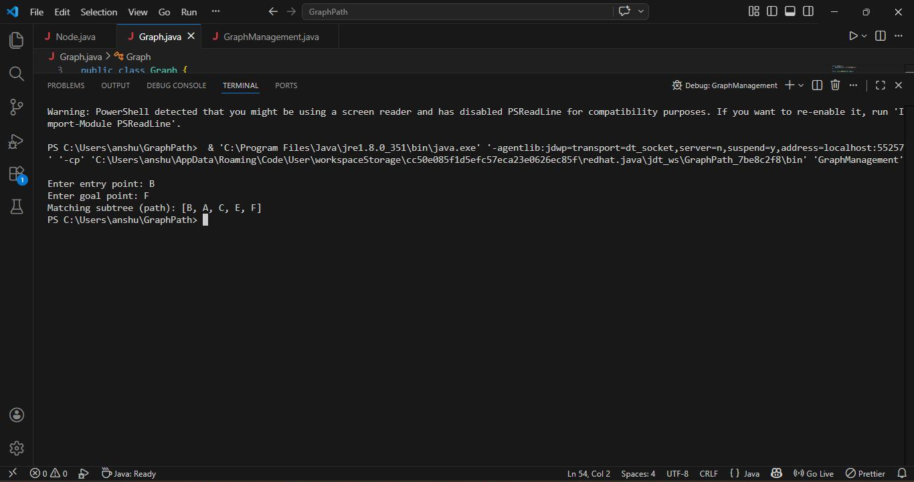

6.) Give the weightage for each edge of nodes, and produce the shortest path from start to end node.
import java.util.*;
// Node class
class Node {
String name;
List<Edge> edges;
Node(String name) {
this.name = name;
this.edges = new ArrayList<>();
}
void addEdge(Node destination, int weight) {
edges.add(new Edge(this, destination, weight));
}
}
// Edge class
class Edge {
Node source;
Node destination;
int weight;
Edge(Node source, Node destination, int weight) {
this.source = source;
this.destination = destination;
this.weight = weight;
}
}
// Graph class
class Graph {
Map<String, Node> nodes;
Graph() {
nodes = new HashMap<>();
}
void addNode(String name) {
nodes.put(name, new Node(name));
}
void addEdge(String source, String destination, int weight) {
Node src = nodes.get(source);
Node dest = nodes.get(destination);
if (src != null && dest != null) {
src.addEdge(dest, weight);
dest.addEdge(src, weight); // undirected graph
}
}

void dijkstra(String start, String end) {
Map<Node, Integer> distances = new HashMap<>();
Map<Node, Node> previous = new HashMap<>();
PriorityQueue<Node> queue = new PriorityQueue<>(Comparator.comparingInt(distances::get));
for (Node node : nodes.values()) {
distances.put(node, Integer.MAX_VALUE);
previous.put(node, null);
}
Node startNode = nodes.get(start);
distances.put(startNode, 0);
queue.add(startNode);
while (!queue.isEmpty()) {
Node current = queue.poll();
for (Edge edge : current.edges) {
int newDist = distances.get(current) + edge.weight;
if (newDist < distances.get(edge.destination)) {
distances.put(edge.destination, newDist);
previous.put(edge.destination, current);
queue.add(edge.destination);
}
}
}
// Print shortest path
Node endNode = nodes.get(end);
if (distances.get(endNode) == Integer.MAX_VALUE) {
System.out.println("No path found from " + start + " to " + end);
return;
}
List<String> path = new ArrayList<>();
for (Node at = endNode; at != null; at = previous.get(at)) {
path.add(at.name);
}
Collections.reverse(path);

System.out.println("Shortest path from " + start + " to " + end + ": " + path);
System.out.println("Total distance: " + distances.get(endNode));
}
}
// Main class
public class Main {
public static void main(String[] args) {
Graph graph = new Graph();

// Add nodes
graph.addNode("A");
graph.addNode("B");
graph.addNode("C");
graph.addNode("D");
graph.addNode("E");

// Add weighted edges
graph.addEdge("A", "B", 4);
graph.addEdge("A", "C", 2);
graph.addEdge("B", "C", 5);
graph.addEdge("B", "D", 10);
graph.addEdge("C", "E", 3);
graph.addEdge("E", "D", 4);
Scanner sc = new Scanner(System.in);
System.out.print("Enter start node: ");
String start = sc.nextLine();
System.out.print("Enter end node: ");
String end = sc.nextLine();
graph.dijkstra(start, end);
sc.close();
}
}
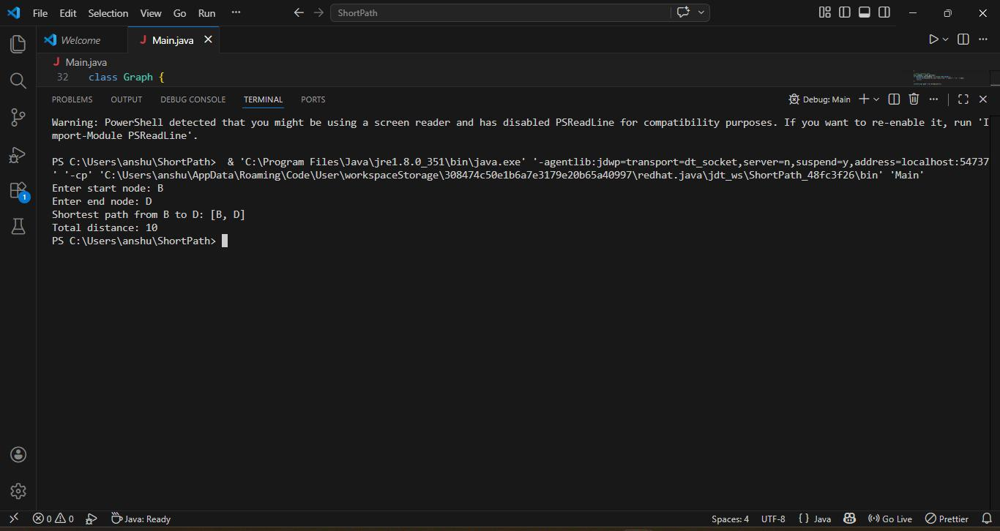

7.) Write a program to demonstrate the use of all keywords made for exception handling.
// Custom Exception Class
class InvalidAgeException extends Exception {
public InvalidAgeException(String message) {
super(message);
}
}
// Person class demonstrating OOP + exception handling
class Person {
private String name;
private int age;

public Person(String name, int age) throws InvalidAgeException {
this.name = name;
// Using 'throw' to explicitly raise exception
if (age < 0) {
throw new InvalidAgeException("Age cannot be negative!");
}
this.age = age;
}
public void display() {
System.out.println("Name: " + name + ", Age: " + age);
}
}
// Main class
public class ExceptionDemo {
// Method with 'throws' declaration
public static void createPerson(String name, int age) throws InvalidAgeException {
Person p = new Person(name, age);
p.display();
}
public static void main(String[] args) {
try {
// Valid case
createPerson("Rakesh", 22);
// Invalid case to trigger exception
createPerson("Ramesh", -5);
} catch (InvalidAgeException e) {
// 'catch' block handles the thrown exception
System.out.println("Exception caught: " + e.getMessage());
} finally {
// 'finally' block always executes
System.out.println("Program execution completed. Resources closed.");
}
}
}
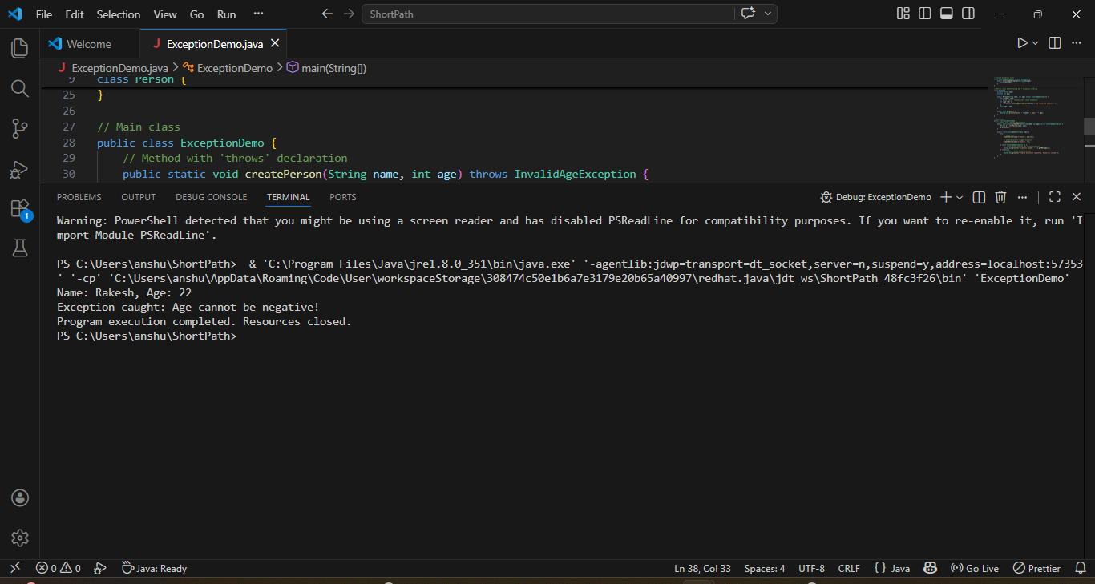

8.) Write a program to withraw money from a bank account, if the withdrawn money is greater than the balance, then it throws NoMoneyException.
// Custom Exception Class
class NoMoneyException extends Exception {
public NoMoneyException(String message) {
super(message);
}
}
// BankAccount class demonstrating OOP + exception handling
class BankAccount {
private String accountHolder;
private double balance;
public BankAccount(String accountHolder, double balance) {
this.accountHolder = accountHolder;
this.balance = balance;
}
// Method to withdraw money
public void withdraw(double amount) throws NoMoneyException {
if (amount > balance) {
// Throw custom exception if insufficient funds
throw new NoMoneyException("Insufficient balance! Withdrawal denied.");
} else {
balance -= amount;
System.out.println("Withdrawal successful. Remaining balance: " + balance);
}
}
public void displayBalance() {
System.out.println("Account Holder: " + accountHolder + ", Balance: " + balance);
}
}
// Main class
public class BankDemo {
public static void main(String[] args) {
BankAccount account = new BankAccount("Rakesh", 5000);
account.displayBalance();
try {
// Valid withdrawal
account.withdraw(2000);
// Invalid withdrawal (greater than balance)
account.withdraw(4000);
} catch (NoMoneyException e) {
System.out.println("Exception caught: " + e.getMessage());
} finally {
System.out.println("Transaction process completed.");
}
}
}
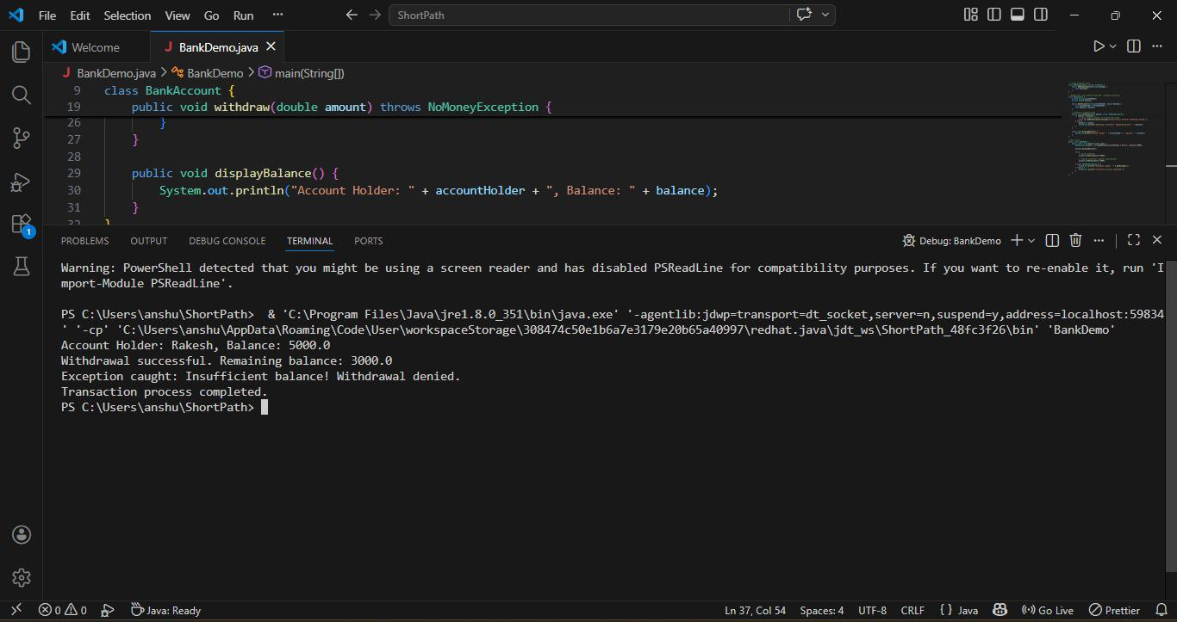

9.) Write a program which enables to use a platform by a train one at a time.
// File: PlatformManagement.java
// Class representing a Train
class Train {
private String trainName;
public Train(String trainName) {
this.trainName = trainName;
}
public String getTrainName() {
return trainName;
}
}
// Class representing a Platform
class Platform {
private boolean isOccupied;
private Train currentTrain;
public Platform() {
this.isOccupied = false;
this.currentTrain = null;
}
// Allow a train to enter the platform
public void allowTrain(Train train) {
if (!isOccupied) {
currentTrain = train;
isOccupied = true;
System.out.println("Train " + train.getTrainName() + " is now using the platform.");
} else {
System.out.println("Platform is occupied by " + currentTrain.getTrainName() + ". Train "
+ train.getTrainName() + " must wait.");
}
}
// Release the platform
public void releasePlatform() {
if (isOccupied) {
System.out.println("Train " + currentTrain.getTrainName() + " has left the platform.");
currentTrain = null;
isOccupied = false;
} else {
System.out.println("Platform is already free.");
}
}
}
// Main class to test the program
public class PlatformManagement {
public static void main(String[] args) {
Platform platform = new Platform();
Train train1 = new Train("Express-101");
Train train2 = new Train("Local-202");
platform.allowTrain(train1); // Train 1 enters
platform.allowTrain(train2); // Train 2 tries but must wait
platform.releasePlatform(); // Train 1 leaves
platform.allowTrain(train2); // Train 2 enters now
}
}
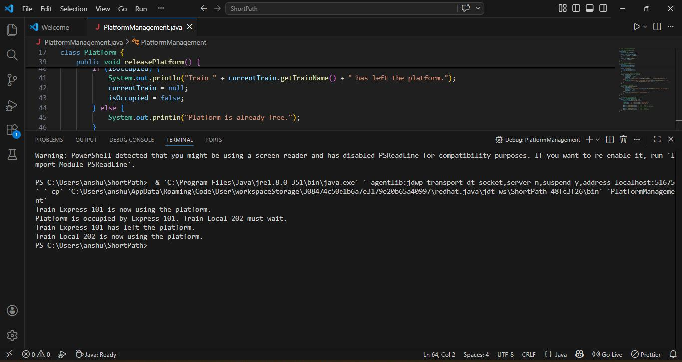

10.) Write a programme of Restaurant and Waiter, which accept order if kitchen if free and sheff deliver orders if he is free.
import java.util.concurrent.BlockingQueue;
import java.util.concurrent.LinkedBlockingQueue;
// Kitchen manages the order queue
class Kitchen {
private BlockingQueue<String> orders = new LinkedBlockingQueue<>();
public void acceptOrder(String order) {
try {
orders.put(order); // add order to queue
System.out.println("Kitchen accepted order: " + order);
} catch (InterruptedException e) {
e.printStackTrace();
}
}
public String getNextOrder() throws InterruptedException {
return orders.take(); // waits if no order available
}
}
// Waiter places orders into the kitchen
class Waiter extends Thread {
private Kitchen kitchen;
private String order;
public Waiter(Kitchen kitchen, String order) {
this.kitchen = kitchen;
this.order = order;
}
@Override
public void run() {
kitchen.acceptOrder(order);
System.out.println("Waiter placed order: " + order);
}
}
// Chef continuously delivers orders from the kitchen
class Chef extends Thread {
private Kitchen kitchen;
public Chef(Kitchen kitchen) {
this.kitchen = kitchen;
}
@Override
public void run() {
try {
while (true) {
String order = kitchen.getNextOrder();
System.out.println("Chef is delivering order: " + order);
Thread.sleep(2000); // simulate cooking time
System.out.println("Order delivered: " + order);
}
} catch (InterruptedException e) {
e.printStackTrace();
}
}
}
// Main simulation
public class RestaurantSimulation {
public static void main(String[] args) {
Kitchen kitchen = new Kitchen();
// Start one chef thread
Chef chef = new Chef(kitchen);
chef.start();
// Start multiple waiter threads
Waiter waiter1 = new Waiter(kitchen, "Pizza");
Waiter waiter2 = new Waiter(kitchen, "Pasta");
Waiter waiter3 = new Waiter(kitchen, "Burger");
waiter1.start();
waiter2.start();
waiter3.start();
}
}
