- Write a program to take a list of 10 farmers, fruits they sell, their cities & the quantity of fruits they have as input. Save the data to notepad before & after sorting based on quantity in tabular manner. Also perform search operation based on farmers' name.

import java.io.*;
import java.util.*;
public class FarmersProgram {
static class Farmer {
private String name;
private String fruit;
private String city;
private int quantity;

Farmer(String name, String fruit, String city, int quantity) {
this.name = name;
this.fruit = fruit;
this.city = city;
this.quantity = quantity;
}

public String getName() { return name; }
public int getQuantity() { return quantity; }

@Override
public String toString() {
return String.format("%-15s %-10s %-12s %8d", name, fruit, city, quantity);
}
}

public static void main(String[] args) {
Scanner sc = new Scanner(System.in);
List<Farmer> list = new ArrayList<>();

System.out.println("Enter details for 10 farmers: name fruit city quantity");
for (int i = 0; i < 10; i++) {
System.out.printf("Farmer %d: ", i + 1);
String name = sc.next();
String fruit = sc.next();
String city = sc.next();
int qty;
try {
qty = sc.nextInt();
} catch (InputMismatchException e) {
System.out.println("Invalid quantity. Using 0.");
sc.nextLine();
qty = 0;
}
list.add(new Farmer(name, fruit, city, qty));
}

try {
saveTable(list, "farmers_before.txt");
} catch (IOException e) {
System.err.println("Error writing before file: " + e.getMessage());
}

// Sort by quantity ascending
list.sort(Comparator.comparingInt(Farmer::getQuantity));

try {
saveTable(list, "farmers_after.txt");
} catch (IOException e) {
System.err.println("Error writing after file: " + e.getMessage());
}

// Search by name (case-insensitive)
System.out.print("Enter farmer name to search: ");
String query = sc.next();
boolean found = false;
for (Farmer f : list) {
if (f.getName().equalsIgnoreCase(query)) {
System.out.println("Found: " + f);
found = true;
}
}
if (!found) System.out.println("No farmer found with name: " + query);
sc.close();
}

private static void saveTable(List<Farmer> list, String filename) throws IOException {
try (BufferedWriter bw = new BufferedWriter(new FileWriter(filename))) {
bw.write(String.format("%-15s %-10s %-12s %8s%n", "Name", "Fruit", "City", "Quantity"));
bw.write("--------------------------------------------------------\n");
for (Farmer f : list) {
bw.write(f.toString());
bw.newLine();
}
}
System.out.println("Saved table to " + filename);
}
}

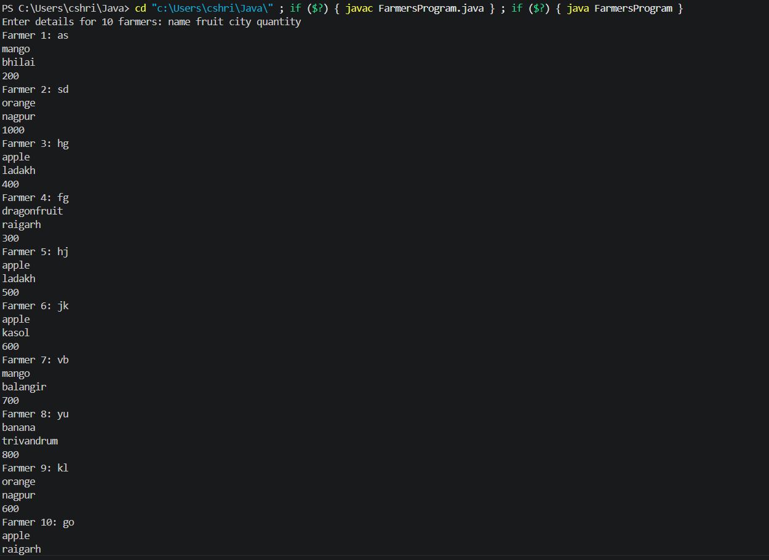

- Write a program to take quantity & quality of fruits Mango, Apple & Papaya as input. Quality may be good, bad or average. If entered quantity of fruit is greater than 1000, store it as half. Perform search for a given fruit with given quality.
- import java.util.*;
- public class FruitQualityProgram {
- static class Fruit {
- private final String name;
- private final String quality; // good, average, bad
- private final int quantity;

- Fruit(String name, int quantity, String quality) {
- this.name = name;
- this.quality = quality.toLowerCase();
- this.quantity = (quantity > 1000) ? quantity / 2 : quantity;
- }

- public String getName() { return name; }
- public String getQuality() { return quality; }
- public int getQuantity() { return quantity; }

- @Override
- public String toString() {
- return String.format("%-12s | %-7s | %6d", name, quality, quantity);
- }
- }

- public static void main(String[] args) {
- Scanner sc = new Scanner(System.in);
- String[] names = {"Mango", "Apple", "Banana", "Orange", "Dragonfruit"};
- List<Fruit> list = new ArrayList<>();

- System.out.println("Enter quantity and quality (good/average/bad) for each fruit.");
- for (String n : names) {
- System.out.printf("%s -> Quantity: ", n);
- int qty = readIntSafe(sc);
- sc.nextLine();

- System.out.printf("%s -> Quality: ", n);
- String quality = sc.nextLine().trim();
- while (!isValidQuality(quality)) {
- System.out.print("Invalid quality. Enter good, average, or bad: ");
- quality = sc.nextLine().trim();
- }
- list.add(new Fruit(n, qty, quality));
- }

- System.out.println("\nStored fruits:");
- System.out.println(String.format("%-12s | %-7s | %6s", "Fruit", "Quality", "Qty"));
- System.out.println("-------------------------------------");
- list.forEach(System.out::println);

- // Search (single query)
- System.out.print("\nSearch fruit name: ");
- String fname = sc.nextLine().trim();
- System.out.print("Search quality: ");
- String fquality = sc.nextLine().trim().toLowerCase();

- boolean found = false;
- for (Fruit f : list) {
- if (f.getName().equalsIgnoreCase(fname) && f.getQuality().equals(fquality)) {
- System.out.println("Match: " + f);
- found = true;
- }
- }
- if (!found) System.out.println("No matching fruit found.");
- sc.close();
- }

- private static boolean isValidQuality(String q) {
- if (q == null) return false;
- q = q.toLowerCase();
- return q.equals("good") || q.equals("average") || q.equals("bad");
- }

- private static int readIntSafe(Scanner sc) {
- while (true) {
- String line = sc.nextLine().trim();
- try {
- return Integer.parseInt(line);
- } catch (NumberFormatException e) {
- System.out.print("Invalid number. Enter integer: ");
- }
- }
- }
- }
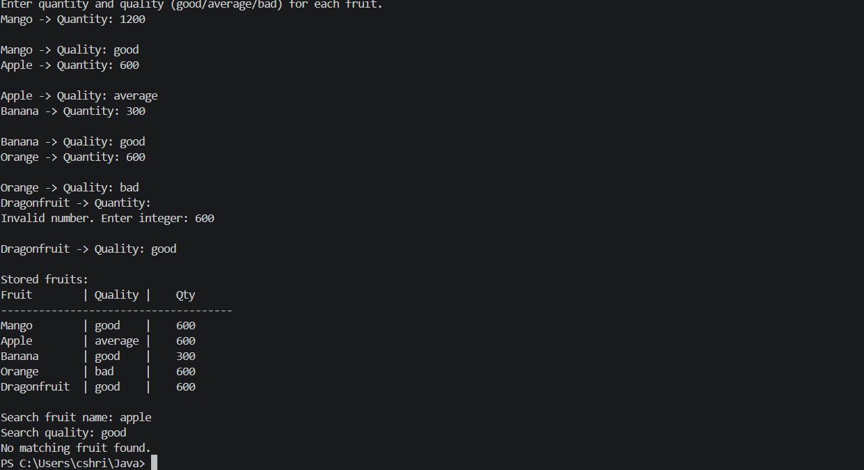
3. There are four orchards, namely A, B, C & D with fruits in them as Apple, Litchi, Mango, Apple, respectively. The qualities of the fruits in the orchards are good, good, good & bad respectively.
import java.util.*;
public class OrchardProgram {
static class Orchard {
final String id;
final String fruit;
final String quality;

Orchard(String id, String fruit, String quality) {
this.id = id;
this.fruit = fruit;
this.quality = quality;
}
}

private static final List<String> ALLOWED_FRUITS =
Arrays.asList("Mango", "Apple", "Banana", "Orange", "Dragonfruit");

public static void main(String[] args) {
Map<String, Orchard> orchards = new LinkedHashMap<>();
orchards.put("A", new Orchard("A", "Mango", "good"));
orchards.put("B", new Orchard("B", "Apple", "good"));
orchards.put("C", new Orchard("C", "Banana", "good"));
orchards.put("D", new Orchard("D", "Orange", "bad"));
orchards.put("E", new Orchard("E", "Dragonfruit", "average"));
orchards.put("F", new Orchard("F", "Mango", "average")); // duplicate fruit allowed

printTree(orchards);

Scanner sc = new Scanner(System.in);
String query = readFruitQuery(sc);
searchAndPrint(orchards, query);
sc.close();
}

private static void printTree(Map<String, Orchard> orchards) {
System.out.println("Orchards");
System.out.println("└─ Root");
for (Orchard o : orchards.values()) {
System.out.printf(" └─ Orchard %s: %s (%s)%n", o.id, o.fruit, o.quality);
}
}

private static String readFruitQuery(Scanner sc) {
System.out.println();
System.out.println("Searchable fruits: " + String.join(", ", ALLOWED_FRUITS));
System.out.print("Enter fruit to search: ");
while (true) {
String line = sc.nextLine();
if (line == null) line = "";
String trimmed = line.trim();
if (trimmed.isEmpty()) {
System.out.print("Please enter a fruit name: ");
continue;
}
String match = findAllowedFruit(trimmed);
if (match != null) return match;
System.out.print("Invalid fruit. Enter one of " + ALLOWED_FRUITS + ": ");
}
}

private static String findAllowedFruit(String input) {
for (String f : ALLOWED_FRUITS) {
if (f.equalsIgnoreCase(input)) return f;
}
return null;
}

private static void searchAndPrint(Map<String, Orchard> orchards, String fruit) {
System.out.println();
System.out.println("Search results for: " + fruit);
boolean found = false;
for (Orchard o : orchards.values()) {
if (o.fruit.equalsIgnoreCase(fruit)) {
System.out.printf("Orchard %s -> %s (%s)%n", o.id, o.fruit, o.quality);
found = true;
}
}
if (!found) System.out.println("No orchards contain " + fruit);
}
}

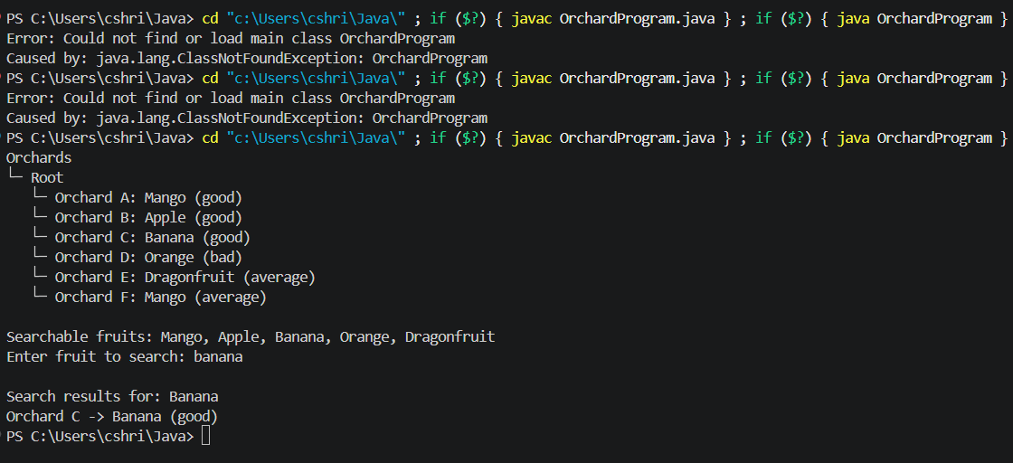

4. Take a map provided as a graph & display all the subtrees of connected points.
import java.util.*;
public class GraphComponentsFruits {
private Map<String, List<String>> adj = new HashMap<>();

public void addEdge(String u, String v) {
adj.computeIfAbsent(u, k -> new ArrayList<>()).add(v);
adj.computeIfAbsent(v, k -> new ArrayList<>()).add(u);
}

public List<List<String>> connectedComponents() {
Set<String> visited = new HashSet<>();
List<List<String>> components = new ArrayList<>();
// Ensure all five fruits exist in adjacency map even if isolated
List<String> allFruits = Arrays.asList("Mango", "Apple", "Banana", "Orange", "Dragonfruit");
for (String f : allFruits) adj.putIfAbsent(f, new ArrayList<>());

for (String node : adj.keySet()) {
if (!visited.contains(node)) {
List<String> comp = new ArrayList<>();
dfs(node, visited, comp);
components.add(comp);
}
}
return components;
}

private void dfs(String u, Set<String> visited, List<String> comp) {
visited.add(u);
comp.add(u);
for (String v : adj.getOrDefault(u, Collections.emptyList())) {
if (!visited.contains(v)) dfs(v, visited, comp);
}
}

public static void main(String[] args) {
Scanner sc = new Scanner(System.in);
GraphComponentsFruits g = new GraphComponentsFruits();

System.out.print("Enter number of edges: ");
int m = Integer.parseInt(sc.nextLine().trim());
System.out.println("Enter edges (fruit1 fruit2) one per line:");
for (int i = 0; i < m; i++) {
String line = sc.nextLine().trim();
if (line.isEmpty()) { i--; continue; }
String[] parts = line.split("\\s+");
if (parts.length < 2) { System.out.println("Invalid input, provide two fruit names."); i--; continue; }
g.addEdge(parts[0], parts[1]);
}

List<List<String>> comps = g.connectedComponents();
System.out.println("Connected components:");
int idx = 1;
for (List<String> c : comps) {
System.out.println("Component " + (idx++) + ": " + c);
}
sc.close();
}
}

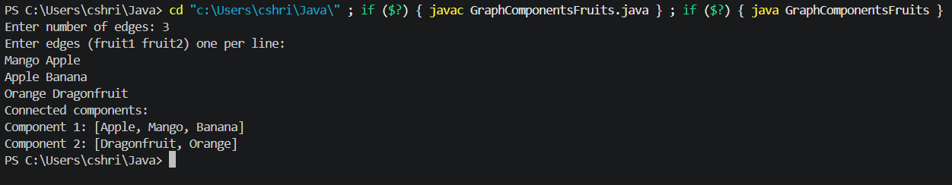

5. Enter entry point & goal point & produce the matching subtree of the graph.

import java.util.*;
public class GraphPathSubtreeFruits {
private Map<String, List<String>> adj = new HashMap<>();

public void addEdge(String u, String v) {
adj.computeIfAbsent(u, k -> new ArrayList<>()).add(v);
adj.computeIfAbsent(v, k -> new ArrayList<>()).add(u);
}

public List<String> findPath(String src, String dest) {
// Ensure all fruits exist
List<String> allFruits = Arrays.asList("Mango", "Apple", "Banana", "Orange", "Dragonfruit");
for (String f : allFruits) adj.putIfAbsent(f, new ArrayList<>());

if (!adj.containsKey(src) || !adj.containsKey(dest)) return null;
Queue<String> q = new LinkedList<>();
Map<String, String> parent = new HashMap<>();
q.add(src);
parent.put(src, null);
while (!q.isEmpty()) {
String u = q.poll();
if (u.equals(dest)) break;
for (String v : adj.getOrDefault(u, Collections.emptyList())) {
if (!parent.containsKey(v)) {
parent.put(v, u);
q.add(v);
}
}
}
if (!parent.containsKey(dest)) return null;
List<String> path = new ArrayList<>();
String cur = dest;
while (cur != null) {
path.add(cur);
cur = parent.get(cur);
}
Collections.reverse(path);
return path;
}

public static void main(String[] args) {
Scanner sc = new Scanner(System.in);
GraphPathSubtreeFruits g = new GraphPathSubtreeFruits();

System.out.print("Enter number of edges: ");
int m = Integer.parseInt(sc.nextLine().trim());
System.out.println("Enter edges (fruit1 fruit2):");
for (int i = 0; i < m; i++) {
String[] parts = sc.nextLine().trim().split("\\s+");
if (parts.length < 2) { System.out.println("Invalid input"); i--; continue; }
g.addEdge(parts[0], parts[1]);
}

System.out.print("Enter entry fruit: ");
String entry = sc.nextLine().trim();
System.out.print("Enter goal fruit: ");
String goal = sc.nextLine().trim();

List<String> path = g.findPath(entry, goal);
if (path == null) {
System.out.println("No path exists between " + entry + " and " + goal);
} else {
System.out.println("Path: " + path);
System.out.println("Subtree (edges on path):");
for (int i = 0; i < path.size() - 1; i++) {
System.out.println(path.get(i) + " - " + path.get(i + 1));
}
}
sc.close();
}
}

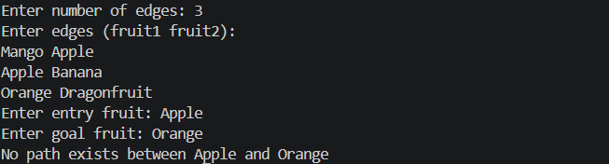

6. Give the weightage for each edge of nodes, and produce the shortest path from start to end node.

import java.util.*;
public class DijkstraFruits {
static class Edge {
String to;
int weight;
Edge(String to, int weight) { this.to = to; this.weight = weight; }
}

private Map<String, List<Edge>> adj = new HashMap<>();

public void addEdge(String u, String v, int w) {
adj.computeIfAbsent(u, k -> new ArrayList<>()).add(new Edge(v, w));
adj.computeIfAbsent(v, k -> new ArrayList<>()).add(new Edge(u, w)); // undirected
}

public Result dijkstra(String src, String dest) {
// Ensure all fruits exist
List<String> allFruits = Arrays.asList("Mango", "Apple", "Banana", "Orange", "Dragonfruit");
for (String f : allFruits) adj.putIfAbsent(f, new ArrayList<>());

if (!adj.containsKey(src) || !adj.containsKey(dest)) return null;
Map<String, Integer> dist = new HashMap<>();
Map<String, String> parent = new HashMap<>();
for (String node : adj.keySet()) dist.put(node, Integer.MAX_VALUE);
dist.put(src, 0);
parent.put(src, null);

PriorityQueue<String> pq = new PriorityQueue<>(Comparator.comparingInt(dist::get));
pq.add(src);

while (!pq.isEmpty()) {
String u = pq.poll();
int d = dist.get(u);
if (u.equals(dest)) break;
for (Edge e : adj.getOrDefault(u, Collections.emptyList())) {
int nd = d + e.weight;
if (nd < dist.getOrDefault(e.to, Integer.MAX_VALUE)) {
dist.put(e.to, nd);
parent.put(e.to, u);
pq.remove(e.to); // update priority
pq.add(e.to);
}
}
}

if (!parent.containsKey(dest)) return null;
List<String> path = new ArrayList<>();
String cur = dest;
while (cur != null) {
path.add(cur);
cur = parent.get(cur);
}
Collections.reverse(path);
return new Result(path, dist.get(dest));
}

static class Result {
List<String> path;
int totalWeight;
Result(List<String> path, int totalWeight) { this.path = path; this.totalWeight = totalWeight; }
}

public static void main(String[] args) {
Scanner sc = new Scanner(System.in);
DijkstraFruits g = new DijkstraFruits();

System.out.print("Enter number of weighted edges: ");
int m = Integer.parseInt(sc.nextLine().trim());
System.out.println("Enter edges (u v w) one per line:");
for (int i = 0; i < m; i++) {
String line = sc.nextLine().trim();
if (line.isEmpty()) { i--; continue; }
String[] parts = line.split("\\s+");
if (parts.length < 3) { System.out.println("Invalid input"); i--; continue; }
String u = parts[0], v = parts[1];
int w;
try {
w = Integer.parseInt(parts[2]);
} catch (NumberFormatException ex) {
System.out.println("Invalid weight; must be integer.");
i--; continue;
}
if (w < 0) {
System.out.println("Negative weight detected. Dijkstra cannot handle negative weights.");
return;
}
g.addEdge(u, v, w);
}

System.out.print("Enter start fruit: ");
String start = sc.nextLine().trim();
System.out.print("Enter end fruit: ");
String end = sc.nextLine().trim();

Result res = g.dijkstra(start, end);
if (res == null) {
System.out.println("No path found or nodes missing.");
} else {
System.out.println("Shortest path: " + res.path);
System.out.println("Total weight: " + res.totalWeight);
}
sc.close();
}
}

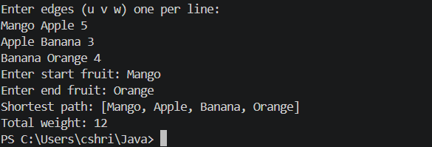

7. Write a program to demonstrate the use of all keywords made for exception handling.

import java.io.*;

// Demonstrates try, catch, finally, throw, throws, and a custom exception
public class ExceptionKeywordsDemo {

// Custom checked exception
static class MyCheckedException extends Exception {
MyCheckedException(String msg) {
super(msg);
}
}

public static void main(String[] args) {
// Example 1: try-catch-finally with an unchecked exception
try {
int a = 10 / 0; // ArithmeticException (unchecked)
} catch (ArithmeticException e) {
System.out.println("Caught ArithmeticException: " + e.getMessage());
} finally {
System.out.println("Finally block executed (cleanup).");
}

// Example 2: throw and throws with a custom checked exception
try {
methodThatThrows(true);
} catch (MyCheckedException e) {
System.out.println("Caught custom checked exception: " + e.getMessage());
}

// Example 3: throws IOException in method signature
try {
readFile("nonexistent.txt");
} catch (IOException e) {
System.out.println("Caught IOException from readFile: " + e.getMessage());
}
}

// Method declares it may throw MyCheckedException
static void methodThatThrows(boolean flag) throws MyCheckedException {
if (flag) {
throw new MyCheckedException("Something went wrong in methodThatThrows");
}
}

// Method declares it may throw IOException
static void readFile(String path) throws IOException {
try (BufferedReader br = new BufferedReader(new FileReader(path))) {
System.out.println("First line: " + br.readLine());
}
}
}

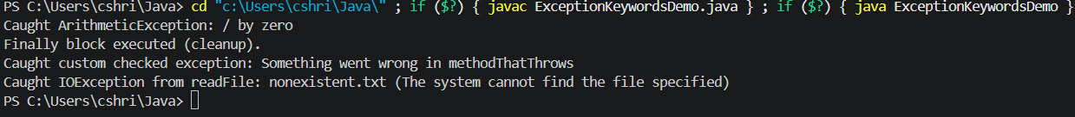

8. Write a program to withraw money from a bank account, if the withdrawn money is greater than the balance, then it throws NoMoneyException.

import java.util.*;
public class BankWithdrawal {
static class NoMoneyException extends Exception {
NoMoneyException(String msg) { super(msg); }
}

static class BankAccount {
private String owner;
private double balance;

BankAccount(String owner, double balance) {
this.owner = owner;
this.balance = balance;
}

public synchronized void deposit(double amt) {
if (amt > 0) balance += amt;
}

public synchronized void withdraw(double amt) throws NoMoneyException {
if (amt > balance) throw new NoMoneyException("Insufficient funds: requested " + amt + ", available " + balance);
balance -= amt;
System.out.println("Withdrawn " + amt + ". Remaining balance: " + balance);
}

public double getBalance() { return balance; }
}
public static void main(String[] args) {
BankAccount acc = new BankAccount("Shrishti", 1000.0);
Scanner sc = new Scanner(System.in);

System.out.print("Enter amount to withdraw: ");
double amt = sc.nextDouble();
try {
acc.withdraw(amt);
} catch (NoMoneyException e) {
System.out.println("Withdrawal failed: " + e.getMessage());
}

// Demonstrate successful withdrawal after deposit
System.out.println("Depositing 500...");
acc.deposit(500);
try {
acc.withdraw(200);
} catch (NoMoneyException e) {
System.out.println("Unexpected: " + e.getMessage());
}
sc.close();
}
}
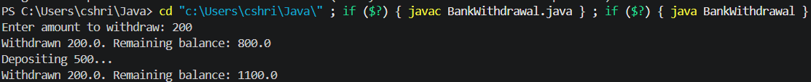

9. Write a program which enables to use a platform by a train one at a time.

public class TrainPlatformSimulation {
static class Platform {
private boolean occupied = false;

public synchronized void usePlatform(String trainName) {
while (occupied) {
try {
wait(); // wait until platform is free
} catch (InterruptedException e) {
Thread.currentThread().interrupt();
return;
}
}
occupied = true;
System.out.println(trainName + " acquired platform at " + System.currentTimeMillis());
try {
Thread.sleep(1000); // simulate time on platform
} catch (InterruptedException e) {
Thread.currentThread().interrupt();
} finally {
occupied = false;
System.out.println(trainName + " left platform at " + System.currentTimeMillis());
notify(); // wake one waiting train
}
}
}

static class Train extends Thread {
private Platform platform;
private String name;

Train(Platform platform, String name) {
this.platform = platform;
this.name = name;
}

@Override
public void run() {
platform.usePlatform(name);
}
}

public static void main(String[] args) throws InterruptedException {
Platform platform = new Platform();
Thread t1 = new Train(platform, "Train-1");
Thread t2 = new Train(platform, "Train-2");
Thread t3 = new Train(platform, "Train-3");

t1.start();
t2.start();
t3.start();

t1.join();
t2.join();
t3.join();
System.out.println("Simulation complete.");
}
}
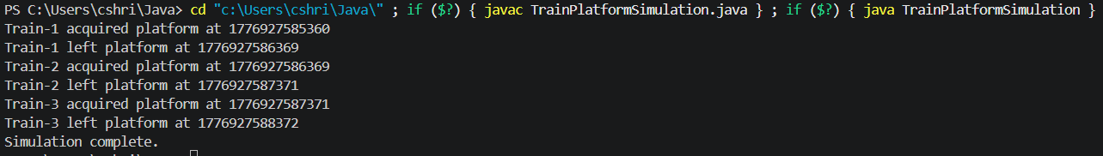

10. 10. Write a programme of Restaurant and Waiter, which accept order if kitchen if free and sheff deliver orders if he is free.

public class RestaurantSimulation {
static class Kitchen {
private String order = null;

public synchronized void placeOrder(String o) throws InterruptedException {
while (order != null) wait(); // kitchen busy
order = o;
System.out.println("Order placed: " + o);
notifyAll(); // notify chef
}

public synchronized String takeOrder() throws InterruptedException {
while (order == null) wait(); // no orders
String o = order;
order = null;
System.out.println("Chef took order: " + o);
notifyAll(); // notify waiters
return o;
}
}

static class Waiter extends Thread {
private Kitchen kitchen;
private String name;
private String dish;

Waiter(Kitchen kitchen, String name, String dish) {
this.kitchen = kitchen;
this.name = name;
this.dish = dish;
}

@Override
public void run() {
try {
kitchen.placeOrder(name + ":" + dish);
} catch (InterruptedException e) {
Thread.currentThread().interrupt();
}
}
}

static class Chef extends Thread {
private Kitchen kitchen;
private volatile boolean running = true;

Chef(Kitchen kitchen) { this.kitchen = kitchen; }

public void shutdown() { running = false; this.interrupt(); }

@Override
public void run() {
while (running) {
try {
String order = kitchen.takeOrder();
// simulate cooking
System.out.println("Chef preparing " + order);
Thread.sleep(800);
System.out.println("Chef delivered " + order);
} catch (InterruptedException e) {
if (!running) break;
Thread.currentThread().interrupt();
}
}
System.out.println("Chef stopped.");
}
}

public static void main(String[] args) throws InterruptedException {
Kitchen kitchen = new Kitchen();
Chef chef = new Chef(kitchen);
chef.start();

Waiter w1 = new Waiter(kitchen, "Waiter1", "Pasta");
Waiter w2 = new Waiter(kitchen, "Waiter2", "Pizza");
Waiter w3 = new Waiter(kitchen, "Waiter3", "Salad");

w1.start();
w2.start();
w3.start();

w1.join();
w2.join();
w3.join();

// Give chef time to finish
Thread.sleep(2000);
chef.shutdown();
chef.join();
System.out.println("Restaurant closed.");
}
}

