- Write a program to take a list of 10 farmers, fruits they sell, their cities & the quantity of fruits they have as input. Save the data to notepad before & after sorting based on quantity in tabular manner. Also perform search operation based on farmers' name.

import java.io.*;
import java.util.*;

public class firstcode {

static class Farmer {
private String name, city, fruit;
private int quantity;

public Farmer(String name, String city, String fruit, int quantity) {
this.name = name;
this.city = city;
this.fruit = fruit;
this.quantity = quantity;
}

public String getName() { return name; }
public String getCity() { return city; }
public String getFruit() { return fruit; }
public int getQuantity() { return quantity; }
}

// Display table
public static void displayTable(List<Farmer> farmers) {
System.out.printf("%-15s %-15s %-15s %-10s\n",
"Name", "City", "Fruit", "Quantity");
System.out.println("----------------------------------------------------------");

for (Farmer f : farmers) {
System.out.printf("%-15s %-15s %-15s %-10d\n",
f.getName(), f.getCity(), f.getFruit(), f.getQuantity());
}
}

// Write to file
public static void writeToFile(List<Farmer> farmers, String filename) {
try {
BufferedWriter writer = new BufferedWriter(new FileWriter(filename));

writer.write(String.format("%-15s %-15s %-15s %-10s\n",
"Name", "City", "Fruit", "Quantity"));
writer.write("----------------------------------------------------------\n");

for (Farmer f : farmers) {
writer.write(String.format("%-15s %-15s %-15s %-10d\n",
f.getName(), f.getCity(), f.getFruit(), f.getQuantity()));
}

writer.close();
} catch (IOException e) {
System.out.println("File error");
}
}

// SEARCH FUNCTION
public static void searchFarmer(List<Farmer> farmers, String name) {
boolean found = false;

System.out.println("\n--- SEARCH RESULT ---");
System.out.printf("%-15s %-15s %-15s %-10s\n",
"Name", "City", "Fruit", "Quantity");
System.out.println("----------------------------------------------------------");

for (Farmer f : farmers) {
if (f.getName().equalsIgnoreCase(name)) {
System.out.printf("%-15s %-15s %-15s %-10d\n",
f.getName(), f.getCity(), f.getFruit(), f.getQuantity());
found = true;
}
}

if (!found) {
System.out.println("Farmer not found");
}
}

public static void main(String[] args) {
Scanner sc = new Scanner(System.in);
List<Farmer> farmers = new ArrayList<>();

// Input
for (int i = 0; i < 10; i++) {
System.out.println("\nEnter details for Farmer " + (i + 1));

System.out.print("Name: ");
String name = sc.nextLine();

System.out.print("City: ");
String city = sc.nextLine();

System.out.print("Fruit: ");
String fruit = sc.nextLine();

System.out.print("Quantity: ");
int quantity = sc.nextInt();
sc.nextLine();

farmers.add(new Farmer(name, city, fruit, quantity));
}

// BEFORE SORTING
System.out.println("\n--- BEFORE SORTING ---");
displayTable(farmers);
writeToFile(farmers, "before_sort.txt");

// SORT BY QUANTITY
farmers.sort((f1, f2) -> f1.getQuantity() - f2.getQuantity());

// AFTER SORTING
System.out.println("\n--- AFTER SORTING ---");
displayTable(farmers);
writeToFile(farmers, "after_sort.txt");

// SEARCH
System.out.print("\nEnter farmer name to search: ");
String searchName = sc.nextLine();

searchFarmer(farmers, searchName);

sc.close();
}
}
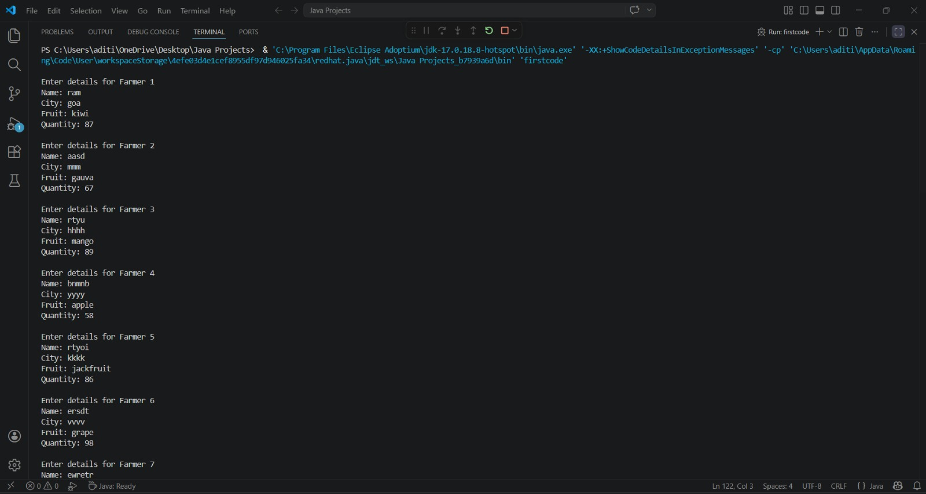
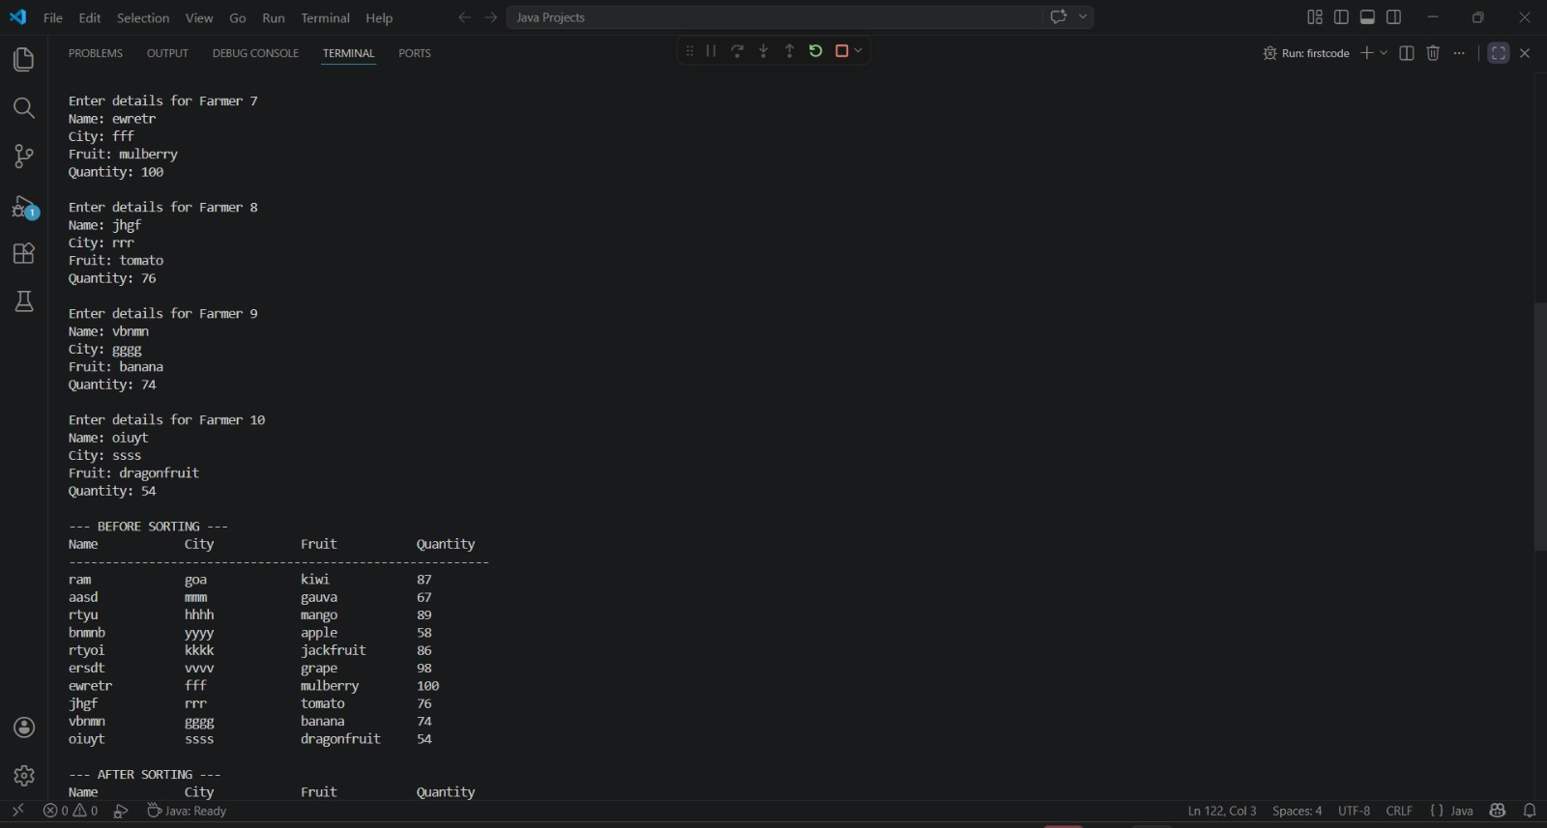

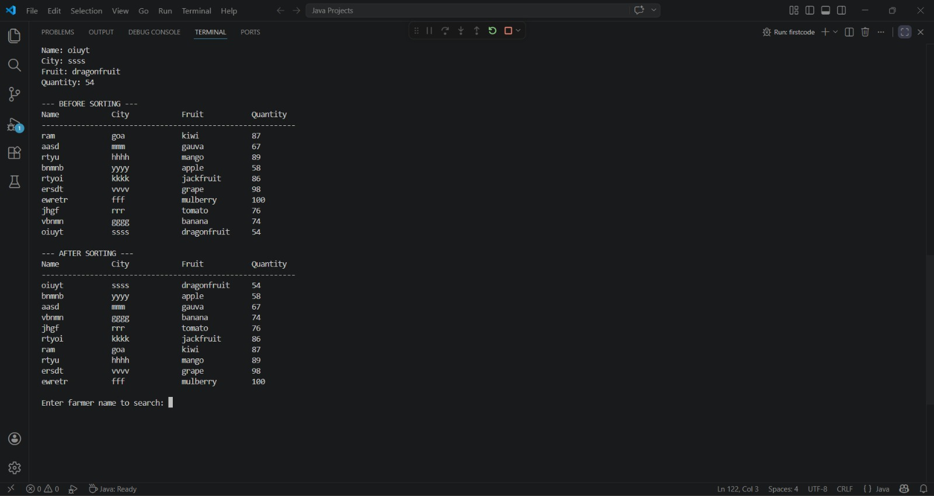

- Write a program to take quantity & quality of fruits Mango, Apple & Papaya as input. Quality may be good, bad or average. If entered quantity of fruit is greater than 1000, store it as half. Perform search for a given fruit with given quality.

import java.util.*;

// Fruit class with encapsulation
class Fruit {
private String name;
private int quantity;
private String quality;

// Constructor
public Fruit(String name, int quantity, String quality) {
this.name = name;
this.quality = quality;

// Rule: if quantity > 1000, store as half
if (quantity > 1000) {
this.quantity = quantity / 2;
} else {
this.quantity = quantity;
}
}

// Getters
public String getName() {
return name;
}

public int getQuantity() {
return quantity;
}

public String getQuality() {
return quality;
}

// Display method
@Override
public String toString() {
return String.format("%-10s %-8d %-10s", name, quantity, quality);
}
}

// Main class
public class FruitSearchApp {
public static void main(String[] args) {
Scanner sc = new Scanner(System.in);

// List to store fruits
List<Fruit> fruits = new ArrayList<>();

// Input for Mango, Apple, Papaya
System.out.println("Enter quantity and quality (good/bad/average) for Mango:");
fruits.add(new Fruit("Mango", sc.nextInt(), sc.next()));

System.out.println("Enter quantity and quality (good/bad/average) for Apple:");
fruits.add(new Fruit("Apple", sc.nextInt(), sc.next()));

System.out.println("Enter quantity and quality (good/bad/average) for Papaya:");
fruits.add(new Fruit("Papaya", sc.nextInt(), sc.next()));

// Display entered data
System.out.println("\nFruit Data:");
System.out.printf("%-10s %-8s %-10s\n", "Fruit", "Quantity", "Quality");
for (Fruit f : fruits) {
System.out.println(f);
}

// Search operation
System.out.println("\nEnter fruit name to search:");
String searchFruit = sc.next();
System.out.println("Enter quality to search:");
String searchQuality = sc.next();

boolean found = false;
for (Fruit f : fruits) {
if (f.getName().equalsIgnoreCase(searchFruit) &&
f.getQuality().equalsIgnoreCase(searchQuality)) {
System.out.println("Found: " + f);
found = true;
break;
}
}

if (!found) {
System.out.println("No match found!");
}

sc.close();
}
}

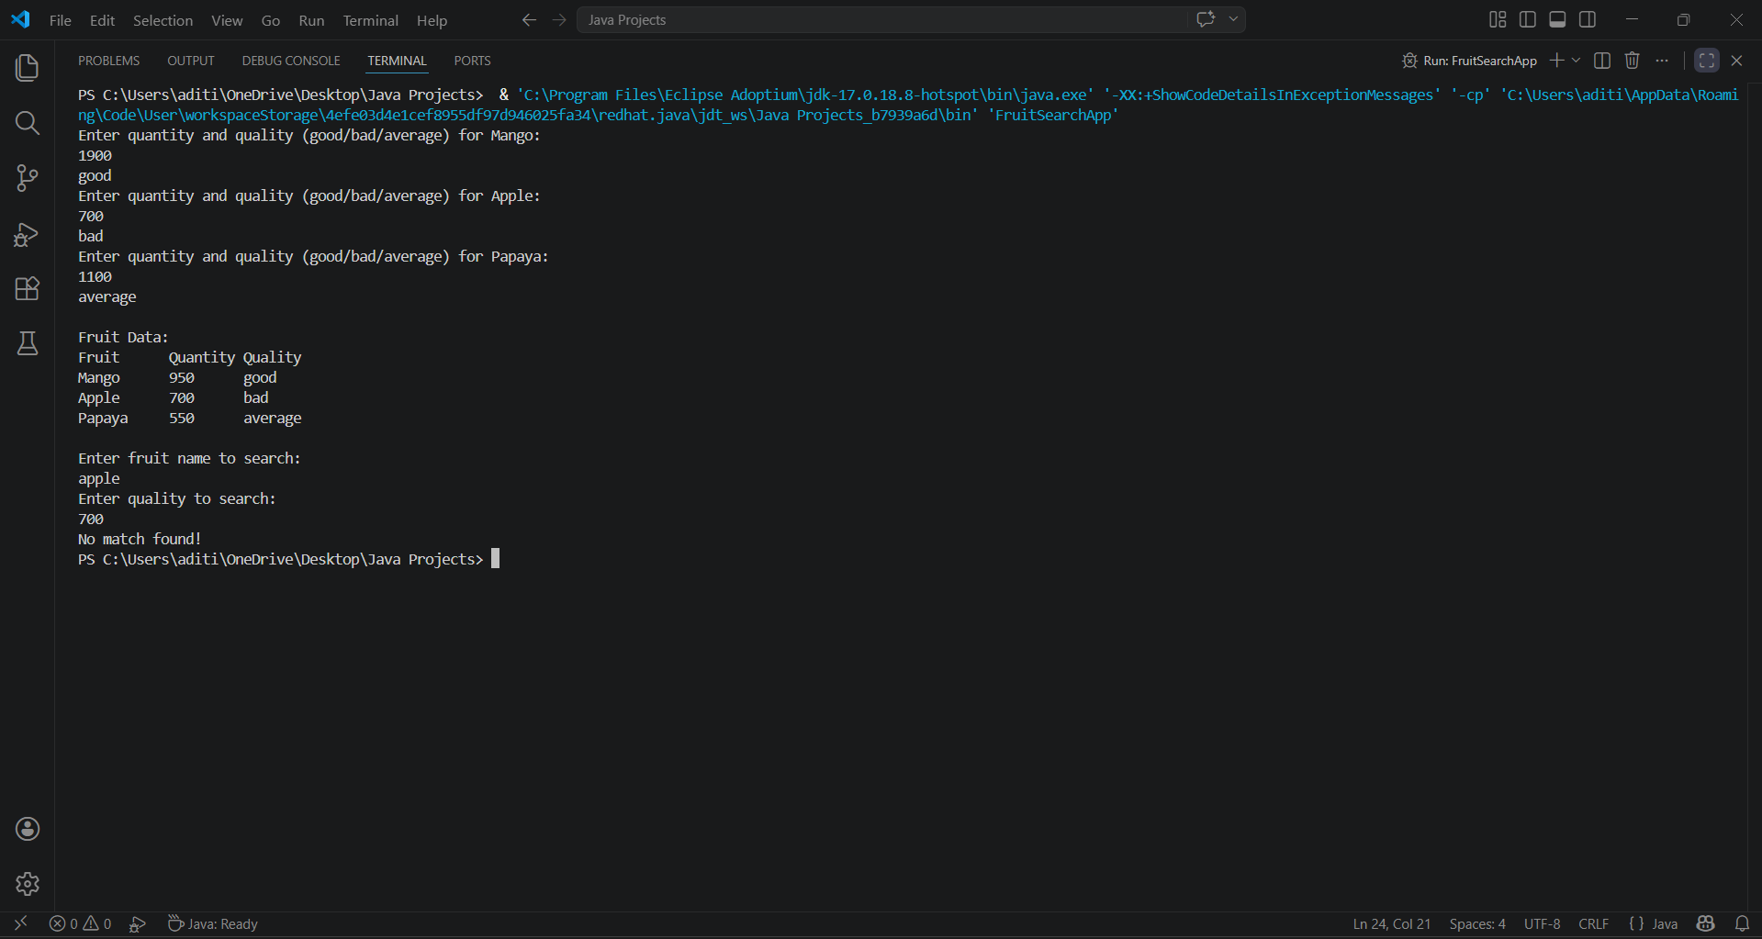

- There are four orchards, namely A, B, C & D with fruits in them as Apple, Litchi, Mango, Apple respectively. The qualities of the fruits in the orchards are good, good, good & bad respectively. The available orchards in a tree-view. Search for a given fruit in the available orchards after taking input from the user & print the tree.

import java.util.*;

// Orchard class
class Orchard {
private String name;
private String fruit;
private String quality;

public Orchard(String name, String fruit, String quality) {
this.name = name;
this.fruit = fruit;
this.quality = quality;
}

public String getName() {
return name;
}

public String getFruit() {
return fruit;
}

public String getQuality() {
return quality;
}

@Override
public String toString() {
return name + " → " + fruit + " (" + quality + ")";
}
}

// Main class
public class OrchardTreeApp {
public static void main(String[] args) {
Scanner sc = new Scanner(System.in);

// Create orchards
List<Orchard> orchards = new ArrayList<>();
orchards.add(new Orchard("A", "Apple", "Good"));
orchards.add(new Orchard("B", "Litchi", "Good"));
orchards.add(new Orchard("C", "Mango", "Good"));
orchards.add(new Orchard("D", "Apple", "Bad"));

// Display orchards in tree view
System.out.println(" Available Orchards (Tree View):");
System.out.println("Root");
for (Orchard o : orchards) {
System.out.println(" └── " + o);
}

// Search operation
System.out.print("\nEnter fruit name to search: ");
String searchFruit = sc.nextLine();

boolean found = false;
System.out.println("\nSearch Results:");
for (Orchard o : orchards) {
if (o.getFruit().equalsIgnoreCase(searchFruit)) {
System.out.println("Found in Orchard " + o.getName() + ": " + o.getFruit() + " (" + o.getQuality() + ")");
found = true;
}
}

if (!found) {
System.out.println("Fruit not found in any orchard!");
}

sc.close();
}
}

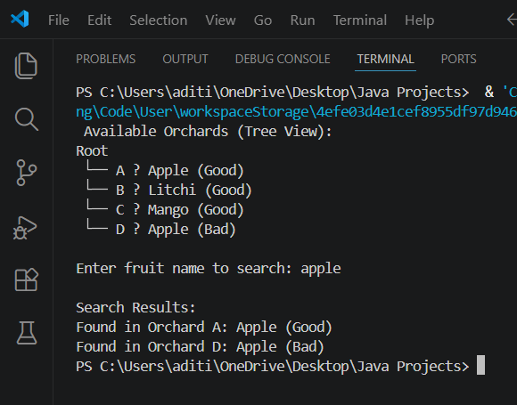

- Take a map provided as a graph & display all the subtrees of connected points.
import java.util.*;

class Graph {
private Map<Integer, List<Integer>> adjList;

public Graph(int vertices) {
adjList = new HashMap<>();
for (int i = 0; i < vertices; i++) {
adjList.put(i, new ArrayList<>());
}
}

public void addEdge(int src, int dest) {
adjList.get(src).add(dest);
adjList.get(dest).add(src); // undirected graph
}

public void displaySubtrees() {
Set<Integer> visited = new HashSet<>();
for (int node : adjList.keySet()) {
if (!visited.contains(node)) {
System.out.println("Subtree starting at node " + node + ":");
dfs(node, visited, 0);
System.out.println();
}
}
}

private void dfs(int node, Set<Integer> visited, int depth) {
visited.add(node);
// indentation for tree-like view
for (int i = 0; i < depth; i++) {
System.out.print(" ");
}
System.out.println("- " + node);

for (int neighbor : adjList.get(node)) {
if (!visited.contains(neighbor)) {
dfs(neighbor, visited, depth + 1);
}
}
}
}

public class GraphSubtrees {
public static void main(String[] args) {
Scanner sc = new Scanner(System.in);

System.out.print("Enter number of points (vertices): ");
int vertices = sc.nextInt();

Graph graph = new Graph(vertices);

System.out.print("Enter number of connections (edges): ");
int edges = sc.nextInt();

System.out.println("Enter each connection as: src dest");
for (int i = 0; i < edges; i++) {
int src = sc.nextInt();
int dest = sc.nextInt();
graph.addEdge(src, dest);
}

System.out.println("\nDisplaying all subtrees of connected points:");
graph.displaySubtrees();

sc.close();
}
}

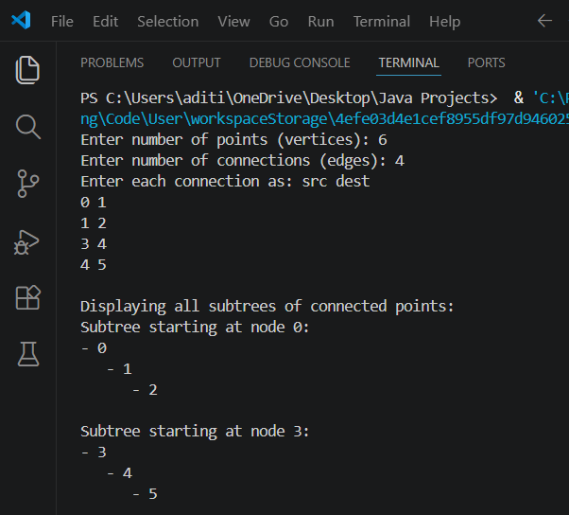

- Enter entry point & goal point & produce the matching subtree of the graph.

import java.util.*;

class Graph {
private Map<Integer, List<Integer>> adjList;

public Graph(int vertices) {
adjList = new HashMap<>();
for (int i = 0; i < vertices; i++) {
adjList.put(i, new ArrayList<>());
}
}

public void addEdge(int src, int dest) {
adjList.get(src).add(dest);
adjList.get(dest).add(src); // undirected graph
}

// Find path between entry and goal using DFS
public List<Integer> findPath(int entry, int goal) {
Set<Integer> visited = new HashSet<>();
List<Integer> path = new ArrayList<>();
if (dfs(entry, goal, visited, path)) {
return path;
}
return Collections.emptyList(); // no path found
}

private boolean dfs(int current, int goal, Set<Integer> visited, List<Integer> path) {
visited.add(current);
path.add(current);

if (current == goal) {
return true;
}

for (int neighbor : adjList.get(current)) {
if (!visited.contains(neighbor)) {
if (dfs(neighbor, goal, visited, path)) {
return true;
}
}
}

path.remove(path.size() - 1); // backtrack
return false;
}

// Display path in tree-like format
public void displayPath(List<Integer> path) {
if (path.isEmpty()) {
System.out.println("No path found between entry and goal.");
return;
}
System.out.println("Matching subtree path:");
for (int i = 0; i < path.size(); i++) {
for (int j = 0; j < i; j++) {
System.out.print(" "); // indentation
}
System.out.println("- " + path.get(i));
}
}
}

public class GraphPath {
public static void main(String[] args) {
Scanner sc = new Scanner(System.in);

System.out.print("Enter number of points (vertices): ");
int vertices = sc.nextInt();

Graph graph = new Graph(vertices);

System.out.print("Enter number of connections (edges): ");
int edges = sc.nextInt();

System.out.println("Enter each connection as: src dest");
for (int i = 0; i < edges; i++) {
int src = sc.nextInt();
int dest = sc.nextInt();
graph.addEdge(src, dest);
}

System.out.print("Enter entry point: ");
int entry = sc.nextInt();

System.out.print("Enter goal point: ");
int goal = sc.nextInt();

List<Integer> path = graph.findPath(entry, goal);
graph.displayPath(path);

sc.close();
}
}

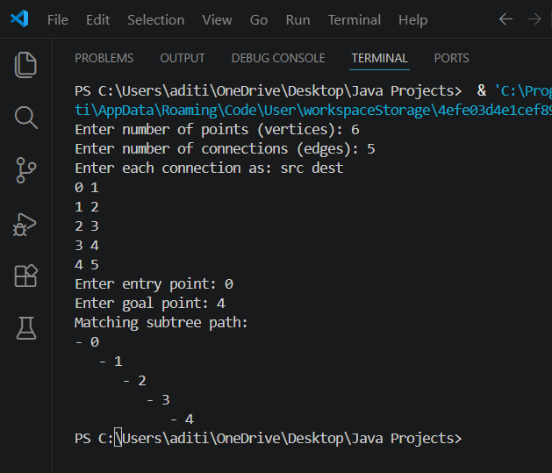

- Give the weightage for each edge of nodes, and produce the shortest path from start to end node.
import java.util.*;

class Graph {
private Map<Integer, List<Edge>> adjList;

public Graph(int vertices) {
adjList = new HashMap<>();
for (int i = 0; i < vertices; i++) {
adjList.put(i, new ArrayList<>());
}
}

public void addEdge(int src, int dest, int weight) {
adjList.get(src).add(new Edge(dest, weight));
adjList.get(dest).add(new Edge(src, weight)); // undirected graph
}

// Dijkstra’s Algorithm
public List<Integer> shortestPath(int start, int end) {
Map<Integer, Integer> dist = new HashMap<>();
Map<Integer, Integer> prev = new HashMap<>();
PriorityQueue<Node> pq = new PriorityQueue<>(Comparator.comparingInt(n -> n.distance));

for (int node : adjList.keySet()) {
dist.put(node, Integer.MAX_VALUE);
prev.put(node, -1);
}
dist.put(start, 0);
pq.add(new Node(start, 0));

while (!pq.isEmpty()) {
Node current = pq.poll();
int u = current.id;

if (u == end) break; // stop early if we reached the goal

for (Edge edge : adjList.get(u)) {
int v = edge.dest;
int newDist = dist.get(u) + edge.weight;
if (newDist < dist.get(v)) {
dist.put(v, newDist);
prev.put(v, u);
pq.add(new Node(v, newDist));
}
}
}

// reconstruct path
List<Integer> path = new ArrayList<>();
for (int at = end; at != -1; at = prev.get(at)) {
path.add(at);
}
Collections.reverse(path);

if (dist.get(end) == Integer.MAX_VALUE) {
return Collections.emptyList(); // no path found
}
return path;
}

public int getPathWeight(List<Integer> path) {
if (path.isEmpty()) return -1;
int total = 0;
for (int i = 0; i < path.size() - 1; i++) {
int u = path.get(i);
int v = path.get(i + 1);
for (Edge e : adjList.get(u)) {
if (e.dest == v) {
total += e.weight;
break;
}
}
}
return total;
}
}

class Edge {
int dest, weight;
public Edge(int dest, int weight) {
this.dest = dest;
this.weight = weight;
}
}

class Node {
int id, distance;
public Node(int id, int distance) {
this.id = id;
this.distance = distance;
}
}

public class ShortestPathGraph {
public static void main(String[] args) {
Scanner sc = new Scanner(System.in);

System.out.print("Enter number of points (vertices): ");
int vertices = sc.nextInt();

Graph graph = new Graph(vertices);

System.out.print("Enter number of connections (edges): ");
int edges = sc.nextInt();

System.out.println("Enter each connection as: src dest weight");
for (int i = 0; i < edges; i++) {
int src = sc.nextInt();
int dest = sc.nextInt();
int weight = sc.nextInt();
graph.addEdge(src, dest, weight);
}

System.out.print("Enter start node: ");
int start = sc.nextInt();

System.out.print("Enter end node: ");
int end = sc.nextInt();

List<Integer> path = graph.shortestPath(start, end);

if (path.isEmpty()) {
System.out.println("No path found between " + start + " and " + end);
} else {
System.out.println("Shortest path from " + start + " to " + end + ": " + path);
System.out.println("Total weight: " + graph.getPathWeight(path));
}

sc.close();
}
}

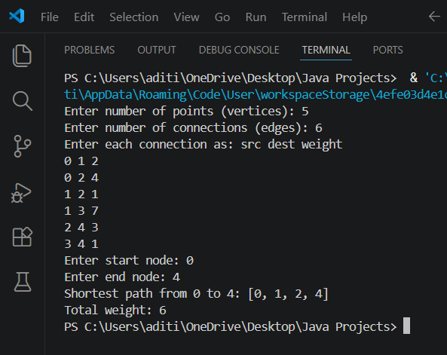

- Write a program to demonstrate the use of all keywords made for exception handling.
To demonstrate the use of all exception handling keywords:
- try
- catch
- finally
- throw
- throws

import java.util.*;
// Custom Exception class
class InvalidFruitException extends Exception {
public InvalidFruitException(String message) {
super(message);
}
}
// Fruit class
class Fruit {
private String name;
private int quantity;
public Fruit(String name, int quantity) throws InvalidFruitException {
if (quantity < 0) {
// Demonstrating 'throw'
throw new InvalidFruitException("Quantity cannot be negative!");
}
this.name = name;
this.quantity = quantity;
}
public String getName() {
return name;
}
public int getQuantity() {
return quantity;
}
}

// Main class
public class ExceptionDemo {
// Demonstrating 'throws'
public static Fruit createFruit(String name, int quantity) throws InvalidFruitException {
return new Fruit(name, quantity);
}

public static void main(String[] args) {
Scanner sc = new Scanner(System.in);

try {
// Demonstrating 'try'
System.out.print("Enter fruit name: ");
String name = sc.nextLine();

System.out.print("Enter fruit quantity: ");
int qty = sc.nextInt();

// Method may throw exception
Fruit f = createFruit(name, qty);

System.out.println("Fruit created: " + f.getName() + " with quantity " + f.getQuantity());

} catch (InvalidFruitException e) {
// Demonstrating 'catch'
System.out.println("Caught Exception: " + e.getMessage());

} catch (InputMismatchException e) {
System.out.println("Caught Exception: Invalid input type!");

} finally {
// Demonstrating 'finally'
System.out.println("Program execution finished. Closing resources...");
sc.close();
}
}
}
CASE 1: VALID INPUT
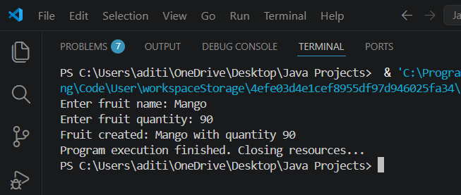
CASE 2: NEGATIVE QUANTITY
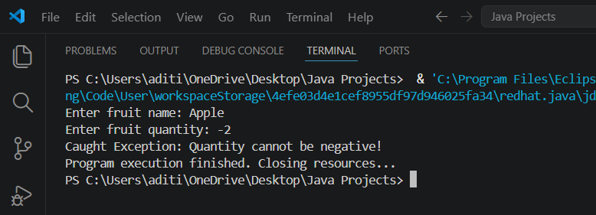

CASE 3: WRONG INPUT TYPE
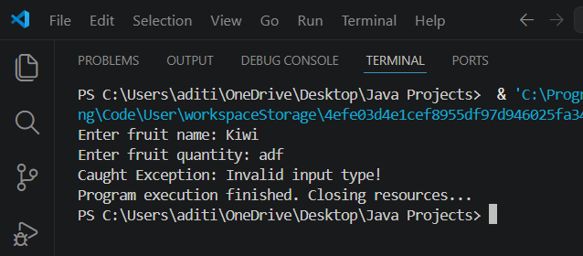

- Write a program to withraw money from a bank account, if the withdrawn money is greater than the balance, then it throws NoMoneyException.

import java.util.*;

// Custom Exception class
class NoMoneyException extends Exception {
public NoMoneyException(String message) {
super(message);
}
}

// BankAccount class
class BankAccount {
private int balance;

public BankAccount(int balance) {
this.balance = balance;
}

public int getBalance() {
return balance;
}

// Withdraw method with exception handling
public void withdraw(int amount) throws NoMoneyException {
if (amount > balance) {
// Demonstrating 'throw'
throw new NoMoneyException("Withdrawal failed! Not enough balance.");
} else {
balance -= amount;
System.out.println("Withdrawal successful! Remaining balance: " + balance);
}
}
}

// Main class
public class BankApp {
// Demonstrating 'throws'
public static void main(String[] args) throws NoMoneyException {
Scanner sc = new Scanner(System.in);

System.out.print("Enter initial balance: ");
int initialBalance = sc.nextInt();

BankAccount account = new BankAccount(initialBalance);

System.out.print("Enter amount to withdraw: ");
int amount = sc.nextInt();

try {
// Demonstrating 'try'
account.withdraw(amount);
} catch (NoMoneyException e) {
// Demonstrating 'catch'
System.out.println("Caught Exception: " + e.getMessage());
} finally {
// Demonstrating 'finally'
System.out.println("Transaction complete. Current balance: " + account.getBalance());
sc.close();
}
}
}
Case 1: Enough Balance
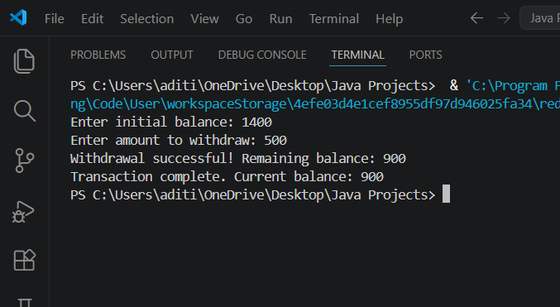
Case 2: Insufficient Balance
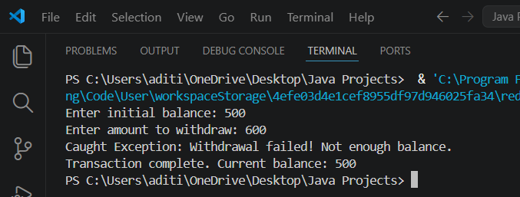
- Write a program which enables to use a platform by a train one at a time.

// Custom Exception if platform is occupied
class PlatformOccupiedException extends Exception {
public PlatformOccupiedException(String message) {
super(message);
}
}

// Platform class
class Platform {
private boolean occupied = false;

// synchronized ensures only one train can access at a time
public synchronized void usePlatform(String trainName) throws PlatformOccupiedException {
if (occupied) {
throw new PlatformOccupiedException("Platform is already occupied! " + trainName + " must wait.");
}
occupied = true;
System.out.println(trainName + " is using the platform...");
}

public synchronized void leavePlatform(String trainName) {
occupied = false;
System.out.println(trainName + " has left the platform. Platform is now free.");
}
}

// Train class
class Train extends Thread {
private String trainName;
private Platform platform;

public Train(String trainName, Platform platform) {
this.trainName = trainName;
this.platform = platform;
}

@Override
public void run() {
try {
platform.usePlatform(trainName);
// Simulate train staying on platform
Thread.sleep(2000);
platform.leavePlatform(trainName);
} catch (PlatformOccupiedException e) {
System.out.println("Exception: " + e.getMessage());
} catch (InterruptedException e) {
System.out.println(trainName + " was interrupted.");
}
}
}

// Main class
public class RailwayApp {
public static void main(String[] args) {
Platform platform = new Platform();

// Create multiple trains
Train t1 = new Train("Train A", platform);
Train t2 = new Train("Train B", platform);
Train t3 = new Train("Train C", platform);

// Start trains
t1.start();
t2.start();
t3.start();
}
}
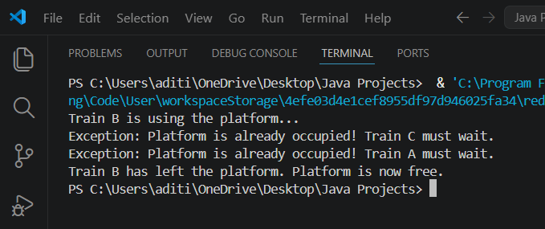

- Write a programme of Restaurant and Waiter, which accept order if kitchen if free and sheff deliver orders if he is free.

// Custom Exception if kitchen is busy
class KitchenBusyException extends Exception {
public KitchenBusyException(String message) {
super(message);
}
}

// Kitchen class
class Kitchen {
private boolean occupied = false;

// synchronized ensures only one order at a time
public synchronized void acceptOrder(String waiterName, String order) throws KitchenBusyException {
if (occupied) {
throw new KitchenBusyException("Kitchen is busy! " + waiterName + " must wait.");
}
occupied = true;
System.out.println(waiterName + " placed order: " + order);
}

public synchronized void deliverOrder(String chefName, String order) {
System.out.println(chefName + " delivered order: " + order);
occupied = false;
}
}

// Waiter class
class Waiter extends Thread {
private String waiterName;
private Kitchen kitchen;
private String order;

public Waiter(String waiterName, Kitchen kitchen, String order) {
this.waiterName = waiterName;
this.kitchen = kitchen;
this.order = order;
}

@Override
public void run() {
try {
kitchen.acceptOrder(waiterName, order);
// Simulate time before chef delivers
Thread.sleep(1000);
kitchen.deliverOrder("Chef", order);
} catch (KitchenBusyException e) {
System.out.println("Exception: " + e.getMessage());
} catch (InterruptedException e) {
System.out.println(waiterName + " was interrupted.");
}
}
}

// Main class
public class RestaurantApp {
public static void main(String[] args) {
Kitchen kitchen = new Kitchen();

// Multiple waiters trying to place orders
Waiter w1 = new Waiter("Waiter A", kitchen, "Pizza");
Waiter w2 = new Waiter("Waiter B", kitchen, "Pasta");
Waiter w3 = new Waiter("Waiter C", kitchen, "Burger");

// Start threads
w1.start();
w2.start();
w3.start();
}
}

