Air Quality Index (AQI) Analysis Across Major Cities Python Data Analysis Project Report
1. Introduction
Air pollution is a major environmental challenge for urban populations. The Air Quality Index (AQI) is a common measure used to indicate and share air pollution levels. This project examines AQI data from various cities using Python. The goals are to: - Combine AQI datasets from different cities - Clean and prepare the data - Perform exploratory data analysis (EDA) - Identify trends and patterns over time - Compare air quality across cities.
2. Objectives
The main objectives of this project are: - To gather AQI data from multiple CSV files - To clean and prepare raw air quality data - To analyze AQI distribution and trends over time - To compare pollution levels between cities - To derive insights from statistical and visual analysis.
3. Tools & Technologies Used
Programming Language: Python Libraries Used: - pandas, for data manipulation and cleaning - matplotlib, for data visualization - seaborn, for statistical visualization - os, for file handling.
4. Data Collection & Integration
Multiple .csv files with AQI data were loaded dynamically. Each file contained AQI data for one city. The city name was taken from the file name and added as a new column. All datasets were combined into a single DataFrame using pd.concat(). This created a unified dataset for comparisons between cities.
5. Data Cleaning & Preprocessing
The following data preparation steps were taken:
5.1 Removing Unnecessary Columns
- Columns labeled as Unnamed were removed.
5.2 Date Formatting
- The Date column was reformatted into proper datetime format.
- Year and Month columns were extracted for trend analysis.
combined_df["Year"] = combined_df["Date"].dt.year
combined_df["Month"] = combined_df["Date"].dt.month
5.3 Handling Missing Values
- Rows with missing AQI values were dropped.
- Missing value checks were done using:
combined_df.isnull().sum()
5.4 Final Dataset
- The cleaned and structured dataset is ready for analysis.
- It contains AQI, Date, City, Year, and Month information.
6. Exploratory Data Analysis (EDA)
6.1 Statistical Summary
Descriptive statistics were created using:
combined_df.describe()
This provided: - Mean AQI, Standard deviation, Minimum and maximum AQI values, Quartiles
6.2 AQI Distribution
A histogram was created to show AQI frequency distribution.
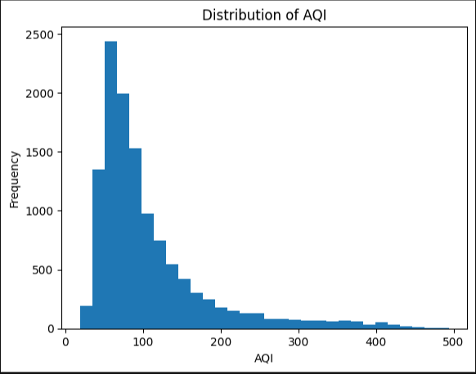
Key Observations: - AQI values vary across cities, the distribution shows days with moderate to high pollution, some extreme values indicate severe pollution events.
6.3 AQI Trend Over Time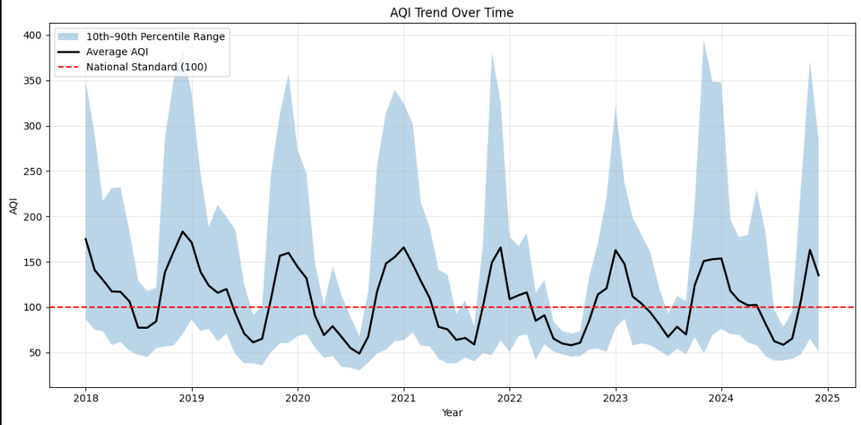
A monthly trend analysis was conducted. Monthly average AQI was plotted over time. The region from the 10th to 90th percentile showed variability. A reference line for the national AQI standard (100) was added for comparison. Key Observations: Clear seasonal patterns were noted. - Some months had higher AQI peaks, likely in winter. Many times exceeded the standard AQI limit of 100. Pollution levels varied but showed regular seasonal trends.
6.4 City-wise AQI Comparison
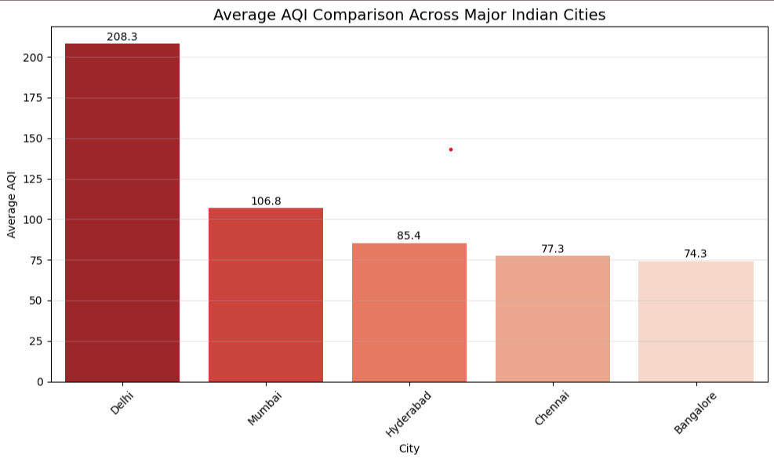
Average AQI per city was calculated:
city_avg = combined_df.groupby("City")["AQI"].mean()
A bar chart was created for comparison.
Key Insights:
- Delhi has the highest AQI (208.3), showing severe pollution.
- Mumbai is moderate (106.8), while Hyderabad, Chennai, and Bangalore have lower AQI.Southern cities have better air quality compared to Delhi. 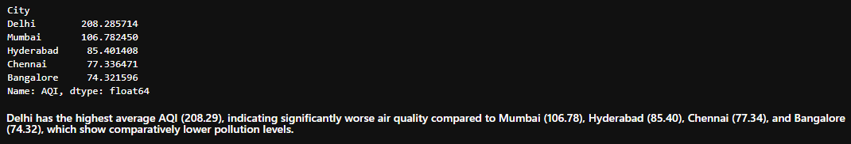
7. Key Findings
- AQI levels differ significantly between cities.
- Seasonal patterns are evident in monthly trends.
- Many cities often exceed the safe AQI limit of 100.
- There is high variability in air quality indicated by the 10th to 90th percentile range. Some cities are consistently more polluted than others.
8. Conclusion
This project effectively analyzed AQI data across various cities using Python.
The study revealed strong seasonal pollution trends, significant differences in air quality among cities, and frequent violations of national AQI standards. The analysis underscores the need for monitoring air quality and implementing focused environmental policies for cities at high risk.

9. Limitations
- Only AQI values were analyzed, with no pollutant-level analysis included.
- External factors like weather, traffic, or industry were not taken into account.
- Data completeness is reliant on the source CSV files.
10. Future Scope
This project can be expanded by: Predicting AQI using machine learning models. Analyzing individual pollutants (PM2.5, PM10, NO₂, SO₂). Comparing AQI with weather data. Creating an interactive dashboard using Power BI or Streamlit. Conducting anomaly detection for extreme pollution events.
11. Project Outcome
- This project showcases strong skills in:
- Data cleaning and preparation
- Analyzing time trends
- Statistical interpretation
- Data visualization
- Integrating data from multiple files
- It reflects practical data analysis abilities in addressing real-world environmental issues.

