Lucid Gloves(x1) - LucidGloves: VR Haptic Gloves on a budget | Hackaday.io + Home · LucidVR/lucidgloves Wiki (github.com)
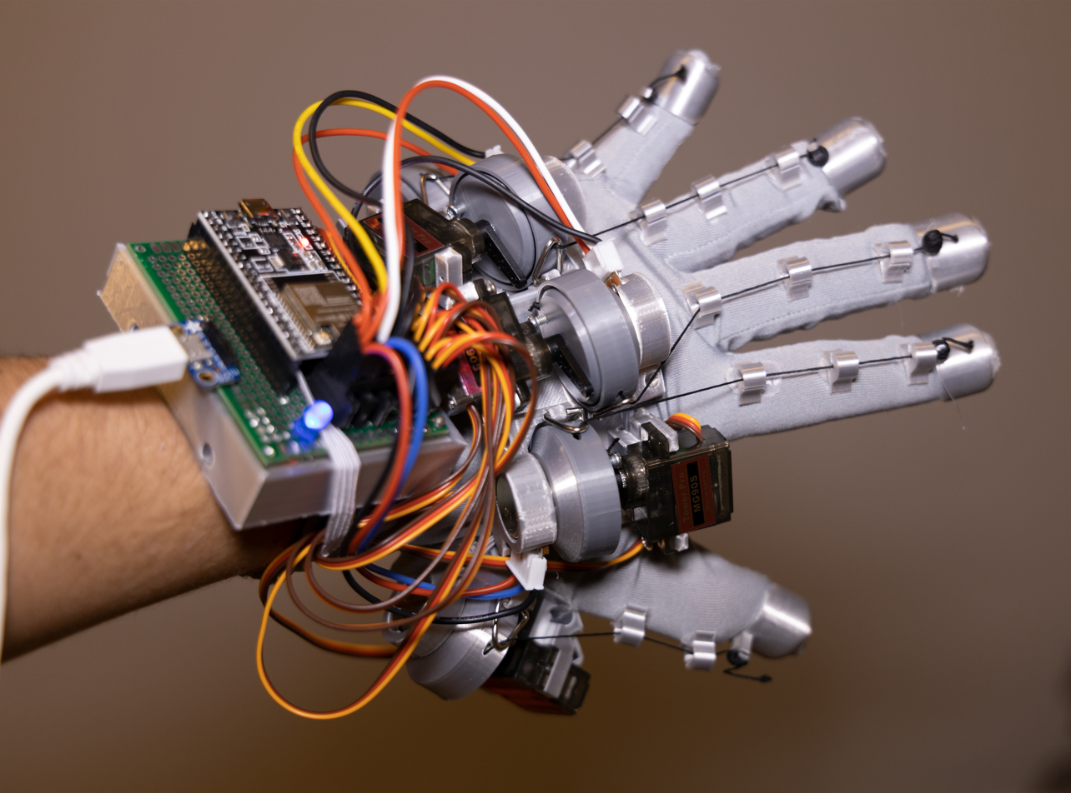

Parts Needed - Prototype 4 Parts List · LucidVR/lucidgloves Wiki (github.com)
Object | Needed | Site | Got
B10k ohm potentiometer | 5 | TWTADE 10Pcs Single Linear Rotary Seal Amplifier Potentiometers Type 10k Ohm Knurled Shaft 3Pin RK097N-3-10K: Amazon.com: Industrial & Scientific | We got 100K - Does Not Work with Original Glove Design  Need THESE
9g servo motors for haptics | 5 | https://www.amazon.com/dp/B0925V3X2S/?coliid=I31W7FVICO2OVB&colid=1X1QS7M1NI6DG&psc=1&ref_=list_c_wl_lv_ov_lig_dp_it | 5
ESP-WROOM-32 | 1 | https://www.amazon.com/KeeYees-Development-Bluetooth-Microcontroller-ESP-WROOM-32/dp/B07QCP2451/ref=sr_1_5 | 1
Cheap retractable badge reels | 5 | Amazon.com : 50 Pcs Retractable Badge Reel Clips Holder for Hanging ID Card Name Key Chain (Black) : Office Products | 50
Glove Material (Preferably Cycling or Golf) | 1 | Garden for Durability, Cycling/Medical for Movement | 1 (Garden)
Velcro Strap |  | https://www.amazon.com/Fastening-YiwerDer-Adjustable-Multi-Purpose-Organized/dp/B071DGMNMX/ref=sr_1_3?keywords=velcro%2Bstrap&s=industrial&sr=1-3&th=1 | Yes
5 pin JST-XH 2.54mm | *crimped or solder | Wires female and male based on wire diagram | We ended up just using Jumper Wires to connect to the board and duct tape to hold it together
WD-40, Foam, elastic (hot or super glue) |  | Can get from various areas at Pitt like the Creative Center in the University Store or Open Lab in Hillman | Foam Yes, WD-40 No
5v 2+ amps | 2 | https://www.amazon.com/dp/B094G1GL8T/ref=cm_sw_r_cp_api_glt_fabc_DW1G0CYTDMAXEMEMPS3Y?_encoding=UTF8&th=1 | NO. Powering with PC

3D Prints - lucidgloves/hardware at main · LucidVR/lucidgloves (github.com)
Details Recommeded According to Guide
- Shell thickness: 0.8mm (2 outlines)
- Layer height: 0.2mm
- Website claims you can have no supports (I don’t trust this…)
- Note that the more objects put on the overall time is reduced
Technically it would be best to make it in all Tough 2000 Resin or TPU (3D printer) and the EndCap in resin standard
We made everything PLA with EndCap in resin standard
Object | Needed | File | Time to Slice | Done | Other Notes: | RecommendMaterial
HapticSpool | 5 | lucidgloves/hardware/Prototype4.1/HapticSpool_Proto4.1.STL at main · LucidVR/lucidgloves (github.com) | 41min | 5 | 1 was snipped so if using the right potentiometer than remake 1 | Tough 2000 Resin
GuideNode | 9 | lucidgloves/hardware/Prototype4.1/GuideNode_upgraded.STL at main · LucidVR/lucidgloves (github.com) | 6min | 12* | *Need to add it with another heavy object. High chance of it falling off/tiliting by itself as it is too small and light.  *Recommend to build +3 as can easily break | Doesn’t Matter
Quest 2 MountSlider | 1 | lucidgloves/hardware/Prototype4/Quest2_MountSlider.STL at main · LucidVR/lucidgloves (github.com) | Rotate for 49 min | 1 |  | Tough Resin
RigidMount Right | 1 | lucidgloves/hardware/Prototype4/RigidMount_rightHand.STL at main · LucidVR/lucidgloves (github.com) | 1hr 49min | 1 |  | TPU
PotHolder (can remove bottom bit if needed) | 5 | https://github.com/LucidVR/lucidgloves/blob/main/hardware/Prototype4.1/GreenPotSildeHolder_Proto4.1.STL | 1hr 48min | 5 |  | Tough Resin
Green Tensioner | 5 | lucidgloves/hardware/Prototype4/Tensioner_GreenPot.STL at main · LucidVR/lucidgloves (github.com) | Rotate 24min | 4 |  | Tough Resin
Spool Cover | 5 | lucidgloves/hardware/Prototype4/SpoolCover_open.STL at main · LucidVR/lucidgloves (github.com) | Rotate 13min | 5 |  | Tough Resin/Doesn’t Matter
EndCap | 5 | lucidgloves/hardware/Prototype4/Prot4_EndCap.STL at main · LucidVR/lucidgloves (github.com) | Size based on glove | 0 - Tried 5 on resin but was too big | *Needs to be done in resin…  *Measure by Glove, not hand (Hand if the glove material is very strechty/elastic) | Standard Resin

Wiring - Prototype 4 Wiring Diagram · LucidVR/lucidgloves Wiki (github.com)
Pin Diagram for Programing
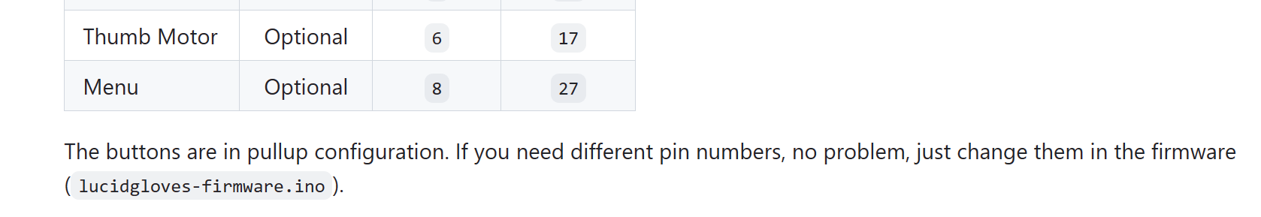
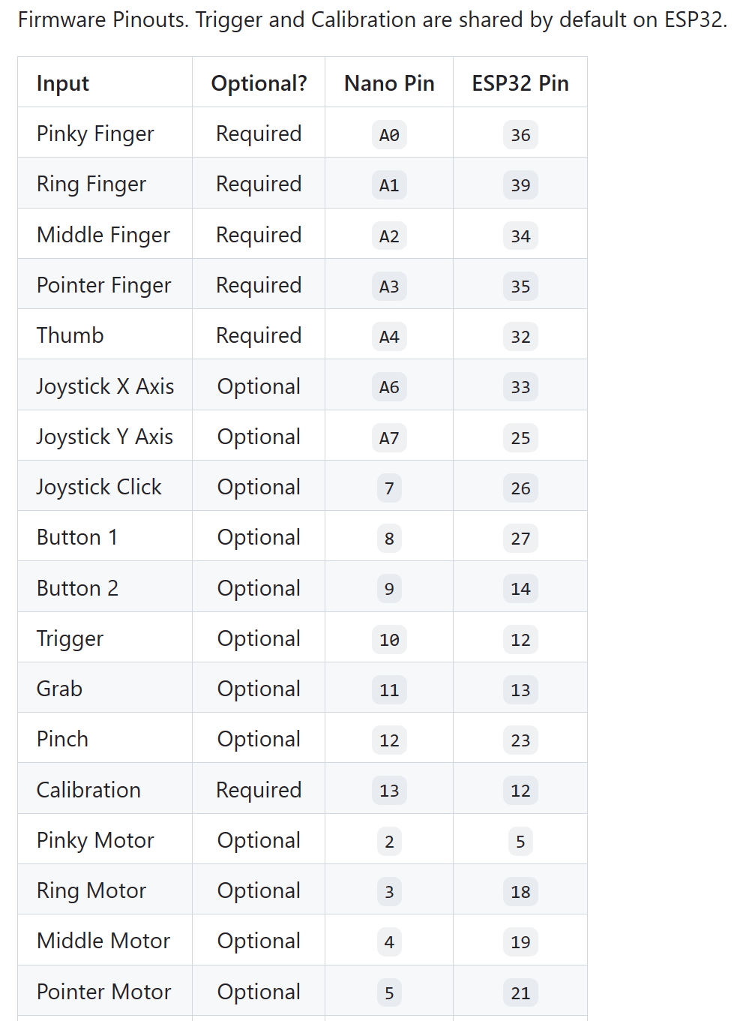

Wire Diagram for power and soldering
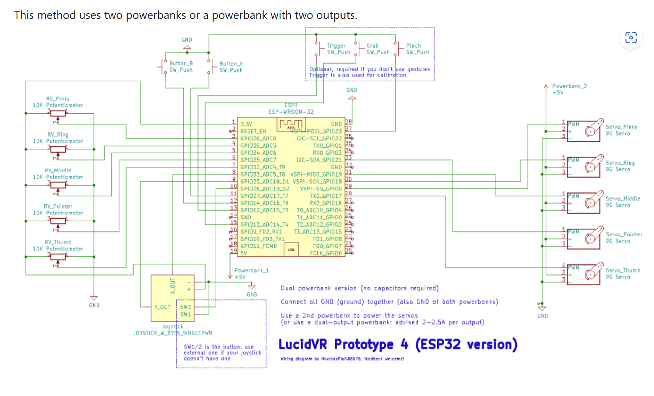
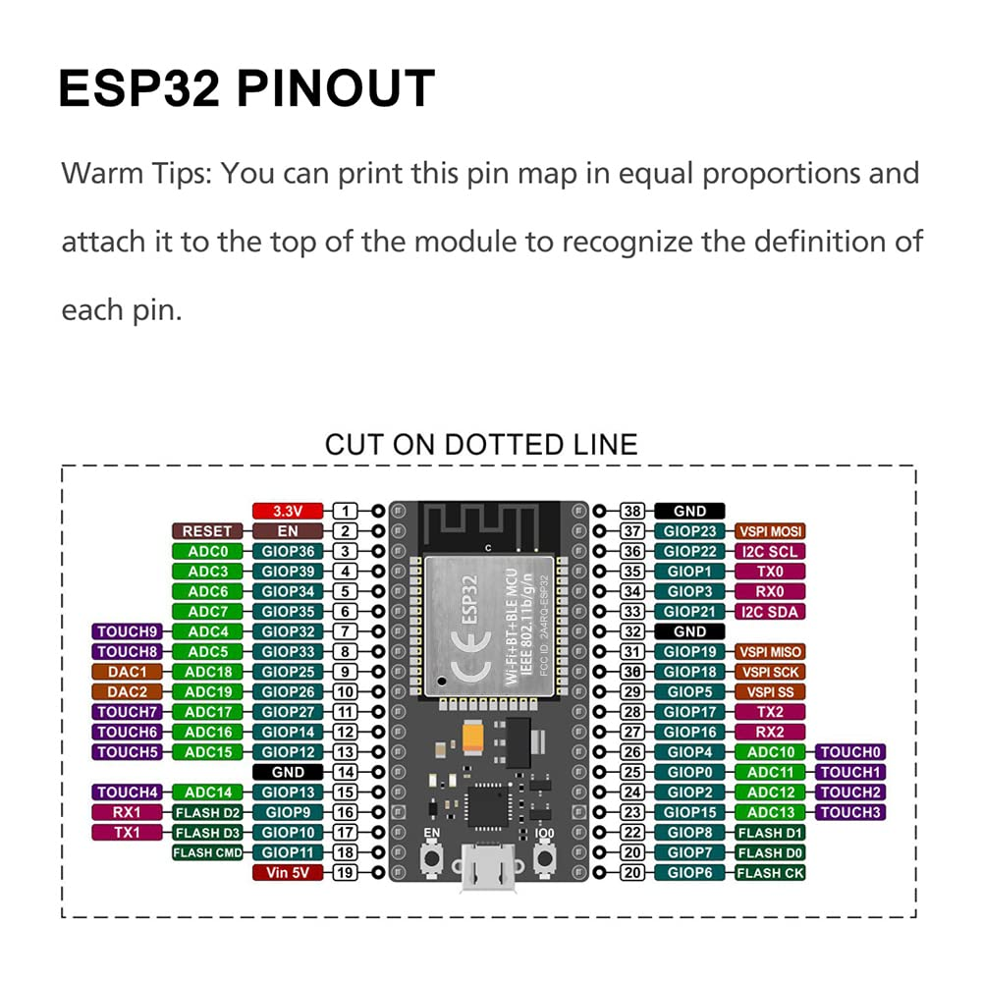

Building Tutorial Prototype 4 - How to build cheap VR Haptic Gloves to FEEL VR. - YouTube [Highly Recommend Following This!!!]
Assembling Spools - How I build CHEAP VR Gloves. - YouTube
Assembling Modules -
- Fit the potentiometer into the holder piece (the square hole for green pots or the round hole for WL pots)
- Use a pair of pliers to remove the metal loops from the badge reel ends, and then clamp them to the plastic loops on the holders
- Run the strings through these metal loops
Setting Up Rigid Mount
- Take your rigid mount piece and glue a layer of foam on the bottom
Optionally also use the two circular holes to add a loop of elastic (that will go in front of the thumb)
- Next, add a velcro strap between the two loops of the rigid mount. Trim it so that you can strap it on your hand nicely
- Once you have it mounted on your hand, you can now slide the modules onto the rigid mount
- You may need to slide some on backward, depending on the size of your hand, in order to get the string to come out at the right place
Gluing Nodes and Caps - How I build CHEAP VR Gloves. - YouTube (6:03-6:12)
Adding Haptics (Recommend Need Working Firmware)
- Once you have working finger tracking, you fit the servo motors into their respective slots on each assembly
- Use the single direction servo head and place it on the gear
- You will need to do some trial and error to find the right rotation of the servo head, but you can use the "extend/retract servos fully" buttons in the openglove UI to help you. You want to get it where your hand is fully limited open when the servos are extended, and not limited at all when the servos are retracted.

Firmware Setup - Firmware Setup and Customization Tutorial · LucidVR/lucidgloves Wiki (github.com)
You can see it here: https://youtu.be/Qj4hqRKiy8g?t=543 Note: this video was made on an older version of the firmware
This configuration is stored inside of lucidgloves-firmware.ino.
- DEBUG_LED - The pin on the board to be used for LED debugging.
- COMMUNICATION - Set this to your preferred communication protocol.
  - COMM_SERIAL - USB Serial Communication
  - COMM_BTSERIAL - Bluetooth Serial Communication
- LOOP_TIME - The time to be elapsed between loops, how many ms between data sends
- CALIBRATION_LOOPS - The number of loops that should occur until the glove stops calibrating. Set to -1 to always calibrate.
- SERIAL_BAUD_RATE - The baud rate of the serial communication. Only used if COMMUNICATION is COMM_SERIAL
- BTSERIAL_DEVICE_NAME - The name of the Bluetooth device advertized. Only used if COMMUNICATION is COMM_BTSERIAL
Recommended Pin Configuration
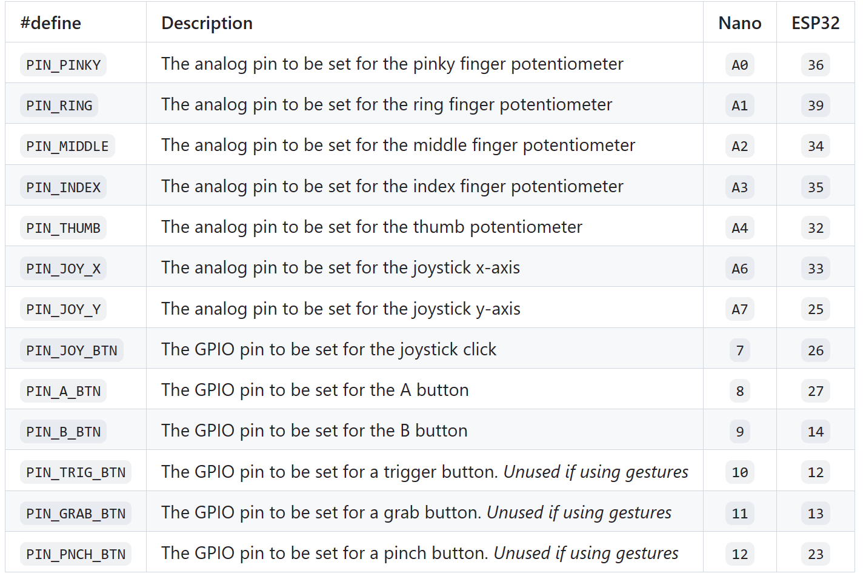

- ANALOG_MAX - The maximum analog value to be used. Depends on the ADC resolution.
  - Use 1023 for Arduino, 4095 for ESP32
- FLIP_POTS - Whether or not the finger potentiometer values need to be flipped.
- TRIGGER_GESTURE - Whether or not to recognize gestures for the trigger (closing your index finger)
- GRAB_GESTURE - Whether or not to recognize gestures for grab (closing your hand)
- PINCH_GESTURE - Whether or not to recognize gestures for pinch (pinching with thumb and index finger)
- JOYSTICK_BLANK - Set this to true if you don't have a joystick plugged in. Set false if you have a joystick.
- JOY_FLIP_X - Flip the x-axis values in the joystick
- JOY_FLIP_Y - Flip the y-axis values in the joystick
- NO_THUMB - If you have no thumb plugged in.
Adding Required ESP-32 Libraries
- Go to Silicon Labs' official driver download page
- Go to the downloads section and download the "CP210x Windows Drivers" (third in the list).
- Extract the .zip and run CP210xVCPInstaller_x64.exe.
- Your ESP32 should now show up in your devices manager under ports as Silicon Labs CP210x USB to UART Bridge (COM<number>). This is the port you should select in your IDE. If it doesn't show up, make sure you are using a data capable USB cable.
Adding ESP32Servo library for haptic servo control
- Go to Tools > Manage Libraries in Arduino IDE
- Search for ESP32Servo in the search bar
- Find the ESP32Servo library authored by Kevin Harrington, click 'More info...' and then Install

For Future Progress
Mechanical Process
- For the potentiometer
If using the given potentiometer…
- Resize the circle for Haptic Circle to be capable of covering the top of the given potentiometer than reprint (x4)
- Make an indent in the back of PotHolder to confiscate the flat end of the potentiometer (make sure the voltage and GND is able to be wired.
If using the correct potentiometer from website…
- Reprint one Haptic Circle to replace the one that was destroyed
- Be mindful of the holes in each part, printing on the 3D printed has a high chance of smaller or messed up holes (semi-thick string has to go through them!)
- If you want more reliable connections. Solder wires with multiple lines (mostly GND and voltage)
- Create a 3D print to hold circuit board/battery underneath glove/velcro
- Create EndCaps in Resin based on glove. Hint : Measure the length to velcro, width of the glove, and smaller in height
- You will need to attach the motors in the specified location in the gloves skeleton. You can find this when watching the video.

Software Process
- If using a 100K potentiometer…
- (These are the ones with the jumper wires connecting to the board.)
- If using intended potentiometer just follow the instructions of this video to set them up:
https://www.youtube.com/watch?v=2yF-SJcg3zQ&t=267s
- If you want to go down the haptic route…
- You will need to incorporate the motors by following the video instructions.

