|  |  |
| --- | --- |
|  | VibroAcustica Acoustics Laboratories  Joinville – SC, 89219-600, Brazil |
| +55 (47) 3440-1787 |
| Page 1 of 9 |

**LABORATORY TEST REPORT**

**BS EN ISO 10534-2: 2001. DETERMINATION OF SOUND ABSORPTION COEFFICIENT  
IN IMPEDANCE TUBES. TRANSFER-FUNCTION METHOD.**

|  |  |
| --- | --- |
| **CLIENT:** | Client |
| **PRODUCT(S):** |  |
| **TEST DATE:** | <built-in method today of type object at 0x00007FFEB28C0F40> |
|  |  |

|  |  |
| --- | --- |
| **TEST REPORT No.:** Test No | **DATE OF ISSUE:** <built-in method today of type object at 0x00007FFEB28C0F40> |

|  |  |
| --- | --- |
| **Signed:** | **Approved:** |
| Pessoa 1 Cargo 1 | Pessoa 2 Cargo2 |

**1. TEST SAMPLES AND CONDITIONS**

**1.1. Description of Test Samples**

Product Identification: {self.model.product_name}

Manufacturer: {self.model.manufacturer}

Description: {self.model.description}

Layers: {self.model.layers}

Sample Conditions: {self.model.sample_conditions}

Mounting: {self.model.mounting_description}

**1.2. Test Conditions**

Temperature: {self.model.temperature} °C

Humidity: {self.model.humidity} %

Pressure: {self.model.pressure} hPa

**2. MEASUREMENT DETAILS**

**2.1. Equipment**

* Equipment {item+1}: Serial {1000+item}
* Equipment {item+1}: Serial {1000+item}

**2.2. Procedure**

Sound absorption measurements were conducted according to the standard BS EN ISO 10534-2: 2001 using impedance tubes.

For this particular test, a B&K Type 4206 Impedance Tube was used (Figure 2). This   
 impedance tube is in accordance with BS EN ISO 10534-2 and consists of an adjustable signal   
 filter, a loudspeaker, a sound propagation tube, microphone holders, a large sample tube (100   
 mm diameter), and a small sample tube (29 mm diameter). Each sample tube contains an   
 adjustable plunger for positioning the test sample and creating air gaps behind it if desired.

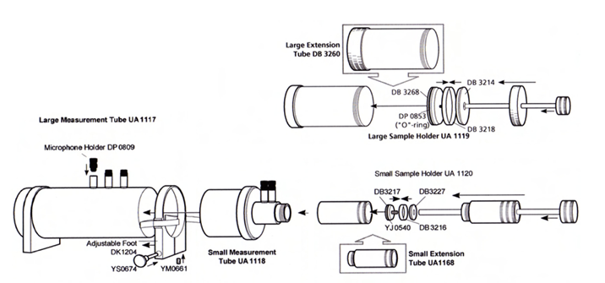

*Figure 1: B&K Type 4206 Impedance Tube Setup*

The test sample was mounted at   
 the end of the impedance tube by means of the sample holder, which is assumed to behave as   
 a rigid termination, with no gaps between the sample and the termination. The sample holder   
 was then mounted to the end of the tube and the microphones placed at measurement positions   
 following the characteristics described in Section 2.1 for samples with 29mm and 100mm   
 diameter. The impedance tube was mounted vertically on the wall, to allow the thin fabric to be   
 placed on top of the melamine foam surface. Finally, a broadband stationary random signal   
 was generated from B&K Pulse through a power amplifier and into the loudspeaker mounted   
 in the impedance tube.   
 For each one of the test samples, the normal incidence sound absorption coefficient was then   
 determined by decomposing the incident and reflected components of the sound field within   
 the tube, which were measured by the two separated microphones along the tube length. The   
 incident and reflected components of the sound pressure level, at the two microphone positions,   
 were then used to calculate three frequency response functions, from which the reflection and   
 absorption coefficients can be calculated.

A full list of the equipment used during the tests is presented in Table 1 below.

|  |  |
| --- | --- |
| **Equipment** | **Serial/Ref No.** |
| DewesoftX | 2477213 / PULSE N.2 |
| Impedance Tube Type 4206 | 2681869 |
| Desktop PC with Software and Peripheral Equipment | 21329 |
| Two ¼” Condenser Microphones Type 4187 | 2677390 & 2677391 |
| Power Amplifier | 129003364 |

*Table 1: List of equipment.*

**2.3. Calculations**

Absorption coefficient α is calculated from reflection coefficient R:

*α = 1 - |R|²*

R is derived from the measured transfer function H₁₂ of the two microphones.

**3. RESULTS**

|  |  |  |  |
| --- | --- | --- | --- |
| Frequency Hz | αₙ (tube Ø100 mm) | αₙ (tube Ø29 mm) | αₙ (combined) |
| 80 | 0.07 | - | 0.07 |
| 100 | 0.08 | - | 0.08 |
| 125 | 0.30 | 0.30 | 0.30 |
| 160 | 0.38 | 0.45 | 0.39 |
| 200 | 0.50 | 0.55 | 0.51 |

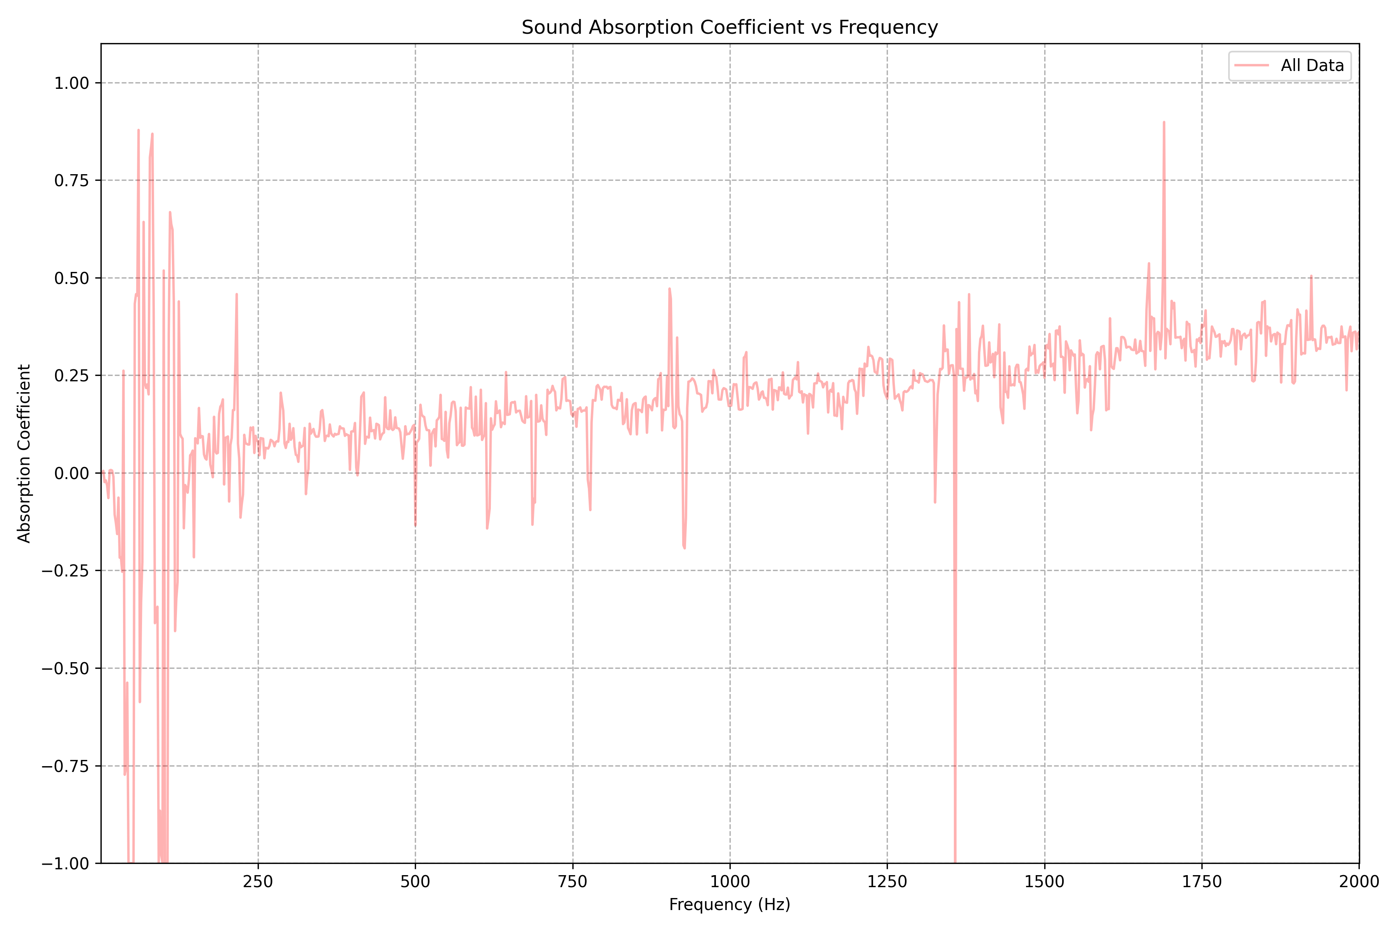

*Figure 1: Absorption Coeficent vs Frequency*