1

3



**INTRODUCTION**

* **This Library Management System project is for monitoring and controlling the transactions in a library.**
* **It mainly focuses on basic operations in a library like adding new members, new books, and updating new information, searching books and members and provides facility to borrow and return books.**
* **We can enter the record of new books and retrieve the details of books available in the library.**
* **We can issue the books to the students and maintain their records.**
* **Late fine is charged for students who return the issued books after the due date.**
* **Only one book is issued to students at a time.**
* **New Book is not issued to students who have not returned the last book.**

4

**Objective of Project**

* The objective of the project is to computerise the functions of the Library.
* Computerisation helps in better record keeping and management of the Library.
* This simplifies the work of the Librarian as he/she is able to keep a better check on which book is issued by which student.
* Newly arrived books can easily be added, and data about any book can easily be modified with the help of this project.
* Also, records can be transferred from one system to the other without any loss of information.

System Implementation

The Hardware Used :

While developing the software, the hardware used are :

PC with Intel Core 2 Duo processor having 2.00 GB RAM , 500 GB Hard Disk, SVGA and other required devices.

The Software Used :

* Microsoft Windows® 8 as Operating System.
* TurboC 7 v2.1 for coding.
* MS-Word 2010 for documentation.

**HEADER FILES USED**

#include<fstream.h>

#include<conio.h>

#include<stdio.h>

#include<process.h>

#include<string.h>

#include<iomanip.h>

CLASSES

1. **Class book**

**PRIVATE MEMBERS**

**Data members**

**bno : char type (6 characters)**

**bname : char type (50 characters)**

**aname : char type (20 characters)**

**PUBLIC MEMBERS**

**Functions**

**create_book() : to read bno, bname & aname and create book.**

**show_book() : to display details of the book when it is issued.**

**modify_book() : to modify the name & author of the**

**bookretbno() : to return bno**

**2) CLASS STUDENT**

**PRIVATE MEMBERS**

**Data members**

**Admno : char type (6 characters)**

**name : char type (20 characters)**

**stbno : char type (6 characters)**

**token : integer type**

**PUBLIC MEMBERS**

**Functions**

**create_student() : to create student record.**

**show_student() : to display a specific student record.**

**modify_student() : to modify student’s name.**

**retadmno() : to return admission no. of student.**

**retstbno() : to return the issued book no.**

**addtoken() : to store the value of token as 1 book is**

**issued.**

**resettoken() : to reset the value of token to 0 is book is returned.**

FUNCTIONS

1. **functions to write in file**

* **write_book()**
* **write_student()**

1. **functions to read specific record from file**

* **display_spb()**
* **display_sps()**

1. **function to modify record of file**

* **modify_book()**
* **modify_student()**

1. **function to delete record from file**

* **delete_student()**
* **delete_book()**

1. **function to display all record lists**

* **display_alls()**
* **display_allb()**

1. **Other functions**

* **book_issue() : function to issue book**
* **book_deposit() : function to deposit book**
* **intro() : Introduction function**
* **admin_menu() : Administrator menu function**

**SOURCE CODE**

**//****************************************************************************************************//**

**HEADER FILES USED IN PROJECT**

**//****************************************************************************************************//**

**#include<fstream.h>**

**#include<conio.h>**

**#include<stdio.h>**

**#include<process.h>**

**#include<string.h>**

**#include<iomanip.h>**

**//****************************************************************************************************//**

**CLASSES USED IN PROJECT**

**//****************************************************************************************************//**

**class book**

**{**

**char bno[6];**

**char bname[50];**

**char aname[20];**

**public:**

**void create_book()**

**{**

**cout<<"\nNEW BOOK ENTRY...\n";**

**cout<<"\nEnter The book no.";**

**cin>>bno;**

**cout<<"\n\nEnter The Name of The Book ";**

**gets(bname);**

**cout<<"\n\nEnter The Author's Name ";**

**gets(aname);**

**cout<<"\n\n\nBook Created..";**

**}**

**void show_book()**

**{**

**cout<<"\nBook no. : ";**

**cout<<bno;**

**cout<<"\nBook Name : ";**

**puts(bname);**

**cout<<"Author Name : ";**

**puts(aname);**

**}**

**void modify_book()**

**{**

**cout<<"\nBook no. : "<<bno;**

**cout<<"\nModify Book Name : ";**

**gets(bname);**

**cout<<"\nModify Author's Name of Book:";**

**gets(aname);**

**}**

**char* retbno()**

**{**

**return bno;**

**}**

**void report()**

**{**

**cout<<bno<<setw(30)<<bname<<setw(30)<<aname<<endl;**

**}**

**}; //CLASS BOOK ENDS HERE**

**class student**

**{**

**char admno[6];**

**char name[20];**

**char stbno[6];**

**int token;**

**public:**

**void create_student()**

**{**

**clrscr();**

**cout<<"\nNEW STUDENT ENTRY...\n";**

**cout<<"\nEnter The admission no. ";**

**cin>>admno;**

**cout<<"\n\nEnter The Name of the student";**

**gets(name);**

**token=0;**

**stbno[0]='/0';**

**cout<<"\n\nStudent Record Created..";**

**}**

**void show_student()**

**{**

**cout<<"\nAdmission no. : ";**

**cout<<admno;**

**cout<<"\nStudent Name : ";**

**puts(name);**

**cout<<"\nNo of Book issued : "<<token;**

**if(token==1)**

**{**

**cout<<"\nBook No "<<stbno;**

**}**

**}**

**void modify_student()**

**{**

**cout<<"\nAdmission no. : "<<admno;**

**cout<<"\nModify Student Name : ";**

**gets(name);**

**}**

**char* retadmno()**

**{**

**return admno;**

**}**

**char* retstbno()**

**{**

**return stbno;**

**}**

**int rettoken()**

**{**

**return token;**

**}**

**void addtoken()**

**{**

**token=1;**

**}**

**void resettoken()**

**{**

**token=0;**

**}**

**void getstbno(char t[])**

**{**

**strcpy(stbno,t);**

**}**

**void report()**

**{**

**cout<<"\t"<<admno<<setw(20)<<name<<setw(10);**

**cout<<token<<endl;**

**}**

**}; //CLASS STUDENT ENDS HERE**

**//**********************************************************//**

**GLOBAL DECLARATION FOR STREAM OBJECT**

**//**********************************************************//**

**fstream fp,fp1;**

**book bk;**

**student st;**

**//**********************************************************//**

**FUNCTIONS TO WRITE IN FILE**

**//**********************************************************//**

**void write_book()**

**{**

**char ch;**

**fp.open("book.dat",ios::out|ios::app);**

**do**

**{**

**clrscr();**

**bk.create_book();**

**fp.write((char*)&bk,sizeof(book));**

**cout<<"\n\nDo you want to add more record..(y/n?)";**

**cin>>ch;**

**} while(ch=='y'||ch=='Y');**

**fp.close();**

**}**

**void write_student()**

**{**

**char ch;**

**fp.open("student.dat",ios::out|ios::app);**

**do**

**{**

**st.create_student();**

**fp.write((char*)&st,sizeof(student));**

**cout<<"\n\ndo you want to add more record..(y/n?)";**

**cin>>ch;**

**} while(ch=='y'||ch=='Y');**

**fp.close();**

**}**

**//**********************************************************//**

**FUNCTION TO READ SPECIFIC RECORD FROM FILE**

**//**********************************************************//**

**void display_spb(char n[])**

**{**

**cout<<"\nBOOK DETAILS\n";**

**int flag=0;**

**fp.open("book.dat",ios::in);**

**while(fp.read((char*)&bk,sizeof(book)))**

**{**

**if(strcmpi(bk.retbno(),n)==0)**

**{**

**bk.show_book();**

**flag=1;**

**}**

**}**

**fp.close();**

**if(flag==0)**

**{**

**cout<<"\n\nBook does not exist";**

**}**

**getch();**

**}**

**void display_sps(char n[])**

**{**

**cout<<"\nSTUDENT DETAILS\n";**

**int flag=0;**

**fp.open("student.dat",ios::in);**

**while(fp.read((char*)&st,sizeof(student)))**

**{**

**if((strcmpi(st.retadmno(),n)==0))**

**{**

**st.show_student();**

**flag=1;**

**}**

**}**

**fp.close();**

**if(flag==0)**

**{**

**cout<<"\n\nStudent does not exist";**

**}**

**getch();**

**}**

**//*****************************************************//**

**FUNCTION TO MODIFY RECORD OF FILE**

**//*****************************************************//**

**void modify_book()**

**{**

**char n[6];**

**int found=0;**

**clrscr();**

**cout<<"\n\n\tMODIFY BOOK REOCORD.... ";**

**cout<<"\n\n\tEnter The book no. of The book";**

**cin>>n;**

**fp.open("book.dat",ios::in|ios::out);**

**while(fp.read((char*)&bk,sizeof(book)) && found==0)**

**{**

**if(strcmpi(bk.retbno(),n)==0)**

**{**

**bk.show_book();**

**cout<<"\nEnter The New Details of book”; cout<<endl;**

**bk.modify_book();**

**int pos=-1*sizeof(bk);**

**fp.seekp(pos,ios::cur);**

**fp.write((char*)&bk,sizeof(book));**

**cout<<"\n\n\t Record Updated";**

**found=1;**

**}**

**}**

**fp.close();**

**if(found==0)**

**{**

**cout<<"\n\n Record Not Found ";**

**}**

**getch();**

**}**

**void modify_student()**

**{**

**char n[6];**

**int found=0;**

**clrscr();**

**cout<<"\n\n\tMODIFY STUDENT RECORD... ";**

**cout<<"\n\n\tEnter The admission no. of The student";**

**cin>>n;**

**fp.open("student.dat",ios::in|ios::out);**

**while(fp.read((char*)&st,sizeof(student)) && found==0)**

**{**

**if(strcmpi(st.retadmno(),n)==0)**

**{**

**st.show_student();**

**cout<<"\nEnter The New Details of student";**

**cout<<endl;**

**st.modify_student();**

**int pos=-1*sizeof(st);**

**fp.seekp(pos,ios::cur);**

**fp.write((char*)&st,sizeof(student));**

**cout<<"\n\n\t Record Updated";**

**found=1;**

**}**

**}**

**fp.close();**

**if(found==0)**

**{**

**cout<<"\n\n Record Not Found ";**

**}**

**getch();**

**}**

**//********************************************************//**

**FUNCTION TO DELETE RECORD OF FILE**

**//********************************************************//**

**void delete_student()**

**{**

**char n[6];**

**int flag=0;**

**clrscr();**

**cout<<"\n\n\n\tDELETE STUDENT...";**

**cout<<"\n\nEnter The admission no. of the Student you”;**

**cout<<"want To Delete : ";**

**cin>>n;**

**fp.open("student.dat",ios::in|ios::out);**

**fstream fp2;**

**fp2.open("Temp.dat",ios::out);**

**fp.seekg(0,ios::beg);**

**while(fp.read((char*)&st,sizeof(student)))**

**{**

**if(strcmpi(st.retadmno(),n)!=0)**

**{**

**fp2.write((char*)&st,sizeof(student));**

**}**

**else**

**{**

**flag=1;  
 }**

**}**

**fp2.close();**

**fp.close();**

**remove("student.dat");**

**rename("Temp.dat","student.dat");**

**if(flag==1)**

**{**

**cout<<"\n\n\tRecord Deleted ..";**

**}**

**else**

**{**

**cout<<"\n\nRecord not found";**

**}**

**getch();**

**}**

**void delete_book()**

**{**

**char n[6];**

**clrscr();**

**cout<<"\n\n\n\tDELETE BOOK ...";**

**cout<<"\n\nEnter The Book no. of the Book You Want To “; cout<<"Delete: ";**

**cin>>n;**

**fp.open("book.dat",ios::in|ios::out);**

**fstream fp2;**

**fp2.open("Temp.dat",ios::out);**

**fp.seekg(0,ios::beg);**

**while(fp.read((char*)& bk,sizeof(book)))**

**{**

**if(strcmpi(bk.retbno(),n)!= 0)**

**{**

**fp2.write((char*)&bk,sizeof(book));**

**}**

**}**

**fp2.close();**

**fp.close();**

**remove("book.dat");**

**rename("Temp.dat","book.dat");**

**cout<<"\n\n\tRecord Deleted ..";**

**getch();**

**}**

**//********************************************************//**

**FUNCTION TO DISPLAY ALL STUDENTS LIST**

**//********************************************************//**

**void display_alls()**

**{**

**clrscr();**

**fp.open("student.dat",ios::in);**

**if(!fp)**

**{**

**cout<<"ERROR!!! FILE COULD NOT BE OPEN ";**

**getch();**

**return;**

**}**

**cout<<"\n\n\t\tSTUDENT LIST\n\n";**

**cout<<"##############################################\n";**

**cout<<"\tAdmissionNo.";**

**cout<<<<setw(10)<<"Name"<<setw(20)<<"Book Issued\n";**

**cout<<"##############################################\n";**

**while(fp.read((char*)&st,sizeof(student)))**

**{**

**st.report();**

**}**

**fp.close();**

**getch();**

**}**

**//**********************************************************//**

**FUNCTION TO DISPLAY BOOKS LIST**

**//**********************************************************//**

**void display_allb()**

**{**

**clrscr();**

**fp.open("book.dat",ios::in);**

**if(!fp)**

**{**

**cout<<"ERROR!!! FILE COULD NOT BE OPEN ";**

**getch();**

**return;**

**}**

**cout<<"\n\n\t\tBook LIST\n\n";**

**cout<<"##############################################\n";**

**cout<<"BookNumber"<<setw(20)<<"BookName"<<setw(25);**

**cout<<"Author\n";**

**cout<<"##############################################\n";**

**while(fp.read((char*)&bk,sizeof(book)))**

**{**

**bk.report();**

**}**

**fp.close();**

**getch();**

**}**

**//********************************************************//**

**FUNCTION TO ISSUE BOOK**

**//********************************************************//**

**void book_issue()**

**{**

**char sn[6],bn[6];**

**int found=0,flag=0;**

**clrscr();**

**cout<<"\n\nBOOK ISSUE ...";**

**cout<<"\n\n\tEnter The student's admission no.";**

**cin>>sn;**

**fp.open("student.dat",ios::in|ios::out);**

**fp1.open("book.dat",ios::in|ios::out);**

**while(fp.read((char*)&st,sizeof(student))&& found==0)**

**{**

**if(strcmpi(st.retadmno(),sn)==0)**

**{**

**found=1;**

**if(st.rettoken()==0)**

**{**

**cout<<"\n\n\tEnter the book no. ";**

**cin>>bn;**

**while(fp1.read((char*)&bk,sizeof(book))&& flag==0)**

**{**

**if(strcmpi(bk.retbno(),bn)==0)**

**{**

**bk.show_book();**

**flag=1;**

**st.addtoken();**

**st.getstbno(bk.retbno());**

**int pos=-1*sizeof(st);**

**fp.seekp(pos,ios::cur);**

**fp.write((char*)&st,sizeof(student);**

**cout<<"\n\n\t Book issued successfully";**

**cout<<"\n\nPlease Note: Write current";**

**cout<<"date in backside of book and";**

**cout<<"submit within 15 days\n.";**

**cout<<"Fine of Rs.1 for each day will be";**

**cout<<"taken after 15 days period";**

**}**

**}**

**if(flag==0)**

**{ cout<<"Book no. does not exist"; }**

**}**

**else**

**{**

**cout<<"You have not returned the last book.”;**

**cout<<" Book can be issued only after returning the”;**

**cout<<"previous one.";**

**}**

**}**

**if(found==0)**

**{ cout<<"Student record not exist..."; }**

**getch();**

**fp.close();**

**fp1.close();**

**}**

**//**********************************************************//**

**FUNCTION TO DEPOSIT BOOK**

**//*********************************************************//**

**void book_deposit()**

**{**

**char sn[6],bn[6];**

**int found=0,flag=0,day,fine;**

**clrscr();**

**cout<<"\n\nBOOK DEPOSIT ...";**

**cout<<"\n\n\tEnter The student’s admission no.";**

**cin>>sn;**

**fp.open("student.dat",ios::in|ios::out);**

**fp1.open("book.dat",ios::in|ios::out);**

**while(fp.read((char*)&st,sizeof(student)) && found==0)**

**{**

**if(strcmpi(st.retadmno(),sn)==0)**

**{**

**found=1;**

**if(st.rettoken()==1)**

**{**

**while(fp1.read((char*)&bk,sizeof(book))&& flag==0)**

**{**

**if(strcmpi(bk.retbno(),st.retstbno())==0)**

**{**

**bk.show_book();**

**flag=1;**

**cout<<"\n\nBook deposited in no. of days";**

**cin>>day;**

**if(day>15)**

**{**

**fine=(day-15)*1;**

**cout<<"\n\nFine has to deposited Rs";**

**cout<<fine;**

**}**

**st.resettoken();**

**int pos=-1*sizeof(st);**

**fp.seekp(pos,ios::cur);**

**fp.write((char*)&st,sizeof(student));**

**cout<<"\n\n\t Book deposited successfully";**

**}**

**}**

**if(flag==0)**

**{**

**cout<<"Book no does not exist";**

**}**

**else**

**{**

**cout<<"No book is issued..please check!!";**

**}**

**}**

**}**

**}**

**if(found==0)**

**cout<<"Student record not exist...";**

**getch();**

**fp.close();**

**fp1.close();**

**}**

**//***************************************************************//**

**INTRODUCTION FUNCTION**

**//***************************************************************//**

**void intro()**

**{**

**clrscr();**

**gotoxy(25,11);**

**cout<<"LIBRARY MANAGEMENT SYSTEM";**

**cout<<"\n\nMADE BY : $udhanshu Dubey";**

**cout<<"\n\nSCHOOL : KENDRIYA VIDYALAYA No.2 AFS HALWARA";**

**getch();**

**}**

**//***************************************************************//**

**ADMINISTRATOR MENU FUNCTION**

**//***************************************************************//**

**void admin_menu()**

**{**

**clrscr();**

**int ch2;**

**cout<<"\n\n\n\tADMINISTRATOR MENU";**

**cout<<"\n\n\t1.CREATE STUDENT RECORD";**

**cout<<"\n\n\t2.DISPLAY ALL STUDENTS RECORD";**

**cout<<"\n\n\t3.DISPLAY SPECIFIC STUDENT RECORD ";**

**cout<<"\n\n\t4.MODIFY STUDENT RECORD";**

**cout<<"\n\n\t5.DELETE STUDENT RECORD";**

**cout<<"\n\n\t6.CREATE BOOK ";**

**cout<<"\n\n\t7.DISPLAY ALL BOOKS ";**

**cout<<"\n\n\t8.DISPLAY SPECIFIC BOOK ";**

**cout<<"\n\n\t9.MODIFY BOOK ";**

**cout<<"\n\n\t10.DELETE BOOK ";**

**cout<<"\n\n\t11.BACK TO MAIN MENU";**

**cout<<"\n\n\tPlease Enter Your Choice (1-11): ";**

**cin>>ch2;**

**switch(ch2)**

**{**

**case 1: clrscr();**

**write_student();**

**break;**

**case 2: display_alls();**

**break;**

**case 3: char num[6];**

**clrscr();**

**cout<<"\n\n\tPlease Enter The Admission No. ";**

**cin>>num;**

**display_sps(num);**

**break;**

**case 4: modify_student();**

**break;**

**case 5: delete_student();**

**break;**

**case 6: clrscr();**

**write_book();**

**break;**

**case 7: display_allb();**

**break;**

**case 8: char num[6];**

**clrscr();**

**cout<<"\n\n\tPlease Enter The book No. ";**

**cin>>num;**

**display_spb(num);**

**break;**

**case 9: modify_book();**

**break;**

**case 10: delete_book();**

**break;**

**case 11: return;**

**default:**

**cout<<"\a";**

**}**

**admin_menu();**

**}**

**//***************************************************************//**

**THE MAIN FUNCTION OF PROGRAM**

**//***************************************************************//**

**void main()**

**{**

**char ch;**

**intro();**

**do**

**{**

**clrscr();**

**cout<<"\n\n\n\t MAIN MENU";**

**cout<<"\n\n\t01. ADMINISTRATOR MENU";**

**cout<<"\n\n\t02. BOOK ISSUE";**

**cout<<"\n\n\t03. BOOK DEPOSIT;**

**cout<<"\n\n\t04. EXIT";**

**cout<<"\n\n\tPlease Select Your Option (1-4): ";**

**ch=getche();**

**switch(ch)**

**{**

**case '1': clrscr();**

**admin_menu();**

**break;**

**case '2': book_issue();**

**break;**

**case '3': book_deposit();**

**break;**

**case '4': exit(0);**

**default : cout<<"\a";**

**}**

**} while(ch!='4');**

**}**

**//**********************************************************//**

**END OF CODE**

**//**********************************************************//**

OUTPUTS

1. 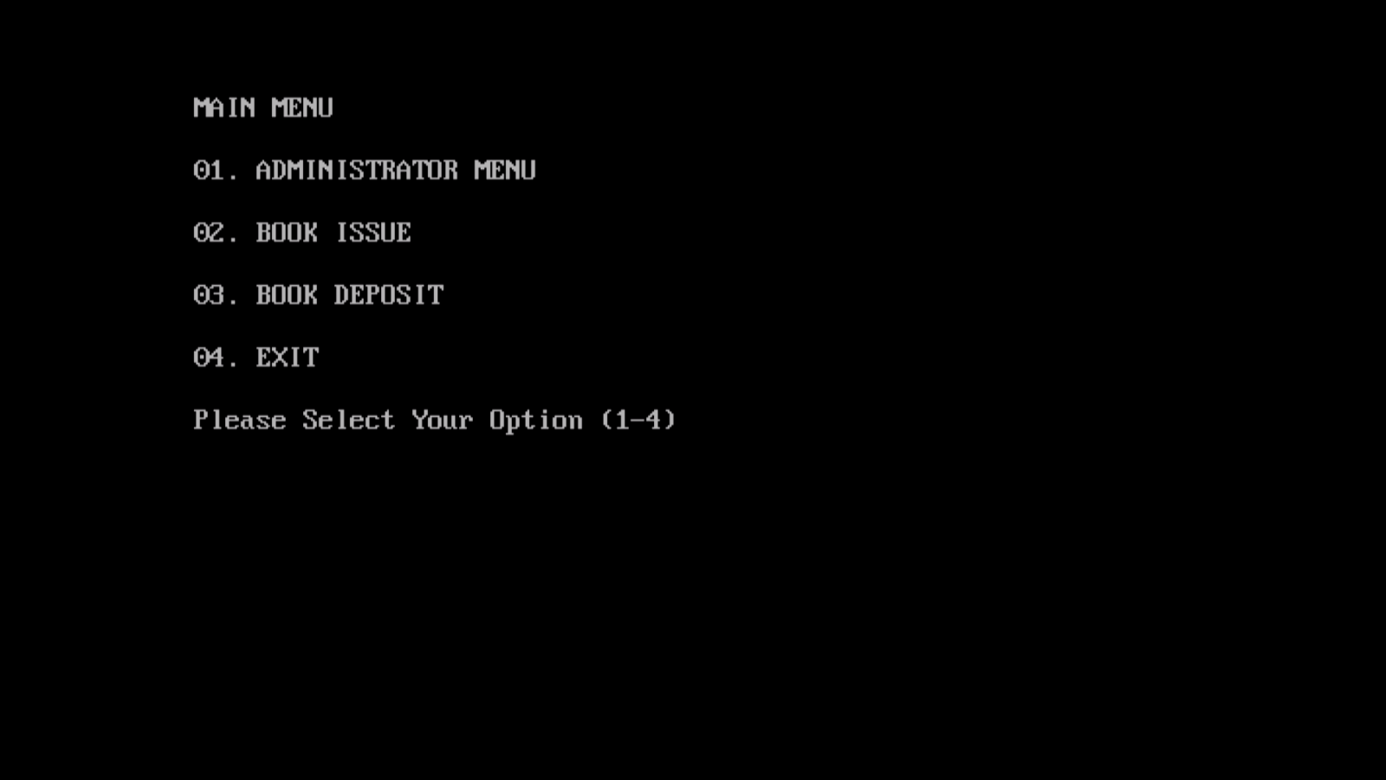Main menu
2. 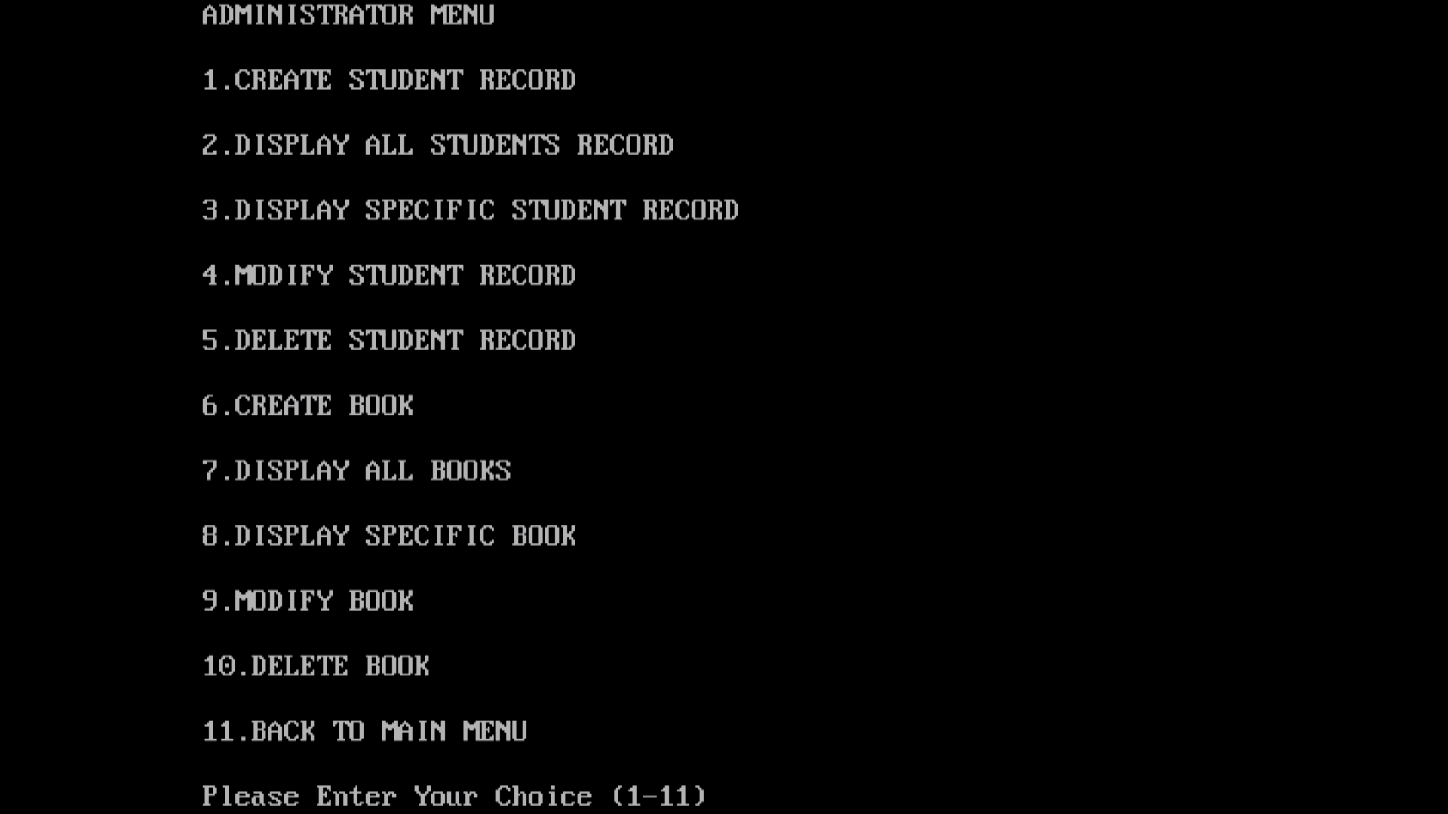Administrator Menu
3. Creating a Student record

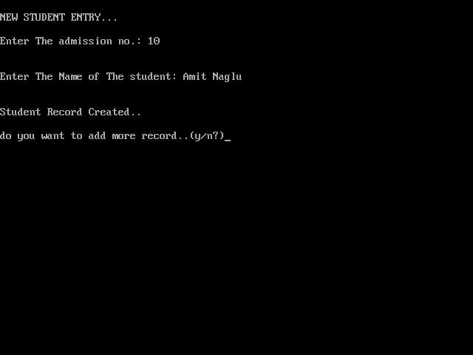

1. Displaying all the student’s record

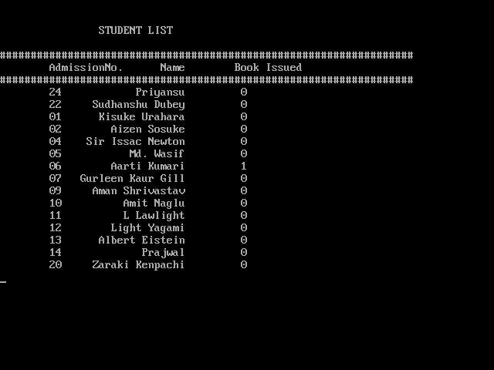

1. Displaying details of a specific student

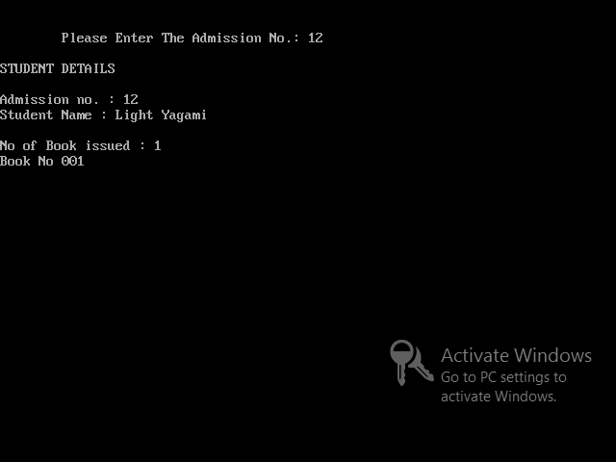

1. Modifying a student’s record

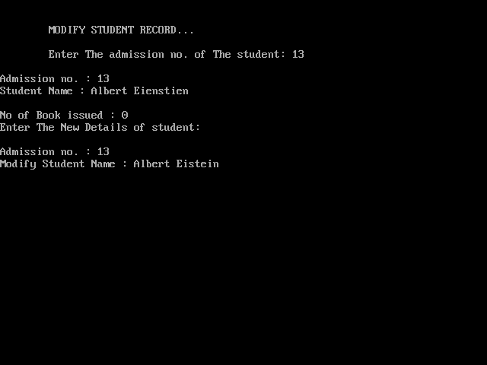

1. Deleting a student’s record

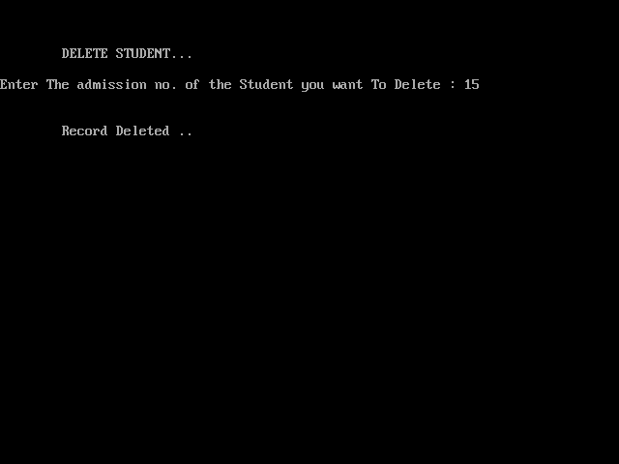

1. Entering a new book

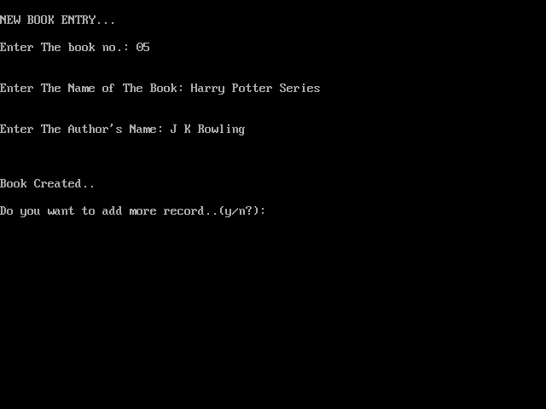

1. Displaying all the books

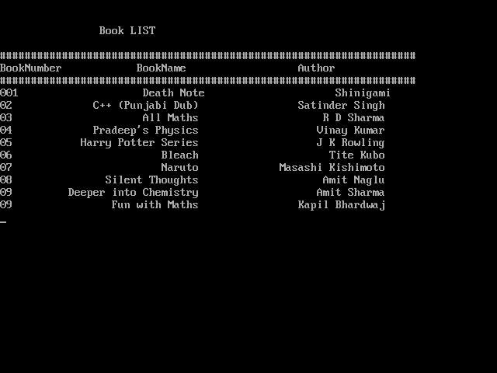

1. Displaying details of a specific book

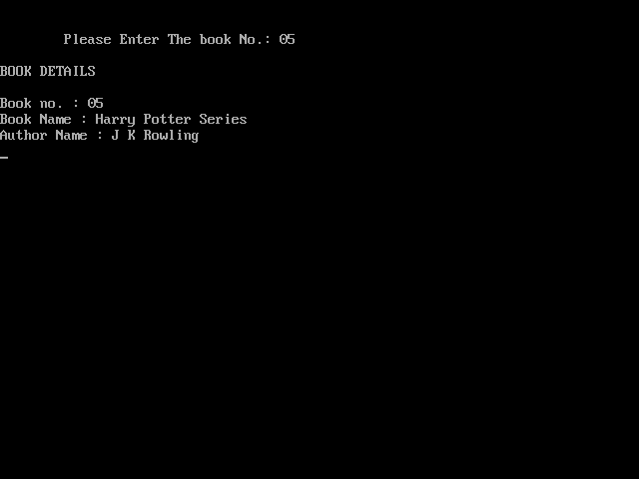

1. Modifying details of a book

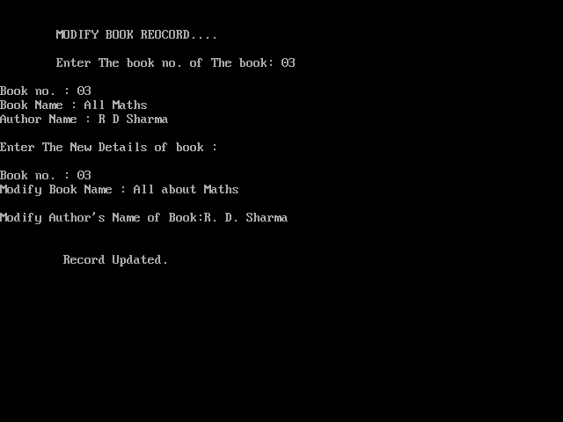

1. Deleting a book

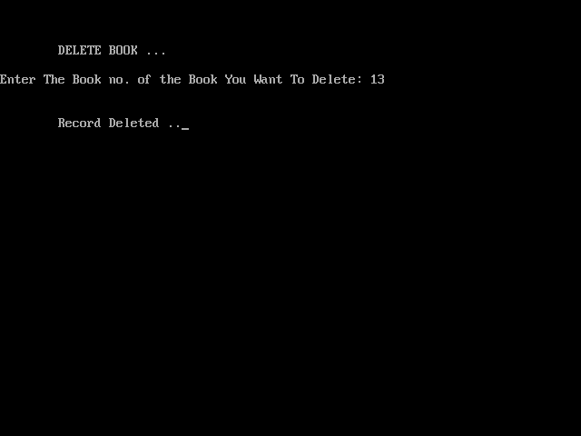

1. Issuing a book

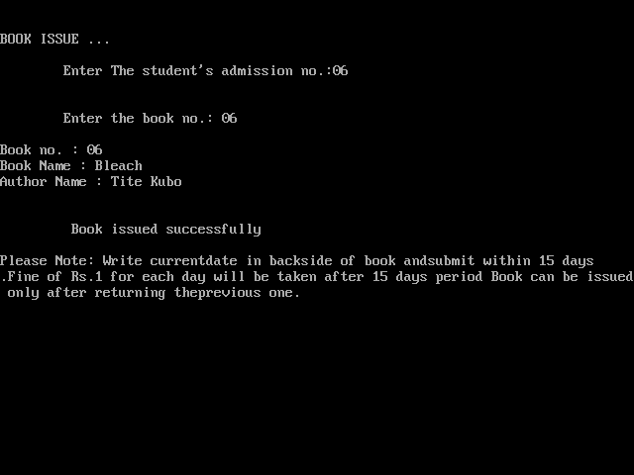

1. Depositing a book

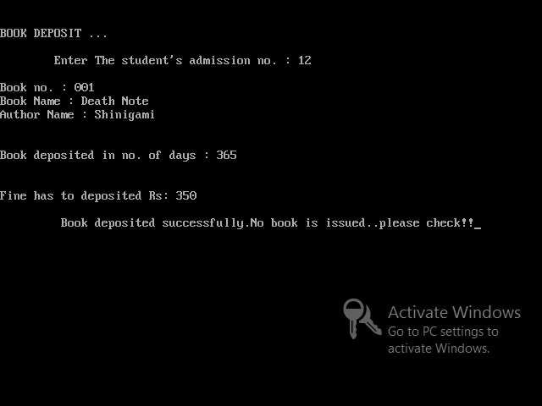



33

**Bibliography**

* **Computer Science Text Book for**

**Class XII by Sumita Arora**

* **www.cppforschool.com**
* [**www.icbse.com**](http://www.icbse.com)

* **google images**