SENTIMENT ANALYSIS ON MOVIE REVIEWS
Machine Learning Mini Project

Student Name | Vikas R
SRN | PES1UG24CS915
Dataset | IMDB Movie Reviews
Final Model | Linear SVM + TF-IDF Unigram/Bigram

Final Test Accuracy: 91.86%
Final F1-score: 91.99%

Abstract
This project develops a supervised machine learning system for binary sentiment classification of movie reviews as positive or negative. The IMDB movie-review dataset was explored and cleaned, followed by text preprocessing and TF-IDF feature extraction using unigram and bigram features. Three classifiers—Multinomial Naive Bayes, Logistic Regression, and Linear Support Vector Machine (SVM)—were evaluated using the same train-test split. Feature-selection and SVM hyperparameter experiments were also conducted. The best-performing configuration was a Linear SVM with TF-IDF unigram and bigram features and C=0.5, achieving 91.86% accuracy and 91.99% F1-score on the held-out test set. A Streamlit application was implemented to allow users to enter new movie reviews and obtain sentiment predictions.

1. Introduction
Sentiment analysis is a natural language processing task that determines the underlying opinion expressed in text. Movie reviews are a suitable application because the same review may contain many words and short phrases that collectively indicate whether the reviewer is satisfied or dissatisfied. The project investigates how different traditional machine learning classifiers perform when text is represented using TF-IDF features.
The methodology was motivated by the supplied reference work, which studies Naive Bayes, Logistic/Softmax Regression, SVM, n-gram representations, and feature-selection methods for movie-review sentiment classification. The reference emphasizes that bigram representations produce a high-dimensional sparse feature space and that feature selection can reduce the effect of uninformative features. fileciteturn2file2

2. Problem Statement
Given a movie review in natural language, build a machine learning system that automatically predicts whether the review expresses positive or negative sentiment. The system should be evaluated quantitatively and deployed through a simple interface for real-time prediction.

3. Objectives
- Explore and understand the IMDB movie-review dataset.
- Clean and preprocess raw review text.
- Represent reviews numerically using TF-IDF unigram and bigram features.
- Compare Multinomial Naive Bayes, Logistic Regression, and Linear SVM.
- Study the effect of feature selection on SVM performance.
- Tune the SVM hyperparameter C.
- Perform error analysis using negation and ambiguous reviews.
- Build a working Streamlit application for live sentiment prediction.

4. Dataset
The project uses an IMDB movie-review dataset containing 50,000 labeled reviews with two sentiment classes: positive and negative.
Property | Value
Initial dataset size | 50,000 reviews
Positive reviews | 25,000
Negative reviews | 25,000
Missing values | 0
Duplicate reviews detected | 418
Reviews containing HTML tags | 28,968 (58.42%)
Dataset after raw duplicate removal | 49,582
Final cleaned dataset used | 49,577
The original class distribution was balanced, with 25,000 positive and 25,000 negative reviews. After cleaning and duplicate removal, the final dataset contained 49,577 reviews. The small reduction after cleaning was caused by additional reviews becoming identical after normalization.

5. Exploratory Data Analysis
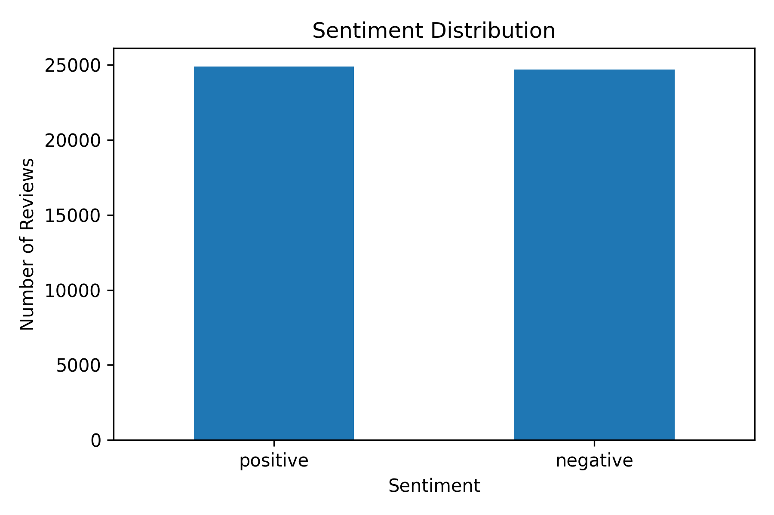
Figure 1: Sentiment Distribution of the IMDB dataset.
Initial analysis checked dataset shape, column names, missing values, class balance, duplicates, HTML content, and representative positive and negative reviews. No missing values were present. A large proportion of reviews contained HTML tags, making HTML removal an important preprocessing step.
The sentiment distribution remained approximately balanced after preprocessing, which reduced the need for class rebalancing techniques.

6. Text Preprocessing
- HTML entities were decoded.
- HTML tags such as <br> were removed.
- Text was converted to lowercase.
- Unnecessary characters were removed.
- Extra whitespace was normalized.
- Duplicate reviews were removed after preprocessing.
A separate negation-aware preprocessing experiment was also conducted by marking tokens occurring after negation words. This experiment increased the feature space but slightly reduced overall performance, so it was not selected for the final model.

7. Feature Extraction using TF-IDF
TF-IDF was used to convert cleaned review text into numerical sparse feature vectors. Two representations were evaluated: unigram TF-IDF and combined unigram-bigram TF-IDF.
Representation | Number of features
Unigram TF-IDF | 54,357
Unigram + Bigram TF-IDF | 613,727
The unigram-bigram representation is much larger because it captures both individual words and adjacent two-word expressions. The supplied reference similarly investigates unigram and bigram features and notes that bigrams create a high-dimensional sparse feature space. fileciteturn2file0

8. Machine Learning Methodology
The final experiments used an 80:20 stratified train-test split with a fixed random state of 42. Stratification preserved the positive/negative class proportions in both sets. The final split contained 39,661 training samples and 9,916 testing samples.

8.1 Multinomial Naive Bayes
Multinomial Naive Bayes was used as a probabilistic baseline for text classification. It models class priors and feature likelihoods under a multinomial assumption. The reference project also uses a Multinomial Naive Bayes formulation for text sentiment classification. fileciteturn2file2

8.2 Logistic Regression
Logistic Regression was evaluated as a discriminative linear classifier. It provides a useful comparison against the generative Naive Bayes baseline.

8.3 Linear Support Vector Machine
Linear SVM was evaluated because sparse, high-dimensional text features are well suited to linear decision boundaries. The supplied reference also studies SVM for text classification. fileciteturn2file4

9. Model Comparison
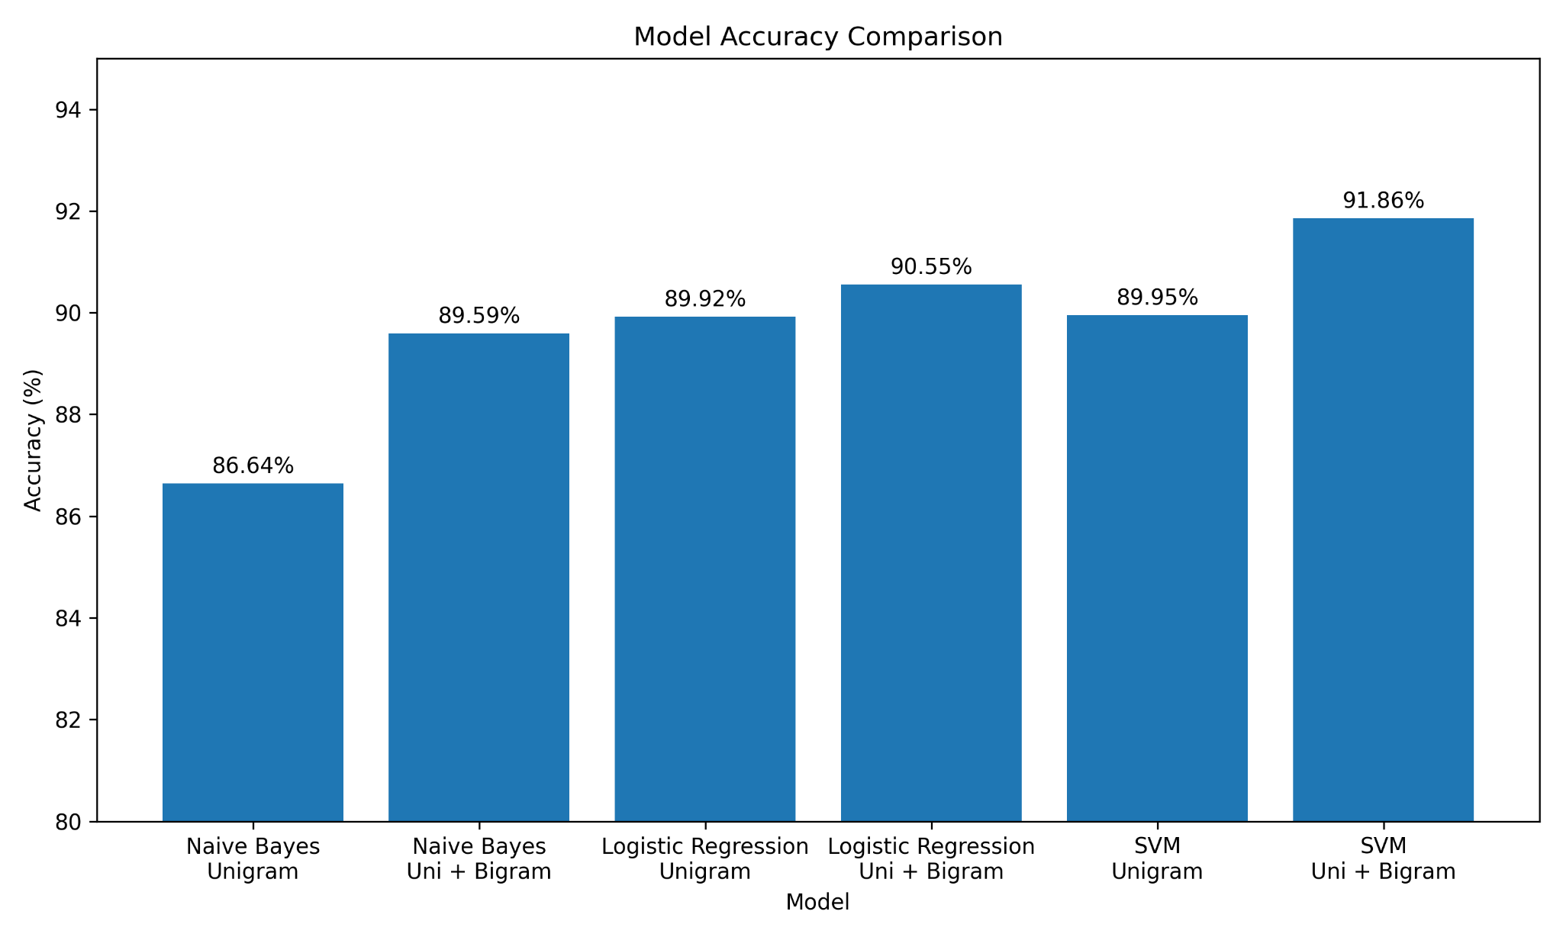
Figure 2: Accuracy comparison across the evaluated classifiers and feature representations.
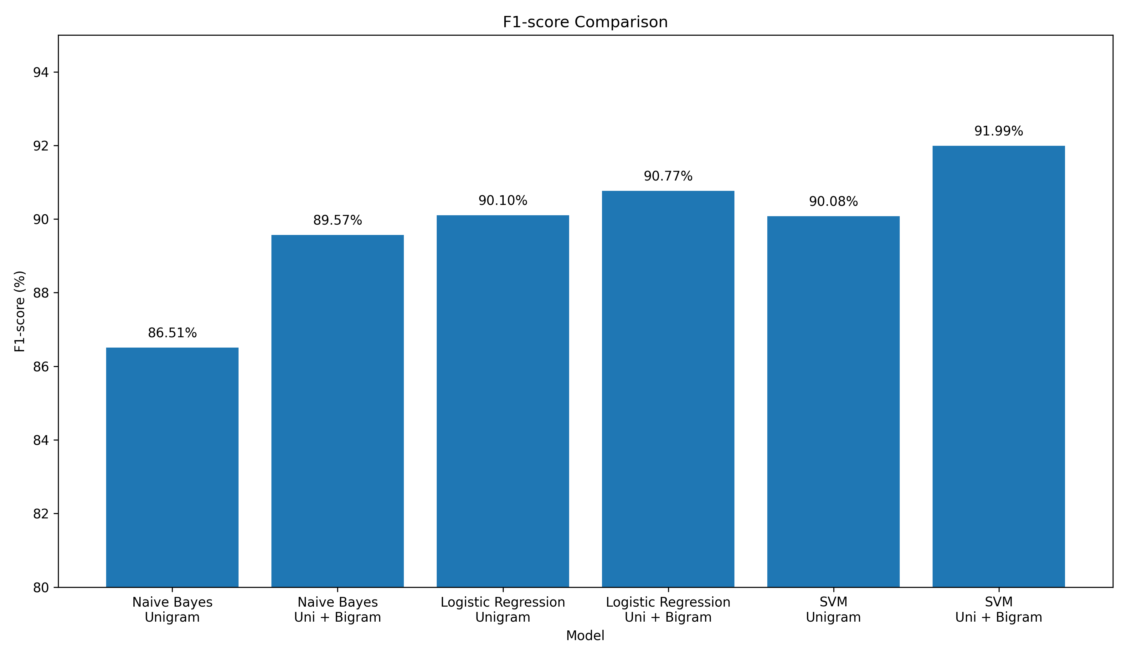
Figure 3: F1-score comparison across the evaluated classifiers and feature representations.
Model | Features | Accuracy | Precision | Recall | F1-score
Naive Bayes | Unigram | 86.64% | 87.71% | 85.33% | 86.51%
Naive Bayes | Uni + Bigram | 89.59% | 90.13% | 89.01% | 89.57%
Logistic Regression | Unigram | 89.92% | 88.83% | 91.40% | 90.10%
Logistic Regression | Uni + Bigram | 90.55% | 89.01% | 92.61% | 90.77%
SVM | Unigram | 89.95% | 89.24% | 90.94% | 90.08%
SVM | Uni + Bigram | 91.86% | 90.95% | 93.05% | 91.99%
The Linear SVM with unigram and bigram features achieved the highest accuracy and F1-score. Adding bigrams improved all three classifiers, indicating that short word combinations contain useful contextual information for the sentiment task.

10. Feature Selection Experiment
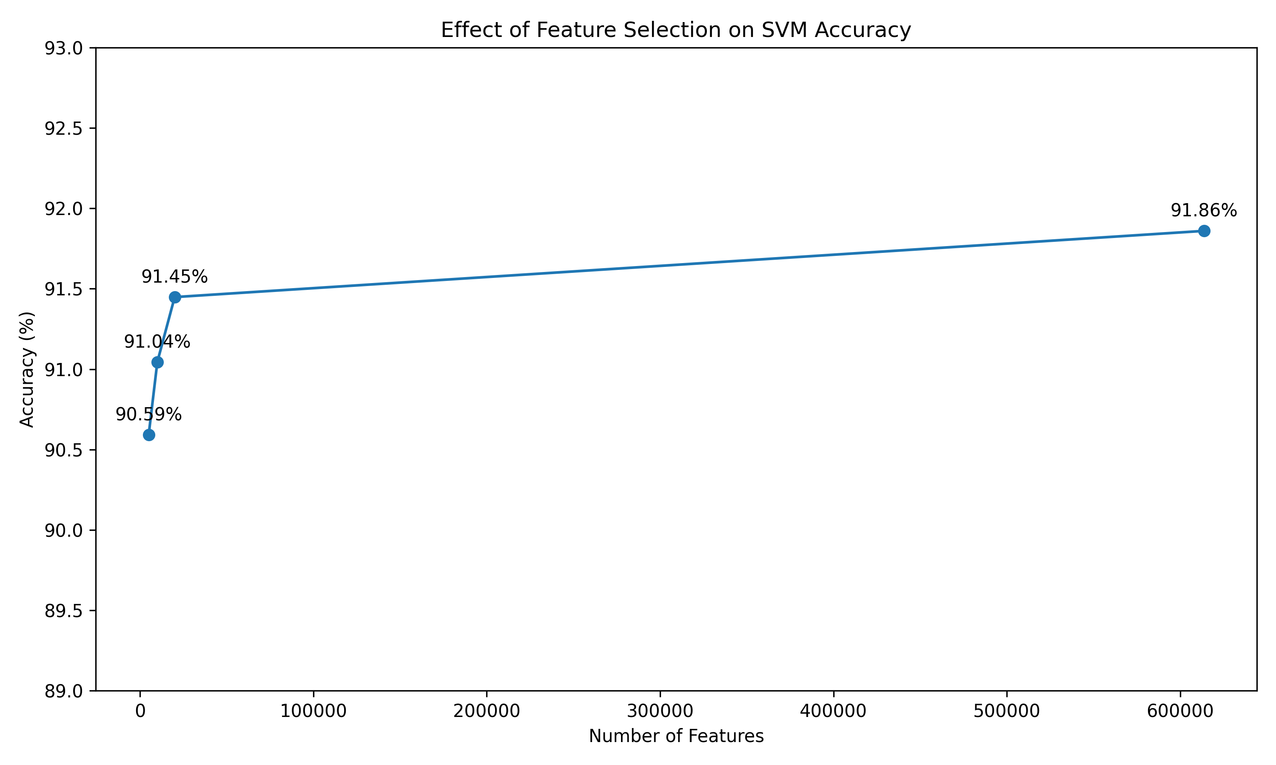
Figure 4: Effect of feature selection on SVM accuracy.
Chi-square SelectKBest feature selection was used to investigate whether a smaller feature space could preserve SVM performance. The full unigram-bigram representation contained 613,727 features.
Selected features | Accuracy | Precision | Recall | F1-score
5,000 | 90.59% | 89.68% | 91.82% | 90.74%
10,000 | 91.04% | 90.30% | 92.04% | 91.16%
20,000 | 91.45% | 90.62% | 92.55% | 91.57%
613,727 (baseline) | 91.86% | 90.95% | 93.05% | 91.99%
The 20,000-feature model achieved 91.45% accuracy, only 0.41 percentage points below the full-feature model while using about 97% fewer features. However, because the full model achieved the best measured accuracy, it was retained as the final classifier. This finding is consistent with the supplied reference's observation that increasing the number of features does not necessarily produce proportional gains in accuracy. fileciteturn2file3

11. SVM Hyperparameter Tuning
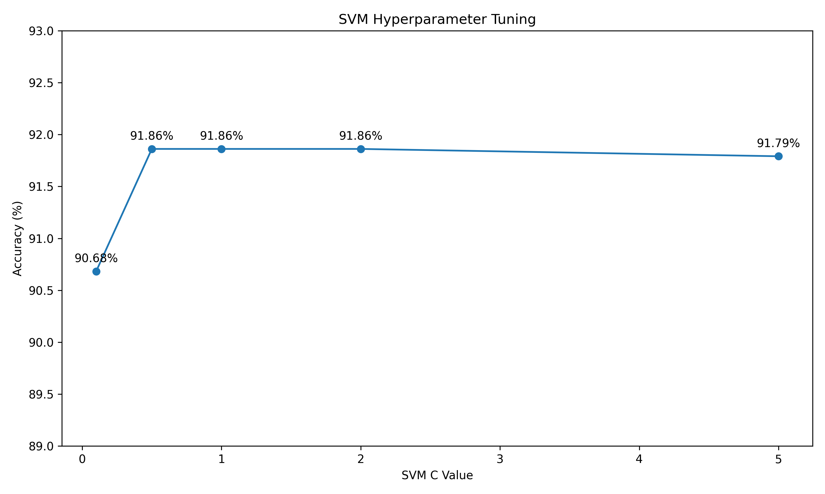
Figure 5: SVM hyperparameter tuning using the C value.
C | Accuracy | Precision | Recall | F1-score
0.1 | 90.68% | 89.90% | 92.79% | 90.91%
0.5 | 91.86% | 90.90% | 93.11% | 91.99%
1 | 91.86% | 90.95% | 93.05% | 91.99%
2 | 91.86% | 91.04% | 92.93% | 91.98%
5 | 91.79% | 91.10% | 92.71% | 91.89%
C=0.5 was selected as the final configuration because it achieved the highest measured accuracy and tied for the highest F1-score. The differences among C=0.5, 1 and 2 were very small, showing that performance was relatively stable in this range.

12. Error Analysis and Additional Experiments

12.1 Negation-aware preprocessing
A negation-aware preprocessing approach was tested by marking tokens following negation words such as 'not', 'never', and contracted forms. The resulting model achieved 91.72% accuracy and 91.83% F1-score, slightly below the original SVM. Therefore, the original preprocessing pipeline was retained.

12.2 Probability calibration
A calibrated SVM was also evaluated to obtain probability-like outputs for the application. The calibrated model achieved 91.46% accuracy and 91.56% F1-score, lower than the original SVM. It was therefore not selected as the final classifier.

12.3 Ambiguous reviews
Testing with mixed or ambiguous reviews showed that the classifier can be less reliable when positive and negative expressions occur together. For example, a review describing a movie as 'decent and average' while praising its acting can lie very close to the SVM decision boundary. This is a limitation of a conventional bag-of-n-grams model.

13. Final Model
Component | Final configuration
Dataset | IMDB movie reviews
Preprocessing | HTML removal, normalization, lowercase, duplicate removal
Feature extraction | TF-IDF
N-grams | Unigrams + Bigrams
Feature count | 613,727
Classifier | Linear SVM
C | 0.5
Accuracy | 91.86%
Precision | 90.95%
Recall | 93.05%
F1-score | 91.99%
The final model and TF-IDF vectorizer were serialized using joblib and used by the prediction application.

14. Application Development
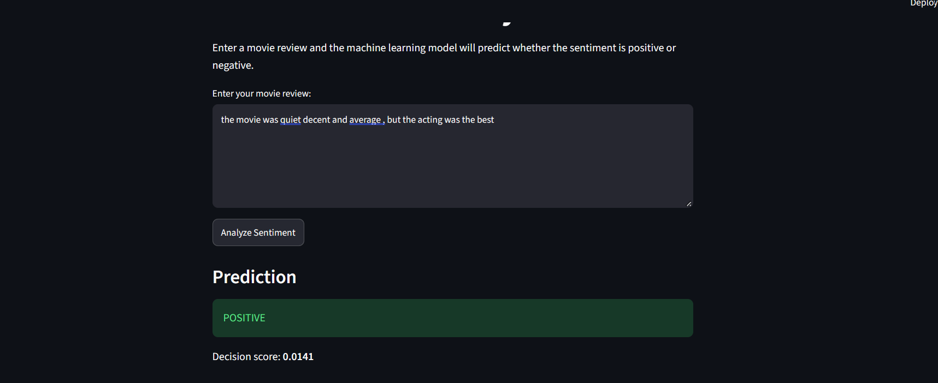
Figure 7: Streamlit application showing a positive sentiment prediction.
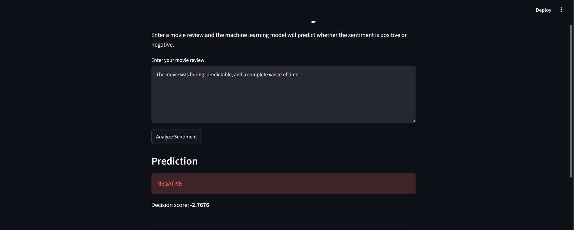
Figure 8: Streamlit application showing a negative sentiment prediction.
A Streamlit-based web application was developed for live demonstration. The application accepts a movie review, applies the same preprocessing and TF-IDF transformation used during training, and passes the resulting vector to the saved Linear SVM.
- User enters a movie review.
- The review is cleaned using the trained pipeline's preprocessing logic.
- The saved TF-IDF vectorizer converts the text into the learned feature space.
- The saved Linear SVM predicts positive or negative sentiment.
- The prediction is displayed in the browser.
The application was tested with clearly positive, clearly negative, and mixed reviews. The clearly positive and negative test cases produced the expected predictions, while mixed reviews demonstrated the model's uncertainty near the decision boundary.

15. Results and Discussion
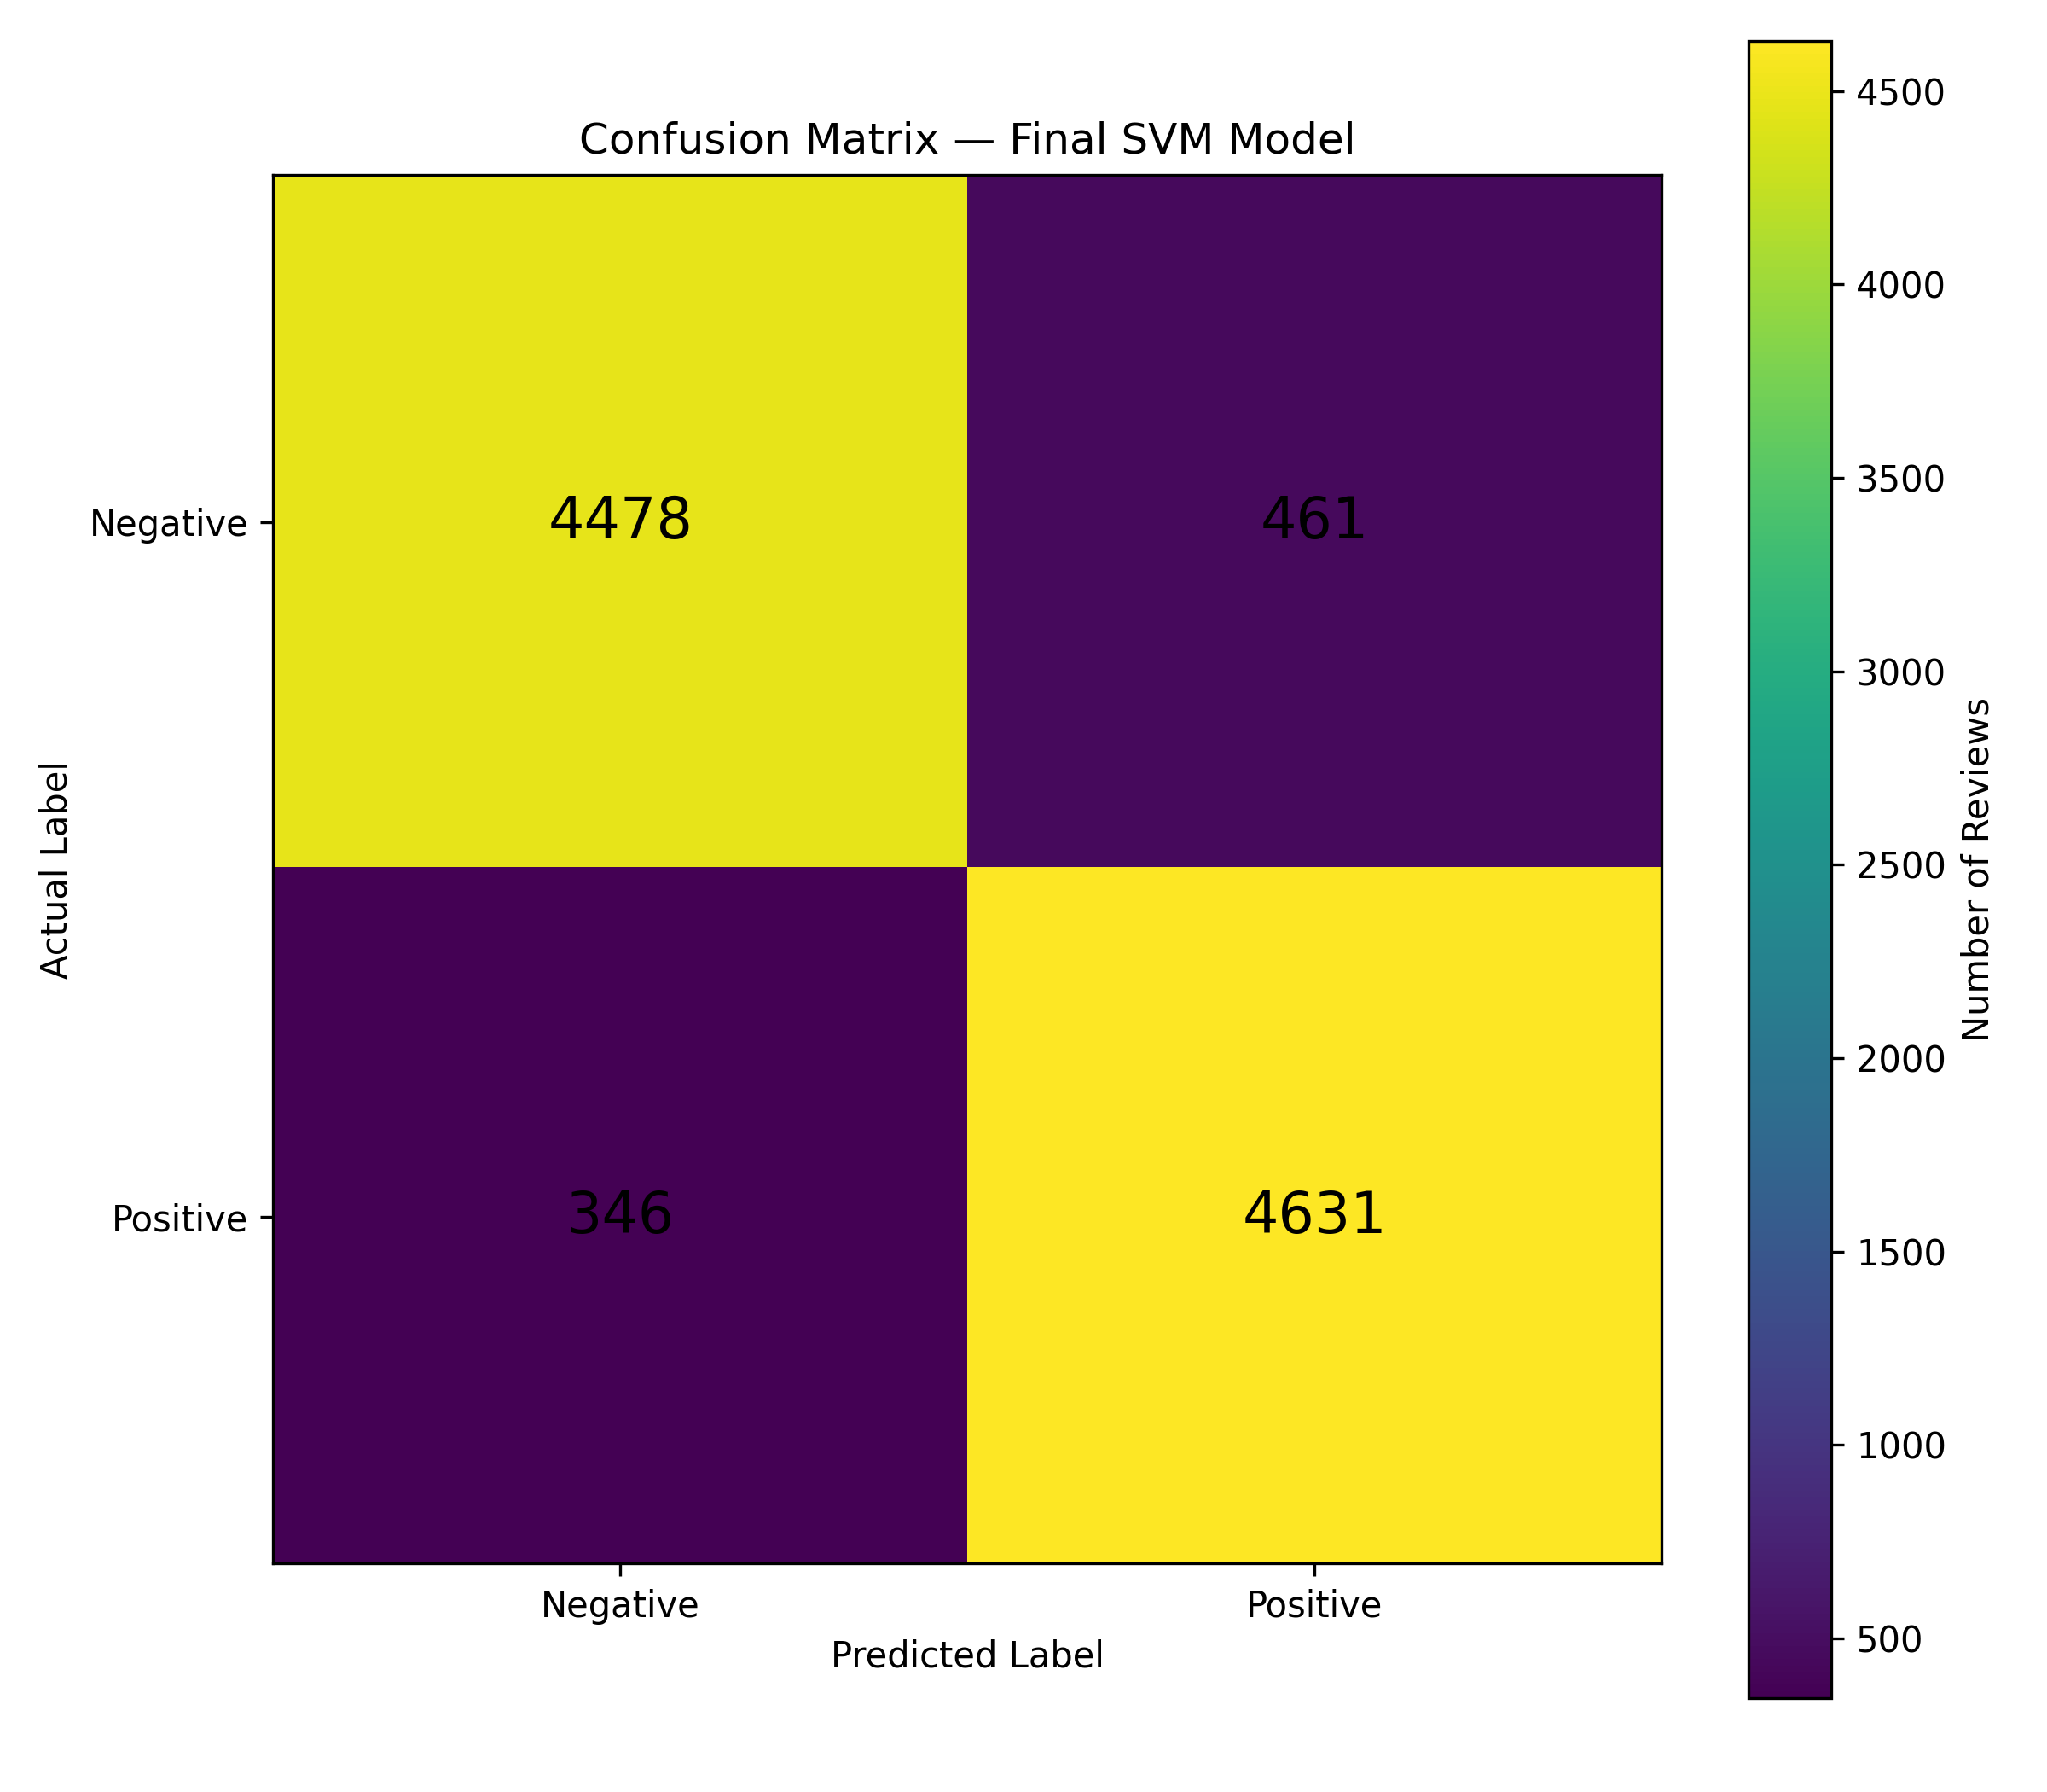
Figure 6: Confusion matrix of the final SVM model.
The experiments show that feature representation has a substantial effect on sentiment classification. For every classifier, adding bigram features improved accuracy over the unigram-only representation. SVM produced the strongest overall result, reaching 91.86% accuracy. The feature-selection experiment showed that much smaller feature sets can approach the full model's performance, but the complete representation remained the best-performing configuration in this study.

16. Limitations
- The model is limited to binary positive/negative sentiment.
- Subtle, sarcastic, or mixed reviews can be difficult to classify.
- The bag-of-ngrams representation does not fully capture long-range context.
- The raw SVM decision score should not be interpreted as a probability.
- The application is intended as a demonstration of the trained model rather than a production-scale sentiment service.

17. Future Scope
- Use transformer-based models such as BERT for stronger contextual understanding.
- Support neutral and multi-class sentiment categories.
- Investigate sarcasm and negation using contextual language models.
- Add probability calibration without sacrificing predictive performance.
- Deploy the application as a hosted web service.
- Evaluate the model on additional movie-review datasets to test generalization.

18. Conclusion
A complete movie-review sentiment analysis pipeline was developed, evaluated, and deployed. The project covered data exploration, preprocessing, TF-IDF feature extraction, comparison of three machine learning algorithms, feature selection, hyperparameter tuning, error analysis, and application deployment. The best configuration was Linear SVM with TF-IDF unigram and bigram features and C=0.5, achieving 91.86% test accuracy and a 91.99% F1-score. The Streamlit application demonstrates that the trained model can be used to classify new movie reviews interactively.

19. References
- Cai, X. and Wang, Y., 'Sentiment Analysis on Movie Reviews', CS229 Fall 2014 Final Project Report. Supplied reference document.
- scikit-learn documentation: text feature extraction, LinearSVC, MultinomialNB, LogisticRegression, and model evaluation utilities.
- IMDB movie-review dataset used for binary sentiment classification.

20. Appendix — Project Files
- 01_eda.py
- 04_train_test_split.py
- 05_tfidf.py
- 06_naive_bayes.py
- 07_logistic_regression.py
- 08_svm.py
- 09_feature_selection.py
- 10_svm_tuning.py
- 11_train_final_model.py
- 12_predict.py
- 13_negation_experiment.py
- 14_calibrated_model.py
- 15_results_visualization.py
- app.py
- models/sentiment_svm.pkl
- models/tfidf_vectorizer.pkl
Note: Insert the generated result figures and application screenshots in the Results and Application sections if the submission format requires visual evidence.

