# Shopee Sales Data Analysis Report

## 1. Project Background

Shopee is one of the leading e-commerce platforms in Southeast Asia, with a large user base and a diverse range of products.  
The objective of this analysis is to study Shopee’s sales data, identify the characteristics of best-selling products, and explore key factors affecting sales to develop more effective sales strategies.

## 2. Data Overview and Preprocessing

**Data Source**: Shopee E-commerce Sales Dataset  
  
**Example Data Fields**:  
- `title`: Product name  
- `price_actual`: Product price  
- `total_sold`: Total sales  
- `rating`: Customer rating  
- `reviews`: Number of reviews  
- `location`: Seller location  
  
**Data Cleaning Steps**:  
- **Handling Missing Values**: Removed rows with excessive missing values and filled in certain empty fields.  
- **Data Type Conversion**: Converted `total_sold` from `object` to `int` to ensure compatibility for analysis.  
- **Outlier Removal**: Filtered out abnormally low or high-priced products to ensure representative analysis results.

## 3. Data Analysis and Visualization

## (1) Best-Selling Product Analysis

Visualized the **TOP 10 best-selling products**.  
Found that best-selling products are mainly concentrated in **electronics, home essentials, and beauty care**.

## (2) Price vs. Sales Relationship

Analyzed the correlation between price and sales using a scatter plot.  
Found that **products priced between $10-$50 tend to have higher sales**, while extremely high or low-priced products have relatively lower sales.

## (3) Customer Ratings and Sales Impact

Calculated the average sales across different rating intervals (1-5 stars).  
Found that **products with ratings above 4.5 tend to have significantly higher sales**, indicating a positive relationship between customer ratings and sales performance.

## (4) K-Means Clustering Analysis

Selected `price_actual` and `total_sold` as feature variables.  
Applied **K-Means clustering** to categorize products into **high-sales low-price, low-sales high-price, and balanced sales** groups.  
Found that **high-value-for-money products are more likely to become best-sellers**.

## 4. Key Insights

✅ **Best-Selling Categories**: Electronics, home essentials, and beauty care are the most popular.  
✅ **Price Impact on Sales**: Products priced between **$10-$50** achieve the best sales, requiring strategic pricing adjustments.  
✅ **Importance of Customer Ratings**: Products with **ratings above 4.5** perform better, emphasizing the need for positive customer feedback.  
✅ **Characteristics of High-Sales Products**: Affordable pricing, high ratings, appropriate pricing, and active customer engagement.

## 5. Conclusions and Recommendations

📌 **Optimize Product Pricing**: Set mainstream product prices between **$10-$50** to maximize sales.  
📌 **Improve Customer Ratings**: Encourage customer reviews and address negative feedback to boost ratings and increase sales.  
📌 **Implement Targeted Marketing Strategies**: Optimize promotional tactics for different product categories, such as offering discounts on electronics.  
📌 **Enhance Inventory Management**: Ensure sufficient stock for best-selling products (e.g., home essentials and beauty care) to avoid stockouts and revenue loss.

## Next Steps

1. **Apply these analytical insights to Shopee’s platform** to test the impact of pricing optimization and customer rating management.  
2. **Further segment product categories** and develop tailored marketing strategies for different types of products.  
3. **Develop a predictive model** using machine learning to forecast future best-selling products.  
  
🚀 Through this analysis, we provide actionable sales strategy recommendations for Shopee merchants, paving the way for deeper insights and optimization in the future!

Best-Selling Product Analysis:

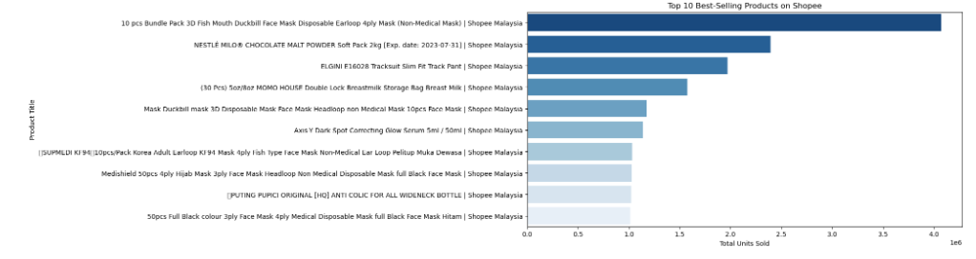

Price vs. Sales Relationship:

