Scaling Complex Mathematical Reasoning via Hierarchical Synthetic Word Problems

Abstract
Training language models to solve complex multi-step mathematical word problems remains a significant challenge, largely due to the scarcity of high-quality, scalable data covering hierarchical reasoning and long variable dependency chains. We present a fully programmatic pipeline for synthesizing mathematical word problems with controllable entity counts (5–30+), hierarchical containment structures, and mixed arithmetic/logical operations. Our pipeline constructs a 50-domain hierarchical entity library supporting up to 2⁵⁰ unique combinations per domain, grows parameterized logic trees, and renders them into natural language problems with GPT-4o-polished chain-of-thought solutions (~90% usable rate). Extensive experiments on Qwen2.5-3B using SFT, DPO, and RL (GRPO) demonstrate that: (1) RL on synthetic data yields up to +276% accuracy on business-domain problems; (2) a cold-start SFT with only 500 samples before RL preserves reasoning chain extensibility while establishing the required output format; (3) mixed-difficulty SFT (op0-20) achieves the most robust generalization with near-flat accuracy decay across difficulty levels. These results establish the practical value of hierarchical synthetic data for advancing long-chain mathematical reasoning.
Keywords: mathematical word problems, synthetic data generation, hierarchical entity structures, reinforcement learning, chain-of-thought, long-chain reasoning
1. Introduction
The ability to solve complex mathematical word problems requires models to parse natural language, extract relevant entities, track variable dependencies across long chains of operations, and perform multi-step arithmetic — capabilities that remain difficult to develop through standard pre-training alone (Cobbe et al., 2021; Hendrycks et al., 2021).

Most existing high-quality math data (e.g., GSM8K) consists of problems with at most a few reasoning steps and limited inter-variable dependencies. This creates a data bottleneck: models trained on such datasets generalize poorly to problems requiring 10–30 interdependent computations (Patel et al., 2021; Miao et al., 2020).

Prior programmatic synthesis approaches fall into two categories. OP10-style pipelines rely on LLMs to generate both entities and problems, but LLM consistency degrades when entity counts exceed 10, producing logically incoherent problems. OP20-style pipelines use manually built flat entity libraries, sidestepping LLM consistency but producing rigid, low-diversity problems lacking hierarchical logical structure.

We address both limitations by introducing a hierarchical entity library combined with a logic tree synthesis engine. Our approach is inspired by the Physics of Language Models (Part 2.1) framework (Ye et al., 2024) but extends it significantly to support: (a) multi-level containment hierarchies, (b) mixed additive and multiplicative relations, (c) ultra-long reasoning chains, and (d) LLM-based CoT polishing. The result is a pipeline capable of generating arbitrarily complex, verifiable, and diverse mathematical word problems at scale.

Our main contributions are:
- A hierarchical entity library of 50 domains, each supporting up to 2⁵⁰ unique entity combinations, with programmatic logic-tree synthesis for generating problems of controllable complexity.
- A systematic study of how SFT, DPO, and RL training on synthetic data of varying difficulty affect model performance on both domain-specific and general benchmarks.
- Empirical evidence that a cold-start SFT regime (500 samples) before RL is superior to full-dataset SFT + RL, and that mixed-difficulty SFT achieves the best generalization across problem complexity levels.
2. Related Work
2.1 Mathematical Word Problem Datasets
Benchmark datasets such as GSM8K (Cobbe et al., 2021), MATH (Hendrycks et al., 2021), ASDiv (Miao et al., 2020), and SVAMP (Patel et al., 2021) have driven significant progress in math reasoning. However, these datasets have fixed difficulty ceilings and were not designed for systematic complexity control. Our synthetic dataset allows fine-grained difficulty control via entity count and tree depth parameters.
2.2 Synthetic Data for Reasoning
Physics of Language Models Part 2.1 (Ye et al., 2024) proposes generating grade-school math problems from hidden dependency structures, demonstrating that models can learn reasoning strategies from purely synthetic data. ControlMath (Chen et al., 2024) takes a divergent generation approach, prompting models to construct problems from random arithmetic expressions. Our approach builds on Ye et al.'s dependency structure but replaces LLM-generated entities with a programmatic hierarchical library, enabling reliable scaling beyond 10 entities.
2.3 RL for Mathematical Reasoning
Recent work has shown that GRPO-based RL on outcome rewards significantly improves math reasoning in small models. DeepSeekMath (Shao et al., 2024) introduces Group Relative Policy Optimization (GRPO), a memory-efficient PPO variant, demonstrating that further RL fine-tuning boosts reasoning even in already-instruction-tuned models. Our work studies how domain-specific synthetic data interacts with RL training, showing both the benefits and the risks (format over-fitting) of SFT pre-training before RL.
3. Hierarchical Synthetic Word Problem Pipeline
3.1 Overview
The pipeline consists of four stages: (1) hierarchical entity library construction, (2) entity identification and assignment, (3) parameterized logic tree synthesis, and (4) natural language problem and CoT generation with optional LLM polishing. Figure 1 illustrates the complete pipeline.

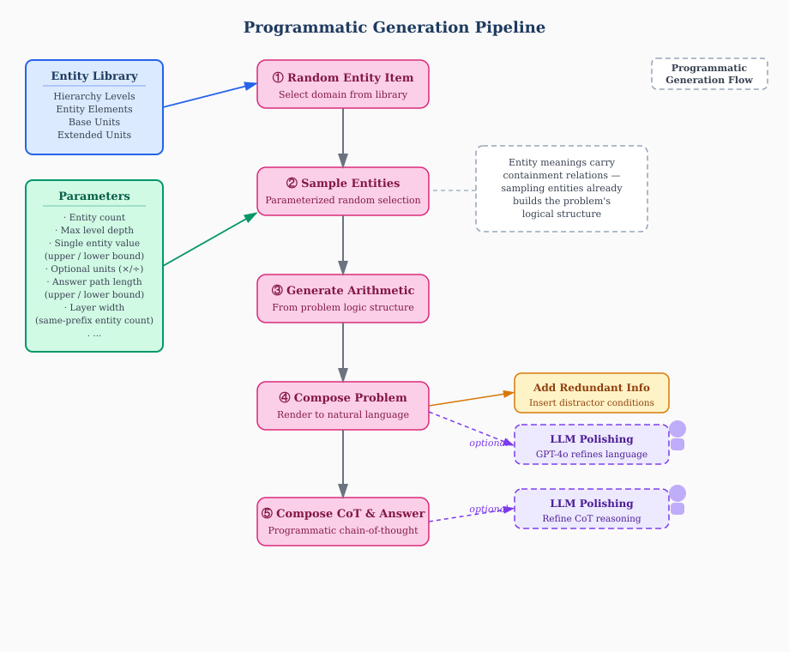
Figure 1: Programmatic Generation Pipeline. Inputs: entity library (blue) and configurable parameters (green). Stages: random domain selection → entity sampling → arithmetic generation → problem composition → CoT composition. Dashed purple branches indicate optional GPT-4o polishing.
3.2 Hierarchical Entity Library
3.2.1 Base Framework Generation
Given a random domain topic, an LLM generates: a contextual background story, 3–5 parallel classification levels with hierarchical relationships (e.g., Factory → Production Line → Production Unit), and a base measurement unit. Each level is internally independent (no sub/super-class overlap within a level) and mutually associated across levels (any element from one level can logically combine with any element from another).
3.2.2 Entity Identification: Letter Codes and Composite Keys
Each level element is assigned an uppercase letter identifier; the base unit receives a lowercase identifier. A composite code of the form (L1)(L2)…(unit) uniquely identifies any entity in the hierarchy. For example, given the factory domain entity library below:

Level | A | B | C | D
L1: Factory | Maria Factory | Burns Factory | Caesar Factory | Davis Factory
L2: Prod. Line | Pharma Line | Food Processing | Chemical Line | Smelting Line
L3: Prod. Unit | Unit A | Unit B | Unit C | Unit D

The composite code CBB resolves as: C (L1 = Caesar Factory) → B (L2 = Food Processing Line) → B (L3 = Unit B). If the base unit is "Daily Output", the full entity CBB means Caesar Factory's Food Processing Line's Unit B's Daily Output. This systematic encoding ensures every entity is unambiguously defined and every parent-child containment relation is structurally embedded.

Two types of natural language condition keys are derived:
- Same-level containment: "Caesar Factory's total daily output across all production lines" → Ca = CBa + CCa + CDa + … (summing over all L2 children of C).
- Cross-level key: "Caesar Factory's Food Processing Line's Unit B's daily output" → CBBa (reading down three levels).

3.2.3 Level Expansion and Network Construction
Each level is expanded to 5–10 elements via LLM plus human review. For problems involving multiplication/division, corresponding extended unit triplets are generated (e.g., Total Amount = Rate × Duration). Entities across unit types are linked by multiplication/division; entities sharing the same unit within a level are linked by addition/subtraction (containment).
3.2.4 Scale
50 entity sets across diverse domains have been constructed. With 3–5 hierarchy levels and 4–10 elements per level, each library supports between 2⁴ and 2⁵⁰ distinct entity combinations — approximately 1 billion combinations per library on average.
3.3 Logic Tree Synthesis
3.3.1 Tree Structure
Each problem corresponds to a directed tree. The queried entity is the root. Edges encode arithmetic or containment relations. Leaf nodes are known entities; internal nodes are unknown (to be computed); one designated unknown node is the queried entity. Redundant entities (not on the answer path) are optionally added to increase difficulty. Figure 2 illustrates a representative answer tree.

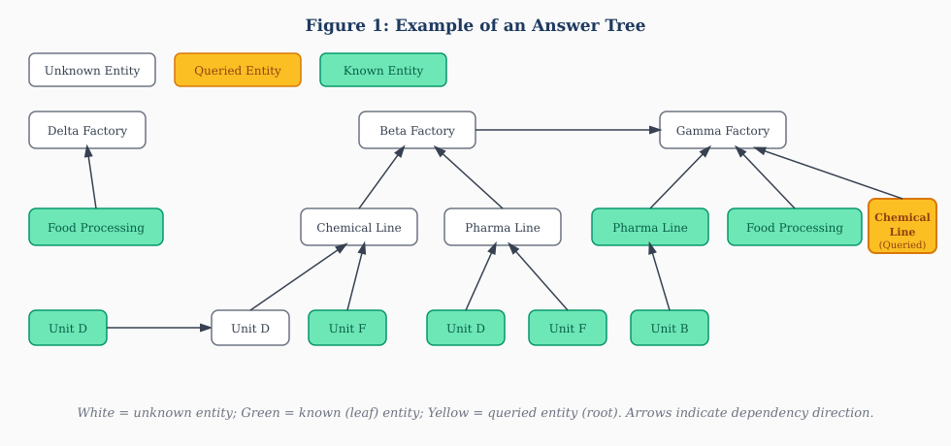
Figure 2: Example answer tree. White boxes = unknown entities; green = known (leaf) entities; yellow = queried entity (root). Upward arrows indicate containment or arithmetic dependency direction.
3.3.2 Generation Algorithm
Starting from an initial entity, the tree expands iteratively. At each step, one of four operations is selected: (1) define a parent entity (E₀ = E₁ + E₂ + … + Eₙ), (2) define child entities (E₁ = E₂ + … + Eₙ), (3) define an arithmetic relation (E₁ ± × ÷ value = E₀, with distinct prefixes), or (4) define a multiplication unit relation (Eₐ = E_b × E_c for unit triplets). If no expansion is chosen, the current entity is designated as a known leaf. Expansion continues until the total entity count reaches the configured maximum. Figure 3 shows a high-complexity tree demonstrating cross-source arithmetic relations at op20+ difficulty.

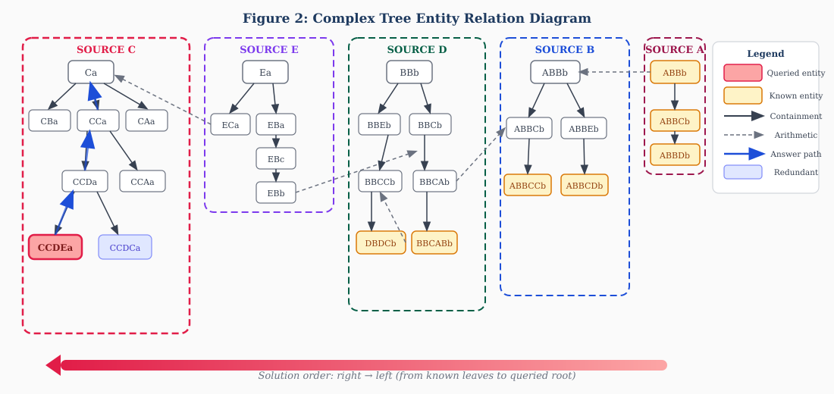
Figure 3: Complex Tree entity relation diagram (op20+ difficulty). Each colored rectangle is a "source group" (entities sharing the same L1 prefix). Solid arrows = containment; dashed arrows = cross-source arithmetic relations. Blue thick arrows trace the answer path from queried entity (red) to known leaf nodes.
3.3.3 Parameters
The tree is controlled by: total entity count (excluding redundant), maximum level depth, maximum answer path length, maximum layer width (entities sharing the same prefix), and a multiplication switch. This parameterization allows continuous difficulty scaling from op5 (5 unknown entities) to op30+.
3.4 Problem and CoT Rendering
Problems are rendered by mapping the tree's entities and relations onto the entity library. The format is: (Background story) + (Known entity values as natural language conditions) + (Logical/numerical relations) + (Question). Approximately 70 paraphrase templates are applied to condition expressions, and conditions are optionally shuffled and augmented with redundant distractors.

Chain-of-thought solutions are first generated programmatically in the format: (Extract knowns) → (Restate relations) → (Arithmetic computation). GPT-4o then polishes these into fluent, hierarchically structured CoT answers. This achieves approximately 90% usable output on mixed-difficulty datasets.
3.5 Four Generation Methods
Each problem can be expressed in four variants, used to probe different model capabilities:
- Method 1: Addition/subtraction expressed as containment ("Farm A's total fertilizer includes Wheat, Corn, and Soybean").
- Method 2: Explicit arithmetic expression ("Farm A's Wheat = Farm A total − Corn − Soybean").
- Method 3: Method 1 with conditions shuffled.
- Method 4: Method 2 with conditions shuffled.
4. Experiments
4.1 Benchmark Evaluation of Dataset Difficulty
4.1.1 Setup
We generate op5–op20 test sets (15 difficulty levels, 300 samples each, 4 methods). Models evaluated: GPT-4o, O1, Qwen-72B, Qwen-7B-Math. Metric: exact-match accuracy (correct/300).
4.1.2 Results
Model | Method | op5 | op7 | op10 | op12 | op15
GPT-4o | 1 | 207/300 | 143/300 | 82/300 | 68/300 | 43/300
GPT-4o | 4 | 233/300 | 179/300 | 119/300 | 98/300 | 62/300
Qwen-72B | 1 | 199/300 | 148/300 | 98/300 | 71/300 | 41/300
Qwen-7B-Math | 1 | 70/300 | 31/300 | — | — | —
O1 | — | 230/300 | 227/300 | 223/300 | 207/300 | 192/300

Table 1: Benchmark evaluation results. All models degrade monotonically with op count except O1, which maintains ~65% accuracy up to op15.
4.1.3 Analysis
All models except O1 show monotonic accuracy degradation with increasing entity count, confirming the dataset's difficulty scaling properties. 7B-scale models reach ~10% accuracy at op7; 72B and GPT-4o at op15. Method 1 (containment) is harder than Method 2 (explicit), confirming that inferring arithmetic from containment descriptions is a distinct and challenging capability. Shuffling has minimal impact, indicating models are proficient at relevant condition retrieval.
4.2 SFT Experiments
4.2.1 Setup
Five Qwen2.5-3B models are fine-tuned on: op0-5, op5-10, op10-15, op15-20 (~2000 samples each), and mixed op0-20 (~4000 samples). Hyperparameters: lr = 1e-5, 1 epoch. Evaluated on four test sets (op0-5, op5-10, op10-15, op15-20, ~400 each).
4.2.2 Results
Training data | op0-5 | op5-10 | op10-15 | op15-20
Base (no SFT) | 68.05% | 25.08% | 20.57% | 16.30%
SFT op0-5 | 87.59% | 34.08% | 19.54% | 16.85%
SFT op10-15 | 72.93% | 72.93% | 59.64% | —
SFT op15-20 | 66.92% | 64.31% | — | 59.38%
SFT mixed op0-20 | 93.05% | 81.03% | ~70% | ~70%

Table 2: SFT evaluation results. Mixed-difficulty training achieves consistently high accuracy across all test sets with near-flat degradation.
4.2.3 Key Findings
Difficulty matching yields the best within-domain accuracy. However, single-difficulty SFT collapses on harder test sets: SFT on op0-5 scores only 16.85% on op15-20 (barely above base). Negative transfer is observed: SFT on op0-5 scores below base on the op10-15 test (19.54% vs. 20.57%), indicating low-difficulty over-training damages higher-order reasoning. Mixed-difficulty SFT (op0-20) achieves the best generalization, with approximately 70% improvement over base on hard problems and near-flat cross-difficulty degradation.
4.3 DPO Experiments
4.3.1 Setup
Positive/negative DPO pairs are constructed by running each SFT model 10 times on all test sets. Two DPO configurations are compared: Base + DPO (no prior SFT) and SFT + DPO. Test sets include an additional op20-25 split.
4.3.2 Results and Analysis
Base + DPO is largely ineffective: DPO-only models score far below base (e.g., op5-10: best DPO 28% vs. base 68%). SFT + DPO provides modest improvements (+10%+ on op15-25 vs. base), with difficulty-matched training showing the best generalization. However, SFT + DPO consistently underperforms pure SFT across all test sets. We hypothesize this is due to the small model's sensitivity to RL sample selection dynamics: the DPO training signal may be dominated by easy examples that do not reinforce hard-problem reasoning strategies.
4.4 RL Experiments
4.4.1 Setup
Five RL settings (GRPO via verl) are evaluated on Qwen2.5-3B-Instruct: (1) direct RL on synthetic data, (2) full SFT + RL, (3) cold-start SFT (500 samples) + RL, (4) RL on MATH hard samples, (5) RL on mixed synthetic + MATH data. Training: lr = 1e-6, n_rollout = 8, 8×GPU, 150 steps. Reward: exact final answer match.
4.4.2 Results
Setting | MATH-500 | GSM8K | op0-10 | op10-15 | op15-20 | op25-30
1: Base + Synth RL | 57.0% | 83.7% | 95.33% | 81.33% | 43.0% | 0.33%
2: Full SFT + RL | 29.8% | 29.8% | 69.0% | 36.33% | 16.0% | 1.0%
3: Cold-start SFT + RL | 55.2% | 77.6% | 90.67% | 65.0% | 41.33% | 11.33%
4: Base + Math RL | 64.0% | 86.2% | 25.33% | 2.67% | 0% | 0.33%
5: Base + Mixed RL | 65.8% | 87.9% | 46.33% | 5.67% | 1.0% | 0%

Table 3: Zero-shot RL evaluation results. Setting 1 achieves the highest domain accuracy; Setting 3 achieves the best hard-problem performance; Settings 4-5 achieve the best general math benchmarks.
4.4.3 Key Findings
Synthetic data dramatically boosts domain reasoning. RL on synthetic data (Setting 1) raises op0-10 accuracy from 25.33% to 95.33% (+276%). On op25-30, Setting 3 achieves 11.33% while the base scores 0%.

"Less SFT is more." Full SFT + RL (Setting 2) collapses on harder problems: op10-15 drops from 81.33% to 36.33% (−55%) versus Setting 1. Large-scale SFT rigidifies the output format, suppressing the model's ability to extend reasoning chains dynamically. Cold-start SFT with 500 samples (Setting 3) achieves the best hard-problem results (op15-30) while remaining competitive on easier bands.

Mixed data shows threshold effects. Adding ~10% synthetic data to math RL (Setting 5) improves op0-10 by +21% over Setting 4 but has minimal impact on op15-30. Mixed RL accuracy lies between pure synthetic and pure math RL, indicating domain mismatch can introduce interference.
5. Analysis and Ablations
5.1 Impact of SFT Data Volume Before RL
Settings 2 and 3 isolate the effect of SFT data volume. Full SFT (thousands of samples) before RL leads to format over-fitting — the model learns to reproduce a fixed output template, losing the flexibility needed to extend reasoning chains during RL. Cold-start SFT with only 500 samples installs the required output format with minimal format over-fitting, preserving reasoning extensibility. This suggests a strong interaction between SFT data volume and the model's subsequent RL trainability.
5.2 Difficulty Curriculum Effects
Across SFT experiments, single-difficulty training shows strong in-distribution performance but poor out-of-distribution generalization. Negative transfer appears when training difficulty is too low (op0-5 SFT degrades op10-15 performance below base). Mixed-difficulty training eliminates this effect, producing a model that generalizes across the full difficulty spectrum with near-flat accuracy degradation.
5.3 Method 1 vs. Method 2 as Training Signal
Method 1 (containment-based conditions) is harder and requires models to infer arithmetic relations from hierarchical descriptions — a more semantically demanding skill than parsing explicit equations (Method 2). Training on Method 1 data may produce stronger generalization to real-world problems where conditions are expressed implicitly. We leave a systematic study of training method effects to future work.
6. Conclusion
We presented a scalable, programmatic pipeline for generating hierarchically structured mathematical word problems with controllable complexity. The pipeline constructs a 50-domain hierarchical entity library, synthesizes logic trees parameterized by entity count and depth, and renders them into natural language problems with LLM-polished CoT solutions.

Our experiments establish three key findings: (1) RL on synthetic domain data is a highly effective strategy for improving complex multi-step reasoning, yielding up to +276% accuracy improvement; (2) cold-start SFT with minimal data (500 samples) before RL is optimal, preserving reasoning extensibility while establishing required output formats; (3) mixed-difficulty SFT training produces the most robust generalization across problem complexity levels.

The pipeline and dataset provide a practical infrastructure for developing and evaluating long-chain mathematical reasoning in language models, with clear paths toward further improvement through higher-difficulty synthetic samples and adversarial generation mechanisms.

References
[1] Ye, T., Xu, Z., Li, Y., and Allen-Zhu, Z. (2025). Physics of Language Models: Part 2.1, Grade-School Math and the Hidden Reasoning Process. In Proceedings of the 13th International Conference on Learning Representations (ICLR 2025). arXiv:2407.20311.

[2] Chen, N., Wu, N., Chang, J., Shou, L., and Li, J. (2024). ControlMath: Controllable Data Generation Promotes Math Generalist Models. In Proceedings of the 2024 Conference on Empirical Methods in Natural Language Processing (EMNLP 2024), pp. 12201–12217. Association for Computational Linguistics. arXiv:2409.15376.

[3] Cobbe, K., Kosaraju, V., Bavarian, M., Chen, M., Jun, H., Kaiser, L., Plappert, M., Tworek, J., Hilton, J., Nakano, R., Hesse, C., and Schulman, J. (2021). Training Verifiers to Solve Math Word Problems. arXiv:2110.14168. [GSM8K]

[4] Hendrycks, D., Burns, C., Kadavath, S., Arora, A., Basart, S., Tang, E., Song, D., and Steinhardt, J. (2021). Measuring Mathematical Problem Solving With the MATH Dataset. In Advances in Neural Information Processing Systems: Datasets and Benchmarks Track (NeurIPS 2021). arXiv:2103.03874.

[5] Miao, S., Liang, C., and Su, K. (2020). A Diverse Corpus for Evaluating and Developing English Math Word Problem Solvers. In Proceedings of the 58th Annual Meeting of the Association for Computational Linguistics (ACL 2020), pp. 975–984. doi:10.18653/v1/2020.acl-main.92. [ASDiv]

[6] Patel, A., Bhattamishra, S., and Goyal, N. (2021). Are NLP Models really able to Solve Simple Math Word Problems? In Proceedings of the 2021 Conference of the North American Chapter of the Association for Computational Linguistics (NAACL 2021), pp. 2080–2094. doi:10.18653/v1/2021.naacl-main.168. [SVAMP]

[7] Shao, Z., Wang, P., Zhu, Q., Xu, R., Song, J., Zhang, M., Li, Y.K., Wu, Y., and Guo, D. (2024). DeepSeekMath: Pushing the Limits of Mathematical Reasoning in Open Language Models. arXiv:2402.03300.

