Mathematical Word Problem
Generation Pipeline V2
Technical Report · 2025

A scalable programmatic pipeline for synthesizing hierarchically structured mathematical word problems with controllable complexity. Built upon the Physics of Language Models (Part 2.1) framework with significant extensions to support multi-level entity hierarchies, long reasoning chains (20+ entities), and diverse logical relations.

1. Background

1.1 Limitations of Prior Approaches
OP10 Pipeline: The OP10 pipeline leverages large language models (LLMs) to synthesize math word problems. However, its generation quality degrades significantly at higher complexity levels. When the number of entities exceeds 10, the LLM tends to produce logically inconsistent scenarios and entities, making it impossible to construct well-formed problems.

OP20 Pipeline: To address OP10's shortcomings, OP20 introduced a manually constructed "flat" entity library — entities are defined as independent, non-hierarchical, and linked only by simple numerical relationships. While this sidesteps the LLM consistency problem, the generated problems are rigid and lack both diversity and layered logical structure.

1.2 Implementation Approach and Improvements
To overcome the limitations of both OP10 and OP20, this work designs and implements an improved math word problem generation pipeline based on the algorithmic framework from:
- Physics of Language Models: Part 2.1, Grade-School Math and the Hidden Reasoning Process

Core innovations:
- Hierarchical Entity Library: Constructs an entity library with multi-level hierarchical structure, supporting complex subordination and containment relationships.
- Logical Diversity: Implements diverse entity combination methods to produce problems containing hierarchical relations and varied mathematical logic.
- Long-Chain Synthesis: Supports ultra-long logical chains (entity count exceeding 10), expanding problem complexity and expressiveness.

Implementation improvements:
- Background Narrative: Each problem is embedded within a contextual background story, making problems more engaging and grounded in real-world logic.
- Extended Mathematical Relations: The original paper only supported entity-value arithmetic (A ± × ÷ value = B). This work additionally supports complex logical containment: A ± × ÷ C = B, deepening logical structure.
- LLM-Based Polishing: GPT-4o is used in a post-processing stage to perform logical correction and linguistic refinement of generated CoT answers. In practice, this achieves approximately 90% usable output rate on mixed-difficulty datasets.

2. Implementation Pipeline

2.1 Pipeline Overview
The overall pipeline consists of four major stages: (1) entity library construction, (2) entity identification and assignment, (3) logic tree synthesis, and (4) problem and CoT generation. The process begins with a randomly selected entity domain, builds a hierarchical entity network, programmatically grows a logic tree according to configurable parameters, and finally renders the tree into a natural language problem with a step-by-step solution.

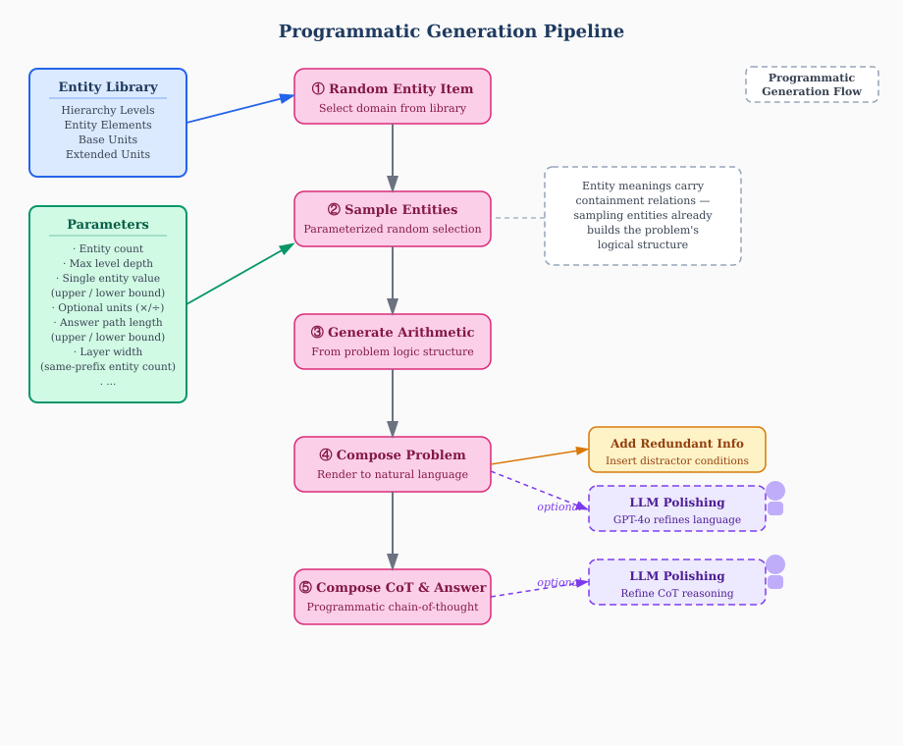
Figure 1: Programmatic Generation Pipeline. Blue box = entity library input; green box = configurable parameters; pink boxes = generation stages; yellow = redundant info insertion; dashed purple = optional LLM polishing stages.

2.2 Detailed Steps

2.2.1 Building the Entity Library

Step 1: Generate Base Classification Framework
- Given a random topic, an LLM generates a background story, 3–5 parallel classification sets with hierarchical relationships, and a base unit of measurement.
- Classification sets must balance association and independence: association ensures each level logically complements the others; independence ensures each level has a clear, distinct role without overlap or subordination.
- The unit of measurement specifies the concrete metric for entities within a given classification.

Step 2: Expand Classification Set Elements
- Using an LLM combined with human review, each classification level is expanded to 5–10 elements. Elements within a level must be parallel, independent, and mutually relatable across all pairings.
- For multiplication/division problems, corresponding multiplication-unit elements are generated from the base unit, ensuring any arithmetic operation can be embedded in the hierarchical network.

Example entity library (JSON):
{
"item": {
"background": "In a fertile rural region, many farms grow various crops...",
"classification_sets": ["Farm", "Crop", "Growth Stage"],
"base_unit": "Total Fertilizer Amount"
}
}

Step 3: Build Entity Network
- Entity relationships are established through an LLM: entities sharing the same unit are linked by addition/subtraction (containment); entities across different units are linked by multiplication/division.
- Same-level and cross-level linkage patterns are distinguished to ensure accurate and coherent data representation.

Example expanded network (JSON):
{
"item": {
"hierarchy": {
"Farm": ["Green Valley Farm", "Sunshine Ranch", "Blue Sky Farm", ...],
"Crop": ["Wheat", "Corn", "Soybean", "Rice", "Barley", ...],
"Growth Stage": ["Seedling", "Vegetative", "Flowering", "Fruiting"]
},
"extended_units": ["Fertilizer per Hour", "Growth Hours"]
}
}

2.2.2 Entity Identification and Assignment
- Level elements are assigned uppercase letter identifiers (e.g., A, B, C per level); description units receive lowercase identifiers.
- Composite entity codes follow the format (L1 code)(L2 code)...(unit code), e.g., AAa = Total Fertilizer for Crop A of Farm A.
- Same-level linkage key: "{layer_i} required {unit}"; adjacent-level linkage key: "{layer_1}'s {layer_2}'s required {unit}".

- Entities are classified into four types:
  - Known entities: assigned values directly from the answer tree
  - Unknown entities: solved by tracing the answer path
  - Queried entities: a special class of unknown entity — the target of the question
  - Redundant entities: not on the answer path; added to increase problem difficulty

Worked Example: Entity Identification
Consider a 3-level entity library with the topic "Factory Production":

Level | A | B | C | D
L1: Factory | Maria Factory | Burns Factory | Caesar Factory | Davis Factory
L2: Prod. Line | Pharma Line | Food Processing | Chemical Line | Smelting Line
L3: Prod. Unit | Unit A | Unit B | Unit C | Unit D

Given this lookup table, the composite code CBB identifies a specific entity by reading each character as a level selector:
- C from L1 → Caesar Factory
- B from L2 → Food Processing Line
- B from L3 → Unit B

If the base unit is "Daily Output", then the full entity CBB means: Caesar Factory's Food Processing Line's Unit B's Daily Output. This hierarchical naming scheme uniquely identifies any entity in the network, enables systematic traversal, and ensures all parent-child containment relationships are structurally consistent.

Same-level key (L2): "Caesar Factory's total daily output across production lines" → CCa = CBa + CCa + CDa + …
Cross-level key (L1→L2→L3): "Caesar Factory's Food Processing Line's Unit B's daily output" → CBBa
Entity Library Scale: 50 entity sets have been constructed across diverse domains. Each set has 3–5 hierarchical levels with 4–10 elements per level, yielding 2⁴ to 2⁵⁰ unique entity combinations per set. On average, each entity library supports approximately 1 billion distinct entity combinations.

2.2.3 Logic Tree Synthesis

Tree Structure
The logic tree is a directed tree where the queried entity is the root. Edges represent arithmetic or containment relationships. The answer is derived by traversing the tree from leaf (known) nodes to the root. Each node is either known, unknown, or redundant. The diagram below illustrates a representative answer tree:

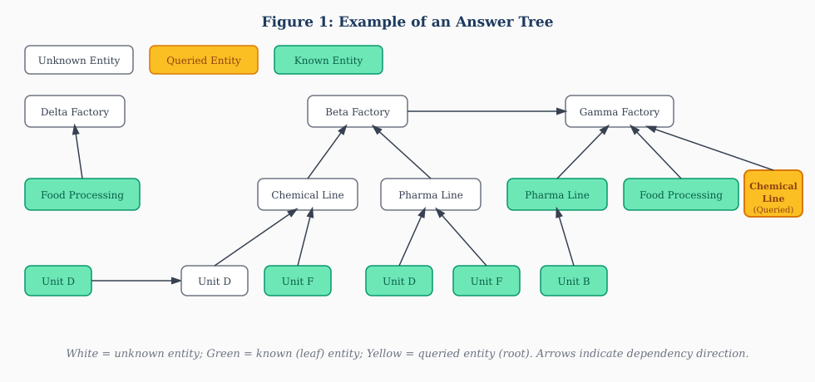
Figure 2: Example answer tree. White boxes = unknown entities; green = known (leaf) entities; yellow = queried entity (root). Upward arrows represent containment or arithmetic dependency.

Tree Parameters
- Total entity count (excluding redundant entities)
- Maximum entity level depth
- Maximum answer path length
- Maximum layer width (max entities sharing the same prefix)
- Multiplication switch (whether to generate × / relations)

Tree Generation Algorithm
Starting from an initial entity A, the tree expands by repeatedly selecting one of the following operations at each node:
- Define parent level: Entity E₁ at level i is given a parent E₀ at level i−1, plus siblings E₂…Eₙ at level i. Relationship: E₀ = E₁ + E₂ + … + Eₙ.
- Define child level: Entity E₁ at level i is given children E₂…Eₙ at level i+1. Relationship: E₁ = E₂ + E₃ + … + Eₙ.
- Define arithmetic relation: Entity E₁ at level i is linked to E₀ at the same level (different prefix) by: E₁ ± × ÷ value = E₀.
- Define multiplication unit relation: If unit a = b × c, an entity with unit a derives entities with units b and c at the same position.
- If no expansion is chosen, the entity is designated as a known (leaf) entity.
Expansion continues until the total entity count reaches the configured maximum.

The figure below shows a high-complexity (op20+) tree demonstrating how multiple source groups connect through cross-source arithmetic relations:
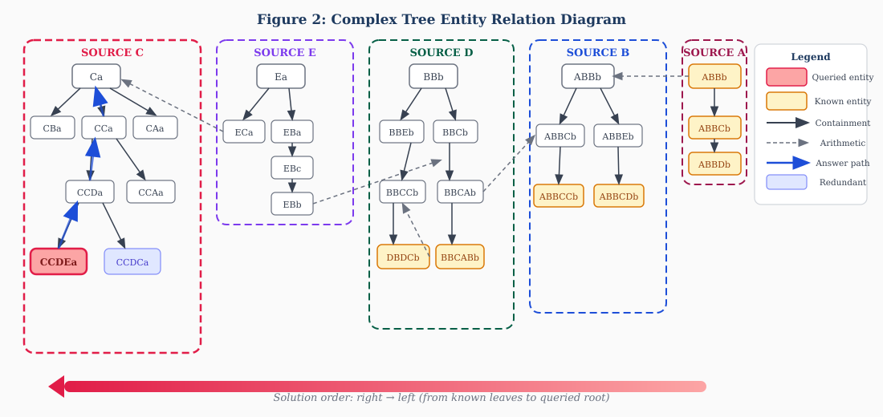
Figure 3: Complex Tree entity relation diagram. Each colored rectangle is one "source group" (entities sharing the same L1 prefix). Solid arrows indicate containment; dashed arrows indicate arithmetic relations. Blue thick arrows trace the answer path from the queried entity (red) back through intermediate unknowns to known leaf nodes.

2.2.4 Problem and CoT Generation

Problem Composition
- The problem is rendered from the logic tree using the entity library. Format: (Background story) + (Known entity values) + (Logical/numerical relations) + (Question entity).
- To avoid directly exposing the hierarchy, when conditions constrain a higher-level entity, the lower-level entities use same-level linkage keys.
- Approximately 70 paraphrase templates are used for condition expression, significantly enhancing linguistic diversity. For example, for multiplication: "AAA is XXX times larger than BBB" / "AAA is the result of scaling up BBB by XXX" / etc.
- Conditions are shuffled and redundant entity conditions are inserted as distractors to increase retrieval difficulty.

CoT Generation and Polishing
The programmatic CoT follows the format: (Extract known values) → (Restate logical/numerical relations) → (Arithmetic computation). Three limitations exist in raw program-generated CoT:
- The reasoning path does not reflect hierarchical classification structure
- Computation steps are not integrated into the reasoning narrative
- Language is rigid and mechanical

GPT-4o is used to resolve these issues. The polishing prompt provides: (1) the original problem, (2) the program-generated reference CoT, and (3) an ideal answer framework. GPT-4o outputs a refined CoT that integrates reasoning, hierarchy, and natural language. In practice, this achieves ~90% usable rate on mixed-difficulty datasets.

3. Experimental Results

3.1 Benchmark Evaluation

3.1.1 Experimental Setup
- Test set: op5–op20, 15 groups, 300 samples per group.
- Four generation methods (per group):
  - Method 1: Addition/subtraction expressed as containment relations (e.g., "Farm A's total fertilizer includes Wheat, Corn, and Soybean")
  - Method 2: Addition/subtraction expressed as explicit arithmetic (e.g., "Farm A's Wheat = Farm A total − Corn − Soybean")
  - Method 3: Method 1 with all conditions shuffled
  - Method 4: Method 2 with all conditions shuffled
- Models tested: GPT-4o, O1 (closed-source); Qwen-72B, Qwen-7B-Math (open-source).
- Metric: exact match accuracy (correct / 300).

3.1.2 Benchmark Results
Model | Method | op5 | op6 | op7 | op8 | op9 | op10 | op11 | op12 | op13 | op14 | op15
GPT-4o | 1 | 207 | 185 | 143 | 116 | 99 | 82 | 65 | 68 | 41 | 49 | 43
GPT-4o | 2 | 215 | 212 | 178 | 134 | 126 | 115 | 84 | 94 | 69 | 68 | 44
GPT-4o | 3 | 217 | 200 | 158 | 133 | 107 | 103 | 64 | 68 | 42 | 54 | 38
GPT-4o | 4 | 233 | 219 | 179 | 159 | 146 | 119 | 103 | 98 | 80 | 83 | 62
Qwen-72B | 1 | 199 | 178 | 148 | 109 | 122 | 98 | 65 | 71 | 47 | 58 | 41
Qwen-72B | 2 | 200 | 154 | 131 | 97 | 79 | 81 | 64 | 53 | 53 | — | —
Qwen-7B-Math | 1 | 70 | 45 | 31 | — | — | — | — | — | — | — | —
O1 | — | 230 | 232 | 227 | 224 | 196 | 223 | 214 | 207 | 191 | 197 | 192

3.1.3 Conclusions
- Accuracy monotonically decreases as the number of unknown entities increases. 7B models drop to ~10% at op7; 72B and GPT-4o reach ~10% at op15.
- O1 degrades more slowly with difficulty, stabilizing around 65% accuracy at op15.
- Difficulty ranking by method: Method 1 < Method 3 ≈ Method 2 < Method 4.
- Models struggle more with inferring arithmetic from containment descriptions (Method 1) than from explicit operations (Method 2).
- Shuffling conditions has relatively little effect, indicating models are proficient at condition retrieval.
- This confirms that the generated dataset (especially Method 1) provides a genuinely challenging training signal for complex multi-step reasoning.

3.2 Model Fine-Tuning

3.2.1 SFT Fine-Tuning

Experimental Setup
- Five training sets generated (V0): op0-5, op5-10, op10-15, op15-20 (~2000 samples each, Method 1), plus mixed op0-20 (~4000 samples).
- Fine-tuning: learning_rate = 1e-5, train_epochs = 1.0, base model Qwen2.5-3B.
- Four test sets (V0): op0-5, op5-10, op10-15, op15-20 (~400 samples each, Method 1).

SFT Results
Model | op0-5 test | op5-10 test | op10-15 test | op15-20 test
Qwen2.5-3B (base) | 68.05% | 25.08% | 20.57% | 16.30%
SFT on op0-5 | 87.59% | 34.08% | 19.54% | 16.85%
SFT on op5-10 | 75.75% | 54.98% | — | 32.71%
SFT on op10-15 | 72.93% | 72.93% | 59.64% | —
SFT on op15-20 | 66.92% | 64.31% | — | 59.38%
SFT on mixed op0-20 | 93.05% | 81.03% | — | ~70%

SFT Conclusions
- Difficulty matching is optimal: Training and test sets at matching difficulty yield the best results. SFT on op0-5 achieves +19.54% vs. base on the op0-5 test; SFT on op15-20 achieves +43.08% vs. base on the op15-20 test.
- Single-difficulty models collapse on harder tests: SFT on op0-5 scores only 16.85% on the op15-20 test (barely above base). SFT on op5-10 scores 32.71% on op15-20, far below the matched setting's 59.38%.
- Mixed-data generalizes best: Mixed op0-20 SFT achieves top performance on all test sets, with near-flat accuracy decay as difficulty increases — nearly 70% improvement over base on hard problems.
- Negative transfer: SFT on op0-5 scores below base (19.54% vs. 20.57%) on the op10-15 test, indicating low-difficulty over-training can degrade mid-to-hard reasoning ability.

3.2.2 DPO Fine-Tuning

Experimental Setup
- Positive/negative samples constructed by running each SFT model 10 times on all test sets: correct answers = positive, incorrect = negative.
- Two DPO configurations: (a) Base + DPO; (b) SFT + DPO.
- Four test sets (V1): op5-10, op10-15, op15-20, op20-25 (~400 each).

Base + DPO Results
Model (trained on) | op5-10 test | op10-15 test | op15-20 test | op20-25 test
DPO on op0-5 | 26% | 21% | 17% | 22%
DPO on op5-10 | 28% | 19% | 18% | 21%
DPO on op10-15 | 27% | 18% | 18% | 20%
DPO on op15-20 | 25% | 17% | 17% | 19%
Base Qwen2.5-3B | 68% | 25% | 21% | 16%

SFT + DPO Results
Model (SFT+DPO on) | op5-10 test | op10-15 test | op15-20 test | op20-25 test
SFT+DPO on op0-5 | 18% | 17% | 17% | 17%
SFT+DPO on op5-10 | 24% | 20% | 22% | 26%
SFT+DPO on op10-15 | 23% | 27% | 32% | 28%
SFT+DPO on op15-20 | 28% | 24% | 32% | 29%
Base Qwen2.5-3B | 68% | 25% | 21% | 16%
SFT mixed op0-20 | 93% | 81% | 73% | 69%

DPO Conclusions
- Base + DPO is largely ineffective: DPO-only models perform far below base (op5-10: best DPO 28% vs. base 68%). Marginal improvement only on op20-25 (+5–10%).
- SFT + DPO shows moderate improvement: +10%+ on op15-25 compared to base, with difficulty-matched training showing the best generalization (op15-20 and op10-15 both reach 32% on op15-20 test).
- SFT + DPO underperforms SFT alone: Adding DPO on top of SFT significantly lowers accuracy compared to pure SFT. This may relate to sample selection strategy and training dynamics in the RL phase.

3.3 RL Fine-Tuning

Model Settings
Setting | Base Model | Training Data | Strategy
Setting 1 | Qwen2.5-3B-Instruct | Synthesized business data | Direct RL (GRPO)
Setting 2 | Qwen2.5-3B-Instruct | Synthesized data: full SFT → RL | Full SFT + RL
Setting 3 | Qwen2.5-3B-Instruct | Synthesized data: 500-sample SFT → RL | Cold-start SFT + RL
Setting 4 | Qwen2.5-3B-Instruct | MATH hard samples | Direct RL
Setting 5 | Qwen2.5-3B-Instruct | Mixed: business + MATH | Direct RL

RL Results (Zero-Shot)
Setting | MATH-500 | GSM8K | ASDiv | SVAMP | Avg | op0-10 | op10-15 | op15-20 | op20-25 | op25-30
Setting 1 | 57.0 | 83.7 | 91.3 | 91.2 | 80.8 | 95.33 | 81.33 | 43.0 | 9.33 | 0.33
Setting 2 | 29.8 | 29.8 | 67.7 | 51.5 | 44.7 | 69.0 | 36.33 | 16.0 | 9.33 | 1.0
Setting 3 | 55.2 | 77.6 | 87.9 | 85.7 | 76.6 | 90.67 | 65.0 | 41.33 | 17.0 | 11.33
Setting 4 | 64.0 | 86.2 | 92.7 | 92.9 | 83.9 | 25.33 | 2.67 | 0 | 0.33 | 0.33
Setting 5 | 65.8 | 87.9 | 93.4 | 92.9 | 85.0 | 46.33 | 5.67 | 1.0 | 0 | 0

RL Conclusions
- Synthetic data dramatically boosts domain reasoning: Direct RL on synthetic data (Setting 1) raises op0-10 accuracy from 25.33% to 95.33% (+276%). On the hardest op25-30 band, Setting 3 (cold-start SFT + RL) achieves 11.33% while the base model scores 0%.
- "Less SFT is more": Full SFT + RL (Setting 2) is markedly weaker than pure RL (Setting 1): on op10-15, accuracy drops from 81.33% → 36.33% (−55%). This is likely due to over-fitting of output format caused by large-scale SFT, which suppresses the model's capacity to extend reasoning chains. Cold-start SFT with only 500 samples (Setting 3) outperforms full SFT + RL across all difficulty bands and achieves the best results on hard problems (op15-30).
- Mixed data shows threshold effects: Mixing ~10% synthetic data into math RL (Setting 5) noticeably improves easier problems (op0-10: +21% over Setting 4) but has minimal impact on harder bands (op15-30). Mixed RL accuracy lies between the base model and pure synthetic RL, suggesting domain mismatch can introduce interference.
- Recommended training recipe: 500-sample SFT cold start → RL on synthetic data → final fine-tuning with a small math mixture. This combines Setting 3's superior hard-problem reasoning with Setting 5's domain generalization.
- At op20-30 difficulty, improvements are limited. Increasing the proportion of op20+ synthetic samples or introducing adversarial generation mechanisms may be needed to further improve complex reasoning.

4. Conclusions
This pipeline generates a hierarchically structured, programmatically verifiable dataset that substantially improves model performance on long-chain mathematical reasoning and variable dependency tracking. Key takeaways:

- The hierarchical entity library with logic tree synthesis enables scalable, diverse, and difficulty-controlled problem generation.
- Synthetic data is highly effective for training domain-specific reasoning: RL on business-domain synthetic data can boost in-domain accuracy by ~3×.
- Cold-start SFT with minimal data (500 samples) followed by RL is the optimal training recipe — preserving the model's reasoning extension capacity while establishing the required output format.
- Mixed-difficulty SFT training (op0-20) provides the most robust generalization across all difficulty levels, with near-constant accuracy degradation as problem complexity grows.
- DPO, when applied after SFT, consistently underperforms pure SFT, likely due to the constraints of RL sample selection on small models.

The dataset reliably challenges models on hierarchical containment reasoning, long-chain arithmetic, condition retrieval from shuffled contexts, and multi-step variable dependency tracking — all critical capabilities for real-world complex mathematical problem solving.

Appendix A: Sample Problem
The following is a representative generated problem at ~op10 difficulty (Method 1, polished by GPT-4o):

In a fertile rural region, many farms grow various crops. Each crop requires different amounts of fertilizer at different growth stages. One day, the farm management decided to conduct an in-depth data analysis to accurately understand fertilizer requirements.

Known conditions:
- Green Valley Farm's oats hourly fertilizer requirement during the flowering stage is 22.
- Green Valley Farm's oats growth hours is 2.
- Green Valley Farm's total fertilizer requirement is 18.
- Green Valley Farm's barley total fertilizer during the seed stage is 29; during flowering is 28.
- Green Valley Farm's potato total fertilizer during the seed stage is 12; vegetative stage is 17.
- Sunshine Ranch's potato hourly fertilizer requirement is 7.
- Golden Harvest Farm's potato hourly fertilizer requirement during flowering is 20.
- Green Valley Farm's oats hourly fertilizer includes flowering, vegetative, and seed stage requirements.
- Golden Harvest Farm's potato seed stage hourly fertilizer = Sunshine Ranch's potato seed stage hourly fertilizer × 4.
- Green Valley Farm's total fertilizer includes barley, potato, and oats total requirements.
- Green Valley Farm's oats total fertilizer includes seed and vegetative stage requirements.
- Sunshine Ranch's potato seed stage hourly fertilizer = Green Valley Farm's oats seed stage hourly fertilizer − 1.

Question: Calculate Golden Harvest Farm's potato hourly fertilizer requirement. Negative values may appear in the answer.

Appendix B: RL Training Configuration
Key GRPO training parameters used in Settings 1–3:
python3 -m verl.trainer.main_ppo \
algorithm.adv_estimator=grpo \
data.train_batch_size=128 \
data.max_prompt_length=1024 \
data.max_response_length=4096 \
actor_rollout_ref.actor.optim.lr=1e-6 \
actor_rollout_ref.actor.use_kl_loss=True \
actor_rollout_ref.actor.kl_loss_coef=0.001 \
actor_rollout_ref.rollout.temperature=0.6 \
actor_rollout_ref.rollout.n=8 \
trainer.n_gpus_per_node=8 \
trainer.nnodes=1 \
trainer.save_freq=50

Reward function requirement: the final answer must be exactly correct (no partial credit).

