Life748 Skills & Project Planning and Development TEMPLATE

Please complete this template for your skills and project planning and development. This will need to be submitted to the MO in Semester 2, Week 16.

COVER PAGE

Your Name: Victoria Aldcroft
Your Programme of Study: MSc Bioinformatics
Your Supervisor Name: Prof. Alistair Darby

Project Title: You won’t be-leaf the size of this genome (Phyllium philippinicum)

Academic Year: 2024-25

Update this contents page as you go

Table of Contents
Acronyms 3
1. Your Project Plans 4
2. Reflective Logs 5
2.1 Initial Reflective Log 5
2.2 Interim Reflective Log 5
2.3 Final Reflective Log 5
3. Development of Generic Research Skills 6
3.1 Tracking of Generic Research Skills Development 6
3.2 Evidence of Development of Generic Research Skills 8
4. Development of Specific Research Skills and Knowledge 9
4.1 Identification of Specific Research Skills and Knowledge Needed for your Project 9
4.2 Evidence of Development of Specific Research Skills and Knowledge 10
5. Record of Meetings 11

Acronyms

Add explanation of any acronyms used throughout your portfolio here.

ONT – Oxford Nanopore Technology
PacBio – Pacific Biosciences

Your Project Plans

In this section include dated entries detailing your project plans as they develop, including:

- Your project aims
- Broadly, the approach(es) you plan to be taking

You may find that you have clear plans for your LIFE703 project right from the start, in which case you may only need one or two entries in this section.

However, you may also find that your project plans are less clear at the start and develop throughout semesters 1 and 2. In this case, we would expect to see more entries in this section detailing the development of these plans.

AIM 1: Get a high quality DNA extraction from an adult female P. philippinicum
AIM 2: Assemble the genome to contig level
AIM 3: Gene calling, I would really like to try and locate Ultrabithorax as this is my main gene of interest but I would like to annotate as many as possible.
AIM 4: Comparative genomics this could be finding where Ultrabithorax fits in the phylogenetic tree in comparison the Ubx from the related stick insects.
AIM 5: Look into where the genome fits into the Phasmatodea phylogenetic tree.
AIM 6: Estimate genome size and repeat content

Ideas of figures:
- AlphaFold to visualise some of the proteins from a selection of genomes.
- Genome size comparisons

Statistics:
- Contig lengths
- Size
- Number of genes found
- Repetitive region %
- Completed-ness BUSCO
- Missing
GC content

Reflective Logs

Use this section to complete your three reflective logs.

Include reflections on your progress gaining both generic research skills, and research skills and knowledge that are specific to your project.

Also, include your current understanding of your project aims and research plan for Life703.

See your handbook for further guidance on what is expected, and the deadline for each log entry.

Initial Reflective Log

The main commands are not the most difficult part, it is knowing which parameters to use or which things to specify/change in order to get it to work. The only command I have used out of the box is QUAST, all others needed some tweaking. Especially purge_dups which required a lot of further reading to realise that ‘-p bash’ was missing from the documentation. The most difficult parts are the data pre-prep before commands such as creating a meryl database for merqury etc. it seems like there is always more that needs to be done than just using the commands. I have had to taught myself all new things such as what is an assembly graph, to then how to view it and interpret it. I have enjoyed it all but it can be quite overwhelming but patience is key.

Interim Reflective Log

Final Reflective Log

Development of Generic Research Skills

Generic, or ‘dry’ research skills are skills that are important for all science researchers regardless of research topic/area and include skills such as using a referencing software, critical thinking, time management and using generic software such as PowerPoint, Word and Excel, as well as Bioinformatics tools.

This section of your portfolio should be dedicated to reflecting on your generic research skills and logging your progress in developing these further.

Tracking of Generic Research Skills Development

Complete this table three times throughout the year, in weeks 4 and 11 of semester 1, and week 7 of semester 2. This will help you identify areas you need to develop and will help you monitor your progress.

Add any further skills that you can think of by adding rows to the bottom of the table.

You should then document your progress on developing these skills in the next section.

As a starting point, we have provided links to training resources in Appendix I of your module handbook. These resources are a starting point, please do use other resources you find as well.

Generic Research Skill | If needed, how will you address this area? | Confidence Rating  (1 to 5, where 5 is very confident)
 |  | S1, W5 | S1, W11 | S2, W8
Understanding and applying Academic Integrity standards
Searching the Literature

Referencing

Using a Reference Manager, such as Endnote
Word Processing using Microsoft Word
Creating a presentation in PowerPoint
Creating a poster in PowerPoint
Using Excel for simple manipulation and presentation of data
Applied bioinformatics skills e.g., Data visualisation, HPC and job submission, version control, containerisation, reproducible pipeline production
Applied bioinformatics for omics
Machine Learning (ML) and Artificial Intelligence (AI)
Understanding of Research Ethics
Critically reading of Literature

Literature review writing

Grant Proposal Writing

Report Writing

Sitting a Viva

Time Management

Note Taking

Record keeping

Professional use of the English Language

Reflective writing

Add Additional Skills Below (add more rows as required)

Evidence of Development of Generic Research Skills

As you work on developing your generic research skills, identified in the table above, add evidence of your work here.

Remember to include reflections on your progress.

Date each entry.

Development of Specific Research Skills and Knowledge

This section is for you to log your progress on the development of skills and knowledge that are specific to your research project. This will include up-to-date knowledge around your research area, experimental skills, specific data analysis skills etc.

Identification of Specific Research Skills and Knowledge Needed for your Project

Complete this table three times throughout the year, in weeks 5 and 11 of semester 1, and week 8 of semester 2. It should help you identify areas you need to develop and will help you monitor your progress.

It is important that you collaborate with your supervisor to identify areas that you need to develop in preparation for your research project. Make sure you discuss this table regularly with your supervisor.

Keep adding to the table as you progress through semesters 1 and 2. You can insert more rows when you need them.

Specific Research Skill or Knowledge Area | How will you address this area? | Confidence Rating  (1 to 5, where 5 is very confident)
 |  | S1, W5 | S1, W11 | S2, W8

Evidence of Development of Specific Research Skills and Knowledge

As you work on developing your specific research skills and knowledge, identified in the table above, add evidence of your work here.

Remember to include reflections on your progress.

See your handbook for further guidance.

Date each entry.
- Cps
- Screen

13/12/2024 – Raw Data

Total amount of data is 319GB – the estimated genome size Is 2.8GB. Coverage = x 113 (See Genomescope later on)

Include data statistics

14/12/2024 – Basic Aim

I will try 4 different assemblers: Shasta, Flye, HiCanu and HiFiASM. For each of them I will get the following statistics:

-QUAST
-Bandage
-BUSCO
-samtools mapping
-Merqury

I will then take the best assembly forwards for gene calling and annotation/downstream analysis.

15/12/2024 – Jellyfish

Background
Use jellyfish to create kmers of the reads to estimate genome size. For this, I used a kmer size = 21. Since this was my first time running anything, I spoke to Mark about what parameters (hash size and threads) to use.

Useful Links
GitHub - gmarcais/Jellyfish: A fast multi-threaded k-mer counter
GitHub - zippav/Jellyfish-2: A fast multi-threaded k-mer counter

Method
Step 1. Install Jellyfish
conda install -c bioconda -c conda-forge jellyfish

Step 2. Create k-mer file – REMEMBER -C
jellyfish count -m [kmer_size] -s 1G -t [thread number] -C -o [output file name.jf] [raw_reads.fastq]

Step 3. Create histo file
jellyfish histo -o [output.histo] [input.jf]

15/12/2024 – GenomeScope2

Background
Once I have created the histo file with jellyfish, I can then use this either on the command line or on the online genomescope2 website. I chose to do it on the command line.

Useful Links
GitHub - tbenavi1/genomescope2.0: Reference-free profiling of polyploid genomes

Method

Step 1. Install GenomeScope2
conda install bioconda::genomescope2

Step 2. Run GenomeScope2
genomescope.R -i [input.histo] -o [output_directory] -k [kmer_size] -p [ploidy]

Notes
Initially I ran it with an assumption of diploidy, followed by assumption of triploidy. If I look at the model, the diploidy model seems to fit better due to higher model fit and all p-values < 0.01. This diploid model predicts genome size of 2,758,362,861bp and 99.1% homozygosity. Interestingly, 34.2% of the genome is predicted to be repeats - much lower than other Phasmids.

Diploid results

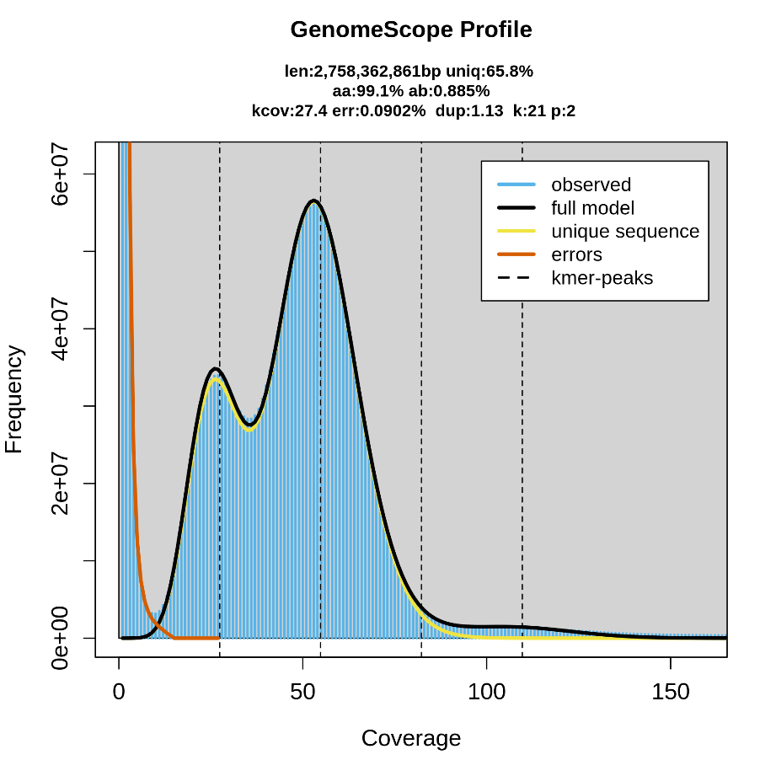

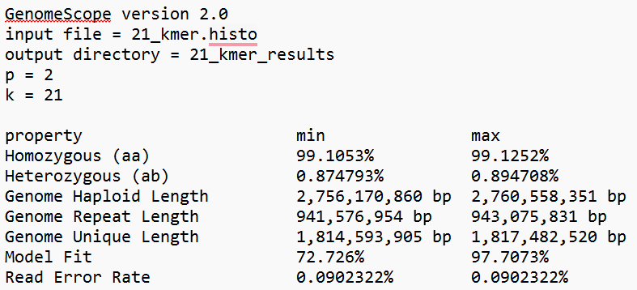
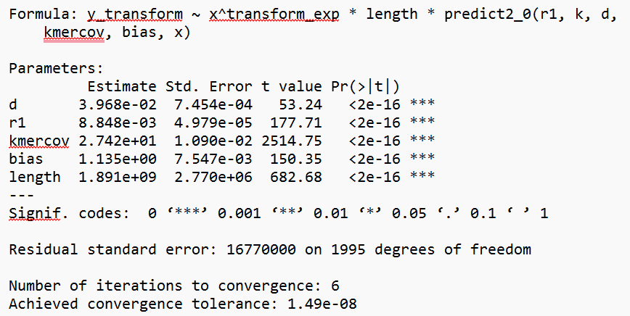
Triploid Results
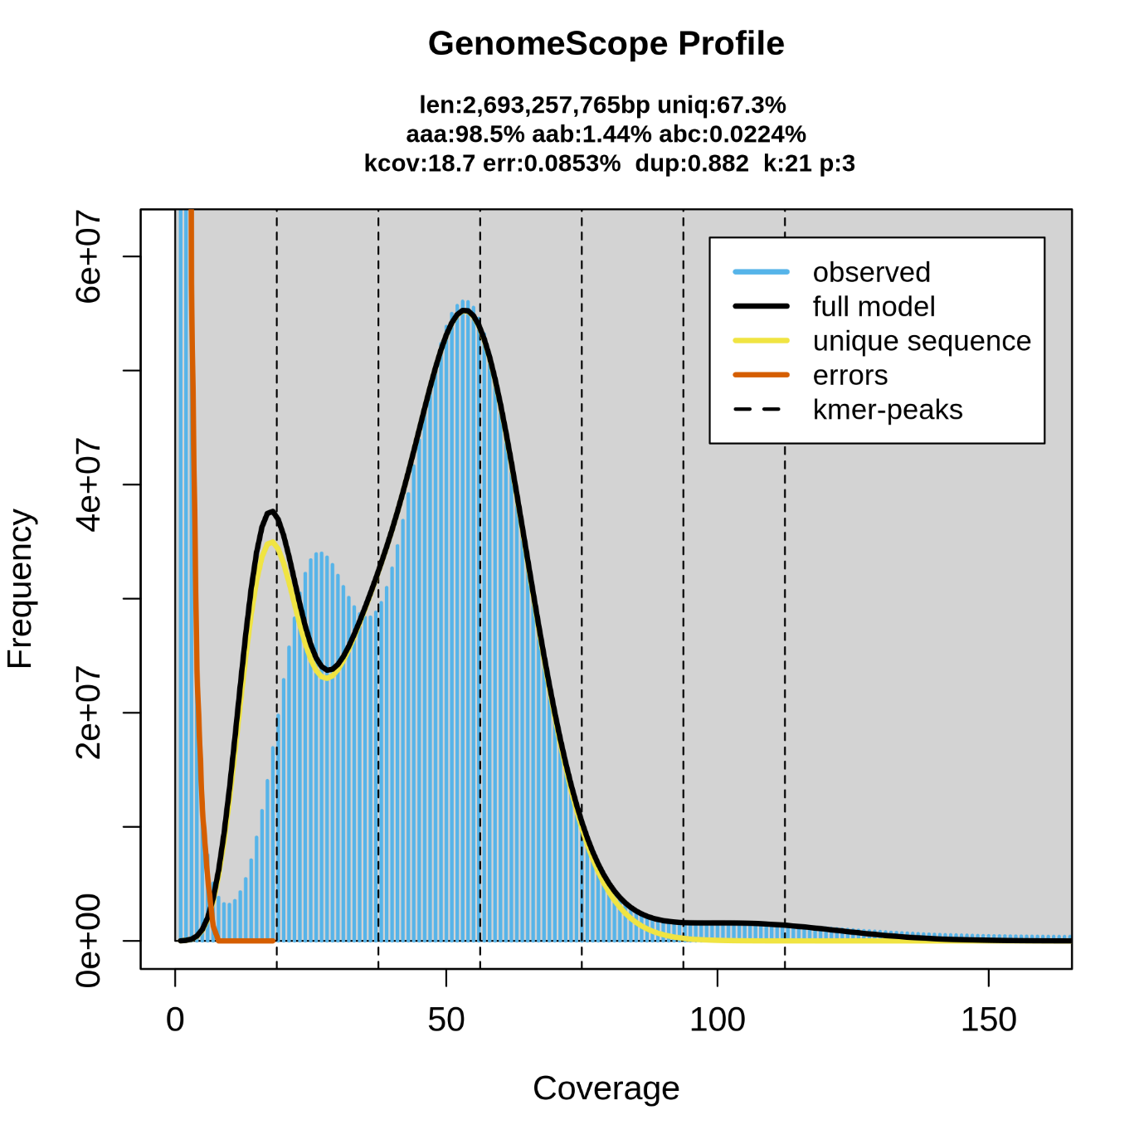
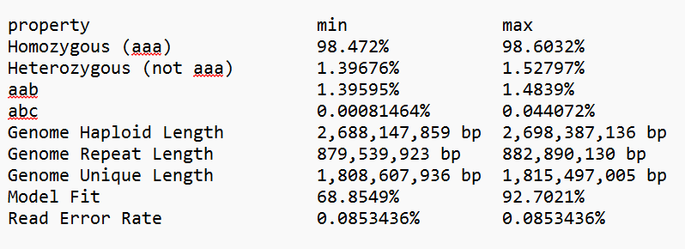

06/01/25 - Smudgeplot Attempt 1

Background

This will produce an ouput pdf file, in it should be the smudge plot along with a ploidy prediction and confidence values for other ploidys. GenScope2 inferred diploid status from the kmers.

Useful Links

Smudgeplot | Anaconda.org
Fastk | Anaconda.org
Histogram was gone · Issue #177 · KamilSJaron/smudgeplot · GitHub
Multiple lines of evidence suggest mosaic polyploidy in the hybrid parthenogenetic stick insect lineage Acanthoxyla

Attempt 1: DIDN’T WORK - MEM peaked at 97%. Can only use 1 thread. Updated the version to 0.4.0 which has multithreading.

Method
Step 1. Download newest version
conda install bioconda::smudgeplot=0.4.0

Step 2. Dump kmers from the jellyfish .jf file to .txt
jellyfish dump -c [mer_counts.jf] > kmer_counts.txt

Step 3. Then use smudgeplot to identify heterozygous kmers to infer ploidy
smudgeplot.py hetkmers [kmer_counts.txt] > smudge_input.tsv

Step 4. Create plot using tsv file
smudgeplot.py plot smudge_input.tsv

07/01/25 - Smudgeplot Attempt 2

Background

Useful Links

Method
Step 1. Download FastK

Step 2. Run FastK this will output several files, .ktab is the most useful
fastK -t[threads]-k[kmer length] -T32 [raw_reads.fastq]

Step 2. Calculate hetmers, the .smu output is the most important
smudgeplot.py hetmers -L 10 -t [threads] -o [output file] [reads.ktab]

Step 3. Plot
smudgeplot.py all -o [output_prefix] [input_file.smu]

Notes
Expected histograms on plot too as that is what I am used to seeing but Nov 2024 they removed histograms as part of the plot.
It works best on short-read technology, and genomes with high repeats can cause high error rates (like ours) but this concurs with genscope of this leg tissue being diploid - remember that mosaic polyploidy exists though.

Results
0.86 prediction rate of diploidy, vs 0.07 triploidy. There is average cover of 54 and there is a 22% error rate for this estimate which is quite high.

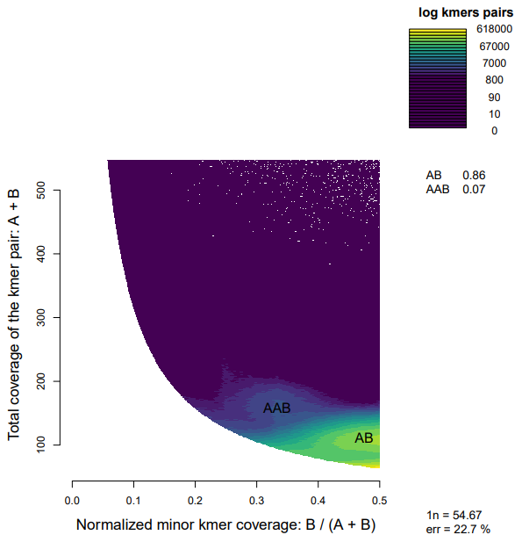

16/12/2024 - QUAST

Background
Run QUAST to look at the genome statistics.
I can ask for al of the metrics that are between N0 to N100 so that we can combine the data and then create a plot of all of all the data so that I can create an Nx graph to then see if the N50 for which assembly is the best. QUAST doesn’t usually output all of the metrics so we have to specify using metaQUAST that we waquasnt the values between x and x. See the link below

Useful Links
QUAST 5.3.0 manual
GitHub - ablab/quast: Genome assembly evaluation tool

Method
Step 1. Install quast
conda install bioconda::quast

Step 2. Run
quast.py genome_assembly.fasta -o quast_assembly

20/12/2024 – Bandage

Using bandage to look at the assembly graph. Al asked what the assembly graph looked like? I thought he meant the gfa file but when I run it with bandage it doesn’t look correct. I tried running it on all the gfa files. I then decided to practice with the Ecoli file to see what is going on. I ran the .bp.p_utg.gfa file and this gave a better graph I think? I ran the p_ctg.gfa file and it was just lots of lines with no connection between them?

Assembly Graph -Software -De Novo Assembly -Official 10x Genomics Support

Command Line Bandage
Bandage image [input.gfa] [output.png]

18/12/2024 – Merqury

Background

Useful Links
GitHub - thegenemyers/MERQURY.FK: FastK based version of Merqury
GitHub - marbl/merqury: k-mer based assembly evaluation
Hands On | Eukaryotic Genome Assembly Using PacBio and Hi-C
Prepare meryl dbs · marbl/merqury Wiki · GitHub
Quick Start — meryl 1.3 documentation

Messed up downloading merquryfk - had to fix conda:
python - Solve conda-libmamba-solver (libarchive.so.19) error after updating conda to 23.11.0 without reinstalling conda? - Stack Overflow

Method
Step 1: Use meryl to create a database
meryl k=21 count [reads_file.fastq] output [meryl_database.meryl]

Step 2: Run Merqury
$MERQURY/merqury.sh [meryl_database.meryl] [genome.fasta] [out_prefix]

18/12/2024 – Purge_haplotigs ????????????

mroachawri / purge_haplotigs — Bitbucket

To run the purge_haplotigs we need to create a kmer file using meryl (see above). It isn’t compatible with jellyfish unfortunately. Once we have done that (I didn’t) this would’ve been the code.

Step 1: Align PacBio reads to a reference genome
minimap2 -x map-hifi -t 16 reference.fasta pacbio_reads.fq > pacbio_aligned.sam

Step 2: Convert SAM to BAM
samtools view -bS pacbio_aligned.sam > pacbio_aligned.bam

Step 3: Sort the BAM file
samtools sort pacbio_aligned.bam -o pacbio_aligned_sorted.bam
Step 4: Index the BAM file
samtools index pacbio_aligned_sorted.bam

Step 5: Index the genome fasta file
Samtools faidx genome.fasta

19/12/2024 – Purge_dups Attempt 1

GitHub - dfguan/purge_dups: haplotypic duplication identification tool

Managed to figure out the wrapper script - turns out you have to add ‘-p bash’ to the line of code and then redirect to the bin file of the executable files for run_purge_dups.py. You can also m ake up your own species ID. Code:

Step 1. Use pd_config.py to generate a configuration file.
pd_config.py [assembly.fasta] [reads.fastq]

This gives an output pb.fofn and a config.json file.

Step 2. Modify the configuration file manually (optional).
Used nano to open config.json. Here I had to specify the BUSCO lineage as well as the directory for the pb.fofn files. Make sure to set “mnmp” as -x map-hifi and for the reference genome in the nano file to be the current directory

Step 3. Run purge_dups
run_purge_dups.py -p bash [config.json] [directory where purge_dup files are, this was /pub63/vica/miniconda3/envs/purge_dups/bin] [species ID]

Forums with issues in:

Crashed.

Crashed for a 2nd time

08/01/2025 - Purge_dups Attempt 2

Background

Useful Links
GitHub - dfguan/purge_dups: haplotypic duplication identification tool
High amount of duplication after purge_dups · Issue #1731 · marbl/canu · GitHub
species identifier (spid) & platform (PLTFM) · Issue #23 · dfguan/purge_dups · GitHub
Command split_fa failed return code: 2 · Issue #139 · dfguan/purge_dups · GitHub
ERROR: run_busco2 failed, return code: 127 · Issue #146 · dfguan/purge_dups · GitHub
Unable to locate files in config · Issue #48 · dfguan/purge_dups · GitHub

Method (Repeat min. twice)
Step 1: Map the reads to the assembly
minimap2 -t 64 -x map-hifi -I 20G assembly.fasta S1_S4_reads.fastq | gzip -c - > assembly.paf.gz

Step 2: pbcstat
/pub63/vica/miniconda3/envs/purge_dups/bin/pbcstat assembly.paf.gz

Step 3: calcuts
/pub63/vica/miniconda3/envs/purge_dups/bin/calcuts PB.stat > cutoffs 2>calcuts.log

Step 4: Split fasta
/pub63/vica/miniconda3/envs/purge_dups/bin/split_fa assembly.fasta > assembly.split

Step 5: Self-alignment
Minimap2 -t 64 -xasm5 -DP assembly.split assembly.split | gzip -c - > assembly.split.self.paf.gz

Step 6: Purge dups
/pub63/vica/miniconda3/envs/purge_dups/bin/purge_dups -2 -T cutoffs -c PB.base.cov assembly.split.self.paf.gz > dups.bed 2> purge_dups.log

Step 7: Purged fasta
/pub63/vica/miniconda3/envs/purge_dups/bin/get_seqs -e dups.bed assembly.fasta

REPEAT BUT REPLACE THE INITIAL ASSEMBLY WITH PURGED ASSEMBLY
Remember to rename the purged.fa file to (eg.) Shasta_purged_1.fa or it will overwrite

19/12/2024 – KILLING A SCREEN

screen -X -S 12345 quit

19/12/2024 – Samtools Mapping Attempt 1

I am going to use samtools as well as QUAST and BUSCO to assess genome completeness. Unfortunately I learned the hard way that minimap is much quicker, after I started running bwa for 24+ hours.

Step 1. Map the reads to the reference genome
Minimap2 -x [assembly.fasta] [reads.fastq]

Step 2. Convert SAM to BAM
Samtools view -S -b mapped_reads.sam > mapped_reads.bam

Step 4. Sort BAM file
Samtools sort mapped_reads.bam -o sorted_reads.bam

Step 5. Index the sorted BAM file
Samtools index sorted_reads.bam

Step 6. Look at the statistics
Samtools flagstat sorted_reads.bam
Samtools depth sorted_reads.bam > depth.txt

Step 7. Extract info
awk '{sum+=$3; count++} END {print "Average Coverage:", sum/count}' coverage.txt awk '{if($3==0) count++} END {print "Uncovered Bases:", count}' coverage.txt

THIS HAS BEEN RUNNING FOR OVER 48 HOURS NOW - rethink approach.

29/12/2024 – Minimap2 and SAMTOOLS ATTEMPT 2

Background

Useful Links
[WARNING] For a multi-part index, no @SQ lines will be outputted. Please use --split-prefix. · Issue #301 · lh3/minimap2 · GitHub

Method
Step 1. Mapping reads to the reference genome
time minimap2 -t 64 -ax map-hifi assembly.fasta reads.fq| samtools view -b -o output.bam

Step 2. Sort the BAM file
samtools sort [output.bam] -o [sorted_reads.bam]

Step 3. Index the sorted BAM if necessary
samtools index [sorted_reads.bam]

Step 4. Look at the statistics
Samtools flagstat sorted_reads.bam
Samtools depth sorted_reads.bam > depth.txt

Step 5. Extract mapping information
awk '{sum+=$3; count++} END {print "Average Coverage:", sum/count}' coverage.txt awk '{if($3==0) count++} END {print "Uncovered Bases:", count}' coverage.txt

Results
For some reason the purged duplicate HiFiASM doesn’t work? Managed to do HiFiASM non-purged though in 45 mins ish.

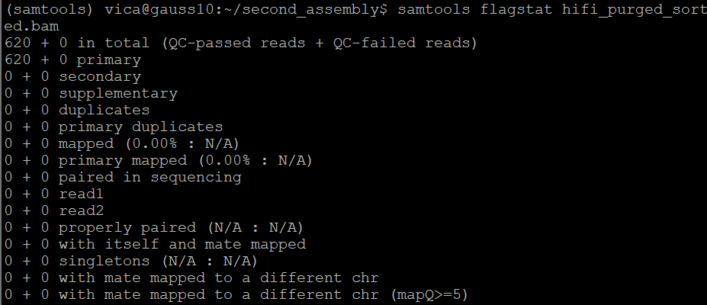

Why do none of my reads map? Why only 620 reads?
Mapped file looks good - 61G in size but sorted file only 700K - this is the problem!

30/12/2024 - Mapping attempt 3

Rerun the sorted step - sorted file = 53G
Index file - 31M

Notes
When a genome is greater than 4G it assumes multi-part index. For this we have to use ‘split-prefix’ where I need to give a prefix for temporary files for the other part of the index.

20/12/2024 – RepeatModeller

Background

Useful Links
GitHub - Dfam-consortium/RepeatModeler: De-Novo Repeat Discovery Tool

Method
Step 1. Download RepeatModeler. Download this by clicking on the repository on the right hand side
wget https://github.com/Dfam-consortium/RepeatModeler/archive/refs/tags/2.0.6.tar.gz

Step 2. Decompress the tar.gz file.
tar -zxvf RepeatModeler-2.0.6.tar.gz

Step 3. Build database.
BuildDatabase -name [prefix of database] [assembly.fasta]

Step 4. Run RepeatModeler
RepeatModeler -database [db-name] -threads 64 -LTRStruct

Notes
The prefix of database will be the input for RepeatMasker.

20/12/25 - RepeatMasker

Background
RepeatMasker is downloadable with conda but I will need to then download a database too which seems to be a bit harder. On the website it says I need to download a database to run it against. I am unsure which one to choose but I will have a look and see which can be downloaded. As I don’t know what the repeats look like in my genome I need to use repeatmodeller first to create a library to then use with repeatmasker.

Useful Links
Download Page
GitHub - Benson-Genomics-Lab/TRF: Tandem Repeats Finder: a program to analyze DNA sequences
RMBlast Download Page
MAFFT - a multiple sequence alignment program
Index of /pub/
GitHub - Benson-Genomics-Lab/TRF: Tandem Repeats Finder: a program to analyze DNA sequences
RepeatModeler2 for automated genomic discovery of transposable element families | PNAS
Releases · oushujun/LTR_retriever
GitHub - Dfam-consortium/RepeatModeler: De-Novo Repeat Discovery Tool

Method
Step 1. Download RepeatMasker
wget https://www.repeatmasker.org/RepeatMasker/RepeatMasker-4.1.7-p1.tar.gz

Step 2. Unpack the distribution
gunzip RepeatMasker-open-4.1.7-p1.tar.gz
tar xvf RepeatMasker-open-4.1.7-p1.tar

Step 3. RepBase RepeatMasker Edition
gunzip RepBaseRepeatMaskerEdition-20181026.tar.gz
tar xvf RepBaseRepeatMaskerEdition-20181026.tar
rm RepBaseRepeatMaskerEdition-20181026.tar
cd /path/to/RepeatMasker
perl ./configure

Step 4. Download TRF following github instructions.
git clone https://github.com/Benson-Genomics-Lab/TRF.git
cd TRF
tar xzvf trf-4.10.0.tar.gz
cd trf-4.10.0
mkdir build
cd build
../configure
make

Step 4. Downloaded RMBlast
wget https://www.repeatmasker.org/rmblast/rmblast-2.14.1+-x64-linux.tar.gz
tar zxvf rmblast-2.14.1-x64-linux.tar.gz
./configure

Step 5. Run RepeatModeler
RepeatMasker -lib [HiFi-families.fa] -pa 64 --xsmall [assembly.fasta]

Results
Final family count = 3692
LTRPipeline Time: 39:44:16 (hh:mm:ss) Elapsed Time.
The results are mostly as expected. However, there are 27% unclassified repeats, which may be due to the lack of available data. There are also 0% small RNA which is unusual. It may be worth creating a library from another Phasmid genome and then masking it using that?

I turned it into a csv file, with the first column just index of numbers. I then used this code to find the most common repeat in the genome:

data <-read.csv("HiFiASM3_repeats2.csv")

value_counts <- table(data$ID)

# Find the most common value
most_common_value <- names(sort(table(data[[ncol(data)]]), decreasing = TRUE))[1]

# Print the most common value
most_common_value

The most common repeat is rnd-5_family-571. There are 64837 instances of this repeat. That means this one repeat makes up of 2.1% the Unknown repeats. The second most common is rnd-1_family-330 with 56574 which makes up 1.9% of the Unknown repeats. The most common known repeat is ltr-1_family-30. There are 41357 instances of this repeat. This makes up 2% of the known repeats. Look back in the HiFiASM3-families.fa file to locate the repeats and BLAST them.

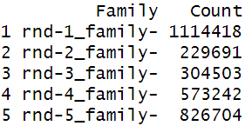

There are 3048558 Unknown sequences.

BLASTing the top repeat rnd-5_family-571 turns up one hit - https://www.ncbi.nlm.nih.gov/nucleotide/XM_049986719.1?report=genbank&log$=nucltop&blast_rank=1&RID=T85N6FGA016 this is a locust predicted protein. ras-associated and pleckstrin homology domains-containing protein 1-like. PREDICTED: Schistocerca cancellata ninjurin-B-like (LOC126148173), tra - Nucleotide - NCBI

BLASTing rnd-1_family-330 brings up no hits.

Plotting Repeats
data <-read.csv("HiFiASM3_repeats2.csv")

count_unknown <- sum(data$repeat_class == "Unknown")
print(count_unknown)

most_common_string <- names(sort(table(data$matching_repeat), decreasing = TRUE))[1]
print(most_common_string)
count_family1 <- sum(data$matching_repeat == "rnd-5_family-571")
print(count_repeat)

freq_table <- table(data$matching_repeat)
sorted_freq <- sort(freq_table, decreasing = TRUE)
second_most_common <- names(sorted_freq)[2]
print(second_most_common)

#second most common
second_most_common <- names(sorted_freq)[2]
count_family2 <- sum(data$matching_repeat == "rnd-1_family-330")

#third most common
third_most_common <- names(sorted_freq)[3]
count_family3 <- sum(data$matching_repeat == "rnd-2_family-120")

#MOST COMMON REPEAT THAT IS NOT UNKNOWN
filtered_data <- data[data$repeat_class == "Unknown", ]
dim(filtered_data)
# Find the most common value in 'matching_repeats' column of the filtered data
most_common_known_value <- names(sort(table(filtered_data$matching_repeat), decreasing = TRUE))[1]

# Print the most common value
print(most_common_known_value)
count_known <- sum(data$matching_repeat == "ltr-1_family-30")
print(count_known)

library(stringr)

count_ltr_1 <- sum(str_detect(filtered_data$matching_repeat, "^rnd-1_family-"))
count_ltr_2 <- sum(str_detect(filtered_data$matching_repeat, "^rnd-2_family-"))
count_ltr_3 <- sum(str_detect(filtered_data$matching_repeat, "^rnd-3_family-"))
count_ltr_4 <- sum(str_detect(filtered_data$matching_repeat, "^rnd-4_family-"))
count_ltr_5 <- sum(str_detect(filtered_data$matching_repeat, "^rnd-5_family-"))

# Create a summary table
summary_table <- data.frame(
Family = c("rnd-1_family-", "rnd-2_family-", "rnd-3_family-", "rnd-4_family-", "rnd-5_family-"),
Count = c(count_ltr_1, count_ltr_2, count_ltr_3, count_ltr_4, count_ltr_5)
)

# Print the summary table
print(summary_table)

data <- data.frame(
category = c("LINEs", "LTR elements", "Transposons", "Rolling Circles", "Simple Repeats", "Low Complexity Repeats"),
percentage = c(2.06, 16.46, 8.56, 1, 1, 1),
subgroup = NA # No subgroups here
)

# Data for the Unclassified subgroups
unclassified_data <- data.frame(
category = rep("Unclassified", 5),
subgroup = c("rnd1", "rnd2", "rnd3", "rnd4", "rnd5"),
percentage = c(22 * 0.36, 22 * 0.075, 22 * 0.10, 22 * 0.189, 22 * 0.271)
)

# Ensure both data frames have the same columns (with NA for missing ones)
data$subgroup <- NA # Add a 'subgroup' column for the main data, to match unclassified_data

# Combine the Unclassified data with the main data
combined_data <- rbind(data, unclassified_data)

category_totals <- combined_data %>%
group_by(category) %>%
summarize(total_percentage = sum(percentage)) %>%
arrange(desc(total_percentage))

combined_data$category <- factor(combined_data$category, levels = category_totals$category)

ggplot(combined_data, aes(x = category, y = percentage, fill = ifelse(is.na(subgroup), category, subgroup))) +
geom_bar(stat = "identity", position = "stack") +
theme_minimal() +
labs(
title = "Repeat composition of an assembled Phyllium philippinicum genome",
x = "Category",
y = "Percentage (%)",
fill = "Subgroup"
) +
scale_fill_manual(values = c("Unclassified" = "grey95", "LINEs" = "grey95", "LTR elements" = "green",
"Transposons" = "red", "Rolling Circles" = "purple", "Simple Repeats" = "orange",
"Low Complexity Repeats" = "yellow",
"rnd1" = "darkblue", "rnd2" = "darkgreen", "rnd3" = "darkred",
"rnd4" = "darkorange", "rnd5" = "lightgoldenrod")) +
theme(axis.text.x = element_text(angle = 45, hjust = 1))

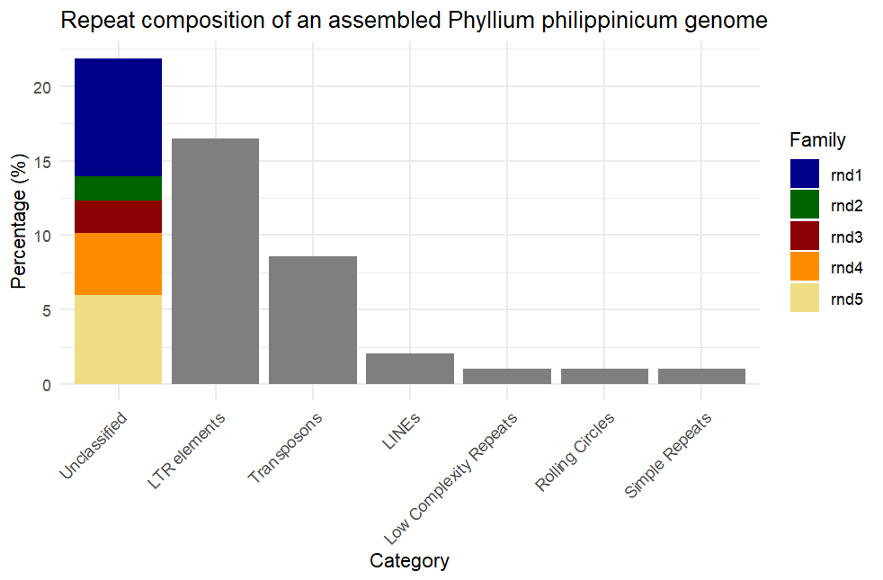

24/01 - cd-hit

Step 1. Conda download
conda install bioconda::cdhit

Results
Biggest repeat family was:
rnd-5_family-508#Unknown ( Recon Family Size = 265, Final Multiple Alignment Size = 254 )

20/12/2024 – Blobtoolkit Attempt 1

GitHub - blobtoolkit/blobtoolkit: Interactive quality assessment of genome assemblies
BlobToolKit

Downloadable with conda. Al said blobtoolkit not blobtool. It is primarily used as an online viewer of assemblies already in their database. But I will have to create my own. Let’s gooooo

Creating a dataset – BlobToolKit
Getting Started with BlobTools2 – BlobToolKit

16/01/2025 - Blobtoolkit Attempt 2

Background

Useful Links
UserWarning: Contig names in the coverage file did not match dataset identifiers. · Issue #45 · genomehubs/blobtoolkit
https://ftp.ncbi.nlm.nih.gov/pub/taxonomy/taxdump.tar.gz
Creating a dataset – BlobToolKit
Getting Started with BlobTools2 – BlobToolKit
GitHub - blobtoolkit/blobtoolkit: Interactive quality assessment of genome assemblies
BlobToolKit

Method
Step 1: Download Blobtoolkit
conda install -c conda-forge -c hcc blobtoolkit=4.3.1

Step 2. Download taxdump
Wget https://ftp.ncbi.nlm.nih.gov/pub/taxonomy/taxdump.tar.gz

Step 3. Unzip taxdump
tar -xzvf taxdump.tar.gz

Step 4: Run blobtools create. This creates a new BlobDir.
Blobtools create --fasta FINAL_GENOME_HIFIASM3.fasta --taxid 1133654 --taxdump [path to taxdump] /pub63/vica/miniconda3/envs/blobtoolkit/ ./

Step 5. Add coverage files - MAKE SURE THE CONTIG NAMES ARE THE SAME AS IN THE FASTA FILE!!
samtools coverage FINAL_GENOME_HIFIASM3_sorted_mapped.bam > FINAL_GENOME_HIFIASM3.coverage.txt
blobtools add --text FINAL_GENOME_HIFIASM3.coverage.txt --text-header --text-cols '#rname=identifier,meandepth=coverage' .

Step 6. Add coverage as the default y axis.
blobtools add --key plot.y=coverage .

Step 7. Add BUSCO
blobtools add --busco [path to BUSCO output busco.tsv file] ./

Step 8. BLAST hits to create output .blastn.out hits file
Blastn -task megablast -query [assembly.fasta] -db /pub65/markw/CGR/progs/ncbi_dbs/nt/nt -outfmt ‘6 qseqid staxids bitscore std sscinames sskingdoms stitle’ -culling_limit 5 -num_threads 64 -evalue 1e-25 -out [megablast.out]

Check the ‘’ are correct.

Step 9. Add BLAST hits
Blobtools add --hits [output].ncbi.blastn.out --hits-cols 1=qseqid,2=staxids,3=bitscore,5=sseqid,10=qstart,11=qend,14=evalue --taxrule bestsumorder --taxdump /pub63/vica/miniconda3/envs/blobtoolkit .

Step 10. View
blobtools view --plot .
blobtools view --view snail --plot .

If coverage doesn’t look right then go in the meta.json file, go down to the coverage section and change scale from scaleLog to scaleLinear

Notes

Results

14/01/25 - BRAKER3

Background

Useful Links
genome_2020_exercise2 part 3.2
GeneMark™ download
GitHub - gatech-genemark/GeneMark-EP-plus: GeneMark-EP and -EP+: automatic eukaryotic gene prediction supported by spliced aligned proteins
[Execution error] Failed to execute: perl /home/gmes_linux_64_4/gmes_petap.pl · Issue #504 · Gaius-Augustus/BRAKER
GeneMark issue: Died at /opt/ETP/bin/format_back.pl line 14. · Issue #648 · Gaius-Augustus/BRAKER
BRAKER_userguide.pdf

Method
Step 1. Download BRAKER3
singularity build braker3.sif docker://teambraker/braker3:latest

Step 2. Download newest GeneMark from GeneMark™ download.
This has to be version GeneMark-ES/ET/EP+ ver 4.72_lic and the Linux 64 option. Also download the key. Unzip what you need to. Put the GeneMark (rename GeneMarkES) in the same file as the genome file and the proteins database fasta file. Make sure the key file is also in here. Try not to cry whilst doing this. I downloaded the earlier version by accident and it created an output file which was not readable further down the pipeline.

Step 2. Run from HOME
Singularity exec braker3.sif braker.pl --genome=genome.fa --prot_seq=[OrthoDB_proteins.fa] --threads=48

If error comes up saying cant create GeneMark-ES, then go into the braker directory and recursively remove GeneMark-ES. Re-run.

Repeated error with GeneMark/ProtHint part of pipeline. This produces a good 60MB genemark.gtf which looks fine. However, DIAMOND produces no output/alignments because there is an error with the geneseeds. The error said either
a) The set of input proteins is too small and/or the proteins are too remote.
b) The gene seeds identified by GeneMark-ES are incorrect.

This error occurs whether I run ProtHint separately, or run it in the Braker pipeline or whether I run GeneMark separately and then put that output into Braker. Nothing has worked. I have reinstalled the singularity. I am now using the genemark.gff file, which to be honest I feel confident that it is correct as it has been identical with every run - unless the Score column being all ‘.’ is the issue, or if the Arthropoda database is not good enough to be used. Currently, I am running DIAMOND separately on the genemark.gff file. The genemark.gtf file is 525542 lines long. If I get DIAMOND results I can use them in ProtHint with the flag --diamondPairs and/or the genemark.gtf file with --geneMarkGtf flag. ProtHint will hopefully then give an output of evidence.gff and prothint_augustus.gff (this one can be used in Braker with the flag --hints=prothint_augustus.gff).

Notes

Results

14/01/25 - GALBA

Background

Useful Links
https://bioinf.uni-greifswald.de/bioinf/partitioned_odb12/Arthropoda.fa.gz

Method
Step 1. Download GALBA
singularity build galba.sif docker://katharinahoff/galba-notebook:latest

Step 2. Download the OrthoDB protein set Arthropoda
wget https://bioinf.uni-greifswald.de/bioinf/partitioned_odb12/Arthropoda.fa.gz

Step 3. Run
singularity exec galba.sif galba.pl --species=[yourSpecies] --genome=[assembly.fasta] --prot_seq=[proteins.fa]

Notes
1st attempt was good. I used the full Arthropoda database.
2nd attempt was good. Used D. australis proteome.
Results
Comparing the 2, there were twice as many proteins in the Arthropoda results than in the D. australis results. The results were interesting though: The Arthropoda database produced longer proteins, often including repetitive protein regions. However, the D. australis database, was missing some proteins which are genuine hits for Bacillus proteins, but they had shorter proteins that tended to start after the repetitive regions identified by the Arthropoda database. I am unsure which database to use, the bigger one that resulted in more redundant proteins or the shorter one that is missing some. I believe this was an issue with GALBA where it said warning low coverage (unsure why). Documentation says if using a species that is distantly related, disable the diamond filter. I have re-run with D. australis with the diamond filter disabled.

13/01/25 - BLAST Linux

Background
I have to use BLAST for several reasons. To locate genes of a similar nature in other species, to get hits results for blobtools, and to get blast results for bandage.

Useful Links
GitHub - blast-io/blast
GitHub - enormandeau/ncbi_blast_tutorial: Crash course for NCBI blast tools

Method
Step 1. Download BLAST.
Conda install -c bioconda blast

Step 2. Run BLAST on contig of interest
blastn -query [contig.fasta] -db nt -remote -out [output.out] -outfmt 6 -max_target_seqs 10

I can do this on thepurged_dups contigs with the highest coverage to try and find 28S and mtDNA.

Step 1. Split the genome into smaller pieces (4 chunks) due to NBCI limit on database sizes
seqkit split ./FINAL_GENOME/FINAL_GENOME_HIFIASM3.fasta -p [number of chunks]

Step 2. Make each chunk a db (repeat with each chunk)
makeblastdb -in ./FINAL_GENOME_HIFIASM3.fasta.split/[FINAL_GENOME_HIFIASM3.part_001.fasta] -dbtype nucl -out chunk1_db

Step 3. NCBI blast a query sequence (phyllium mtdna from NCBI) to my genome.
blastn -query [westwoodii_mtdna.fasta] -db [chunk2_db] -out [chunk2_results.out] -outfmt 6

I then viewed the results in Excel. Top results are on the ptg000007l_1_1_1 contig. I then looked at where the hit started and ended in my genome (column 9/10) and extracted it with:

Step 4. Extracted the hit
dd if=ptg000007.fasta [contig of interest] of=mtdna.fasta [output file name] bs=1 skip=96850534 [the first character hit] count=13753 [length of hit]
I then BLASTed this on the online NCBI to check. I repeated this with the top 3 hits as they looked quite long.

Notes
I also repeated this to find the COII gene which is a known mtDNA gene (EU493007.1), an mtDNA region of another phyllium (MW229063.1) both on contig ptg000007l_1_1_1) and 28S rRNA (EU492954.1). The 28S rRNA was easiest as it coincided with the contig with the highest coverage, as expected (contig ptg000200l_1_1_1). Ptg000200l has the highest error rate as well as the highest coverage

16/01/2025 - MitoHiFi

Background
The mtDNA is a section of the genome that codes for the mitochondrial genes. From a previous blast against a related mitogenome, it appears that the mtDNA may be on ptg000007. I need to find and annotate this.

Useful Links
Singularity and Docker — Singularity container 2.6 documentation
'parsed_blast.txt' empty due to hifiasm empty result files · Issue #24 · marcelauliano/MitoHiFi · GitHub

Method
Step 1. Install MitoHiFi from the docker. It isn’t the one on GitHub.
singularity pull docker://ghcr.io/marcelauliano/mitohifi:master

Step 2. Download the nearest mitogenome
singularity exec mitohifi_master.sif findMitoReference.py --species "Phyllium philippinicum" --outfolder ./mitohifi --min_length 13000

Step 3a. Run from HOME!
singularity exec mitohifi_master.sif mitohifi.py -c [contig_file.fasta] -f [Related_mitogenome.fasta] -g [related_mito.gbk] -t [threads]

This gave an error that the parse txt files were empty.
Tried again but using the reads this time instead of the assembly.

Step 3b. Run from HOME! THIS ONE!
singularity exec mitohifi_master.sif mitohifi.py -r [reads.fasta] -f [Related_mitogenome.fasta] -g [related_mito.gb] -t [threads]

worked

Results
Best annotation found all 37 mitochondrial genes. This mtDNA was annotated based on the mitogenome of P. giganteum (NC_080495.1). I looked at the genbank output file from mitohifi for the final sequences of the CDS genes. I BLASTed these against some known genes to check for accuracy. Jing said to check that each of the CDS have a start codon as sometimes they are missing (M was missing from 2 of my CDS). The long non-coding region in the middle is the D-Loop. The top strand is the light strand and the bottom strand is the heavy strand, I believe. I also BLASTed this mtDNA against ptg000007 to find the location of it on this contig. The top hits were from position 96865086 to 96856052, and then from position 55667763 to position 55660143. BLAST self alignment showed some duplication of around 8271-10244 which was removed.
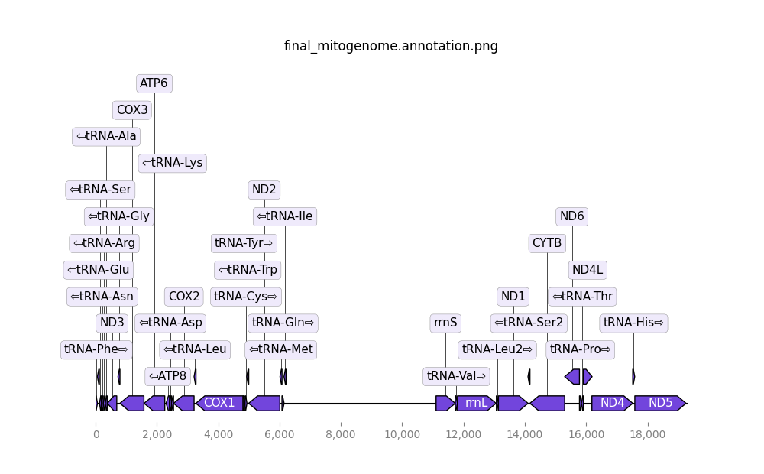

17/01 - Mitos2

Background
This is an alternative/a way to double check the mitogenome annotation from MitoHiFi.

Useful Links
Galaxy

Method
Only needs the mitogenome as in input file. The output file I chose is a bed and a gff file.

Results
The same annotation as MitoHiFi. tRNAs are located but they are not given a coding sequence as they do not have one as tRNAs do not code for proteins.

17/01/2025 - NumtFinder

Background
NUMTs are fragments of mtDNA that have been transferred to the nuclear genome.

Method
Step 1. Download the file to numtfinder environment
git clone https://github.com/slimsuite/numtfinder.git

Step 2. Run.
python2 /pub63/vica/miniconda3/envs/numtfinder/code/numtfinder.py blast+path=/pub63/vica/miniconda3/envs/BLAST/bin seqin= [final_assembly.fasta] mtdna=[mitogenome.fasta] basefile=[output_prefix] circle=T forks=[thread number] localgff=T

Notes
The main output from this that is useful to me is the .gff file. This shows all hits throughout the genome. In this file the final column has ‘length=…” for each hit. We can get a rough estimate of NUMT % in the genome by totalling the length of these hits and dividing by the total length of the genome.

Results
Median coverage of mtDNA = 144
Peak coverage = 156
Total length of NUMTs are 3,046,532bp approximately. This equates to 0.098% of the genome.

18/01/25 - BANDAGE BLAST

Background
Split the final assembly into smaller pieces (less than 1,000,000bp). We need to upload the original unpurged graph to Bandage and then BLAST the split final assembly against the graph databases using the View/Create BLAST in the Bandage app. Due to the size of this genome, BLAST on the command line is much better.

Method
Step 1. Create a blastdb with the ORIGINAL NON_PURGED fasta file. It make have to be split into smaller chunks using seqkit (see previous).
seqkit split [file.fasta] -p [number of chunks]

Step 2. BLAST the PURGED genome against the original.
blastn -task megablast -query [PURGED_GENOME.fasta] -db “Chunk1_db Chunk2_db Chunk3_db”-outfmt 6 -culling_limit 5 -num_threads 64 -evalue 1e-25 -out [OUTPUT_BLAST.OUT]

Step 3. Turn the BLAST output to csv with the same contig names as in the original assembly.

Results

16/12/2024 – HiFiASM (No purge_dups)

I ran this initially with pruge duplicates disabled due to the low heterozygosity of the genome. This ended up greatly inflating the genome size. Used 20% MEM

Step 1. Run HifiASM with purge duplicates disabled (-l 0)
hifiasm -l 0 -o [First assembly name] -t 64 -k 21 S1_S4_reads.fastq

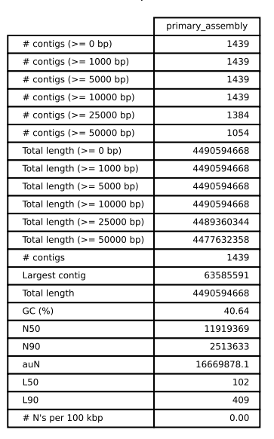

This gave estimated assembly size of approx. 4.5GB. The GC content looks acceptable for a Phasmid (ranges from 35-40%) and there are no missing bases so that is good. The genome size is unusual. Al said he is happy with the number of contigs

C:98.7%[S:63.1%,D:35.6%],F:0.5%,M:0.8%,n:1367,E:2.7%

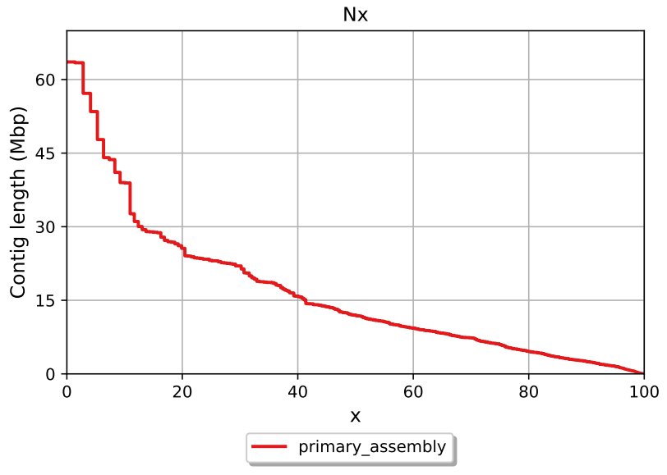

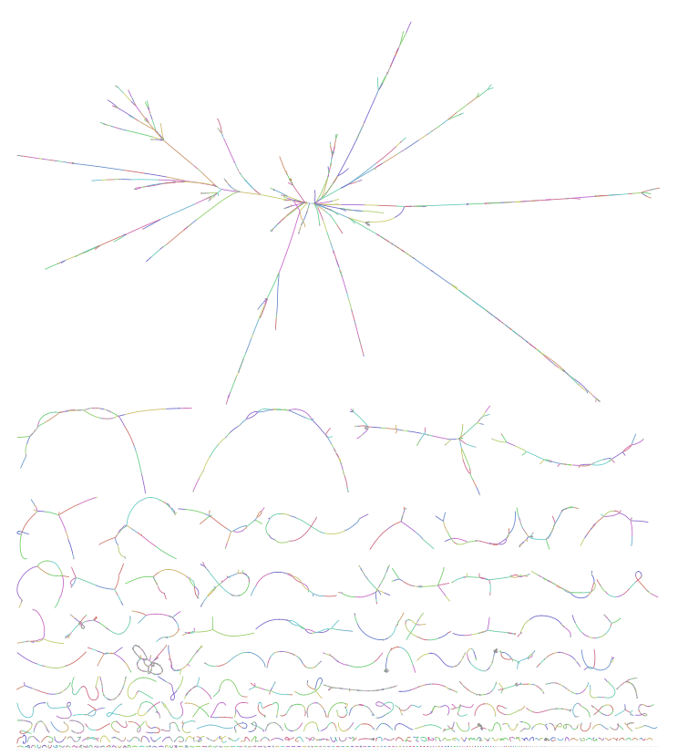

17/12/2024 – HifiASM (built in duplicate purging no purge_dups)

Spoke with Al about the size of the genome – he suggested it was simply because we didn’t purge duplicates which make complete sense. Try running with purge duplicates enabled and see what happens!

Step 1. Run HifiASM with purged duplicates enabled
hifiasm -o [First assembly name] -t 64 -k 21 S1_S4_reads.fastq

17/12/2024 – QUAST

Run QUAST to look at the genome statistics. This will be one of 3 measuring metrics a) QUAST b) BUSCO c) samtools coverage and depth.

GitHub - ablab/quast: Genome assembly evaluation tool

quast.py genome_assembly.fasta -o quast_assembly

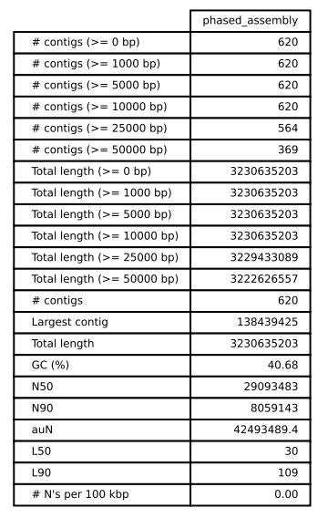

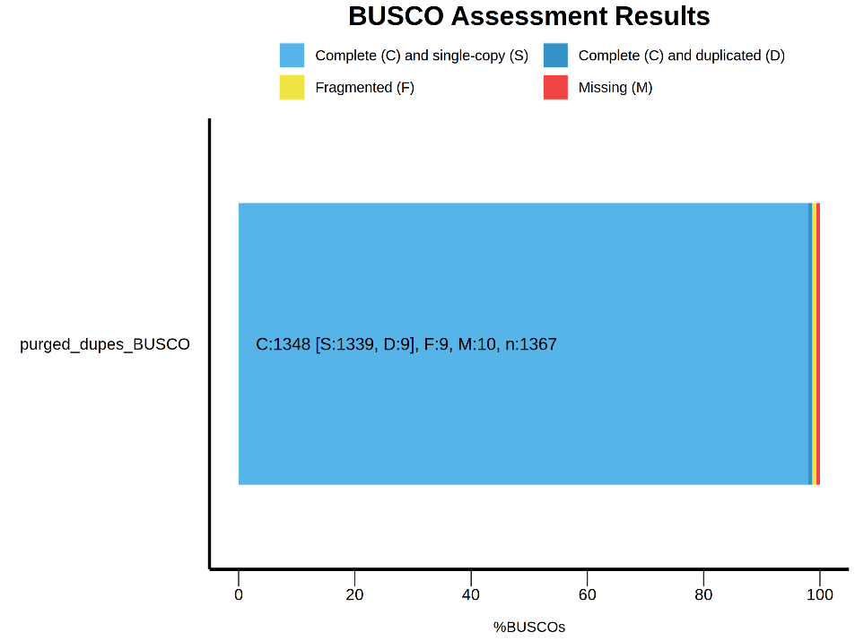

18/12/2024 – BUSCO

GitHub - metashot/busco: Assessing the quality of genomes using busco
User guide BUSCO v5.8.2

Had a bit of an issue with finding the correct path to the database. The database that I used was the Insecta_odb10, which had just been updated in October. Once the new database was downloaded, I ran BUSCO on the second assembly only – for now.

Step 1. Download the database.

Step 2. Run BUSCO
busco -i genome.fasta -m genome -l insecta_odb10 --cpu 64 -o BUSCO_output

One of the other optinons is -augustus –long which runs an optimised Augustus gene calling.

Step 3. Plot BUSCO
python3 /path/to/generate_plot.py -wd [directory with short_ ssummary.txt in]

C:98.6%[S:98.0%,D:0.7%],F:0.7%,M:0.7%,n:1367,E:3.6%

How do we know when it is correct to purge duplicates? How do we know that the 35.7% is not more biologically accurate than the one with more single copy BUSCOs?

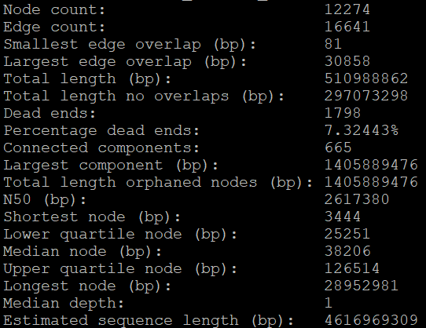

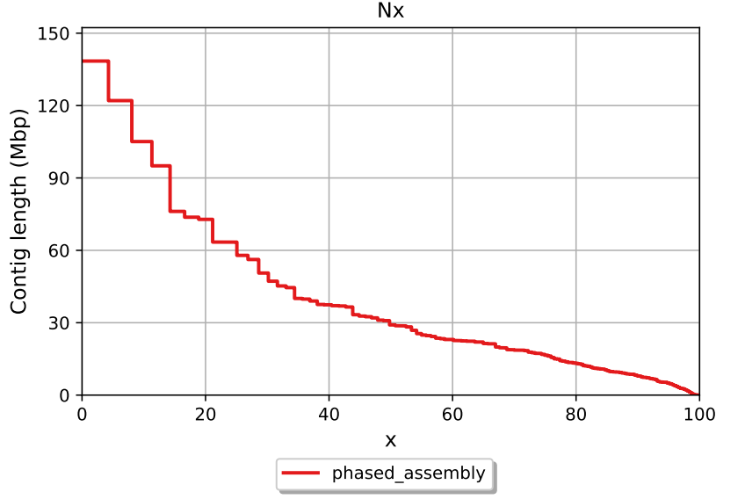
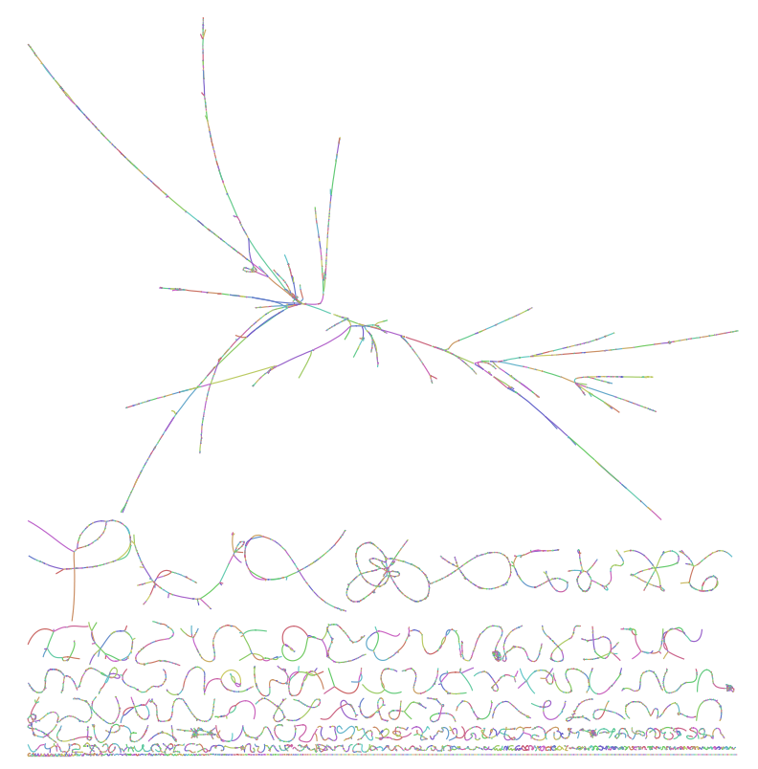
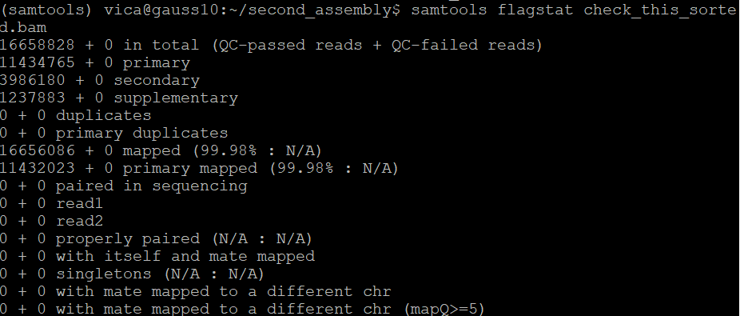

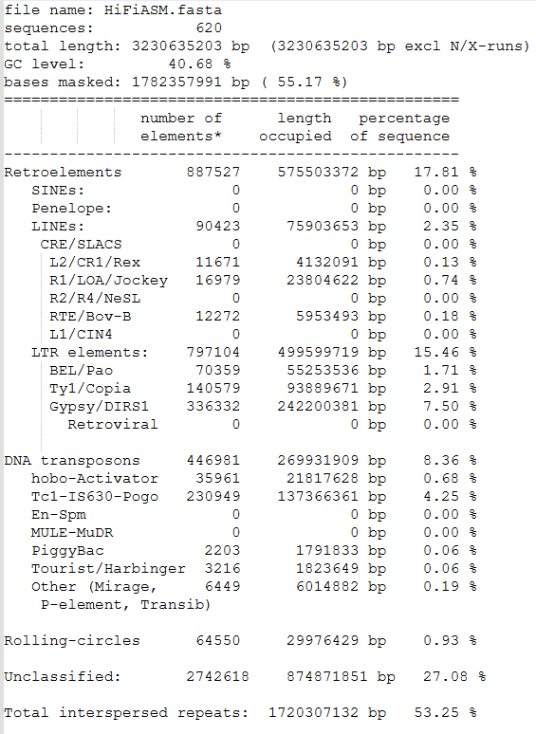
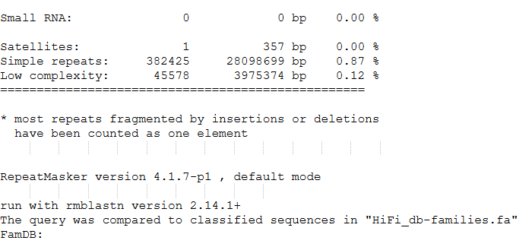

Merqury Results - REMEMBER CONTIGS NOT SCAFFOLDS SO NOT ORDERED

HiFiASM 7283 3230622803 69.6919 1.07351e-07

So this assembly has a QV of 69.7 which equates to an error rate of 0.0000001. This breaks down to this over the genome

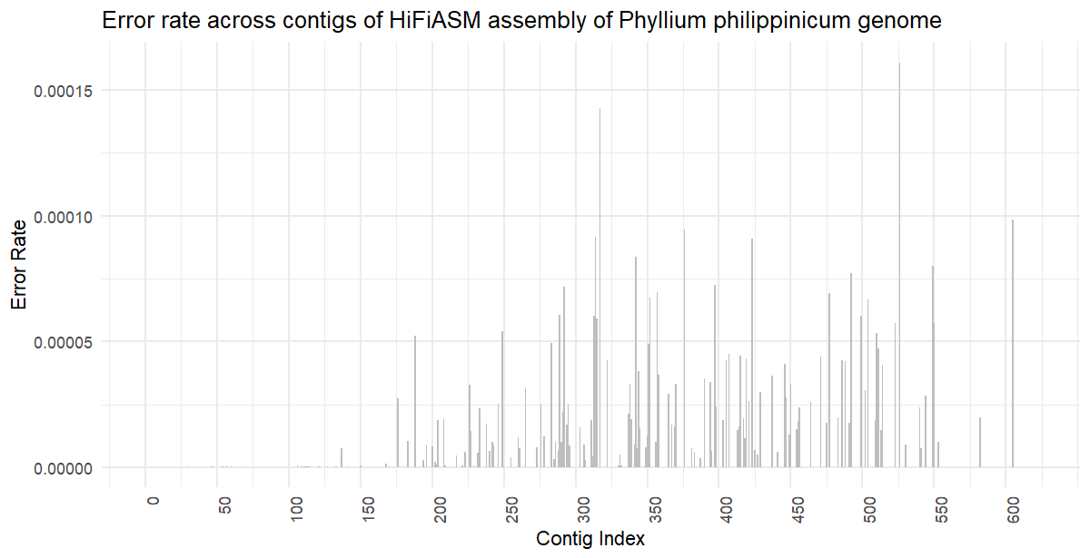

It is interesting that the error peaks in the middle but the beginning is perfect. This could either be biological where there are lots of GC regions (High/Low GC Content - Molecular Assemblies) which can be harder to assemble, or it could be higher repeat content, or it could be these are areas with lower coverage. To check this I used:

GC Content

Seqkit fx2tab HiFiASM.fasta > hifi_contigs.txt

I then used this command (thank you ChatGPT) to calculate the GC content per contig:

awk '{gc=0; total=length($2); for(i=1;i<=total;i++){if(substr($2,i,1)=="G"||substr($2,i,1)=="C") gc++} gc_content=gc/total*100; print $1, gc_content}' hifi_contigs.txt > gc_content_per_contig.txt

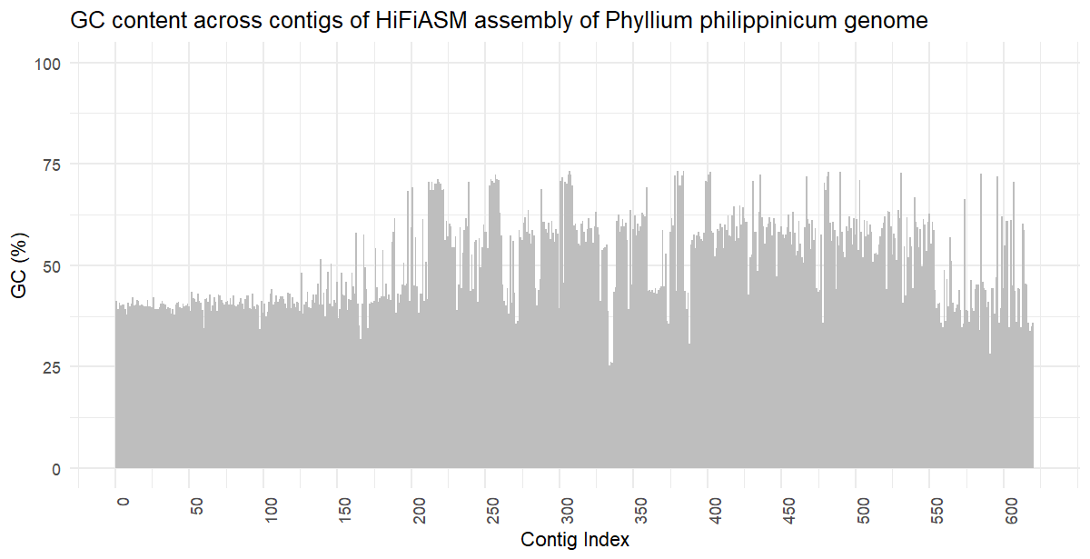

Coverage

Using the previous depth file from samtools I then used this code

awk '{sum[$1]+=$3; count[$1]++} END {for (contig in sum) print contig, sum[contig]/count[contig]}' coverage.txt > contig_coverage.txt

to calculate per contig coverage.
Sort contigs.

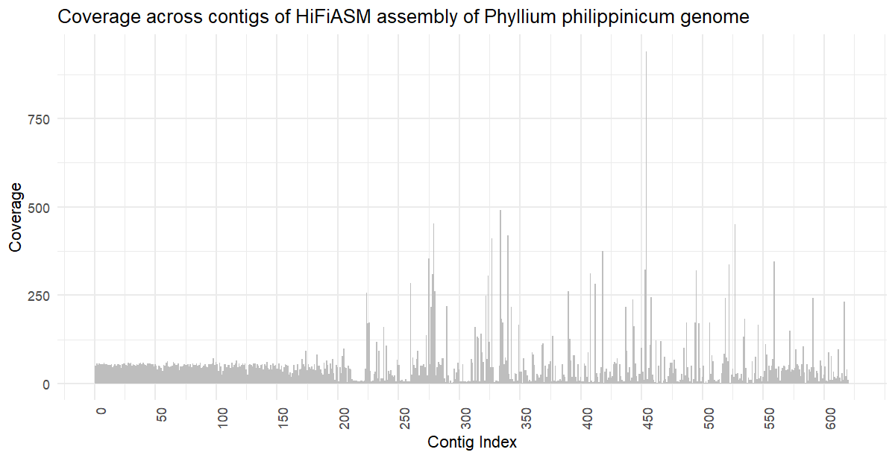

Repeat

Using this code I extracted the start, end and length of repeat region for each contig from the output table from RepeatMasker:

awk '{print $5, $6, $7}' repeatmasker.out > repeat_length_hifi.txt

Then I merged the repeats

sort -k1,1 -k2,2n repeat_positions_HIFIASM3.txt | awk '
BEGIN {contig=""; start=0; end=0}
{
if ($1 == contig) {
if ($2 <= end) {
# Overlapping or adjacent regions, extend the end
if ($3 > end) {
end = $3
}
} else {
# No overlap, print the previous region and reset start/end
print contig, start, end
start = $2
end = $3
}
} else {
# New contig, print the previous one if it exists
if (contig != "") {
print contig, start, end
}
contig = $1
start = $2
end = $3
}
}
END {print contig, start, end}
' > merged_HIFIASM3.txt

Then calculated the length of each repeat:

awk '{print $1, $2, $3, $3-$2+1}' repeat_length_hifi.txt > repeat_length_hifi.txt

I then had to sum the length of the repeats for each contig:

awk '{length = $3 - $2; sum[$1] += length} END {for (contig in sum) print contig, sum[contig]}' input_file > output_file

Then had to find the length of each contig, I am sure they are in a file somewhere but I used:

awk '/^>/ {if (seqlen) print seqlen; print $0; seqlen=0; next} {seqlen += length($0)} END {print seqlen}' HiFiASM.fasta > contig_lengths.txt

I then had to join the contig length and repeat length file:

join repeats_sum.txt contig_lengths.txt > joined_output.txt

Finally I calculated the percentage of repeats for each contig (Note that there are only 585 contigs with repeats out of the total 620):

awk '{print $1, ($2 / $3) * 100}' joined_output.txt > repeats_percentage.txt

Then used RStudio for the plots.
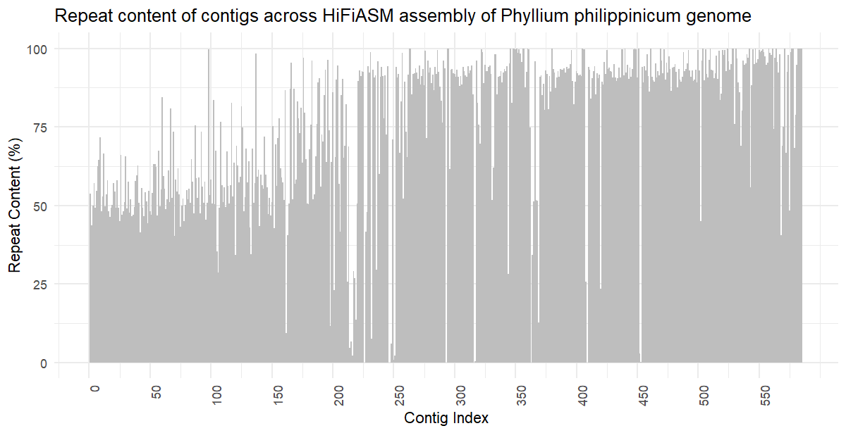

RStudio Code - 05/01/25

data <- read.delim("HiFiASM_merqury.HiFiASM.qv", header = FALSE)
head(data)
library(ggplot2)
data$X <- 1:nrow(data)

##### Error Rate

ggplot(data, aes(x = X, y = V5)) +
geom_bar(stat = "identity", fill = "gray", width =1) + # Bar chart
theme_minimal() +
labs(title = "Error rate across contigs of HiFiASM assembly of Phyllium philippinicum genome",
x = "Contig Index",
y = "Error Rate") +
scale_x_continuous(breaks = seq(0, nrow(data), by = 50)) + # Label every 1000th contig
theme(axis.text.x = element_text(angle = 90, hjust = 1))

##### GC Content
gcdata <- read.csv("gc_content_per_contig.csv", header = FALSE)
gcdata$X <- 1:nrow(gcdata)

ggplot(gcdata, aes(x = X, y = V2)) +
geom_bar(stat = "identity", fill = "gray", width = 1) + # Bar chart
theme_minimal() +
labs(title = "GC content across contigs of HiFiASM assembly of Phyllium philippinicum genome",
x = "Contig Index",
y = "GC (%)") +
scale_x_continuous(breaks = seq(0, nrow(data), by = 50)) + # Label every 1000th contig
theme(axis.text.x = element_text(angle = 90, hjust = 1)) +
ylim(0,100)

##### Coverage

cvdata <- read.csv("coverage_per_contig_SORTED.csv", header = FALSE)
cvdata$X <- 1:nrow(cvdata)

ggplot(cvdata, aes(x = X, y = V2)) +
geom_bar(stat = "identity", fill = "gray", width = 1) + # Bar chart
theme_minimal() +
labs(title = "Coverage across contigs of HiFiASM assembly of Phyllium philippinicum genome",
x = "Contig Index",
y = "Coverage") +
scale_x_continuous(breaks = seq(0, nrow(data), by = 50)) + # Label every 1000th contig
theme(axis.text.x = element_text(angle = 90, hjust = 1))
which.max(cvdata$V2)

##### Repeat
rpdata <- read.csv("repeat_percentage.csv", header = FALSE)
rpdata$X <- 1:nrow(rpdata)

ggplot(rpdata, aes(x = X, y = V2)) +
geom_bar(stat = "identity", fill = "gray", width = 1) + # Bar chart
theme_minimal() +
labs(title = "Repeat content of contigs across HiFiASM assembly of Phyllium philippinicum genome",
x = "Contig Index",
y = "Repeat Content (%)") +
scale_x_continuous(breaks = seq(0, nrow(rpdata), by = 50)) + # Label every 1000th contig
theme(axis.text.x = element_text(angle = 90, hjust = 1))

Interesting Parts!!

Contig 454

Looking at the coverage plot, there appears to be an outlier, where contig 454 has a coverage of 940. When looking at contig 454 in GC content, Error Rate, and Repeats, the values are 59.2%, 1.52491e-05, and 94%. None of these other metrics are remarkable, why is it that contig454 has such a high coverage?? We can confidently rule out any technical abnormalities. Instead considering biological reasons, this could indicate the mtDNA region of the genome as it usually has a much higher coverage than the other areas due to the very high copy number. I BLASTED this contig, and it does have rRNA matches with the top one being another Phylliidae - why does this rRNA have such high coverage when the majority of the mtDNA appears to be around contig 334 (written retrospectively lol)? ANSWER: Because this is 28S is not mitochondrial rRNA - it is nuclear rDNA that consists of 18S/28S and is often one of the most highly repeating areas of the genome. This can often occur in assemblies where the multiple repeats are actually collapsed as a single contig with super high coverage. This also explains why it is so far from the true mtDNA section.
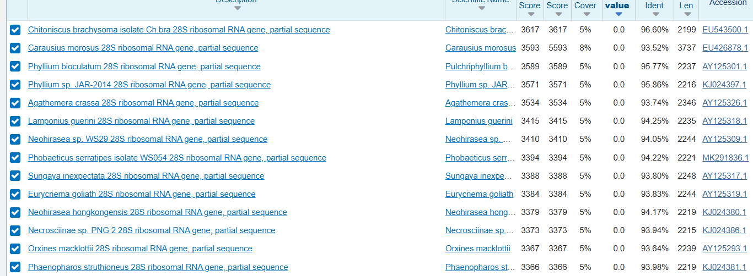
b

Contig 334 & 335 & 336

Using NCBI to locate the COII gene (also mtDNA) from P. philippinicum (Phyllium philippinicum isolate 16-142 cytochrome oxidase subunit II (C - Nucleotide - NCBI) and trying to find this sequence in my assembly file brought up a hit on the ptg000335l.
Due to the linebreaks, this was the line that I located and then I manually inspected the rest of the sequence either side of this motif to find the rest of the sequence. I found that this was located in pgt000335
Searched this motif:
AGAACAATTAGTATATTTCCATGATCACATTATAATAATTTTAATAATAATTGTAACAAT

When looking at the coverage graph, this has a coverage of 184, but interestingly the contig before this, 334, has a coverage of 491. In fact there is a cluster of high coverage here could this be another/the main part of mtDNA? Why is it fragmented? BLASTing contig 334 gave these results:
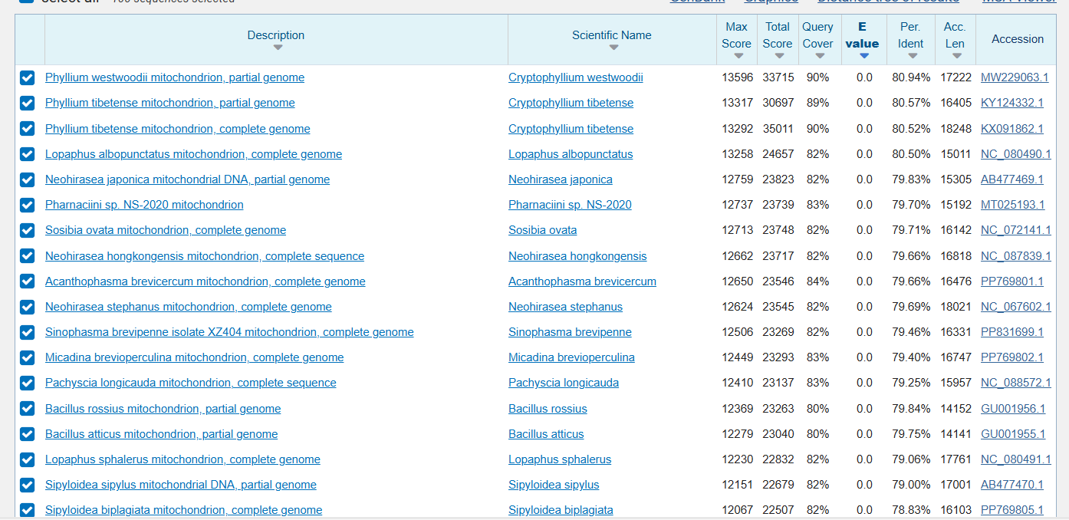
This strongly suggests that this 334/335 is the true mtDNA area as when we BLAST 335, we get identical results to the BLAST results for 334 too. We can again check contig either side:

Contig 333
Does not appear to belong to the mtDNA as the results for this returned a lot of Timema TBC1 domains. (Note: This appears to be annotated by MAKER)

Contig 336
Identical BLAST results - means it is included as part of the mtDNA.

Contig 337
Does not appear to belong to mtDNA - it does however return a match for histone P. philippinicum!

Looks like contig 334-336 contain the mtDNA - these contigs are approximately 256,000bp long in total but the mtDNA is much smaller. This can be looked at in proper detail during the calling/annotation steps. Interestingly, when looking at these 3 contigs, the coverage for 334 = 491, 335 = 184, 336 = 173. Either side of this, the contig coverage drops back to the approximate average of 51. The error rate for these 3 contigs is 0. The GC content for these contigs are lower than the surrounding contigs:

333 ptg000333l 38.8592
334 ptg000334l 25.3851
335 ptg000335l 26.1014
336 ptg000336l 26.0245
337 ptg000337l 43.4190

The repeat content for these 3 contigs are:
ptg000334l: 82.78940000
ptg000335l: 75.76130000
ptg000336l: 69.68340000

It increases either side of these to 96+%

08/01/2025 - HiFiASM after purge_dups

20/12/2024 – Flye Assembly – No purge_dups

Used this before in Al’s workshop. Run overnight as Flye generally takes longer to assemble than HifiASM (which took overnight anyway). Then run QUAST, BUSCO and samtools on this. Downloadable with conda (thank god for conda).

GitHub - mikolmogorov/Flye: De novo assembler for single molecule sequencing reads using repeat graphs

flye –pacbio-hifi S1_S4_reads.fastq --genome-size 3G –threads 64 -o [output directory]

Output does not have duplicates purged so I will ned to use purge_dups.
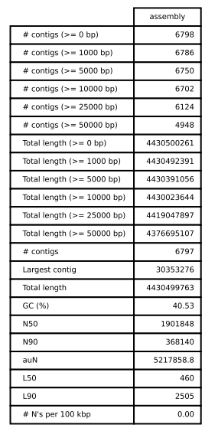

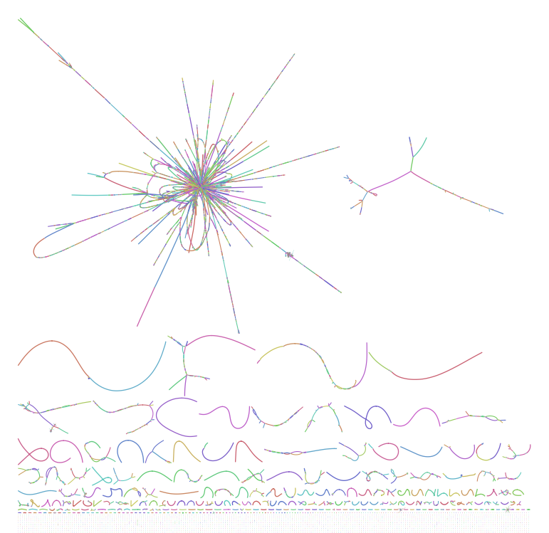
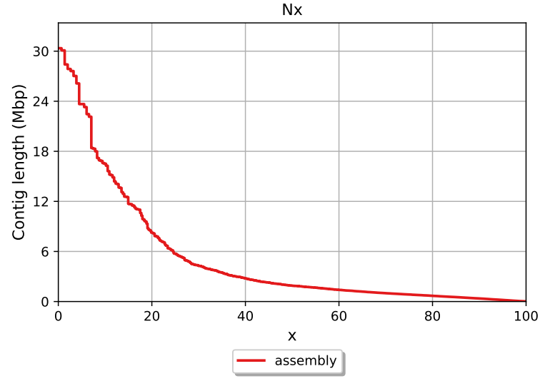
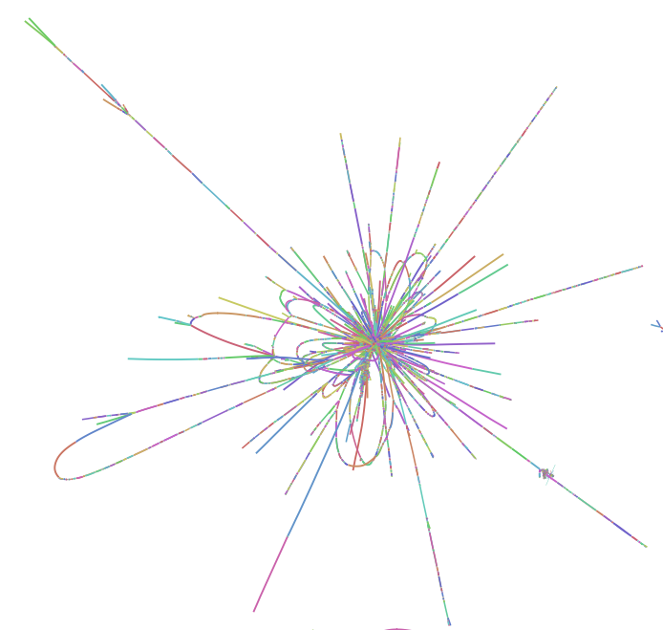
C:98.1%[S:63.2%,D:34.9%],F:1.0%,M:1.0%,n:1367,E:2.8%

Flye Assembly - Purge_dups

22/12/2024 - Shasta – No Purge Dups

shasta –-input [reads.fastq] --assemblyDirectory [Output_directory] --config HiFi-Oct2021

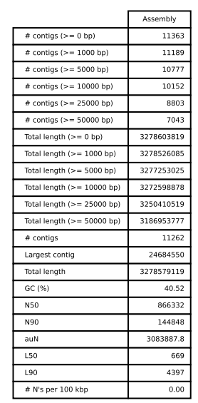

C:93.1%[S:88.8%,D:4.3%],F:3.7%,M:3.2%,n:1367,E:2.4%

This assembly used a maximum of 82% MEM at once.
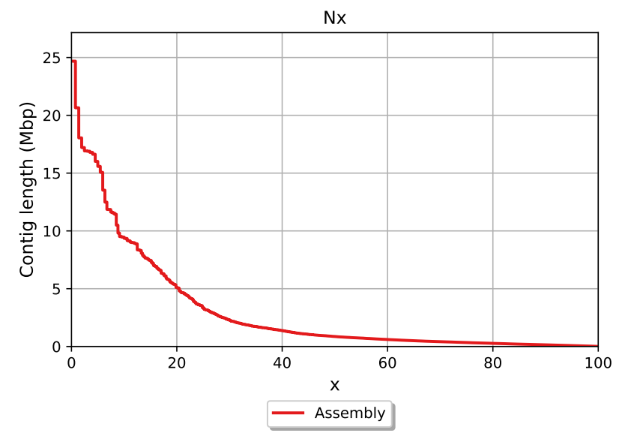
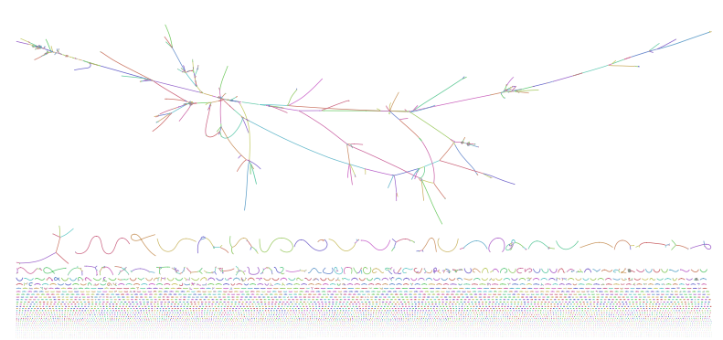
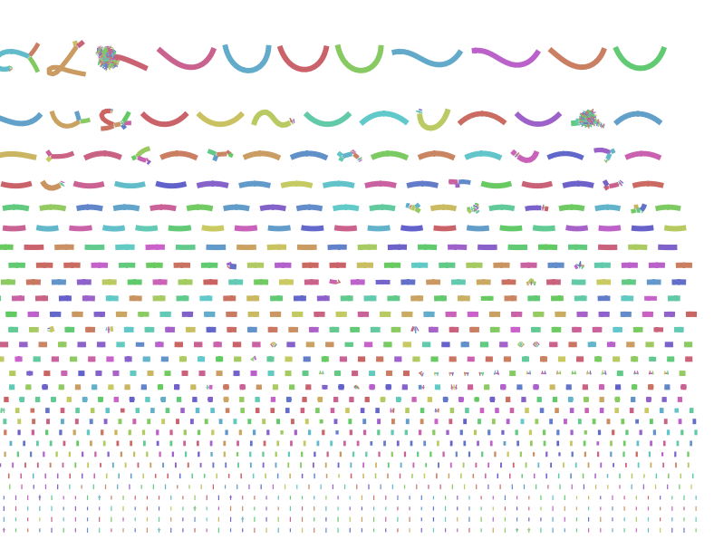
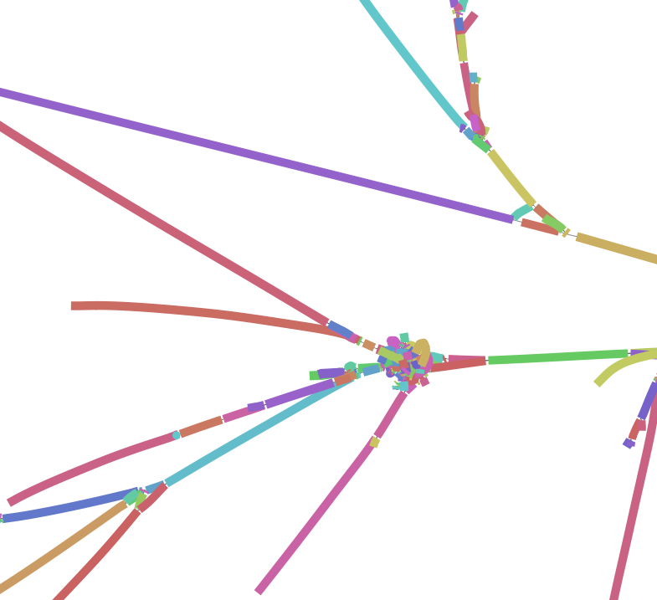

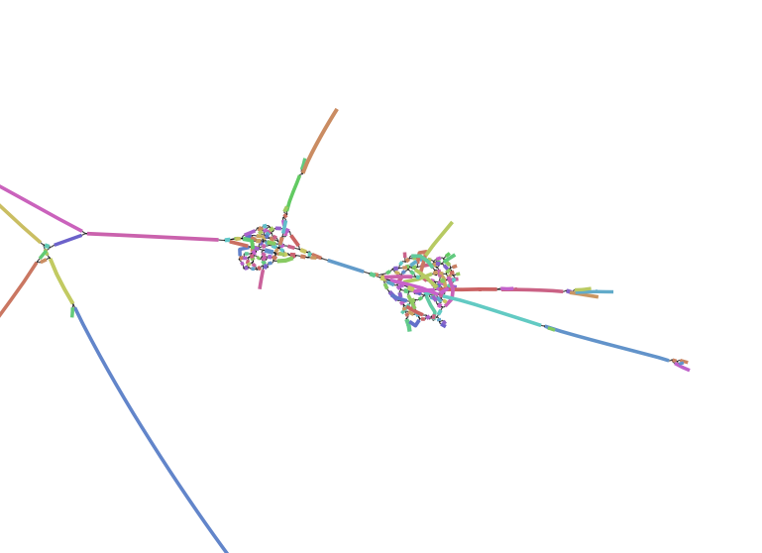
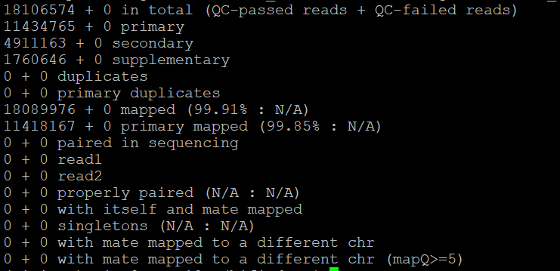

Shasta Assembly - Purge_dups

BUSCO: C:90.3%[S:89.5%,D:0.9%],F:4.4%,M:5.3%,n:1367,E:2.8%

QUAST
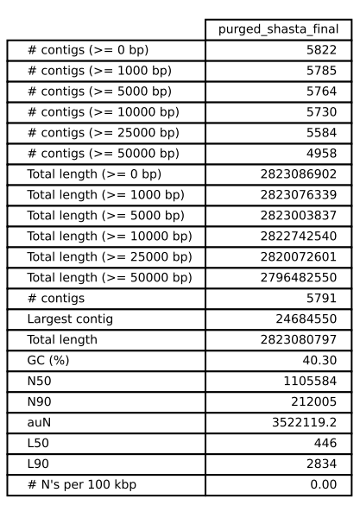

HiCanu Assembly - No purge_dups

This ran 12 processes in parallel, with each process taking about 2% MEM.

1082 repeats of total length 68568160bp.

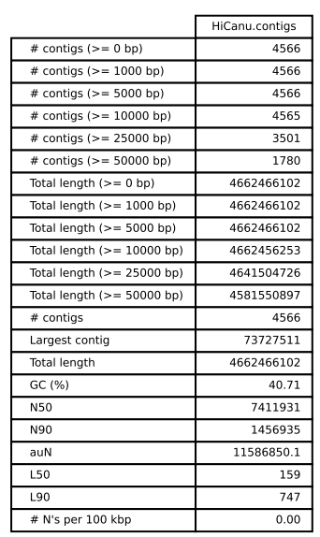
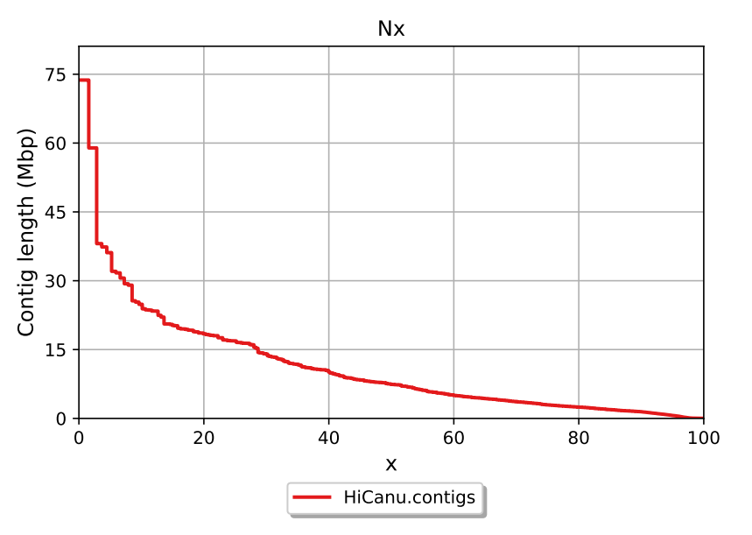
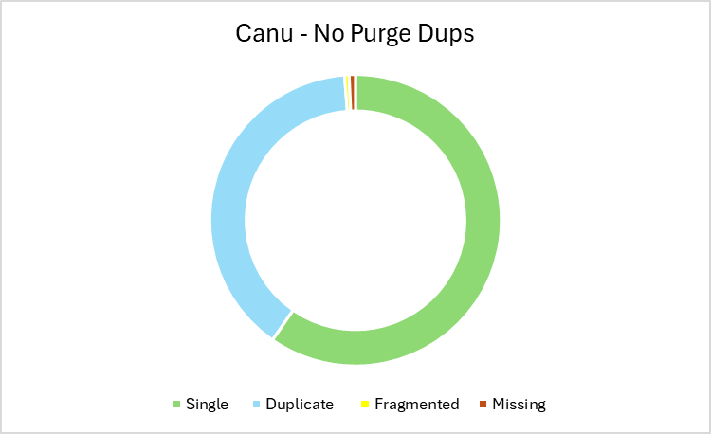

Working with very large graphs · rrwick/Bandage Wiki · GitHub
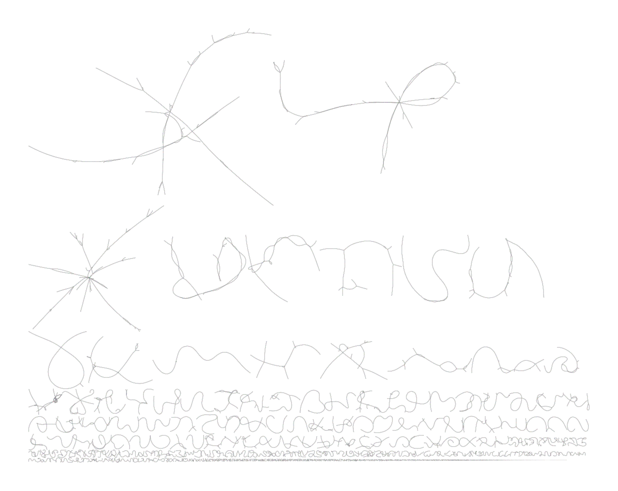

HiCanu Assembly - Purge_dups
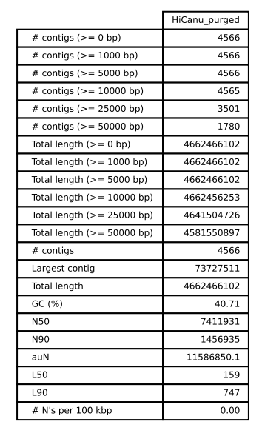
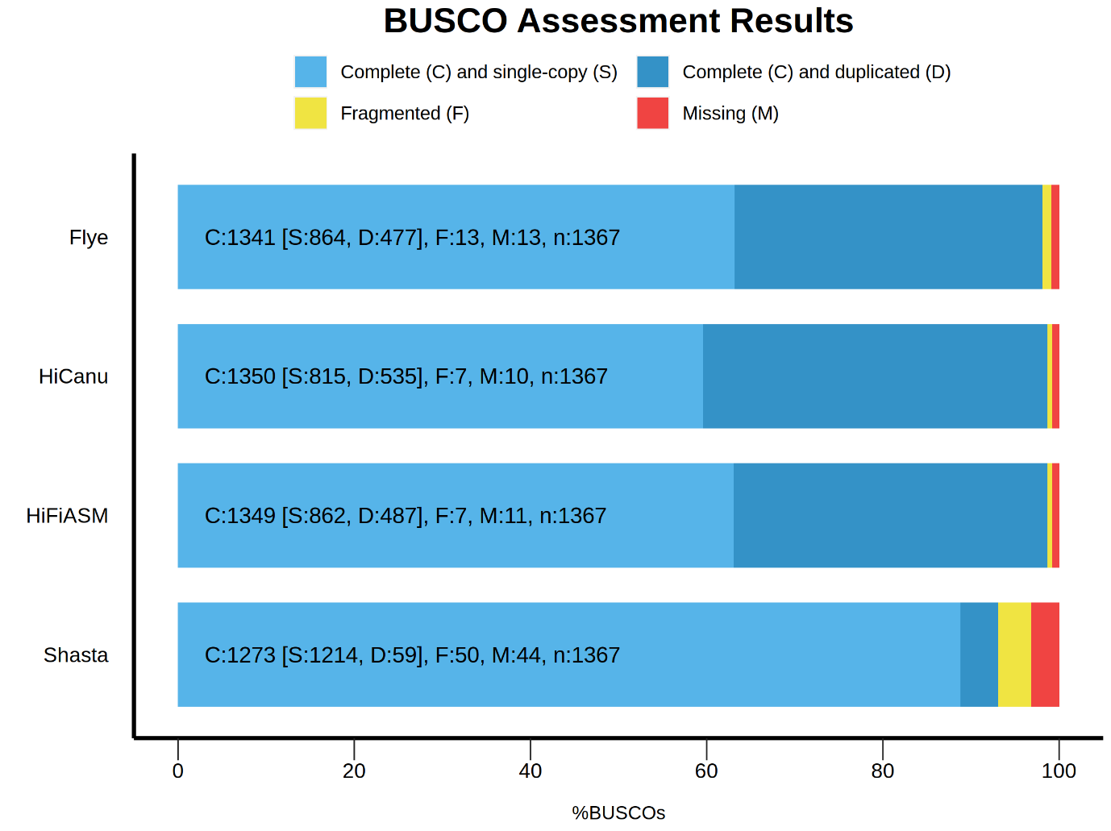
BUSCO Results prior to running purge_dups. Although Shasta found the lowest number of complete BUSCOs overall, it found the highest number of single copy BUSCOs compared to other assemblers as 88% of the BUSCOs found were single copy, compared to 63% single copies on average for the other assemblers. If you do not have time to run purge_dups then Shasta can give the best estimate of BUSCOs. However, as purge_dups is in-built to HiFiASM and requires explicit disabling - HiFiASM still comes out on top as the best assembler.
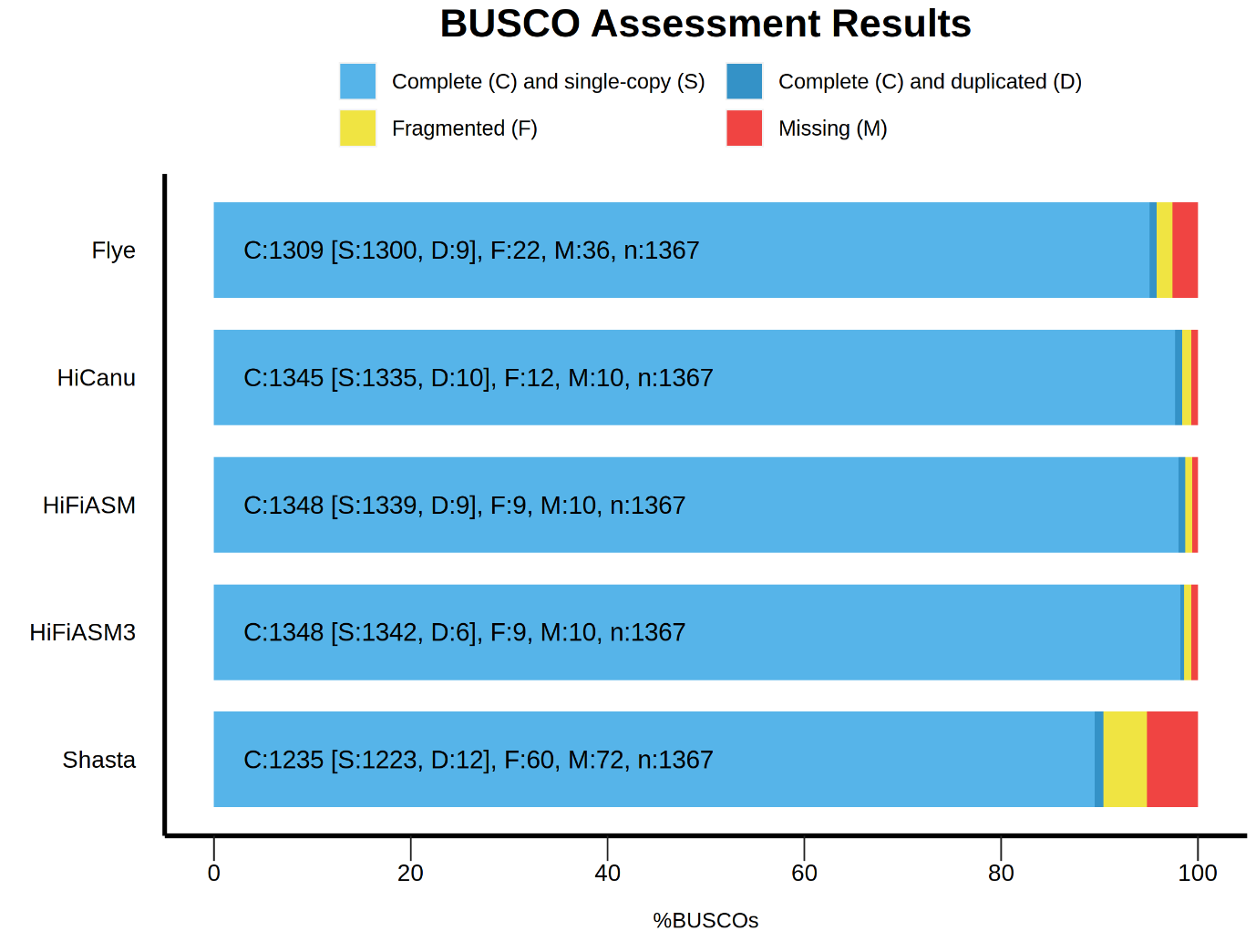

20/12/2024 – BUSCO Results analysis

Due to the low level of duplicates etc. in the BUSCO results from the second assembly I am happy with this assembly. Whilst I wait for Flye to run I have had a look at the missing/fragmented/duplicated BUSCOs. I also BLASTed these and all of the returns were the same orthologs from other phasmids, cockroaches, termites and grasshoppers. This aligns with our current knowledge of their close relationship.
When looking at the missing BUSCOs, I noticed an interesting pattern that a lot of the missing BUSCOs are ribosomal related. rDNA is usually found in repeating regions of the genome, the fact that these are the areas that are missing from our BUSCOs suggests that perhaps the assembly struggled with the repeating regions. When I looked up these BUSCOs on NCBI, they were present in the most closely related genome, B. rossius. To me, this suggests that they are likely still within the genome but are missing due to computational errors.

How can I fix this??
Al says it doesn’t need fixing it is ok

29/12/2024 - Quast Comparison

Initially thought that I had to run --x-for-Nx (0,100) for each assembly. But turns out I can run multiple assemblies at once with QUAST

/pub63/vica/hifi_data/Shasta_Leaf/Assembly.fasta
/pub63/vica/hifi_data/HiCanu_Leaf/HiCanu.contigs.fasta
/pub63/vica/hifi_data/primary_assembly.fasta
/pub63/vica/flye/assembly.fasta
/pub63/vica/second_assembly/duplicate_purged_hifiasm_assembly.fasta

Important to make sure the files are named appropriately as this is what is used in the plot - redo with purged separately

No purge dups

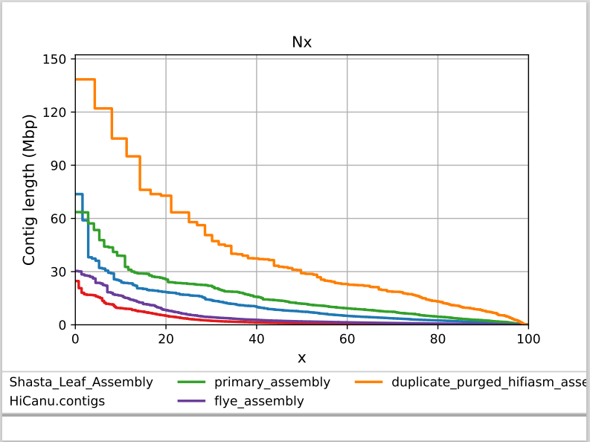
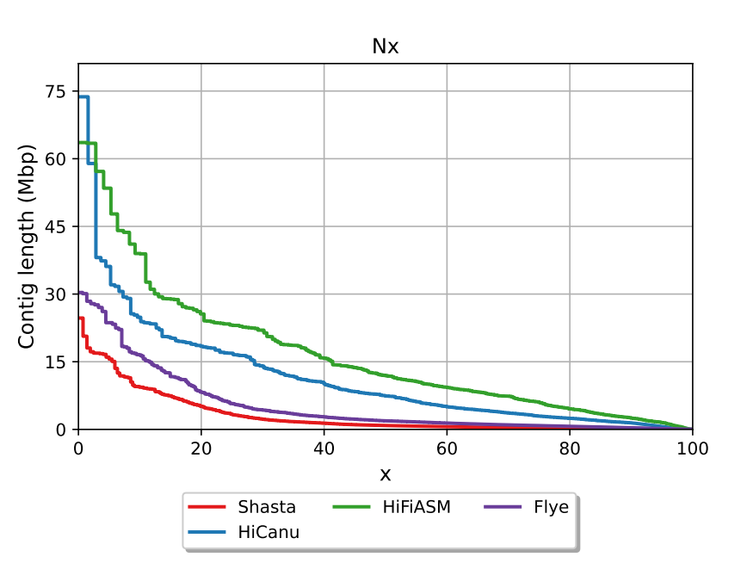

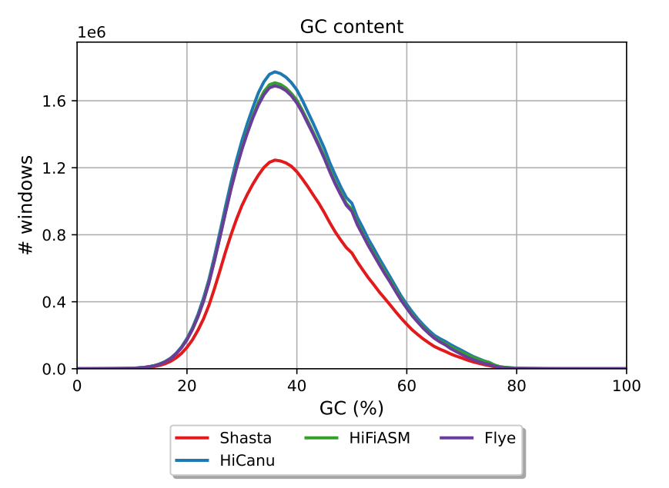
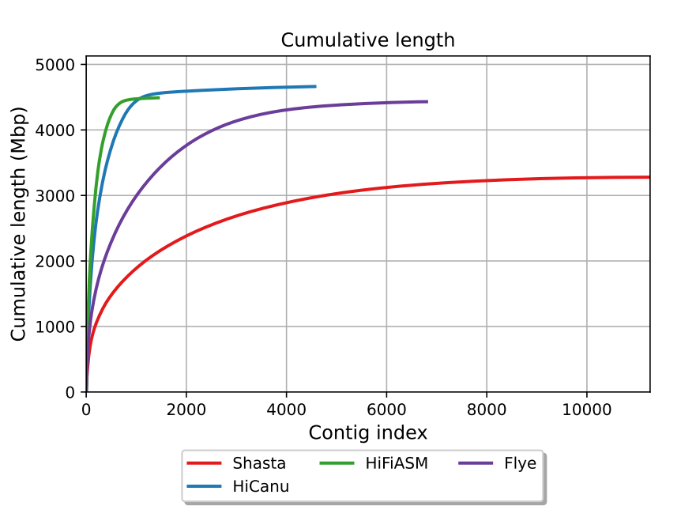

23/01/2025 - Blobtools investigation

I opened the files called identifiers.json and bestsumorder_phylum.json and compared them using the keys at the bottom of the bestsumoder_phylum.json file to find which contigs contained Ascomycota and Mollusca. I then opened the HiFiASM3.ncbi.blastn.out and found the appropriate contigs. I extracted these contigs using grep to look at them easier.

grep “ptg000181l_1_1_1” HiFiASM3.ncbi.blastn.out > ptg000181_Mollusca.tsv
grep “ptg000388l_1_1_1” HiFiASM3.ncbi.blastn.out > ptg000388_Ascomycota.tsv

I could then find there were a lot of hits in ptg000181 for Great Scallop, Bletty, Algaes and a predicted protein for Great White Shark.
In ptg000388 there were fungus such as Ascomycota

Sensory cilia as the Achilles heel of nematodes when attacked by carnivorous mushrooms

24/01/2025 - Mummer

Background
GitHub - mahulchak/mplotter: Creates publication quality dot plot using ggplot

Method
Step 1. Install
wget https://github.com/mummer4/mummer/releases/download/v4.0.0rc1/mummer-4.0.0rc1.tar.gz

Step 2. Unpack and install
tar -xvzf mummer-4.0.0.0rcl.tar.gz
./configure
make
make install

Step 3. Run for nucleotide seq
mummer-4.0.0.0rcl/nucmer -p [prefix] [ref.fasta] [query.fasta]

Step 4. Run for protein seq
mummer-4.0.0.0rcl/promer -p [prefix] [ref.fasta] [query.fasta]

Notes
For my comparison, as there are no other genomes, I decided to compare it to the closest genome we have - amito stick insect, as well as the basal lineage of Phasmids Timema cristinae (GCA_039000515.1).

Step 5. Viewing the plot
./mummerplot [output.delta] --png

This looked like shit hahahahahah
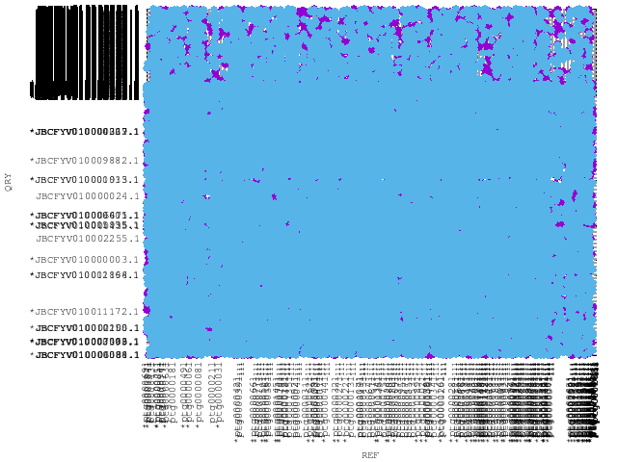
Step 8. Try again
./nucmer --mum -c 200 -l 50 -g 1000 -b 2000 -t 16 -p \ TIMEMA_ATTEMPT_2 \ /pub63/vica/Assemblies/FINAL_GENOME/FINAL_GENOME_HIFIASM3.fasta \
/pub63/vica/ncbi_dataset/data/GCA_039000515.1/GCA_039000515.1_ASM3900051v1_genomic.fna

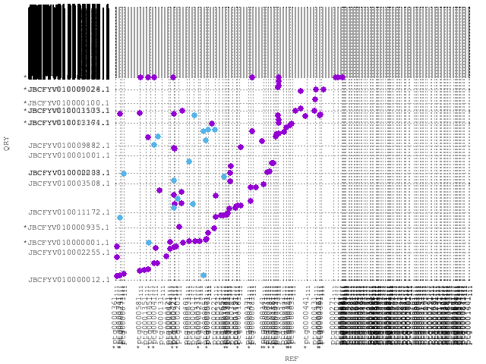

Step 9. Try again
./nucmer --mum -c 100 -l 30 -g 500 -b 1000 -t 64 -p HOOKERI [final_genome.fasta] [Hookeri.fasta]

delta-filter -i 90 -l 1000 -m alignment.delta > filtered.delta
This is mtDNA.

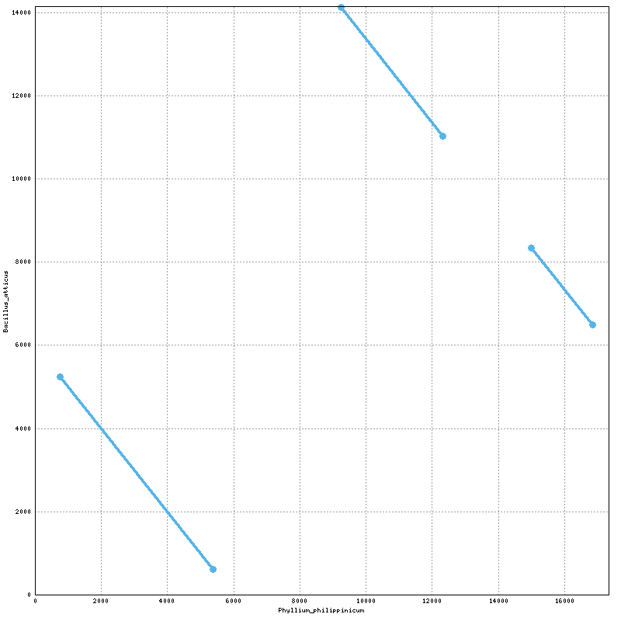

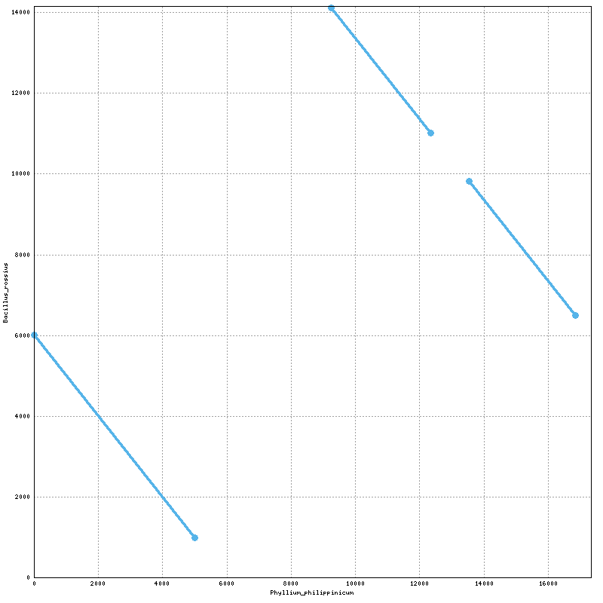
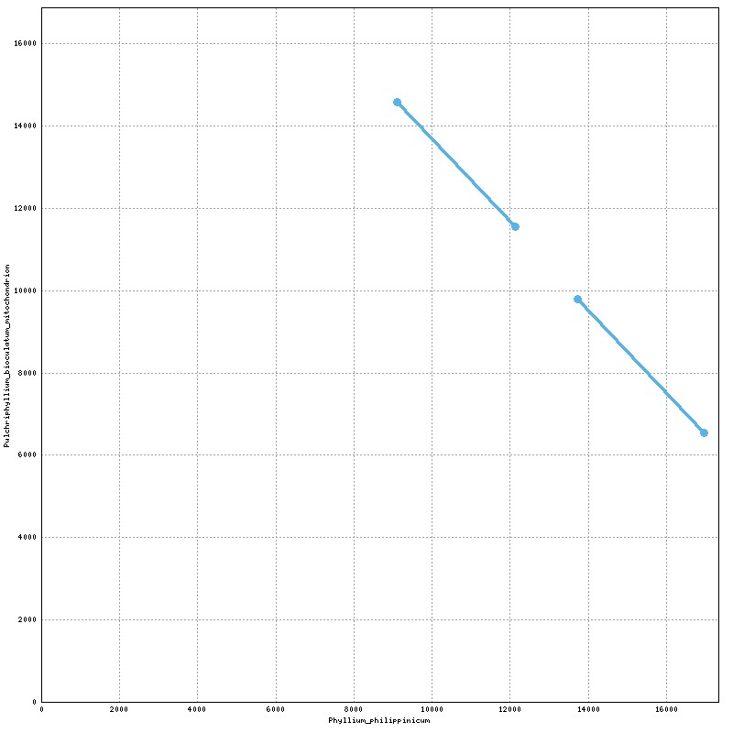
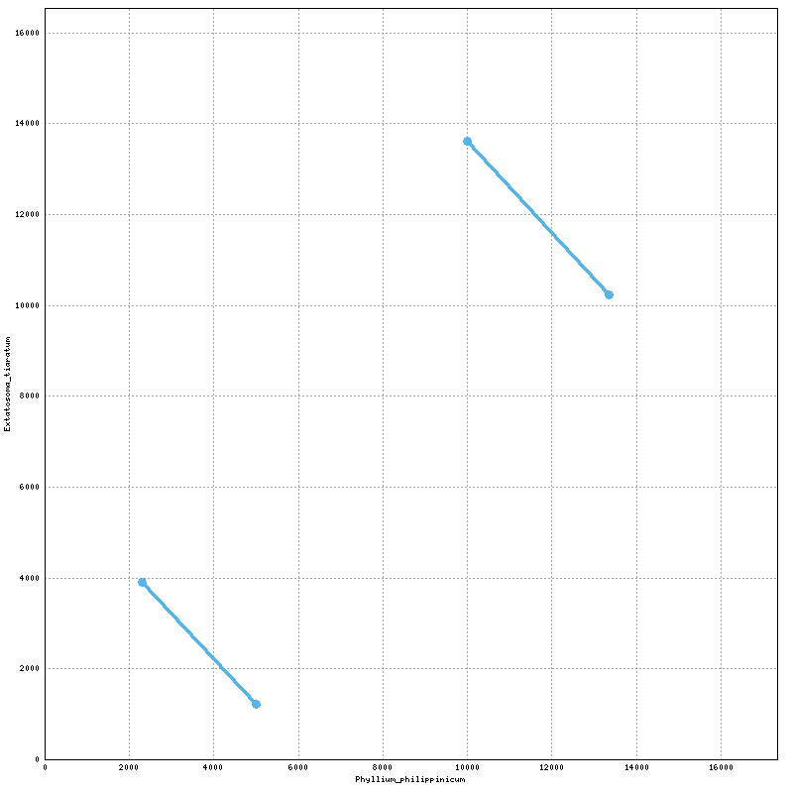
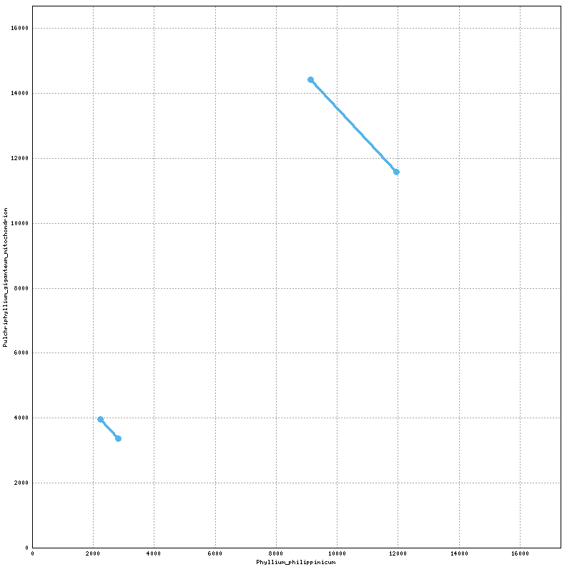
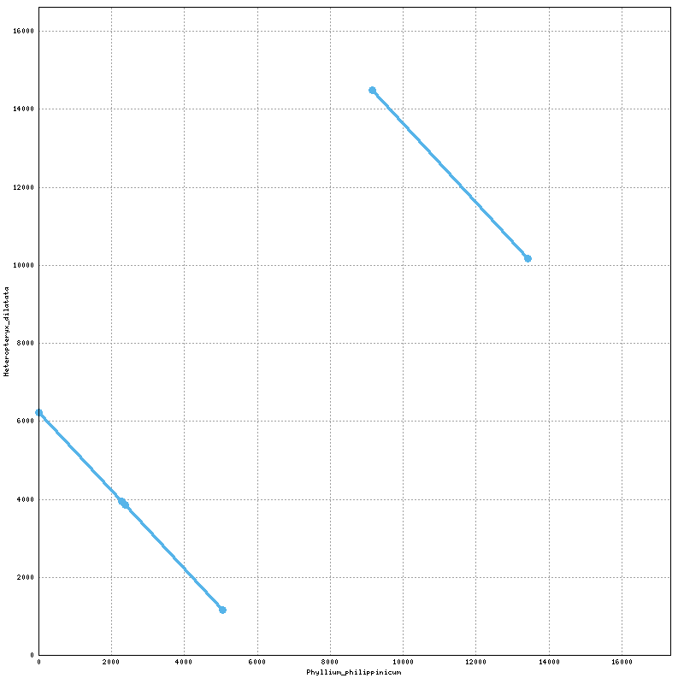
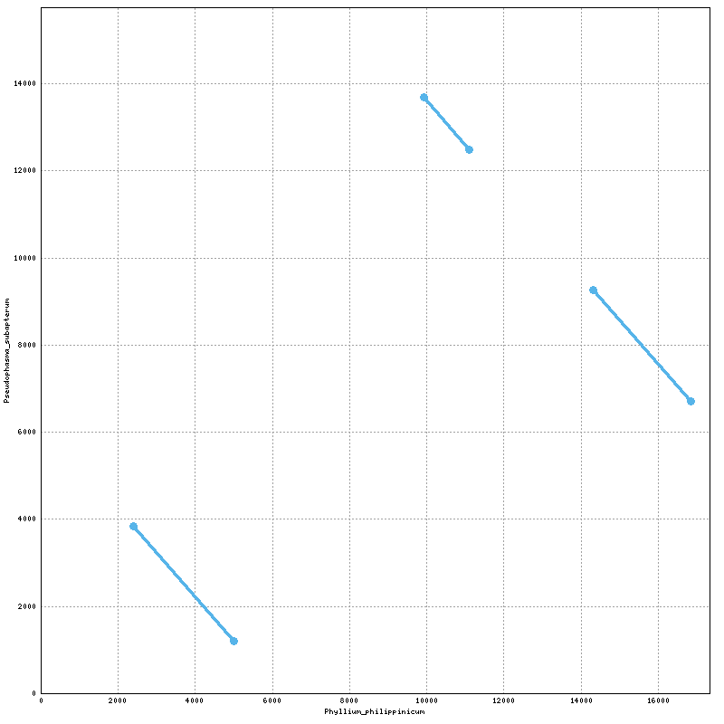
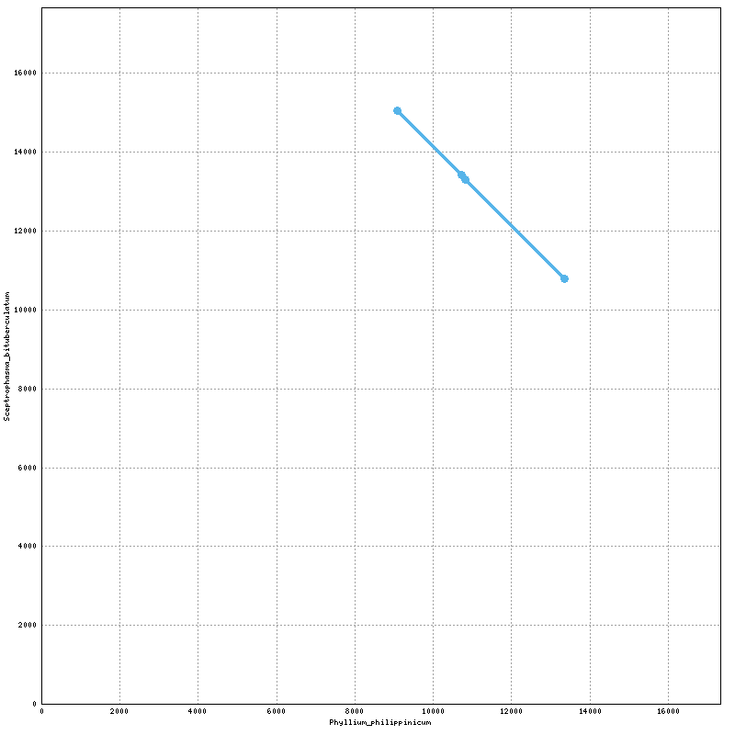
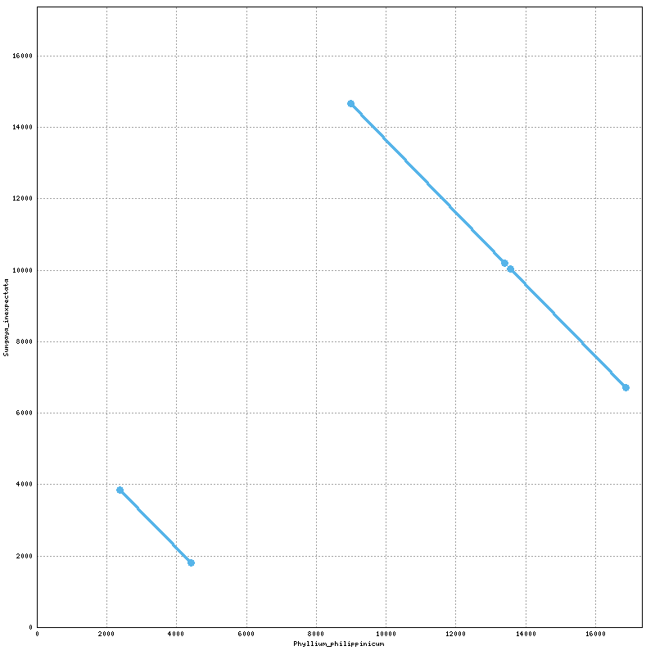
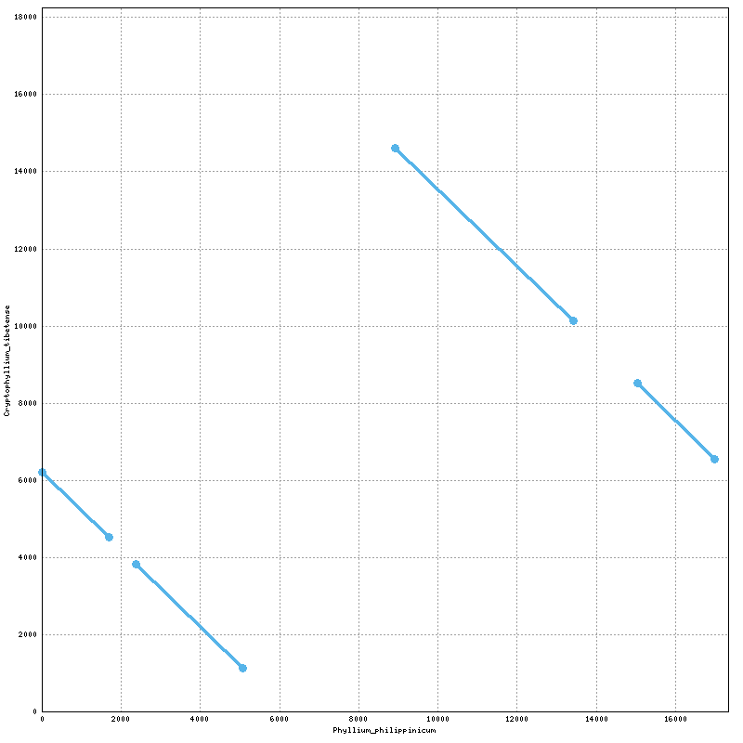
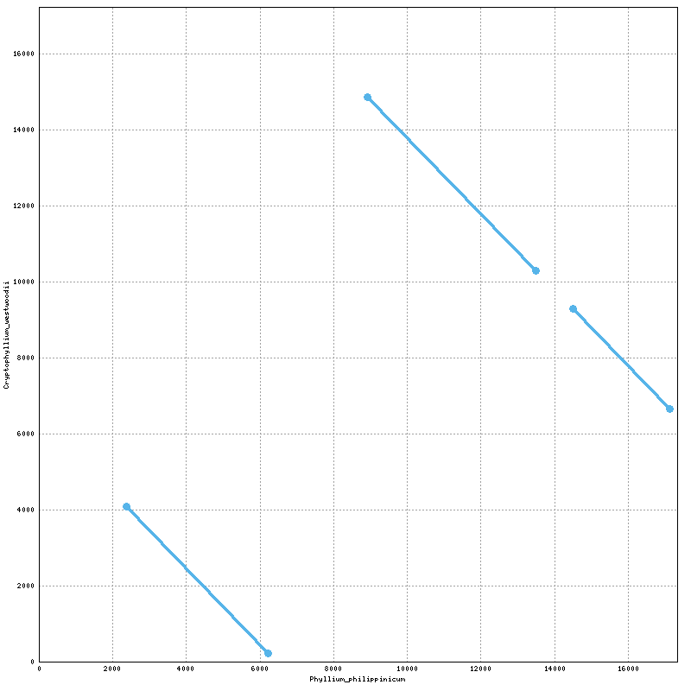

Try again
./nucmer -c 100 [Bacillus.fasta] [my genome.fasta] > Bacillus2.delta

./delta-filter -q -r Bacillus2.delta > Bacillus2_filtered.delta

28/01 - DGenie

D-GENIES - Dotplot large Genomes in an Interactive, Efficient and Simple way

Bacillus rossius redtenbacheri

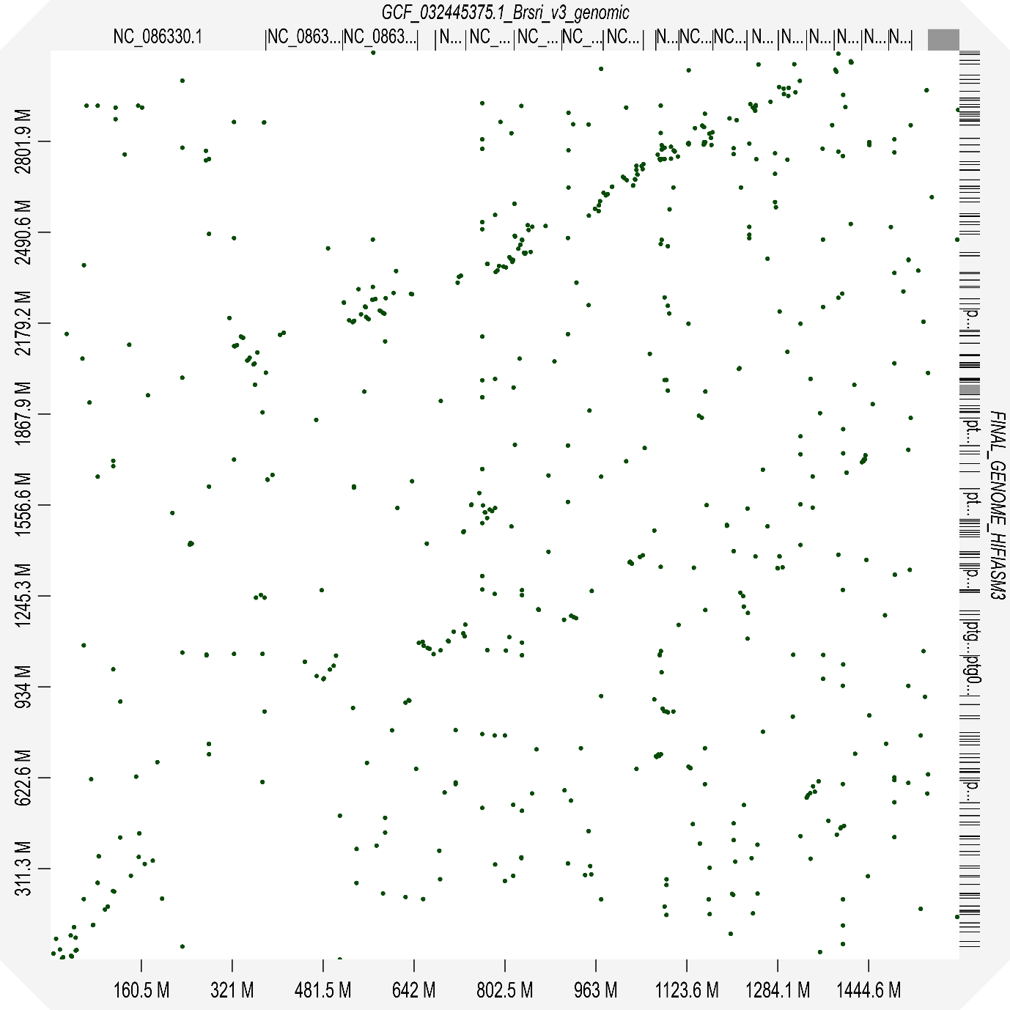
Clitarchus hookeri
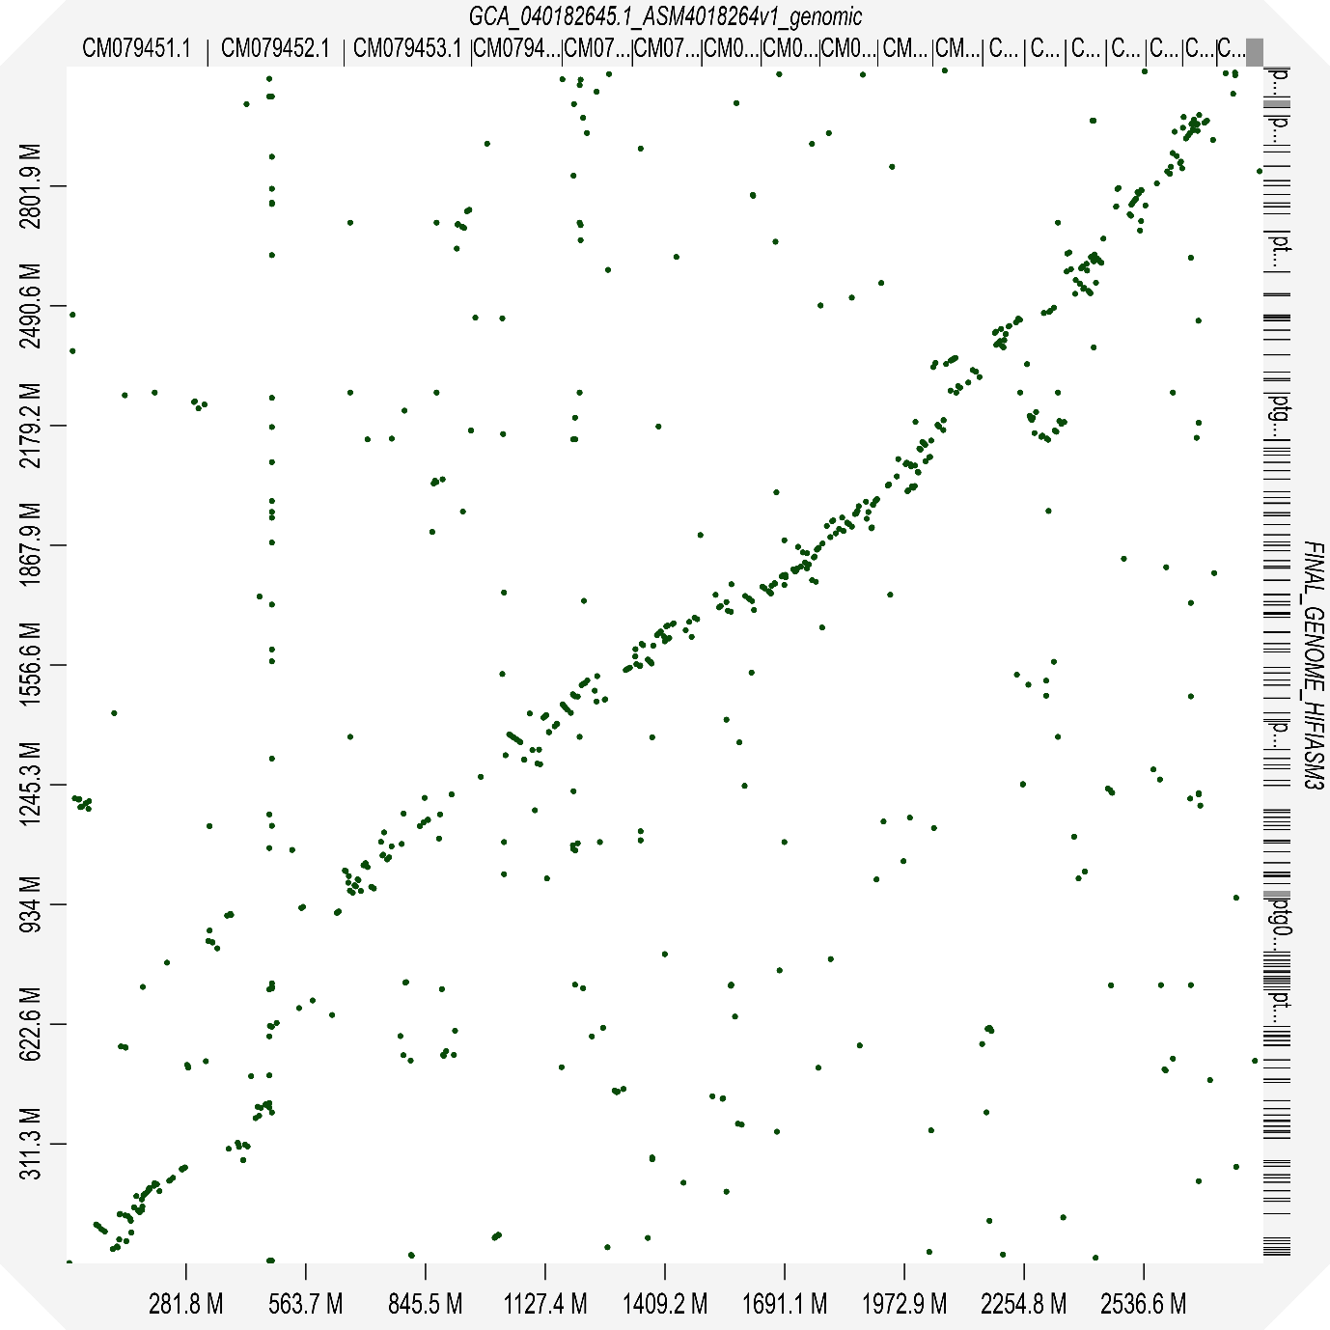

24/01/2025 - MEGA

COII protein model
mtREV24+G+I+F

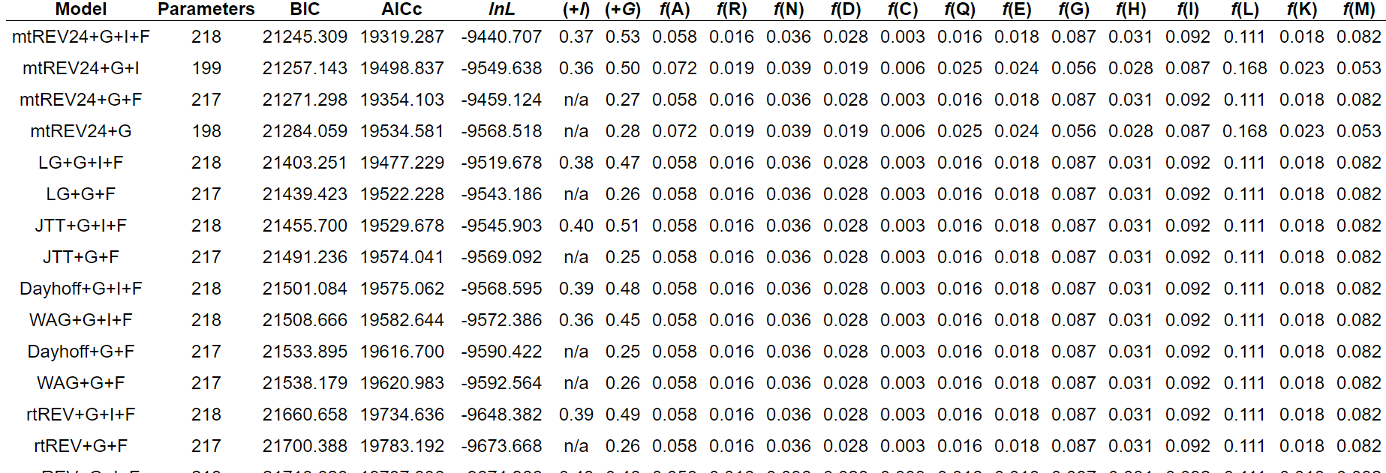

IQTREE is superior (use that instead)

24/01/2025 - IQtree

Method
Webserver: http://iqtree.cibiv.univie.ac.at/

Notes
Using the fasta file called COI_Alignment_2.fas. This file contains mostly Phasmid COI protein sequences, but it also contains a handful of cockroach and locust sequences for COI. All 97 passed and are used in the creation of the tree. The results of model selection from MEGA is slightly different just because IQTREE checks 168 models. The best model is mtZOA+F+I+G4.

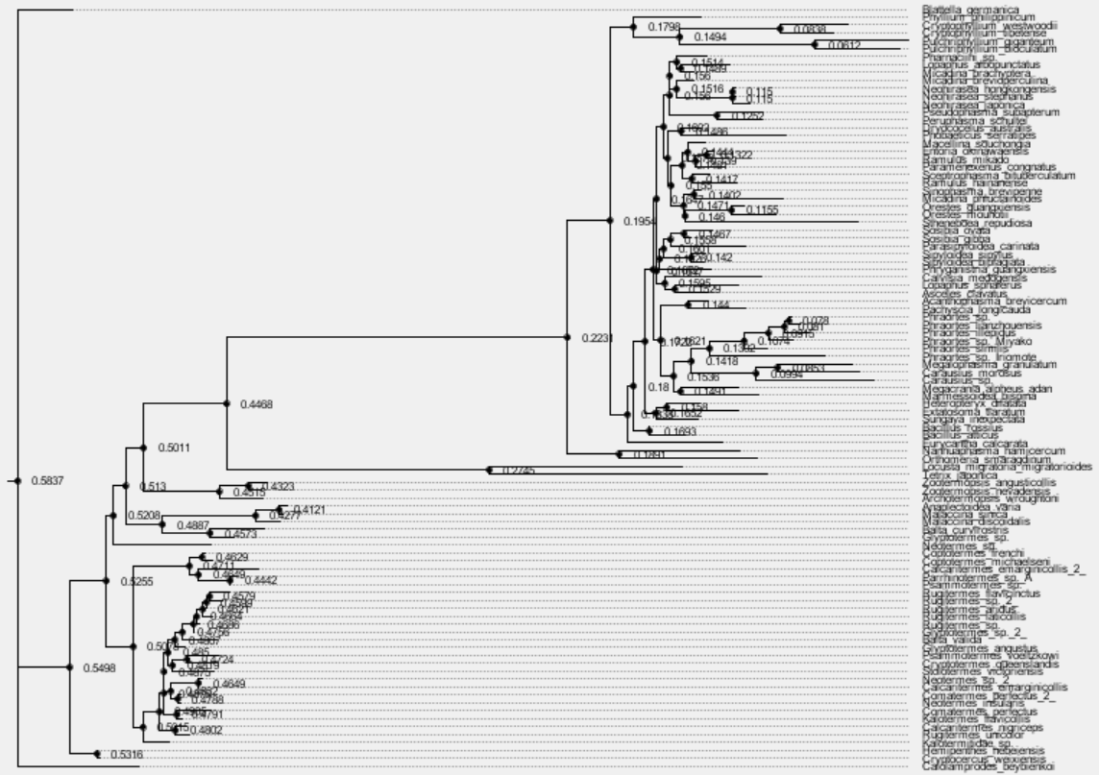
I initially ran it with 100 COI sequences. I did 1,000 iterations and the bootstrap values are pretty shit.

I then did 2,000 iterations with half of the COI sequences. They weren’t much better.

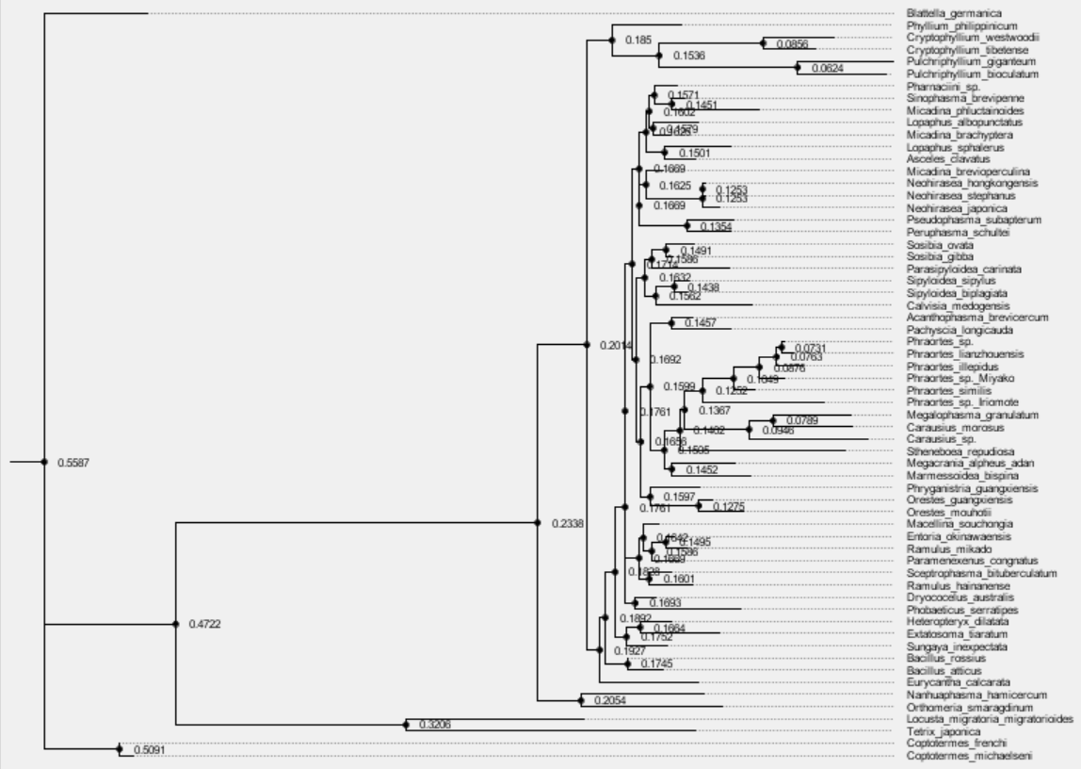

COI tree. It was not displaying bootstrap values. Click on the little arrw next to Node Labels and then select “Display” and change it to “label”. I hate how illegible it is so I will try to fix it. But the important bits are the bootstrap values.

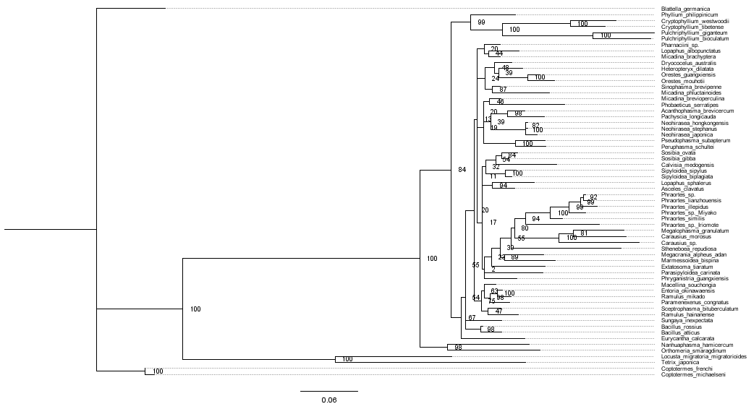
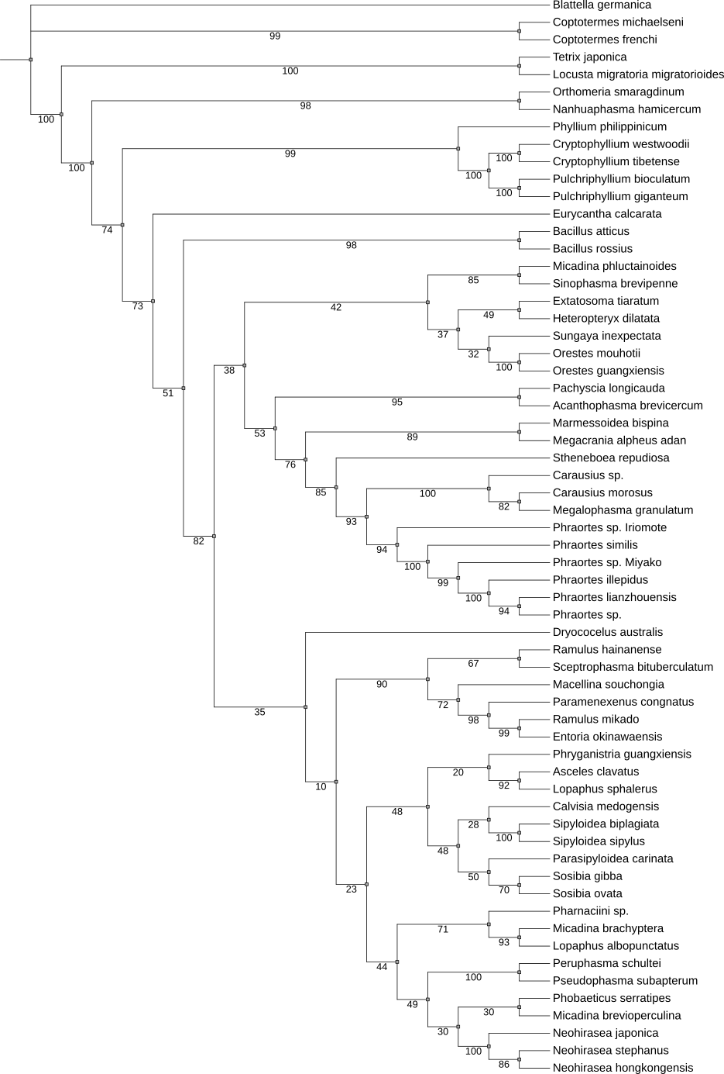

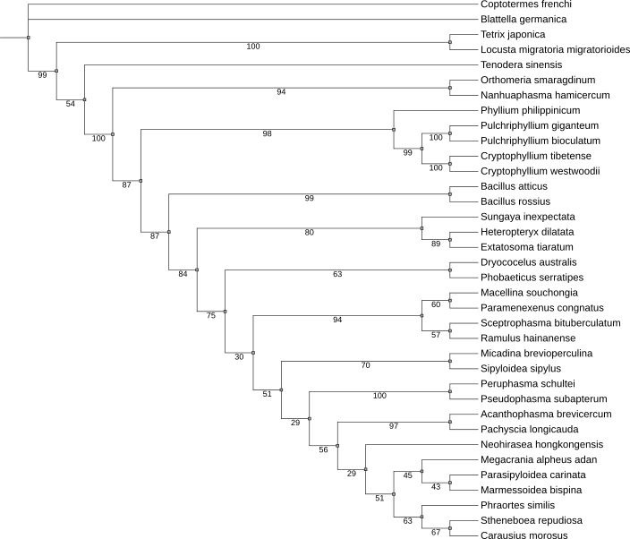
Phylliidae
Phasmatodea
Blattodea
Orthoptera
Mantodea

FINAL TREE
Aligned using CLUSTAL. Tree created with IQTREE. Tree visualised with Interactive Tree of Life. Model used is mtZOA+F+I+G4 with BIC 13422.476. Max. number of iterations = 5000. No improvements to tree were found after 767 iterations. Yellow = Blattodea, Green = Mantidae, Blue = Orthoptera, Red = Phasmatodea, Highlighted = Phylliidae.

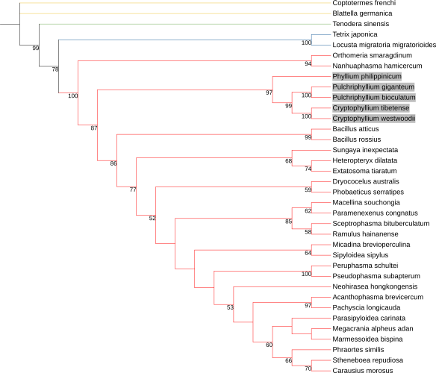

ProtHint - 28/01
Need to cite Diamond, ProtHint, and Spaln.

Useful Links
GitHub - gatech-genemark/ProtHint: Protein hint generation pipeline for gene finding in eukaryotic genomes

Step 1. Download ProtHint
wget https://github.com/gatech-genemark/ProtHint/releases/download/v2.6.0/ProtHint-2.6.0.tar.gz

tar -xzvf ProtHint-2.6.0.tar.gz

Step 2. Download dependencies
Move all GeneMark-ETS files (including gmes folder) to the dependencies file.

Step 3. (This took me approx. 4 hours to figure out). Also install the perl dependencies to local library with:
cpan MCE::Mutex threads YAML Thread::Queue Math::Utils
Hash::Merge ForkManager
You will then need to move the bin and lib folder from in the directory ~/perl5 and then point the @INC to that directory containing YAML.pm, MERGE.pm, ForkManager.pm using
export PERL5LIB=/pub63/vica/perl5/lib/perl5:$PERL5LIB
or whatever directory the files are in, and then source this by:
source ~/.bashrc

Step 5. Run genemark (See BRAKER)
Step 4. Run Prothint
prothint.py genome.fasta proteins.fasta

This will generate a file to be used with BRAKER under the --prot_hints flag: prothint_augustus.gff

04/02/2025 - EggNOG - Mapper
There is a server for this:
eggNOG-mapper

Split the D.austr with no diamond filter up into 3 fasta files of proteins. Put each one through eggnog for a total combination of 27392 proteins in total. This was out of a total 195,000 protein sequences from GALBA.
05/02/2025 - ARTEMIS COMPARISON TOOL

Artemis Comparison Tool (ACT) | The Artemis Software

To run this we need to use tblastx or mummer. I wouldn’t use mummer as it was a bit shit. We also need a genbank file for each genome.

1. Run tblastx using my genome as a query and create a nucleotide database out of the subject genome (D. australis). Or use mummer to get delta, then coords file - use the scrip nucmer_to_crunch.py to turn the output into a crunch file to use in ACT. Then pick the next individual.

I would like to do P. philippinicum -> C. hookeri -> D. australis -> Bacillus rossius -> Timema.

This was a bit of a disaster. The genome alignments are too big for my laptop to open in the GUI. I then can’t view the ACT output on Linux without GUI. I currently do not have a solution to this other than to switch to use Mauve.

07/02 - progressiveMauve

Download
conda install -c bioconda progressivemauve

Use
progressiveMauve --output=[output.xmfa] genome1.fasta genome2.fasta genome3.fasta genome4.fasta genome5.fasta

Make sure no spaces in headers. Make sure the file is formatted correctly. This will output an xmfa file. This can be visualised in Mauve (hopefully if my laptop has enough MEM). To remove spaces in headers use:
awk '/^>/ {gsub(/ /, "_")} {print}' genome.fasta > genome_fixed.fasta

So I used the genomes:
P. phillippincium
D. australis
B. rossius
C. hookeri
T. douglasi

to hopefully look for synteny. I can then create the synteny plot using Mauve.

Old vs New contig mapping.

Download ODGI
conda install -c bioconda odgi

1. Map the new reads to the old reads using minimap2
minimap2 -x asm20 old_assembly.fasta new_assembly.fasta > mappings.paf

2. Convert the old gaf file to ODGI format:
odgi build -g old_assembly.gfa -o old_graph.og

3. Create an image of the graph
odgi viz -i old_graph.og -o old_graph.png

4. Highlight the mappings on the old graph.
odgi depth -i old_graph.og -p mappings.paf -o overlay.og

5. Create the png image
odgi viz -i overlay.og -o overlay.png

Okay so, I am trying 2 different things:
Open bandage p_ctg file, then label with the csv file from mapping. To get this csv file I only wanted the column 6,8,9 from the mapping.paf file. Now I can label which contigs have been retained in the final assembly. BANDAGE DIDN’T REALLY WORK.

Or, if you go to the end of the p_ctg file, there are L lines which can be extracted for odgi. I would also have to extract the S sequence lines too. I could always get the unitig gfa file, extract the utg names and sequences, and create a fasta file. Then map the final assembly to the unitigs instead?

Repeated issue with parsing contig names. Replaced the contig names with the numbers (removed ptg and l/c). Make sure that the columns are separated. There should be lines beginning with S

12/02/2025 - ProgressiveCactus

This is to create a pangenome. Need to use ProgressiveCactus instead of just Cactus as this helps them compare different species genomes
cactus/doc/progressive.md at master · ComparativeGenomicsToolkit/cactus

The input for ProgressiveCactus is

(NEWICK TREE)

What do genome papers contain?

The genome of the sea anemone Actinia equina (L.): Meiotic toolkit genes and the question of sexual reproduction - ScienceDirect

Abstract
- Contig N50
- Contig #
- BUSCO completeness
- Number of protein coding genes
- How many current genomes are known for the Order and Family? If no genomes available are there other DNA info known? - Yes there are mitogenomes available thanks to Royce Cumming’s paper.
- What are the other known genomes like? - Variable in size, ploidy etc.
- Background of the species

Methods
- DNA extraction and sequencing (only brief as my paper focuses on assembly)
- MIxS descriptors (ask as not much info about them!)
- Genome Assembly: 4 separate assembly methods - HiCanu, Flye, Shasta and HiFiASM. What problems did we come across? The inflated genome size, this was resolved with purge_dups (hopefully) - but this paper did use Purge_Haplotigs procedure (The genome of the sea anemone Actinia equina (L.): Meiotic toolkit genes and the question of sexual reproduction - ScienceDirect). Used the default error rate for each, although could’ve used smaller because HiFi reads are highly accurate
- GenomeScope predicted size
- For each assembly: QUAST, BUSCO, Bandage, purge_dups, Merqury and samtools mapping, RepeatMasker/Modeler, were undertaken.
- The best assembly was taken forward for genome calling and annotation. Craig used transcriptome, I don’t have any Hi-C, RNAseq etc. available so I have to use ab initio annotation.
- BLAST used to investigate the high coverage of contig 454.
- Smudgeplot for ploidy? Blobtools? Include this.

Results
- HiFi read info: 361GB data. How many Reads is this? Check the pdf.
- Raw FASTQ have been submitted to the SRA with number SR…….
- Shasta not considered further due to the high number of contigs.
- They judged the best assembly by highest N50 and lowest contig #. They deposited this in GenBank.
- Included a table of statistics that I have made.

- Like me, only their best genome was taken forward.
- Detailed BUSCO analysis.
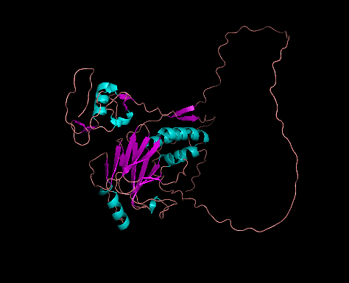
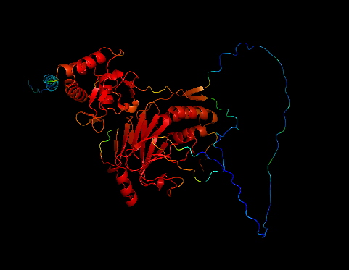
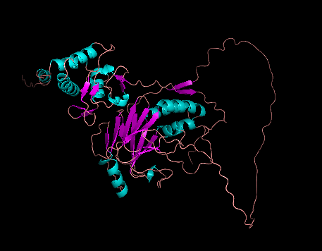
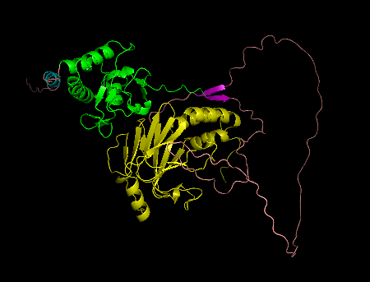
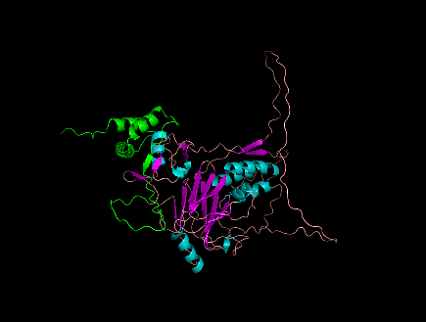
PROTEIN
Figure x. Clockwise from top left: a) Drosophila MAD displaying conserved regions (red) (UniProt: P42003),
b) Drosophila MAD domains - MH1 (green), MH2 (yellow), c) Drosophila MAD structure showing alpha helices (blue) and beta sheets (purple), d) P. philippinicum SMAD2, e) B. rossius MAD homolog 3 (Accession No: XP_063222328.1).

Telomere contigs
Contig 7 = TELOMERE REPEATS CCTAA
Contig 42 = ditto
Contig 53 = ditto
Contig 55 = ditto
Contig 64 = ditto
Contig 69 = ditto
Contig 76 = ditto
Contig 82 = ditto
Contig 85 = ditto
Contig 92 = ditto
Contig 95 = ditto
Contig 104
Contig 124
Contig 130
Contig 154
Contig 178
Contig 199
Contig

FASTQ to FASTA
sed -n '1~4s/^@/>/p;2~4p' INFILE.fastq > OUTFILE.fasta

MakeBLASTDb
makeblastdb -in input_reads.fasta -dbtype nucl -out my_reads_db -max_file_sz 900MB

Ascomycota and Mollusca contigs

- Check Teams message to Al for a better explanation
The coverage of the fungal contig (ptg000388l) was much lower than the average genome coverage (…), this low coverage suggests it is contamination. It is unlikely this is a contaminant from the environment of the specimen as she lived in a well ventilated mesh enclosure. A portion of the fungus are also endemic to South East Asia, the location of the Phillippines, as well as a fungus endemic to Antarctica (NC_044132.1) However, fungal HGT has been found in Phasmids, in particular pectinolytic polygalacturonase which are enzymes that assist in breaking down plant cell walls. If this was the case though, then it would be unusual for only the mtDNA to be present, although this might be due to the fact that the fungus might not be full endosymbionts as well as the higher presence of mtDNA being picked up rather than the full nuclear genome. However, this may be evidence of early acquisition of fungal symbionts, as the fungal presence is also there in the ancient lineage Timema californicum well as D. australis, however as the enzyme has integrated this is the remnance that is left of the fungus. Interesntingly, there were also T. californicum hits on the Ascomycota contig. There were hits for ppg in the genome which suggests that this has occurred at some point previously, and the mtDNA may have integrated into the leg tissue. It is also possible that these are gut fungal symbionts and the trace amounts that have migrated to the leg tissue somehow.
The T. californicum is the only other phasmid species present on the Ascomycota contig. The other phasmids appear to have bacterial contigs rather than fungal contigs. Is it possible that the fungal hits in t. californicum are actually bacterial and are misidentified? When blasting some of the fungal accession numbers that are found in the Ascomycota contig, there are blast hits for bacteria in particular when BLASTing NC_045905.1 (Sydowia polyspora) a 1193bp sequence from contig50637 of an uncultured bacteria (Accession No.: KP445324.1, Identity: 80.77%, E-value = 9E-142) and 3170bp from contig131706 from uncultured bacteria (Accession No.:KP431703.1, Identity: 82.73%, E-value: 6E-114). Could it potentially be that when Timema californicum was sequenced, the first Phasmid, some of the bacterial dna was misannotated as T. californicum which is why these T. californicum hits appear in the P. phyllium contig. This uncultured bacteria is a lichen-associated bacteria, which also makes sense as to why there are also lichen hits in this contig.
The Mollusc are also present in the other {hasmids.

When I BLAST the uncultured bacteria it has a tiny hit for 23S rRNA for Brucella

Mitogenome
In insects there is a conserved sequence of ATACTAA, proposed as the mtTERM in the mtDNA. It is often found between tRNA-ser and NAD1. Other insects have mtTERM at this point but in P. tibense, P. westwoodii and in P. philippinicum have no inter-genic region between these genes (overlap). In my mtDNA, there are 6 instances of ATACTAA, 4 of which are within genes, and 2 are within the D-loop region (pos. 8302 and 10870). Sometimes found between Leu and rRNL - in P. philippinicum there is a 12bp region (pos 13061 - 13073). There are 29 different repeats in the Dloop, ranging from 10bp long to 660bp, the total length of the repeat region is 2528bp and D-loop is 4894bp (51% Dloop is repeats). Normally repeats is between 10-30%. To sort this, blast the D-loop against my reads to find a read that hopefully spans the D-loop, then align this to the current D-loop for comparison.

Record of Meetings

You should be meeting with your supervisor and perhaps also members of the research group.

Create a dated log of these meetings here.
3/10/2024 – First meeting with Al. My project idea was accepted.

7/10/2024 – Email with Al about which sequencing tech to use – PacBio vs. ONT. I am leaning towards PacBio due to its ability to handle repeating regions. There may be a lot of these in this genome due to relatives having a high content of MITEs. BUT it also may not be. The genome of Timematidae is a lot smaller (around 1.2 Gb) who is also the most basal group of Phasmatodea.

7/10/2024 – Email asking for clarification regarding credit. I did not think that I would be getting credit as I didn’t do the sequencing (which I thought was the main part of getting credit). Al reassured me that it is a team effort and we will all get credit :) Found out that Carl Yung will be the individual doing the sequencing. Decided that the individual will be dropped off at some point soon where it will be stored until Carl can do the sequencing in the next few weeks. (Big thanks Carl!)

9/10/2024 – Emailed Al to see if we can locate the X-chromosome. He said yes it’s possible, look at kmers method to ID X chromosome. Sent him a picture of first instar.

11/10/2024 – Make appointment with Al. I would like to ask him about using kmers to identify chromosomes. I also would like to ask about how to make a histogram to estimate genome size using data from Oxford Nanopore as my example data taken directly from NCBI did not work. It produced a dataframe that looked like this after I used jellyfish to reduce it to 20-mers. The file this was from was a strain of E. coli. PROBLEM SOLVED (CANONICAL KMERS)

18/12/2024 – Asked Al which to run first purge_dups or purge_haplotigs. He said Mark said purge-dups first.

19/12/2024 – Query about running Merqury and purge_dups. Why is it so memory intensive? Gauss10 crashed but turns out it wasn’t me yay.

29/12/2024 - Asked Mark for an appointment regarding purge_dups?

29/12/2024 - Showed Al what I have done so far - send him onedrive link to this and to my assembler timetable

06/01/2025 - By this point I can do all steps except for purge_dups and Blobtools. Need to get an appointment for this with Mark still. When I have figured this out I can get the other assemblies and do my comparison. Also ask about using MAKER.

February 2025 - Meeting with Al to discuss problem with the pangenome and GALBA annotation. Use BUSCOs to create a pangenome?

February 2025 - Meeting to discuss starting the write up.

21/03/25 - Discuss getting the RNA-seq data. Go over the write-up so far.

