Model selection and Maximum Likelihood (ML) analyses were performed using IQ-TREE v1.6.1 (IQTREE Web Server: Fast and accurate phylogenetic trees under maximum likelihood). The optimal amino acid substitution models were identified using the FreeRate model, in combination with the default edge-linked partition scheme. ML tree construction was carried out with 10,000 ultrafast bootstrap replicates and a maximum of 5,000 iterations. The partition file for the concatenated dataset, was generated using RAxML format, employing the most recent Le and Gascuel model across all 13 protein-coding genes (PCGs). A total of five ML trees were generated, with the tree generating the best likelihood score selected as the most robust phylogenetic inference.
Taxonomic assignments were based on the Phasmida Species File (https://phasmida.speciesfile.org/), and the final tree was visualised using Interactive Tree of Life (IToL) (https://itol.embl.de/).
The best-supported ML tree (-lnL = -80233.699) exhibits a topology largely consistent with previous phylogenetic studies (Banks et al., 2021). Notably, the Phylliidae clade is recovered as a strongly supported monophyletic group (Bootstrap Support = 100) and represents one of the earliest diverging lineages within Euphasmatodea (BS = 90). Bootstrap support is uniformly high across this clade, with the exception of the node separating C. oyae and C. tibetense (BS = 93). All Phylliidae are grouped according to their currently accepted genera and by the 2021 definition Phyllium is monophyletic with the type species P. siccifolium (Banks et al., 2021)
Consistent with prior studies (Song, Li & Na, 2020; Chen et al., 2024; Banks et al, 2021; Forni et al., 2021; Zeng et al., 2020), the Timema lineage is resolved as the sister group to all other Euphasmatodea (BS = 92), and the Aschiphasmatidae are confirmed as the earliest diverging family within Euphasmatodea (BS = 100) in accordance with the full mitogenome dataset. Moreover, the outgroup Grylloblattodea is recovered as the sister group to Phasmatodea (BS = 100). Even when it comes to morphology, Timema is often considered as the sister taxa to Euphasmatodea, with the evolution of soft egg shells (Timema) to hard casing (Euphasmatodea) considered a major factor in the radiation of Phasmatodea diversity (Robertson, Bradler & Whiting, 2018).
In contrast, bootstrap support across the deeper nodes of the remaining Euphasmatodea clade is relatively weak (BS = 46). Notably, Phraortes sp. is unexpectedly recovered as sister to Bacillidae, despite its current classification within Lonchodinae (BS = 36). This finding aligns with prior studies (Forni et al., 2021), which report ambiguity surrounding the placement of Phraortes, potentially due to misidentification. Nonetheless, these authors also suggest that Phraortes and Bacillidae may form monophyletic clades, consistent with our results.
The Psuedophasmatodae-Heteropterygidae-Lonchodinae-Bacillidae-Phasmatidae grouping as well as their relationship with Phylliidae remains a major source of phylogenetic uncertainty, a pattern widely reflected in the literature (Simon et al., 2019; Komoto et al., 2011) . It is important to note that the present topology is based exclusively on complete mitogenome sequences (n = 24). Given the diversity of Phasmatodea, with numerous families yet to be sequenced, the resolution of deeper nodes remains incomplete. Nevertheless, the Phylliidae clade continues to emerge as a well-supported monophyletic group across phylogenomic studies. The present tree is the first to incorporate complete mitogenomic PCGs of all currently available Phylliidae, including the novel complete mitogenome of Phyllium philippinicum. Previous analyses incorporating P. philippinicum either used it as the sole representative of Phylliidae - providing limited insight into intra-family relationships - or relied on partial genomic data or a reduced selection of mitochondrial gene sequences to place a large number of species.
Although our analysis includes far fewer Phylliidae representatives than that of Bank et al. (2021), the most in-depth Phylliidae phylogeny to date, both studies recovered P. siccifolium as the closest relative of P. philippinicum with 100% bootstrap support. Bank et al. (2021) also noted that these two taxa exhibit the lowest genetic divergence among Phylliidae, a result corroborated here by short branch lengths between these species. This high genetic similarity is unlikely to result from recent divergence alone, especially as earlier estimates place Phylliidae radiation as the mid-Cretaceous (Tihelka et al., 2020). However, it should be noted that P. philippinicum was not included in those chronograms. To more accurately estimate the divergence time between P. philippinicum and P. siccifolium, a chronogram including both species would be informative. This would clarify whether the observed genetic similarity stems from recent radiation or conserved evolutionary trajectories. While Short Branch Attraction (SBA) can confound phylogenetic inference falsely implying conditions of low genetic diversity, the hallmark short internal branch structure predisposing to SBA is not present in this case (Lu et al., 2023), and Bank et al.(2021) also independently reported similar findings of low genetic divergence between the two species. Conversely, Long Branch Attraction (LBA) remains a concern, particularly in Euphasmatodea, where rapidly evolving lineages can falsely cluster together (Su & Townsend, 2015). This may account for the unusual placement of Phraortes in our analysis, however, Lonchodidae, containing Phraortes, has been shown to potentially be polyphyletic (Chen et al., 2024).
When restricting all available trees to Phylliidae-only taxa, most available Phasmid phylogenies put Phylliidae as an early diverging Euphasmatodea lineage (Buckley, Attanayake & Bradler, 2009). Phylogeny based on morphology or a reduced number of genes, has shown Phylliidae has been variably placed as a sister taxon to Heteropteryx and as a much later-diverging clade, underlining the importance of incorporating as much relevant genomic data as possible. (Büscher, et al., 2018; Yang et al., 2019). Banks et al (2023)’s follow-up paper, based off 6 mitochondrial and nuclear loci, suggests that Cryptophyllium is the earliest diverging lineage followed by Phyllium and Pulchriphyllium, respectively. In contrast, this study infers Phyllium as the earliest lineage in Phylliidae, suggesting the quantity of genomic data used affects tree topology.
Relative to the root (Blattella germanica), the Pulchriphyllium genus exhibits the highest uncorrected genetic distance from the root among all Phasmatodea. However, this does not necessarily imply recent divergence, and without a dated phylogeny, these results should be interpreted cautiously. A cladogram with calibrated divergence times based on previous fossil data will provide critical context, allowing integration of developmental traits (e.g. wing evolution (Whiting, Bradler & Maxwell, 2003; Yang et al., 2023), oviposition mechanisms (Robertson, Bradler & Whiting, 2018), and parthenogenesis (Schwander et al., 2025) within a temporal framework, thereby offering deeper evolutionary insights into the radiation of Phylliidae. Despite not including the largest number of species, this phylogeny is robust in terms of using whole PCGs from all complete mitogenomes available and the reduced size of the tree in comparison to previous studies, underscores the urgent need for genomic data to keep pace with the accelerating rate of species descriptions.

Refs
- Cumming R. T., Le Tirant, S., Linde, J. B., Solan, M. E., Foley, E. M., Eulin, N. E. C., Lavado, R., Whiting, M. F., Bradler, S. & Bank, S. (2023). On seven undescribed leaf insect species revealed within the recent “Tree of Leaves” (Phasmatodea, Phylliidae). ZooKeys, 1173 (p. 145-229). doi: 10.3897/zookeys.1173.104413
- Forni, G., Plazzi, F., Cussigh, A., Conle, O., Hennemann, F., Luchetti, A. & Mantovani, B. (2021). Phylomitogenomics provides new perspectives on the Euphasmatodea radiation (Insecta: Phasmatodea). Molecular Phylogenetics and Evolution, 155. doi: 10.1016/j.ympev.2020.106983
- Bank, S., Cumming, R. T., Li, Y., Henze, K., Le Tirant, S. & Bradler, S. (2021). A tree of leaves: Phylogeny and historical biogeography of the leaf insects (Phasmatodea: Phylliidae). Communications Biology, 4(932). doi: 10.1038/s42003-021-02436-z
- Lu, L., Yu, L., Wu, S., Arnold, J., Whalen, C., Davis, C. & Edwards, S. (2023). Short branch attraction in phylogenomic inference under the multispecies coalescent. Frontiers in Ecology and Evolution, 11. doi: 10.3389/fevo.2023.1134764
- Su, Z. & Townsend, J. P. (2015). Utility of characters evolving at diverse rates of evolution to resolve quartet trees with unequal branch lengths: analytical predictions of long-branch effects. BMC Evolutionary Biology, 15(86). doi: 10.1186/s12862-015-0364-7
- Buckley, T. R., Attanayake, D. & Bradler, S. (2009). Extreme convergence in stick insect evolution: phylogenetic placement of the Lord Howe Island tree lobster. Proceedings of the Royal Society B, 276(1659). doi: 10.1098/rspb.2008.1552
- Büscher, T. H., Buckley, T. R., Grohmann, C., Gorb, S. N., Bradler, S. (2018). The Evolution of Tarsal Adhesive Microstructures in Stick and Leaf Insects (Phasmatodea). Frontiers in Ecology and Evolution, 6. doi: doi.org/10.3389/fevo.2018.00069
- Yang, H., Yin, X., Lin, X., Wang, C., Shih, C., Zhang, W., Ren, D., Gao, T. (2019). Cretaceous winged stick insects clarify the early evolution of Phasmatodea. Proceedings of the Royal Society B, 286(1909). doi: 10.1098/rspb.2019.1085
- Robertson, J. A., Bradler, S. & Whiting, M. F. (2018). Evolution of Oviposition Techniques in Stick and Leaf Insects (Phasmatodea). Frontiers in Ecology and Evolution, 6(216). doi: 10.3389/fevo.2018.00216
- Whiting, M. F., Bradler, S. & Maxwell, T. (2003). Loss and recovery of wings in stick insects. Nature, 421(6920). doi: 10.1038/nature01313
- Yang, H., Engel, M. S., Shih, C., Song, F., Zhao, Y., Ren, D. & Gao, T. (2023). Independent wing reductions and losses among stick and leaf insects (Phasmatodea), supported by new Cretaceous fossils in amber. BMC Biology, 21(210). doi: 10.1186/s12915-023-01720-0
- Schwander, T., Soldini, L., Boisseau, R. P., Merel, V., Toubiana, W., Lavanchy, G. (2025). On the Repeated Evolution of Parthenogenesis in Stick Insects. [Preprint]. doi: 10.32942/X21P7G
- Tihelka, E., Cai, C., Giacomelli, M., Pisani, D. & Donoghue, P. C. J. (2020). Integrated phylogenomic and fossil evidence of stick and leaf insects (Phasmatodea) reveal a Permian-Triassic co-origination with insectivores. Royal Society Open Science, 5(11). doi: 10.1098/rsos.201689
- Kômoto, N., Yukuhiro, K., Ueda, K. & Tomita, S. (2011). Exploring the molecular phylogeny of phasmids with whole mitochondrial genome sequences. Molecular Phylogenetics and Evolution, 58(1). doi: 10.1016/j.ympev.2010.10.013
- Song, N., Lie, X. & Na, R. (2020). Mitochondrial genomes of stick insects (Phasmatodea) and phylogenetic considerations. PLoS One, doi: 10.1371/journal.pone.0240186
- Bradler, S., Robertson, J. A. & Whiting, M. F. (2014). A molecular phylogeny of Phasmatoeda with emphasis on Necrosciinae, the most species-rich subfamily of stick insects. Systematic Entomology. 39(2). doi: 10.1111/syen.12055
- Chen, Y., Yuan, Y., Yang, W., Storey, K. B., Zhang, J. & Yu, D. (2024). Insight into the Phylogenetic Relationship of Phasmatodea and Selection Pressure Analysis of Phraortes liaoningensis Chen & He, 1991, (Phasmatodea: Lonchodidae) Using Mitogenomes. Insects, 15(11). doi: 10.3390/insects15110858
- Zeng, Y., O’Malley, C., Singhal, S., Rahim, F., Park, S., Chen, X., Dudley, R. (2020). A Tale of Winglets: Evolution of Flight Morphology in Stick Insects. Frontiers in Ecology and Evolution, 8. doi: 10.3389/fevo.2020.00121
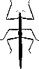

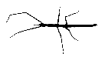
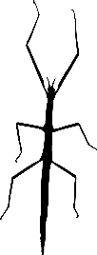
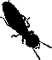
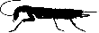

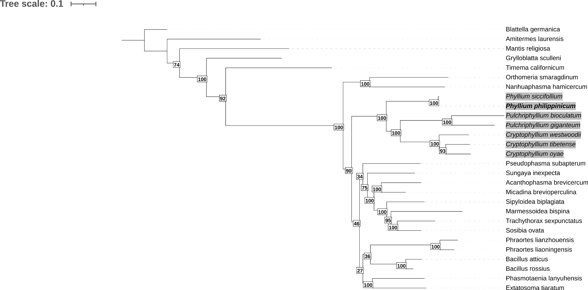
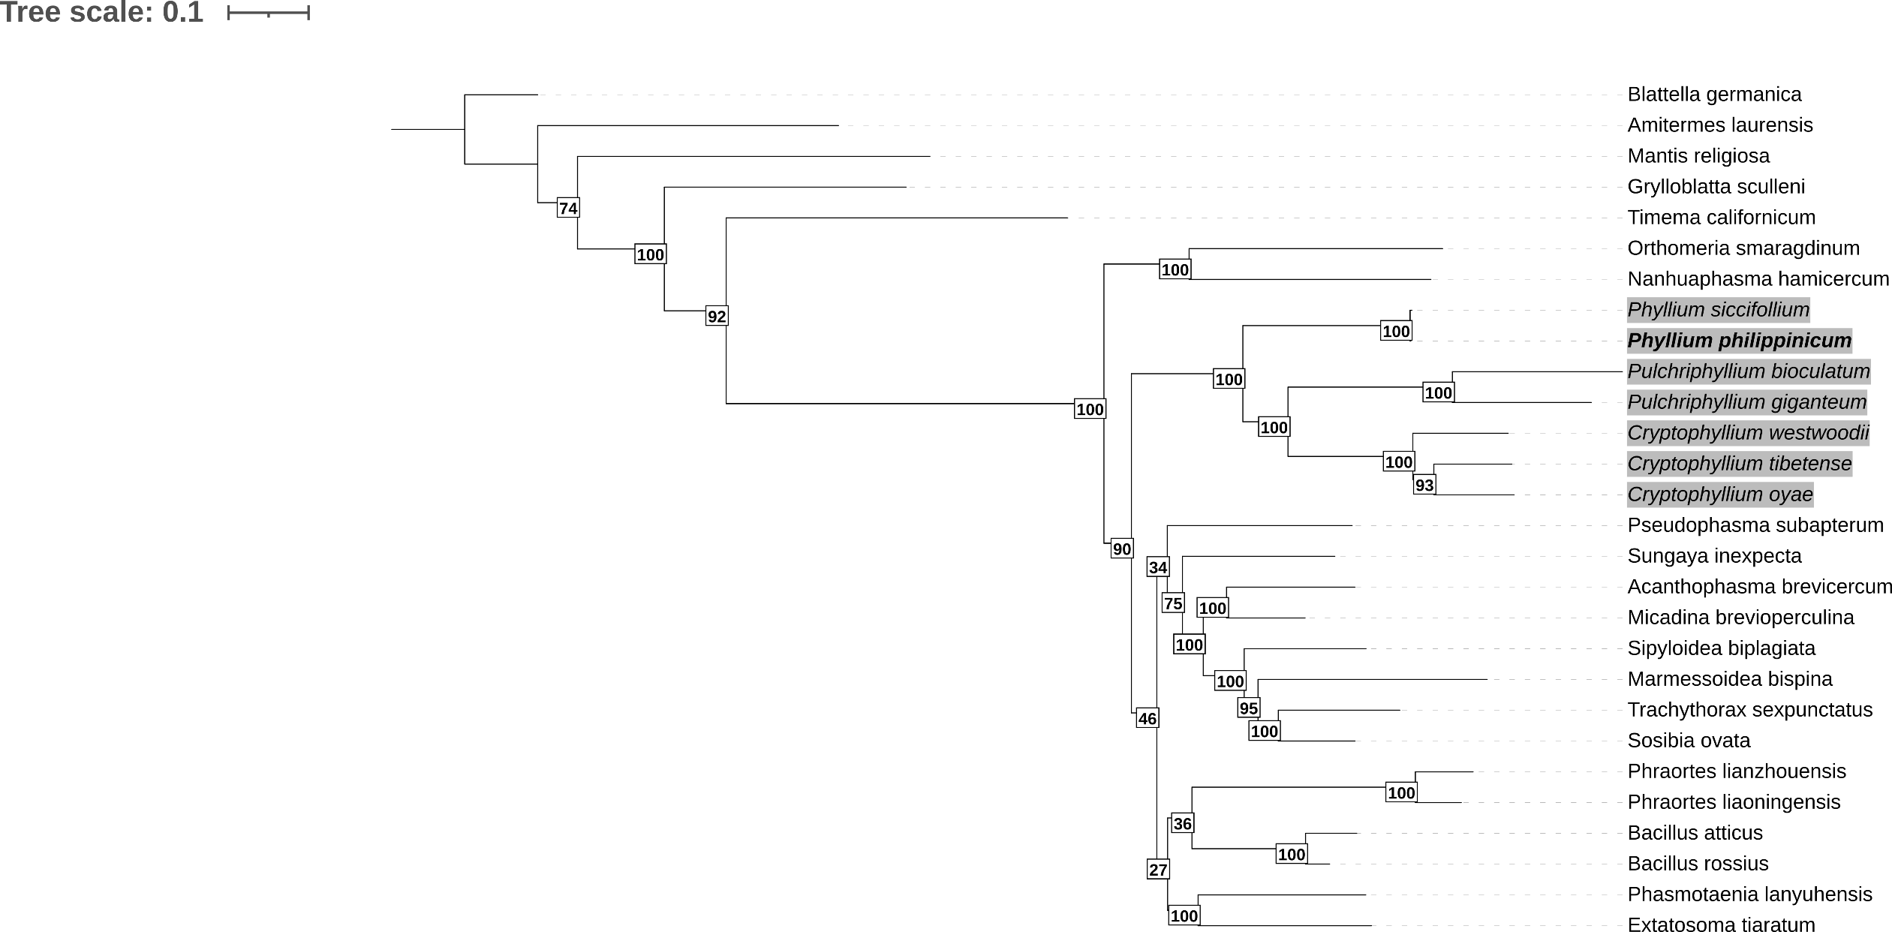
Timematidae
Aschiphasmatidea
Heteropterygidae
Phylliidae
Blattodea
Mantodea
Grylloblattodea
Pseudophasmatidae
Lonchodidae
Phasmatidae
Bacillidae

Caption sjdfasdfoasdfasjdfhaeiohfasjdf
Euphasmatodea

Phasmatodea

