Mitochondria Write Up Draft - REWRITE AS THIS STRUCTURE IS TAKEN FROM Frontiers | Organization of the mitochondrial genome of Ramulus irregulatiter dentatus (Phasmatidae: Phasmatidae) - WHAT CAN GO IN SUPPLEMENTARY DATA
The length of the complete mitochondrial genome of the leaf insect P. philippinicum is 19,627bp, which is longer than all known Phasmatodea mitogenomes (refs here). We found that the total mitogenome lengths of the Phasmatodea mitogenomes range from 15011bp to 19,627bp. Within this range, Phylliidae range from 16,686 (P. giganteum) to our species, P. philippinicum, with an average length of 17579 +- 1053bp. Control region length as well as the varying length of intergenic regions are the biggest contributor to mitogenome length differences as tRNA, CDS, and rRNA lengths are relatively consistent across all Phasmatodea (Fig of boxplot).

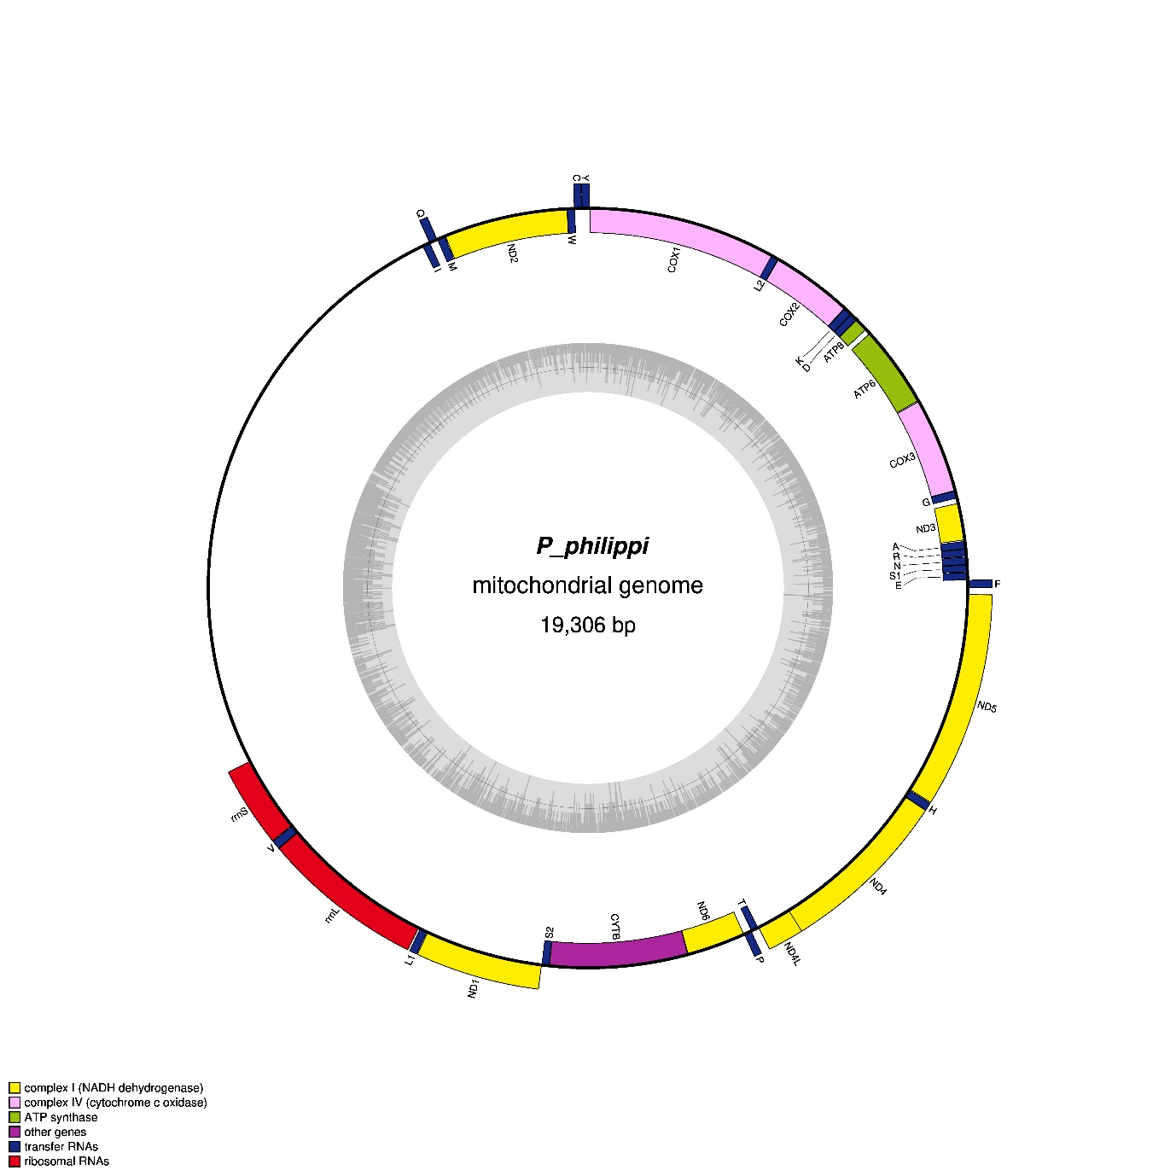


P. philippinicum
Mitochondrial genome

19,306bp
Mitogenomic Map of Phyllium philippinicum Showing Gene Annotations

The gene order of this mitogenome is consistent with that of all other Pylliidae mitochondrial genomes, and B. atticus (The mitochondrial genome of Bacillus stick insects (Phasmatodea) and the phylogeny of orthopteroid insects - ScienceDirect) which in turn is slightly different to other known stick insects (The mitochondrial genome of Eurycantha calcarata Lucas, 1869 (Phasmatodea: Lonchodinae) and its phylogeny - PubMed: . This includes the present of all 37 expected genes (22 tRNA, 13 PCGs, 2 rRNAs).
We found that the total length of the PCGs were 10984bp, the second lowest length of all Phasmatodea, with only C. westwoodii being shorter, and this accounts for 56.4% of the entire mitochondrial genome, the lowest of all Phasmatodea. This is also the same for tRNAs (total length = 1417bp, which account for only 7.2% of the mitogenome. COMPARE TO OTHER PAPERS ON PHASMID MITOGENOMES - THERE ARE A FEW! Put in some of the boxplot stats
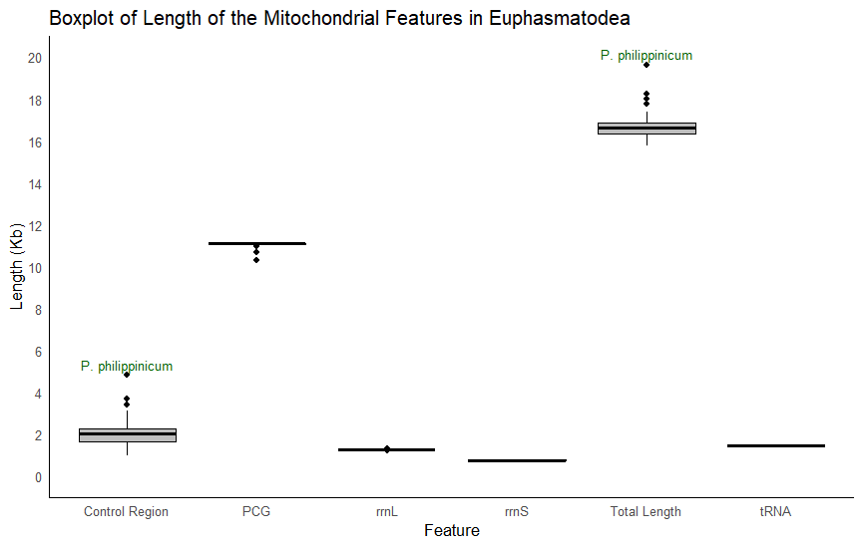

Nine of these PCGs (nad2, cox1, cox2, atp8, atp6, cox3, nad3, nad6, and cob) are on the H-strand, with the other 4 coded by the L-strand (nad5 nad4, nad4L and nad1). All of the PCGs started with the typical start codon seen in insects (ATN), except for ND4L, which starts with TTG, TTN is conserved across other Phasmid mitogenomes (double check). cox2 and nad5 end with a single T stop codon, with the remaining 11 PCGs ending with TAA. In contrast, it was usually nad5 and nad4 that have a single T stop codon in Phasmatodea (Mitochondrial genomes of stick insects (Phasmatodea) and phylogenetic considerations - PubMed). These results taken from Mitos2, yet when looking at cox2 annotation from MitoHifi, this suggests instead that is is an extended TAA codon (TAAAAT) instead. This aligns with the annotation of all other Phylliidae which have an extended stop codon, as well as the T end codon with nad5. This annotation does not follow the other Phylliidae when it comes to nad4 which ends with a T in other Phylliidae but TAA in P. philippinicum.
There are 12 regions that are overlapping in the mitogenome, with overlaps ranging from 1bp - 7bp for a total of 34bp overlap. The longest overlaps occur between tRNA-Cys and tRNA-Trp, and ND4L-ND4. These lower overlaps (check others) also leads to inflated mitogenome size. The intergenic regions are also large, leading to a total of 132bp with the biggest gap, other than control region, is 41bp to ATP6-ATP8. These intergenic gaps are much longer than other gaps in Phasmid mitogenomes and likely contributes to this increased size. This could be linked with the phylogenetics in that this is the basal ancestor of Phylliidae (currently known) and as mitogenomes tend towards becoming more compact over time, it is understandable that this mitogenome is large. (DO THIS FOR ALL OTHER MITOGENOMES). The longest spacer in R. irregulatiter dentatus is only 9bp (stick insect) - check other Phylliidae. The intergenic region of atp6 and atp8 does not contain the conserved region ATGATAA. This is not present in Phyliidae suggesting that this conserved region is no longer present in this region in Phylliidae, in fact, all modern Phylliidae with a known mitogenome, have an overlapping atp6 and atp8 region, suggesting that over evolutionary history, this large intergenic gap found in P. philippinicum has been reduced. The intergenic ATGATAA motif that has been conserved in other Phasmatodea and beyond is not found at all in any intergenic regions of the known Phylliidae mitogenomes. This motif is commonly found in the intergenic regions, but as mitogenomes have become more compact over time, this motif can be often found as an overlap within the atp6 and atp8 coding regions. This is the case for C. westwoodii, and C. tibetense (although this has become ATGATAG). In P. bioculatum and giganteum this motif, found in the overlap between atp6 and atp8 has become ATTATAA. In C. oyae this motif is present as expected in the overlap. Re-looked (had an idea to look at the reverse complement of the long intergenic region of atp6 and atp8 - AATGATAACAAATTTATTCTCAATTTTTGACCCCTGCACTA) and the ATGATAA is present as the compliment in the intergenic region of atp6 and atp8 lending weight to the theory that mitogenomes are becoming more compact over time.
In general the mtTERM for modern Phylliidae is an ATNATAN motif in the overlapping region of atp6 and atp8.
The frequencies of the nucleotides within the mitogenome are A:29.4%, C: 10.9% ,G: 14.8%, T: 43.3%. The total AT content of the genome is 72.7%, which is lower than other non-Phylliidae Phasmatodea, but is similar in content to the basal Timema (Exploring the molecular phylogeny of phasmids with whole mitochondrial genome sequences - ScienceDirect). The average AT content of the mitogenome of Phylliidae is 74.8%+- 1.60, and is the lowest AT content of all Phylliidae, likely due to these repeats. Unusually this decreases to 65.8% but within the control region but this region is made up of many repeats that contain GC (put repeats in here!!!). These repeat regions actually mean that the control region has a skew towards GC, which is not the case for control regions. It is more likely that these duplicates are outside of the CR. BLAST results show a series of overlapping hits to P. giganteum mitochondria that is 1265bp. However, this is then much smaller than the average length of P. philippinicum. Due to the lack of clarity around the limits of the control region, and due to the fact that in other Phasmid species, the entirety of this region is usually the control region, we are keeping the length of the putative CR of P. philippinicum as 4813bp. It is wholly likely that the repeating ‘TAGAAAGCCGAAATCGGGGTT’ unit that repeats 50 times, is a contributing factor to this skew. Removal of this repeat region brings the control region down to 3763bp, which is then only 61bp longer than C. tibetense. However, removal of this region then removes all BLAST hits to any known Phylliidae mitochondrial genomes suggesting this feature is a vital feature of Phylliidae mitochondria. This repeat motif is only seen in P. giganteum, the species used for annotation during mitohifi.
Comparing to a partial P. philippinicum assembly from (see tree of leaves paper), only 4278bp long, After removing all gaps and BLASTing the partial mitogenome, against this full mitogenome, showed a forward hit from 2524 -3217, 3263 - 4052, and 12504 - 12923 against our mitogenome. Each alignment had a 100% identity (E-value: 0.0). However, these hits only cover 10% of our mitogenome, covering both cox1 and cox2 and a partial cover of rrnL. REDO TABLE NICER
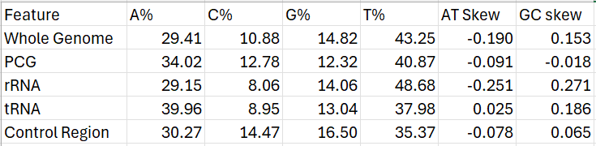

Codon Usage
All codons were used in the mitogenome PCGss except for the Terminal codon UAG. The most abundant codon family in PCGs, and their corresponding codons are AT-rich, and include start codons, AUA (Met) and AUU (Ile), as well as UUA (Leu1) and UUU (Phe). With an RSCU of 4.06, TTA (Leu1) codon is strongly overrepresented in the mitogenome of P. philippinicum (RSCU=4.055) in comparison to all other Leu codons (RSCU < 1). AGA (Ser2) is also preferred (RSCU = 3.583). The only stop codon used was TAA, no PCGs used the alternative codon TAG and as stated above , PCGs (cox2 and nad5) end with an extended TAA codon, that appears as a single T.

tRNA
The mitogenome of P. philippinicum has 22 tRNAs, these range in length from 60bp (trnS1) to 71bp (trnK), this is shorter than other non-Phylliidae phasmids but this is in line with other Phylliidae tRNAs, suggesting that on the whole Phylliidae have shorter tRNAs than stick insects. Like ours, the longest tRNA across all assembled Phylliidae is trnK (70.2bp +- 0.90), but there are several equally short tRNAs across Phylliidae, with minimum length being. The trnS1 of P. philippinicum is the shortest Phylliidae tRNA known to data and no tRNAs across Phylliidae exceed 71bp. (find the reference I lost about stick insect trna). SHORTEN THIS DOWN. Like other Phasmatodea, 14 genes were encoded on the H-strand, and the other 8 on the L- strand (reword this). The total tRNA length was 1417bp, the shortest of any Phylliidae (mean=1426+-4.8), but still highly consistent amongst mitogenomes, with an A+T bias of 77.94%. (BOXPLOT). Both GC (0.186) and AT (0.025) skew were positive.

Using mitos2 all tRNAs were able to be folded into the usual four-leaf clover shape (rewrite this - took word for word from paper just for now), other than tRNS1, which is missing the DHC as seen in many species (ref), and trnR which is missing the D-loop on the DHC arm. (SEE NEXT PAGE - SORT OUT THE FIGURE). This has been known to negatively impact translational activity in other insects (there was a ref somewhere). Despite all other tRNAs possessing all 4 arms, trnA, trnC and trnL2 had the presence of an extra bubble (what is the word???) in the accepter stem (trnA) or the anticodon loop (trnC and trnL2). To check this, they were re-modelled with RNAFold, and trnR and trnL2 resumed their expected cloverleaf shape. The structure of trnA and trnC took on a mostly linear shape, however, this was also found with the tRNAs other Phylliidae too. The loss of one arm has been commonly seen across phasmids, but no literature discusses the absence of both D and T arms. However, the models from tRNA and trnC contain several mismatched pairs, with 3 G-U pairs in trnA, and 5 G-U pairs in trnC. LOOK INTO MISMATCHED PAIRS AND RNA LACKING D AND T ARMS.
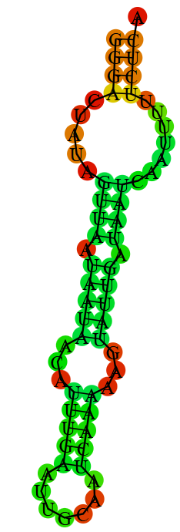
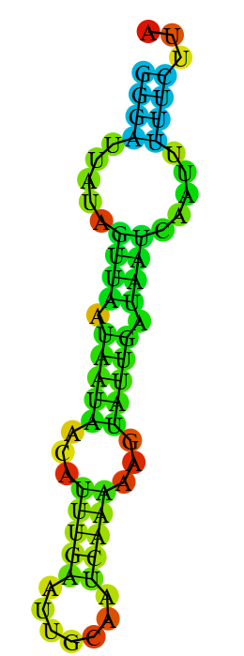
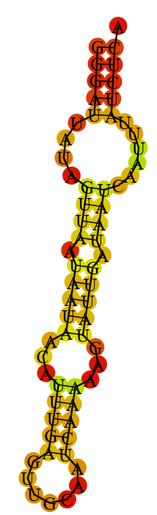
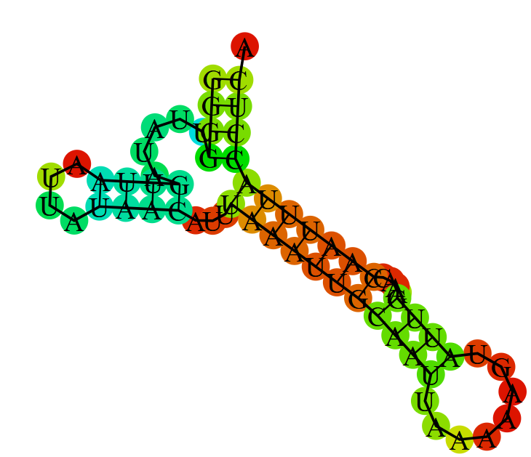
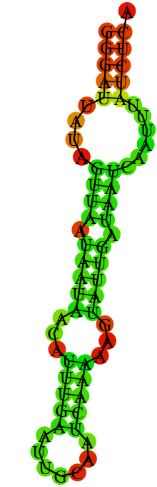
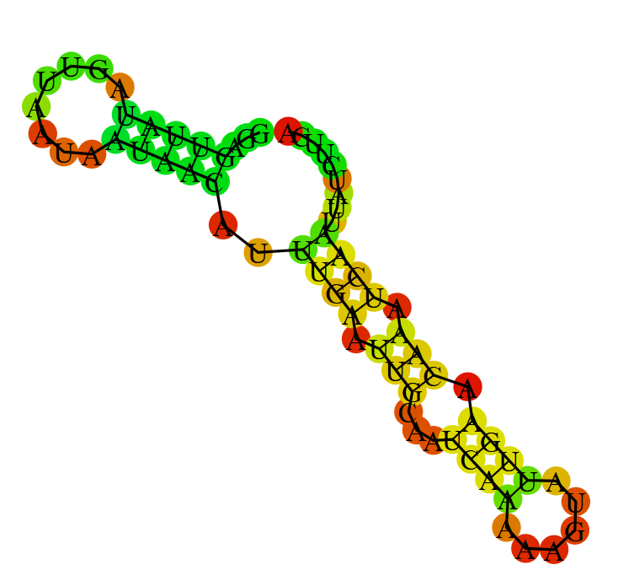
tRNA L-R. tibetense, giganteum, bioculatum, oyae, westwoodii philippinicum

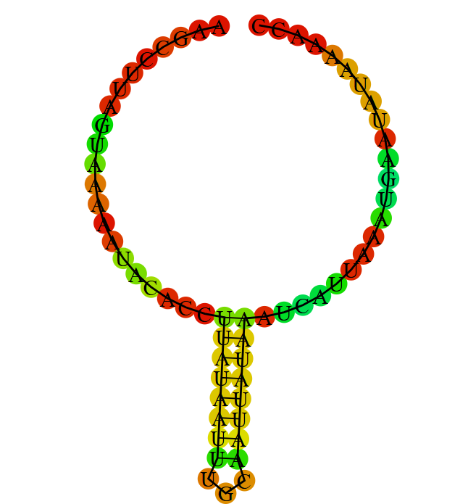
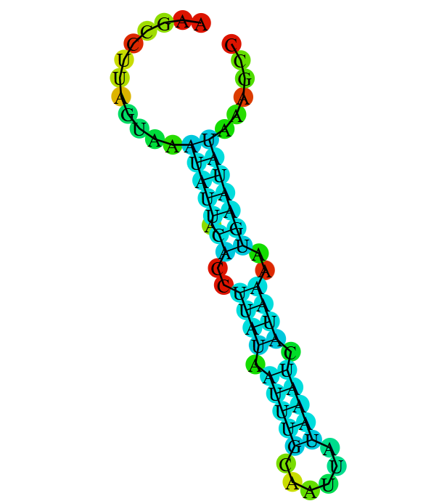
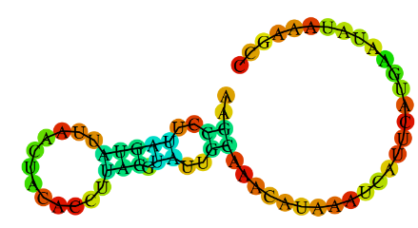
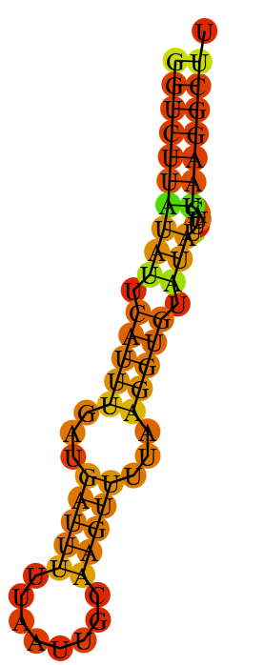
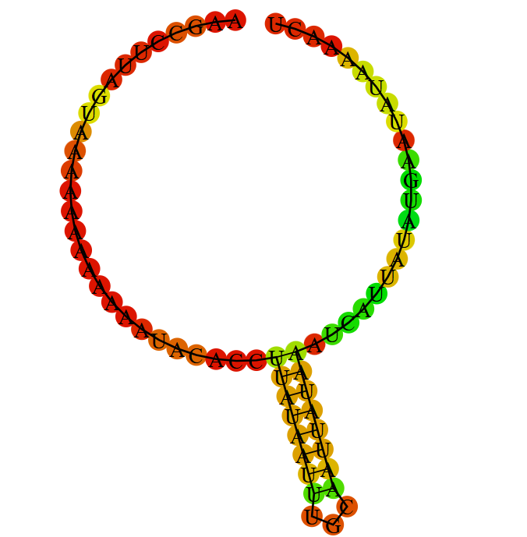
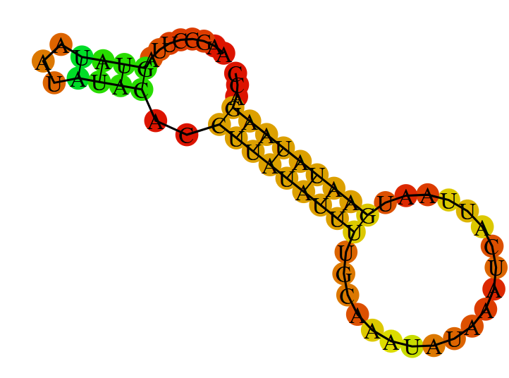
tRNC L-R. tibetense, giganteum, bioculatum, oyae, westwoodii. philippinicum

USE MITOS2!!!! Non Watson-Crick binding is present. Bulges seem to occur at U-U regions. trnR and trnL1 have a variable loop region instead of a stem.
The total length of the tRNAs is the sum of all lengths of tRNAs, not including the overlapping regions.
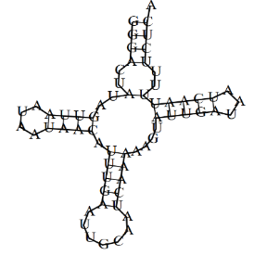
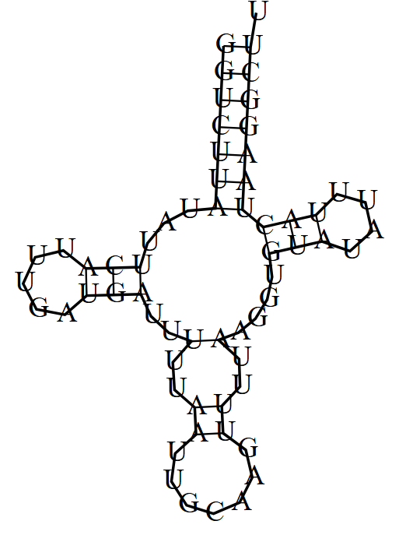
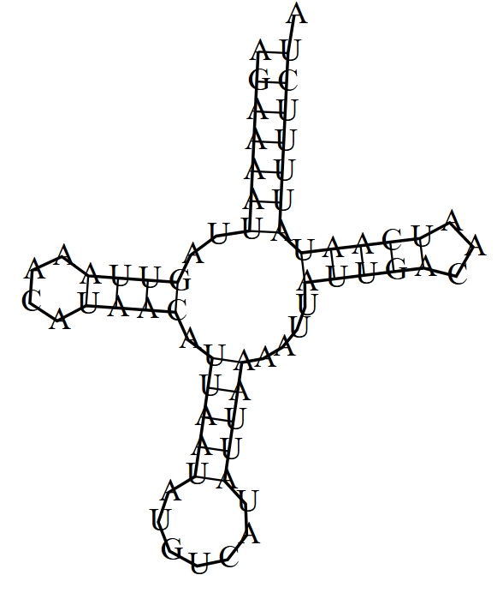
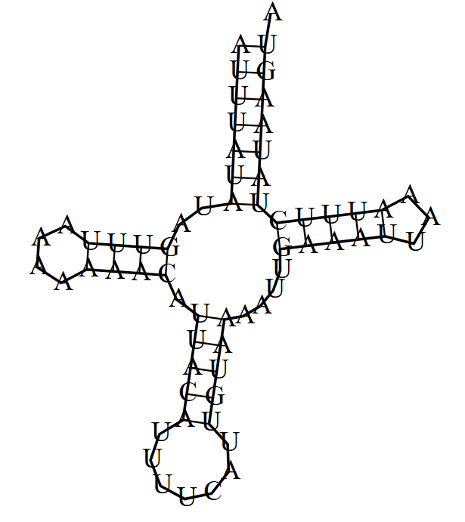
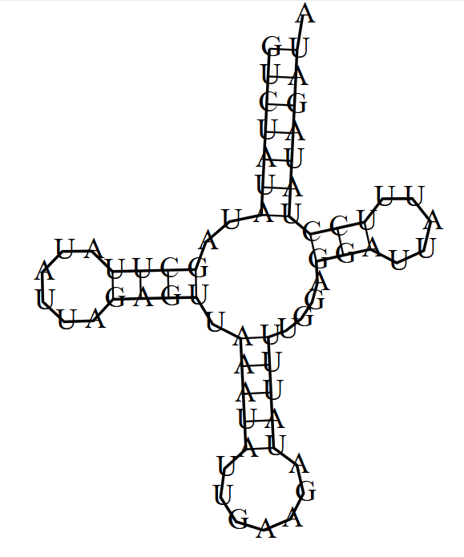
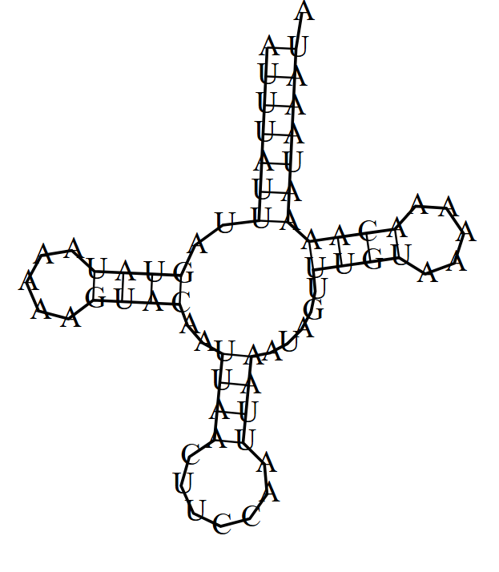
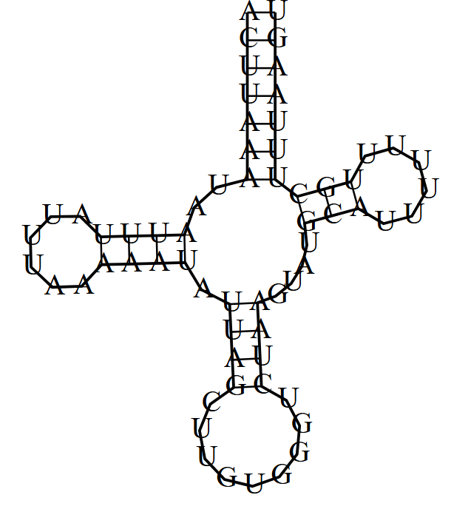
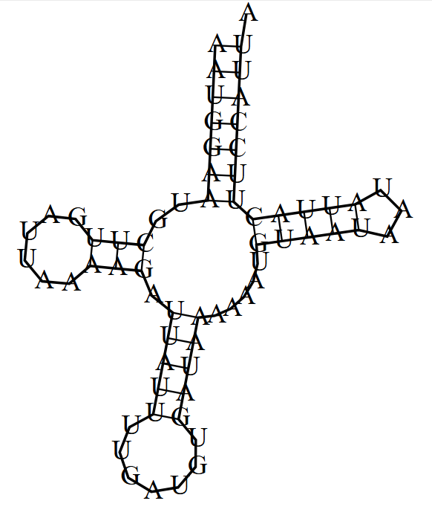
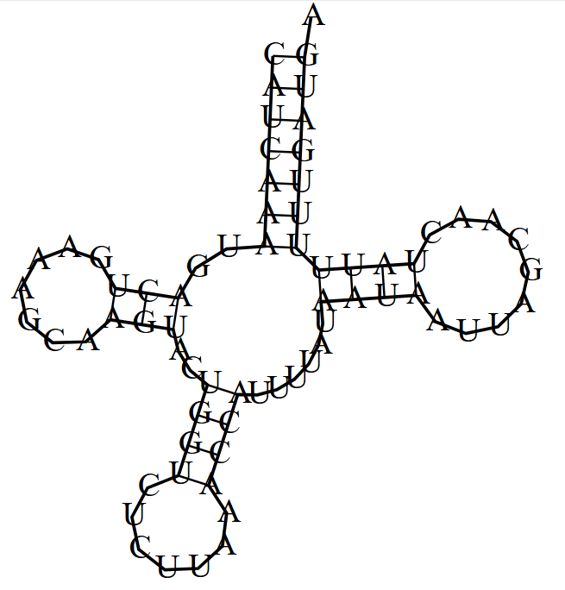
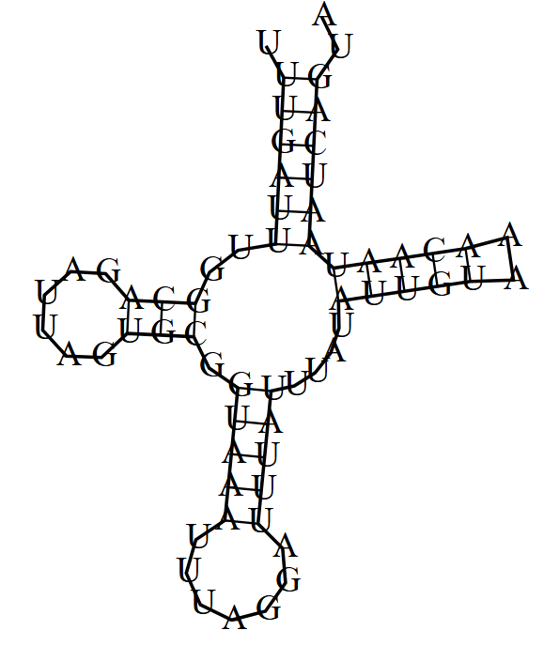
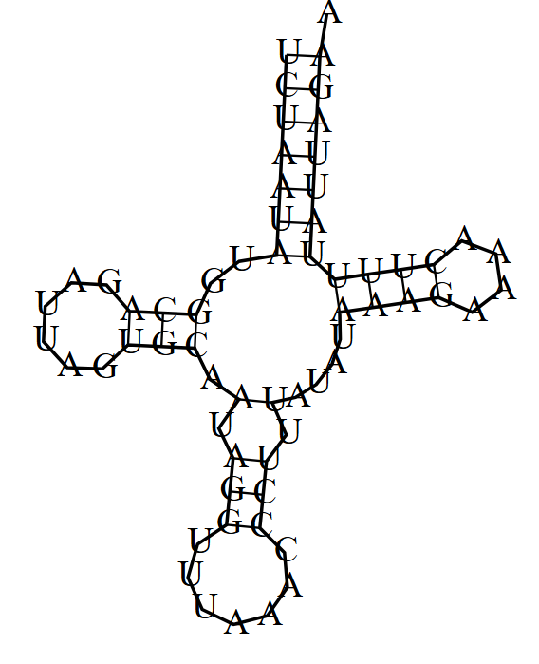
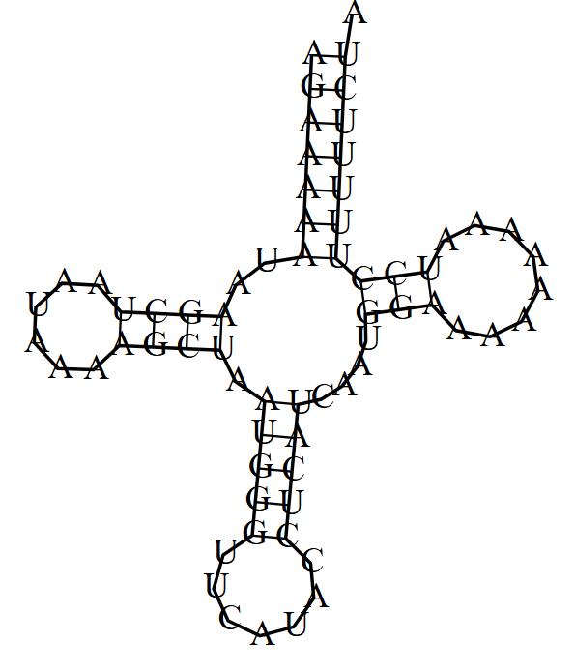
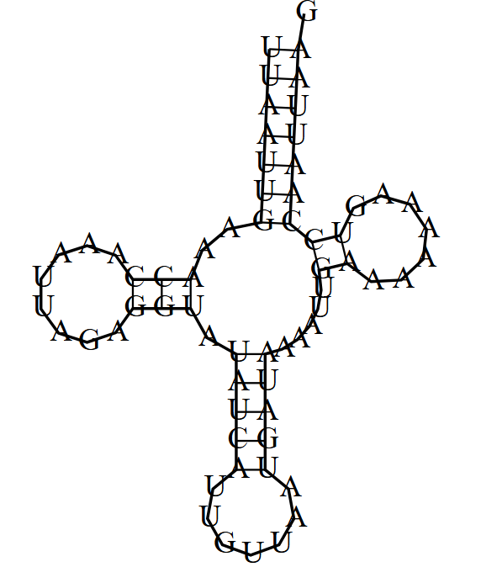
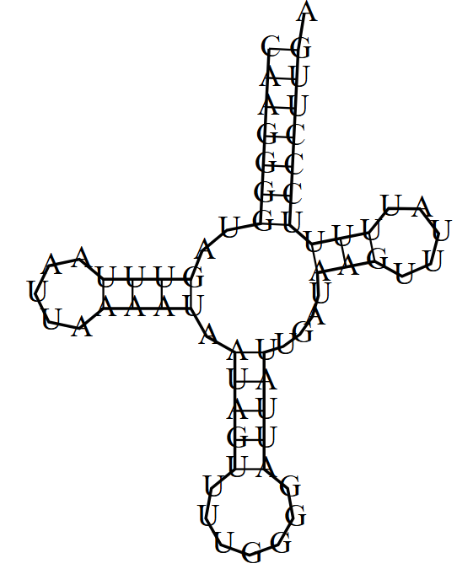
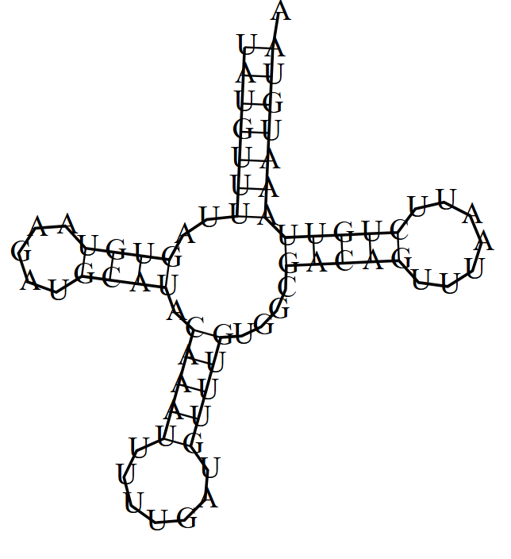
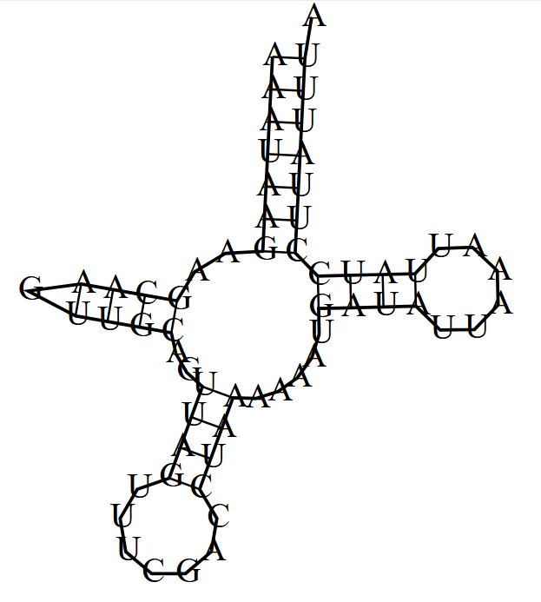
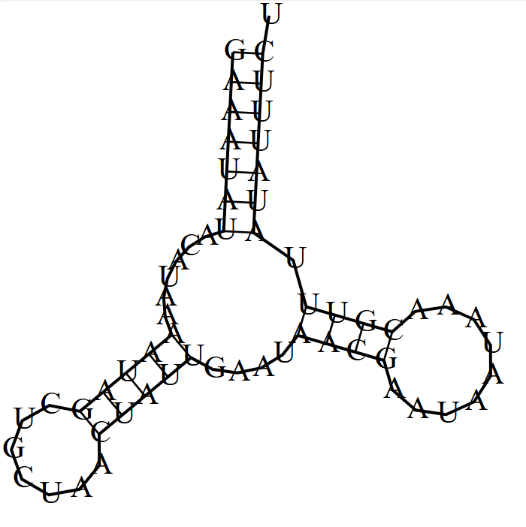
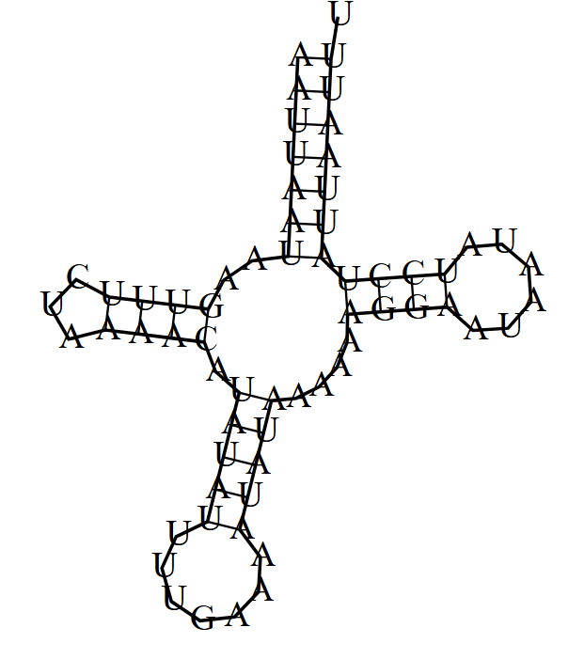
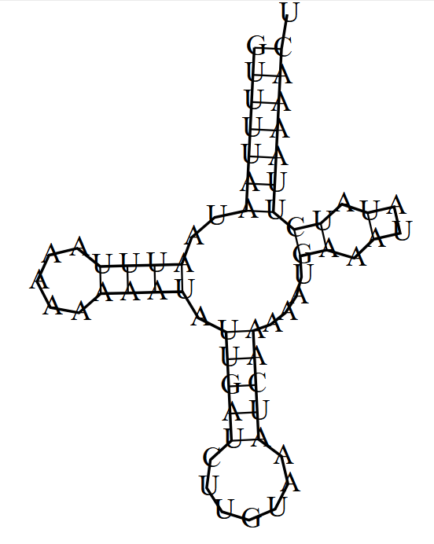
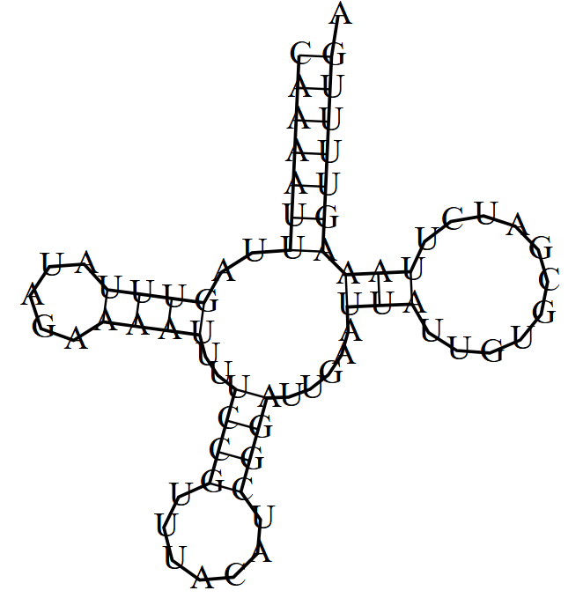
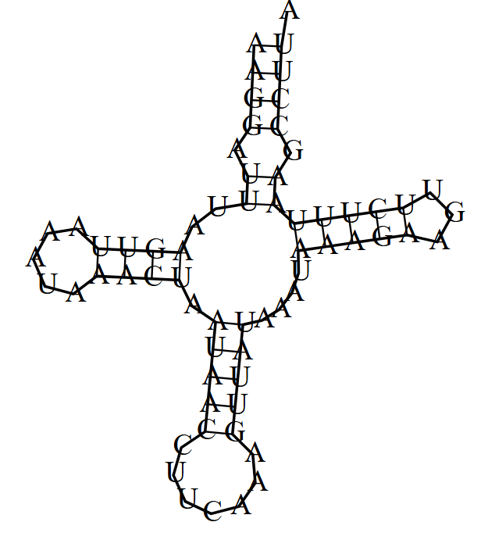
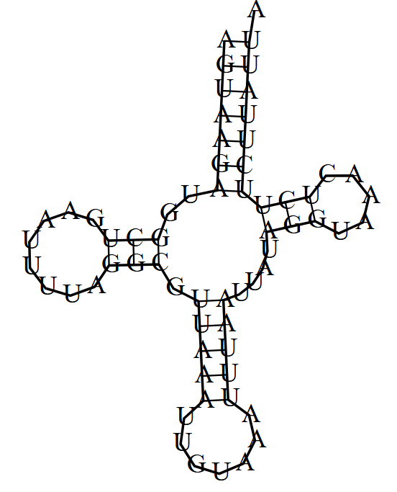
rRNA
Both rrnL (1,171bp) and rrnS (763bp) is present in the mitogenome, and they were located between trnL1 and trnV, and trnV and the Control Region, respectively. This is the same as all other Phylliidae and most known Phasmids (double check this). The lengths of other Phylliidae rrnS range from 760bp (P. bioculatum) to 793bp (C. westwoodii), and the lengths of rrnL range from 1263bp (C. tibetense) to 1292bp (P. bioculatum). How many domains???
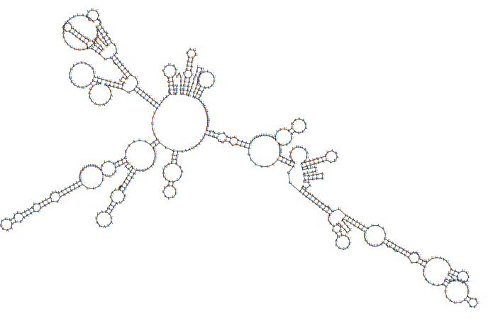

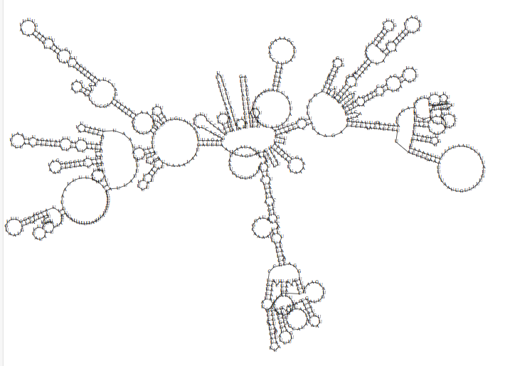
Control Region (again)
In the case of P. philippinicum the extended length appears to be due to an extensive control region. This region accounts for 25.3% of the entire mitogenome length, in comparison the average CR content of all other Phasmid mitogenomes is 11.8% +- 3.96. Due to this CR being an outlier, it was further investigated to determine the cause. The control region has many tandem repeats, with one repeat region being xxx bp long. Removal of these duplicate regions was considered, but as repeats and duplication are common in control regions, and mapping HiFi reads back to this region showed that multiple reads spanning the entire region confirm the true presence of this length, this reads were retained. A possibility is that the d-loop is actually a sub-region of this 4973bp sequence, with the remaining regions being intergenic nucleotides. (Look into this). There is BLAST….bla blab la

PROBABLY MOVE PHYLOGENETICS TO AFTER THIS MITO STUFF
- Include CDpsT or whatever it is called and make the plot like that other paper
- Label domains in rRNAs

PCA results - are there differences between Phylliidae mitogenome features and the rest of the Phasmids?
What does this suggest? It suggests that there is more variation in the Phylliidae (leaf insect) 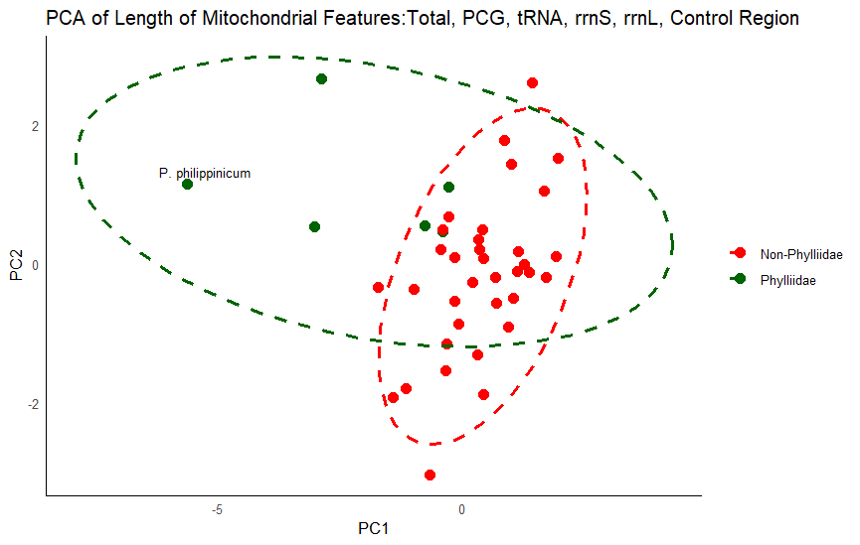
mitogenomes than in the rest of stick insects. Phylliidae are more dispersed along both the PC1 and PC2 axis suggesting high variability in multiple feature lengths. 78.5% of the variance is explained with PC1, PC2 and PC3, with a total of 6 principal components. In contrast, the mitogenomes of stick insects appear to be less variable. The placement of P. philippinicum suggests that, although it is within the range of the others for PC2, it has the most negatively extreme PC1 loading value of all Euphasmids. This large difference is likely due to the size, and the control region lengths being inflated. Phylliidae have more mitogenomic diversity than other Euphasmids. The largest features contributing to PC1 loadings are Total Length (-0.6448) and Control Region Length (-0.6527). The remaining features all contribute less than absolute value of 0.26. PC1 explains x amount of the variance. PC2 loadings are in direct contrast, with Total Length and Control Region Length contributing less than 0.076 of the variance, and the remaining

Note: When comparing MitoHiFi and Mitos2 annotations. MitoHifi, particularly with nad3 is truncated both at the beginning and at the end - it stops at a TGA codon, which is not a stop codon in invert mito - instead it is a W, this is correctly identified by Mitos2. Showing the importance of validation. Use Mitos2 annotation on MitoHifi assembly.

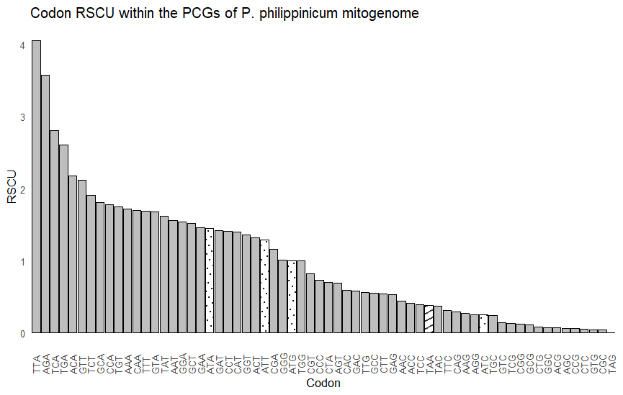
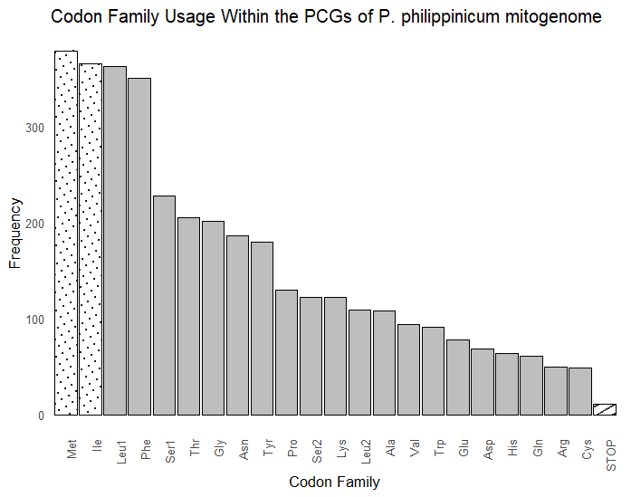

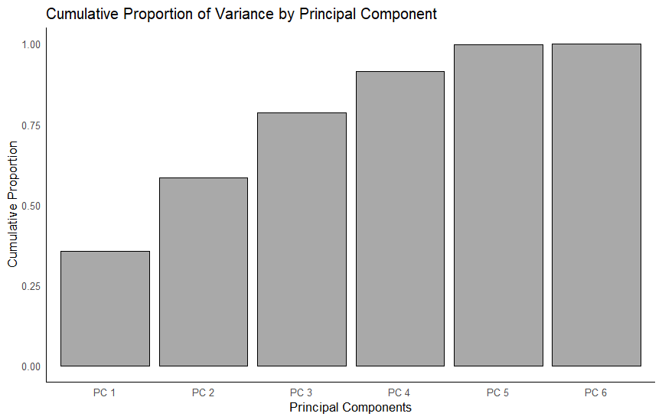
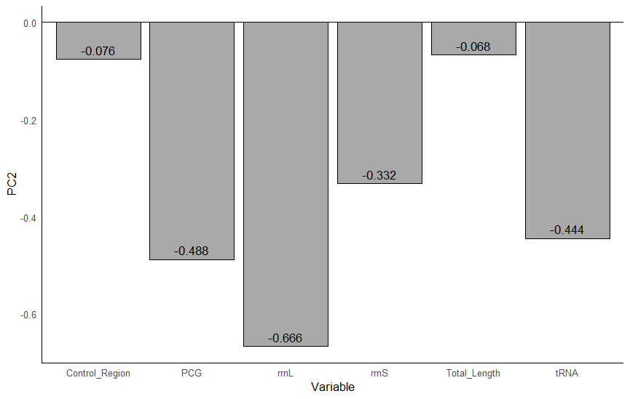

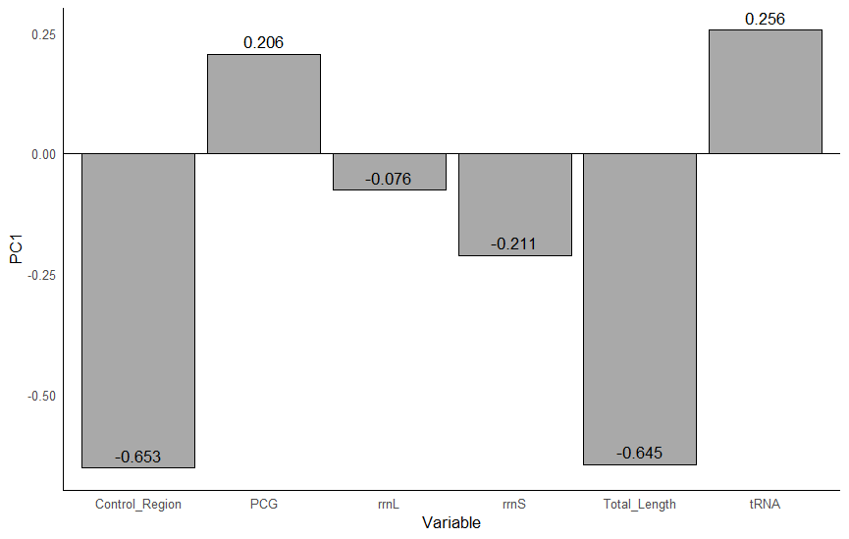
CDspT
The RSCU across all 6 Phylliidae genomes is very similar. The actual count of codons between the 6 genomes is also very similar per genome. However, the CDspT (codons per thousand codons) of each mitogenome is very different. As CDspT is calculated by the (count of each codon/total length of the mitogenome)*1000, and each count is relatively similar across the mitogenomes, it is the mitogenome length that is leading our mito to have a decreased CDspT (as it is the same number of codons spread across a larger mitogenome giving a lower rate). Again, it appears that this inflated length, caused by the extensive repeat region, is skewing the P. philippinicum data. However, as previously stated, reads show that this repeated region is truly present within the mitogenome?? If we look at the plot, the CDspT of our mitogenome is roughly half the value of the rest of the mitogenomes. The trend per codon is the same for our mitogenome too, it is the value that differs, likely based on the repeat region.

