

Victoria Aldcroft
Supervisor: Prof. Alistair Darby

MSc Bioinformatics Thesis
(LIFE748) Summer 2025

You won’t be-leaf your eyes: Assembly, Annotation, and Comparative Genomics of Phyllium philippinicum

Acknowledgments
This work is dedicated to my daughter, Clara. For always asking the questions that spark my curiosity and for reminding me daily of the importance of wonder and discovery. You are my greatest source of inspiration, and I want you to know that no challenge is too great for you to overcome. I love you Monkey - this one’s for you.
Thank you to my supervisor, Alistair Darby, for giving my idea a chance, for tolerating and making sense of my 1am ramblings, and for believing in me when I didn’t believe in myself. I’m also deeply grateful to Mark Whitehead and the CGR for their computational support and for making me feel like no question was too silly. A special thank you to Carl Yung for DNA extraction – without you this work would not exist. I appreciate Royce Cumming, Paul Brock, and all the Phasmid experts who kindly shared their time and expertise. My gratitude also goes to Francesco Del Carratore, whose support over the last two years has been unwavering, and to all the staff in the Biosciences building who showed their interest and gave their advice. Last but not least, thank you to Tarang Metah, for your highly valued ideas and support.
To my brother, Matt, and sister-in-law, Lauren, I’m incredibly grateful for always being able to count on you both, no matter the time or place. Your support extends so far beyond this work. To Mum, Dad, and Keith - I very literally would not have been able to do this without you. Each of you has helped in your own way and I truly appreciate everything you've done and continue to do. To my Nan and Grandad, the effort you've made to understand my work means more to me than I can express. I cherish that I can drop by, and you’re both always eager to listen, no matter what. This work is the result of our conversations, and I hope it makes you proud.
Finally, thank you to my stepsisters for providing consistent entertainment, to my extended family, friends, and anyone who has ever humoured me with a question or even a moment of conversation, it genuinely means the world to me.
In loving memory of Glenys Aldcroft - the bravest woman I know.
Generative AI Declaration
This work was supported in part by code debugging and troubleshooting suggestions provided by OpenAI's ChatGPT. All final modifications and testing were performed by the author to ensure correctness and alignment with project requirements.

ABSTRACT

Background

: Why are Phasmids important? - Cultural aspects, technological importance (see robot based on stick insect)? Why are different assemblers important? Relevance: Why is it relevant? Add to knowledge gap, future research to help in pet trade (high mortality rates for unknown reasons in phasmid hatchling), transcriptomics in future benefit from genome? Loss/re-gain of wings in Phasmid phylogeny. Genetics of camouflage and parthenogenesis. Context: Absolutely massive gap in the literature. Phasmids understudied as is, maybe due to complexity and big genome size/repeats etc. Mimicry

2. Methodology
2.1 Sequencing and Computation Workflow
A DNA sample was extracted from the front leg of a lab-reared, adult female P. philippinicum, approximately 18 months old. Get the name of seq kit/processes etc. Manual quality control checks performed on the Flowcell results to verify read accuracy and ensure high quality data for assembly. All computational analyses were performed on a Linux 11 system with 1TB RAM and 192 processors. Figures X, Y, and Z were generated using RStudio (v2024.04.2+764), and wherever possible, packages were installed via Conda (v25.1.1).

2.2 Pre-Assembly
As HiCanu requires a genome size estimate as input, a k-mer database (k=21) was first generated using Jellyfish (v2.2.10) and analysed with GenomeScope2 (http://genomescope.org/) to estimate genome size, repeat content, and heterozygosity. Given the potential for polyploidy, as observed in other members of the Phasmatodea order, SmudgePlot (v0.4.0), an extension of GenomeScope, was used to assess ploidy based on 21-mers from a FastK (v1.1) database, due to its optimisation for polyploid and highly heterozygous genomes (Ranallo-Benavidez, Jaron & Schatz, 2020).

2.3 Assembly
Four assemblers were selected for comparison: HiFiASM (v0.24.0), HiCanu (v2.2), Flye (v2.9.5-b1801), and the ONT-optimized assembler Shasta (v0.13.0). HiFiASM generated two assemblies - one with default duplicate purging enabled and another with duplicate purging disabled (-l 0). HiCanu and Flye were run with the -pacbio-hifi parameter, while Shasta used --config HiFi-Oct2021.

Each of the five assemblies underwent quality assessment using QUAST and BUSCO using the insecta_odb10 database (n=1367), with reads mapped back to the assemblies using minimap2 (v.2.22-r1101) to evaluate completeness. To refine assemblies and remove duplicates, two rounds of purge_dups (v1.2.6) were applied to the HiCanu, Shasta, Flye, and default HiFiASM assemblies. The HiFiASM assembly with duplicate purging disabled was excluded from purge_dups, as the default HiFiASM assembly was found to be superior. Bandage (v0.9.0) was used to visualise the untig graphical files, showing the connections during assembly, rather than the unconnected final contigs.

Final quality control was performed on the four remaining assemblies using BUSCO, QUAST, read mapping, and an additional Merqury analysis. BlobToolKit (v4.4.0) investigated any potential contamination or contigs of interest in each assembly, as well as being used to produce Figure x,y,z. Regions of interest were then investigated further using BLAST (v2.12.0+), by comparing contigs of interest to the nt database. The assembly with the best overall metrics after two rounds of purge_dups underwent further refinement until quality control metrics stabilized, after which it was used in downstream analyses.

MitoHifi (v3.2.1) was used to assemble the mitogenome from the raw HiFi reads based on the mitogenome of Pulchriphyllium giganteum (NC_080495.1). This has built in annotation as part of the assembly pipeline, but this was externally validated using Mitos2 on the Galaxy webserver (v2.1.9). Following mitogenome assembly, NUMTFinder (v0.5.5) was used to locate and quantify NUMTs in the final chosen genome assembly. Further to this, BLASTing the mitogenome against the HiFi reads was used to validate the existence of unusual features of the assembly. Following confirmation of this, RNAFold and Mitos2 were used to investigate the secondary structure assemblies of the tRNA. Figure x (mitogenome) was created using GeSeq.

2.4 Masking and Annotation
RepeatModeler (v1.0.7), including the LTR pipeline (-LTRStruct, v2.9.0), was used to identify repeat families within the genome, which were then soft-masked (--xsmall) using RepeatMasker (v4.1.2-p1). Gene prediction was performed on the soft-masked genome with the GALBA/miniprot pipeline (v1.0.11), utilising the protein dataset from Dryococelus australis (GCA_029891345.1). Following GALBA recommendations, the Diamond filter was deactivated due to the distant evolutionary relationship between D. australis and P. philippinicum. The predicted genes were subsequently annotated using EggNOG-Mapper (v2.1.12).

2.5 Comparative Analyses
To visualize whole-genome alignments against Clitarchus hookeri and Bacillus rossius, DGenie (v1.5.0) was used to highlight matches with >90% identity. MUMmer (v4.0.0) was employed to visualize alignments of the P. philippinicum mitogenome against a selection of Phasmatodea mitochondrial assemblies.

For phylogenetic analysis, COI sequences were selected from across the Phasmatodea order and nearby orders. These sequences were aligned using Clustal Omega, and a phylogenetic tree was constructed with IQ-TREE (v2.4.0). The tree was visualized with Interactive Tree of Life (v7.0). IQ-TREE performed up to 5000 iterations using the mtZOA+F+I+G4 model.

2.7 Ortholog Analyses
There are no Phasmid orthologs available for comparison in OrthoDB (v12.0), and with only two other annotated Phasmid genomes, the scope of comparison was broadened to include universally conserved proteins well-annotated in Drosophila. The key proteins of interest were mad, SHH, and ultrabithorax, all of which are involved in insect wing development, as well as HSP70, a protein known for its universal conservation and role in helping organisms tolerate environmental stressors like temperature increases. Given their well-established conservation, these were chosen as a benchmark to assess the quality of the final genome assembly. Phylogenetic trees were constructed by aligning these protein sequences using the same method as described in section 2.5 in order to place the Phylliidae family within the evolutionary history of these genes. Additionally, AlphaFold2 was employed to predict the functions of these four proteins in P. philippinicum. These predictions were then structurally compared with available Phasmid, B. rossius (modelled with ColabFold) and Drosophila orthologs using PyMol (v2.5.7) to identify conserved structural features. InterProScan was used to check for domain presence within the P. philippinicum and B. rossius orthologs.

3. Results
3.1 Pre-assembly
A total of 171Gb PacBio HiFi reads were obtained across 2 Revio cells, with a median Phred Score of Q36.5.

Despite expecting a polyploid haplotype, SmudgePlot has predicted that 86% of kmers follow a pattern expected for diploid haplotype with 7% suggesting triploidy, which still leaves the potential open for mosaic polyploidy as seen in other Phasmids particularly as this model has a 22% error rate (Supplementary Figure S1). GenomeScope2 analysis gave an estimated genome size of 2.8GB, firmly within the expected range of a Euphasmid genome (n=4, average=2.64±0.58Gb) (Supplementary Figure S2). The estimates also points to a repeat content of 34.2%, much lower than expected compared to other Euphasmids, as well as heterozygosity of 0.89%, which is consistent with the individual being from a parthenogenetic lineage. There is a very low read error rate (0.09%), which when combined with the raw read quality analysis, suggests these reads are well-suited for assembly.

3.2 Genome Assembly Comparison
Given the sub-optimal results from HiFiASM without the built-in duplicate purging, it was excluded from further analysis, as the version with built-in duplicate purging proved to be immediately superior. Two rounds of purge_dups reduced genome sizes by an average of 0.8 ± 0.59 Gb across all four assemblies (Table 1). Three rounds of purge_dups on the HiFiASM assembly had minimal impact on QUAST and BUSCO results but did lead to a modest reduction in genome size from 3.119 Gb after two rounds to 3.113 Gb after three rounds, along with improved contiguity. From this point forward, unless stated otherwise, ‘HiFiASM’ refers to the HiFiASM assembly following three rounds of purge_dups.
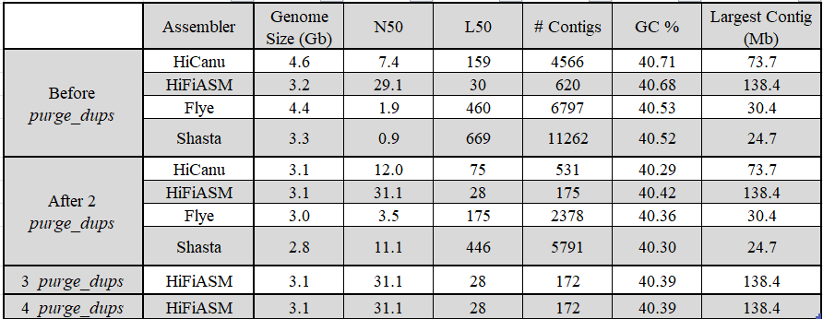
Table 1. xyxyyayxayaxyxyaxyxy

Duplicate purging had the most significant effect on the HiCanu assembly, reducing the genome size by 33%. The final Shasta assembly produced a genome size closest to the estimated value, whereas the other assemblies converged around 3.05 Gb. Notably, even after four rounds of duplicate purging, the HiFiASM assembly remained larger than the estimated 2.7 Gb, indicating that additional purging may not be effective in further reducing its size. Subsequent rounds confirmed that duplicate purging had no effect on the quality control metrics, and it wasn’t until the ..th round of purge_dups that BUSCO quality dropped.
HiFiASM exhibited the highest N50 both before (29.1 Mb) and after (31.1 Mb) duplicate purging, with a post-purged N50 value 2.6 times greater than the next highest assembly, HiCanu. HiFiASM also produced the most contiguous assembly, with only 172 contigs comprising the genome - making it 3.1x, 13.8x, and 33.7x more contiguous than HiCanu, Flye, and Shasta, respectively (Fig. x). HiFiASM also generated the largest contig (138.4 Mb) (Fig. x), which is potentially chromosomal in length and represents 4.36% of the genome. In contrast, Shasta produced the shortest maximum contig (24.7 Mb), covering only 0.86% of the assembly. Despite these differences, all assemblers successfully produced a gap-free assembly.

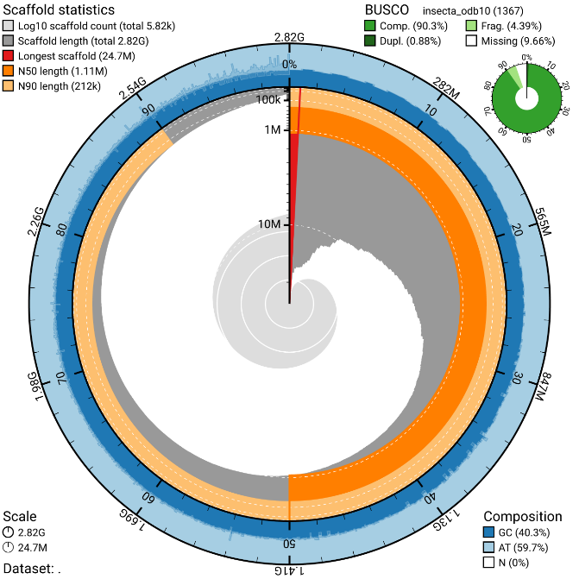
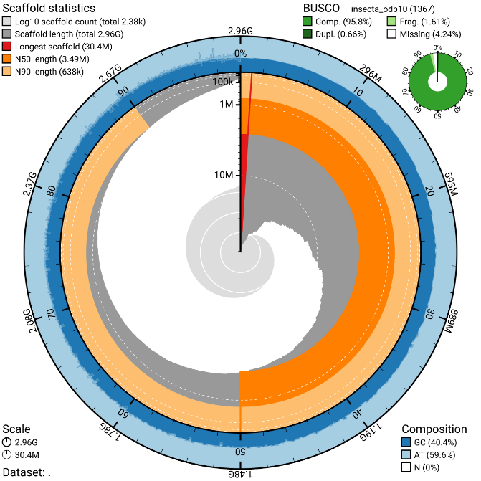
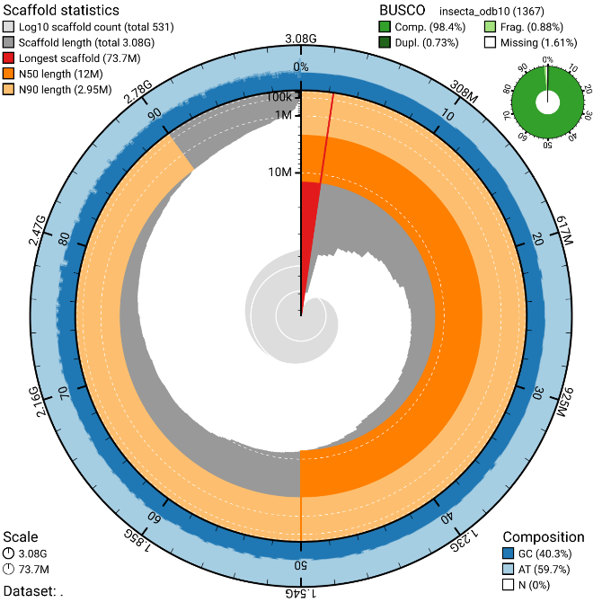
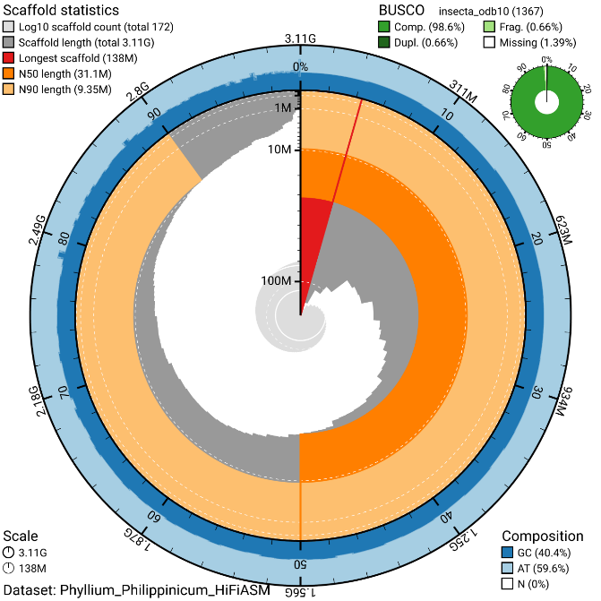
Figure x. xyxyxyxyxyxyxyxyyxyx

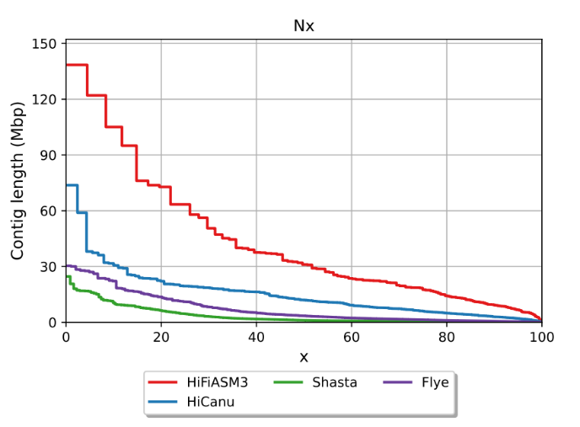
Figure x. xyxyxyxyxyyxxyxyxy

Analysis of the largest contig (ptg000007l) in HiFiASM revealed that its beginning consists of a (CCTAA)n repeat, which is the reverse complement of the common insect telomere sequence (TTAGG)n. This strongly suggests that this contig represents the start of a chromosome. However, the absence of the typical 3’ telomeric sequence indicates that this may not represent a complete chromosome. Instead, the presence of (CT)n microsatellites near the contig's end suggests that this region may correspond to a sub-telomeric region. Further analysis of identified telomeric repeats at the beginning of 17 additional contigs, indicating that P. philippinicum likely possesses the common insect telomere motif. This finding suggests that P. philippinicum may have 17 chromosomes, consistent with the karyotypes reported in other phasmid genomes, making 17 chromosomes a plausible target for future chromosome-level assembly.

Across all QUAST metrics, the optimal assembly was achieved by HiFiASM after three rounds of duplicate purging. In terms of genome completeness assessed by BUSCO, HiFiASM performed best before duplicate purging, with 98% of single-copy BUSCOs, while Shasta followed closely behind at 89%. However, Shasta showed a higher percentage of missing BUSCOs (3%). Before duplicate purging, the percentage of duplicate BUSCOs ranged from 39.1% in HiCanu to 0.7% in HiFiASM. Duplicate purging greatly improved all assemblies, with the exception of HiFiASM, which showed no change, reducing duplicate BUSCOs to below 1% in all cases (Fig. x). However, both Shasta and Flye exhibited increases in fragmented and missing BUSCOs. Overall, HiFiASM had the best BUSCO completeness, identifying 98.6% of BUSCOs (S: 98.0, D: 0.7), with only 0.7% of BUSCOs missing or fragmented, the majority of which were related to ribosomal and ribonuclease functions.

The Merqury quality values (QV) align with the results from QUAST and BUSCO, with HiFiASM showing the highest QV, achieving an assembly error rate of 4.50E-08. In contrast, Shasta exhibited the lowest quality assembly, with an error rate 23.3 times greater than that of HiFiASM (1.20E-06). HiCanu ranked second with an error rate of 5.40E-08, followed by Flye with an error rate of 7.70E-07. Read mapping revealed no significant differences in assembly quality, as all assemblies, both before and after purge_dups, had more than 99.8% of total reads successfully mapped back to the assembly. However, this mapping percentage dropped slightly by between 0.01% and 0.07% for each assembler following the purge_dups process.

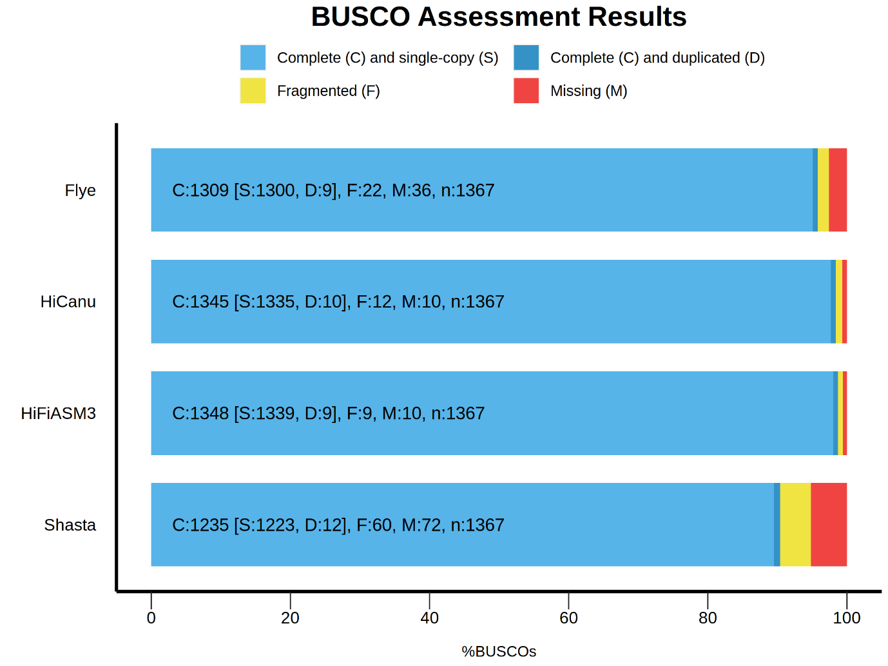
Figure 2.

In the HiFiASM assembly, BlobToolKit identified four contigs with no BLAST hits, one contig with hits to Mollusca (ptg000181l), and a small contig of approximately 47.6Kb with hits to Ascomycota (Fig. 3). Notably, when BLASTing the Ascomycota contig (ptg000388l), there were 60 high-confidence hits to Sydowia polyspora mitochondrion (NC_045905.1) and 41 hits to Cladosporium mitochondrion (NC_050879.1, MN657181.1, MN661341.1, MN657180.1), among other fungal mitochondria. This Ascomycota contig was present in all assemblies except for Flye, which, however, contained 2.5Gb of the genome with no hits (Supplementary Data Figure x). Interestingly, the Mollusca BLAST results yielded 123 hits to an approximately 4200bp sequence from chromosome 18 of Pecten maximus (Great Scallop) (LR736855.1) and 122 hits to an approximately 8000bp sequence of the Homo sapiens BAC clone RP11-517M22 (AC112243.5). There were also varying degrees of hits on this contig for Myripristis murdjan (soldierfish), Danio rerio (zebrafish), and other expected hits, including 1121 hits to Nemoura dubitans (stonefly) and various other insects.

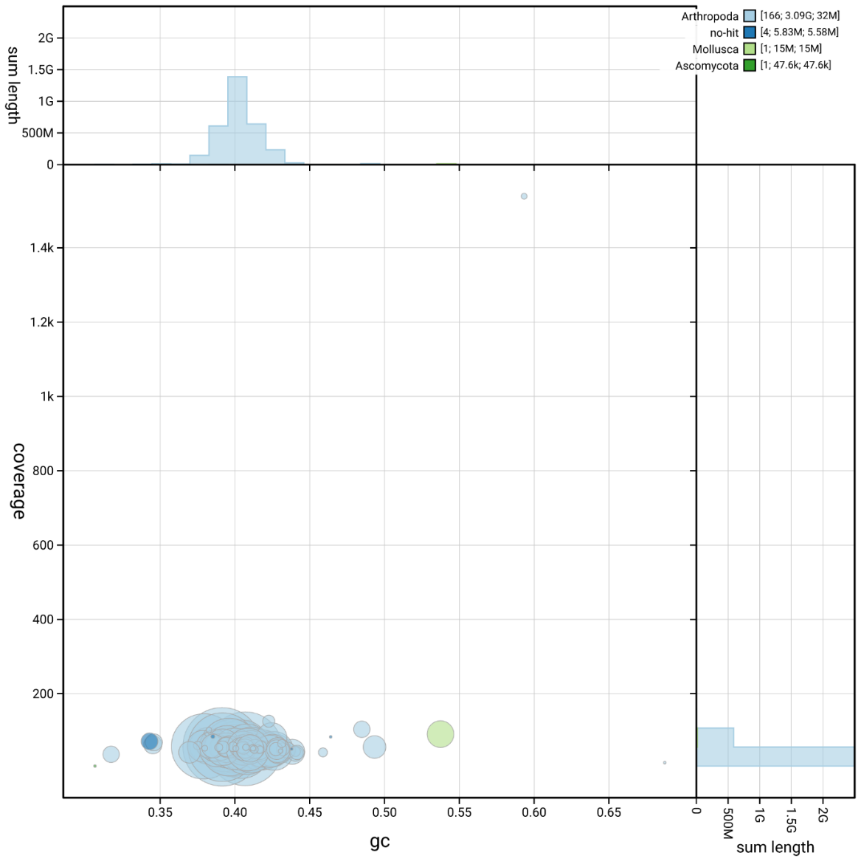
Figure 3. xyzxyzxyzxyzxyzxyzxyzxyz

Visualisation of the assembly process demonstrated that HiFiASM generated the most contiguous assembly (Fig x), whereas other assemblers, such as Shasta, produced numerous smaller contigs, and HiCanu exhibited duplicate regions in the form of ‘bubbles’ (Supplementary Data Fig. Sx). The Flye assembly, in contrast, displayed a complex and highly branched structure, which greatly deviated from a linear assembly pattern (Supplementary Data Fig. Sx). The prominent central branch in the HiFiASM assembly, along with its branching substructures, is indicative of a high-quality assembly, with these branching regions likely reflecting gene duplication events rather than heterozygosity, as the heterozygosity of the genome is below 1%. This hypothesis is further supported by self-alignment using MUMmer, which identified numerous gene duplication events (identity >95%, length >1500 bp, proximity <10 kb). While the main unitig contained few looping regions, a substantial number of smaller unitigs exhibited looping characteristics, contributing to a total of 620 contigs in the assembly. However, the reduction to 172 contigs after the application of purge_dups strongly suggests that these smaller regions were likely mis-assemblies or artifacts, which were either removed or integrated into the primary assembly.

Overall, purge_dups reduced the error rate per contig across the entire HiFiASM assembly (Supplementary Data Fig. S), along with its promising QUAST and Merqury metrics, and near-perfect BUSCO score, this assembly was taken forward for post-assembly investigations.

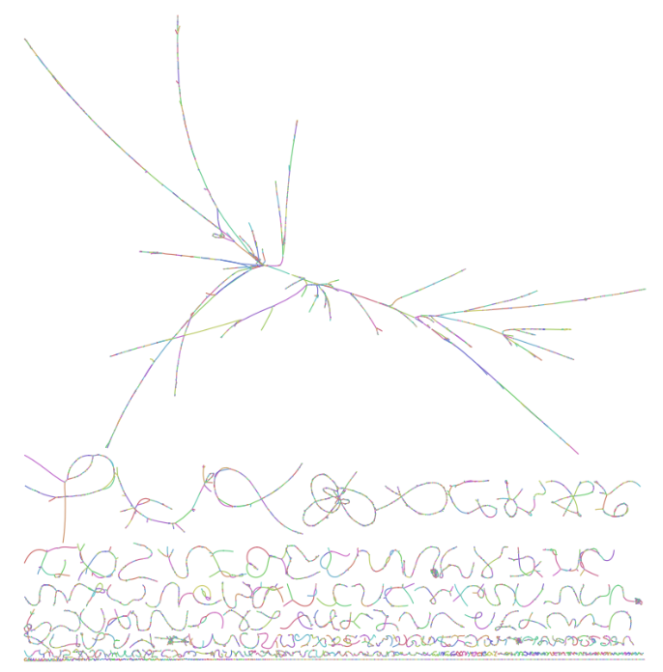
Figure x.
3.3 Repeats and Annotation
Initially, the contig containing 28S RNA was identified as an outlier based on its elevated error rate and coverage, which was 2707% higher than the average (Supplementary Figure S6). This finding was further substantiated by a BLAST search against a Phylliidae sp. 28S sequence (Accession No.: KJ024397.1), yielding a 2223 bp alignment on ptg0002000l with 96% identity (E-value: 0.0). RepeatModeler identified a total of 3692 repeat families, 482 more than reported for C. hookeri (Wu et al., 2017), with 997 (27%) of these being unclassified. Repetitive elements account for 55.2% of the P. philippinicum assembly, compared to 49.3% in Medauroidea extradendata and 63.3% in B. rossius.
Among the unclassified repeats, rnd-5_family-571 was the most abundant, comprising 2.1% of the unclassified repeats. This repeat was identified as a ninjurin-B-like predicted gene in the locust Schistocerca cancellate (NCBI Ref Seq:XM_049915740.1). The most prevalent classified repeat family in the P. philippinicum genome are Long Tandem Repeat elements, which account for 15.5% of the genome. Notably, P. philippinicum contains approximately half the transposon content of Lepidoptera species (8.4% vs. 16.2%) (Ruggieri et al., 2022), and 3.7% and 1% fewer transposable elements than M. extradendata and B. rossius, respectively (Brand et al., 2018; Stuart et al., 2023). Overall, the repeat content of P. philippinicum appears to fall within the expected range for insect genomes.

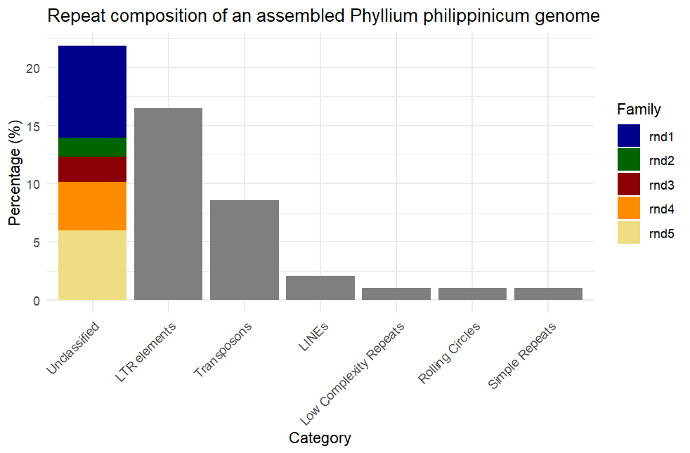
Figure x. Repeat stuff.

The DIAMOND filter was disabled during annotation, resulting in the identification of 192,850 genes. This outcome was anticipated, as the DIAMOND filter typically reduces the number of false positives. To align the gene count more closely with those observed in other Euphasmid assemblies, all annotated genes were subsequently processed through the EggNOG pipeline to extract only those with verified functions. This step reduced the gene count to 27,392, representing an 86% reduction. This number is consistent with the average number of protein-coding genes in other Euphasmid annotations: B. rossius (19,298) and D. australis (33,111), with an average of 26,204 ± 6,906.5 (Table 2).

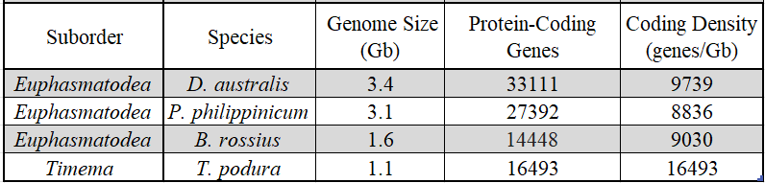
Table 2.

To establish a framework for predicting gene content in Phasmids, linear regression analysis was conducted on all available annotated Phasmid genomes (n = 4), with predicted coding size as the dependent variable and genome size as the predictor. The model explained 85.4% of the variance in the number of protein-coding genes within a Phasmid genome. The resulting equation was:
Number of predicted protein-coding genes = 7521 × (Genome Size in Gb) + 5562
This model was statistically significant (F_{1,2} = 18.52, p < 0.05).
Within the EGGNog annotation, four genes of interest — mad, SHH, ultrabithorax (UBX), and HSP70 — were identified. Ultrabithorax was located within a HOX cluster that included HOXA1, HOXA2, HOXA3, HOXC4, HOXA5, HOXB7, UBX, HOXB7, and HOXC9. Despite EGGNog suggesting that the presence of two HOXB7 genes resulted from gene duplication, BLAST results against B. rossius indicate otherwise. The downstream HOXB7 shows greater similarity to Abdominal-B (Identity = 80.89%, E-value = 4E-121), while the upstream HOXB7 is more closely related to Antennapedia (Identity = 64.92%, E-value = 3E-113).
There are five copies of HSP70 in the genome, which is consistent with patterns observed in other insects (ref). HSP70_1 (g11137) and HSP70_2 (g11138) are located 15 kb apart on ptg000003l and share 99.68% identity (E-value: 0.0) (Table 3), differing only by a single SNP (V5A), which suggests a recent gene duplication event. HSP70_3 (g31976) and HSP70_4 (g31981) are also located close together on ptg000013l. Finally, HSP70_5 is fragmented (g110905, g110906, g110907) and located on ptg000059.
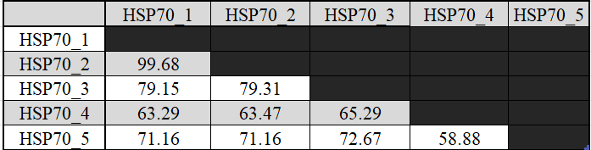
Table 3.

There is a single copy of the SHH gene, which is fragmented across three gene transcripts on ptg000135l (g174856, g174859, g174926), indicating potential fragmentation of the gene. BLAST results against the B. rossius ortholog, Indian Hedgehog (NCBI Ref Seq: XP_063218456.1), confirmed by the GTF file indicating the gene is located on the reverse strand, show that g174926 corresponds to the gene's 5' end (Query Cover = 56%, Identity = 93.55%, E-value = 1E-31), g174859 represents the central portion of the gene (Query Cover = 72%, Identity = 98.86%, E-value = 2E-55), and g174856 aligns with the 3' end (Query Cover = 94%, Identity = 61.28%, E-value = 2E-80).
The full P. philippinicum ortholog exhibited the highest BLAST hit with the Indian Hedgehog from Tenebrio molitor (Accession: XP_068909053.1) (Query Cover = 99%, Identity = 45.34%, E-value = 2E-118), with a secondary hit to the B. rossius ortholog (Query Cover = 100%, Identity = 51.19%, E-value = 1E-98).
Finally, the Mad gene (g674) is represented as a single, complete gene in the annotation, sharing a high degree of identity with the B. rossius Mad gene (Query Cover = 100%, Identity = 70.28%, E-value = 0.0).

3.4 Mitogenome
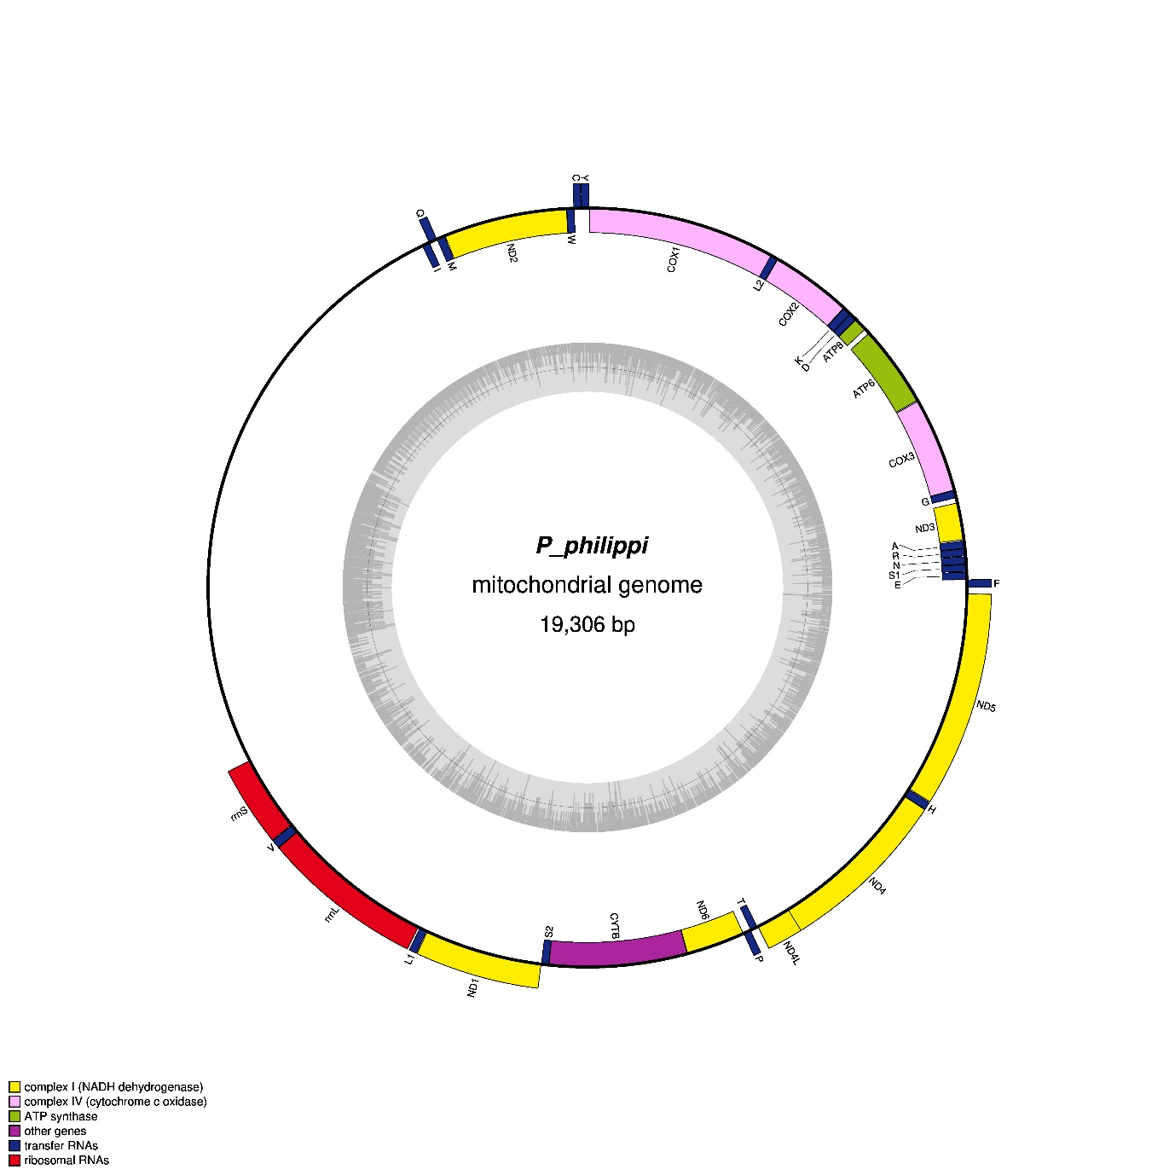

P. philippinicum
Mitochondrial genome

19,306bp
Mitogenomic Map of Phyllium philippinicum Showing Gene Annotations
The length of the complete mitochondrial genome of the leaf insect P. philippinicum is 19,627bp, which is longer than all current Phasmatodea mitogenome assemblies (Yuan et al., 2023; Xu et al., 2023; Tomita, Yukuhiro & Kômoto, 2011; Li et al., 2022, Zhou et al., 2017; Song, Li & Na, 2020; Dong et al., 2021; Kômoto et al., 2011). We found that the lengths of the available complete Phasmatodea mitogenomes range from 14,828bp (GenBank Accession: PP536087.1) to 18,248bp (GenBank Accession: KX091862.1). Within this, Phylliidae range from 16,405bp (GenBank Accession: KY124332.1) to 18,248bp (GenBank Accession: KX091862.1), with an average length of 17,169bp ± 568. Control region length was hypothesised as the biggest contributor to mitogenome length differences, along with intergenic and overlapping regions (Zhang & Guo, 2022) as tRNA, CDS, and rRNA lengths are relatively consistent across all Phasmatodea (Fig. X & Y). with P. philippinicum as an outlier.
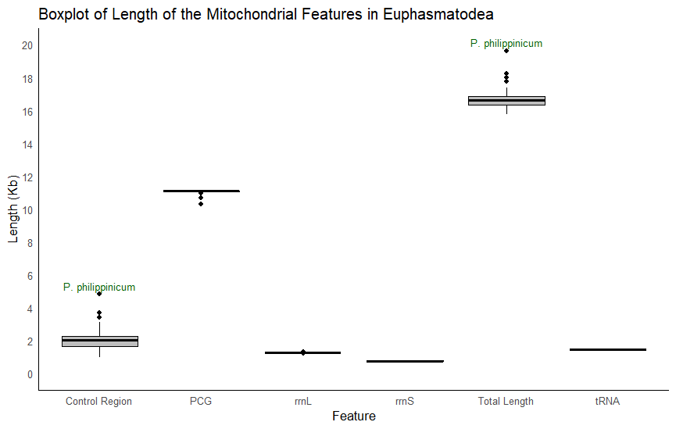
Fig X.
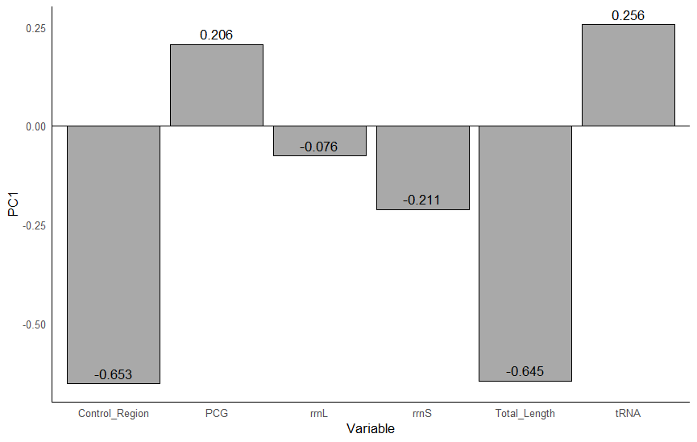

The gene order of P. philippinicum mitogenome is consistent with that of all other Phylliidae mitochondrial genomes and includes the presence of all 37 expected genes (22 tRNA, 13 PCGs, ad 2 rRNAs). Gene re-ordering has been seen in other Phasmatodea taxa (Plazza, Ricci & Passamonti, 2011; Xu, et al., 2021; Yuan et al., 2023), diverging from the canonical Arthropoda gene order (Clary & Wolstenholme, 1985) but Phylliidae family follows the common gene order.
We found that the total length of the P. philippinicum Protein Coding Genes were 10,984bp, the third shortest of all Phasmatodea, with only C. westwoodii (10,301bp) and Pachyscia longicauda (10,703bp) being shorter. The length of the PCGs accounts for 56.0% of the entire P. philippinicum mitochondrial genome, the lowest of all Phasmatodea. P. philippinicum has the shortest total length tRNA length of all Phasmatodea (1,450bp ± 16), 1,417bp, which account for only 7.2% of the mitogenome. This study species has the longest Control Region by far (4,813bp) compared to the rest of the Phasmatodea (2,033bp ± 562), with the shortest control region being only 998bp (Paramenexenus congnatus).
Nine of these PCGs (nad2, cox1, cox2, atp8, atp6, cox3, nad3, nad6, and cob) are on the H-strand, with the other 4 coded by the L-strand (nad5 nad4, nad4l and nad1). All of the PCGs started with either the typical start codon (ATA/G), coding for Methionine, or the alternate start codon Isoleucine (ATT) as in the case of nad5, and nad4 which uses TTG (Leucine). The TTN codon is conserved across nad4l in other Phylliidae mitogenomes (Zhou et al., 2017; Dong et al., 2021), and the use of alternative start codons in general has been documented throughout invertebrates (Ghiselli et al., 2021; Quek et al., 2021). cox2 and nad5 end with a partial T-- stop codon, with the remaining 11 PCGs ending with the expected TAA stop codon. In contrast, it is often nad5 and nad4 that have a single T-- stop codon in non-Phyliidae Phasmatodea (Song, Li & Na, 2020). In C. westwoodii it is only cox2 that ends with a T-- codon (Dong et al., 2021), yet P. tibetense has multiple proteins terminating in this way (Zhou et al., 2017) suggesting that codon usage is highly variable amongst Phylliidae. Incomplete stop codons are common in insects (Li, Wang & Che, 2017; Lui et al., 2020) and do not cause issues as it is resolved during polyadenylation (Chang & Tong, 2011), which could be confirmed with the incorporation of RNA-seq data.
There are 12 overlapping gene regions in the mitogenome, with overlaps ranging from 1bp - 7bp for a total of a 34bp overlap. The longest overlaps occur between tRNA-Cys and tRNA-Trp, and nad4l-nad4. Intergenic regions are also present, with a total length of 132bp and the biggest gap, other than control region, is between atp6-atp8 comprising 1/3 of the total intergenic length. The total intergenic spacers are longer than in all other Phylliidae mitogenomes and may contribute to increased mitogenome size. As our phylogenetic topology suggests that Phyllium is the earliest diverging Phylliidae lineage, this could explain the increased mitogenome size, as mitogenomes tend towards compactness and often lose intergenic regions, increase overlapping regions over time or undergo transfer to the nucleus (Burger, Gray & Lang, 2003). It has also been suggested by Zwonitzer et al. (2024) that “fast mitogenome evolution is also associated with larger mitogenomes”, which correlates with the divergence of Phylliidae occurring early on during the rapid radiation of Phasmatodea.
There are few literatures on the presence of motifs within Phasmatodea mitogenomes, but similar to Lepidoptera, the “ATTTA” motif with a poly-AT tail is present in the control region of P. philippinicum (Despabiladeras & Bautista, 2024). Other motifs of interest that are conserved in insects are the “ATGATAA” motif that is commonly found in the atp6-atp8 intergenic spacer/overlap (Zhang & Guo, 2022; Despabiladeras & Bautista, 2024). This is true for P. philippinicum, however, due to the loss of this intergenic region in the rest of Phylliidae, this motif (‘ATNATAN’) is within the overlap. A Phasmatodea motif (‘TTAACTA’) that is putatively conserved in the intergenic spacer nad1-trnS2 (Zhang & Guo, 2022) is partially present in P. philippinicum (-TAAC--) and other Phylliidae, similar mTERF motifs are found in this region in other insects, particularly in Lepidoptera (Wu et al., 2012). Finally, ‘ATGTTAA’ is a widely conserved 7bp overlap that is also present in P. philippinicum between nad4 and nad4l (Ma et al., 2019).
Control Region
The frequencies of the nucleotides within the mitogenome are A:29.4%, C: 10.9%, G: 14.8%, and T: 43.3%. The total AT content of the genome is 72.7%, which is lower than other non-Phylliidae Phasmatodea, but is similar in content to the basal Timema (Kômoto et al., 2011). The average AT content of the mitogenome of Phylliidae is 74.8%±1.60, and P. philippinicum has the lowest AT content of all Phylliidae. Unusually this decreases to 65.8% within the control region, however, this region is made up of many GC-heavy repeats. The repeat ‘TAGAAAGCCGAAATCGGGGTT’ (AT = 47.6%) repeats 50 times within the control region, as well as other tandem repeats (Table x), giving this region a positive GC skew (0.065) (Table X). It may be that these repeats lie outside of the control region as a separate repeat region as seen in Aphididae (Zhang et al., 2021), and thus the boundaries of the control region in P. philippinicum are uncertain. In all other Phylliidae the entire region is considered the control region, thus for the sake of simplicity, the control region will be kept as 4,813bp long – the longest of all Phasmatodea (2,100bp ± 702).
In the case of P. philippinicum the extended mitogenome length can be attributed to an extensive control region. The control region accounts for 25.3% of the entire mitogenome length, in comparison the average control region of all other Phasmatodea mitogenomes is 11.8% ± 3.96. In the previous Phylliidae mitogenome papers (Kômoto et al., 2011; Zhou et al., 2017; Dong et al., 2021) the control region was unable to be sequenced at the time, which was attributed to extreme length – currently the C. westwoodii mitogenome (Accession: ) is ‘partial’ even with a control region that is 2,642bp, however this supports the fact that Phylliidae control regions are difficult to assemble. Due to the anomalous length of this region, reads spanning this control region were mapped back to this area to confirm the presence of this region. Experimental removal of the repeat regions brings the control region down to 3763bp, which is then only 61bp longer than C. tibetense. However, removal of this region also removes all BLAST hits to any known Phylliidae mitochondrial genomes suggesting this feature is a vital feature of Phylliidae mitochondria, yet this repeat motif is only seen in P. giganteum, the species used for annotation.
AT skew is similar for P. philippinicum and P. tibetense, and P. giganteum in the PCG, rRNA and tRNA. (Zhou et al., 2017)
Feature | A% | C% | G% | T% | AT Skew | GC skew
Whole Genome | 29.41 | 10.88 | 14.82 | 43.25 | -0.19 | 0.153
PCG | 34.02 | 12.78 | 12.32 | 40.87 | -0.091 | -0.018
rRNA | 29.15 | 8.06 | 14.06 | 48.68 | -0.251 | 0.271
tRNA | 39.96 | 8.95 | 13.04 | 37.98 | 0.025 | 0.186
Control Region | 30.27 | 14.47 | 16.5 | 35.37 | -0.078 | 0.065

Codon Usage
All codons were used in the mitogenome PCGs except for the Terminal codon UAG. The most abundant codon family in PCGs, and their corresponding codons are AT-rich, and include start codons, AUA (Met) and AUU (Ile), as well as UUA (Leu1) and UUU (Phe). With an RSCU of 4.06, TTA (Leu1) codon is strongly overrepresented in the mitogenome of P. philippinicum (RSCU=4.055) in comparison to all other Leu codons (RSCU < 1). AGA (Ser2) is also preferred (RSCU = 3.583). P. philippinicum also shares the top 5 most common mitogenomic amino acids, top 3 highest RSCU codons, and the some of the same least used codons (GC-rich) as other insects outside the order (Liu et al., 2020; Chen et al., 2023).

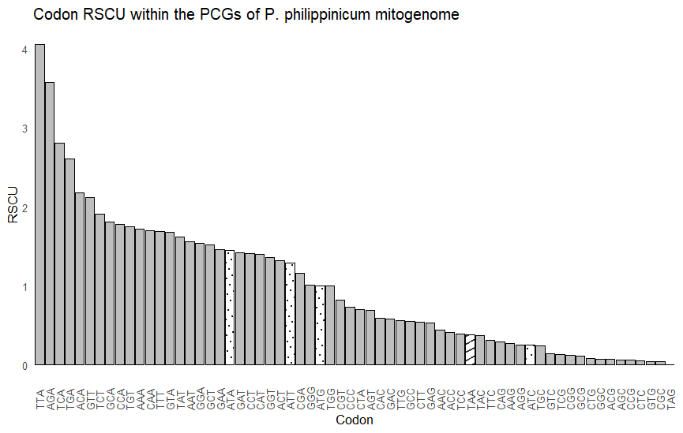

In P. philippinicum, C. oyae, and C. westwoodii the Term2 (TAG) codon is not used at all, and in the remaining 3 Phylliidae (C. tibetense, P. giganteum, and P. bioculatum) the Term2 codon is chosen approximately 10% of the time. All Phyllidae show the same trend in PCG codon CDspT, however, the absolute values for P. philippinicum are lower due to the similar PCG codon frequency but divided by a longer total mitogenome length. In non-Phylliidae Phasmids, the Met codon has been found to have a low CDspT (average = 11.0), however, the CDspT of the Met codon in Phylliidae is almost 10x more prevalent (average = 103.6 +- 20.47). Yet neither ATA or ATG are particularly over-represented, suggesting that selection is occurring at the protein level rather than at nucleotide level, and Phylliidae favour methionine residues (Fig. X). The reason for this strong methionine selection is not known but protein-bound methionine has long been considered to reduce oxidative stress by means of conserved methionine sulfoxide reductase production in both prokaryotes and eukaryotes (Schindeldecker & Moosmann, 2015). Notably, methionine supplementation increases resistance to heat-stress, and alleviates heat-stress injuries, with ants showing an increase in methionine metabolite pathways in response to environment temperature increases (Araujo, et al., 2023; Lugata et al., 2022; Feng, et al. 2024). Phylliidae live in a much smaller range than the rest of Phasmatodea, and this range is solely comprised of tropical regions (23 -25 degrees), potentially necessitating the need for increased mitogenomic protection against heat-stress. This difference between methionine frequency in non-Phylliidae phasmids and Phylliidae species is not small and warrants further investigation.

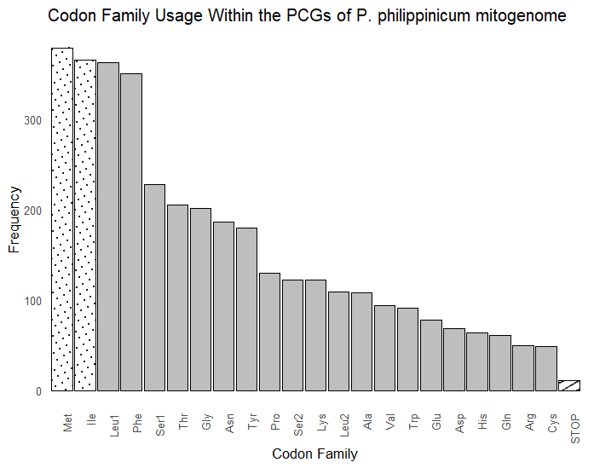
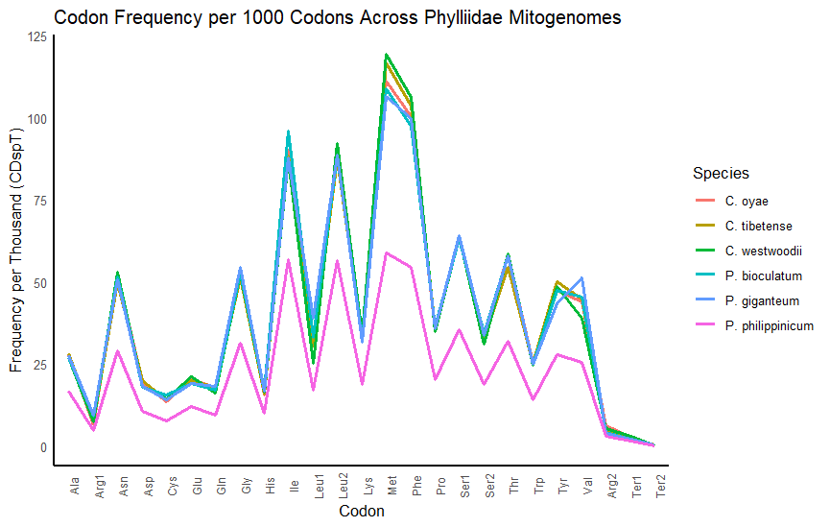
tRNA
The mitogenome of P. philippinicum has 22 tRNAs, these range in length from 60bp (trnS1) to 71bp (trnK), this is shorter than non-Phylliidae phasmids but this is in line with other Phylliidae tRNAs, suggesting that on the whole Phylliidae have shorter tRNAs than stick insects. Including P. philippinicum, the longest tRNA across all assembled Phylliidae is trnK (70.2bp +- 0.90), but there are several equally short tRNAs across Phylliidae, with minimum length being. The trnS1 of P. philippinicum is the shortest Phylliidae tRNA currently known and no tRNAs across Phylliidae exceed 71bp. Like other Phasmatodea, 14 genes were encoded on the H-strand, and the other 8 on the L- strand. The total tRNA length was 1417bp, the shortest of any Phylliidae (mean=1426+-4.8), but still highly consistent amongst mitogenomes, with an A+T bias of 77.94% (BOXPLOT FIG). Both GC (0.186) and AT (0.025) skew were positive (SKEW TABLE).
Using mitos2 all tRNAs were able to be folded into the usual four-leaf clover shape (rewrite this - took word for word from paper just for now), other than trnS1, which is missing the DHC as seen in many species (ref), and trnR which is missing the D-loop on the DHC arm. (SEE NEXT PAGE - SORT OUT THE FIGURE). This has been known to negatively impact translational activity in other insects (there was a ref somewhere). Despite all other tRNAs possessing all 4 arms, trnA, trnC and trnL2 had the presence of an extra bubble (what is the word???) in the accepter stem (trnA) or the anticodon loop (trnC and trnL2). To check this, they were re-modelled with RNAFold, and trnR and trnL2 resumed their expected cloverleaf shape. However, the models from tRNA and trnC contain several mismatched pairs, with 3 G-U pairs in trnA, and 5 G-U pairs in trnC.
When investigating the tRNA stem-bubble structures with RNAFold, it was noted that tRNA in P. philippinicum appeared to require a higher temperature to be able to fold correctly – that consistent with its native environmental temperature – with structural integrity until 35C, meaning the mitogenome may have to be heat-resistant for correct tRNA folding.

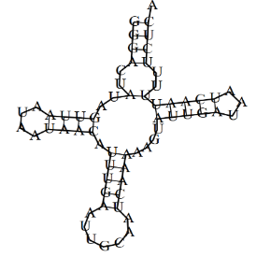
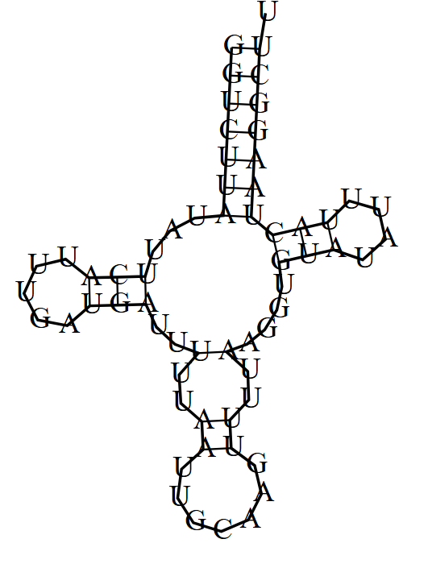
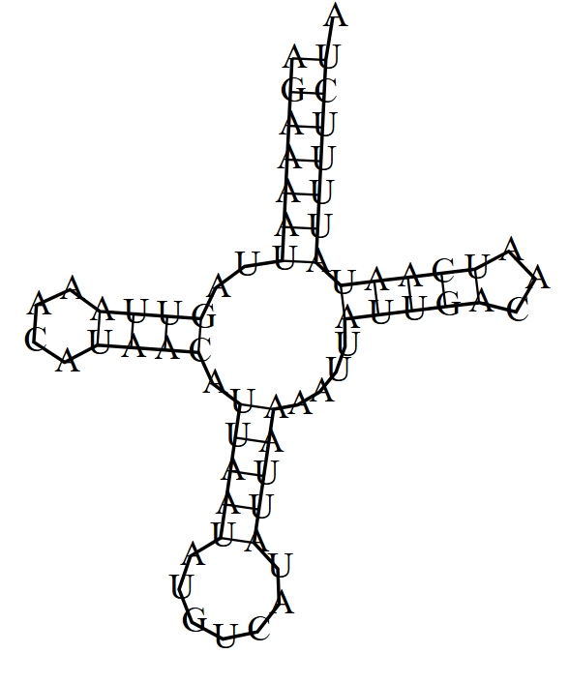
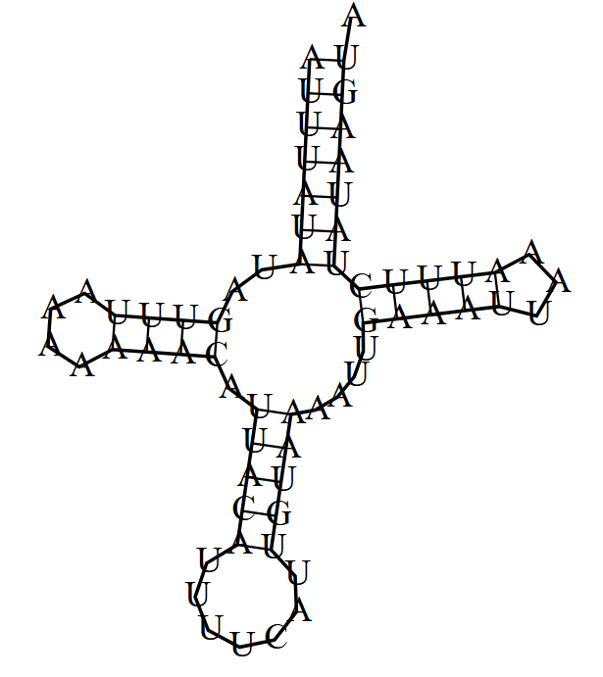
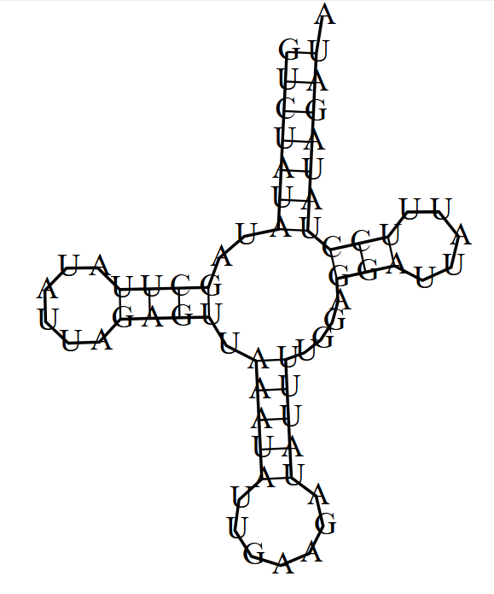
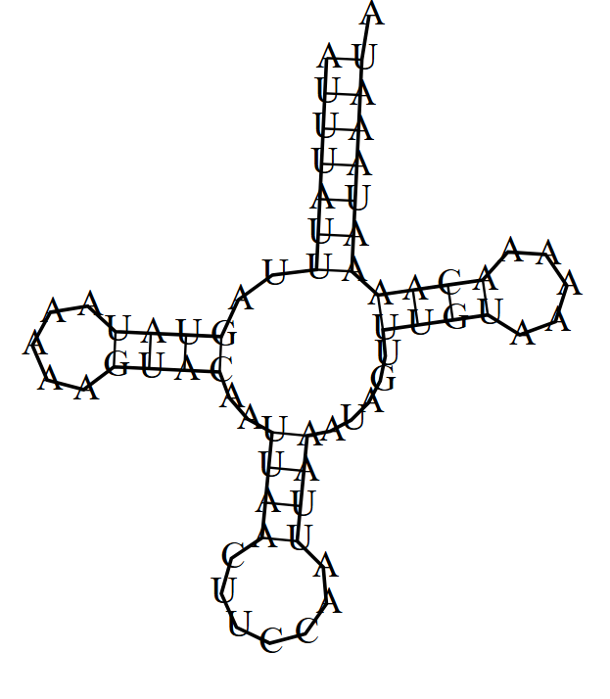
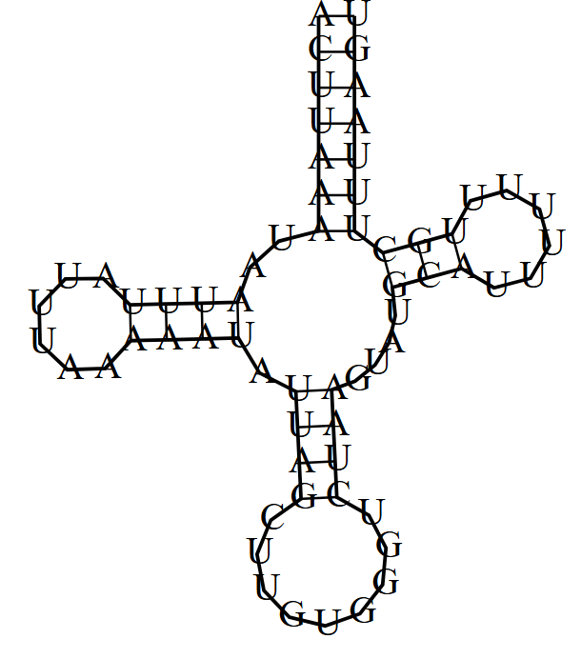
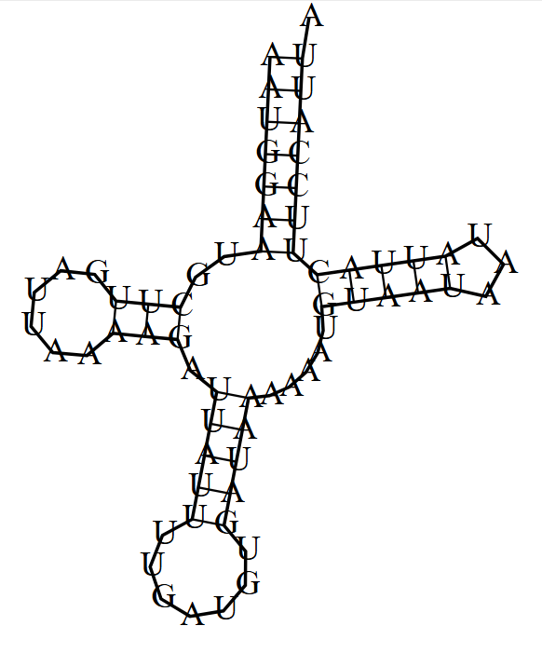
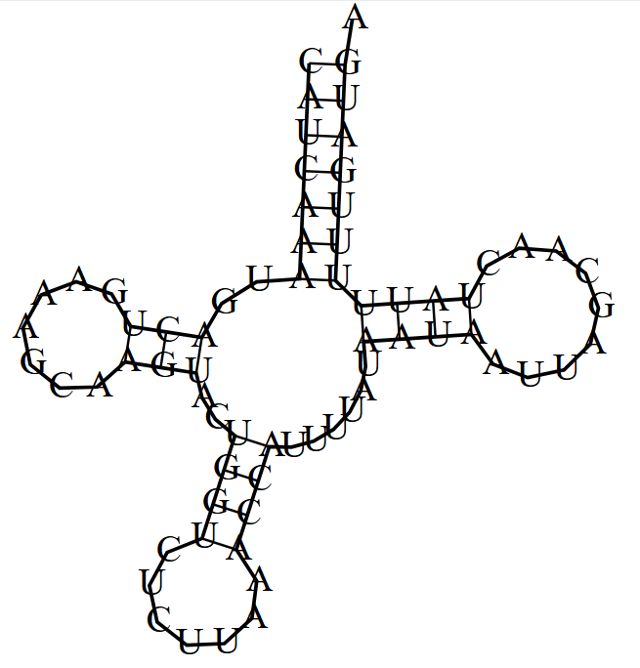
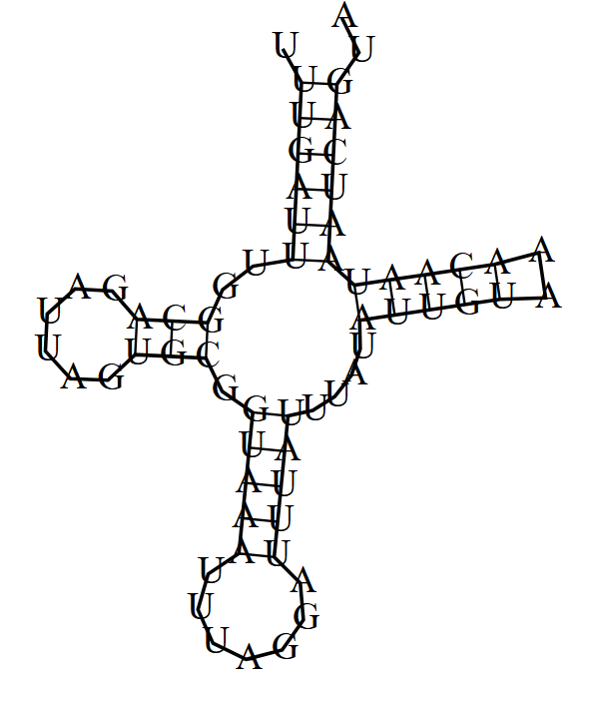
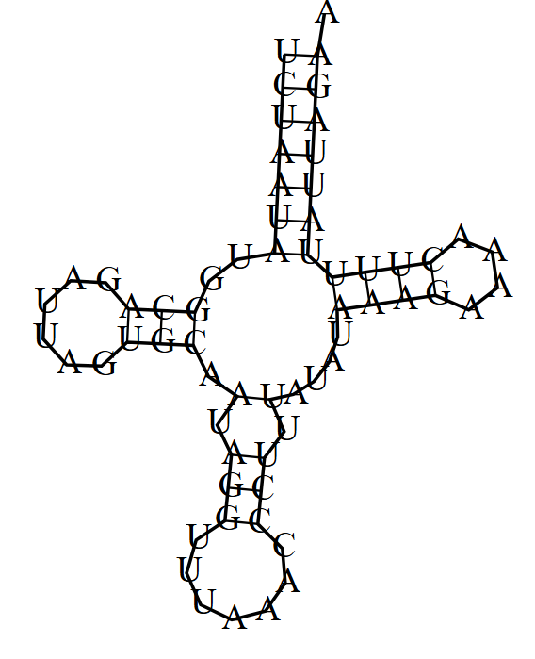
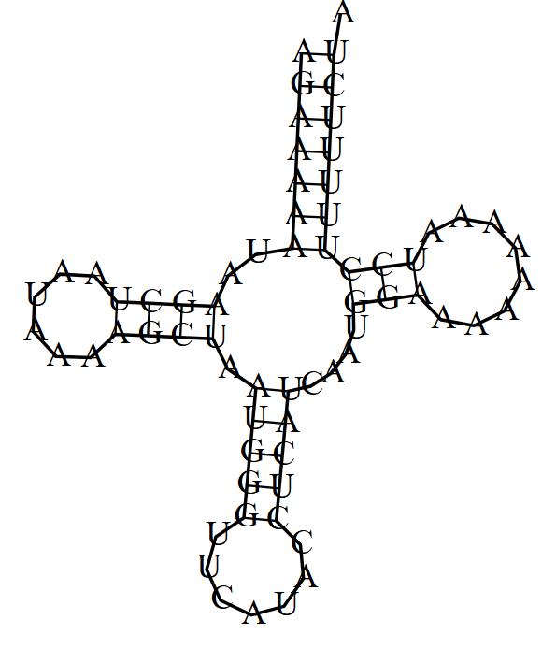
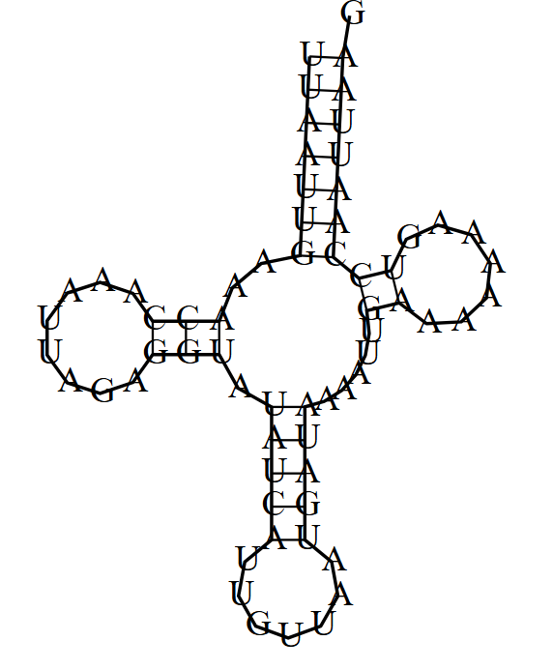
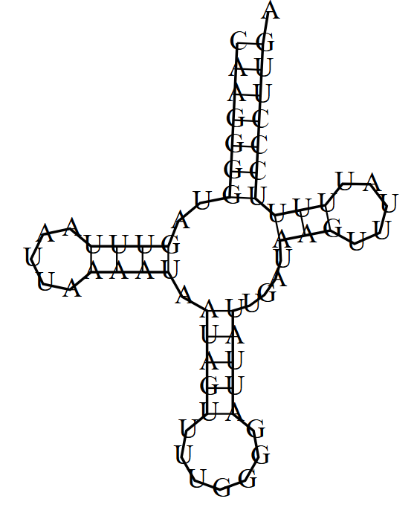
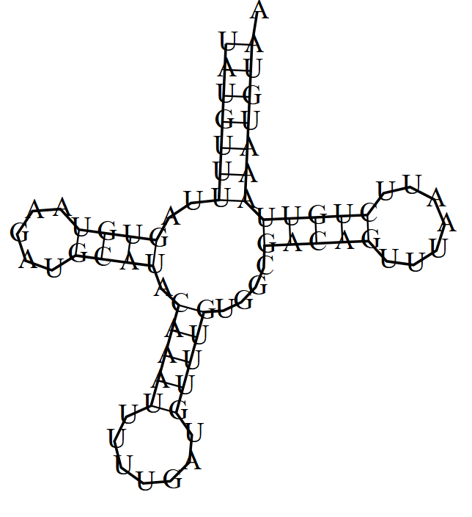
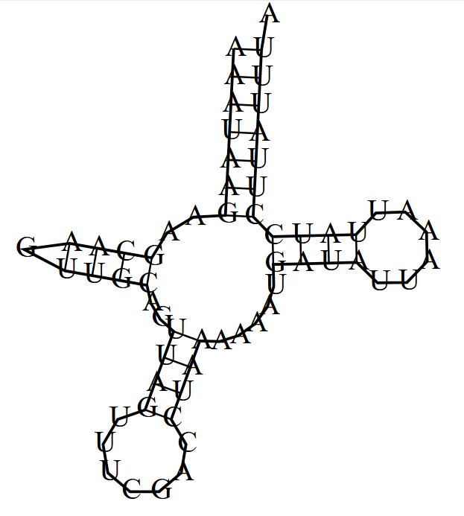
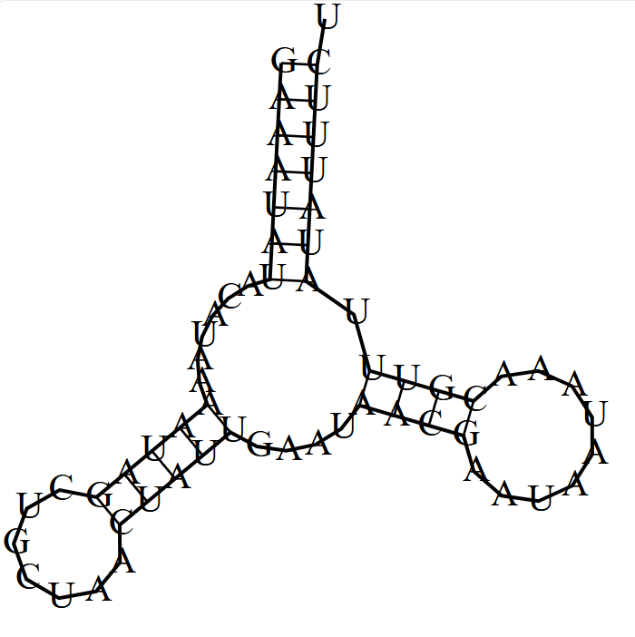
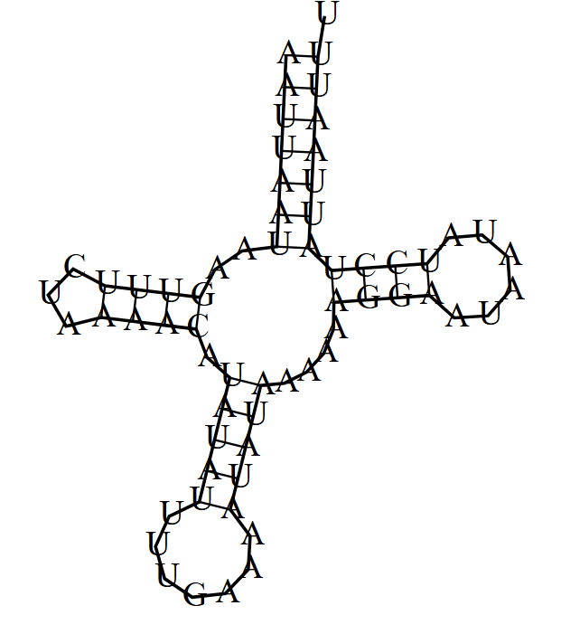
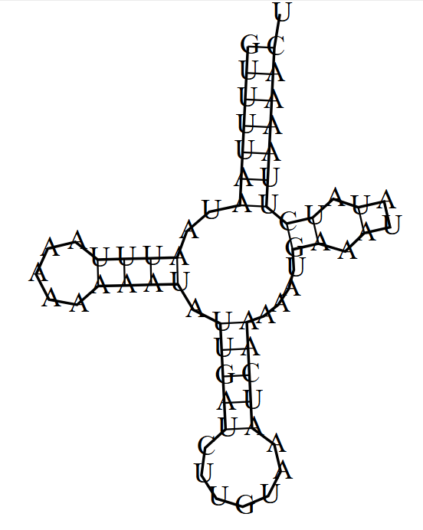
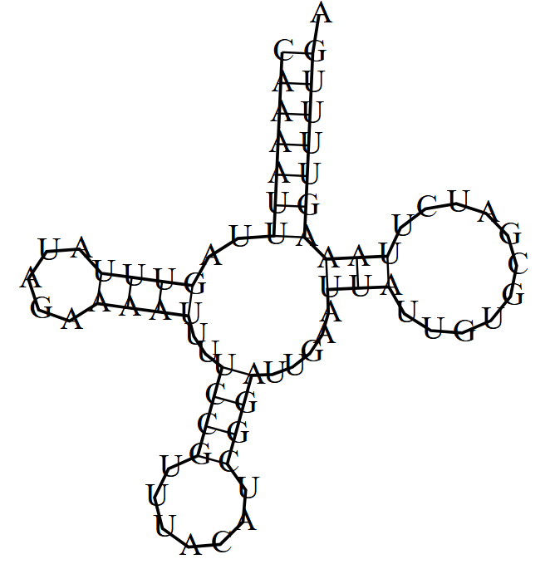
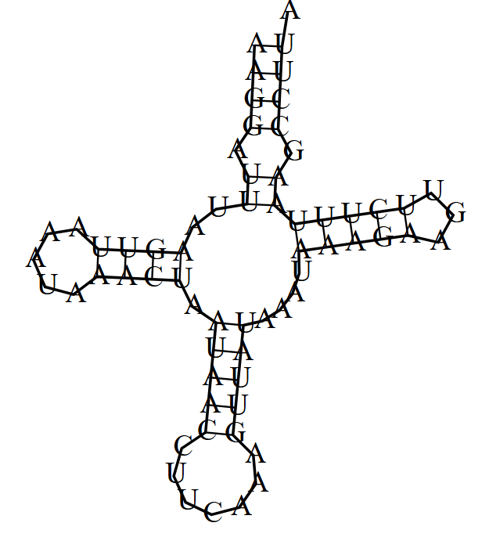
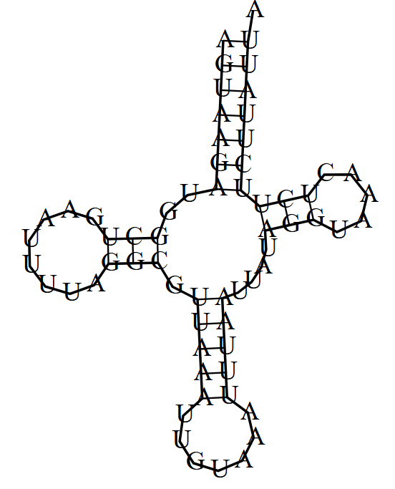

rRNA
Both rrnL (1,171bp) and rrnS (763bp) are present in the mitogenome, and they were located between trnL1-trnV, and trnV-Control Region, respectively. This is the same as all other Phylliidae and most known insects (Cameron, 2014; Song, Li & Na., 2020; Song, Zhang & Zhao, 2019; Zhang et al., 2021; Ding et al., 2023). The lengths of other Phylliidae rrnS range from 760bp (P. giganteum) to 793bp (C. westwoodii), and rrnL from 1269bp (P. bioculatum) to 1292bp (P. giganteum). rrnS has the 3 domains expected in insects (Zhao et al., 2013; Gao et al., 2013)

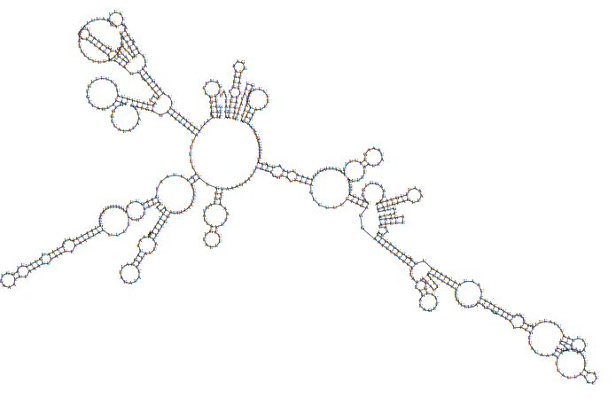
I
II
III

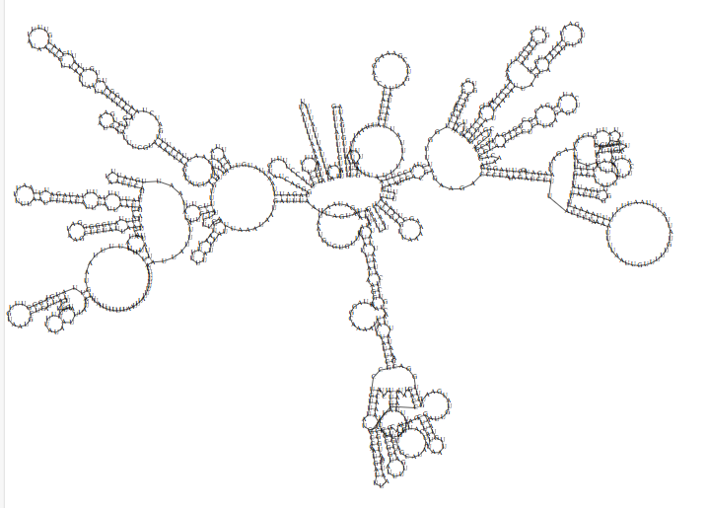

Based on this assembly, the nuclear mitochondrial DNA (NUMT) content was estimated at 0.098%, which falls within the expected range for insects (Wang et al., 2020). When it comes to Phylliidae mitogenomes, there are variations in codon usage, total length, and control region length. The difficulty that has historically come with assembling the control region of Phylliidae mitogenomes continues with P. philippinicum. The variation in features can be explained by the rapid diversification of the Phylliidae within the Miocine era (Bank et al., 2021). Despite the length of the control region and resulting total assembly length, the rest of the mitogenome is relatively unremarkable and follows the expectations of Phylliidae mitochondrial assemblies from broad gene order to the general trend for CDspT. There is no clear distinction between the mitogenomes of Phylliidae and other Phasmids, however, Phylliidae mitogenomes show more variation, although this may be due to the small number of Phylliidae genomes (n = 6) vs other (n = 35) and clear results can be expected as genome assemblies become more available. PC1 contributes the most to Phylliidae variation: with total length and control region being the biggest negative loading. Conversely, PC2 contributes most to non-Phylliidae mitogenome variation (Fig x): that being rrnL and PCG length.
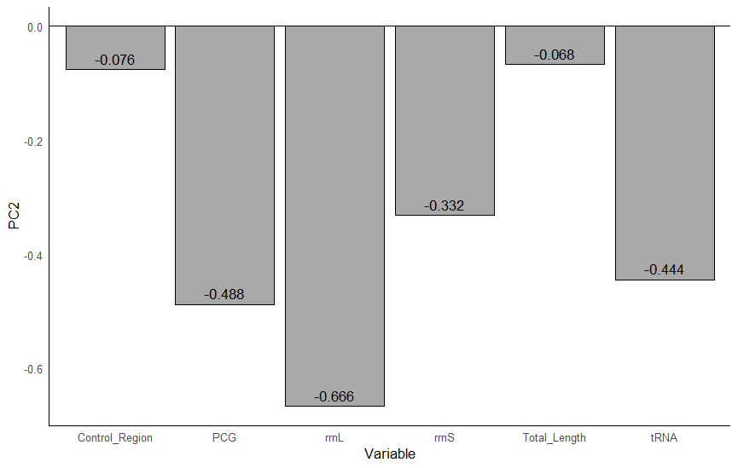

USE MITOS2 ANNOTATIONS AS MITOHIFI APPEAR TRUNCATED.
3.5 Phylogenetics
Model selection and Maximum Likelihood (ML) analyses were performed using IQ-TREE v1.6.1 (IQTREE Web Server: Fast and accurate phylogenetic trees under maximum likelihood). The optimal amino acid substitution models were identified using the FreeRate model, in combination with the default edge-linked partition scheme. ML tree construction was carried out with 10,000 ultrafast bootstrap replicates and a maximum of 5,000 iterations. The partition file for the concatenated dataset, was generated using RAxML format, employing the most recent Le and Gascuel model across all 13 protein-coding genes (PCGs). A total of five ML trees were generated, with the tree generating the best likelihood score selected as the most robust phylogenetic inference.
Taxonomic assignments were based on the Phasmida Species File (https://phasmida.speciesfile.org/), and the final tree was visualised using Interactive Tree of Life (IToL) (https://itol.embl.de/).
The best-supported ML tree (-lnL = -80233.699) exhibits a topology largely consistent with previous phylogenetic studies (Banks et al., 2021). Notably, the Phylliidae clade is recovered as a strongly supported monophyletic group (Bootstrap Support = 100) and represents one of the earliest diverging lineages within Euphasmatodea (BS = 90). Bootstrap support is uniformly high across this clade, with the exception of the node separating C. oyae and C. tibetense (BS = 93). All Phylliidae are grouped according to their currently accepted genera and by the 2021 definition Phyllium is monophyletic with the type species P. siccifolium (Banks et al., 2021)
Consistent with prior studies (Song, Li & Na, 2020; Chen et al., 2024; Banks et al, 2021; Forni et al., 2021; Zeng et al., 2020), the Timema lineage is resolved as the sister group to all other Euphasmatodea (BS = 92), and the Aschiphasmatidae are confirmed as the earliest
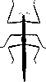

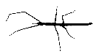
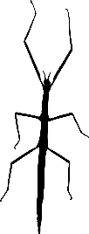
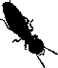


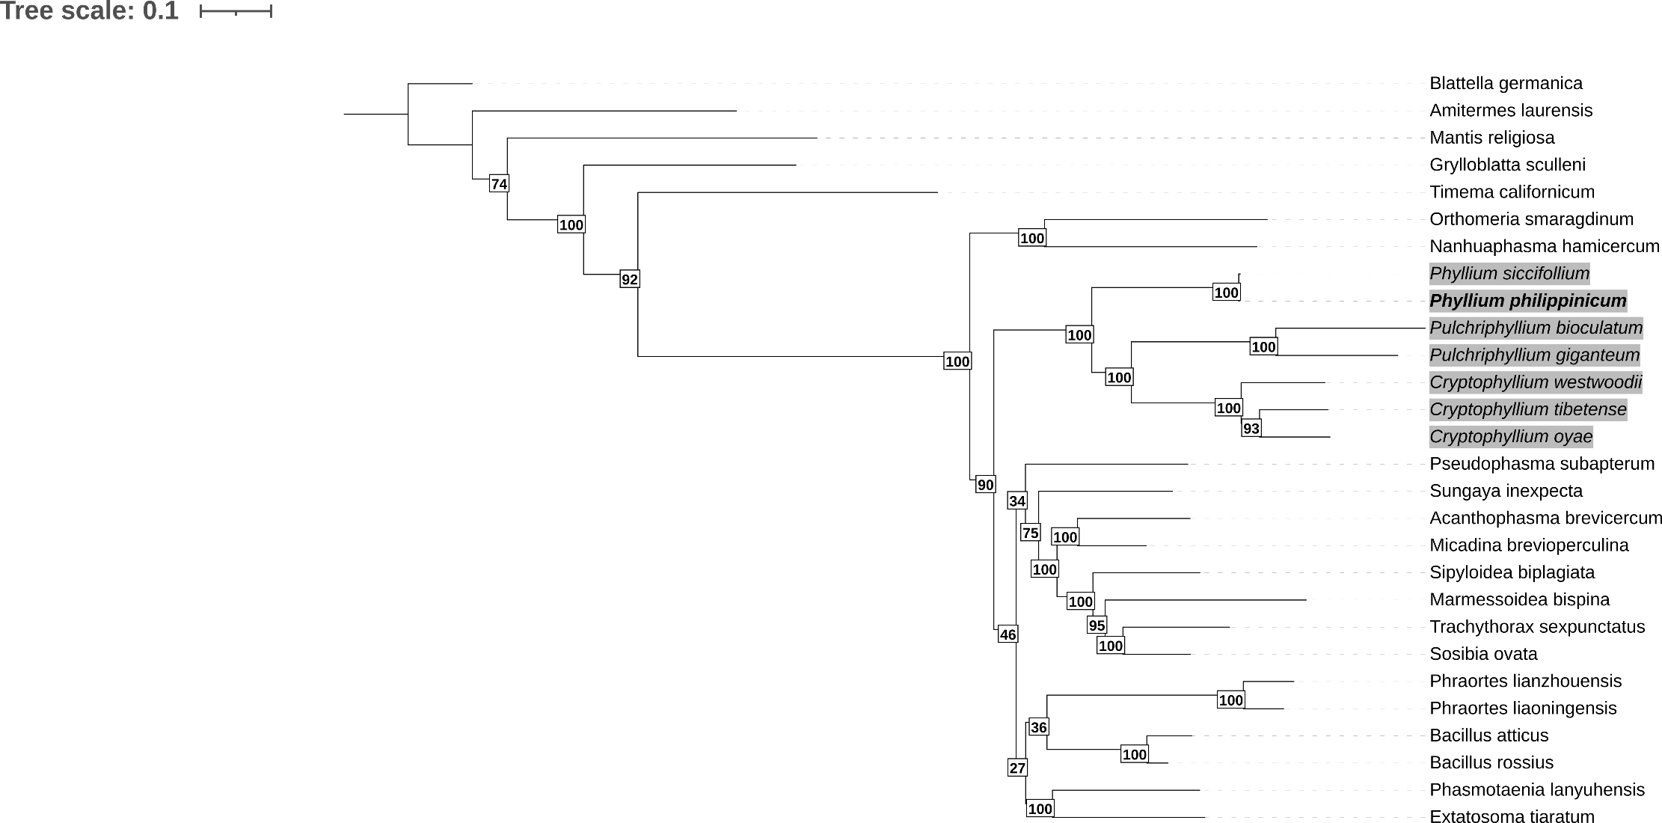
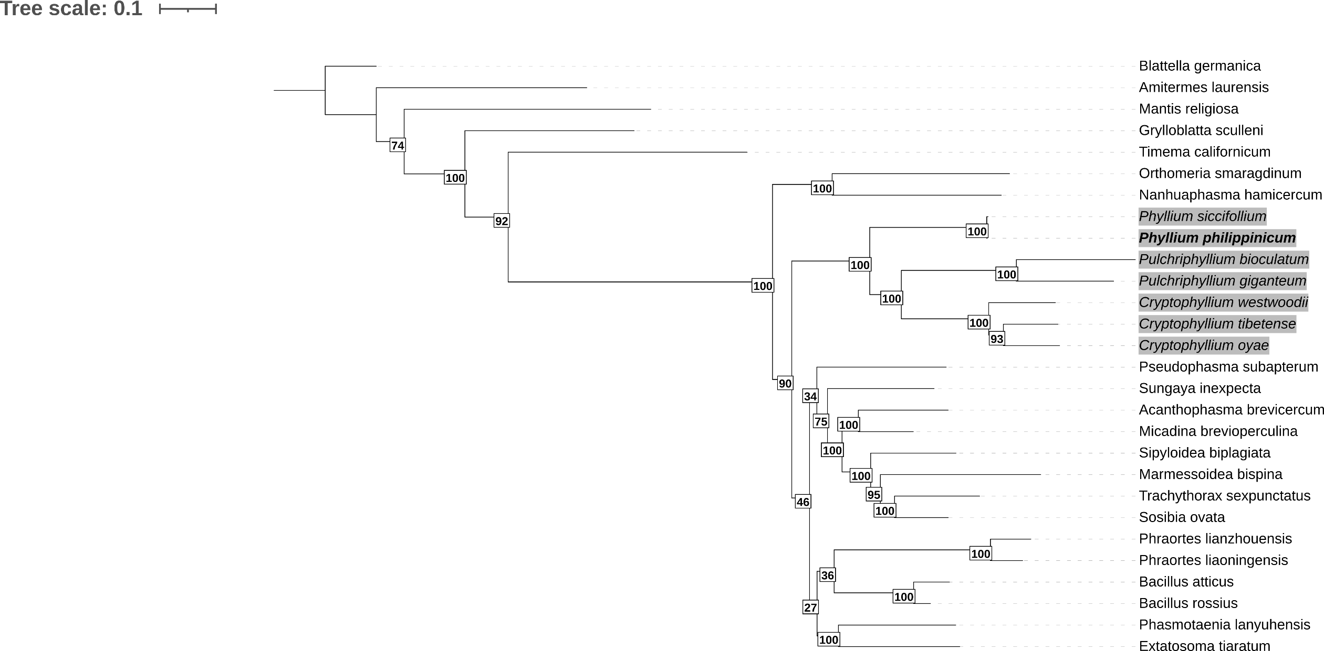
Timematidae
Aschiphasmatidea
Heteropterygidae
Phylliidae
Blattodea
Mantodea
Grylloblattodea
Pseudophasmatidae
Lonchodidae
Phasmatidae
Bacillidae

Euphasmatodea
Phasmatodea

diverging family within Euphasmatodea (BS = 100) in accordance with the full mitogenome dataset. Moreover, the outgroup Grylloblattodea is recovered as the sister group to Phasmatodea (BS = 100). Even when it comes to morphology, Timema is often considered as the sister taxa to Euphasmatodea, with the evolution of soft egg shells (Timema) to hard casing (Euphasmatodea) considered a major factor in the radiation of Phasmatodea diversity (Robertson, Bradler & Whiting, 2018).
In contrast, bootstrap support across the deeper nodes of the remaining Euphasmatodea clade is relatively weak (BS = 46). Notably, Phraortes sp. is unexpectedly recovered as sister to Bacillidae, despite its current classification within Lonchodinae (BS = 36). This finding aligns with prior studies (Forni et al., 2021), which report ambiguity surrounding the placement of Phraortes, potentially due to misidentification. Nonetheless, these authors also suggest that Phraortes and Bacillidae may form monophyletic clades, consistent with our results.
The Psuedophasmatodae-Heteropterygidae-Lonchodinae-Bacillidae-Phasmatidae grouping as well as their relationship with Phylliidae remains a major source of phylogenetic uncertainty, a pattern widely reflected in the literature (Simon et al., 2019; Komoto et al., 2011) . It is important to note that the present topology is based exclusively on complete mitogenome sequences (n = 24). Given the diversity of Phasmatodea, with numerous families yet to be sequenced, the resolution of deeper nodes remains incomplete. Nevertheless, the Phylliidae clade continues to emerge as a well-supported monophyletic group across phylogenomic studies. The present tree is the first to incorporate complete mitogenomic PCGs of all currently available Phylliidae, including the novel complete mitogenome of Phyllium philippinicum. Previous analyses incorporating P. philippinicum either used it as the sole representative of Phylliidae - providing limited insight into intra-family relationships - or relied on partial genomic data or a reduced selection of mitochondrial gene sequences to place a large number of species.
Although our analysis includes far fewer Phylliidae representatives than that of Bank et al. (2021), the most in-depth Phylliidae phylogeny to date, both studies recovered P. siccifolium as the closest relative of P. philippinicum with 100% bootstrap support. Bank et al. (2021) also noted that these two taxa exhibit the lowest genetic divergence among Phylliidae, a result corroborated here by short branch lengths between these species. This high genetic similarity is unlikely to result from recent divergence alone, especially as earlier estimates place Phylliidae radiation as the mid-Cretaceous (Tihelka et al., 2020). However, it should be noted that P. philippinicum was not included in those chronograms. To more accurately estimate the divergence time between P. philippinicum and P. siccifolium, a chronogram including both species would be informative. This would clarify whether the observed genetic similarity stems from recent radiation or conserved evolutionary trajectories. While Short Branch Attraction (SBA) can confound phylogenetic inference falsely implying conditions of low genetic diversity, the hallmark short internal branch structure predisposing to SBA is not present in this case (Lu et al., 2023), and Bank et al.(2021) also independently reported similar findings of low genetic divergence between the two species. Conversely, Long Branch Attraction (LBA) remains a concern, particularly in Euphasmatodea, where rapidly evolving lineages can falsely cluster together (Su & Townsend, 2015). This may account for the unusual placement of Phraortes in our analysis, however, Lonchodidae, containing Phraortes, has been shown to potentially be polyphyletic (Chen et al., 2024).
When restricting all available trees to Phylliidae-only taxa, most available Phasmid phylogenies put Phylliidae as an early diverging Euphasmatodea lineage (Buckley, Attanayake & Bradler, 2009). Phylogeny based on morphology or a reduced number of genes, has shown Phylliidae has been variably placed as a sister taxon to Heteropteryx and as a much later-diverging clade, underlining the importance of incorporating as much relevant genomic data as possible. (Büscher, et al., 2018; Yang et al., 2019). Banks et al (2023)’s follow-up paper, based off 6 mitochondrial and nuclear loci, suggests that Cryptophyllium is the earliest diverging lineage followed by Phyllium and Pulchriphyllium, respectively. In contrast, this study infers Phyllium as the earliest lineage in Phylliidae, suggesting the quantity of genomic data used affects tree topology.
Relative to the root (Blattella germanica), the Pulchriphyllium genus exhibits the highest uncorrected genetic distance from the root among all Phasmatodea. However, this does not necessarily imply recent divergence, and without a dated phylogeny, these results should be interpreted cautiously. A cladogram with calibrated divergence times based on previous fossil data will provide critical context, allowing integration of developmental traits (e.g. wing evolution (Whiting, Bradler & Maxwell, 2003; Yang et al., 2023), oviposition mechanisms (Robertson, Bradler & Whiting, 2018), and parthenogenesis (Schwander et al., 2025) within a temporal framework, thereby offering deeper evolutionary insights into the radiation of Phylliidae. Despite not including the largest number of species, this phylogeny is robust in terms of using whole PCGs from all complete mitogenomes available and the reduced size of the tree in comparison to previous studies, underscores the urgent need for genomic data to keep pace with the accelerating rate of species descriptions.

3.6 Proteomics
Mad
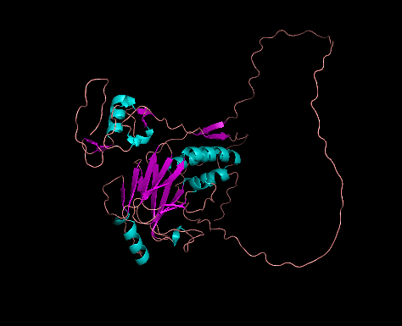
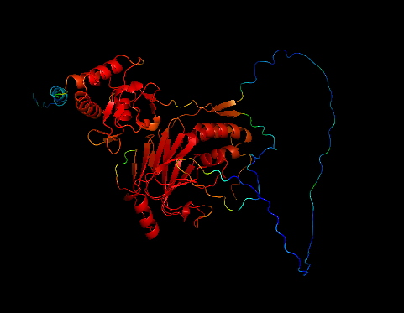
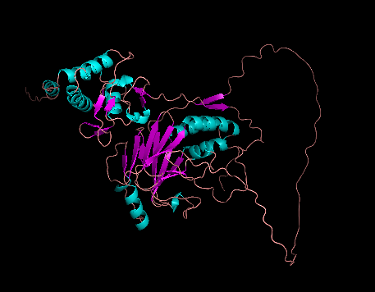
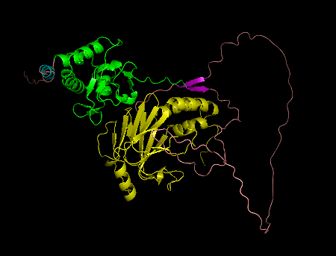
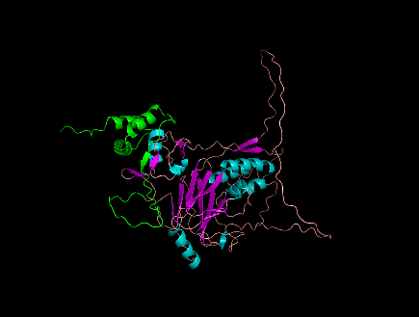
The predicted Mad protein from ColabFold was taken from gene g135356 of GALBA annotation (pLDDT=74.8 pTM=0.628). The prediction had high confidence within the domain regions, but had lower confidence in the inter-domain structure suggesting it is more variable. MH2 was very highly conserved, and the region of MH1 that is present in P. philippinicum prediction is very similar to that of Drosophila, except this domain is much smaller and appears truncated. When BLASTing the P. philippinicum protein against the B. rossius ortholog predicted by ColabFold (pLDDT=77.8 pTM=0.674), this confirms that the P. philippinicum Mad sequence is truncated and is missing 74 bases from the beginning, including some highly conserved helices contained within the MH1 domain.
Figure x. Clockwise from top left: a) Drosophila MAD displaying conserved regions (red) (UniProt: P42003), b) Drosophila MAD domains - MH1 (green), MH2 (yellow), c) Drosophila MAD structure showing alpha helices (blue) and beta sheets (purple), d) P. philippinicum Mad, e) B. rossius MAD homolog 3 (Accession No: XP_063222328.1) with the sequence missing from P. philippinicum in green.

Predicting the function based on sequence with DeepFri confirmed this P. philippinicum protein has a function involved in organic substance metabolic process (0.73, GO:0071704), however, when based on predicted structure, the prediction is less confident (0.60). There were no other predictions available.

Ultrabithorax
Ultrabithorax (Ubx), a HOX gene, contains the homeobox domain and QA motif. In P. philippinicum, Ubx was found split over two genes: g16239 and g16172. A BLAST analysis of the combined transcripts showed a match to B. rossius. However, an additional 60 amino acid sequence was present in P. philippinicum at position 218 before alignment with B. rossius resumed. This corresponds to the first 59 amino acids of the second transcript (g16172.t1), which covers a variable looping region of the protein.
Despite this variation, the Ubx sequence from P. philippinicum retains the expected conserved features, including the Antp-hexapeptide motif, the QA motif, and the HOX domain (100% identity), which are the three critical elements for protein function.
Functional prediction using DeepFri based on sequence suggested nucleic acid binding (GO:0003676) with a confidence score of 0.63. However, structural prediction reduced this confidence to 0.53, instead identifying heterocyclic compound binding (GO:1901363) with the highest confidence score (0.88). DeepFri also showed high confidence (0.99) that Ubx is involved in organic substance metabolic processes (GO:0071704). GPSite supported this by predicting DNA binding with a score of 0.88, consistent with the sequence-based prediction.
These findings suggest that the sequence is accurate, but the structural model is less reliable, which is unsurprising given the low ppDL values (pLDDT = 57.6, pTM = 0.333), likely due to the large amount of variable loops. The agreement between DeepFri and GPSite in predicting DNA binding supports the functional relevance of the conserved motifs. The additional 60 amino acids in P. philippinicum could influence the folding or interaction of Ubx, potentially altering its regulatory function.
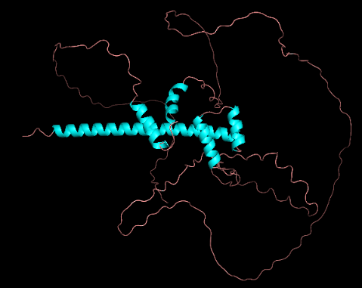
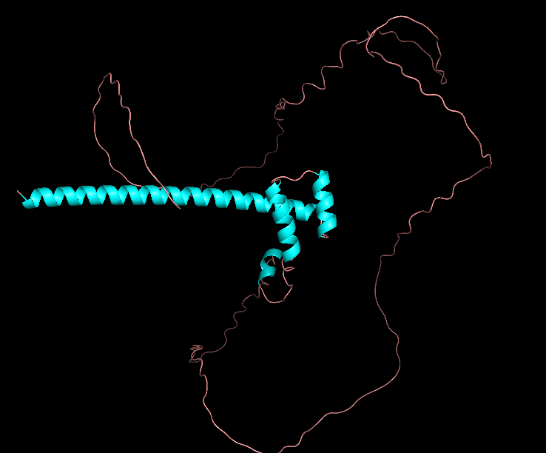
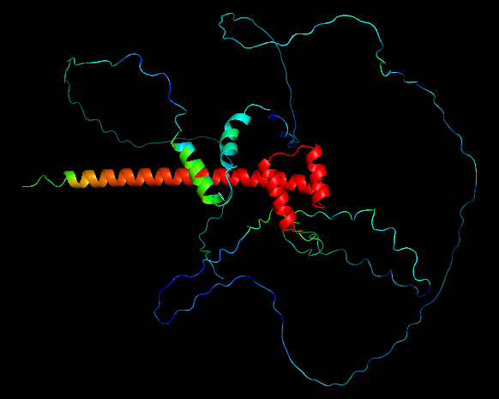

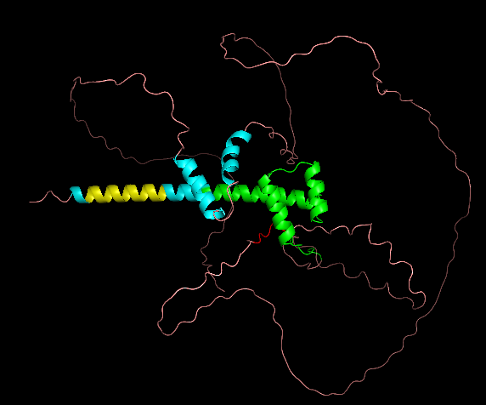
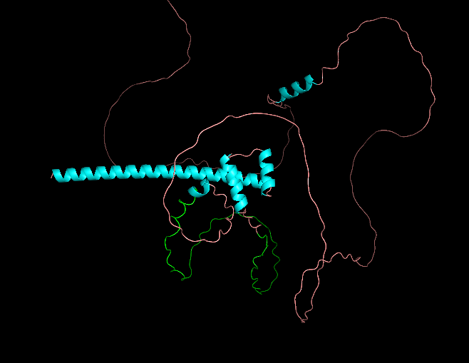
Figure x. Clockwise from top left: a) Drosophila Ultrabithorax displaying conserved regions (red) (UniProt: P83949) b) Drosophila Ultrabithorax features - QA motif (yellow), Homeobox domain (green), Antp-hexapeptide (red) c) Drosophila Ultrabithorax structure showing alpha helices (blue) and variable loops (light pink) d) B. rossius Ultrabithorax (Accession No: XP_063230721.1) (pLDDT=54.3 pTM=0.316) e) P. philippinicum Ultrabithorax with the extra 60 residue sequence that is missing from B. rossius (green).
HSP70
This protein was identified in two adjacent genes, g11137 and g11139, which share 99% identity, differing only by a V5A SNP. The structural model had the highest accuracy among the four predicted proteins (pLDDT = 89, pTM = 0.846). The HSP70 domain showed structural similarity to both Drosophila and B. rossius, although a beta sheet was missing in a more variable region of the protein.
Functional prediction using DeepFri identified 18 binding activities (GO:0032555; GO:1901363; GO:0032553; GO:0035639; GO:0017076; GO:0032559; GO:0005524; GO:003054; GO:0097159; GO:0000166; GO:1901265; GO:0097367; GO:0008144; GO:0036094; GO:0043167; GO:0043168; GO:0051082; GO:0005515) with a confidence of 1.00. DeepFri also predicted involvement in protein folding (GO:0006457) with a confidence of 0.99 based on structure alone, indicating a highly accurate structural model. Interestingly, sequence-based predictions, while all >0.9, were slightly lower than the structural predictions. This suggests that the structural model is highly consistent with the expected functional properties of the sequence. The overall structural conservation with Drosophila and B. rossius reflects the functional importance of HSP70 across insect species and the functional annotation is consistent with its established chaperone function.

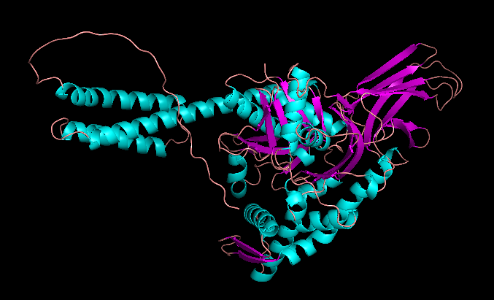
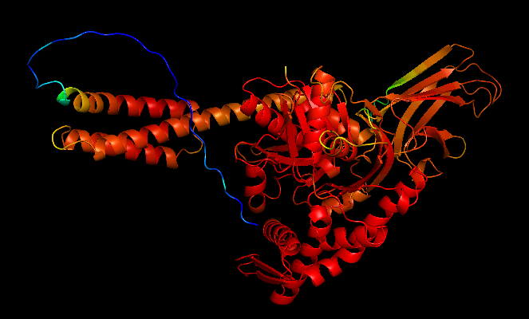
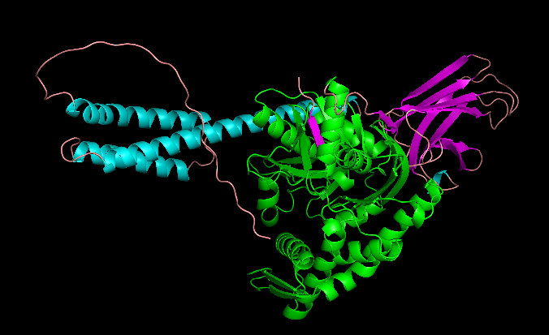
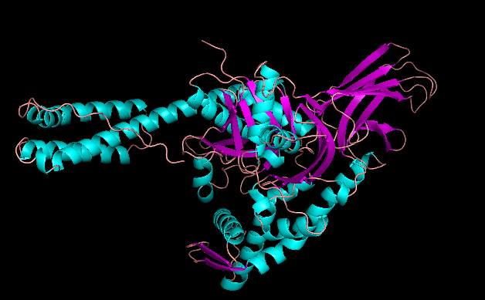

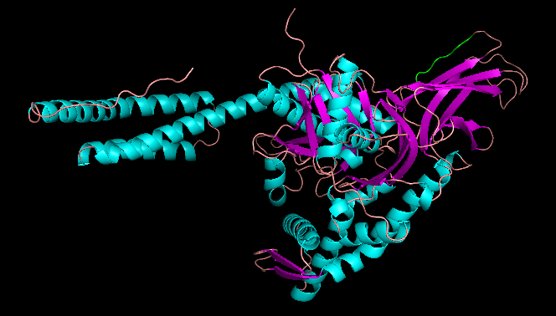
Figure x. Clockwise from top left: a) Drosophila HSP70 displaying conserved regions (red) (UniProt: P82910) b) The HSP70 domain of Drosophila (green). c) The general structure of HSP70 in Drosophila with helices (blue) and beta sheets (purple). d) B. rossius HSP70 ortholog e) HSP70 ortholog of P. philippinicum, a beta sheet is missing (green) and replaced with a variable looping region.

SHH:
This protein begins with a Leucine, and is missing the first 33 residues that are present in B. rossius which are a part of a variable looping region. The AlphaFold Model (pLDDT=72.7 pTM=0.636) shows that there are the 2 subdomains, the N-terminal domain and the C-terminal domain.

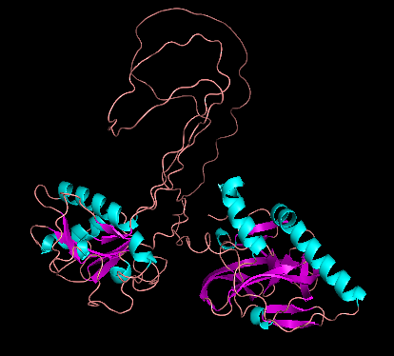

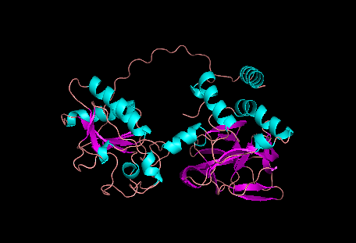
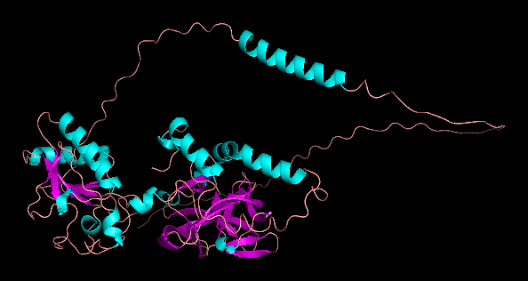
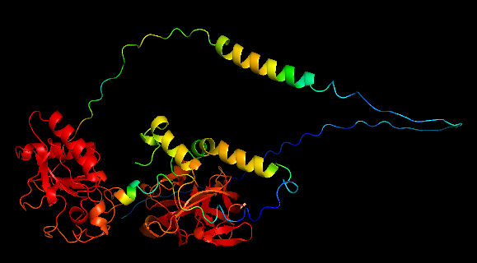
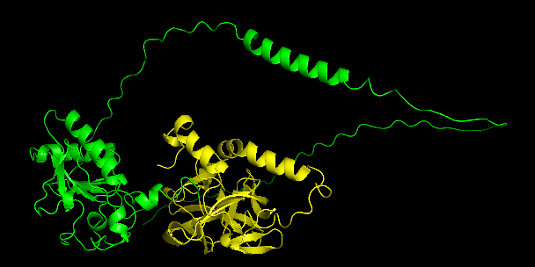
Figure x.

4. Discussion

Assembler Comparison
Genome vs Phasmid Comparison
Limitations
Future Research
Here I will have a bit for each section as above. Comparing how assemblers performed and effect of purge_dups.
Fungal and Mollusca contig should really be addressed?
Brief mention of ploidy and potential mosaic-ploidy (we took leg sample).
Can address mitohifi.
Lots of it will be discussing my genome in the context of genomes within the whole Order. As I have no other Family genomes I can’t do much with that.
It is hard writing a discussion without knowing what is expected of it.
Further research Hi-C and/or RNA-seq. But I think it is a solid start? Compare the stats of my assembly to other known ones.
When get protein data can compare whole genomes (see what has moved about).
Downsides = other genomes are at chromosome level. We have no actual order.
Need the final final final sets of data before deciding this better.
Extreme caution with the model - it has a tiny sample size, but that is all that is available. This could perhaps be used to check any future genomes are along a rough track, and each new genome annotation can improve the model, although it is significant, it is far from being a strong statistical model currently, particularly because of the varying nature of genomes. When a large enough number of species are assembled, the data can be externally validated with test-train modelling but currently with only a sample size of 4, this is not possible. Extreme caution is advised when using this model and

With the proteomic investigation suggesting that the sequence predictions are more confident than that of the strcutres, we can interpret this as the sequences annotated from the genome are accurate when it comes to the functional domains. However, as many of the genes have been freagmented or truncated, they may be missing regions that, although not involved in function, are relevant when it comes to correct folding and structure of the protein. This may be why the sequences contain the functional domains, but the structures seem to be iffy outside of these domain regions. (Checking expression data (RNA-seq) could reveal if both copies of HSP70 are actively transcribed or if one is being silenced - ALSO HELP FIND ACTUAL TRANSCRIPTS

Why 2 copies?:
A functional tandem duplication, where both genes are actively used.
• A recent duplication event, meaning one copy may eventually diverge in function or become a pseudogene.
• An adaptive mechanism, where multiple copies allow for a rapid heat shock response.
2 copies of HSP70 is present in Drosophila too. Consensus disordered region on the end, and InterPro splits the sequence into 2 halves, the first being NBD
Short reads can be used to boost assembly of low coverage regions and error corrections.

5. Conflict of Interest
The author declares that they have no conflict of interest.
6. Supplementary Data
(Need to check this)
7. References
Remember to also reference ALL software!!! Should’ve done this as I went along oops.
Assembling large genomes: analysis of the stick insect (Clitarchus hookeri) genome reveals a high repeat content and sex-biased genes associated with reproduction | BMC Genomics | Full Text
Genome of the Lord Howe Island Stick Insect Reveals a Highly Conserved Phasmid X Chromosome | Genome Biology and Evolution | Oxford Academic
The Draft Genome of the Invasive Walking Stick, Medauroidea extradendata, Reveals Extensive Lineage-Specific Gene Family Expansions of Cell Wall Degrading Enzymes in Phasmatodea - PMC
Tracking the Distribution and Burst of Nuclear Mitochondrial DNA Sequences (NUMTs) in Fig Wasp Genomes - PMC

Supplementary Data
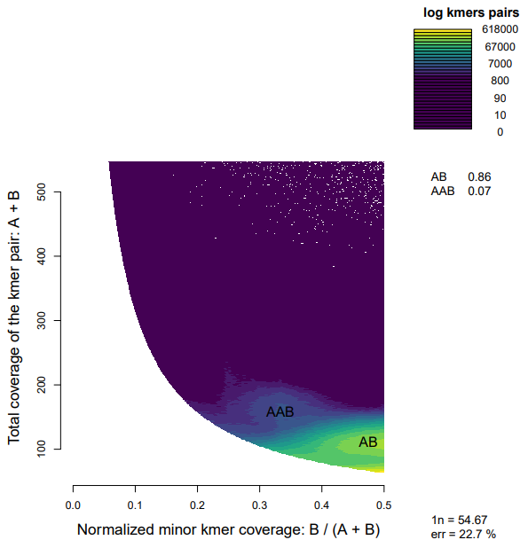
Supplementary Figure S1. SmudgePlot

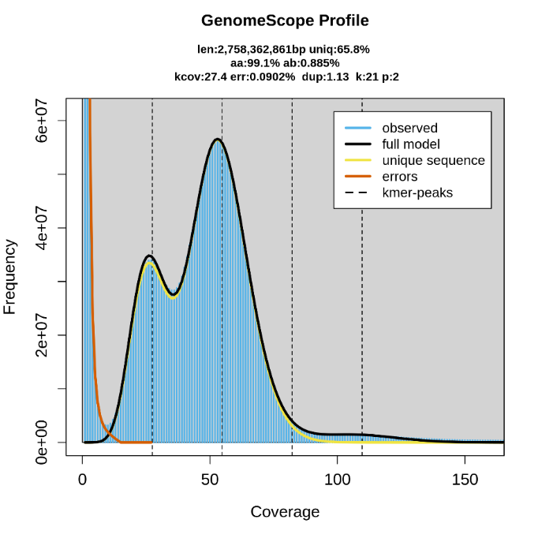
Supplementary Figure S2. GenomeScope

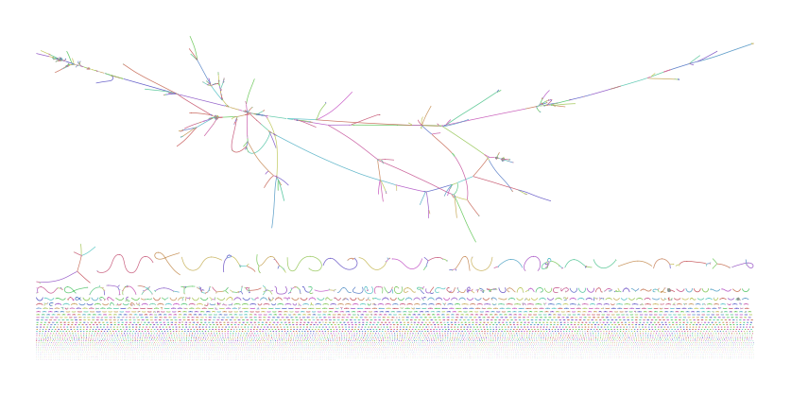
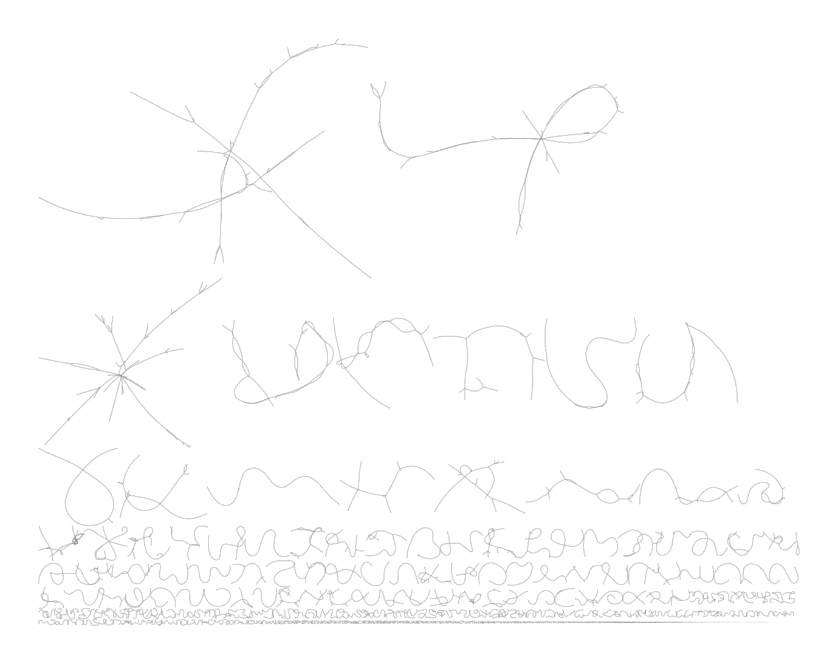

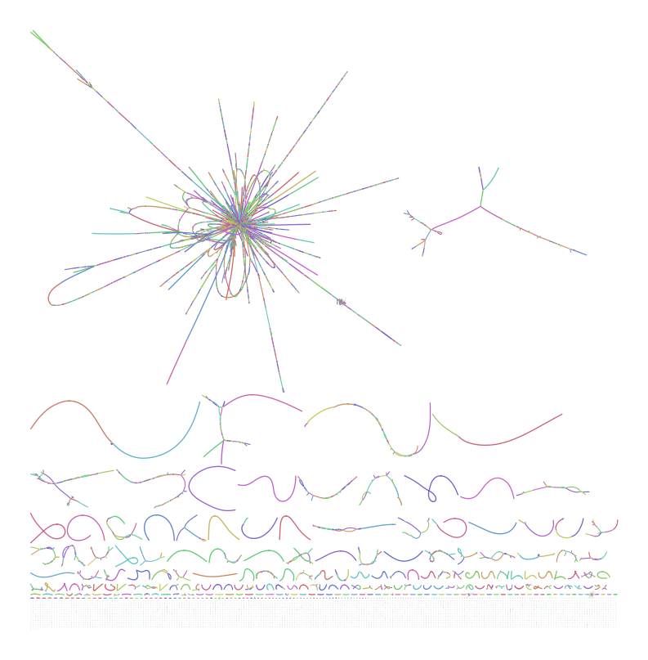

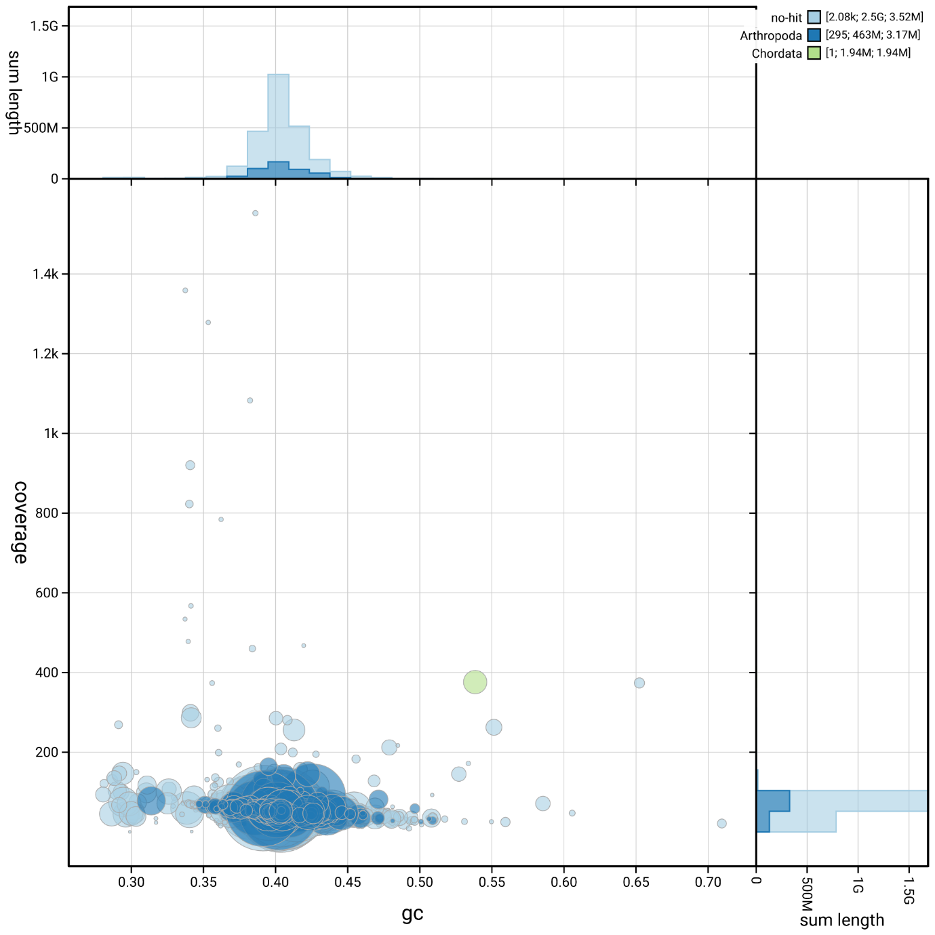
Flye

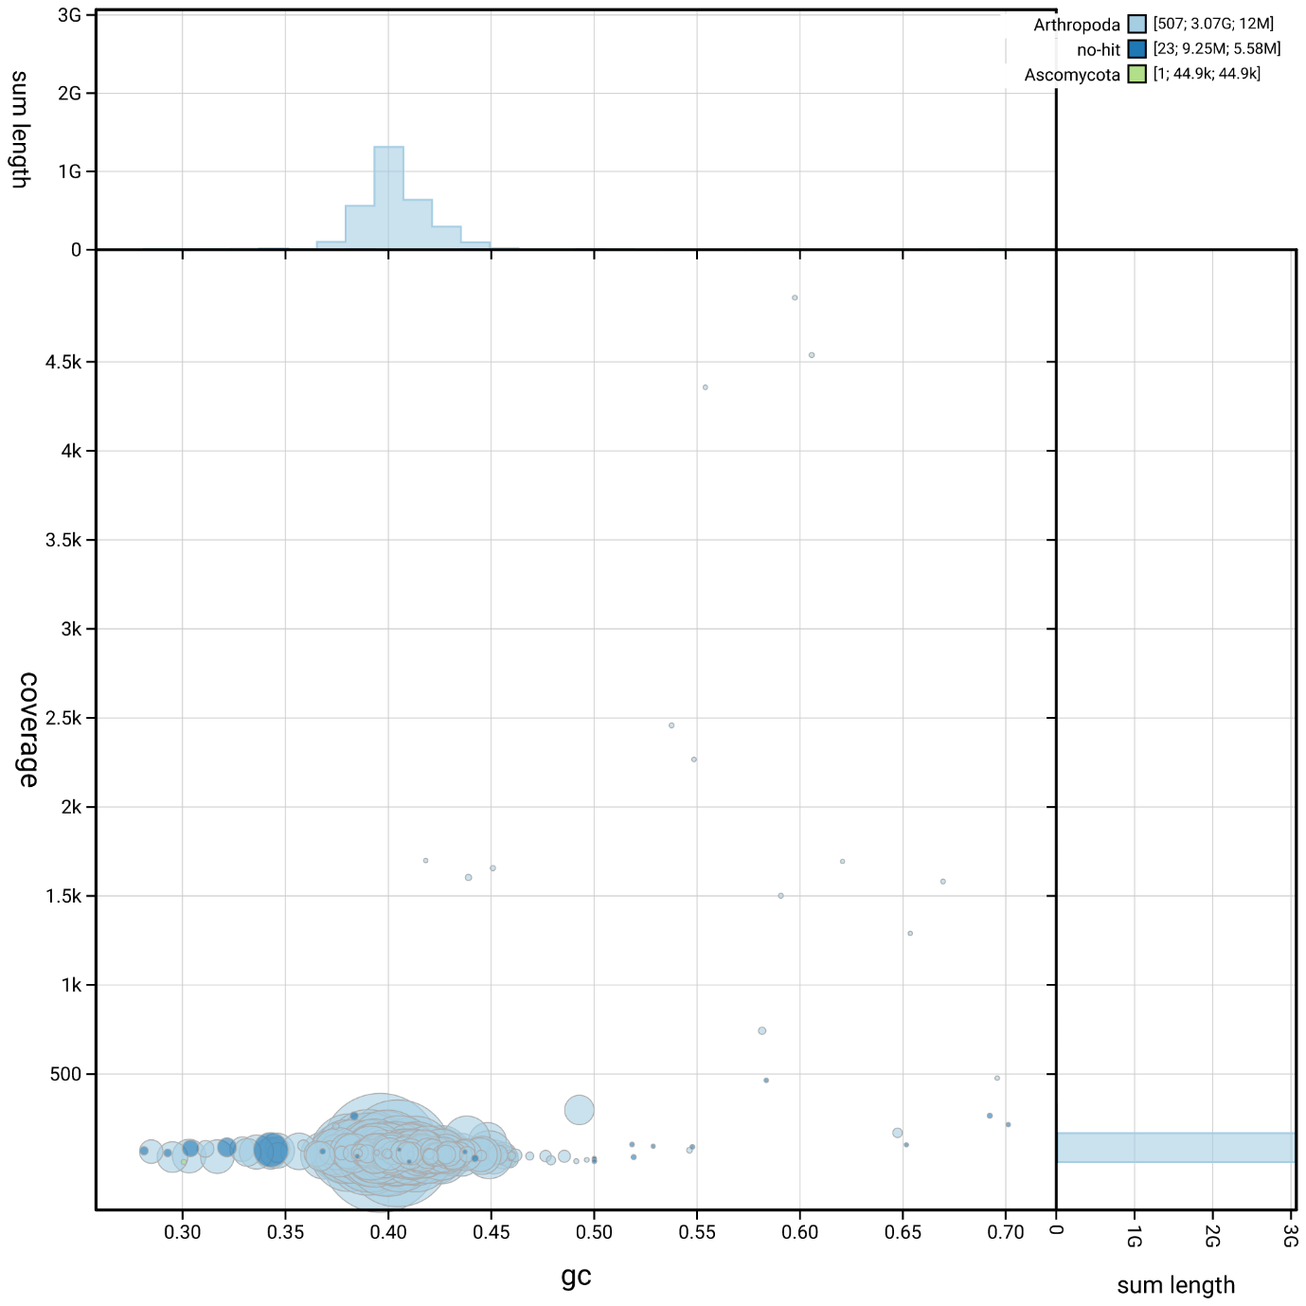
HiCanu

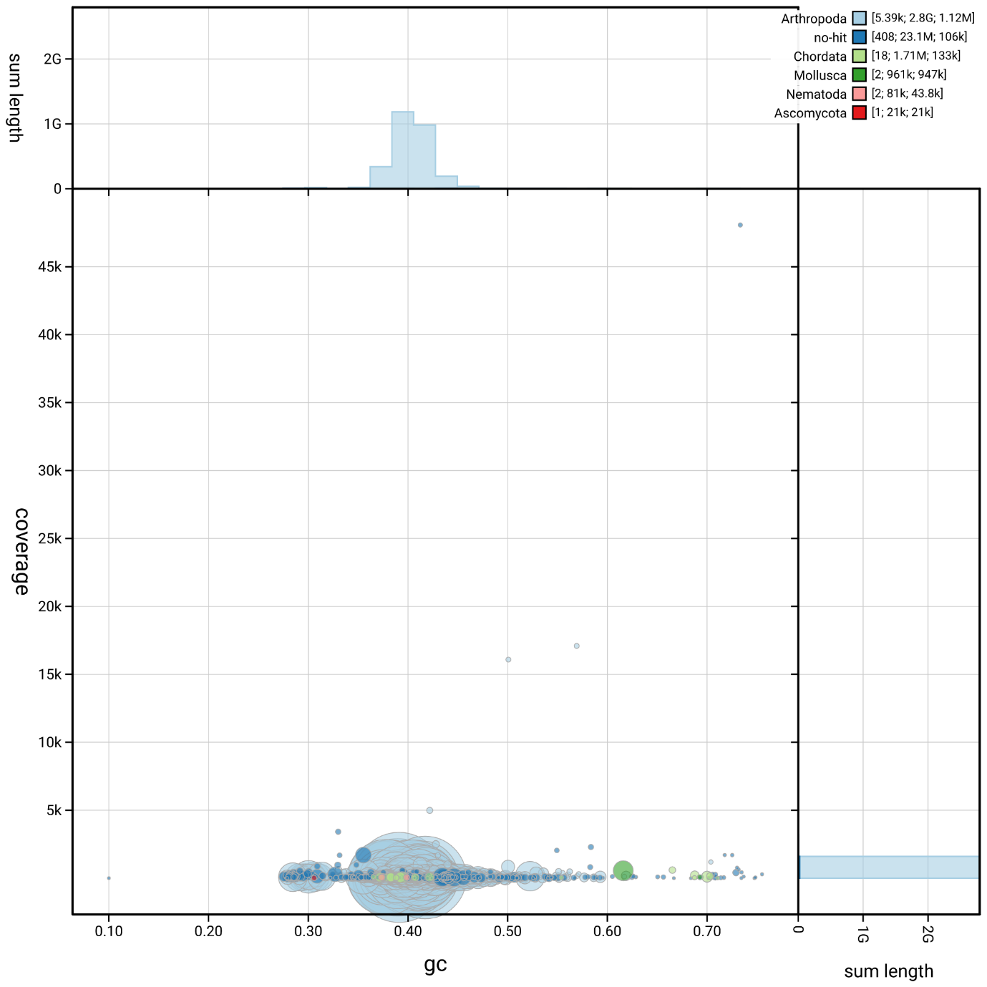
Shasta

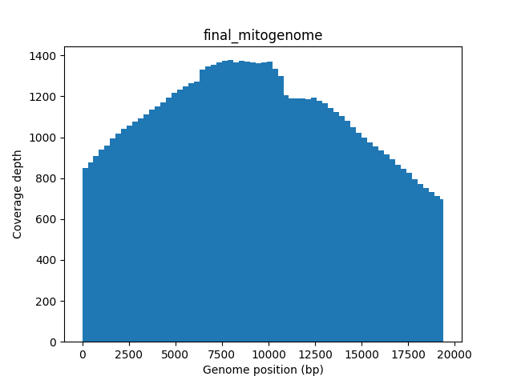

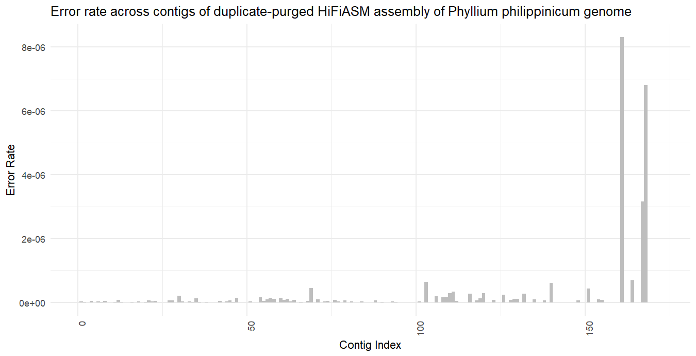
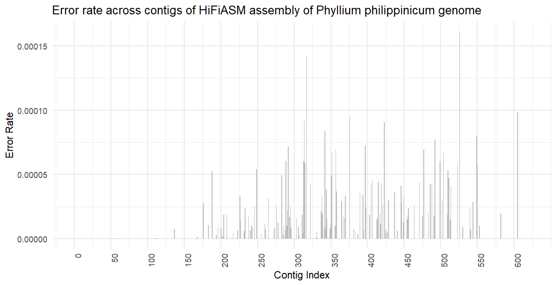

[Grab your reader’s attention with a great quote from the document or use this space to emphasize a key point. To place this text box anywhere on the page, just drag it.]

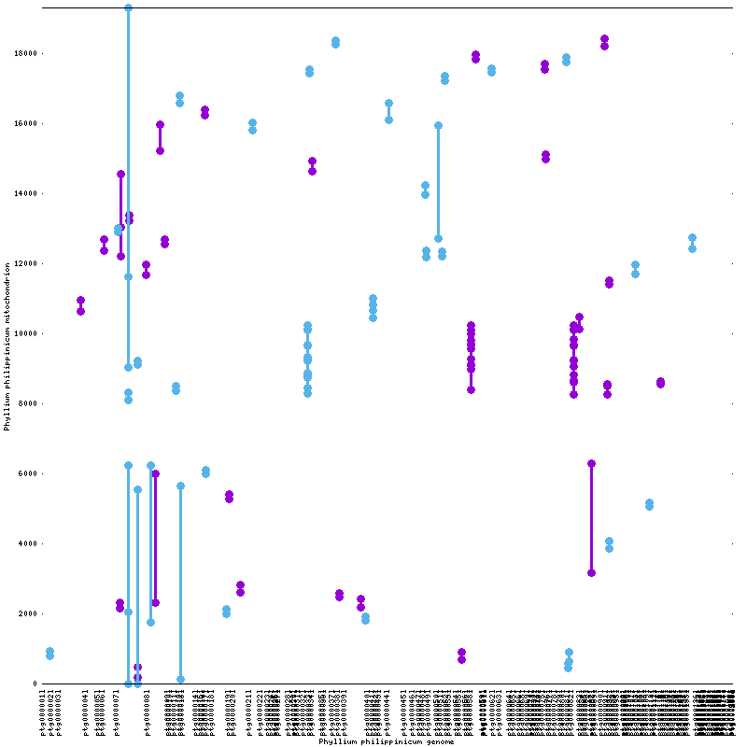
Mummer alignment of mitogenome to full genome of Phyllium philippinicum
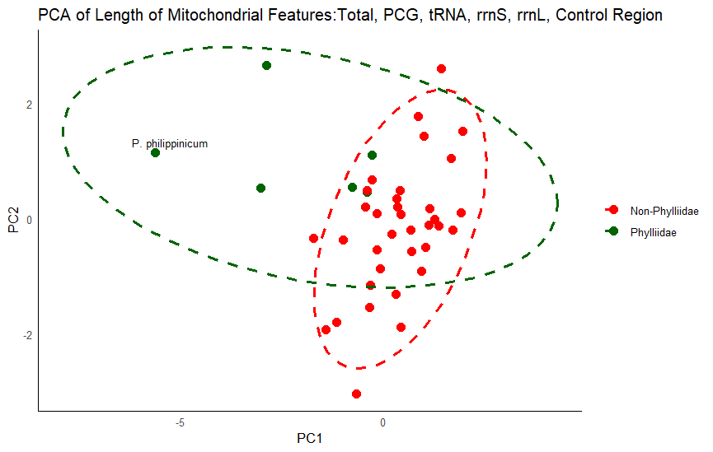

References
- Yuan, Y., Zhang, L., Hong, Y., Storey, K. B., Jiayong, Z. & Yu, D. (2023). Nine Mitochondrial Genomes of Phasmatodea with Two Novel Mitochondrial Gene Rearrangements and Phylogeny. Insects, 14(5). doi: 10.3390/insects14050485
- Xu, K., Chen, Q., Ayivi, S. P. G., Guan, J., Storey, K. B., Yu, D. & Zhang, J. (2023). Three Complete Mitochondrial Genomes of Orestes guangxiensis, Peruphasma schultei, and Phryganistria guangxiensis (Insecta: Phasmatodea) and Their Phylogeny. Insects, 12(9). doi: 10.3390/insects12090779
- Tomita, S., Yukuhiro, K., Kômoto, N. (2011). The mitochondrial genome of a stick insect Extatosoma tiaratum (Phasmatodea) and the phylogeny of polyneopteran insects. JStage, 80(3). doi: 10.11416/jibs.80.3_079
- Xu, K., Chen, Q., Guan, J., Zhang, Z., Storey, K. B., Yu, D. & Zhang, J. (2021). The mitochondrial genome of Eurycantha calcarata Lucas, 1869 (Phasmatodea: Lonchodinae) and its phylogeny. Mitochondrial DNA Part B, 6(11). doi: 10.1080/23802359.2021.1964403
- Song, N., Li, X. & Na, R. (2020). Mitochondrial genomes of stick insects (Phasmatodea) and phylogenetic considerations. PLoS One, 15(10), doi: 10.1371/journal.pone.0240186
- Zhou, Z., Guan, B., Chai, J. & Che, X. (2017). Next-generation sequencing data used to determine the mitochondrial genomes and a preliminary phylogeny of Verophasmatodea insects. Journal of Asia-Pacific Entomology, 20(2), doi: 10.1016/j.aspen.2017.04.012
- Li, Y., Wang, S., Zhou, K., Zhang, Y., Zheng, C., Liang, J. & Bu, W. (2022). The phylogenic position of aschiphasmatidae in euphasmatodea based on mitochondrial genomic evidence. Gene, 808(15), doi: 10.1016/j.gene.2021.145974
- Dong, Z., Li, J., He, J., Liu, G., Mao, C., Zhao, R. & Li, X. (2021). The mitochondrial genome of a leaf insect Phyllium westwoodii (Phasmatodea: Phylliidae) in Southeast Asia. Mitochondrial DNA Part B, 6(3), doi: 10.1080/23802359.2021.1886014
- Kômoto, N., Yukuhiro, K., Ueda, K. & Tomita, S, (2011). Exploring the molecular phylogeny of phasmids with whole mitochondrial genome sequences. Molecular Phylogenetics and Evolution, 58(1), doi: 10.1016/j.ympev.2010.10.013
- Clary, D. O. & Wolstenholme, D. R. (1985). The mitochondrial DNA molecule of Drosophila Yakuba: Nucleotide sequence, gene organization, and genetic code. Journal of Molecular Evolution, 22(pp.252-271), doi: 10.1007/bf02099755
- Plazzi, F., Ricci, A. & Passamonti, M. (2011). The mitochondrial genome of Bacillus stick insects (Phasmatodea) and the phylogeny of orthopteroid insects. Molecular Phylogenetics and Evolution, 58(2), doi: 10.1016/j.ympev.2010.12.005
- Ghiselli, F., Gomes-dos-Santos, A., Adema, C. M., Lopes-Lima, M., Sharbrough, J., Boore, J. L. (2021). Molluscan mitochondrial genomes break the rules. Philosophical Transactions B, 5(376), doi: 10.1098/rstb.2020.0159
- Quek, Z. B. R., Chang, J. J. M., Ip, Y. C. A., Chan, Y. K. S. & Huang, D. (2021). Mitogenomes Reveal Alternative Initiation Codons and Lineage-Specific Gene Order Conservation in Echinoderms. Molecular Biology and Evolution, 38(3), doi: 10.1093/molbev/msaa262
- Chang, J. H. & Tong, L. (2011). Mitochondrial poly(A) polymerase and polyadenylation. Biochimica et Biophysica Acta, 1819, doi: 10.1016/j.bbagrm.2011.10.012
- Burger, G., Gray, M. W. & Lang, B. F. (2003). Mitochondrial genomes: anything goes. Trends in Genetics, 19(12), doi: 10.1016/j.tig.2003.10.012
- Zwonitzer, K. D., Tressel, L. G., Wu, Z., Kan, S., Broz, A. K., Mower, J. P., Ruhlman, T. A., Jansen, R. K., Sloan, D. B. & Havird, J. C. (2024). Genome copy number predicts extreme evolutionary rate variation in plant mitochondrial DNA. Proceedings of the National Academy of Sciences of the United States of America, 121(10), doi: 10.1073/pnas.2317240121
- Despabiladeras, J. B. & Bautista, A. M. (2024). Complete Mitochondrial Genome of the Eggplant Fruit and Shoot Borer, Leucinodes orbonalis Guenée (Lepidoptera: Crambidae), and Comparison with Other Pyraloid Moths. Insect Molecular Biology and Genomics, 15(4), doi: 10.3390/insects15040220
- Wu, Y., Zhao, J., Su, T., Li, J., Yu, F., Chesters, D., Fan, R., Chen, M., Wu, C. & Zhu, C. (2012). The Complete Mitochondrial Genome of Leucoptera malifoliella Costa (Lepidoptera: Lyonetiidae). DNA and Cell Biology, 31(10), doi: 10.1089/dna.2012.1642
- Ma, C., Wang, Y., Zhang, L. & Li, J. (2019). Mitochondrial genome characterization of the family Trigonidiidae (Orthoptera) reveals novel structural features and nad1 transcript ends. Scientific Reports, 9(19092), doi: 10.1038/s41598-019-55740-4
- Zhang, C. & Guo, X. (2022). Organization of the mitochondrial genome of Ramulus irregulatiter dentatus (Phasmatidae: Phasmatidae). Frontiers in Genetics, 13, doi: 10.3389/fgene.2022.967113
- Cumming R. T., Le Tirant, S., Linde, J. B., Solan, M. E., Foley, E. M., Eulin, N. E. C., Lavado, R., Whiting, M. F., Bradler, S. & Bank, S. (2023). On seven undescribed leaf insect species revealed within the recent “Tree of Leaves” (Phasmatodea, Phylliidae). ZooKeys, 1173 (p. 145-229). doi: 10.3897/zookeys.1173.104413
- Forni, G., Plazzi, F., Cussigh, A., Conle, O., Hennemann, F., Luchetti, A. & Mantovani, B. (2021). Phylomitogenomics provides new perspectives on the Euphasmatodea radiation (Insecta: Phasmatodea). Molecular Phylogenetics and Evolution, 155. doi: 10.1016/j.ympev.2020.106983
- Bank, S., Cumming, R. T., Li, Y., Henze, K., Le Tirant, S. & Bradler, S. (2021). A tree of leaves: Phylogeny and historical biogeography of the leaf insects (Phasmatodea: Phylliidae). Communications Biology, 4(932). doi: 10.1038/s42003-021-02436-z
- Lu, L., Yu, L., Wu, S., Arnold, J., Whalen, C., Davis, C. & Edwards, S. (2023). Short branch attraction in phylogenomic inference under the multispecies coalescent. Frontiers in Ecology and Evolution, 11. doi: 10.3389/fevo.2023.1134764
- Su, Z. & Townsend, J. P. (2015). Utility of characters evolving at diverse rates of evolution to resolve quartet trees with unequal branch lengths: analytical predictions of long-branch effects. BMC Evolutionary Biology, 15(86). doi: 10.1186/s12862-015-0364-7
- Buckley, T. R., Attanayake, D. & Bradler, S. (2009). Extreme convergence in stick insect evolution: phylogenetic placement of the Lord Howe Island tree lobster. Proceedings of the Royal Society B, 276(1659). doi: 10.1098/rspb.2008.1552
- Büscher, T. H., Buckley, T. R., Grohmann, C., Gorb, S. N., Bradler, S. (2018). The Evolution of Tarsal Adhesive Microstructures in Stick and Leaf Insects (Phasmatodea). Frontiers in Ecology and Evolution, 6. doi: doi.org/10.3389/fevo.2018.00069
- Yang, H., Yin, X., Lin, X., Wang, C., Shih, C., Zhang, W., Ren, D., Gao, T. (2019). Cretaceous winged stick insects clarify the early evolution of Phasmatodea. Proceedings of the Royal Society B, 286(1909). doi: 10.1098/rspb.2019.1085
- Robertson, J. A., Bradler, S. & Whiting, M. F. (2018). Evolution of Oviposition Techniques in Stick and Leaf Insects (Phasmatodea). Frontiers in Ecology and Evolution, 6(216). doi: 10.3389/fevo.2018.00216
- Whiting, M. F., Bradler, S. & Maxwell, T. (2003). Loss and recovery of wings in stick insects. Nature, 421(6920). doi: 10.1038/nature01313
- Yang, H., Engel, M. S., Shih, C., Song, F., Zhao, Y., Ren, D. & Gao, T. (2023). Independent wing reductions and losses among stick and leaf insects (Phasmatodea), supported by new Cretaceous fossils in amber. BMC Biology, 21(210). doi: 10.1186/s12915-023-01720-0
- Schwander, T., Soldini, L., Boisseau, R. P., Merel, V., Toubiana, W., Lavanchy, G. (2025). On the Repeated Evolution of Parthenogenesis in Stick Insects. [Preprint]. doi: 10.32942/X21P7G
- Tihelka, E., Cai, C., Giacomelli, M., Pisani, D. & Donoghue, P. C. J. (2020). Integrated phylogenomic and fossil evidence of stick and leaf insects (Phasmatodea) reveal a Permian-Triassic co-origination with insectivores. Royal Society Open Science, 5(11). doi: 10.1098/rsos.201689
- Kômoto, N., Yukuhiro, K., Ueda, K. & Tomita, S. (2011). Exploring the molecular phylogeny of phasmids with whole mitochondrial genome sequences. Molecular Phylogenetics and Evolution, 58(1). doi: 10.1016/j.ympev.2010.10.013
- Song, N., Lie, X. & Na, R. (2020). Mitochondrial genomes of stick insects (Phasmatodea) and phylogenetic considerations. PLoS One, doi: 10.1371/journal.pone.0240186
- Bradler, S., Robertson, J. A. & Whiting, M. F. (2014). A molecular phylogeny of Phasmatoeda with emphasis on Necrosciinae, the most species-rich subfamily of stick insects. Systematic Entomology. 39(2). doi: 10.1111/syen.12055
- Chen, Y., Yuan, Y., Yang, W., Storey, K. B., Zhang, J. & Yu, D. (2024). Insight into the Phylogenetic Relationship of Phasmatodea and Selection Pressure Analysis of Phraortes liaoningensis Chen & He, 1991, (Phasmatodea: Lonchodidae) Using Mitogenomes. Insects, 15(11). doi: 10.3390/insects15110858
- Zeng, Y., O’Malley, C., Singhal, S., Rahim, F., Park, S., Chen, X., Dudley, R. (2020). A Tale of Winglets: Evolution of Flight Morphology in Stick Insects. Frontiers in Ecology and Evolution, 8. doi: 10.3389/fevo.2020.00121
- Leaf insects from Luzon, Philippines, with descriptions of four new species, the new genus Pseudomicrophyllium, and redescription of Phyllium (Phyllium) geryon Gray, 1843, (Phasmida: Phylliidae). Zootaxa, 4365(2), doi: 10.11646/zootaxa.4365.2.1
- Liu, H., Chen, Q., Chen, S., Pu, D., Chen, Z., L., Y. & Liu, X. (2020). The highly rearranged mitochondrial genomes of three economically important scale insects and the mitochondrial phylogeny of Coccoidea (Hemiptera: Sternorrhyncha). PeerJ, 6(8), doi: 10.7717/peerj.9932
- Li, w., Wang, Z., Chem Y. (2017). The Complete Mitogenome of the Wood-Feeding Cockroach Cryptocercus meridianus (Blattodea: Cryptocercidae) and Its Phylogenetic Relationship among Cockroach Families. International Journal of Molecular Sciences, 18(11), doi: 10.3390/ijms18112397
- Schindeldecker, M. & Moosmann, B. (2015). Protein-borne methionine residues as structural antioxidants in mitochondria. Amino Acids, 47, doi: 10.1007/s00726-015-1955-8
- Lugata, J. K., Ortega, A. & Szabo, C. (2022). The Role of Methionine Supplementation on Oxidative Stress and Antioxidant Status of Poultry-A Review. Agriculture, 12(10), doi: 10.3390/agriculture12101701
- Feng, S., Zeng, J., Li, J., Yuan, S. & Wu, B. (2024). Alleviating the effect of methionine on intestinal mucosal injury induced by heat stress. Journal of Thermal Biology, 123, doi: 10.1016/j.jtherbio.2024.103935
- Chen, Q., Li, Y., Chen, Q., Tian, X., Wang, Yu. & Wang, Ye. (2023). Mitogenome of the stink bug Aelia fieberi (Hemiptera: Pentatomidae) and a comparative genomic analysis between phytophagous and predatory members of Pentatomidae. PLOS One, doi: 10.1371/journal.pone.0292738
- de Souza Araujo, N., Perez, R., Willot, Q., Defrance, M. & Aron, S. (2023). Facing lethal temperatures: Heat-shock response in desert and temperate ants. Ecology and Evolution, 13(9), doi: 10.1002/ece3.10438
- Liu, H., Chen, Q., Chen, S., Pu, D., Chen, Z., Liu, Y. & Liu, X. (2020). The highly rearranged mitochondrial genomes of three economically important scale insects and the mitochondrial phylogeny of Coccoidea (Hemiptera: Sternorrhyncha). PeerJ 6(8), doi: 10.7717/peerj.9932
- Song, N., L, X., Na, R. (2020). Mitochondrial genomes of stick insects (Phasmatodea) and phylogenetic considerations. PLoS One, 6(15), doi: 10.1371/journal.pone.0240186
- Song, N., Zhang, H. & Zhao, T. (2019). Insights into the phylogeny of Hemiptera from increased mitogenomic taxon sampling. Molecular Phylogenetics and Evolution, 137, doi: 10.1016/j.ympev.2019.05.009
- Ding, W. Xu, H., Wu, Z., Hu, L. Huang, L., Yang, M. & Li, L. (2023). The mitochondrial genomes of the Geometroidea (Lepidoptera) and their phylogenetic implications. Ecology and Evolution, 13(2), doi: 10.1002/ece3.9813
- Zhang, H., Liu, Q., Lu, C., Deng, J. & Huang, X. (2021). The First Complete Mitochondrial Genome of Lachninae Species and Comparative Genomics Provide New Insights into the Evolution of Gene Rearrangement and the Repeat Region. Insects, 12(1), doi: 10.3390/insects12010055
- Cameron, S. L. (2014). How to sequence and annotate insect mitochondrial genomes for systematic and comparative genomics research. Systematic Entomology, 39(3), doi: 10.1111/syen.12071
- Zhao, J., Li, H. & Winterton, S. L. (2013). Ancestral Gene Organization in the Mitochondrial Genome of Thyridosmylus langii (McLachlan, 1870) (Neuroptera: Osmylidae) and Implications for Lacewing Evolution. PLOS One, 8(5), doi: 10.1371/journal.pone.0062943
- Gao, J., Li, H., Xi, X. & Dai, X. (2013). Complete nucleotide sequence and organization of the mitochondrial genome of Sirthenea flavipes (Hemiptera: Reduviidae: Peiratinae) and comparison with other assassin bugs. Zootaxa, 3669(1), doi: 10.11646/zootaxa.3669.1.1

