Monte Carlo Simulation Report - TRB_EURJPY_USDJPY_Quant_Portfolio_006
5,000 simulated paths generated from the portfolio's combined trade stream using the 'resample' method, evaluated against The5ers High Stakes rules on a $2,500.00 account.

1. Simulation Setup
Portfolio | TRB_EURJPY_USDJPY_Quant_Portfolio_006
Account Size | $2,500.00
Simulations | 5,000
Randomisation Method | Bootstrap - trades drawn with replacement (different but statistically similar sequences)
Per-Trade P&L Noise | None
Trades per Simulation | 3,181
Source Trade Stream Rows | 3,181
Random Seed | 42
Candidates in Portfolio | cand_011 (run_20260909_101955), cand_002 (run_20260920_134306)

2. Prop Firm Rule Set Applied
Firm / Programme | The5ers High Stakes
Static Max Drawdown | 10.00% below initial balance (floor = $2,250.00)
Daily Drawdown | 5.00% below each day's starting balance
Phase 1 Target | 8.00% (time limit: No limit)
Phase 2 Target | 5.00% (time limit: No limit)
Each simulated path is walked trade-by-trade in chronological order. The daily floor is re-based at the start of every trading day using the real day boundaries from the backtest. A path stops the moment it hits the target (pass) or breaches a floor (fail), mirroring how the firm would actually close the account.

3. Prop Firm Phase Outcomes
Phase | Target | Pass Rate | Static Breach | Daily Breach | No Target Hit | Median Days to Pass
Phase 1 | 8.0% | 99.24% | 0.72% | 0.04% | 0.00% | 69
Phase 2 | 5.0% | 99.26% | 0.72% | 0.02% | 0.00% | 44

Phase 1 detail
Pass Rate | 99.24%
Any Breach Rate | 0.76%
- Static Max DD Breach | 0.72%
- Daily DD Breach | 0.04%
Ran Out of Trades Without Target | 0.00%
Timed Out | 0.00%
Median Days to Pass | 69
90th Percentile Days to Pass | 154
Median Trades to Pass | 128

Phase 2 detail
Pass Rate | 99.26%
Any Breach Rate | 0.74%
- Static Max DD Breach | 0.72%
- Daily DD Breach | 0.02%
Ran Out of Trades Without Target | 0.00%
Timed Out | 0.00%
Median Days to Pass | 44
90th Percentile Days to Pass | 104
Median Trades to Pass | 77

4. Full-Run Distribution (No Phase Stop)
These figures run every path to its full length without stopping at a target or breach, to show the raw return and drawdown distribution of the strategy mix itself.
Median Final Return | +177.18%
Mean Final Return | +176.79%
5th Percentile Return | +128.87%
95th Percentile Return | +226.94%
Probability of Profit | 100.00%
Actual Backtest Return | +176.57%
Median Max Drawdown | 5.71%
95th Percentile Max Drawdown | 10.25%
Worst Max Drawdown | 21.67%
Actual Backtest Max Drawdown | 4.58%
Paths Exceeding 10% DD | 5.62%

5. Charts
Simulated Equity Paths vs Actual Backtest
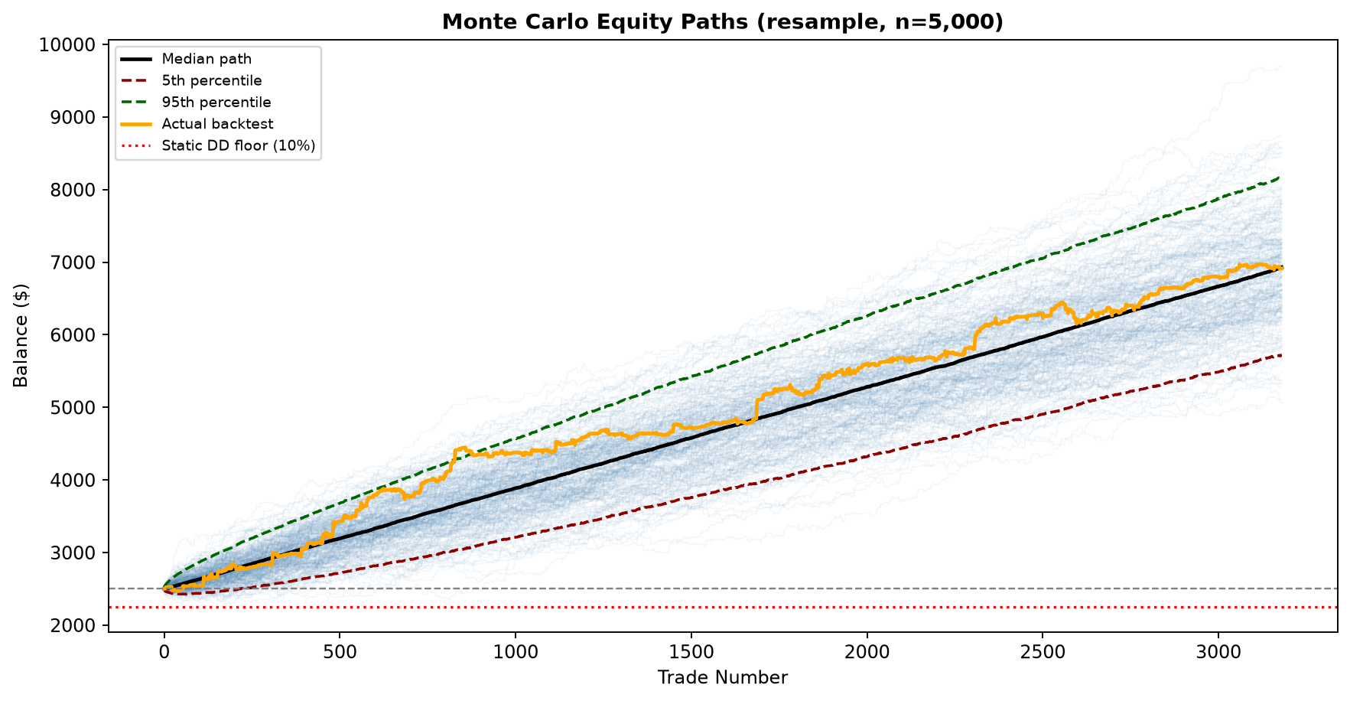
Distribution of Final Returns
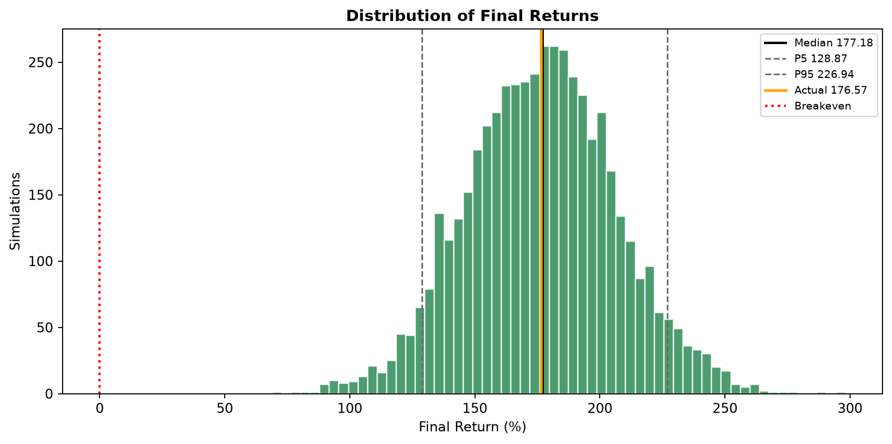
Distribution of Maximum Drawdowns
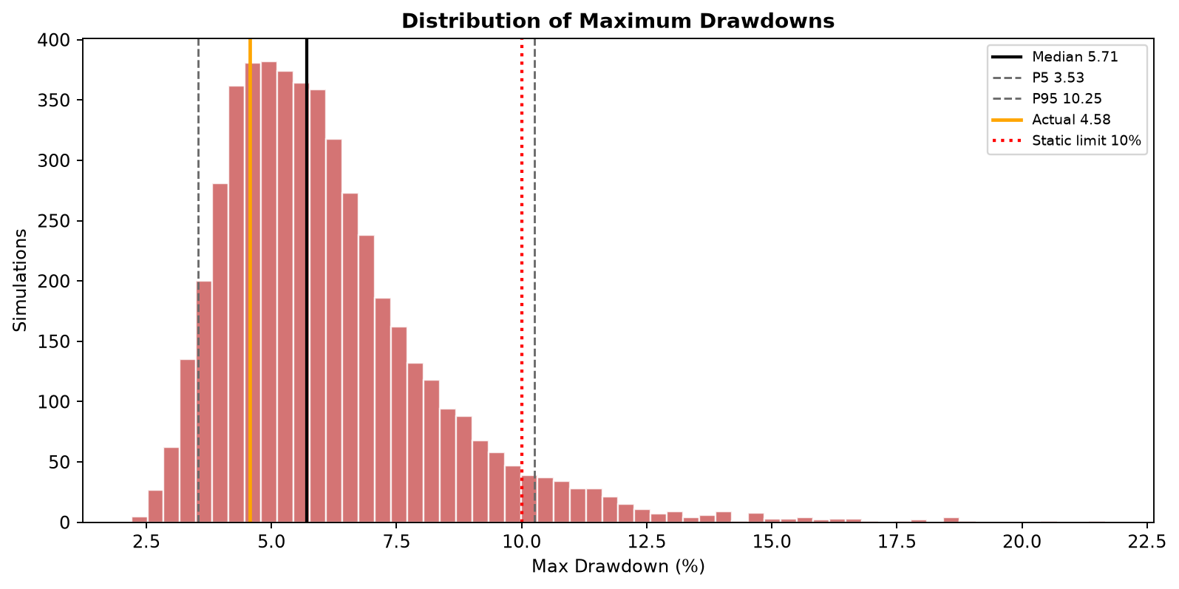
Days to Reach Phase 1 Target (passing paths only)
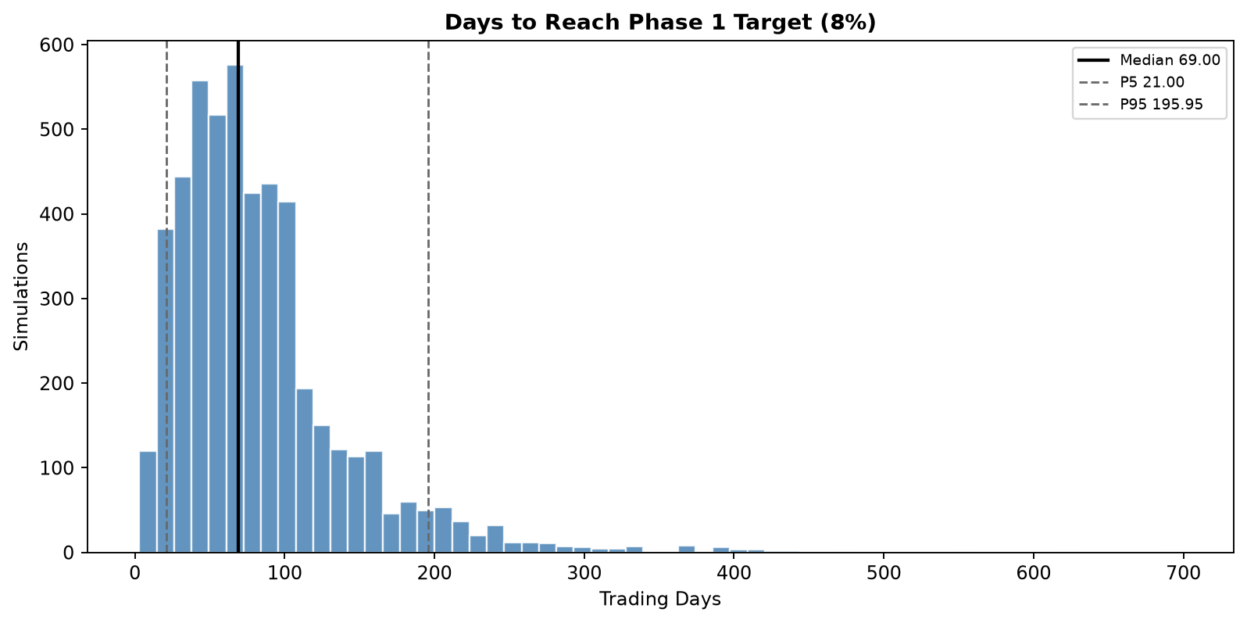

6. How to Read This
Phase 1 pass rate of 99.2% is the headline number: out of 5,000 alternate histories of this portfolio, that is the share that reached the 8% target without breaching a floor first.
Breach mix matters as much as the pass rate. This run failed 0.7% of paths on the static 10% floor and 0.0% on the 5% daily floor. Daily-floor failures usually point to position sizing or trade clustering within a day rather than a broken edge.
The 'resample' method draws trades with replacement, so a path can repeat bad trades and produce sequences worse than anything in the backtest. That is intentional - it is the point of the exercise, and it is why the pass rate here will always look worse than the single historical run.
The 'shuffle' method preserves the exact trade set and therefore the true total P&L; differences between shuffle and resample results isolate how much of the outcome depends on trade ORDER versus trade SELECTION.
A single backtest is one sample. Treat the distribution here, not the historical curve, as the realistic expectation for a live funded account.

