Quant Portfolio Report - TRB_Quant_Portfolio_001
This portfolio combines 8 candidate(s) into one simulated equity stream using a shared starting deposit of $2,500.00.

1. Portfolio Composition & Standalone Performance
Candidate | Run Folder | Weight | Standalone P/L % | Standalone Max DD % | Standalone PF | Avg Corr vs Others
cand_015 | run_20260911_094409 | 1.00 | 65.34% | 12.64% | 1.77 | 0.87
cand_013 | run_20260909_101955 | 1.00 | 78.22% | 16.86% | 1.65 | 0.92
cand_014 | run_20260909_101955 | 1.00 | 78.89% | 16.86% | 1.65 | 0.90
cand_011 | run_20260909_101955 | 1.00 | 78.85% | 16.86% | 1.65 | 0.92
cand_009 | run_20260909_101955 | 1.00 | 76.80% | 16.86% | 1.65 | 0.92
cand_003 | run_20260909_101955 | 1.00 | 77.18% | 16.86% | 1.65 | 0.92
cand_014 | run_20260911_094409 | 1.00 | 57.94% | 18.15% | 1.65 | 0.90
cand_007 | run_20260911_094409 | 1.00 | 53.65% | 14.16% | 1.73 | 0.81

2. Pairwise Monthly P&L Correlation
Correlation is computed from each candidate's own unweighted monthly net P&L. Off-diagonal values at or below 0.50 are shaded green; values above the threshold are shaded red.
 | cand_015 | cand_013 | cand_014 | cand_011 | cand_009 | cand_003 | cand_007
cand_015 | 1.00 | 0.85 | 0.90 | 0.85 | 0.85 | 0.85 | 0.92
cand_013 | 0.85 | 1.00 | 0.91 | 1.00 | 1.00 | 1.00 | 0.78
cand_014 | 0.90 | 0.91 | 1.00 | 0.91 | 0.91 | 0.91 | 0.84
cand_011 | 0.85 | 1.00 | 0.91 | 1.00 | 1.00 | 1.00 | 0.78
cand_009 | 0.85 | 1.00 | 0.91 | 1.00 | 1.00 | 1.00 | 0.78
cand_003 | 0.85 | 1.00 | 0.91 | 1.00 | 1.00 | 1.00 | 0.78
cand_007 | 0.92 | 0.78 | 0.84 | 0.78 | 0.78 | 0.78 | 1.00

3. Combined Portfolio Performance Overview
Profit / Loss ($) | $14,171.61
Profit / Loss (%) | 566.86%
Max Balance Drawdown | $891.46
Max Balance Drawdown (%) | 5.90%
Profit Factor | 1.21
Recovery Factor | 15.90
Return / Drawdown Ratio | 15.90
Sharpe Ratio | 0.98
Max Consecutive Wins | 0
Max Consecutive Losses | 0

4. Combined Trade Statistics Breakdown
Total Completed Trades | 3,326
Profit Trades | 1,669
Loss Trades | 1,657
Breakeven Trades | 0
Long Trades (Won %) | N/A
Short Trades (Won %) | N/A
Average Win per Trade | $49.06
Average Loss per Trade | $-40.87
Largest Profit Trade | $277.99
Largest Loss Trade | $-211.35
Gross Profit | $81,889.17
Gross Loss | $-67,717.56

4A. Trade Count Audit
cand_015: 293 completed trade(s) from MT5's official tester summary (STAT_TRADES); 1,326 raw activity/deal rows were used for the equity stream.
cand_013: 482 completed trade(s) from MT5's official tester summary (STAT_TRADES); 2,188 raw activity/deal rows were used for the equity stream.
cand_014: 478 completed trade(s) from MT5's official tester summary (STAT_TRADES); 2,166 raw activity/deal rows were used for the equity stream.
cand_011: 486 completed trade(s) from MT5's official tester summary (STAT_TRADES); 2,216 raw activity/deal rows were used for the equity stream.
cand_009: 487 completed trade(s) from MT5's official tester summary (STAT_TRADES); 2,243 raw activity/deal rows were used for the equity stream.
cand_003: 488 completed trade(s) from MT5's official tester summary (STAT_TRADES); 2,250 raw activity/deal rows were used for the equity stream.
cand_014: 375 completed trade(s) from MT5's official tester summary (STAT_TRADES); 1,702 raw activity/deal rows were used for the equity stream.
cand_007: 237 completed trade(s) from MT5's official tester summary (STAT_TRADES); 1,001 raw activity/deal rows were used for the equity stream.

5. Combined Averages & Holding Times
Average Trades per Month | 20.53
Average Profit per Day | $2.87
Average Profit per Month | $87.48
Average Profit per Year | $1,049.72
Min Position Holding Time | N/A
Max Position Holding Time | N/A
Avg Position Holding Time | N/A
Historical Trading Days (Active) | 1,529

6. Combined Equity Curves
Total Profit / Loss ($)
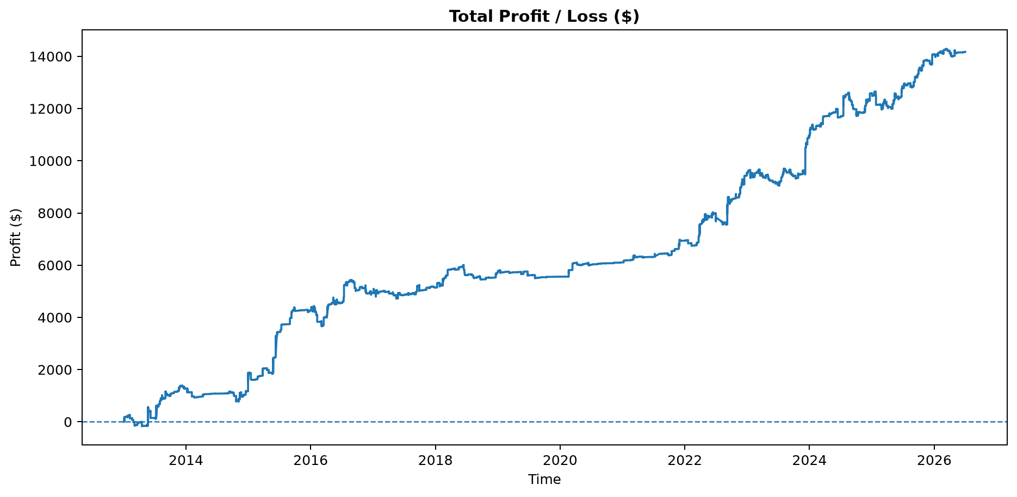
Equity / Balance Growth
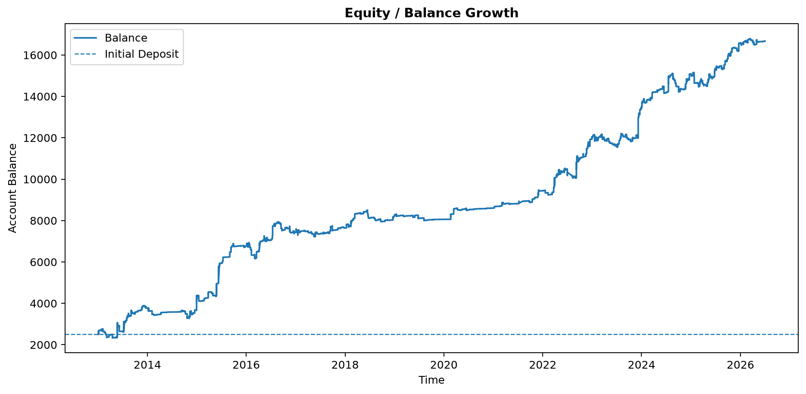
Percentage Gain / Loss (%)
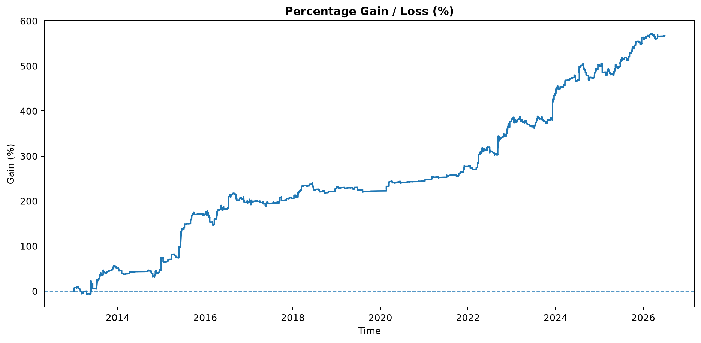
Individual Candidates vs Combined Portfolio
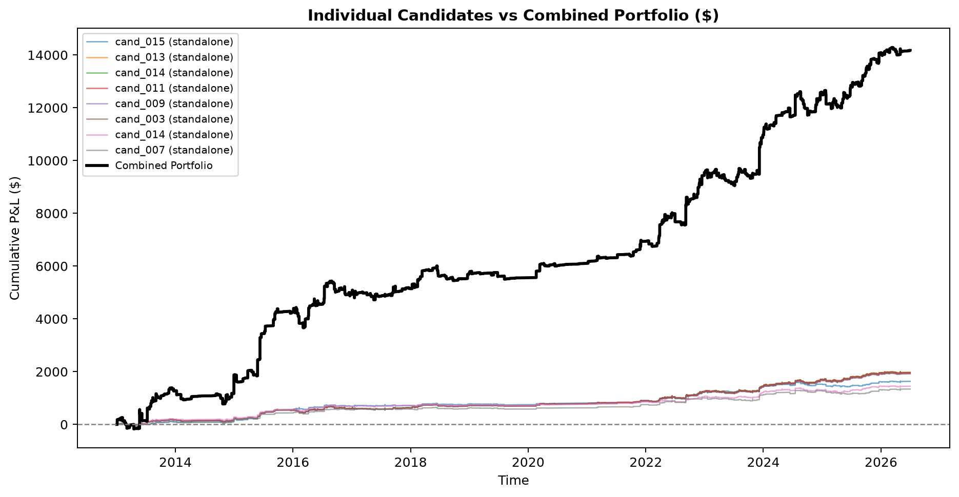

7. Combined Monthly Performance Heatmap ($ and %)
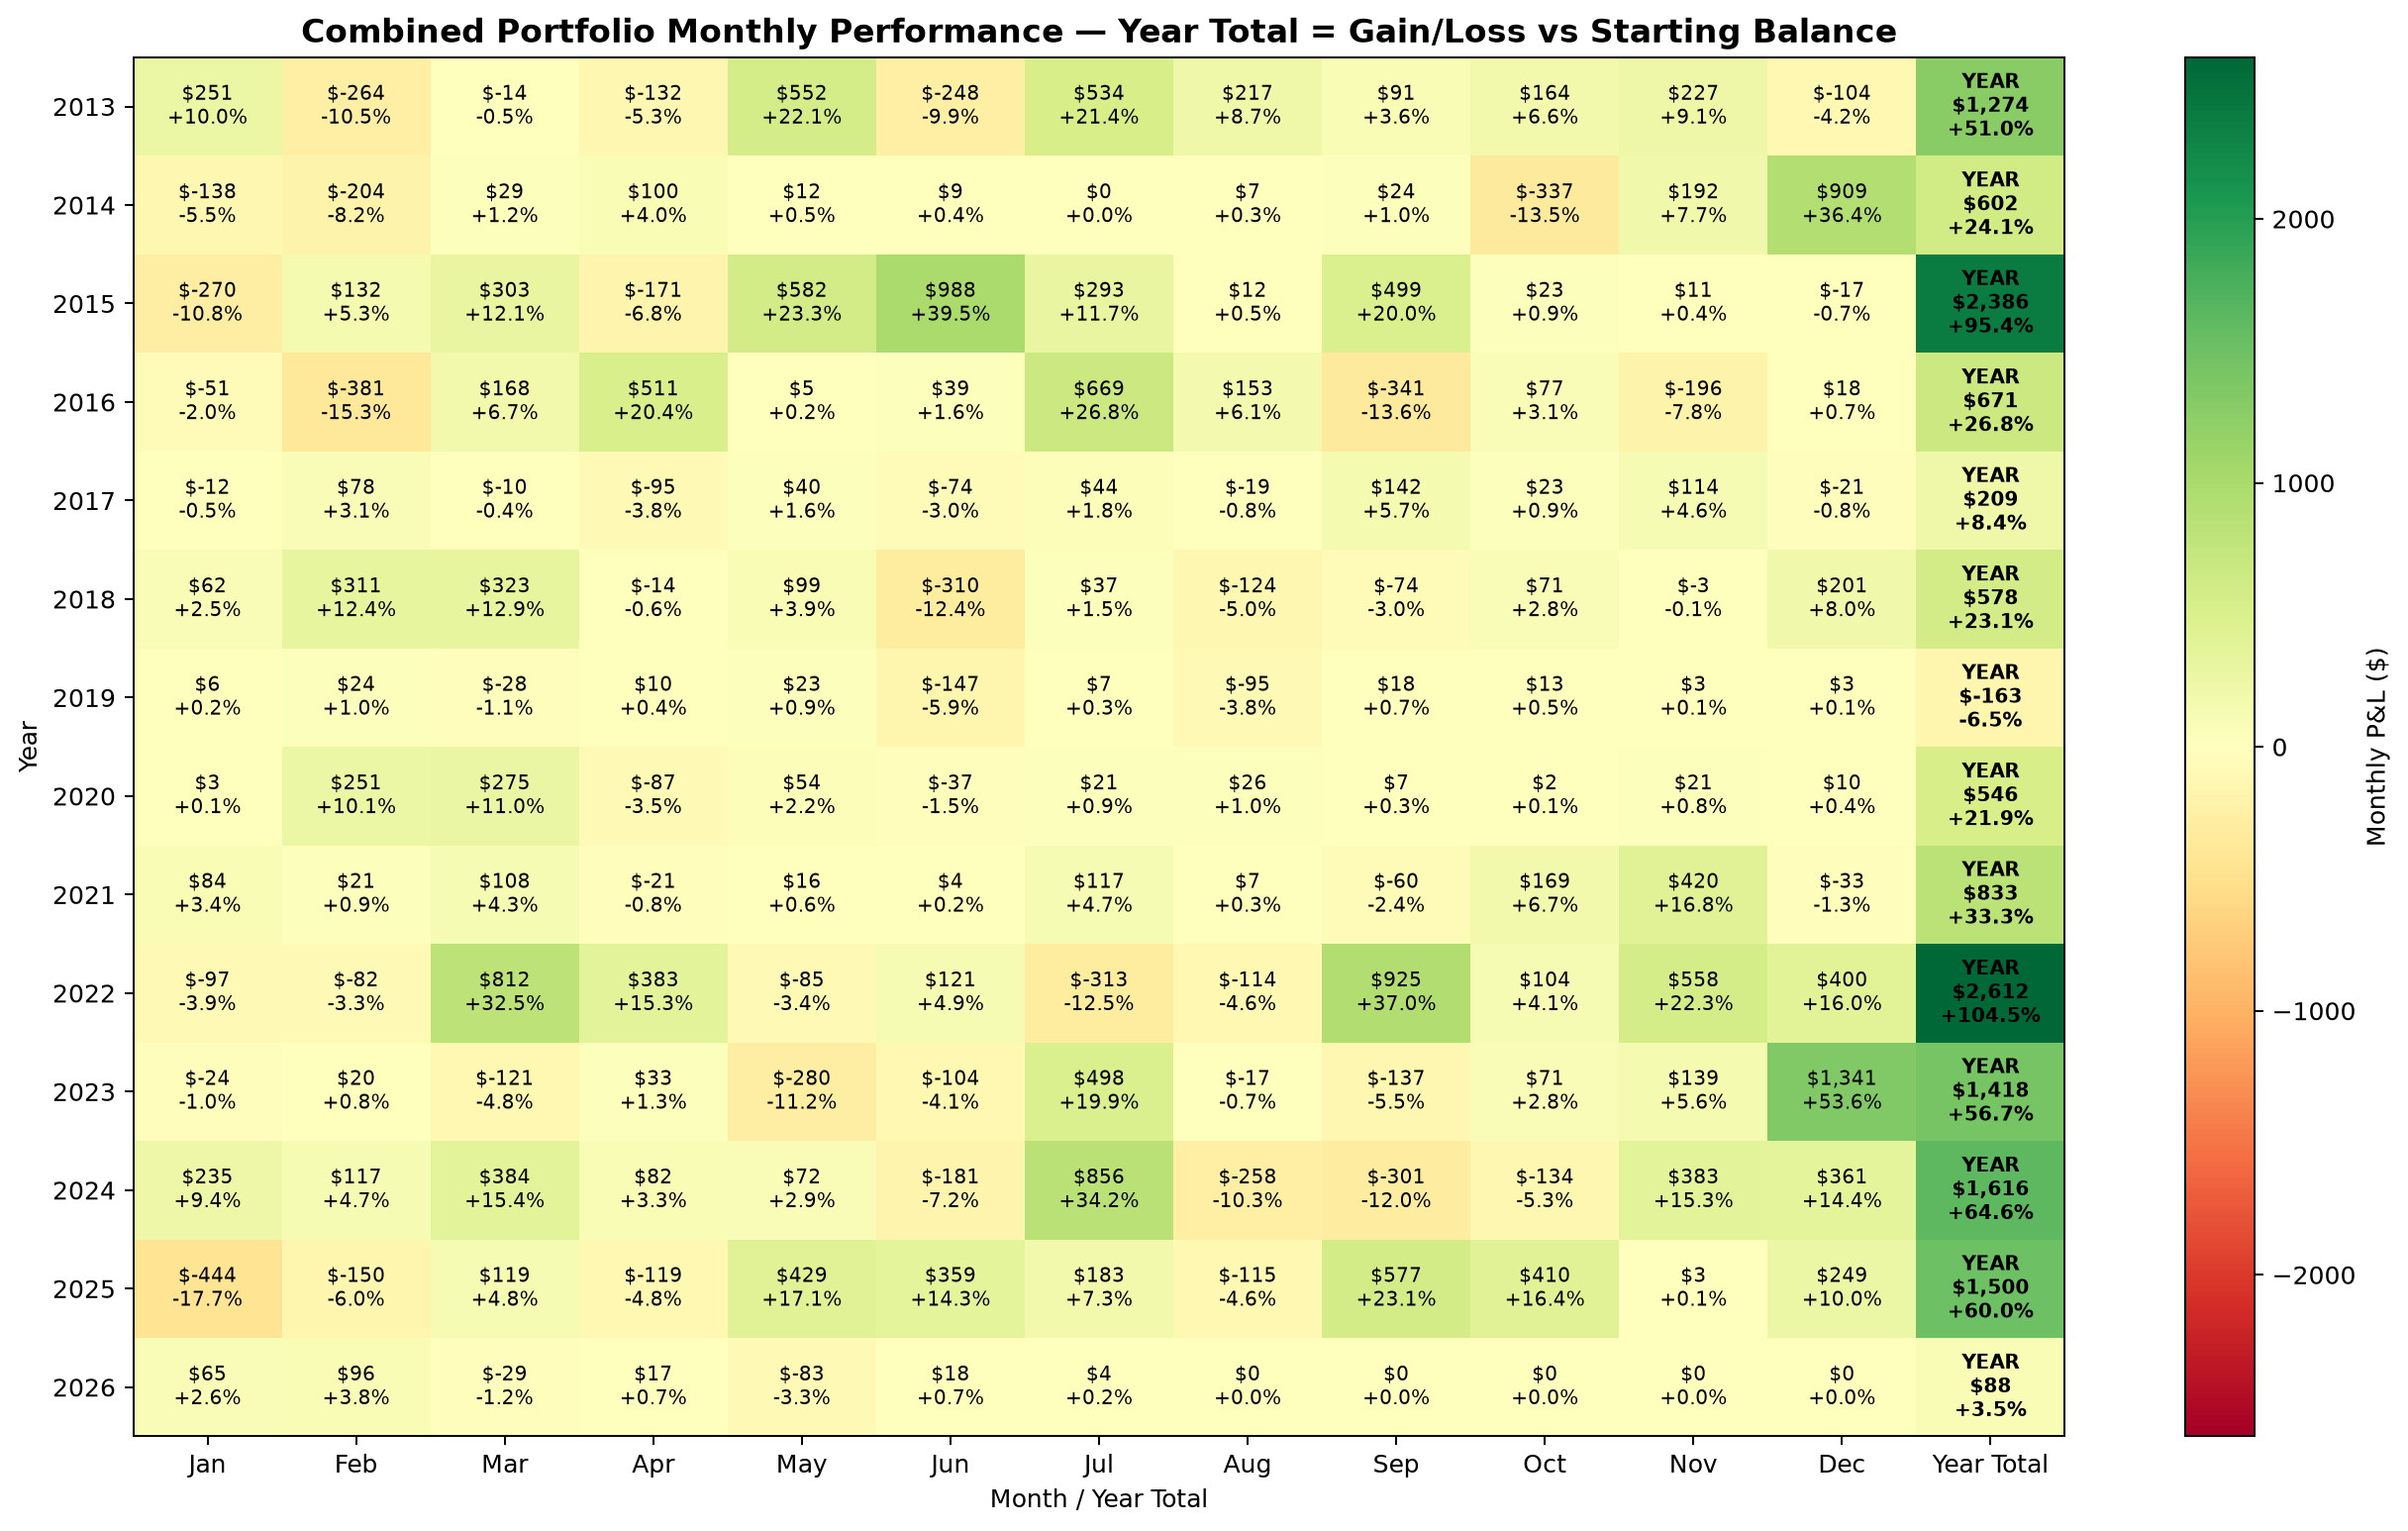
Monthly P&L is shown in dollars; percentage is monthly (or yearly for the Total column) P&L divided by the shared starting deposit.
Year | Jan | Feb | Mar | Apr | May | Jun | Jul | Aug | Sep | Oct | Nov | Dec | Total
2013 | $251  (+10.0%) | $-264  (-10.5%) | $-14  (-0.5%) | $-132  (-5.3%) | $552  (+22.1%) | $-248  (-9.9%) | $534  (+21.4%) | $217  (+8.7%) | $91  (+3.6%) | $164  (+6.6%) | $227  (+9.1%) | $-104  (-4.2%) | $1,274  (+51.0%)
2014 | $-138  (-5.5%) | $-204  (-8.2%) | $29  (+1.2%) | $100  (+4.0%) | $12  (+0.5%) | $9  (+0.4%) | $0  (+0.0%) | $7  (+0.3%) | $24  (+1.0%) | $-337  (-13.5%) | $192  (+7.7%) | $909  (+36.4%) | $602  (+24.1%)
2015 | $-270  (-10.8%) | $132  (+5.3%) | $303  (+12.1%) | $-171  (-6.8%) | $582  (+23.3%) | $988  (+39.5%) | $293  (+11.7%) | $12  (+0.5%) | $499  (+20.0%) | $23  (+0.9%) | $11  (+0.4%) | $-17  (-0.7%) | $2,386  (+95.4%)
2016 | $-51  (-2.0%) | $-381  (-15.3%) | $168  (+6.7%) | $511  (+20.4%) | $5  (+0.2%) | $39  (+1.6%) | $669  (+26.8%) | $153  (+6.1%) | $-341  (-13.6%) | $77  (+3.1%) | $-196  (-7.8%) | $18  (+0.7%) | $671  (+26.8%)
2017 | $-12  (-0.5%) | $78  (+3.1%) | $-10  (-0.4%) | $-95  (-3.8%) | $40  (+1.6%) | $-74  (-3.0%) | $44  (+1.8%) | $-19  (-0.8%) | $142  (+5.7%) | $23  (+0.9%) | $114  (+4.6%) | $-21  (-0.8%) | $209  (+8.4%)
2018 | $62  (+2.5%) | $311  (+12.4%) | $323  (+12.9%) | $-14  (-0.6%) | $99  (+3.9%) | $-310  (-12.4%) | $37  (+1.5%) | $-124  (-5.0%) | $-74  (-3.0%) | $71  (+2.8%) | $-3  (-0.1%) | $201  (+8.0%) | $578  (+23.1%)
2019 | $6  (+0.2%) | $24  (+1.0%) | $-28  (-1.1%) | $10  (+0.4%) | $23  (+0.9%) | $-147  (-5.9%) | $7  (+0.3%) | $-95  (-3.8%) | $18  (+0.7%) | $13  (+0.5%) | $3  (+0.1%) | $3  (+0.1%) | $-163  (-6.5%)
2020 | $3  (+0.1%) | $251  (+10.1%) | $275  (+11.0%) | $-87  (-3.5%) | $54  (+2.2%) | $-37  (-1.5%) | $21  (+0.9%) | $26  (+1.0%) | $7  (+0.3%) | $2  (+0.1%) | $21  (+0.8%) | $10  (+0.4%) | $546  (+21.9%)
2021 | $84  (+3.4%) | $21  (+0.9%) | $108  (+4.3%) | $-21  (-0.8%) | $16  (+0.6%) | $4  (+0.2%) | $117  (+4.7%) | $7  (+0.3%) | $-60  (-2.4%) | $169  (+6.7%) | $420  (+16.8%) | $-33  (-1.3%) | $833  (+33.3%)
2022 | $-97  (-3.9%) | $-82  (-3.3%) | $812  (+32.5%) | $383  (+15.3%) | $-85  (-3.4%) | $121  (+4.9%) | $-313  (-12.5%) | $-114  (-4.6%) | $925  (+37.0%) | $104  (+4.1%) | $558  (+22.3%) | $400  (+16.0%) | $2,612  (+104.5%)
2023 | $-24  (-1.0%) | $20  (+0.8%) | $-121  (-4.8%) | $33  (+1.3%) | $-280  (-11.2%) | $-104  (-4.1%) | $498  (+19.9%) | $-17  (-0.7%) | $-137  (-5.5%) | $71  (+2.8%) | $139  (+5.6%) | $1,341  (+53.6%) | $1,418  (+56.7%)
2024 | $235  (+9.4%) | $117  (+4.7%) | $384  (+15.4%) | $82  (+3.3%) | $72  (+2.9%) | $-181  (-7.2%) | $856  (+34.2%) | $-258  (-10.3%) | $-301  (-12.0%) | $-134  (-5.3%) | $383  (+15.3%) | $361  (+14.4%) | $1,616  (+64.6%)
2025 | $-444  (-17.7%) | $-150  (-6.0%) | $119  (+4.8%) | $-119  (-4.8%) | $429  (+17.1%) | $359  (+14.3%) | $183  (+7.3%) | $-115  (-4.6%) | $577  (+23.1%) | $410  (+16.4%) | $3  (+0.1%) | $249  (+10.0%) | $1,500  (+60.0%)
2026 | $65  (+2.6%) | $96  (+3.8%) | $-29  (-1.2%) | $17  (+0.7%) | $-83  (-3.3%) | $18  (+0.7%) | $4  (+0.2%) | $0  (+0.0%) | $0  (+0.0%) | $0  (+0.0%) | $0  (+0.0%) | $0  (+0.0%) | $88  (+3.5%)

8. Data Quality & Calculation Notes
Combined from 8 candidate report(s). The portfolio starts from one shared deposit; the individual candidates' deposits are not added together.
The chronological equity stream retains each parsed monetary activity row exactly once, after applying the configured portfolio weight.
Trade statistics are NOT counted from raw MT5 deal-row count. Where Position IDs are available, all activity belonging to one Position ID is aggregated into one completed trade.
Monthly correlation uses unweighted monthly net P&L so portfolio sizing does not distort the diversification measurement.
Portfolio max drawdown is calculated from the combined chronological balance curve.
The report uses MT5's official STAT_TRADES value for the completed trade count when available. Raw deal/activity rows are retained for equity and monetary statistics. Position-level win/loss breakdowns are not fabricated when the parsed HTML does not expose Position IDs.

