9t January, 2019

**Elshcon Nigeria Limited,**

**Port Harcourt.**

**QUOTATION FOR MOORING ROPE AND MARINE MATERIALS**

|  |  |  |  |  |
| --- | --- | --- | --- | --- |
| **S/N** | **QTY** | **DESCRIPTION** | **UNIT PRICE** | **AMOUNT(N)** |
| 1.  2.  3.  4.  5. | 1 pc  1pc  1pc.  1pc  1pc | X15mtrs 12mm dia lea line (polyrope)  X 100mtrs,19mm is steel wire rope  X 50mtrs,60mm polypropylene rope  X 3mtrs boat hook  50mtrs 35mm polypropylene mooring | 6,000.00  2,000.00  4,500.00  35,000.00  100,000.00 | 6,000.00  200,000.00  225,000.00  35,000.00  100,000.00 |
|  |  |  |  |  |
|  | **TOTAL** | | | **566,000.00** |
|  |  | | |  |

**Amount in Words:Five hundred and sixty six thousand naira only**

**TERMS:**

Add 5% VAT TIN: 17792697-00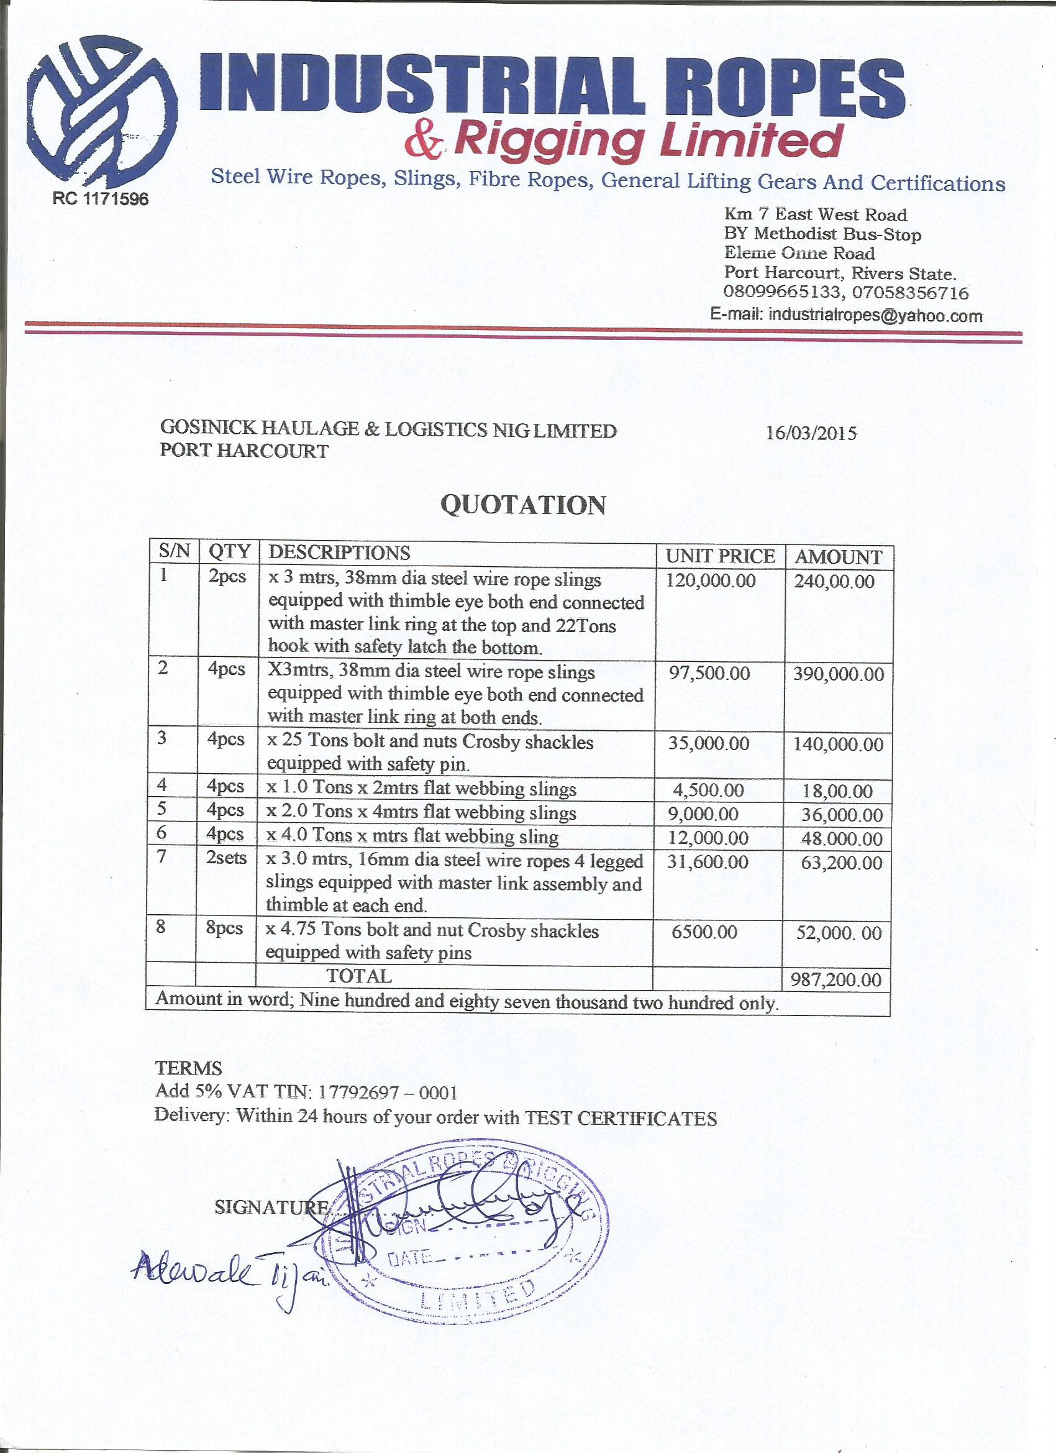011 **Delivery:** Within 24 hours of your order