4th Febuary, 2019

**Elshcon Nigeria Limited,**

**Port Harcourt.**

**QUOTATION FOR STEEL WIRE ROPE**

|  |  |  |  |  |
| --- | --- | --- | --- | --- |
| **S/N** | **QTY** | **DESCRIPTION** | **UNIT PRICE** | **AMOUNT(N)** |
| 1. | 1pc | X 100mtrs, 3/4" 19mn did steel wire rope. | .  2,000.00 | 200,000. |
|  |  |  |  |  |
|  | **TOTAL** | | | **200,000.00** |
|  |  | | |  |

**Amount in Words: Two hundred thousand naira only**

**TERMS:**

Add 5% VAT TIN: 17792697-00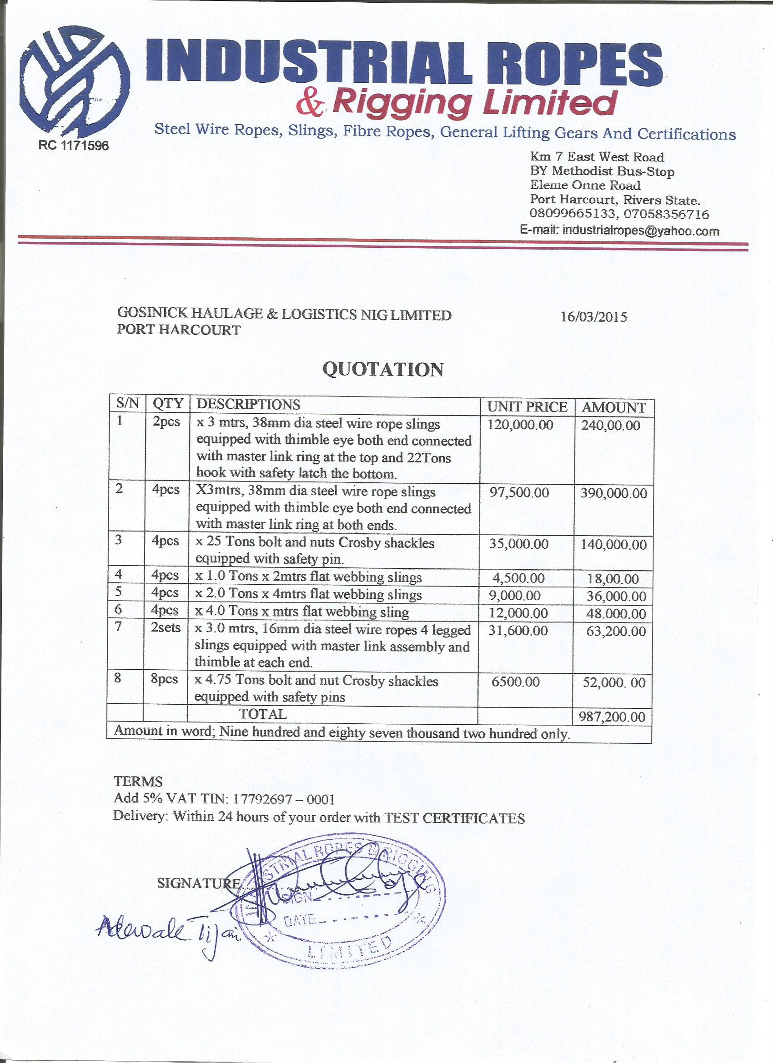011 **Delivery:** Within 24 hours of your order