

Conoil Service Center

Amadi-Ama Round About

Port Harcourt, Rivers State.

**Tel:** 07039516005

**Email:** watechlinks2003@gmail.com

**Date: ___________________**

**16th April, 2019**

**INVOICE FOR REPAIR OF VHF RADIO**



|  |  |  |  |  |
| --- | --- | --- | --- | --- |
| **S/N** | **DESCRIPTION** | **QTY** | **RATE** | **AMOUNT** |
|  | Repair of VHF radio | 1 | 20,000 | 20,000 |
|  | **TOTAL** | | | **20,000** |

**AMOUNT IN WORDS:** Twenty Thousand Naira Only.

Yours faithfully,

**For: WATECH LINKS LOGISTICS SERVICES**

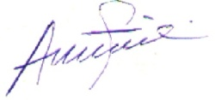

_____________________

**Tony Ekeh**

Technical Manager

