23,January, 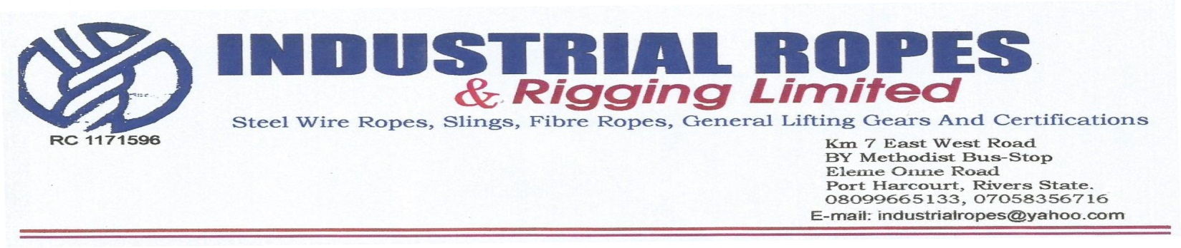2020

**Elshcom Nigeria Limited,**

**Port Harcourt.**

**PROFORMA INVOICE**

|  |  |  |  |  |
| --- | --- | --- | --- | --- |
| **S/N** | **QTY** | **DESCRIPTION** | **UNIT PRICE** | **AMOUNT(N)** |
| 1 | 2PCS | X 5mtrs, 26mm dia steel wire rope slings equipped with soft high both ends. | 47,000.00x2 | 94,000.00 |
|  |  |  |  |  |
|  | **TOTAL** | | | **94,000.00** |
|  |  | | |  |

**Amount in Words: Ninety four Thousand Naira Only**

**TERMS:**

Add 5% VAT TIN: 17792697-00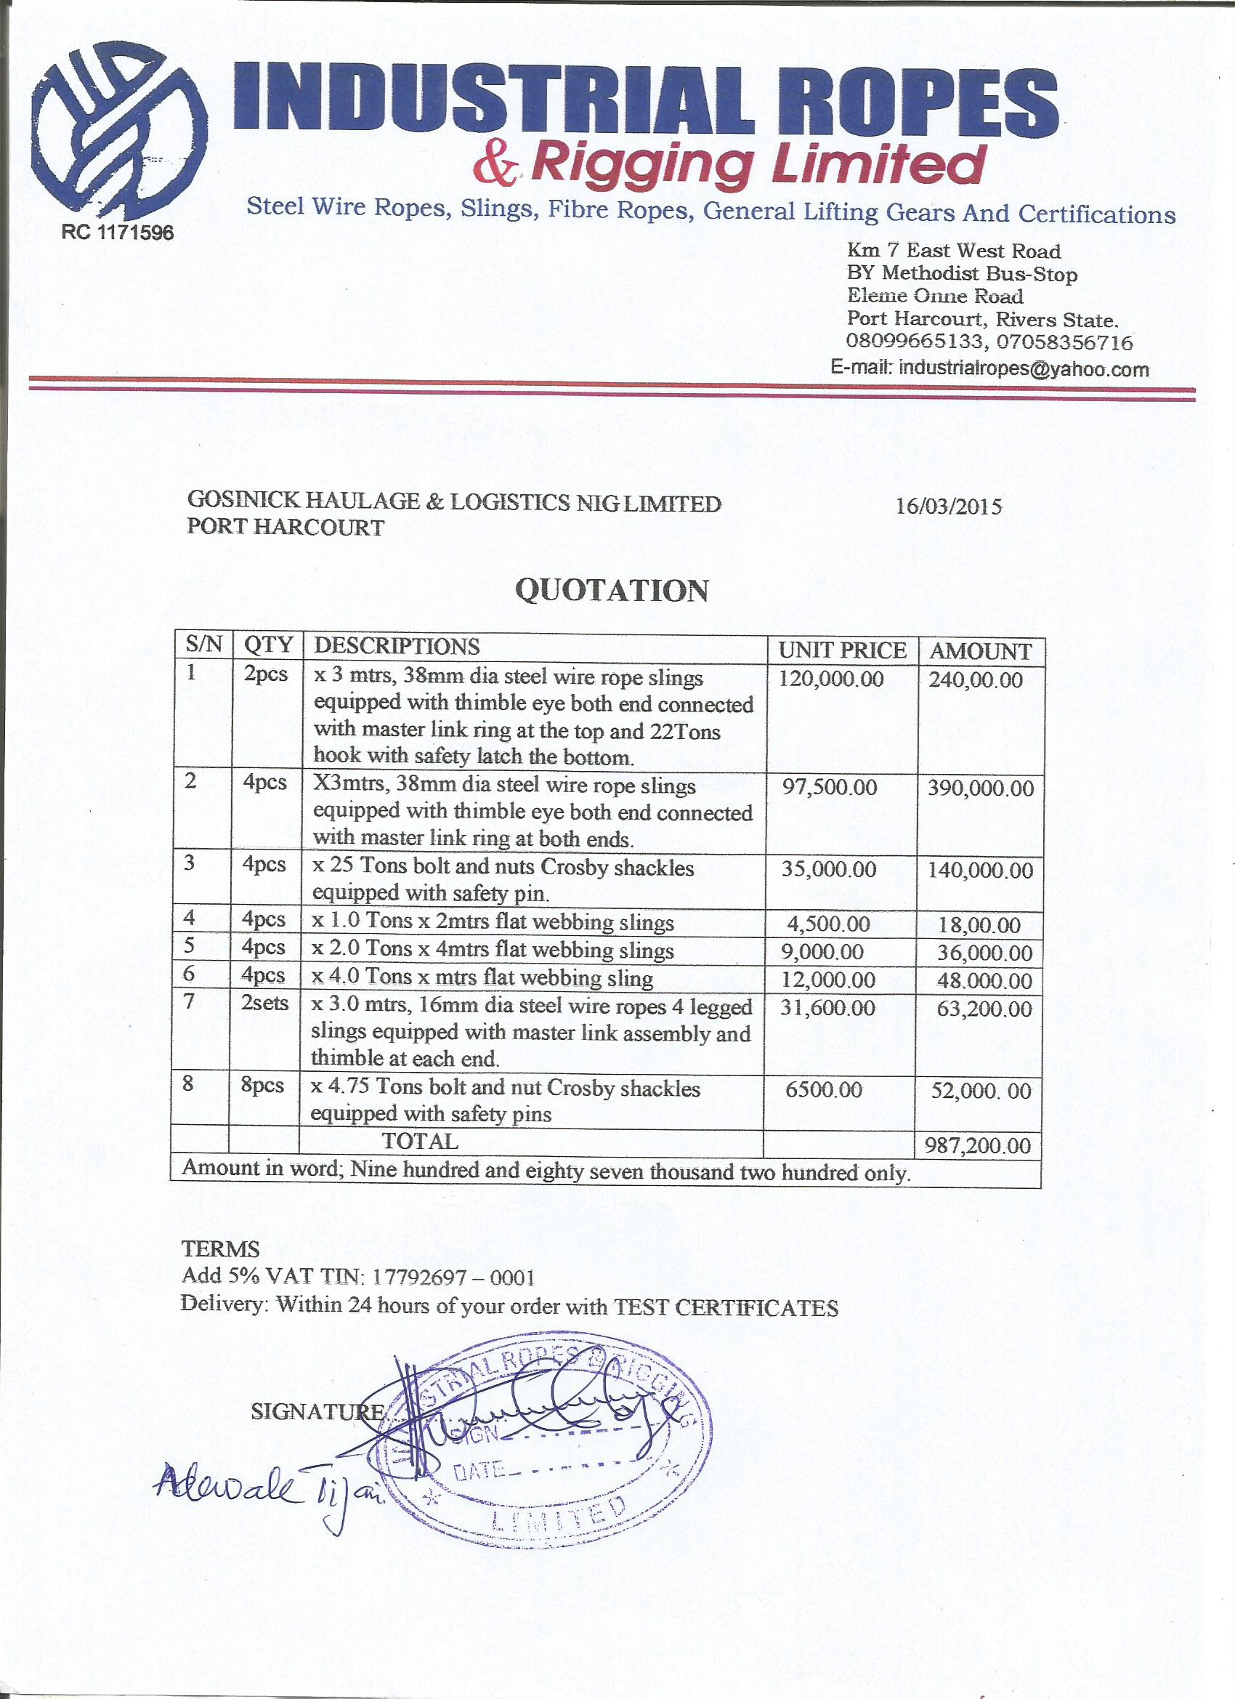011**Delivery:** Within 24 hours of your order