Elshcon Nig Ltd.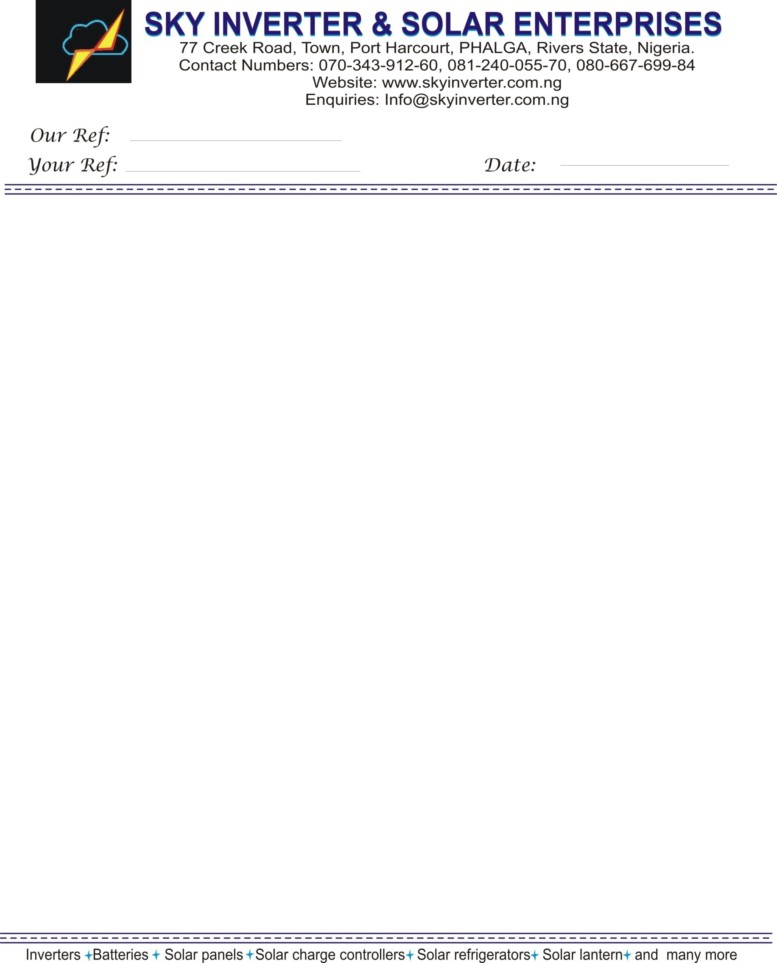

QUOTATION FOR 10 UNITS OF 2V/1000AH BATTERIES

|  |  |  |  |  |  |
| --- | --- | --- | --- | --- | --- |
| **Sr. No** | **ITEM DESCRIPTION** | **BRAND** | **UNIT PRICE (N)** | **QTY** | **TOTAL (N)** |
| 01 | 2V/1000AH | RUBITEC | 115,000 | 10 | 1,150.000 |
|  |  |  |  |  |  |
|  |  |  |  |  |  |
|  | SUB TOTAL |  |  |  | 1,150,000 |
|  |  |  |  |  |  |
|  | 5% VAT |  |  |  | 57,500 |
|  |  |  |  |  |  |
| **GRAND TOTAL** | | | | | 1,207,000 |
| **Amount in words; One Million Two Hundred And Seven Thousand Five Hundred Naira only.** | | | | | |

SKY INVERTER AND SOLAR ENT， 0090259439 Access Diamond Bank Plc

**Terms & Conditions**

Validity : The above prices are valid for 15 days from the date of offer

Payment Terms : 100% Advance along with order confirmation

Delivery : Ex-stock

Warranty : Inverters  12 Months from the date of invoice

: Batteries  12 Months from the date of invoice

: (Warranty is against manufacturing defects only)

Installation Charge : Cost of any additional items, extra length of cable will be charge

For Sky Inverter & Solar Enterprises.

CHUKWU FELIX S I

07034391260

