- -- -- --

BOUGHT OF:

ADDREss: Na L fs:B JJ_ P--H- *D<615A*

*Importer and Exporters, Dealers and Suppliers on General Goods* & Se.-.',cc.

l%fi! U8,q,Jiti:l!fil:l'l1lt8J 1-- --

[ : -:

) '---------"

.:JJ,._._,. , .._,

.

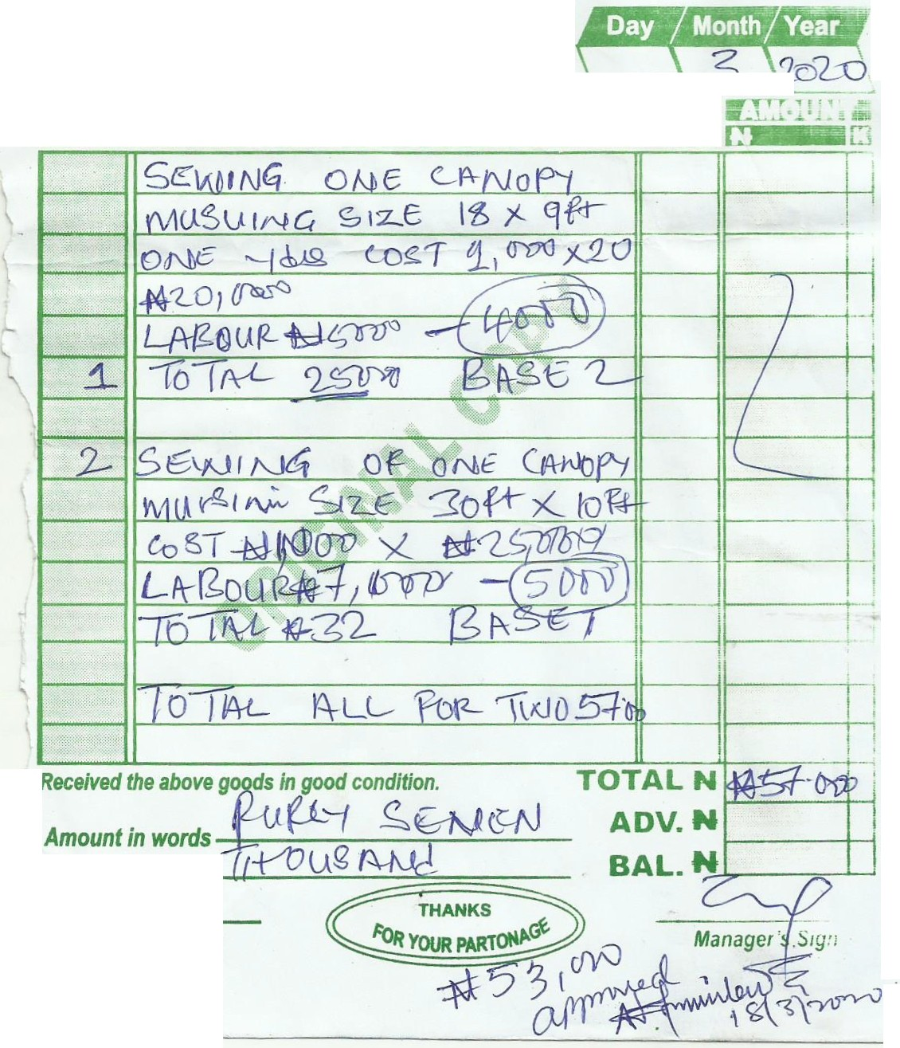

**QTY. DESCRIPTION OF GOODS' RiTE**

*Received the above g*

*Customers Sign* •

.

.