22nd September, 2020.

**Elshcon Nigeria Limited,**

**Port Harcourt.**

**PROFORMA INVOICE**

|  |  |  |  |  |
| --- | --- | --- | --- | --- |
| **S/N** | **QTY** | **DESCRIPTION** | **UNIT PRICE** | **AMOUNT** |
| 1 | 1pc | X 3.5mtrs embarkation ladder | 75,000.00 | 75,000.00 |
|  |  |  |  | 75,000.00 |
|  |  | **TOTAL** |  | **75,000.00** |

**Amount in Words: Seventy five Thousand Naira only.**

**TERMS:**

Add 7.5% VAT TIN: 17792697-00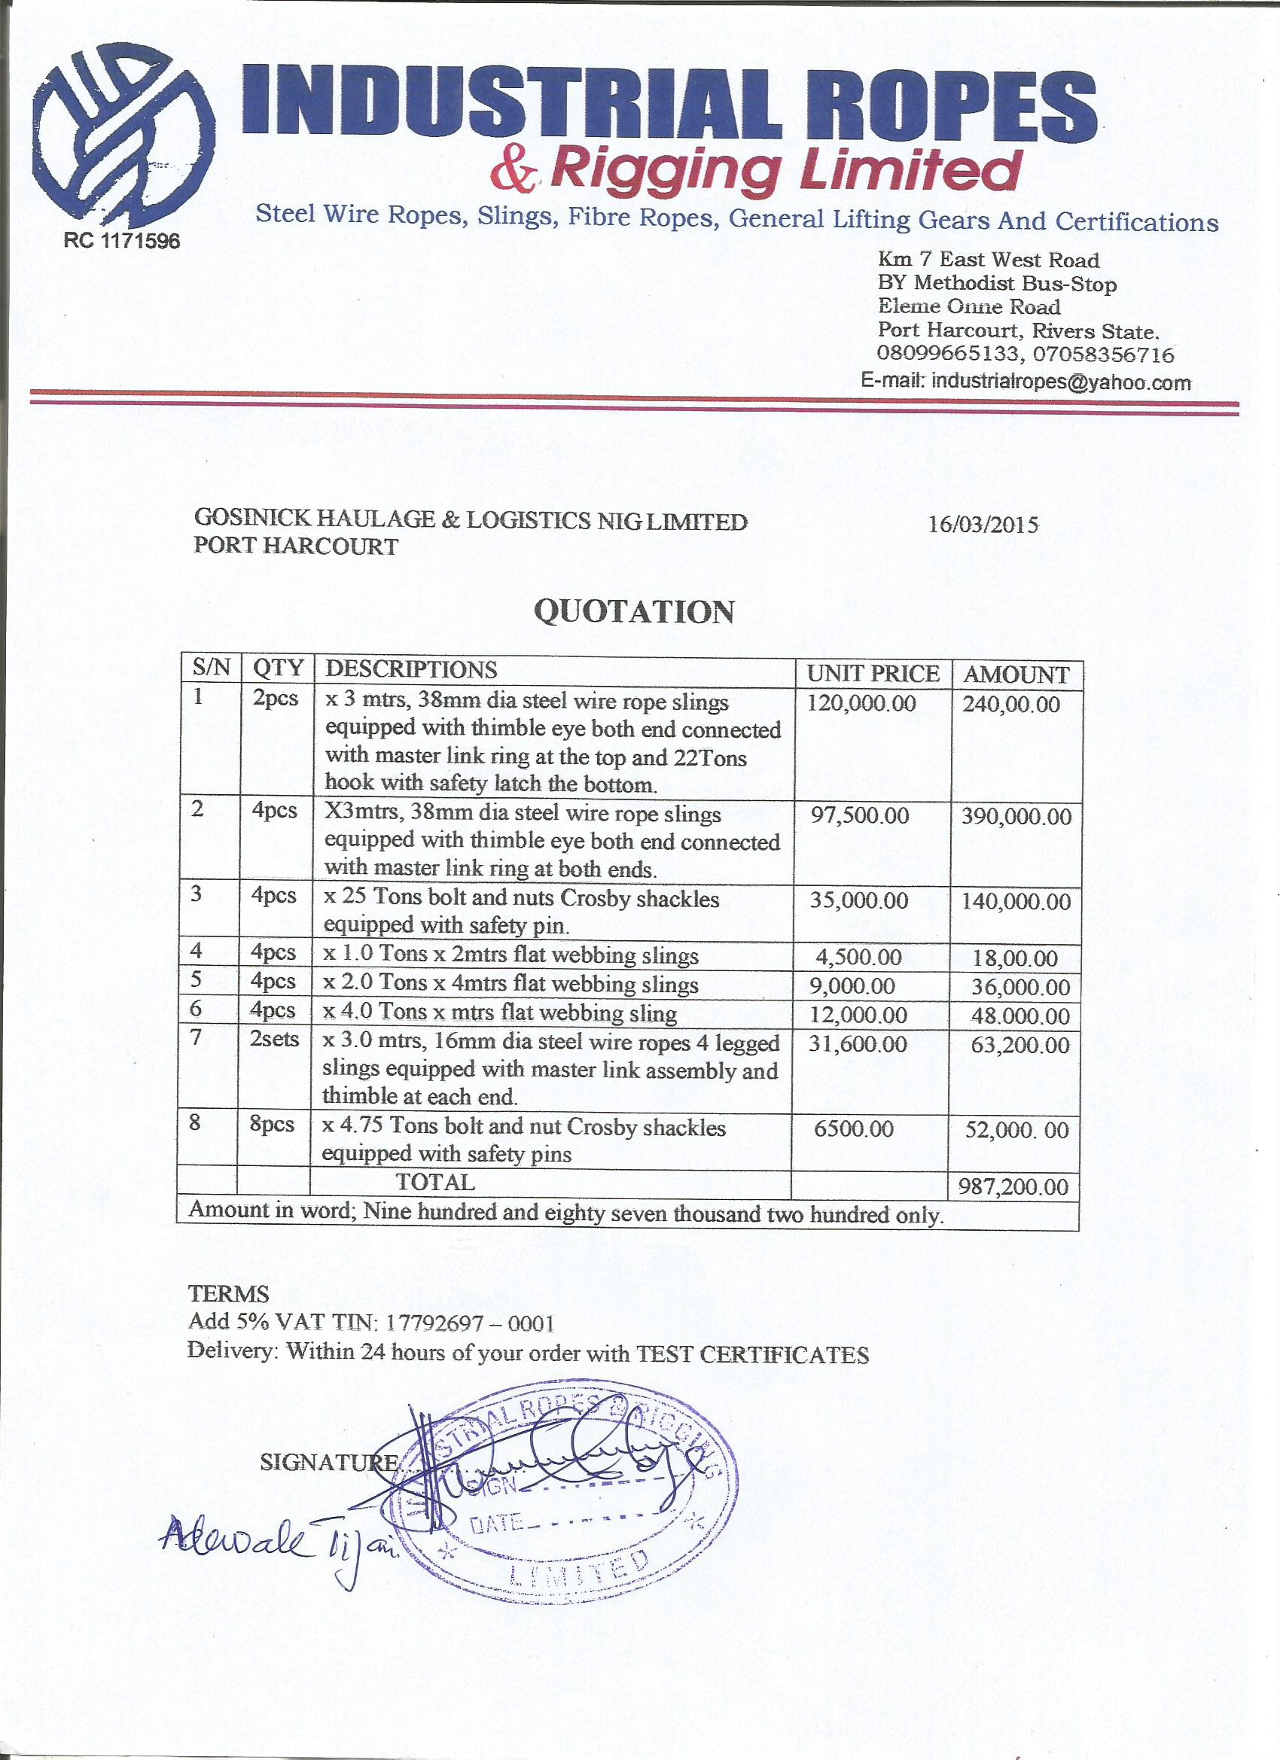01

**Delivery:** Within 48 hours of your order