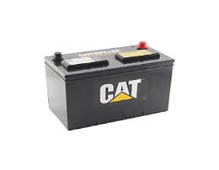 **CENCO INTERNATIONAL AGENCY LTD**

58 Amaigbo Street.

Mile 2, Diobu, Port Harcourt.

08152101148.

|  |  |  |  |  |
| --- | --- | --- | --- | --- |
| S/N | ITEM | QTY | UNIT COST | AMOUNT |
| 1. | 200A CAT DRY CELL, NON-SERVICEABLE BATTERY | 4 | N125,000 | N500,000 |

Clement Uzohor

Managing Director.