10th,February, 2021

**Elshcon Nigeria Limited,**

**Port Harcourt.**

**PROFORMA INVOICE**

|  |  |  |  |  |
| --- | --- | --- | --- | --- |
| **S/N** | **QTY** | **DESCRIPTION** | **UNIT PRICE** | **AMOUNT** |
| 1 | 3pcs | 60m, 19mm dia, (6 x 25 IWRC) Steel wire rope with both ends plain.  **NOTE:** Items be delivered with certificate | 132,000.00 | 396,000.00 |
|  |  | **TOTAL** |  | **396,000.00** |

**Amount in Words: Three Hundred and ninety-Six Thousand Naira Only**

**TERMS:**

Add 5% VAT TIN: 17792697-00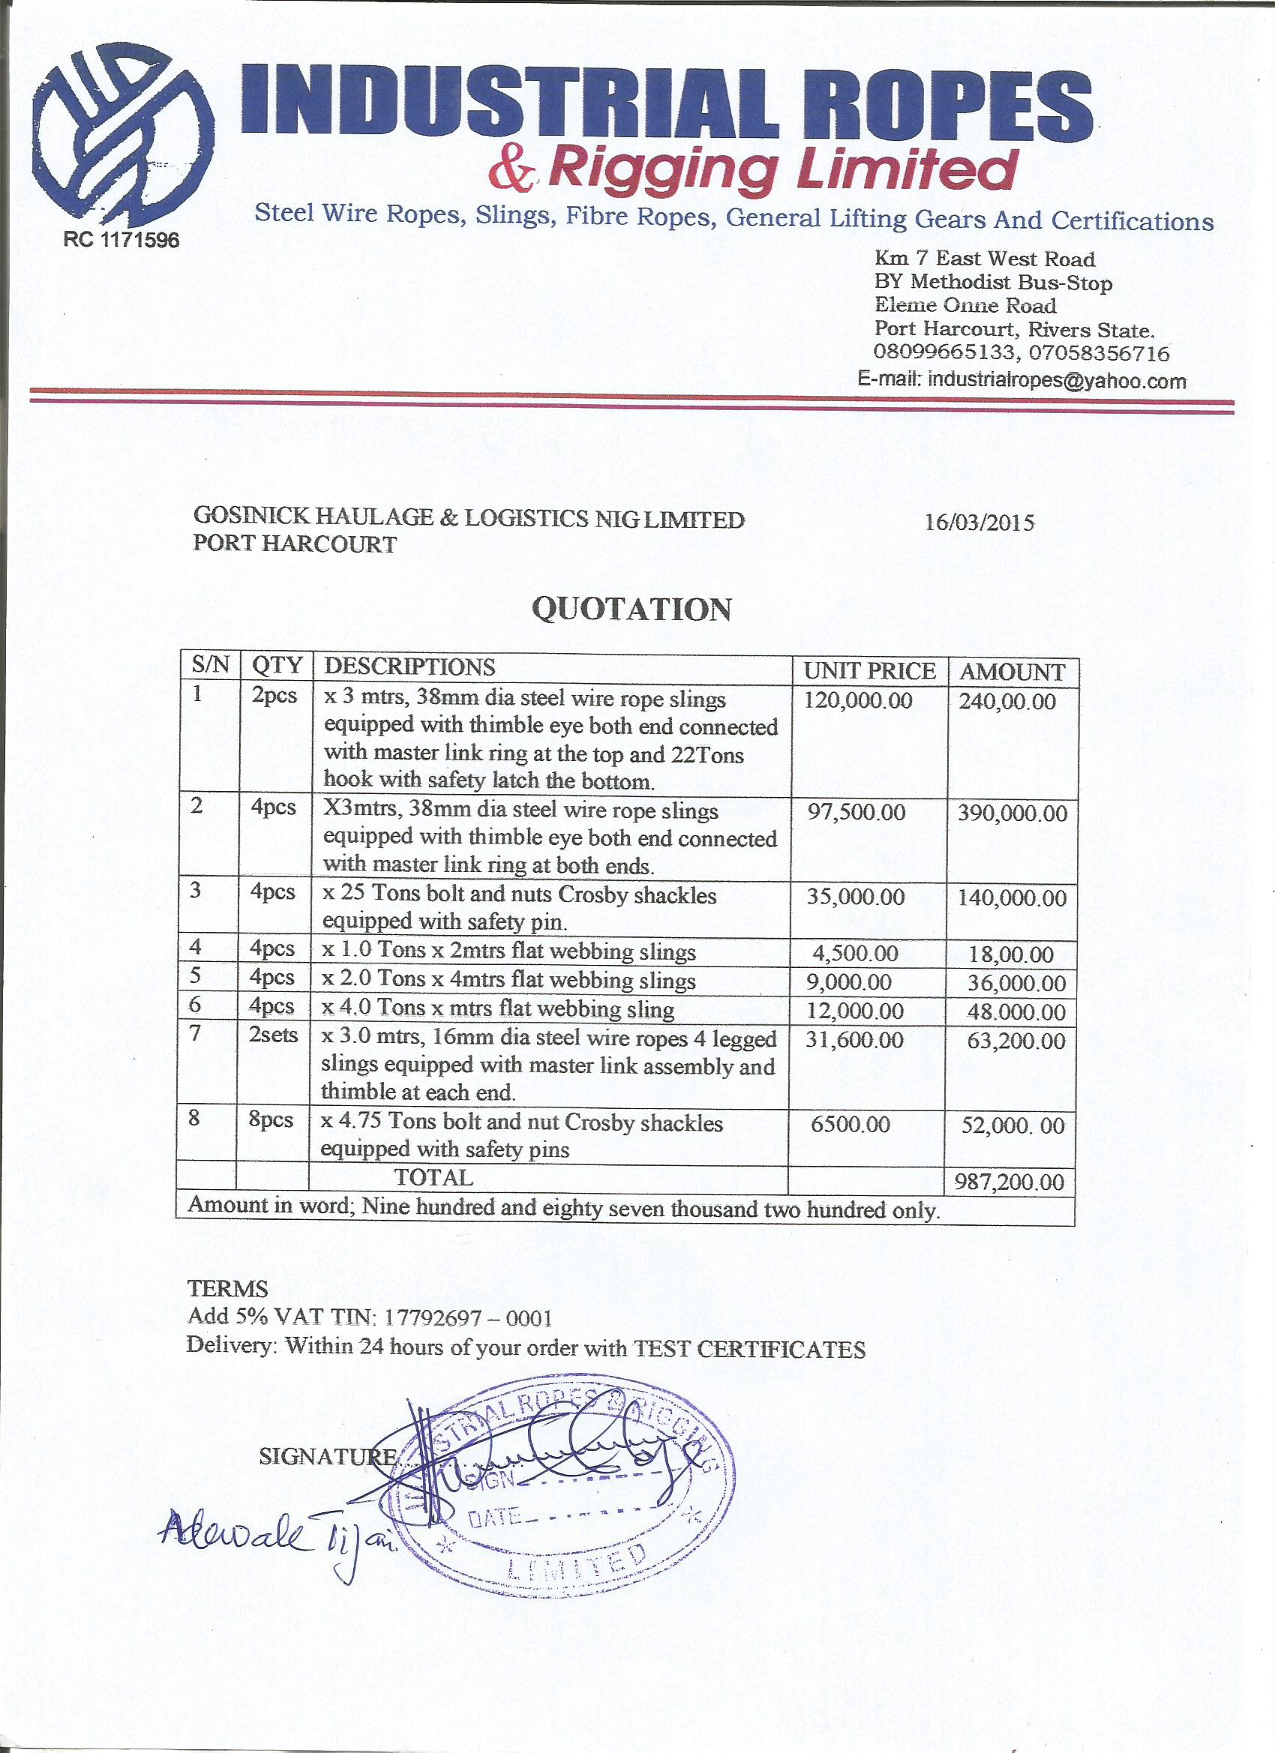011**Delivery:** Within 24 hours of your order