DANFIELD SERVICES LIMITED

DANFIELD

D

TWO-WAY RADIOS SECURITY AND SURVEILANCE SYSTEMS SOLAR POWER SOLUTIONS MASTS & TOWERS

**DATE: 27 – 04- 2021**

The Managing Director

Elshcon Nigeria Limited

Port Harcourt.

Sir,

**QUOTATION FOR IBISO VHF RADIO SERVICING**

|  |  |  |  |  |
| --- | --- | --- | --- | --- |
| S/N | DESCRIPTION OF GOODS  & SERVICES | QTY | UNIT PRICE | AMOUNT  N |
| 1 | Replacement of ON/OFF/Volume control knob | 1 | 8,000 | 8,000.00 |
| 2 | Servicing of radio | 1 | 10,000 | 10,000.00 |
|  | **TOTAL** |  |  | **18,000.00** |

**Eighteen Thousand Naira Only**

Yours faithfully

For: **Danfield Services Ltd.**

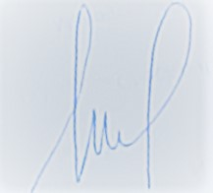

**Engr. Danison Umoh**

*Tech. Director*

N0 8 EDE STREET OFF OBUNABALI ROAD, GARRISON BUS STOP, PORT HARCOURT-RIVERS STATE.

08033103086 08027901919; Email: danfield_services@yahoo.com