29th April, 2021

Ellshcon  **Nigeria Limited,**

**Port Harcourt.**

**PROFORMA INVOICE**

|  |  |  |  |  |
| --- | --- | --- | --- | --- |
| **S/N** | **QTY** | **DESCRIPTION** | **UNIT PRICE** | **AMOUNT** |
|  | 1 coil X 200mtrs 36mm nylon mooring rope.  **NOTE:** Items be delivered with certificate | | 550, 000.00 | 550,000.00 |
|  |  | **TOTAL** |  | **550,000.00** |

**Amount in Words: Five Hundred and fiftyThousand Naira only.**

**TERMS:**

Add 7.5% VAT TIN: 17792697-00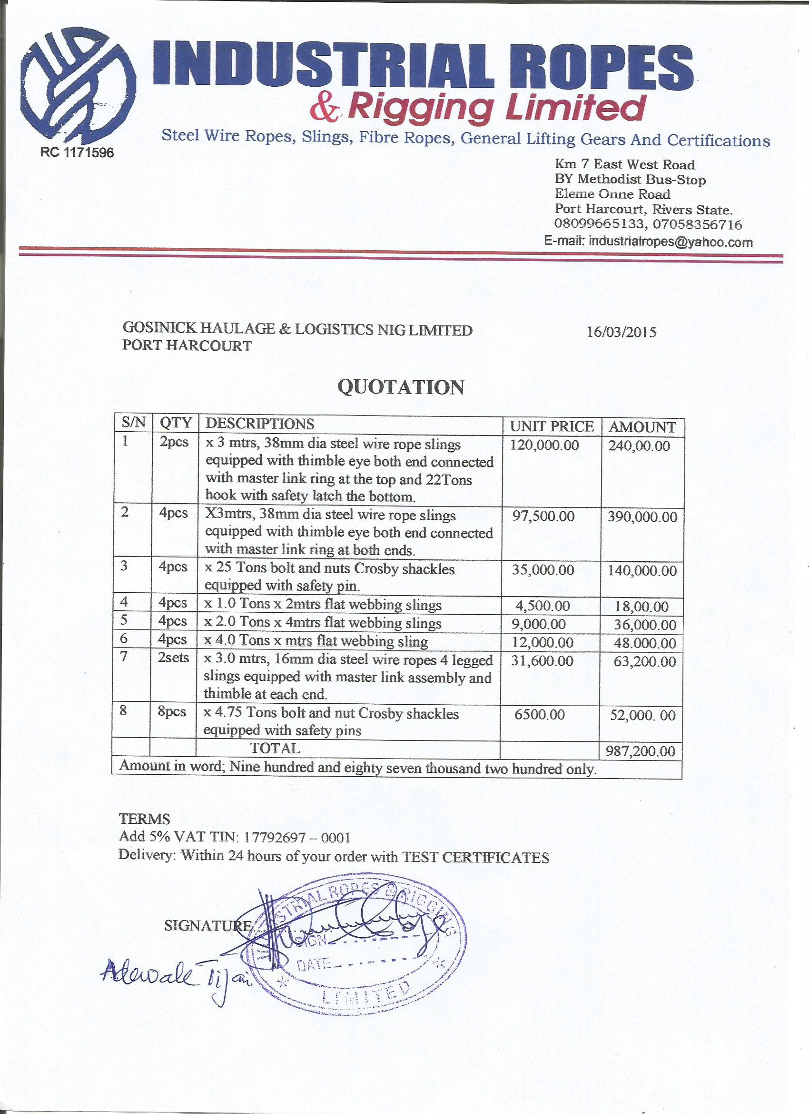01**Delivery:** Within 48 hours of your order