**GENERAL REQUISITION FORM**

|  |  |  |  |
| --- | --- | --- | --- |
| ***Requested by:*** | BRIGGS OLAWUMI | ***Position:*** | HR/ADMIN  OFFICER |
| ***Date of Request:*** | 23/11/21 | ***Location of need*** | ALL LOCATIONS |
| ***Purpose:*** | SUNDRY ITEMS NOV 2021. (BASE 1 & 2) OFFICE USE | | |
| ***Signature:*** |  | | |

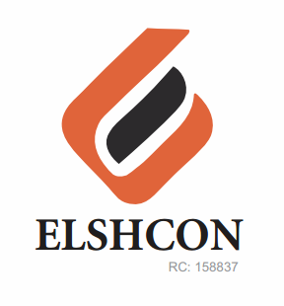

**ITEMS:**

|  |  |  |  |  |
| --- | --- | --- | --- | --- |
| **S/N** | **DESCRIPTION OF ITEMS** | **QTY** | **MARKET**  **PRICE PER ITEM** | **TOTAL**  **(N)** |
| 1. | AIR FRESHENER (AIR WICK BRAND) | 2 CANS (12PCS) | 1.800 | 3,600 |
| 2. | |  |  |  |  | | --- | --- | --- | --- | | MAMA LEMON WASHING UP LIQUID (BIG SIZE) | 12 BTLS | 500.00 | 6,000.00 | | 1 CANS(12PCS) | 750 | 8.800 |
| 3. | DETERGENT 3KG | 3 PKTS | 1,300 | 3,900.00 |
| 4. | HYPO BLEACH (BIG SIZE) 1 LIT | 12 BTLS | 750 | 9,000 |
| 5. | HARPIC TOILET CLEANSER 500GM | 6 PCS | 790 | 4,740 |
| 6. | HAND SANITIZER 200GM | 4 | 1,250 | 5,000 |
| 7 | TOWEL( FOR WASHING OF CARS) | 2PIECES | 500 | 1,000 |
| 8 | EVAPORATED PEAK MILK(FOR WELDERS) | 24PCS | 270 | 6,280 |
| 9 | WINDOLENE WINDOW CLEANER | 1PC | 1,100 | 1,100 |
|  | **TOTAL** |  |  | **#39,820** |

ELSHCON NIGERIA LIMITED (RC 158837)

|  |  |  |  |  |
| --- | --- | --- | --- | --- |
| www.elshcon.com | CORPORATE OFFICE | LAGOS OFFICE | FABRICATION YARDS/JETTIES | TELEPHONE |
| info@elshcon.com | Deborah Lawson House | 169A Moshood Olugbani Street | 3&11 Trans Woji Road, | +2348033061804 |
| enlmarine1@yahoo.co.uk | Plot F6 Abacha Road, GRA, Phase III  Port Harcourt Rivers State, Nigeria | Off Ligali Ayorinde Street, Victoria Island, Lagos State, Nigeria | By Zoo-Woji Bridge)Trans Amadi,  Industrial Layout, Port Harcourt. Rivers State, Nigeria | +2347029242162  +2348033107554 |
|  |  |  |  |  |
|  |  |  |  |  |