**GENERAL REQUISITION FORM**

|  |  |  |  |
| --- | --- | --- | --- |
| ***Requested by:*** | BRIGGS OLAWUMI | ***Position:*** | HR/ADMIN  OFFICER |
| ***Date of Request:*** | 10/1/22 | ***Location of need*** | ALL LOCATIONS |
| ***Purpose:*** | SUNDRY ITEMS JAN 2022. (BASE 1 & 2) OFFICE USE | | |
| ***Signature:*** |  | | |

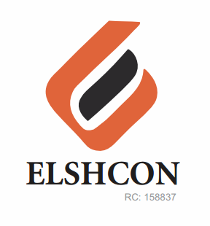

**ITEMS**

|  |  |  |  |  |
| --- | --- | --- | --- | --- |
| **S/N** | **DESCRIPTION OF ITEMS** | **QTY** | **MARKET**  **PRICE PER ITEM** | **TOTAL**  **(N)** |
| 1. | AIR FRESHENER (AIR WICK BRAND) | 2CRTS (12PCS) | 1.800 | 3,600 |
| 2. | |  |  |  |  | | --- | --- | --- | --- | | MAMA LEMON WASHING UP LIQUID (BIG SIZE) | 12 BTLS | 500.00 | 6,000.00 | | 1 CANS(12PCS) | 750 | 9.000 |
| 3. | DETERGENT 3KG | 3 PKTS | 1,300 | 3,900.00 |
| 4. | HYPO BLEACH (BIG SIZE) 1 LIT | 12 BTLS | 750 | 9,000 |
| 5. | HARPIC TOILET CLEANER | 12 PCS | 790 | 9,480 |
| 6. | HAND SANITIZER 200GM | 4 | 1,250 | 5,000 |
| 7 | PEN | 1 PKT (50 PCS) | 45 | 2,250 |
| 8 | EVAPORATED PEAK MILK(FOR WELDERS) | 24PCS | 270 | 6,280 |
| 9 | WINDOLENE WINDOW CLEANER | 1PC | 1,100 | 1,100 |
|  | **TOTAL** |  |  | **#49,610** |
|  | **BOMADI SUNDRY** |  |  |  |
| 1 | TISSUE PAPER | (50PCS) | #80 | 4,000 |
| 2 | MAMA LEMON WASHING UP LIQUID (BIG SIZE) | 6PCS | 750 | 4,500 |
| 3 | HAND SANITIZER 200GM | 2 | 1,250 | 2,500 |
| 4 | DETERGENT | 2KG | 1,300 | 2,600 |
| 6 | HARPIC TOILET CLEANER | 4 | 790 | 3,160 |
|  | **TOTAL** |  |  | **#16,760** |

***GRAND TOTAL #66,370***