**GENERAL REQUISITION FORM**

|  |  |  |  |
| --- | --- | --- | --- |
| ***Requested by:*** | BRIGGS OLAWUMI | ***Position:*** | HR/ADMIN  OFFICER |
| ***Date of Request:*** | 24/1/22 | ***Location of need*** | ALL LOCATIONS |
| ***Purpose:*** | REFRESHMENT FOR SEMINAR AND WORKOUT | | |
| ***Signature:*** |  | | |

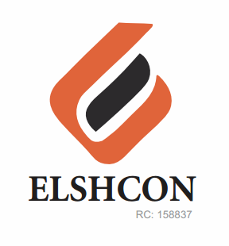

**ITEMS**

|  |  |  |  |  |
| --- | --- | --- | --- | --- |
| **S/N** | **DESCRIPTION OF ITEMS** | **QTY** | **MARKET**  **PRICE PER ITEM** | **TOTAL**  **(N)** |
| 1. | MEATPIE | 60 PCS | 400 | 24,000 |
| 2. | |  |  |  |  | | --- | --- | --- | --- | | MALT | 12 BTLS | 500.00 | 6,000.00 | | 2CTN & HALF | 187 | 11,220 |
| 3. | BOTTLED WATER (FOR WORKOUT) | 3 CARTONS | 1,400 | 4,200 |
| 4. | CHAIRS | 60PCS | 100 | 6,000 |
| 5 | BODYBOOST INSTRUCTOR FEE |  |  | 5,000 |
|  | **TOTAL** |  |  | **#50,420** |