1st February 2021

**Elshcon Nigeria Limited,**

**Port Harcourt.**

**PRO FORMA INVOICE FOR STEEL WIRE ROPE**

|  |  |  |  |  |
| --- | --- | --- | --- | --- |
| **S/N** | **QTY** | **DESCRIPTION** | **UNIT PRICE** | **AMOUNT(N)** |
| 1. | 4 pcs | x 30 mtrs, 19mm dia steel wire rope equipped with plain end both side. | 105 000.00 | 420,000.00 |
| 2.  3. |  |  |  |  |
|  | **TOTAL** | | | **420,000.00** |
|  | **GRAND TOTAL** | | | **420,000.00** |

**Amount in Words: Four Hundred and twenty thousand naira only**

**TERMS:**

Add 7.5% VAT TIN: 17792697-0001

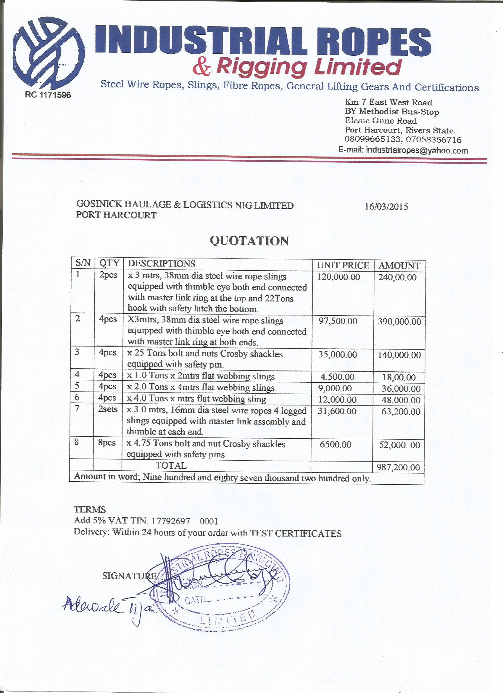**Delivery:** Within 48hours of your order with TEST CERTIFICATE