RC: 1381950

Mgboba Port Harcourt

Tel: 07037106503

ENTREATY MEGA LINKS LTD

**PROFOMA INVOICE**

The Quality Assurance Manager,

Elshcon Nigeria Ltd,

Port Harcourt,

Rivers State.

|  |  |  |  |  |
| --- | --- | --- | --- | --- |
| Dear Sir,**S/N** | **DESCRIPTION** | **QTY** | **RATE** | **AMOUNT (N)** |
| 1. | Fire fighting foam agent | 200L (2 Drums) | 90,000 | 180,000 |

**ACCOUNT DETAILS:**

Entreaty Mega Links

1020772768

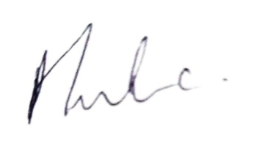UBA

…………………………

**Amaka Evans**

Marketing Manager