**GENERAL REQUISITION FORM**

|  |  |  |  |
| --- | --- | --- | --- |
| ***Requested by:*** | BRIGGS OLAWUMI | ***Position:*** | HR/ADMIN  OFFICER |
| ***Date of Request:*** | 16/5/22 | ***Location of need*** | ALL LOCATIONS |
| ***Purpose:*** | SUNDRY ITEMS APRIL 2022. (BASE 1 & 2)& BOMADI OFFICE USE | | |
| ***Signature:*** |  | | |

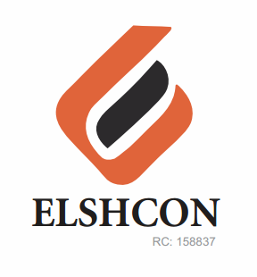

**ITEMS**

|  |  |  |  |  |
| --- | --- | --- | --- | --- |
| **S/N** | **DESCRIPTION OF ITEMS** | **QTY** | **MARKET**  **PRICE PER ITEM** | **TOTAL**  **(N)** |
| 1. | AIR FRESHENER (AIR WICK BRAND) | 2CRTS (12PCS) | 1.800 | 3,600 |
| 2. | |  |  |  |  | | --- | --- | --- | --- | | MAMA LEMON WASHING UP LIQUID (BIG SIZE) | 12 BTLS | 500.00 | 6,000.00 | | 1 CANS(12PCS) | 800 | 9.600 |
| 3. | DETERGENT 4KG | 4 PKTS | 1,300 | 5,200 |
| 4. | HYPO BLEACH (BIG SIZE) 1 LIT | 12 BTLS | 850 | 10,200 |
| 5. | HARPIC TOILET CLEANER | 12 PCS | 890 | 10,680 |
| 6. | HAND SANITIZER 200GM | 4 | 1,500 | 6,000 |
| 7 | EVAPORATED PEAK MILK(FOR WELDERS) | 24PCS | 270 | 6,880 |
| 8 | Insecticides (base 1&2 Mopol) | 4pcs | 1,200 | 4,800 |
|  | **TOTAL** |  |  | **#56,960** |
|  | **BOMADI SUNDRY** |  |  |  |
| 1 | TISSUE PAPER | (50PCS) | #80 | 4,000 |
| 2 | MAMA LEMON WASHING UP LIQUID (BIG SIZE) | 6PCS | 800 | 4,800 |
| 3 | HAND SANITIZER 200GM | 2 | 1,500 | 3,000 |
| 4 | DETERGENT | 3KG | 1,300 | 3,900 |
| 5 | HARPIC TOILET CLEANER | 6 | 890 | 5,340 |
| 6 | HYPO BLEACH | 6 Bottles | 850 | 5,100 |
|  |  |  |  |  |
|  |  |  |  |  |
|  | **TOTAL** |  |  | **#26,140** |

***GRAND TOTAL #83,100***