**GENERAL REQUISITION FORM**

|  |  |  |  |
| --- | --- | --- | --- |
| ***Requested by:*** | BRIGGS OLAWUMI | ***Position:*** | HR/ADMIN  OFFICER |
| ***Date of Request:*** | 17/6/22 | ***Location of need*** | ALL LOCATIONS |
| ***Purpose:*** | REFRESHMENT FOR WORKOUT | | |
| ***Signature:*** |  | | |

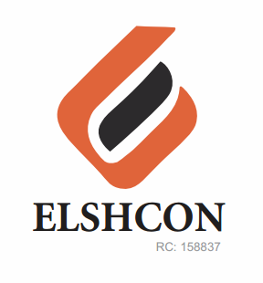

**ITEMS**

|  |  |  |  |  |
| --- | --- | --- | --- | --- |
| **S/N** | **DESCRIPTION OF ITEMS** | **QTY** | **MARKET**  **PRICE PER ITEM** | **TOTAL**  **(N)** |
| 1. | MEATPIE | 65 PCS | 400 | 26,000 |
| 3. | BOTTLED WATER (FOR WORKOUT) | 4 CARTONS | 1,700 | 6,800 |
| 4. | INSTRUCTOR FEE |  |  | 5,000 |
|  |  |  |  |  |
|  | **TOTAL** |  |  | **#37,800** |

***GRAND TOTAL # 37,800***