RC: 1381950

Mgboba Port Harcourt

Tel: 07037106503

ENTREATY MEGA LINKS LTD

**PROFOMA INVOICE**

The Quality Assurance Manager,

Elshcon Nigeria Ltd,

Port Harcourt,

Rivers State.

This is the price for cash on delivery

|  |  |  |  |  |  |  |
| --- | --- | --- | --- | --- | --- | --- |
| Dear Sir,**S/N** | **DESCRIPTION** | **QTY** | **RATE** | **Product price per liter** | **Profit/VAT** | **Total Price** |
| 1. | Diesel (AGO) | 20000L | 550 | 540 | 10 |  |
|  |  |  | 11,000,000 | 10,800000 | 185,000 | 10,985,000 |

**ACCOUNT DETAILS:**

Entreaty Mega Links

1020772768

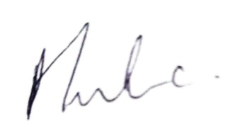UBA

…………………………

**Amaka Evans**

Marketing Manager